# Software Requirements

**Specification**

**for**

# Servicely

### Version 1.0.0

**Prepared by**

**Aaveg Tomar**

**Arpit Puri**

**Abhi Singhal**

***Copyright © 1999 by Karl E. Wiegers. Permission is granted to use, modify, and distribute this document.***

## Table of Contents

Table of Contents ii

Revision History ii

1. Introduction 1
   1. Purpose 1
   2. Document Conventions 1
   3. Intended Audience and Reading Suggestions 1
   4. Product Scope 1
   5. References 1
2. Overall Description 2
   1. Product Perspective 2
   2. Product Functions 2
   3. User Classes and Characteristics 2
   4. Operating Environment 2
   5. Design and Implementation Constraints 2
   6. User Documentation 2
   7. Assumptions and Dependencies 3
3. External Interface Requirements 3
   1. User Interfaces 3
   2. Hardware Interfaces 3
   3. Software Interfaces 3
   4. Communications Interfaces 3
4. System Features 4
   1. System Feature 1 4
   2. System Feature 2 (and so on) 4
5. Other Nonfunctional Requirements 4
   1. Performance Requirements 4
   2. Safety Requirements 5
   3. Security Requirements 5
   4. Software Quality Attributes 5
   5. Business Rules 5
6. Other Requirements 5

Appendix A: Glossary 5

Appendix B: Analysis Models 5

Appendix C: To Be Determined List 6

## Revision History

|  |  |  |  |
| --- | --- | --- | --- |
| **Name** | **Date** | **Reason For Changes** | **Version** |
|  |  |  |  |
|  |  |  |  |

## Introduction

### Purpose

The Local Services Marketplace is a platform that connects consumers with local service providers such as painters, pest control experts, plumbers, mechanics, and more. The platform will enable users to search and rate service providers based on their experience, providing them with an easy and reliable way to find the right service provider for their needs. This document outlines the requirements for the Local Services Market place Product Functions.

### Product Scope

The scope of our project is to designing a complete environment to provide a safe and user friendly environment for online service booking. The main aim of the project is to provider an easy to use application for services provided for customer.

We often get frustrated while taking the appointment of service provider because there the many problems are occur,  like the service provider is busy art somewhere else or  his not receiving our call or his cost is very high according to problem. So in this project we will remove this headache.

### 1.3 Purpose

Our purpose of developing this project is mainly online there website and android application.

We have observed how limitations in existing system:

* Existing system is offline
* No time limit for service to be provided.
* No guarantied service
* 24 hours service is not available.

So, our purpose is to overcome this limitation with following features.

* House hold services easy available.
* To provide house hold services any time.
* Easy online payment.
* Saving of time.
* Make available house hold services through website & application.
* Direct Interaction with vendor.

## Overall Description

### Characteristics

The Local Services Marketplace is a web application that provides a platform for consumers to find local service providers directly. The platform allows consumers to search for service providers based on their location and the type of service required. Additionally, users can rate and review service providers based on their experience, ensuring that the platform remains a reliable source for quality service providers.

### Design and Implementation Constraints

Website will be made for the ease of people with the latest technology used.

**2.2.1 Technology Used are**

* ReactJS
* NodeJS
* Tailwindcss
* MondgoDb
* ExpressJS

## Functional Requirement:

### Functional Requirement:

The platform must allow users to create an account and log in. The platform must allow users to search for service providers based on location and service type. The platform must display a list of service providers based on the search query. The platform must allow users to view service provider profiles, which include service descriptions, prices, and user reviews. The platform must allow users to rate and review service providers. The platform must include a chat system for users to communicate with service providers. The platform must include a payment system for users to pay service providers for their services.

### Performance Requirements:

The platform must be responsive and load quickly. The platform must be available 24/7 with minimal downtime. The platform must be able to handle a large number of users and service providers. The platform must be secure and protect user data.

### Usability Requirements:

The platform must be easy to navigate and use. The platform must have a user-friendly interface. The platform must be accessible on both desktop and mobile devices. The platform must be available in multiple languages.

## External Interface Requirements

### User Interfaces

The Local Services Marketplace will have two main interfaces: Web Application: The web application will be built using React.Js and Node.Js and will be accessible through a web browser. Mobile Application: The mobile application will be built using React Native and will be available for download on both Android and iOS devices.

### 3.2 Communications Interfaces

The Local Services Marketplace will include a chat system that allows users to communicate with service providers

**3.3 Payment Interfaces**

The Local Services Marketplace will integrate with a payment gateway to allow users to pay service providers for their services.

**3.4 Software Requirement**

* Web Browser : Internet Explorer, Google Chrome, Mozilla Firefox etc.
* **Database management system.**
* **Payment Gateway Integration.**
* **Hosting Services.**

## 4.System Features:

### 4.1 User Management:

The platform will allow users to create an account, log in, and manage their account information.

### 4.2 Service Provider Management:

The platform will allow service providers to create a profile, manage their services and prices, and view user reviews.

### 4.3 Service Search:

The platform will allow users to search for service providers based on location and service type**.**

### 4.4 Service Provider Rating:

The platform will allow users to rate and review service providers based on their experience.

### 4.5 Chat System:

The platform will include a chat system that allows users to communicate with service providers.

### 4.6 Payment System:

The platform will integrate with a payment gateway to allow users to pay service providers for their services

### 5.1 Functions of System

The function of the system consist of the Usecase Diagram which represents how the customer, Service Provider & admin interact with the system.

#### **5.2.1 Use case Diagram**

Use case diagrams are a set of use cases, actors and their relationships. They represent the use case view of a system. A use case represents a particular functionality of a system. So use case diagram is used to describe the relationships among the functionalities and their internal/external controllers.

**Use Case Diagram For Admin**

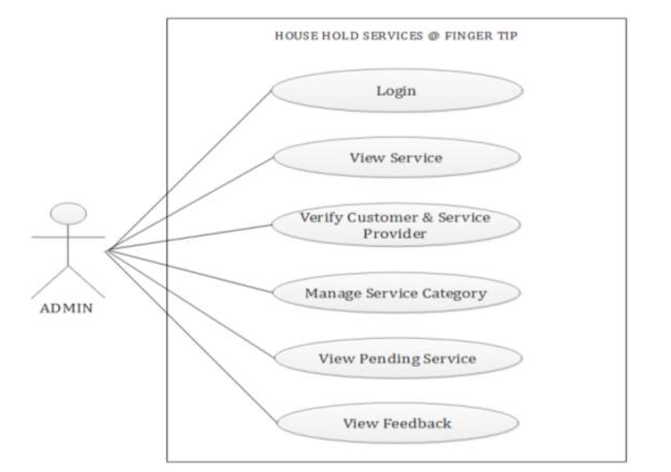

**Use case Diagram for Service Provider**

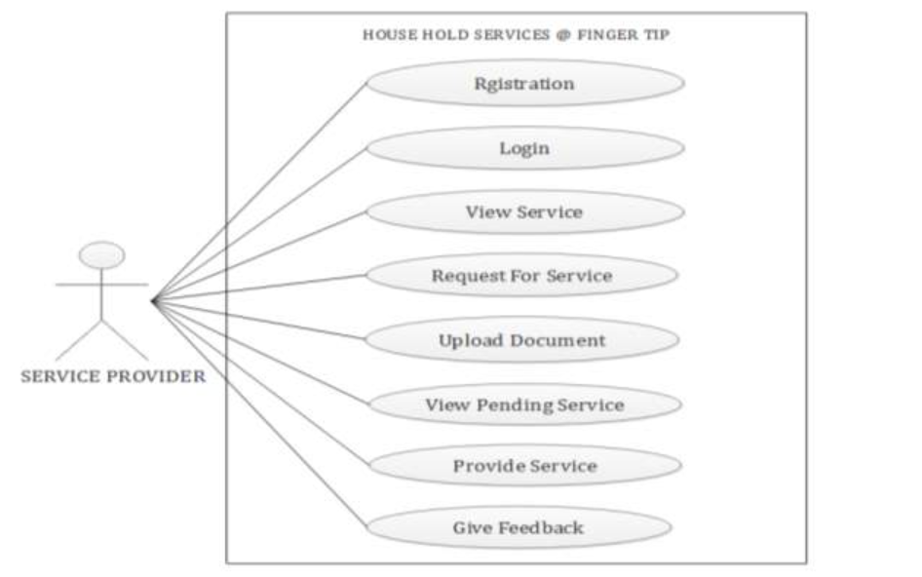

**Use case diagram for Customer**

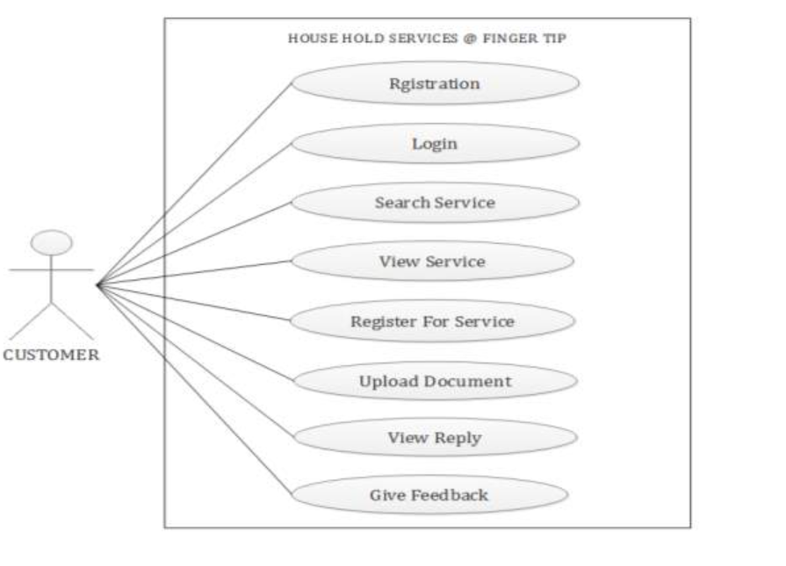

### 5.2 Functional and Behavioral Modeling

It gives the basic description of the functions and the behavior of the system.

#### **5.2.1 Data Flow Diagram**

A data flow diagram is a graphical representation of the “flow” of data through an information system, modeling its process aspects.

**DFD DIAGRAM LEVEL 0**

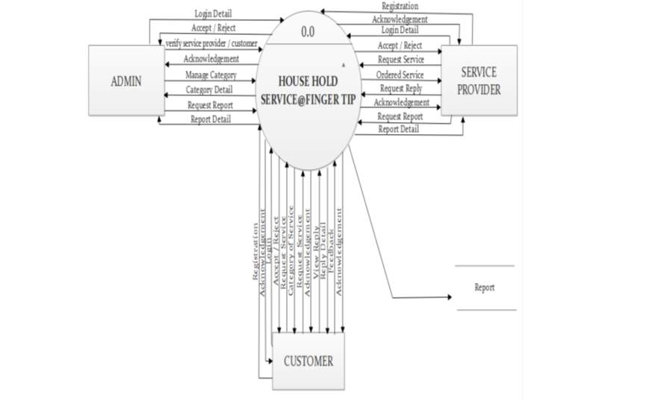

**DFD Diagram Level 1 For Admin**

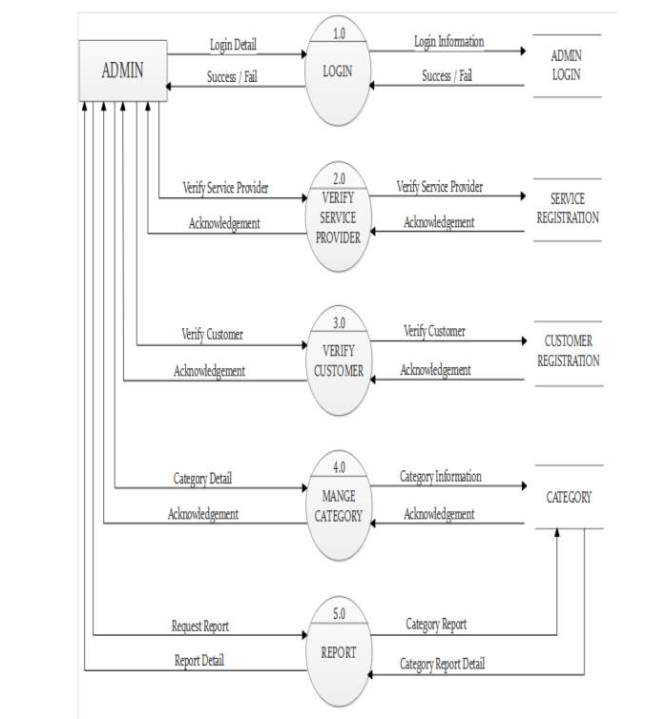

**DFD Diagram Level 1 For Customer**

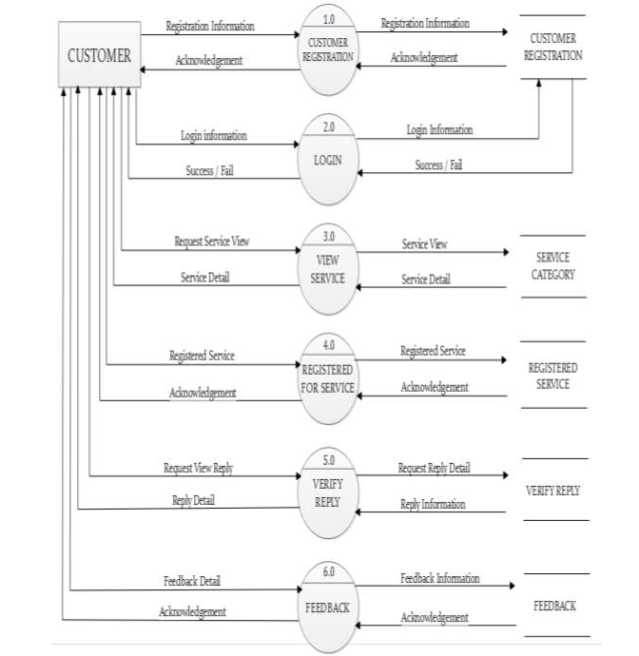

**DFD Diagram Level 1 For Service Provider**

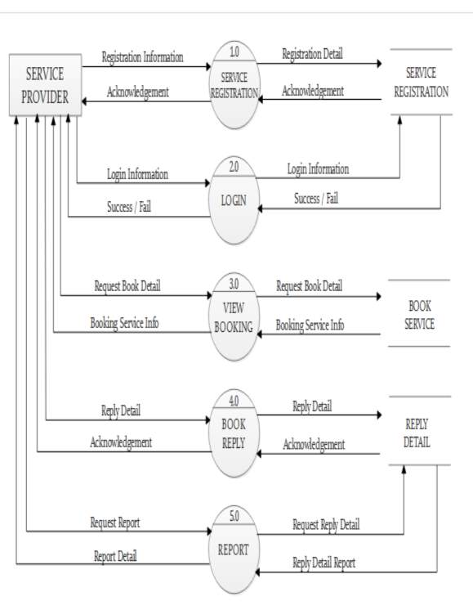

**5.3 E R Diagram**

An entity-relationship diagram (ERD) is a graphical representation of an information system that shows the relationship between people, objects, places, concepts or events within that system. An ERD is a data modeling technique that can help define business processes and can be used as the foundation for a relation database.

­