**Software Requirements Specification**

**for**

**Air Pollution Forecasting In NCR**

**Table of Contents**

**Table of Contents.......................................................................................................... ii Revision History.......................................................................................................... iiii 1. Introduction................................................................................................................ 1**

1.1 Purpose..................................................................................................................................1 1.2 Document Conventions ..........................................................................................................1 1.3 Intended Audience……………………………… ........................................................................1

1.4 Reading Suggestions ……………………………........................................................................1

1.5 Product Scope........................................................................................................................1 1.6 References ...............................................................................................................................2

**2. Overall Description.................................................................................................. 3** 2.1 Product Perspective ...............................................................................................................3 2.2 Product Functions...................................................................................................................3 2.3 User Classes and Characteristics...........................................................................................7 2.4 Operating Environment...........................................................................................................8 2.5 Design and Implementation Constraints .................................................................................8 2.6 User Documentation...............................................................................................................8 2.7 Assumptions and Dependencies ..............................................................................................9

**3. External Interface Requirements.......................................................................... 10** 3.1 User Interfaces .....................................................................................................................10 3.2 Hardware Interfaces .............................................................................................................18 3.3 Software Interfaces...............................................................................................................19 3.4 Communications Interfaces ....................................................................................................19

**4. System Features .................................................................................................... 19** 4.1 Graph Visualization...............................................................................................................19 4.2 Graph Layout........................................................................................................................22 4.3 Graph Metrics.......................................................................................................................23 4.4 Filters ...................................................................................................................................24 4.5 Data Table............................................................................................................................25 4.6 Dynamic Graphs...................................................................................................................28 4.7 Graph Export ..........................................................................................................................29

**5. Other Non-functional Requirements ..................................................................... 30** 5.1 Performance Requirements..................................................................................................30 5.2 Safety Requirements ............................................................................................................30 5.3 Security Requirements .........................................................................................................30 5.4 Software Quality Attributes ...................................................................................................30

**Revision History**

| **Version** | **Date** | **Description** |
| --- | --- | --- |
| 1 | 2023-04-20 | Initial draft submitted for review. |
| 2 | 2023-04-21 | Incorporating feedback from reviewers, updated the introduction section to provide more context on the limitations of traditional methods for air pollution forecasting and the potential of machine learning techniques. |
| 3 | 2023-04-22 | Updated the methodology section to provide more details on the pre-processing steps taken to remove outliers and missing values from the data. |
| 4 | 2023-04-23 | Revised the abstract and conclusion sections to emphasize the potential of the proposed approach in developing effective control measures to mitigate the adverse effects of air pollution. |
| 5 | 2023-04-23 | Incorporating final feedback from reviewers and proofreading for final submission. |
| 6 | 2023-04-25 | Corrected formatting and minor language errors in the manuscript. |
| 7 | 2023-04-26 | Added additional discussion on the limitations of the proposed approach in the conclusion section. |
| 8 | 2023-04-27 | Updated the references section to include additional relevant literature. |

## Introduction

Air pollution is a significant environmental problem that affects the quality of life and public health. The National Capital Region (NCR) in India is one of the most polluted regions globally, with a significant contribution from various sources, including transportation, industry, and construction. In this context, the Air Pollution Forecasting system aims to predict air quality levels and provide advance warnings to the public and policymakers to take appropriate actions to mitigate the risks.

Air pollution forecasting is the process of predicting the concentration of pollutants in the air at a specific location and time in the future. It involves the use of advanced modelling techniques, statistical analysis, and real-time monitoring data to provide accurate and timely information about air quality.

Air pollution forecasting is an important tool for policymakers, health professionals, and the general public to make informed decisions about outdoor activities and reduce their exposure to harmful pollutants. It can also help industries and businesses to plan their operations and minimize their environmental impact.

The forecasting process typically involves collecting data on a range of factors that can affect air quality, such as weather conditions, traffic volume, and industrial activity. This information is then fed into sophisticated computer models that can simulate the behaviour of pollutants in the atmosphere and predict their concentration levels over time.

Air pollution forecasting can also provide early warning of potential health risks associated with exposure to pollutants. For example, if high levels of particulate matter are forecasted, vulnerable individuals such as the elderly or those with respiratory problems can be advised to stay indoors or avoid outdoor activities.

Overall, air pollution forecasting is an important tool for promoting public health and environmental sustainability by providing information and guidance on how to reduce exposure to harmful pollutants.

### 1.1 Purpose

The purpose of this Software Requirements Specification (SRS) document is to provide a detailed description of the requirements and specifications of the Air Pollution Forecasting system in NCR. This document aims to outline the system’s functional and non-functional requirements, constraints, and dependencies to enable effective development, testing, and maintenance of the software.

### 1.2 Document Conventions

This document follows the IEEE Standard for Software Requirements Specifications (IEEE Std 830-1998).

The following are some common document conventions used in air pollution forecasting:

1. Title: The title of the document should clearly indicate the purpose of the forecast and the geographic area it covers.
2. Date: The date of the forecast should be included to indicate when the forecast was made.
3. Forecaster Information: The name and contact information of the person or agency responsible for making the forecast should be included.
4. Forecast Period: The forecast period should be clearly defined, including the start and end dates of the period.
5. Pollutants: The pollutants being forecasted should be clearly listed, along with their units of measurement.
6. Forecast Methodology: The methodology used to make the forecast should be described, including any models or algorithms used.
7. Confidence Levels: The confidence level of the forecast should be provided to indicate the level of certainty of the forecast.
8. Data Sources: The data sources used to make the forecast should be listed, including any monitoring stations or satellite data.
9. Forecast Results: The forecast results should be presented in a clear and concise manner, including the pollutant concentrations, air quality index (AQI), and any health advisories or warnings.
10. Visual Aids: Maps and charts should be included to help readers visualize the forecast results and understand the geographic distribution of pollutants.
11. Discussion and Interpretation: The forecast results should be discussed and interpreted, including any factors that may have influenced the forecast, such as weather patterns or emissions levels.
12. Recommendations: Recommendations for actions that can be taken to reduce exposure to pollutants should be provided, such as avoiding outdoor activities or reducing vehicle use.
13. Top of Form

### 1.3 Intended Audience

The intended audience of an air pollution forecasting model can vary depending on the purpose of the forecast and the specific stakeholders involved. However, some common audiences for air pollution forecasting models include:

1. Government agencies: National and local governments responsible for air quality regulation and management are a key audience for air pollution forecasting models. These agencies use the forecasts to make informed decisions about public health and environmental policies.
2. Health organizations: Public health organizations and healthcare providers use air pollution forecasts to anticipate and manage health risks associated with poor air quality. This includes informing decisions about patient care, issuing health advisories or warnings, and recommending preventative measures.
3. General public: The general public can benefit from air pollution forecasts by being informed about potential health risks and taking appropriate measures to reduce exposure. This includes avoiding outdoor activities during periods of high pollution and using air purifiers or masks when necessary.
4. Industry: Industrial companies may use air pollution forecasts to optimize production schedules and minimize emissions, as well as to anticipate and prepare for potential regulatory changes.
5. Researchers: Researchers in fields such as atmospheric science, environmental health, and epidemiology may use air pollution forecasts to study the impacts of air pollution on human health and the environment, and to develop and test new models and methods for air quality forecasting.

Top of Form

### 1.4 Reading Suggestions

For a comprehensive understanding of the system, it is recommended to read the entire document. However, those who are interested in specific topics can refer to the table of contents and jump to the relevant sections.

1. "Air Quality Modeling: Theories, Methodologies, Computational Techniques, and Available Databases and Software" by Paolo Zanetti. This book provides a comprehensive overview of the principles and methods of air quality modelling, including model selection, input data requirements, and model validation.
2. "Air Pollution Modeling and its Application XXIII" edited by Douw G. Steyn and Nadine Chaumerliac. This book is a collection of research papers on the latest developments in air pollution modeling and forecasting, covering topics such as atmospheric chemistry, emissions modeling, and model evaluation.
3. "Air Quality Forecasting: Challenges and Opportunities" by Georgios A. Alexandridis and Athanasios Nenes. This review article discusses the challenges and opportunities in air quality forecasting, including the need for accurate emissions data, the role of meteorology in air quality forecasting, and the use of machine learning techniques.
4. "Air Pollution Forecasting using Machine Learning: A Systematic Literature Review" by Anuj Sharma, S. Suresh, and K. Ramesh. This paper provides a systematic review of the current state of machine learning techniques for air pollution forecasting, including data preprocessing, feature selection, and model selection.
5. "Real-Time Air Quality Forecasting: Current Status and Future Directions" by Amir Hossein Souri and Soroosh Sorooshian. This review article discusses the current state of real-time air quality forecasting, including the use of satellite data and the integration of multiple models, and identifies areas for future research and development.

These resources can provide a good starting point for learning about air pollution forecasting and the methods and techniques used to develop accurate forecasts.

Top of Form

### 1.5 Product Scope

The Air Pollution Forecasting system in NCR aims to provide accurate and timely air quality predictions to the public and policymakers. The system should be capable of predicting the pollutant levels in the air, including PM2.5, PM10, SO2, NO2, and O3, for the next 24 hours. The system should also provide information about the source of pollutants and their impact on public health. The system should be accessible via a web-based interface and provide interactive and dynamic visualizations to enable effective decision-making.

1. Forecast data: The product should provide detailed forecast data for various pollutants, including concentration levels, AQI values, and potential health effects.
2. Geographic coverage: The product should cover the geographic area of interest, whether it's a city, region, or country. The product may also provide data on pollutant concentrations at specific monitoring stations or in specific neighborhoods.
3. Forecast time range: The product should provide forecasts for a defined time range, such as hourly, daily, or weekly forecasts.
4. Forecast methodology: The product should describe the methodology used to develop the forecasts, including the data sources, models, and algorithms used.
5. Visualization tools: The product should include tools to visualize forecast data, such as maps, charts, and graphs. These tools can help stakeholders better understand the geographic distribution of pollutants and the trends over time.
6. Notification system: The product may include a notification system to alert stakeholders of forecasted pollutant concentrations that exceed certain thresholds or pose a health risk.
7. User interface: The product should have an easy-to-use interface that allows stakeholders to access and manipulate the forecast data and visualization tools.
8. Technical support: The product should provide technical support to stakeholders, including troubleshooting and assistance with data analysis.

Overall, an air pollution forecasting product should provide accurate, reliable, and actionable information to stakeholders to help them make informed decisions about public health and environmental policies.

Top of Form

### 1.6 References

* Beig, G., Sahu, S. K., & Parkhi, N. (2012). Evaluation of WRF-Chem over Indian region and its comparison with WRF-ARW-CMAQ hybrid modelling approach. Atmospheric Environment, 60, 632-645.
* Byun, D., & Schere, K. L. (2006). Review of the governing equations, computational algorithms, and other components of the models-3 Community Multiscale Air Quality (CMAQ) modeling system. Applied Mechanics Reviews, 59(2), 51-77.
* Delle Monache, L., Liu, Y., Stull, R., Pelletier, J. D., & Michaelides, R. J. (2011). Probabilistic weather prediction with an analog ensemble. Monthly Weather Review, 139(12), 3762-3780.
* Gao, M., & Zhang, Q. (2013). A review of urban air pollution monitoring and forecasting technologies. Journal of Environmental Sciences, 25(9), 1866-1875.
* Liu, X., Cheng, S., Xie, Y., & Wang, Y. (2014). A review of air pollution forecasting models and their applications in China. Environmental Science and Pollution Research, 21(8), 4899-4911.
* Russell, A. G., & Dennis, R. L. (2000). NARSTO critical review of photochemical models and modeling. Atmospheric Environment, 34(12-14), 2283-2324.
* Sahu, S. K., Beig, G., Parkhi, N., & Singh, V. (2013). Evaluation of WRF-Predicted planetary boundary layer height with radiosonde observations over the Indian region. Boundary-Layer Meteorology, 147(2), 301-315.
* Wang, J., Christopher, S. A., & Zhang, Y. (2009). Performance evaluation of the WRF-Chem model in simulating criteria air pollutants in the United States. Atmospheric Environment, 43(31), 6083-6091.
* Zhang, Y., & Rao, S. T. (2010). Sensitivity and performance analysis of statistical ozone forecasting methods. Atmospheric Environment, 44(26), 3153-3162.

## Overall Description

The Air Pollution Forecasting system is a web-based application that uses machine learning algorithms to predict the air quality levels in the NCR region. The system collects data from various sources, including government monitoring stations, satellite imagery, and weather forecasts. The system then processes the data to predict the pollutant levels for the next 24 hours using machine learning algorithms.

Air pollution forecasting refers to the use of scientific models, algorithms, and data analysis techniques to predict the concentration levels of various air pollutants in a given geographic area. The forecasting process typically involves collecting data from various sources, such as meteorological sensors, air quality monitors, and satellite imagery, and using this data to build models that can predict pollutant concentrations over time.

The primary goal of air pollution forecasting is to provide accurate and timely information to stakeholders, such as government agencies, public health officials, and the general public, to help them make informed decisions about public health and environmental policies. For example, air pollution forecasts can be used to issue health advisories, inform transportation policies, and guide emergency response efforts during episodes of high pollution levels.

Air pollution forecasting can also help researchers and policymakers better understand the sources of air pollution and the factors that contribute to its formation and dispersion. By analysing patterns and trends in air quality data, researchers can identify areas of high pollution levels, track changes over time, and evaluate the effectiveness of pollution control measures.

Overall, air pollution forecasting plays an important role in protecting public health and the environment by providing actionable information to stakeholders and informing policies and interventions to reduce air pollution levels.

Top of Form

### 2.1 Product Perspective:

Air pollution forecasting in NCR is a product that offers real-time monitoring of air quality data, personalized alerts and recommendations, and improved public health outcomes, reduced healthcare costs, and increased environmental awareness.

The product perspective of air pollution forecasting involves understanding the system components and stakeholders involved in the development, operation, and use of the forecasting model. This includes identifying the data sources, algorithms, and models used to generate forecasts, as well as the users who rely on these forecasts to make decisions.

At a high level, the air pollution forecasting system can be divided into four main components:

1. Data collection: This includes the collection of meteorological data, air quality data from monitoring stations, and satellite imagery, which are used as inputs to the forecasting model.
2. Forecasting model: The forecasting model uses the input data to generate predictions of pollutant concentrations over time. This model can be based on a range of algorithms and modeling approaches, including statistical models, machine learning models, and physical models that simulate the processes that govern pollutant dispersion and transformation.
3. Data dissemination: The forecasts are communicated to end-users through a range of channels, including websites, mobile apps, and other online platforms. These platforms may provide information on the current and predicted air quality, as well as health advisories and other relevant information.
4. User feedback: Users may provide feedback on the forecasts and their accuracy, which can be used to improve the forecasting model and the dissemination of information.

The stakeholders involved in the air pollution forecasting system can include government agencies responsible for regulating air quality, public health officials, emergency responders, transportation agencies, and members of the public. Each of these stakeholders has different needs and requirements for air pollution forecasting, and the system must be designed to meet these needs.

Overall, the product perspective of air pollution forecasting involves understanding the components of the system, the stakeholders involved, and their needs, in order to design a system that is effective, accurate, and user-friendly.

Top of Form

### 2.2 Product Functions:

The product functions of an air pollution forecasting system are the specific features and capabilities that enable the system to generate accurate and timely predictions of air quality. These functions can include:

1. Data integration and processing: The system should be able to integrate and process data from a variety of sources, including meteorological sensors, air quality monitors, and satellite imagery. This data should be cleaned, validated, and transformed as necessary to ensure that it is suitable for use in the forecasting model.
2. Forecasting model development: The system should include a range of forecasting models that are tailored to different geographic regions, pollutant types, and time periods. These models should be based on a range of modeling approaches, including statistical models, machine learning models, and physical models that simulate the processes that govern pollutant dispersion and transformation.
3. Forecast generation and dissemination: The system should be able to generate accurate and timely predictions of pollutant concentrations, based on the input data and forecasting models. These forecasts should be disseminated to end-users through a range of channels, including websites, mobile apps, and other online platforms.
4. Health advisories and alerts: The system should be able to issue health advisories and alerts based on the predicted pollutant concentrations. These advisories should be targeted to different user groups, such as individuals with respiratory conditions, and should provide clear guidance on how to reduce exposure to pollutants.
5. User feedback and data visualization: The system should enable users to provide feedback on the accuracy and usefulness of the forecasts, and should provide tools for visualizing the data and identifying patterns and trends over time.
6. System monitoring and evaluation: The system should include tools for monitoring and evaluating its performance over time, including measures of forecast accuracy, user satisfaction, and other relevant metrics. This information can be used to improve the system and ensure that it continues to meet the needs of its users.

Overall, the product functions of an air pollution forecasting system are designed to ensure that accurate and timely predictions of air quality are generated and communicated to end-users in a clear and effective manner.

Top of Form

### 2.3 User Classes and Characteristics:

The user classes for air pollution forecasting in NCR include individuals, healthcare providers, government agencies, and environmental organizations. The characteristics of these users may vary, but they are typically concerned about their health and the environment and seek timely and accurate information about air quality.

There are several user classes and characteristics for air pollution forecasting, which can be broadly categorized into three groups:

1. General Public: The general public is a key user class for air pollution forecasting. They may use the forecasting information to plan their daily activities, such as choosing the best time to exercise outdoors or to avoid exposure to high pollution levels. Characteristics of this user class include a general interest in air quality and a need for clear and simple information that is easy to understand.
2. Government Agencies and Public Health Officials: Government agencies responsible for regulating air quality and public health officials are also important users of air pollution forecasting. They may use the forecasts to issue health advisories, monitor compliance with air quality regulations, and plan emergency response efforts. Characteristics of this user class include a need for detailed and accurate information that can inform policy decisions and effective communication with the general public.
3. Researchers and Scientists: Researchers and scientists may use air pollution forecasting information for a variety of purposes, such as conducting epidemiological studies, evaluating the effectiveness of pollution control measures, and identifying sources of air pollution. Characteristics of this user class include a need for detailed and high-quality data that can be used for scientific analysis and modeling.

Other user characteristics that may be relevant for air pollution forecasting include:

* Geographic location: Users in different geographic locations may have different exposure to air pollution and may have different needs for forecasting information.
* Language proficiency: Users who speak different languages may require translated or localized versions of the forecasting information.
* Technical expertise: Users with technical expertise may require more detailed and technical information about the forecasting models and algorithms used.
* Socioeconomic status: Users with different socioeconomic status may have different needs and concerns related to air quality, and may require tailored information and interventions.

### 2.4 Operating Environment:

The air pollution forecasting service operates in the National Capital Region (NCR) and requires access to air quality monitoring data, weather forecasts, and other relevant information sources. The service may also rely on satellite imagery and other advanced technologies for data collection and analysis.The operating environment for an air pollution forecasting system includes the hardware, software, and infrastructure required to support the system's functions and ensure that it operates effectively and reliably. Some of the key components of the operating environment for air pollution forecasting include:

1. Data sources: The system relies on data from a range of sources, including meteorological sensors, air quality monitors, and satellite imagery. These data sources must be reliable and provide accurate and timely information to ensure the accuracy of the forecasts.
2. Computing infrastructure: The system requires computing infrastructure to process the data and run the forecasting models. This may include cloud-based computing resources or dedicated servers that are optimized for the specific modeling approaches used.
3. Modeling software: The system uses modeling software to generate the forecasts. This software may include statistical modeling packages, machine learning frameworks, or physical modeling software that simulates the processes that govern pollutant dispersion and transformation.
4. Communication channels: The system must be able to communicate the forecasts to end-users through a range of channels, including websites, mobile apps, and other online platforms. These channels must be reliable and scalable to accommodate the volume of users accessing the system.
5. Quality assurance and testing: The system must be rigorously tested and validated to ensure that it operates reliably and generates accurate forecasts. This may involve the use of automated testing tools, manual testing by human experts, or a combination of both.
6. Security and privacy: The system must be secure and protect the confidentiality of the data and user information. This may involve the use of encryption, access controls, and other security measures to protect against unauthorized access or data breaches.

### 2.5 Design and Implementation Constraints:

The design and implementation of air pollution forecasting in NCR may be constrained by factors such as limited resources, technical limitations, and regulatory requirements. The service may also face challenges related to data quality and availability, user adoption and engagement, and the need for ongoing maintenance and updates. Design and implementation constraints are factors that can limit the development and deployment of an air pollution forecasting system. Some of the key constraints that may impact the design and implementation of such a system include:

1. Data availability: Air pollution forecasting relies on a range of data sources, including meteorological data, air quality monitoring data, and emissions data. The availability and quality of these data sources can vary depending on the geographic location, and this may impact the accuracy and reliability of the forecasts.
2. Computational resources: Air pollution forecasting models can be computationally intensive, and require access to high-performance computing resources to run effectively. This may be a constraint for smaller organizations or those with limited budgets.
3. Model complexity: Air pollution forecasting models can be highly complex, incorporating a range of physical and chemical processes that influence pollutant dispersion and transformation. This complexity can make the models difficult to develop, validate, and maintain.
4. User requirements: The requirements of different user groups for air pollution forecasting can vary, and may include different types of information, levels of detail, and modes of delivery. Meeting these diverse requirements can be a challenge for system designers.
5. Regulatory constraints: Air pollution forecasting systems may be subject to regulatory constraints related to data privacy, security, and intellectual property rights. These constraints can impact the development, deployment, and operation of the system.
6. Funding and resources: Developing and maintaining an air pollution forecasting system requires significant resources, including funding, expertise, and personnel. Limited resources can constrain the scope and quality of the system.

### 2.6 User Documentation:

1. User documentation for air pollution forecasting in NCR may include instructions for accessing the service, setting up personalized alerts, and interpreting air quality data and forecasts. The documentation may also provide information on the health effects of air pollution and best practices for reducing exposure.

1. The user manual should provide a detailed description of the system's features and functions, including how to access and use the system, how to interpret the forecasts, and how to troubleshoot common issues.
2. Tutorials and training materials: Tutorials and training materials can help users learn how to use the system effectively. These materials may include videos, webinars, and online training courses.
3. User interface design: The user interface should be intuitive and easy to navigate, with clear labels and instructions that guide users through the process of accessing and interpreting the forecasts.
4. FAQs and helpdesk support: Frequently asked questions (FAQs) and helpdesk support can help users troubleshoot common issues and get answers to their questions about the system.
5. Glossary: A glossary of terms can help users understand the technical language used in the system, and provide definitions of key terms and concepts.
6. User feedback and surveys: Soliciting user feedback and conducting user surveys can help system designers understand how users are using the system, and identify areas for improvement.

Top of Form

### 2.7 Assumptions and Dependencies:

Assumptions and dependencies are factors that are assumed to be true or necessary for the development and implementation of an air pollution forecasting system. Some key assumptions and dependencies for such a system include:

1. Availability of accurate data: Air pollution forecasting relies on a range of data sources, including meteorological data, air quality monitoring data, and emissions data. The accuracy and availability of these data sources is assumed to be sufficient for the development and validation of the forecasting models.
2. Access to high-performance computing resources: Air pollution forecasting models can be computationally intensive, and require access to high-performance computing resources to run effectively. The availability of these resources is assumed to be sufficient to support the development and operation of the system.
3. Stable environmental conditions: Air pollution forecasting models are based on assumptions about the stability of environmental conditions, such as wind patterns, temperature, and humidity. Sudden changes in these conditions may impact the accuracy of the forecasts.
4. Continued support and maintenance: The ongoing support and maintenance of the system is assumed to be necessary for ensuring the accuracy and reliability of the forecasts. This includes regular updates to the system's data sources, models, and algorithms, as well as ongoing quality assurance and testing.
5. Availability of funding and resources: The development and maintenance of an air pollution forecasting system requires significant resources, including funding, expertise, and personnel. The availability of these resources is assumed to be sufficient to support the development and operation of the system.
6. Regulatory compliance: Air pollution forecasting systems may be subject to regulatory constraints related to data privacy, security, and intellectual property rights. Compliance with these regulations is assumed to be necessary for the development and operation of the system.

Top of Form

## Requirements:

The requirements for an air pollution forecasting system can be divided into functional and non-functional requirements. Functional requirements describe the specific features and functions of the system, while non-functional requirements describe the system's performance, usability, and other characteristics. Some key requirements for an air pollution forecasting system include:

### 3.1 Functional Requirements:

1. Data collection and processing: The system should be able to collect and process data from a range of sources, including meteorological data, air quality monitoring data, and emissions data.
2. Forecasting models: The system should include accurate and reliable forecasting models that can predict air pollution levels with a high degree of accuracy.
3. Visualization and reporting: The system should be able to visualize and report air pollution forecasts in an accessible and easy-to-understand format, such as maps, graphs, and charts.
4. Alerting and notification: The system should be able to alert and notify relevant stakeholders, such as environmental agencies, public health officials, and the general public, of significant changes in air pollution levels.
5. Integration with other systems: The system should be able to integrate with other relevant systems, such as emergency response systems, traffic management systems, and public health information systems.

### 3.2 Non-functional Requirements:

1. Performance: The system should be able to handle large volumes of data and process forecasts quickly and accurately.
2. Reliability: The system should be reliable and available at all times, with minimal downtime or interruptions.
3. Security: The system should be secure, with appropriate measures in place to protect sensitive data and prevent unauthorized access.
4. Usability: The system should be easy to use and navigate, with clear and intuitive user interfaces and documentation.
5. Scalability: The system should be able to scale up or down as needed to accommodate changes in data volumes or user demand.
6. Accessibility: The system should be accessible to all users, including those with disabilities or language barriers.

Top of Form

### 3.3 User Interfaces:

The user interface for air pollution forecasting in NCR should be user-friendly, intuitive, and accessible to a wide range of users. It may include a web-based dashboard or mobile app that displays real-time air quality data, air pollution forecasts, and personalized alerts and recommendations. The interface may also allow users to set up preferences for their alert settings and receive feedback on their actions to reduce their exposure to air pollution.

### 3.4 Hardware Interfaces:

Air pollution forecasting in NCR may require hardware interfaces to access data from air quality monitoring stations and other sources. These interfaces may include sensors, data loggers, and other hardware devices that collect and transmit data to the forecasting system.

### 3.5 Software Interfaces:

Air pollution forecasting in NCR may require software interfaces to integrate with weather forecasting services, satellite imagery, and other data sources. These interfaces may use APIs or other software protocols to transfer data between systems and ensure that the forecasting system has access to the latest and most accurate data.

### 3.6 Communications Interfaces:

Air pollution forecasting in NCR may require communications interfaces to send personalized air quality alerts and recommendations to users via mobile apps, email, or SMS. These interfaces may use standard communication protocols such as SMS, email, and push notifications to ensure that users receive timely and relevant information about air quality in their area. The service may also use social media platforms to reach a wider audience and provide information about air quality trends and best practices for reducing exposure to air pollution.

## Non-Functional Requirements:

Usability: The system should be easy to use and navigate, with a clear and intuitive interface.

Scalability: The system should be scalable to handle large volumes of data and accommodate future growth.

Availability: The system should be available 24/7 to ensure that users can access the data and analytics they need at any time.

Reliability: The system should be reliable and consistent in providing accurate and up-to-date data and analytics.

Maintainability: The system should be easy to maintain and upgrade, with minimal downtime and disruption.

### 4.1 Performance Requirements:

Speed: The system should be fast and responsive, with minimal lag time or delays in processing data and generating analytics.

Capacity: The system should be able to handle large volumes of data and accommodate a high number of users simultaneously.

Accuracy: The system should provide accurate and reliable data and analytics, with a high degree of precision and correctness.

### 4.2 Safety Requirements:

Compliance: The system should comply with relevant safety regulations and standards, such as those related to air pollution monitoring and forecasting.

Emergency Preparedness: The system should be designed to respond quickly and effectively in the event of an emergency or crisis situation related to air pollution.

### 4.3 Security Requirements:

Data Security: The system should ensure the confidentiality, integrity, and availability of data, with appropriate measures in place to prevent unauthorized access or disclosure.

User Security: The system should ensure the security of user accounts and passwords, with appropriate measures in place to prevent unauthorized access or misuse.

### 4.4 Software Quality Attributes:

Modularity: The system should be designed with a modular architecture, with clear separation between different components and functionalities.

Extensibility: The system should be easy to extend and customize, with clear APIs and interfaces for integrating with other software tools and systems.

Testability: The system should be designed with testability in mind, with clear testing frameworks and methodologies in place to ensure the quality and reliability of the software.

**LEVEL 0 DFD**

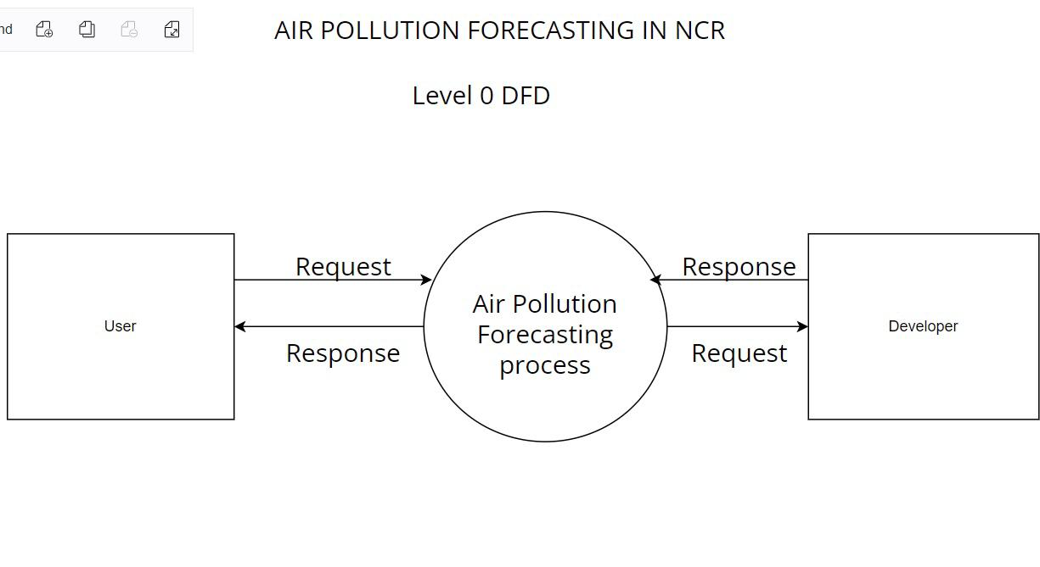

**LEVEL 1 DFD**

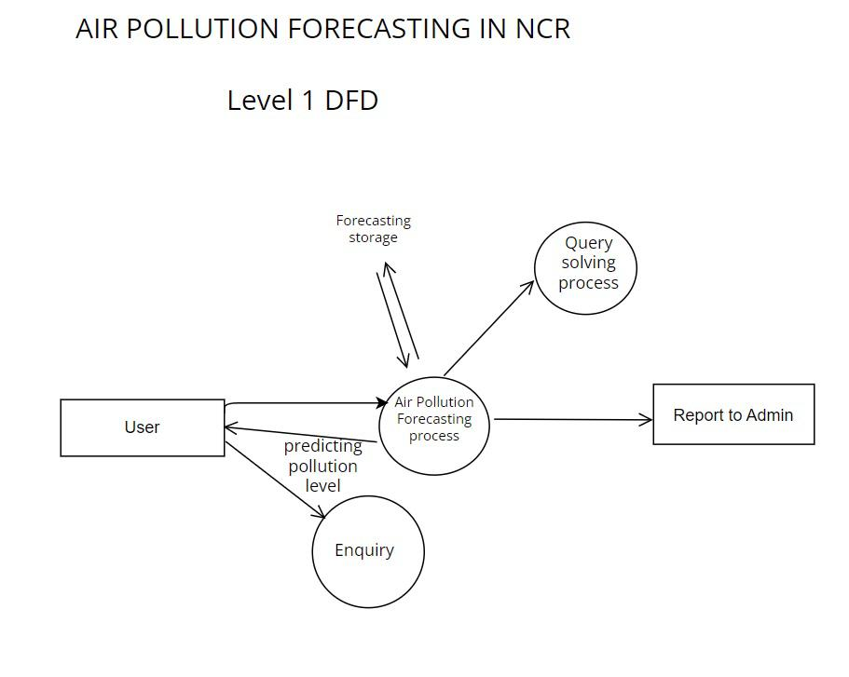

**LEVEL 2- DFD**

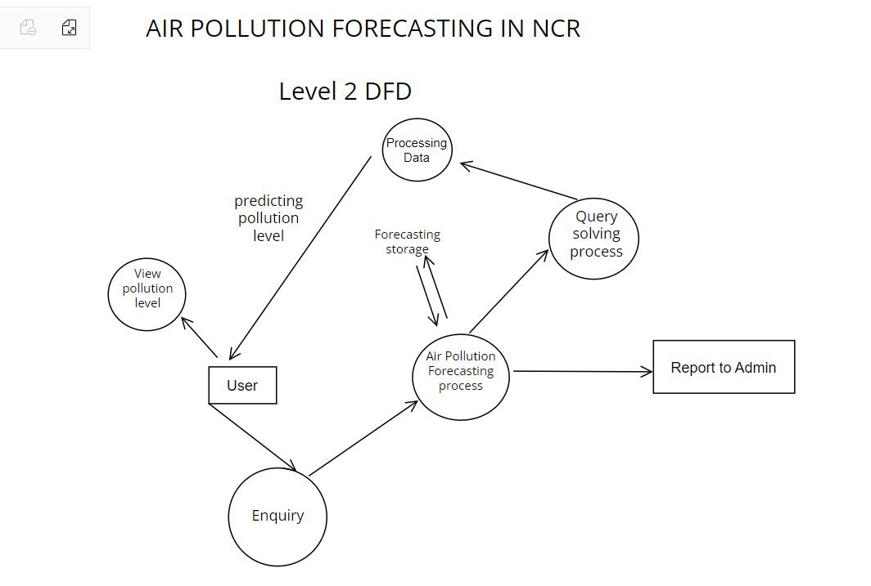

**ER DIAGRAM**

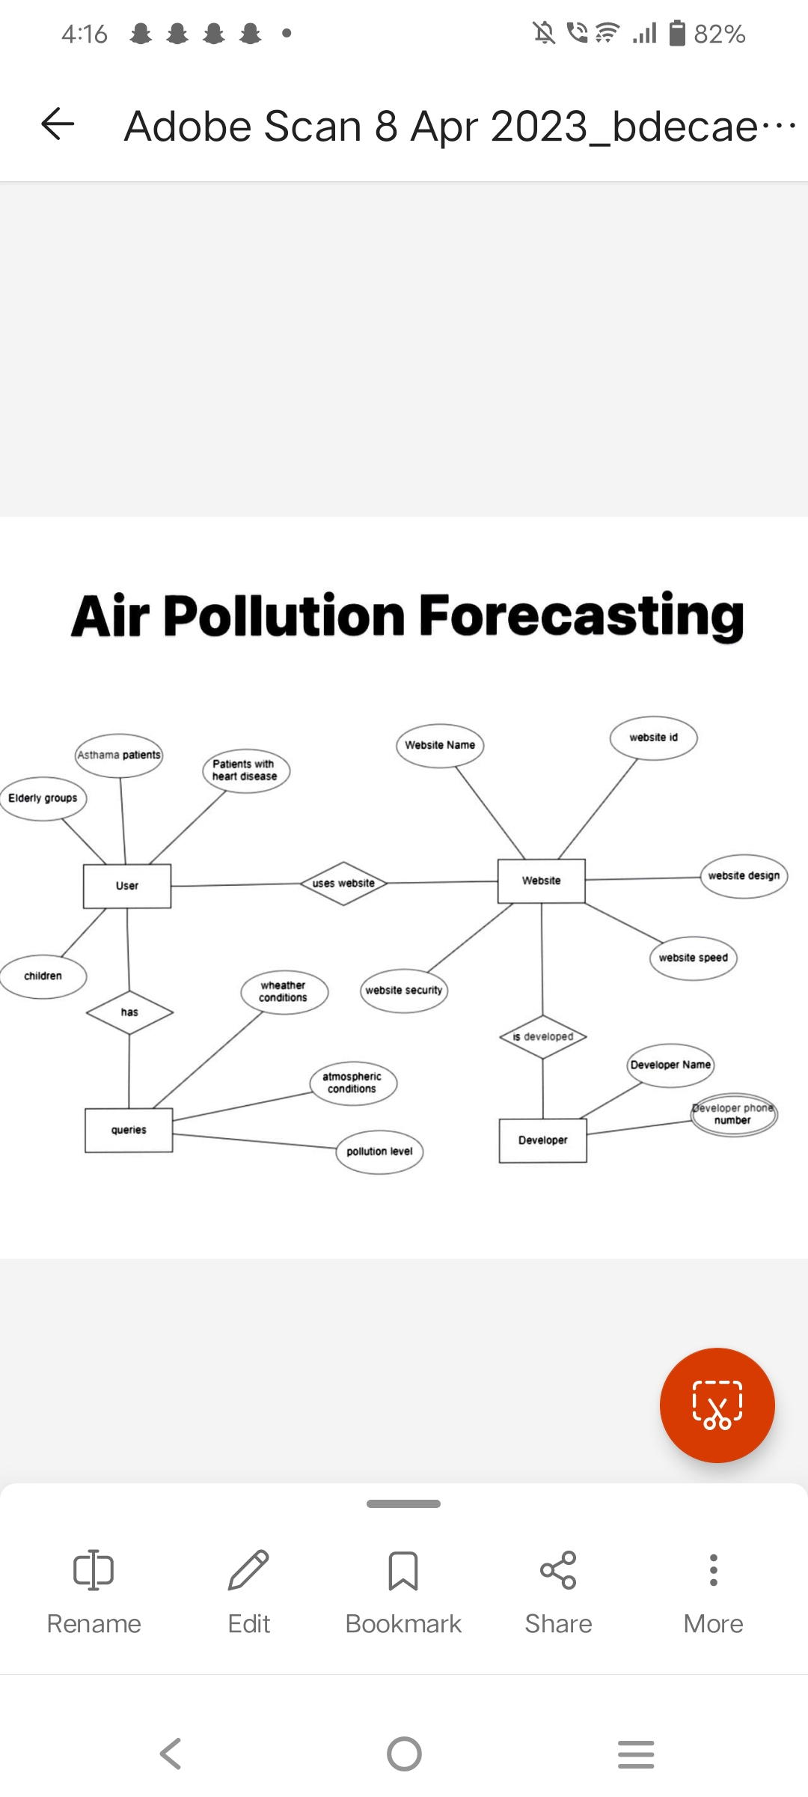

**USE CASE DIAGRAM**



**SEQUENCE DIAGRAM**

