Proposed Title:

System and Method for Road Accident Analysis and Classification  
  
Field of the Invention:

The present invention pertains to the field of road safety and accident analysis. More specifically, it relates to a novel system and method for road accident analysis and classification using real-time data and advanced machine learning techniques. This invention finds applications in the domain of road safety, law enforcement, and accident prevention, aiding in the efficient allocation of resources and informed decision-making for safer roadways.

Background:

Accurate analysis is required to deal with massive traffic accidents on the ground. Existing methods lack real-time capabilities and comprehensive insights into accident causality, hindering proactive measures.

The field of road safety and accident prevention faces challenges in accurately analysing and classifying road accidents for effective mitigation and policy-making. Discovering the associations among the traffic accidents and related injuries is the key factor in reducing the traffic accidents. Identification of injuries severity is a key factor for the proper treatment. As number of traffic accidents are increasing and injuries severity is a critical factor to identify.

Objectives:

The main objectives of the present invention are as follows:

1. Develop a real-time system for collecting and analyzing road accident data.
2. Classify road accidents based on factors such as location, weather conditions, road surface, and day of the week.
3. Allow users to input start and end location and thereafter calculate accident severity on their route.
4. Provide actionable insights to authorities for improved road safety planning.

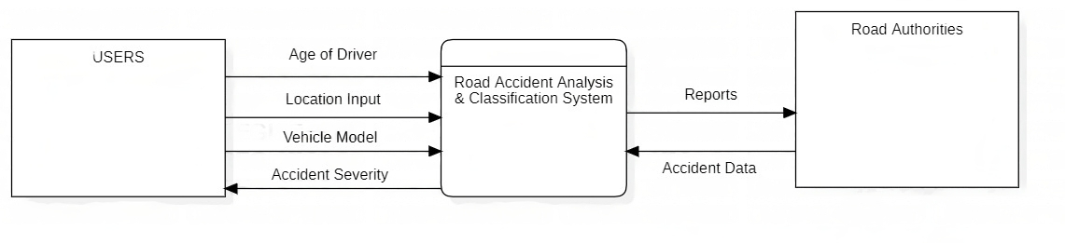Related Diagrams:

Figure (DFD Level 0)

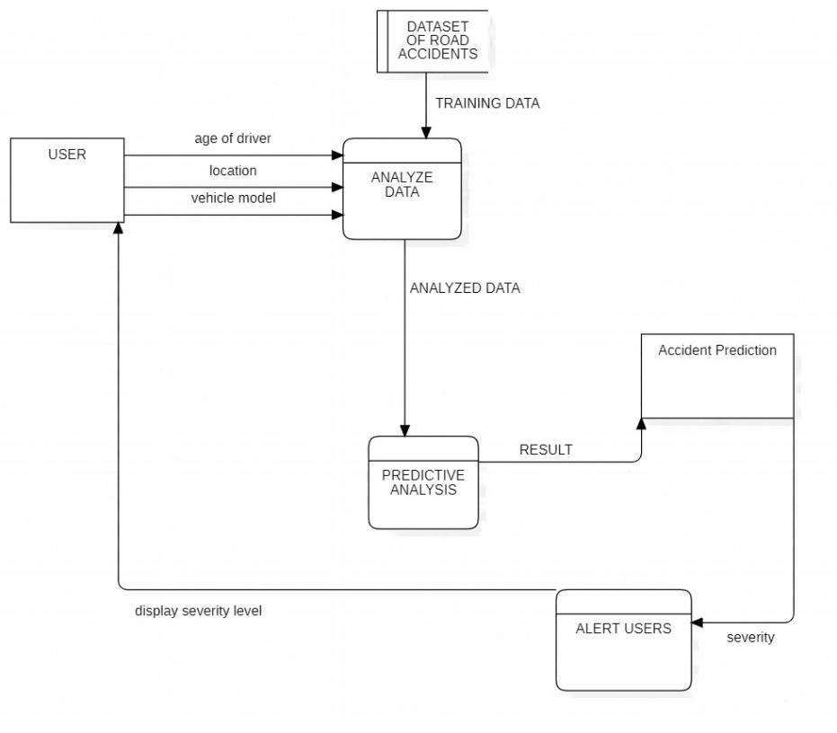

Figure (DFD Level 1)

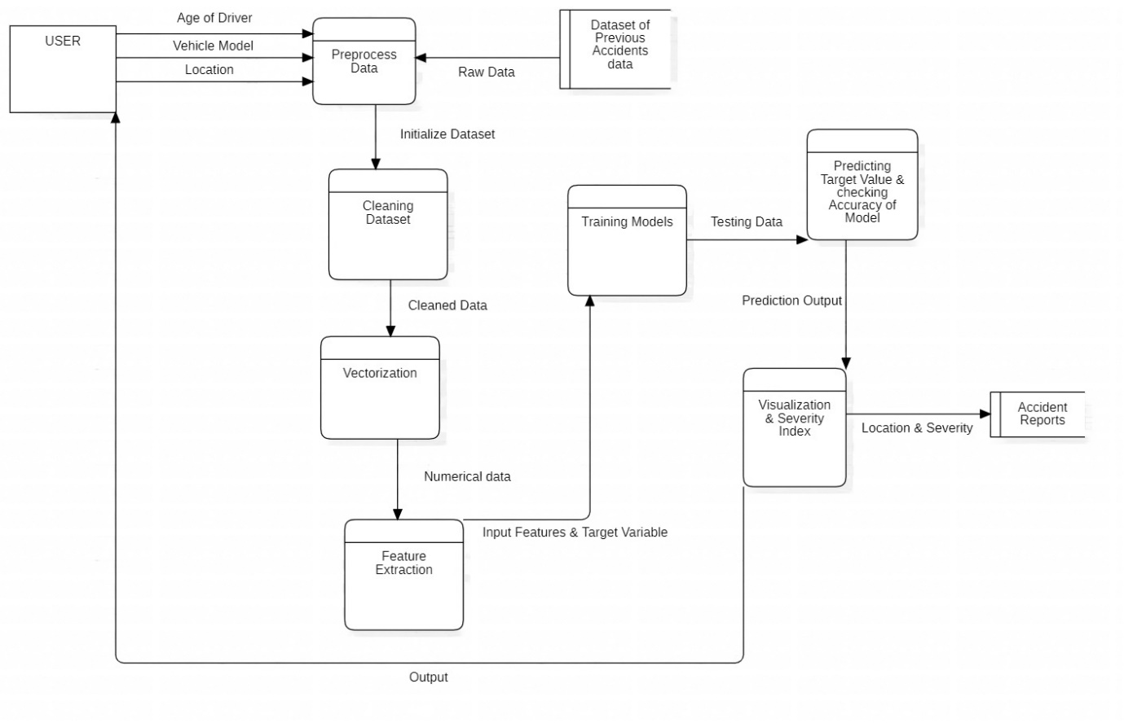

Figure (DFD Level 2)

Claims:

Claim 1: A system for road accident analysis and classification comprising:

* A data collection module to gather geographical coordinates, weather conditions, and road surface conditions.
* Data preprocessing modules for imputing missing values and encoding categorical data.
* An accident classification module utilizing machine learning algorithms to classify accidents based on multiple parameters.

Claim 2: The system of claim 1, wherein the accident classification module employs historical accident data for enhancing accuracy.

Apparatus / Technology Used:

The invention employs the following technologies:

* Data preprocessing algorithms (NumPy, Pandas, Scikit-learn, and Matplotlib).
* Categorical data encoding module (LabelEncoder).
* Machine learning models for accident classification (RandomForestClassifier, DecisionTreeClassifier, LogisticRegression, GaussianNB, VotingClassifier).
* Object serialization and function pipelining modules (Python Pickle, Joblib).
* APIs used for location and weather data (Google Maps API, OpenWeatherMap API).

Abstract:

The present invention discloses a novel system and method for road accident analysis and classification. It leverages real-time data and advanced classification algorithms to accurately categorize road accidents based on critical parameters, such as location, weather conditions, road surface conditions, and day of the week. The invention aims to enhance road safety and accident prevention by providing accurate insights to relevant authorities.

End Users:

The invention is intended for use by government agencies responsible for road safety, law enforcement, traffic management, and urban planning. Additionally, insurance companies, researchers, and road safety advocates can benefit from the insights provided by the invention.

Advantages:

The Road Accident Analysis and Classification System offers several advantages:

* Real-time accident classification enhances emergency response times and accident investigations.
* Accurate classification enables policy-makers to identify accident hotspots and implement targeted safety measures.
* Machine learning algorithms improve over time, enhancing the system's predictive capabilities.

Summary of the Invention:

In conclusion, the present invention introduces an innovative solution for road accident analysis and classification. By utilizing real-time data and advanced machine learning techniques, the invention aims to contribute significantly to road safety, accident prevention, and improved traffic management.