Project Synopsis

on

Truck Driver Safety Assistance

Submitted as a part of course curriculum for

# Bachelor of Technology

in

# Computer Science



## Submitted by

Abhinav Tripathi (2000290120008) Anshul Nigam(2000290120030) Nikita Jain(2000290310115)

**Under the Supervision of** Prof. Arti Sharma Assistant Professor

# KIET Group of Institutions, Ghaziabad Department of Computer Science

**Dr. A.P.J. Abdul Kalam Technical University**

**2022-2023**

# DECLARATION

We hereby declare that this submission is our work and that, to the best of our knowledge and belief, it contains no material previously published or written by another person nor material which to a substantial extent has been accepted for the award of any other degree or diploma of the university or other institute of higher learning, except where due acknowledgement has been made in the text.

Signature of Students

|  |  |  |  |
| --- | --- | --- | --- |
| Name | Abhinav Tripathi | Anshul Nigam | Nikita Jain |
| Roll no.  Date: | (2000290120008) | (2000290120030) | (2000290310115) |

# CERTIFICATE

This is to certify that Project Report entitled “**Truck Driver Safety Assistance**” which is submitted by **Abhinav Tripathi , Anshul Nigam and Nikita Jain** in partial fulfilment of the requirement for the award of degree B. Tech. in Department of Computer Science of Dr A.P.J. Abdul Kalam Technical University, Lucknow is a record of the candidates own work carried out by them under my supervision. The matter embodied in this report is original and has not been submitted for the award of any other degree.

## Date: Supervisor Signature

Prof. Arti Sharma Assistant Professor

# ACKNOWLEDGEMENT

It gives us a great sense of pleasure to present the synopsis of the B.Tech Mini Project undertaken during B.Tech. Third Year. We owe a special debt of gratitude to **Prof. Arti Sharma Assistant Professor** Department of Computer Science, KIET Group of Institutions, Delhi- NCR, Ghaziabad, for his/her constant support and guidance throughout the course of our work. Her sincerity, thoroughness and perseverance have been a constant source of inspiration for us. It is only his/her cognizant efforts that our endeavours have seen the light of the day.

We also take the opportunity to acknowledge the contribution of Dr. Ajay Kumar Shrivastava, Head of the Department of Computer Science, KIET Group of Institutions, Delhi- NCR, Ghaziabad, for his full support and assistance during the development of the project. We also do not like to miss the opportunity to acknowledge the contribution of all the faculty members of the department for their kind assistance and cooperation during the development of our project.

Last but not the least, we acknowledge our friends for their contribution to the completion of the project.

Signature

|  |  |  |  |
| --- | --- | --- | --- |
| Name | Abhinav Tripathi | Anshul Nigam | Nikita Jain |
| Roll no.  Date : | (2000290120008) | (2000290120030) | (2000290310115) |

# ABSTRACT

The primary goal of this research is to create a non-intrusive system that can recognize driver weariness and send a timely warning. This method will help prevent many accidents because driver fatigue contributes to a significant number of traffic accidents. Through the use of a camera, this system will track the drivers` eyes, and by creating an algorithm, we can identify signs of driver drowsiness early enough to prevent an accident. Therefore, this research will aid in the early detection of driver fatigue and provide warning output in the form of sound and seat belt vibration, with a frequency range of 50 to 60 Hz. Additionally, the alert will be manually turned off rather than automatically.

For this reason, the warning will be turned off using a deactivation switch. A Warning signal is issued in the form of text or a red color circle if all three input variables indicate a potential for weariness at the same time. This will provide a clear sign of exhaustion or drowsiness, which may then be utilized to record the performance of the driver.

# TABLE OF CONTENTS

|  |  |
| --- | --- |
| TITLE PAGE | Page  No. |
| DECLARATION…………………………………………………………………….. | i |
| CERTIFICATE………………………………………………………………………. | ii |
| ACKNOWLEDGEMENT…………………………………………………………… | iii |
| ABSTRACT………………………………………………………………………….. | iv |
| CHAPTER 1 INTRODUCTION | 1-2 |
| 1.1. Introduction…………………………………………………………………... |  |
| 1.2 Problem Statement…………………………………………………………… |  |
| 1.3 Objective………………………………………………………........................ |  |
| 1.4 Scope of Study………………………………………………………………...  1.5 Future Scope………………………………………………………………….. |  |
| CHAPTER 2 LITERATURE REVIEW……………………………………………… | 3-6 |
| CHAPTER 3 PROPOSED METHODOLOGY | 7-8 |
| 3.1 Flowchart………………………………………………………………………….. |  |
| 3.2 Algorithm Proposed………………………………………………………………. |  |
| CHAPTER 4 TECHNOLOGY USED………………………………………………... | 9 |
| CHAPTER 5 DIAGRAMS……………………………………………………………. | 10-11 |
| CHAPTER 6 CONCLUSION…………………………………………………………. | 12 |
| REFERENCES……………………………………………………………………….... | 13 |

|  |
| --- |
| **CHAPTER 1 INTRODUCTION** |
| **1.1. Introduction**  Eye closure and body posture are two instances of fatigue-related real-time hazardous behaviours or mental activity In light of this, we can either track changes in physiological signals like brain waves, eye blinking and heart rate to track tiredness or accommodate for bodily changes like sagging posture, the way the driver's head is cocked, and the state of their eyes.  Although more accurate, the earlier method is unrealistic since super sensitive electrodes would it must be linked directly to the driver's body, which might irritate and distract the driver. Additionally, prolonged driving would cause perspiration on the sensors, reducing their effectiveness to precisely observe. The second method uses a video camera to evaluate physical changes, such as open or closed eyelids to detect weariness. This method is well suited for use in real-world driving situations because it is non-intrusive. Micro sleeps, which are brief periods of sleep lasting 2 to 3 seconds, are another reliable sign of exhaustion. Therefore, a timely warning is given when a driver's eyes are continuously monitored for signs of sleepiness. |
| **1.2 Problem Statement**  Our main Problem is accidents due to drowsiness.The shortage of drivers in the market led to over burdening of truck drivers with long working hours by the fleet owners, which caused fatigue and reduced the resting time.According to a survey on the status of truck drivers in India, over-speeding was stated as the major cause for road crashes by the truck drivers as of February 2020. Fatigue and sleepiness was stated as the second major reason for road accidents among 38 percent of truck drivers in the south Asian country.  According to the stats of National Highway Traffic Safety Administration (NHTSA),there were 795 fatalities from drowsy driving related crashes in 2017.  NHTSA estimates fatigue-related crashes resulting in injury or death cost society $109 billion annually, not including property damage.  Exhausted drivers who doze off at the wheel are responsible for about 40% of road accidents, says a study by the Central Road Research Institute (CRRI) on the 300-km Agra-Lucknow Expressway.  The National Highway Safety Administration estimates that drowsy driving results in 1,550 deaths, 71,000 injuries and more than 100,000 accidents per year.  Driver weariness was selected as the top priority CMV by highway safety, which included many drivers. safety concern As a result, current FHWA-sponsored human factors research is dominated by the fatigue issue on the safety of CMV driving.  The project's goal is to identify driver drowsiness and alert them when necessary so accidents can be avoided.  The concept directly impacts the automotive industry, improving driving safety and reducing the number of fatalities in crashes brought on by drowsy driving.  1 |

## Objective

It has been suggested that fatigue warning systems (FWS) be used as a specific countermeasure to lessen collisions brought on by driver drowsiness. When crucial levels of drowsiness are reached, these devices alert the driver. They use a number of approaches to detect driver drowsiness while operating a vehicle. However, it is still difficult to identify driver wearnes using reliable, unobtrusive, and objective measurements. Lane departure, steering wheel movement, ocular or facial traits may all be used as detection methods. Of course, drivers also have a responsibility to follow speed limits, work-permitting limits, and rest-period regulations. Additionally, those in the chain of command are required to take reasonable action to avoid situations that could result in driver weariness or speed limit violations. It delivers in-depth details regarding physiological parameters like alertness, driving performance, and drivers' subjective states.

## Scope of Study

* + - In this project, we will focus on these following procedures:
    - Basic concept of drowsiness detection system
    - Familiarize with the signs of drowsiness
    - Determine the drowsiness from these parameters
      * Eye blink
      * Area of the pupils detected at eyes
    - Data collection and measurement
    - Integration of the methods chosen
    - Coding development and testing
    - Complete testing and improvement.

## Future Scope

Future research may concentrate on how to assess weariness using external aspects like vehicle states, sleeping patterns, weather, mechanical data, etc. Highway safety is seriously threatened by driver drowsiness, which is especially problematic for drivers of commercial vehicles. This major safety concern is a result of 24-hour operations, high annual mileage, exposure to difficult environmental conditions, and rigorous work schedules. One important step in a series of preventive steps required to address this issue is to monitor the driver's level of alertness and drowsiness and give feedback on their state so they may take appropriate action. Currently, the camera's zoom or direction cannot be changed while it is in use.Future effort may be to automatically zoom in on the eyeballs once they are localised.

# CHAPTER 2 LITERATURE REVIEW

## PAPER 1: Design of a Vehicle Driver Drowsiness Detection System through Image Processing using Matlab

**Introduction**

Feeling drowsy during long drives when your main focus is on the road all the time is a very common problem. This leads to some serious accidents caused on the roads, mostly truck and bus drivers are sleep deprived, because of their odd working hours. Some of the common identified factors causing this problem are: less than 8 hours sleep, no appropriate sleeping environment, no work schedule.

## Summary

The drowsiness in a driver can be observed by many facial changes which are: blinking of eye, moving head from side to side, and yawning. The most dominating factor considered here is blinking of eyes. A normal person blinks 15 times a minute while a drowsy person blinks 21 times approximately. Using the eye-detection code in MATLAB, the number of blinks are calculated in a time period after processing the image and making a matrix of the image.

All this work is done by a laptop and based on the set target of the software, in case of more than a specific number of blinks, an alarm will be triggered in order to inform the driver about staying focussed or to take a rest.

## Conclusion

Inadequate rest and sleep schedules in drivers causes drowsiness during driving. Drowsiness can be detected by some major factors that are noticeable like: blinking of eyes, yawning and moving head from side to side. Here, blinking of eyes was considered the dominating factor out of all and the project is based on it. Drowsiness during driving can cause accidents and hence should be taken care of.

## Paper 2: Detecting Driver Drowsiness Based on Sensors: A Review Introduction

Drowsiness during driving has been a very common issue, which causes a large number of accidents on the road. Most accidents are caused in night time or during afternoons on high- speed highways, where mostly the driver is male (aged 18-25 years) and is alone in the vehicles with no traffic. This is the ideal condition to feel drowsy.

To detect the drowsiness, the following three approaches are used and compared: vehicle- based measures, behavioral measures, and physiological measures.

## Summary

In this research, the simulator of a car is used with the drowsy driver in order to maintain the safety of the driver. The drowsiness can be caused by: lack of sleep, time of the day and increase in duration of driving hours. All these factors were considered while performing experiments in the simulator. KSS drowsiness scale (1-9) was used to measure the amount of drowsiness where 1 is ideal condition and 9 is the most dangerous condition to drive.

In vehicle based approach, Steering Wheel movement and standard deviation of lane positioning was used.

In behavioral measure, blinking of eyes, movement of head from side to side and yawning was considered.

In Physiological measures, various body signals like ECG, EMG, etc were used.

## Conclusion

Upon comparing all the methods, the most dominant and reliable was the Physiological method as it predicted drowsiness most accurately. The other method, that is the behavioral measure used the computer vision approach which is not very good at times due to the camera positioning and poor lighting conditions at night. However Physiological methods can also be probed to be invasive in the long run, which needs to be taken care of during driving to make the driver comfortable.

It is also important to consider that these results are based upon simulated setup and not on real-time conditions.

## Paper 3: DRIVER DROWSINESS DETECTION SYSTEM

**Introduction**

Drowsiness causes a large number of accidents every year and it isn’t a self solving issue.In this research paper, a ADAS system is developed that is based on the image processing and identifies the blinking of eyes as a common factor to measure the drowsiness of the driver. These tests were performed on real drivers on the road. Several other approaches are also considered during these tests.

## Summary

An algorithm to detect the state of an eye is implemented in this research paper. It is based on the Digital Signal Processor (DSP). Steps that follow are Face detection -> Eyes localization -> Eyes tracking -> Eyes state -> Driver state.

In case the driver's eyes are found close for more than 5 consecutive frames, this means the driver is drowsy and an alarm is triggered.

## Conclusion

In this project, the drowsiness is detected and informed if found.

It is done via the IR camera that possesses the ability to see in low light conditions also. Hough Transform for Circles is used for the decision of the eyes states.

Results are very accurate with a very low false-positive rate, which means the design is good and implementable.

## Paper 4: Driver Drowsiness Detection using Eye-Closeness Detection Introduction

Car accidents are a major problem in this developing world. One of the most commonly identified driver-error is accidents caused due to drowsiness of the driver. In this research paper, the authors have worked to improve the eye closeness detection system developed by Volkswagen in their cars. The most common issues faced in the vehicle were: Lighting conditions, driver wearing eyeglasses, and dark skin tone.

These issues are tackled in the research paper.

## Summary

Raspberry pi 3 along with Raspberry camera module was used to capture the image.

The following methods were followed to get the proper eye closeness of the driver:Face Detection (Haar Cascade Classifier -> Region of Interest -> Eye Detection -> Eye closeness detection -> Geometrical rotation). Here, geometrical rotation is used to deal with the limitation of the Haar Cascade classifier and to get the tilt of the head of the driver.

## Conclusion

Raspberry pi 3 was the cheapest option that was used and that can be further improved for faster calculations. The algorithm was first implemented to the photos captured by the mobile phones and then it was uploaded to Raspberry pi 3. It showed an accuracy of 99.85% based on the sample data which was quite good.

Although for real-world applications, more improvements are needed.

## Paper 5 : Driver Drowsiness Detection Introduction

All over the world, drowsiness has been a significant problem causing horrible accidents. There have been many proposed approaches to solve this issue, some being wearables and external hardware’s, that in term reduces the comfort of the driver while driving. In this method, the author has proposed an experimental setup that has 2 factors to detect the drowsiness- eye blinking and hand-pressure exerted on the steering wheel.

Used hardware is Arduino UNO and software is OpenCV and HOG.

## Summary

Data was collected while normal driving and analyzed. According to which a threshold value is set by the author which tells that whenever the eye blinking is above a specific rate and the pressure exerted on the steering wheel is less than a threshold value, an alarm will

trigger itself, warning the user to focus on the road, in other case, the alarm will stay off.

## Conclusion

When compared to other methods and techniques where both the approaches (eye blinking and hand-pressure) were not being used together, it was found that this approach gives the correct result for around 96% of the time about the driver being drowsy. This is the highest among all the approaches.Only limitation is the hardware that is a little invasive in nature.

# CHAPTER 3 PROPOSED METHODOLOGY

## Flowchart

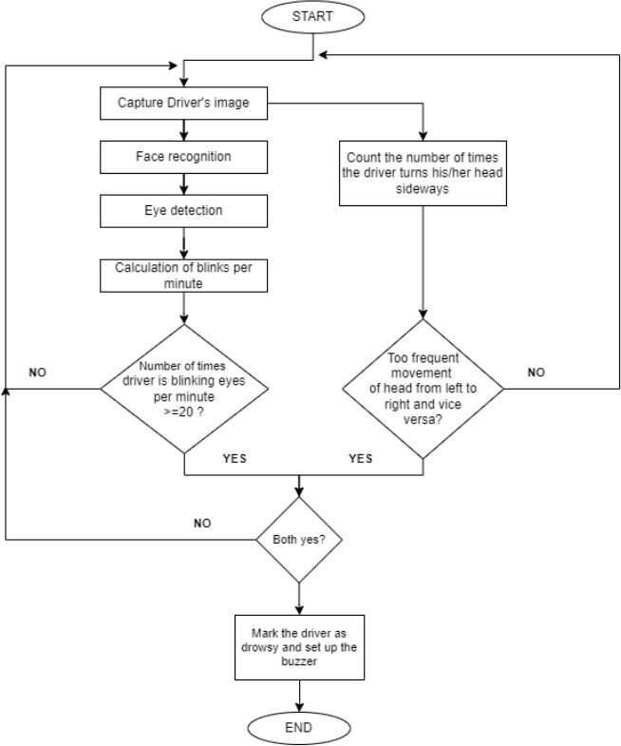

* 1. **Algorithm Proposed**

After going through the previous experiments and facts, it’s been seen that the best invasive way to figure out whether the driver is feeling drowsy during driving or not is by checking the number of times he blinks. It’s been found that a normal driver blinks around 15-16 times per minute, compared to 20+ times for a drowsy driver.

Although, the good accuracy can be calculated by the above stated method, but to be more sure, we also use the second approach, where we will see the number of times the driver turns his/her head sideways, as this is also a sign of drowsiness as mentioned in the research papers (link and summary attached).

To implement the model, the camera will be placed in front of the driver in such a way that it doesn’t bother the driver while driving. It’ll click photos on short durations to get the status of the driver. If the driver is attentive, then it'll wait for some time and repeat the process.

In case, the driver is turning his head sideways and at the same time he’s blinking more than a threshold, then the device will automatically compute the fault and set off the alarm or the buzzer to gain the driver’s attention, hence avoiding any further driving that could lead to an accident.

## Steps:

* + 1. Camera clicks the photo of driver
    2. Face is detected
    3. Eyes are detected from the face, to see whether they’re open or closed.
    4. Movement of head is also monitored
    5. If movement is too frequent and eyes are found close, then the device will set off the alarm.
    6. Else, the device will continue to do its work.

# CHAPTER 4 TECHNOLOGY USED

## Internet of Things:

According to Wikipedia, “The Internet of things (IoT) describes physical objects (or groups of such objects) with sensors, processing ability, software, and other technologies that connect and exchange data with other devices and systems over the Internet or other communications networks. Internet of things has been considered a misnomer because devices do not need to be connected to the public internet, they only need to be connected to a network and be individually addressable.”

## Computer Vision:

It is a field of artificial intelligence that deals with the real world images by interpreting the images. It gives the “dumb” machine (i.e. computers), the ability to see and understand.

Using digital images from cameras, this field can process the data and behave according to what it “sees”.

## OpenCV:

OpenCV (Open Source Computer Vision Library) is a computer vision and machine learning library that is open-source and is available for multiple programming languages to implement in.

OpenCV was built to provide a common infrastructure for computer vision applications and to accelerate the use of machine perception in the commercial products.

## Raspberry Pi:

It is a development board that’ll behave as the master-mind in our project. A development board houses a processor to perform all the necessary actions and gather and work upon the data internally. It is generally a low cost and small-sized development board that will be connected to a camera module and continuously monitor the drowsiness of the driver.

## Cloud Platform:

A cloud platform is used to store the generated data and to monitor the condition of the truck driver in this case. It is a robust replacement for the local storage as cloud computing allows multiple users to connect to the similar server and access the data securely.

Some popular cloud services are : Amazon AWS, Google cloud Platform, Alibaba cloud, Microsoft Azure, etc. For IoT, we can also use Arduino cloud, Blynk IoT cloud, etc.

# CHAPTER 5 DIAGRAMS

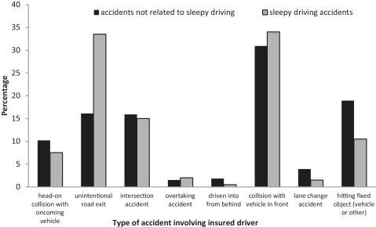

fig 1

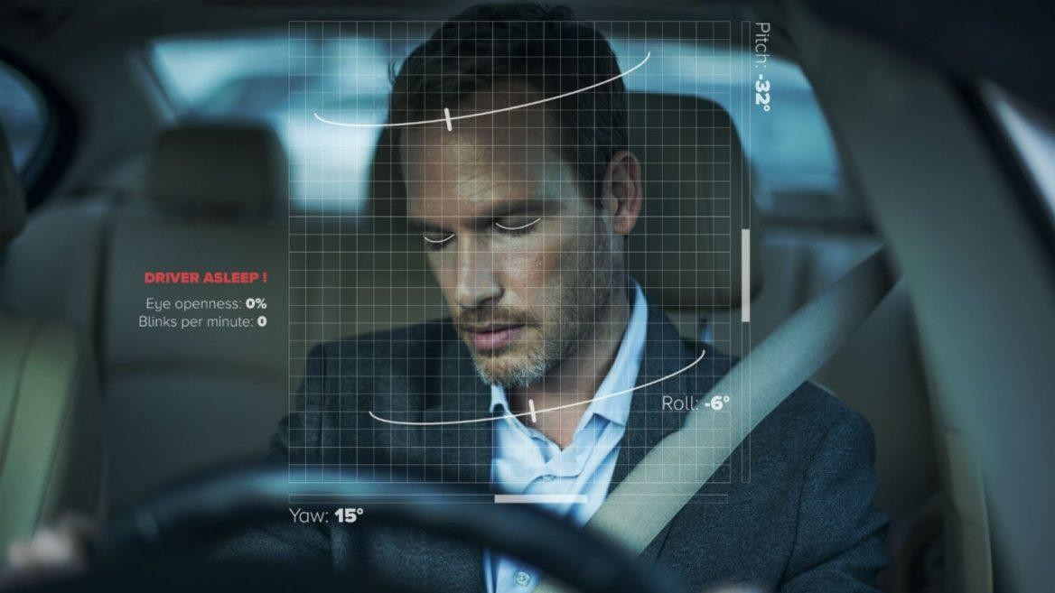

fig 2

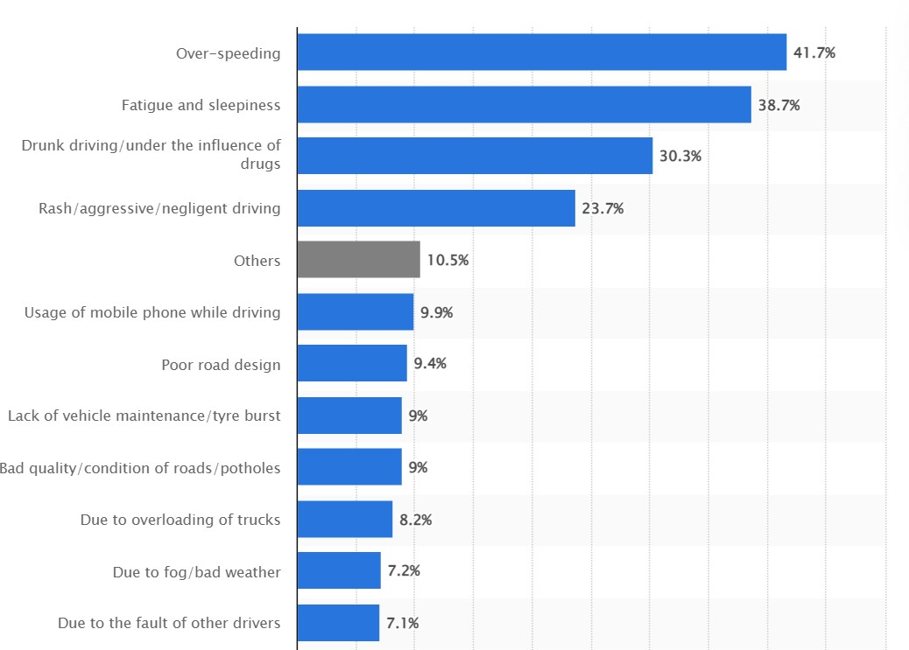

fig 3

# CHAPTER 6 CONCLUSION

Drowsiness impairs mental awareness, making it more difficult for someone to drive safely and raising the possibility that a mistake could result in fatalities or serious injuries. It has also been demonstrated to diminish consciousness, slow reaction speed, and impede judgement. Truck drivers are particularly vulnerable to sleepy driving accidents due to long hours behind the wheel and boring road conditions. It is a difficult and complex challenge to successfully manage driver drowsiness in the commercial motor vehicle sector.

This method will be useful in reducing many accidents because driver fatigue contributes to a significant number of traffic accidents. This will assist save money and lessen personal suffering by averting many accidents.

The device will use a camera to track the driver's eyes, and by creating an algorithm, we can identify signs of driver drowsiness early enough to prevent an accident. Therefore, this project will be useful in anticipating driver fatigue and will provide a warning output in the form of sound with a frequency range of 50 to 60 Hz.

# References

1. <https://ieeexplore.ieee.org/document/8596513>
2. <https://ieeexplore.ieee.org/document/6602353>
3. <https://ieeexplore.ieee.org/document/7907537>
4. <https://ieeexplore.ieee.org/document/9182237>
5. [https://www.researchgate.net/publication/233881105_Detecting_Driver_Drowsin ess_Based_on_Sensors_A_Review#:~:text=We%20 conclude%20that%20 by%20 designing](https://www.researchgate.net/publication/233881105_Detecting_Driver_Drowsiness_Based_on_Sensors_A_Review#%3A~%3Atext%3DWe%20conclude%20that%20by%20designing)
6. <https://www.sciencedirect.com/science/article/abs/pii/S0001457512001352>
7. [https://www.statista.com/statistics/1110224/india-reasons-for-accidents-cited-by- truck-drivers/](https://www.statista.com/statistics/1110224/india-reasons-for-accidents-cited-by-truck-drivers/)