Project Synopsis

on

**Innovative Platform for Learning**

Submitted as a part of course curriculum for

**Bachelor of Technology**

in

**Computer Science**



**Submitted by**

Amod Katiyar (2000290120022)

Himanshu Kumar (2000290120076)

Aniket Bhardwaj (2000290120024)

**Under the Supervision of**

Dr. Gaurav Dubey

**KIET Group of Institutions, Ghaziabad**

**Department of Computer Science**

**Dr. A.P.J. Abdul Kalam Technical University**

**2022-2023**

**DECLARATION**

We hereby declare that this submission is our work and that, to the best of our knowledge and belief, it contains no material previously published or written by another person nor material which to a substantial extent has been accepted for the award of any other degree or diploma of the university or other institute of higher learning, except where due acknowledgement has been made in the text.

Signature of Students

Name:

Roll No.:

Date:

**CERTIFICATE**

This is to certify that Project Report entitled “**Innovative Platform for Learning**” which is submitted by **Amod Katiyar, Aniket Bhardwaj, Himanshu Kumar** in partial fulfilment of the requirement for the award of degree B. Tech. in Department of Computer Science of Dr A.P.J. Abdul Kalam Technical University, Lucknow is a record of the candidates own work carried out by them under my supervision. The matter embodied in this report is original and has not been submitted for the award of any other degree.

**Date: Supervisor Signature**

Dr. Gaurav Dubey

**ACKNOWLEDGEMENT**

It gives us a great sense of pleasure to present the synopsis of the B.Tech Mini Project undertaken during B.Tech. Third Year. We owe a special debt of gratitude to Dr. Gaurav Dubey (Professor), Department of Computer Science, KIET Group of Institutions, Delhi- NCR, Ghaziabad, for his/her constant support and guidance throughout the course of our work. His sincerity, thoroughness and perseverance have been a constant source of inspiration for us. It is only his cognizant efforts that our endeavours have seen the light of the day.

We also take the opportunity to acknowledge the contribution of Dr. Ajay Kumar Shrivastava, Head of the Department of Computer Science, KIET Group of Institutions, Delhi- NCR, Ghaziabad, for his full support and assistance during the development of the project. We also do not like to miss the opportunity to acknowledge the contribution of all the faculty members of the department for their kind assistance and cooperation during the development of our project.

Last but not the least, we acknowledge our friends for their contribution to the completion of the project.

Signature:

Date :

Name :

Roll No:

**ABSTRACT**

**In this vastly expanding world with thousands of opportunities, it can be extremely difficult for students to decide and pursue what they truly enjoy and are passionate about. With the rise of new technologies, the most pressing question for students today is what to learn and how to learn.**

**Students find it difficult to learn despite the fact that there are numerous options and that everything is so diverse. Nothing can ever be found on a single platform. We intend to solve this issue.**

**We will provide a platform that will give students an idea about the languages that are currently the most sought after in the industry, as well as a road map and resources from various platforms that will allow students to hone their grasp on the fundamental concepts and the entire language.**

**TABLE OF CONTENTS**

|  |  |
| --- | --- |
|  | Page No. |
| TITLE PAGE .................................................................................................................... | i |
| DECLARATION .............................................................................................................. | ii |
| CERTIFICATE …........................................................................................................... | iii |
| ACKNOWLEDGEMENT.................................................................................................. | iv |
| ABSTRACT...................................................................................................................... | v |
|  |  |
| CHAPTER 1 INTRODUCTION | 1-n |
| 1.1.          Introduction ……………………................................................... | 1 |
| 1.2 Problem Statement.……………………....................................... |  |
| 1.2.          Objective………………………………………………………… | 2 |
| 1.3.          Scope……………………………………………………………. | 3 |
| CHAPTER 2 LITERATURE REVIEW…………………………………………….... | 7-p |
| CHAPTER 3 PROPOSED METHODOLOGY …………………………………........ | 8-m |
| 3.1 Flowchart |  |
| 3.2 Algorithm Proposed | 10 |
| CHAPTER 4 TECHNOLOGY USED ………...……………………….………………. | 12 |
| CHAPTER 5 CONCLUSION …....................................................................................... |  |
| REFERENCES….............................................................................................................. |  |

**INTRODUCTION**

Technological advancements have dramatically increased access to learning materials and are rapidly changing the educational landscape. With the advancement of internet and mobile phone technology, more education and learning can take place online—on laptop computers, tablets, and mobile phones. Everyone with internet access can benefit from online courses. Learners interested in a specific topic are brought together to learn collaboratively via discussion forums, tweets, and other internet resources.

The platform that we intend to build will provide a platform for comparing

different existing languages that are currently the most in demand in the industry.

The comparison will help students decide which language to pursue for future endeavours.

The students will also learn about the various opportunities that will be available to them after learning a specific language.

Furthermore, the students will be able to share their own hands-on experience and will be

able to guide and assist others in their learning journey.

Various resources from renowned platforms will be provided, as well as a road map for getting better and better at that specific language.

**PROBLEM STATEMENT**

**Despite the fact that there are many options and that everything is so diverse, students find it difficult to learn. Nothing can ever be found on a single platform. We intend to resolve this issue.**

**The numerous possibilities that a student faces when deciding on a**

**Specific domain to work in, the numerous questions that arise in his mind**

**as to whether this is suitable for me or not, whether it will help me land a**

**job in an MNC or not.**

**Even after deciding on a domain, the next question is how to get there, how to get started, and how to properly learn each and every concept.**

**How to practice and revise concepts to achieve the best results. Instead of spending hours researching which courses to take and which channels to follow on the internet, our platform has already done all of the legwork for you, saving you a lot of time. Furthermore, all of that content will be available in a single location.**

**OBJECTIVE**

**Our goal is to address the issues that students face on a daily basis, which may**

**not seem significant at first but can be extremely harmful in the long run.**

**Choosing a domain that does not excite you or is not of your interest and devoting time to it will result in time wasted.**

**It is pointless to learn essentially extinct technologies that have been replaced by newer and more advanced technologies. knowing the current industry trend and selecting a domain based on it will prove fruitful to you.**

**Following a dedicated roadmap to learn the respective languages will assist students**

**in learning the fundamental concepts and thereby strengthening their foundation.**

**Learning the concepts in the prescribed order ensures that no important topics are overlooked and that the student has a thorough understanding of each and every topic.**

**SCOPE**

**In the future, we will provide a much simpler user interface as well as various**

**other resources to improve the quality of content offered.**

**We will also be providing certification for the specific languages learned as well as**

**practice sets for students to test their skills in real time.**

**Offering a premium membership that includes dedicated videos on important topics as well as live sessions with pre-experienced people who are already working in the respective fields.**

**Students who have completed all of the test series on the given topics will receive paid certified certification, and dedicated questions focusing on placements will also be provided.**

**LITERATURE REVIEW**

**RESEARCH PAPER -1**

**Review of WordPress website vs coding website**

**By-Swapnil S More**

**SUMMARY-**

This research paper mainly aims at shedding light on the two ways you can create a website that is either by using Content Management System (eg. -WordPress Website) and Coding Website (HTML).

**CONTENT MANAGEMNET SYSTEM**

A Content Management System or CMS is a type of software which allows users to easily create, manage and modify websites without any prior knowledge of coding or coding languages like HTML, CSS and JavaScript. It has an admin area specifically designed to be user-friendly.

**FEATURES-**

* Easy to use.
* Simple and secure.
* Has a number of pre-defined themes according to the user’s needs.
* Easy updation and management.

**PROBLEMS –**

* White Screen of Death (WSOD)

In this a white screen appears on the main page and no contents of the website are displayed. The most common solution to the problem is log out and then login in again and then disable and delete all plug-ins and replace the theme. Thereafter reinstall all plug-ins and theme then the problem will be solved.

* WP memory limit

It is one of the most common problems WordPress problems in which the memory limit of WordPress file is less than required. The solution is to simply to increase the WordPress memory limit in the file.

* Maintenance issues

**CODING WEBSITE**

It is a website created using various programming language like HTML, CSS, JavaScript. In this it becomes absolutely necessary to have prior knowledge of the various programming languages and to have a proper command on them.HTML provides the basic structure of the website whereas CSS is used to visually style our website and JavaScript is used to make the website interactive.

**FEATURES-**

* Provides more control over the website.
* Debugging is easy.
* One can style website according to one’s need.
* Uses fewer resources

**PROBLEMS-**

* It is not beginner friendly.
* Requires prior knowledge of the programming languages.
* Requires time and effort to build.

**Deciding on whether to choose WordPress or HTML as the foundation for your website clearly depends on what your objective is.**

**If your no site requires no updates, regular changes them HTML is the perfect choice as it will make the functioning of website very fast whereas WordPress is a perfect pic if you want to expand your site by regularly adding content and features to it as it is more user-friendly.**

**RESEARCH PAPER-2**

***A review and analysis of technologies for developing web applications***

***BY-SOLOMON ANTONY***

Abstract: In this paper we review technologies useful for design and development of web-based applications. We also discuss about the technologies that are used at the client side and server side of web application. Next, we compare different web application development frameworks. In addition, we discuss life cycle model and framework of web application development.

1

A review and analysis of technologies for developing web

applications

Asha Mandava and Solomon Antony

Murray state University

Murray, Kentucky

Abstract

In this paper we review technologies useful for design and development of web-based

applications. We also discuss about the technologies that are used at the client side and server

side of web application. Next, we compare different web application development

frameworks. In addition, we discuss life cycle model and framework of web application

development.

1

A review and analysis of technologies for developing web

applications

Asha Mandava and Solomon Antony

Murray state University

Murray, Kentucky

Abstract

In this paper we review technologies useful for design and development of web-based

applications. We also discuss about the technologies that are used at the client side and server

side of web application. Next, we compare different web application development

frameworks. In addition, we discuss life cycle model and framework of web application

development.

Abstract

In this paper we review technologies useful for design and development of web-based

applications. We also discuss about the technologies that are used at the client side and server

side of web application. Next, we compare different web application development

frameworks. In addition, we discuss life cycle model and framework of web application

development.

Abstract

In this paper we review technologies useful for design and development of web-based

applications. We also discuss about the technologies that are used at the client side and server

side of web application. Next, we compare different web application development

frameworks. In addition, we discuss life cycle model and framework of web application

development.

Introduction: Some web applications deliver organizational functionality, some are designed to interactive. Others are for communicational dialogue and others are for presentation. This paper deals with websites that cater to the delivery of business functionality. We examine three popular web application platforms and make recommendations for typical business applications.

Structure of Web page:Web applications tend to be multitiered by nature, with the most common structure being the three-tiered architecture. A web browser is the first tier that is presentation tier. The middle tier will host the application logic. Finally, a database is the third tier storage.

Development practices: Most development work is done in an ad hoc manner, without any specific methodologies. Before the development starts, modelling of the sites using flowcharts, screen mock-ups and storyboards is common. With smaller teams, lighter more agile methods can be employed.

Presentation Layer: The presentation layer of the web applications provides nearly the same user experience as desk top applications. Such interfaces employ a group of technologies collectively called Rich Internet Application (RIA) (Driver, 2005). There are four categories of RIA technologies, namely Script based, plugin based, browser based and web-based desk top technologies.

Conclusion: Object oriented approach build web applications very efficient when one can accomplish more in less time. Because it uses modern processes, by this both developers and clients can benefit. To develop these types of applications there are so many scripting languages and new technologies are there we don’t have to stick to one. It gives good knowledge to the developers as well as clients in choosing of web application platform.

RESEARCH PAPER-3

**Web Application Development -a study on UML Web Application Extension**

BY- Andreas Oskarsson, Martin Kling, Tobias Norberg

Abstract: The use of the Unified Modelling Language (UML) with the newly added Web Application Extension (WAP) resulted in a Web application with good design regarding the maintainability. The UML WAE had a good level of support for extensibility, reusability and documentation. We believe that the use of UML for Web application development will result in good design and maintainability. We have divided the term maintainability into three criteria: Extensibility, Reusability and Documentation. To help draw conclusions from our hypothesis we will answer the following questions.

UML WAE: We will use Web Modelling Extension (WAE) to model a Web shop that sells products. WAE is an extension to UML and was developed by Jim Connellan. We will not use class elements when we model but we may mention them in the \r text.

Web Applications: A Web application is a site that has invoked business logic, interactivity, transaction handling and states. The three components to achieve this are a browser, a Web server, and an application server. Often a database is added to make the application more dynamic.

Web Applications VS Client server: In this report we define a Web application by the definition by Jim Connellan. A Web application is a computer program that has at a minimum, a browser, a Web server, an application server and possibly also a database server. The applications have the same architecture, functionality and are used in many of the same situations.

Conclusion: The use of UML for Web application development will result in good design, regarding to maintainability. Extensibility was supported through low coupling, high cohesion and the possibility to create generalization/specialization hierarchies. Reusability was supported by the ability to apply white-box reuse. This thesis was unable to resolve whether UML WAE supports black-box reuse. The produced documentation was understandable, easy to read and had highly traceable diagrams. With our three criteria extensibility, reusability and documentation examined and found to be in support, the conclusion is that the use of UML for Web application development resulted in good design regarding to maintainability.

RESEARCH PAPER -4

**Website Development Technologies: A Review**

BY- Pratiksha D Dutonde , Shivani S Mamidwar , Monali Sunil Korvate

Introduction: "Web development" typically refers to the most non-design aspects of building net sites. Net development could use content management systems (CMS) to create content changes easier. There square measure 3 styles of net developer specialization: front-end, back-end and full-stack.

Traditional Technologies in Web Development: Knowing the fundamental classes of net technologies is important if you propose to figure in net development. JavaScript could be a lightweight, cross-platform, and taken scripting language. Node.js is an event-driven, non-blocking (asynchronous) I/O and it's not an artificial language.

Back-end development cares with web site design, scripting, and communication with databases. Back-end code permits the communication\r between browsers and data from databases. Databases are necessary as a result of the permit websites and applications to handle user knowledge. There are two main sorts of databases: SQL and NoSQL. Once a business case has been developed and approved, it's time to begin building. A level-3 heading must be indented, in Italic and numbered with an Arabic numeral followed by a right\r parenthesis. The final check of system practicality is when the web site is ready to deploy. The developer should make sure that the positioning is responsive i.e., it seems. properly on devices of all sizes not a part of the web site ought to behave abnormally no matter the scale of the screen. HTML, CSS, and JavaScript square measure the languages used for face development.

Conclusion: The Worldwide internet represents the highest technology to the perfect of a very distributed network atmosphere for polymorphic communication. As such, it should be although of as a paradigm shift aloof from earlier network protocols. Web Applications design issues the look and implementation of pc code that runs on internet servers, rather than running only on desktop computers, laptops or mobile devices.

**RESEARCH PAPER-5**

**Research on HTML5 in Web Development**

BY-Ch Rajesh,K S V Krishna Srikanth

**Abstract—**HTML5 is everywhere these days. HTML5 is the new and elegant standard for HTML that provides web users and developers enhanced functionality. The older versions of HTML, HTML 4.01, which came in 1999, and the web development have changed notably since then. HTML 4, XHTML, CSS and the HTML DOM Level 2 are now replaced with HTML5. It was brought to deliver rich content without the need for additional plug-ins and proprietary technologies. The new power of HTML5 supplies the user with everything from animation to graphics, music to movies, and can also be used to build complicated web applications and also supports cross-platform. HTML5 standard initiates the development of real-time collaborations in web browsers, which leads to less work for web developers.

**INTRODUCTION-** The web is a resource that is widely and steadily usable across many platforms. Some vendors have developed their own proprietary technologies that provide more functionality than web standards. W3C is developing HTML5 with the cooperation of Web Hypertext Application Technology\r Working Group (WHATWG).

**HTML-** New standard for HTML allows us to build rich and interactive web pages. It can play audio and video and supports animations from the browser without the need for proprietary technologies. HTML5 supports cross-platform, designed to display webpages on a PC, a Tablet, a Smartphone, or a Smart TV.

HTML5 FEATURES:

HTML5 provides new features that include

• Canvas – 2D/3D Graphics

• Audio & Video

• Location-based Services

• Working Offline

• Web Workers

• Drag & Drop

• New Input Types

• New Elements

• Form Elements

New Elements in HTML5:

* <acronym>
* <applet>
* <basefont>
* <big>
* <center>
* <dir>
* <font>
* <frame>
* <frameset>
* <isindex>
* <noframes>
* <s>
* <strikes>
* <tt>
* <u>

**CONCLUSION:**

HTML5 introduces new elements and features that allow developers to improve interoperability, handling elements in a precise way saving time and costs. HTML5 is an awesome technology and has the possibility to make the web even more predominant and extensive as it is today from desktop computers to mobile devices and in the future maybe even domestics appliances. The potential of HTML5 will soften the line between desktop and online applications. The problem HTML5 may suffer in the coming days is that an opportunity will be available for the malware writers which may make today's common hacks.

RESEARCH PAPER-6

Big Data-Based Improved Data Acquisition and Storage System for Designing Industrial Data Platform

By DAOQU GENG , CHENGYUN ZHANG , CHENGJING XIA , XUE XIA , QILIN LIU , AND XINSHUAI FU

(Published on 3rd April ’19)

* Big data-based acquisition and storage system (ASS) plays an important role in the design of industrial data platform. Many big data frameworks have been integrated but these methods cannot meet the needs of industrial production information management for requiring time-consuming and mass storage..
* This paper focuses on evaluating the impact of multiple compression and serialization methods on big data platform performance and tries to choose optimal compression and serialization methods for the industrial data platform.
* Compared to the methods integrated in Hadoop and Spark, the experimental results showed the data compression time of the platform has been reduced by 73.9% with a less than 96% the size of data compressed, furthermore, the data serialization time has been reduced by 80.8%. With the increasing amount of data, it takes less time to compare with benchmark methods.
* In the process of building file stored system, the performance of LZO provided by the framework is inferior to LZ4 in the time and the size, and the time spent by LZ4 is only 36% of that spent by LZO. The size of data compressed by LZ4 is 96% of that compressed by LZO.
* Compared with the other serialization methods integrated by Hadoop and Spark, Protobuf performs better and better in data processing as the number of serialized objects increases. Compared with Java defaults, Protobuf takes only 7% of the time to process data. At same time, our data platform has many data analysis functions including machine-learning, Finite Element Analysis, Optimization and Knowledge Mapping.

RESEARCH PAPER-7

Exploratory Analysis for Big Social Data Using Deep Network

By CHAO WU, GUOLONG WANG , JIANGCHENG ZHU , PIYAWAT LERTVITTAYAKUMJORN , SIMON HU , (Member, IEEE), CHILIE TAN , HONG MI, YADAN XU AND JUN XIAO

(Published on 15th Feb ‘ 19)

* Exploratory analysis is an important way to gain understanding and find unknown relationships from various data sources, especially in the era of big data. Traditional paradigms of social science data analysis follow the steps of feature selection, modeling, and prediction.
* In this paper, a new paradigm that does not require feature selection so that data can speak for itself without manually picking out features is proposed. Also, s deep network as a methodology to explore previously unknown relationships and capture complexity and non-linearity between target variables and a large number of input features for big social data is also offered as a solution.
* We conducted three experiments in this paper. In our experiments, the dimension of the explanatory variables was 873 with one target variable at a time in each country (region) per year, and the sample size of the data was 248 countries (regions) with 9 years. The first experiment was a simple example of prediction. In the second one, we tried to find relationships between network capacity modification and test results. The training dataset was the explanatory variables from year 2006 to 2013 and the target variable from year 2007 to 2014. The test dataset was the explanatory variables of year 2014 and the target variable of year 2015. In the third one, we used only one-year data as training dataset with the same test dataset as above and changed the training data year by year in order to understand the influence of time interval difference on prediction results.
* Based on our experiments and their findings, we can infer that our proposed paradigm can be applied to a wide range of scenarios and we can achieve the goal to let the data speak for itself. Further, we can take advantage of the rapid progress in deep learning research and facilitate the data-driven social science research to associate with novel deep learning algorithms

**RESEARCH PAPER-8**

**Mining Conditional Functional Dependency Rules on Big Data**

By Mingda Li, Hongzhi Wang, and Jianzhong Li

(Published on 6th June ‘20)

* Current Conditional Functional Dependency (CFD) discovery algorithms always need a well-prepared training dataset. This condition makes them difficult to apply on large and low-quality datasets. To handle the volume issue of big data, we develop the sampling algorithms to obtain a small representative training set
* We design the fault-tolerant rule discovery and conflict-resolution algorithms to address the low-quality issue of big data. We also propose parameter selection strategy to ensure the effectiveness of CFD discovery algorithms. Experimental results demonstrate that our method can discover effective CFD rules on billion-tuple data within a reasonable period.
* For big data, rule discovery in data cleaning brings new challenges. To solve this problem, we proposed a novel CFD discovery method for big data. For the volume feature of big data, we designed a sampling algorithm to obtain typical samples by scanning data only once. Then, on the sample set, we adapted existing CFD discovery algorithms to tolerate the fault.
* By integrating these modified methods, we discovered a preliminary CFD set. To increase the quality in the discovered rule set, we designed a graph-based rule selection algorithm. Considering that a user may have different requirements for CFD discovery, we proposed a strategy to select parameters according to the requirements of users.
* The experimental results demonstrated that the proposed algorithm is suitable for big data and outperforms existing algorithms. Future work includes extending the proposed algorithm to parallel platforms and modifying the proposed algorithm to discover other rules.

**RESEARCH PAPER-9**

**Big Data Analytics and Mining for Effective Visualization and Trends Forecasting of Crime Data**

By MINGCHEN FENG, JIANGBIN ZHENG, JINCHANG REN , (Senior Member, IEEE), AMIR HUSSAIN , (Senior Member, IEEE), XIUXIU LI , YUE XI , AND QIAOYUAN LIU

(Published on 22nd July’19)

* Big data analytics (BDA) is a systematic approach for analysing and identifying different patterns, relations, and trends within a large volume of data
* In this paper, we apply BDA to criminal data where exploratory data analysis is conducted for visualization and trends prediction. Several the state-of-the art data mining and deep learning techniques are used. Following statistical analysis and visualization, some interesting facts and patterns are discovered from criminal data in San Francisco, Chicago, and Philadelphia.
* For each entry of crime incidents in the datasets, the following 13 featured attributes are included: 1) IncidentNum - Case number of each incident; 2) Dates - Date and timestamp of the crime incident; 3) Category - Type of the crime. This is the target/label that we need to predict in the classification stage; 4) Descript - A brief note describing any pertinent details of the crime; 5) DayOfWeek - Day of the week that crime occurred; 6) PdDistrict - Police Department District ID where the crime is assigned; 7) Resolution - How the crime incident was resolved (with the perpetrator being, say, arrest or booked); 8) Address - The approximate street address of the crime incident; 9) X - Longitude of the location of a crime; 10) Y - Latitude of the location of a crime; 11) Coordinate - Pairs of Longitude and Latitude; 12) Dome - whether crime id domestic or not; 13) Arrest - Arrested or not.
* In future, we plan to complete our on-going platform for generic big data analytics which will be capable of processing various types of data for a wide range of applications. We also plan to incorporate multivariate visualization [59], graph mining techniques [54] and fine-grained spatial analysis [60] to uncover more potential patterns and trends within these datasets

**RESEARCH PAPER-10**

**Social Set Analysis: A Set Theoretical Approach to Big Data Analytics**

By RAVI VATRAPU1,2, RAGHAVA RAO MUKKAMALA1 , ABID HUSSAIN1 , AND BENJAMIN FLESCH1

* Current analytical approaches in computational social science can be characterized by four dominant paradigms: text analysis (information extraction and classification), social network analysis (graph theory), social complexity analysis (complex systems science), and social simulations (cellular automata and agent-based modeling).
* However, when it comes to organizational and societal units of analysis, there exists no approach to conceptualize, model, analyze, explain, and predict social media interactions as individuals’ associations with ideas, values, identities, and so on. To address this limitation, this paper presents a new approach to big data analytics called social set analysis.
* Social set analysis consists of a generative framework for the philosophies of computational social science, theory of social data, conceptual and formal models of social data, and an analytical framework for combining big social data sets with organizational and societal data sets. Three empirical studies of big social data are presented to illustrate and demonstrate social set analysis in terms of fuzzy set-theoretical sentiment analysis, crisp set-theoretical interaction analysis, and eventstudies-oriented set-theoretical visualizations
* In conclusion, one of the contributions of this paper is to demonstrate the suitability and effectiveness of Social Set Analysis for conceptualizing, formalizing and analyzing big social data from content-driven social media platforms like Facebook for event studies such as unexpected crises and/or coordinated marketing campaigns
* Taken together, the three demonstrative case studies illustrate the viability of Social Set Analysis as a holistic approach to Computational Social Science in general and Big Data Analytics in particular
* As part of future work, we would like to extend the Fuzzy Set Theoretical formal model to encompass modelling of networks of groups and friends of users in an online social media platform.

**PROPOSED METHODOLOGY**

**FLOWCHARTS-**

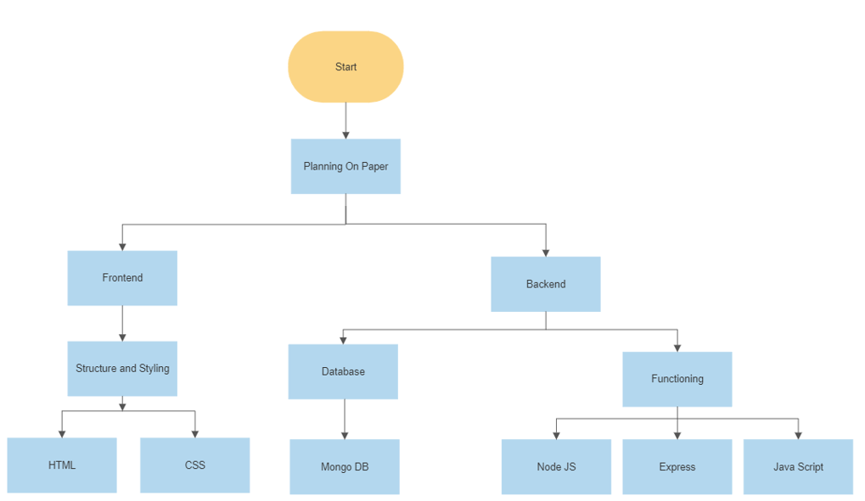

**ALGORITHMS PROPOSED-**

**We will start with the most popular courses or languages.**

**Then, we will use nlp and API to extract the best links from the web for students to learn from.**

**All of this will be done to assist the student in choosing his path and providing him with the resources he needs to succeed.**

**We will deploy a model of recommended systems that will analyse historical data and trends to determine the popularity and usage of languages such as Java, C, and Python and then recommend it to students.**

**We will also show this in real time graphs. Finally, we will use nlp to extract words like python data science best top to analyse and recommend courses.**

**We will also use api for this.**

**ML algorithms –**

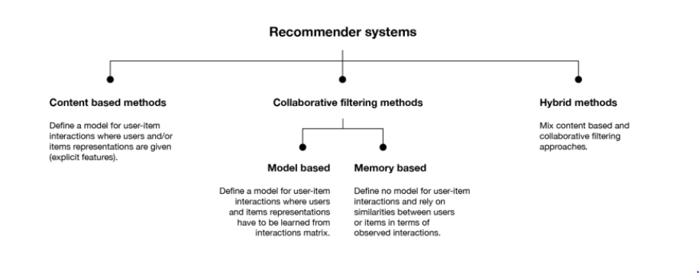

**DETAILED TYPES-**

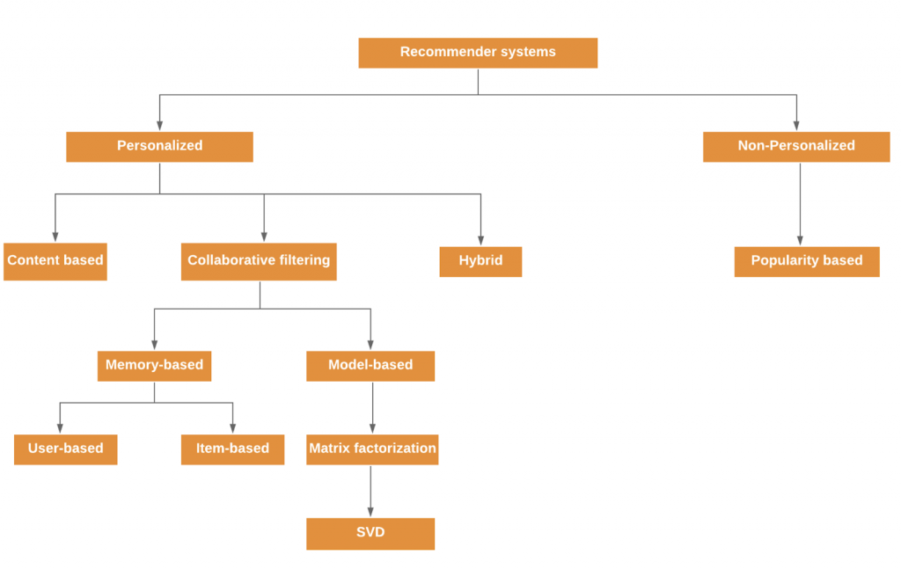

**DECISION TREE APPROACH-**

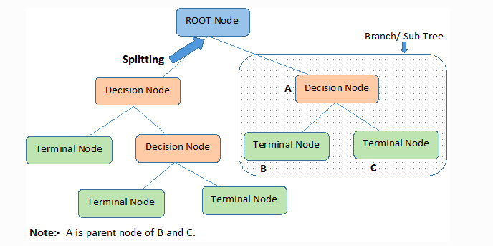

**NLP APPROACH-**

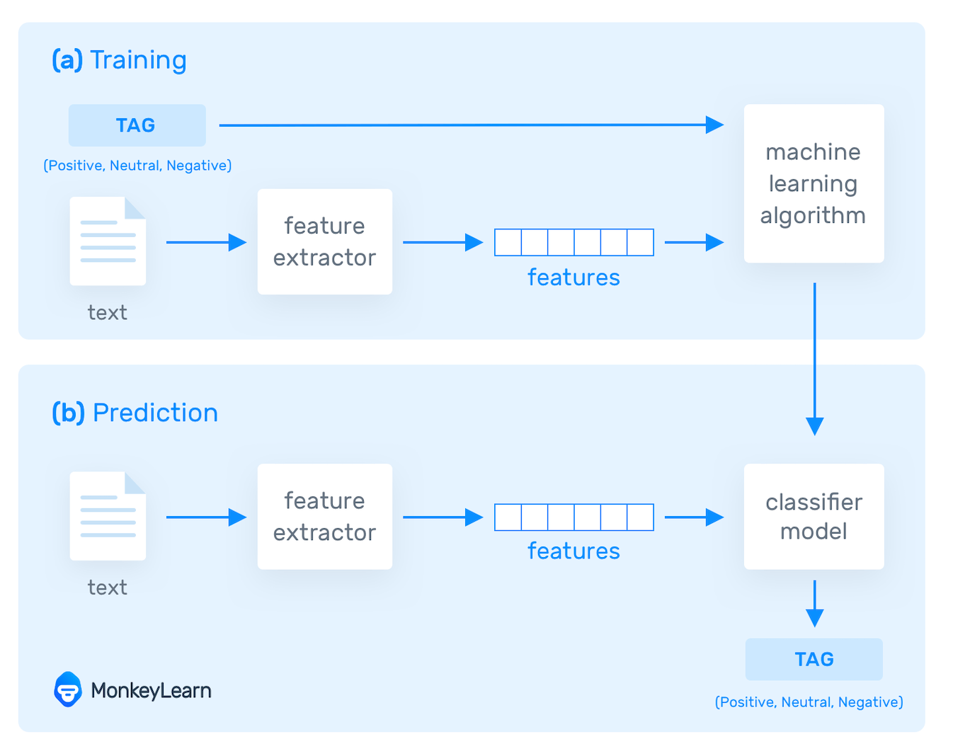

**TECHNOLOGY USED**

**The platform's development has been divided into two parts: frontend and backend.**

**The frontend will be built with HTML and CSS, where HTML will provide the basic**

**framework for the website and CSS will be used for styling.**

**The goal is to create an easy-to-use website that is user-friendly and easy to navigate.**

**The backend will be built with React, Express, and Node js, as well as javascript.**

**React and Javascript will provide functionality to the website, as well as the necessary**

**post and get requests. MongoDB will be used to create a database that will store the**

**students' information as well as their current progress.**

**React will also be used to improve the overall interface of the website, which when combined with the backend will result in the perfect website.**

**Machine learning techniques are used in the industry to implement real-time**

**language usage. the rate at which the particular language is growing and the**

**language's future trends**

**The domains that are currently required in the industry, as well as the average salary**

**trends for jobs in the respective domain.**

**All of this would necessitate the use of the following technologies:**

* **NLP-** **Natural language processing (NLP) refers to the branch of computer science—and more specifically, the branch of artificial intelligence or AI—concerned with giving computers the ability to understand text and spoken words in much the same way human beings can.**
* **TEXTBLOB-** **TextBlob is a Python (2 and 3) library for processing textual data. It provides a simple API for diving into common natural language processing (NLP) tasks such as part-of-speech tagging, noun phrase extraction, sentiment analysis, classification, translation, and more.**
* **EDA-** **TextBlob is a Python (2 and 3) library for processing textual data. It provides a simple API for diving into common natural language processing (NLP) tasks such as part-of-speech tagging, noun phrase extraction, sentiment analysis, classification, translation, and more.**
* **RECOMMENDATION BASED SYSTEMS-** **A recommender system, or a recommendation system (sometimes replacing 'system' with a synonym such as platform or engine), is a subclass of information filtering system that provide suggestions for items that are most pertinent to a particular user**
* **XGBOOST-** **XGBoost is an optimized distributed gradient boosting library designed to be highly efficient, flexible and portable. It implements machine learning algorithms under the Gradient Boosting framework. XGBoost provides a parallel tree boosting (also known as GBDT, GBM) that solve many data science problems in a fast and accurate way.**
* **DECISION TREE-** **Decision Tree is the most powerful and popular tool for classification and prediction. A Decision tree is a flowchart-like tree structure, where each internal node denotes a test on an attribute, each branch represents an outcome of the test, and each leaf node (terminal node) holds a class label.**

**CONCLUSION**

**The final platform would be able to overcome all of the problems that students are**

**currently experiencing in their learning. The students will have a clear idea of which**

**domain to choose and a perfect road map to help them achieve their goals and land**

**a job in an MNC.**

**The recommendation system will help students understand which domains are**

**currently thriving and what job profiles are needed in the industry.**

**This allows the student to easily plan their journey ahead and learn something that**

**they are truly interested in rather than something that they will not feel like**

**continuing in the future.**

**Sample graphs and charts are as follows-**

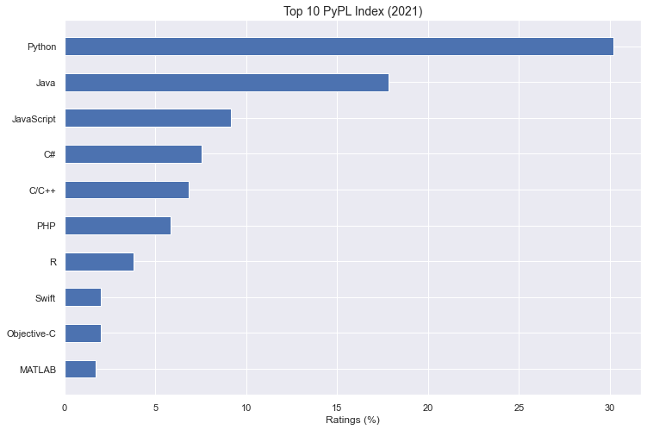

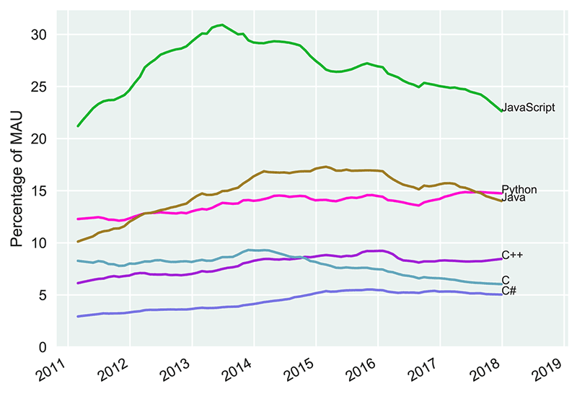

**As the above graphs show that languages such as Python, JavaScript, and Java have**

**been in high demand in recent years, it is recommended that students begin by**

**emphasizing these languages.**