**Test plan for**

**Home Service Provider**

*ChangeLog*

|  |  |  |  |
| --- | --- | --- | --- |
| **Version** | **Change Date** | **By** | **Description** |
| version number | Date of Change | Name of person who made changes | Description of the changes made |
| 1 | November 1 2023 | Aaveg Tomar | First document |
|  |  |  |  |

# Introduction

Our Home Service Provider website project encompasses a wide range of features, including a chat dashboard, sign-in and sign-out functionality, support for multiple home services, and robust user authentication. To ensure the quality, reliability, and performance of these vital components, we have established a comprehensive testing approach.

**Test Strategies:**

Our testing strategy is designed to rigorously evaluate all aspects of the website's functionality, with a particular emphasis on thorough automation using Selenium and precise manual testing with Decision Tables.

**Key strategies include**:

* **Automation Testing with Selenium**: Selenium will be our cornerstone for automation testing, enabling us to automate repetitive tasks, such as regression testing, and ensuring quick feedback on website changes.
* **Manual Testing with Decision Tables**: Decision Tables will guide our manual testing efforts, systematically exploring various input combinations and expected outcomes for scenarios that are difficult to automate or require human judgment.
* **Functional Testing**: Comprehensive functional testing will be conducted for all key features, including the chat dashboard, service selection, sign-in/sign-out processes, and user

**Test Process:**

Our testing process will follow a structured workflow:

* **Test Planning**: We have already outlined our testing objectives, scope, and deliverables in our Test Plan. This step ensures we have a clear roadmap for the testing phase.
* **Test Design**: Detailed test cases will be created, both for automation using Selenium and for manual testing with Decision Tables. These cases will address various usage scenarios and edge cases.
* **Test Execution**: Test cases will be executed, with Selenium handling automation where feasible and manual testing employed for decision-driven scenarios.

## Scope

### In Scope

In scope includes the features, functional, and non-functional requirements of the software that will be thoroughly tested. For your Home Service Provider website, the following items are considered in scope:

* **Chat Dashboard:** Testing the functionality and performance of the chat system, ensuring seamless communication between service providers and customers.
* **User Authentication:** Verification of the sign-in and sign-out processes, including the security and integrity of user credentials.
* **Multiple Home Services:** Comprehensive testing of the platform's support for various home services, ensuring each service can be accessed and requested effectively.
* **Location-Based Tracking:** Validation of the real-time location tracking functionality, ensuring it accurately displays the service provider's location based on the customer's location.
* **Security and Data Protection:** Assessment of the security mechanisms and data protection measures in place to safeguard user information and interactions.

### Out of Scope

Functional, and non-functional requirements that will not be subject to detailed testing. For your Home Service Provider website, the following items are considered out of scope:

* **Third-Party Services:** The integration or functionality of third-party services or APIs not directly controlled by the website (e.g., payment gateways) is not within the scope of this testing phase. Performance Under Heavy Load: While performance testing is in scope, we may not test under extremely heavy loads exceeding the expected capacity.
* **Cross-Browser Testing:** While browser compatibility is important, extensive cross-browser testing with uncommon or outdated browsers is not included in this phase.
* **Database Stress Testing:** Stress testing of the database or other backend components is not part of this project's scope.
* **Business Logic Changes:** Testing of new business logic or major architectural changes that are not directly related to the specified features is out of scope.

## Quality Objective

The overarching goal of our testing project is to ensure the Home Service Provider website meets the highest standards of quality, functionality, and security. To achieve this, we have set the following quality objectives:

* **Compliance with Functional and Non-Functional Requirements:** This includes the proper functioning of features like the chat dashboard, user authentication, and location-based tracking.
* **Enhancing User Satisfaction:** By achieving the above objectives, our ultimate goal is to enhance user satisfaction. We aim to provide a reliable, user-friendly platform that fosters trust and confidence among both service providers and customers.
* **User-Friendly Experience:** Usability testing is integral to our quality objectives. We want to ensure that the website provides a smooth and user-friendly experience for all users, with intuitive navigation and clear interfaces.

## Roles and Responsibilities

Detail description of the Roles and responsibilities of different team members like

* Test Manager (Abhi Singhal)
* Tester (Abhi Singhal) – Tested the test cases.
* Developers (Aaveg Tomar, Abhi Singhal, Arpit Puri) - Addressed and resolved issues identified during testing.
* Project Manager (Dr. Ajay Kumar Shrivastava) - Oversee the project's progress and ensure alignment with testing efforts.

# Test Methodology

## Overview

**Reasons for Adopting Waterfall:**

* **Structured Phases:** The Waterfall model follows a clear and sequential structure, with defined phases for requirements, design, implementation, testing, deployment, and maintenance. This structured approach aligns well with projects that have well-defined and stable requirements, such as your Home Service Provider website.
* **Thorough Planning:** Waterfall emphasizes comprehensive planning and documentation in the early stages. This is crucial for a project like yours, which requires a deep understanding of the chat dashboard, user authentication, and location tracking features.
* **Detailed Requirements:** The Waterfall model is effective when requirements are well understood and unlikely to change significantly during the project. In your case, the functionality of a chat dashboard and location tracking may require detailed specifications that are unlikely to change frequently.
* **Sequential Testing:** Waterfall's phased approach allows for testing after development is complete. This is beneficial for your project, especially when you want to ensure that individual components, such as user authentication, are thoroughly tested before moving to the next phase.
* **Control and Accountability:** Waterfall provides clear control and accountability for each phase, enabling a structured progression from requirements gathering to deployment. This is particularly valuable for meeting quality and security standards in your project.

## Suspension Criteria and Resumption Requirements

### Suspension Criteria

Suspension criteria specify the conditions under which all or part of the testing procedure may be temporarily halted. These criteria help ensure that testing is paused when necessary to address critical issues or to make essential adjustments. For your Home Service Provider website project, the suspension criteria are as follows:

* **Critical Security Vulnerabilities**: If severe security vulnerabilities are identified during testing that could compromise user data or system integrity, testing will be suspended to address and resolve these vulnerabilities.
* **Data Loss or Corruption:** Testing will be suspended if there is a risk of data loss or data corruption that could affect the overall functionality and reliability of the platform.
* **Server or System Failures:** In the event of server or system failures that significantly disrupt testing, suspension may be necessary to address these technical issues.
* **Regulatory Non-Compliance:** If the testing process reveals non-compliance with legal or regulatory requirements, testing may be suspended to address these issues and ensure full compliance.

### **Resumption Requirements**

Resumption requirements specify the conditions and procedures that must be met for testing to resume after it has been suspended. These requirements ensure that testing can continue effectively once the suspension criteria have been addressed. For your Home Service Provider website project, the resumption requirements are as follows:

* **Security Vulnerabilities Resolution:** Testing will resume once critical security vulnerabilities have been thoroughly addressed, and measures are in place to safeguard user data and system integrity.
* **Data Recovery and Integrity Assurance:** When data loss or corruption is identified, testing will resume after data recovery and integrity checks have been successfully conducted to ensure system reliability.
* **Server or System Stability Restoration:** Resumption requires the restoration of server or system stability to prevent further disruptions to the testing process.
* **Regulatory Compliance:** Testing may continue once any regulatory non-compliance issues have been resolved, and measures are in place to ensure ongoing compliance.

## Test Completeness

* All requirements are met.
* Compatibility: Software is compatible with other platforms, browsers, devices, OS.
* 100% test coverage
* All Test cases executed
* All open bugs are fixed or will be fixed in next release.

# Test Deliverables

**Manual Testing - Decision Table**

**Test Case 1 : Professional Registration**

|  |  |  |  |  |  |  |  |  |  |  |
| --- | --- | --- | --- | --- | --- | --- | --- | --- | --- | --- |
| Conditions | T/F | T/F | T/F | T/F | T/F | T/F | T/F | T/F | T/F | T/F |
| Name | T | T | T | T | F | F | F | F | F | T |
| Email | T | F | T | T | T | T | F | F | F | T |
| Phone Number | T | T | F | T | F | F | T | F | F | F |
| Password | T | F | F | F | T | T | T | T | F | T |
| Confirm Password | T | T | T | F | F | F | F | T | T | T |
| Location | T | F | T | F | T | T | F | T | T | F |
| Professional | T | T | F | F | F | F | T | F | T | T |
| Registration Successful (Y/N) | Y | N | N | N | N | N | N | N | N | N |

**Test Case 2 : Professional Login**

|  |  |  |  |  |
| --- | --- | --- | --- | --- |
|  | T/F | T/F | T/F | T/F |
| Email | T | T | F | F |
| Password | T | F | T | F |
| Login(Y/N) | Y | N | N | N |

**Test Case 3 : Customer Registration**

|  |  |  |  |  |  |  |  |  |  |  |
| --- | --- | --- | --- | --- | --- | --- | --- | --- | --- | --- |
|  | T/F | T/F | T/F | T/F | T/F | T/F | T/F | T/F | T/F | T/F |
| Name | T | T | T | T | F | F | F | F | F | T |
| Email | T | F | T | T | T | T | F | F | F | T |
| Phone Number | T | T | F | T | F | F | T | F | F | F |
| Password | T | F | F | F | T | T | T | T | F | T |
| Confirm Password | T | T | T | F | F | F | F | T | T | T |
| Location | T | F | T | F | T | T | F | T | T | F |
| Registration Successful (Y/N) | Y | N | N | N | N | N | N | N | N | N |

**Test Case 4 : Customer Login**

|  |  |  |  |  |
| --- | --- | --- | --- | --- |
|  | T/F | T/F | T/F | T/F |
| Email | T | T | F | F |
| Password | T | F | T | F |
| Login(Y/N) | Y | N | N | N |

**Test Case 5 : Chat Dashboard**

|  |  |  |  |  |  |
| --- | --- | --- | --- | --- | --- |
| **User Type** | **User Status** | **Connection Status** | **Message Type** | **Message Status** | **Chat Functionality** |
| Customer | Logged In | Connected | Text | Sent | Pass |
| Customer | Logged In | Connected | Text | Received | Pass |
| Customer | Logged In | Disconnected | Text | Sent | Fail |
| Customer | Logged In | Disconnected | Text | Received | Fail |
| Service Provider | Logged In | Connected | Text | Sent | Pass |
| Service Provider | Logged In | Connected | Text | Received | Pass |
| Service Provider | Logged In | Disconnected | Text | Sent | Fail |
| Service Provider | Logged In | Disconnected | Text | Received | Fail |
| Service Provider | Logged In | Disconnected | File | Received | Fail |
| Service Provider | Logged Out | - | - | - | Fail |

**Automation testing – Selinium**

**Test Case 1 : Customer Login**

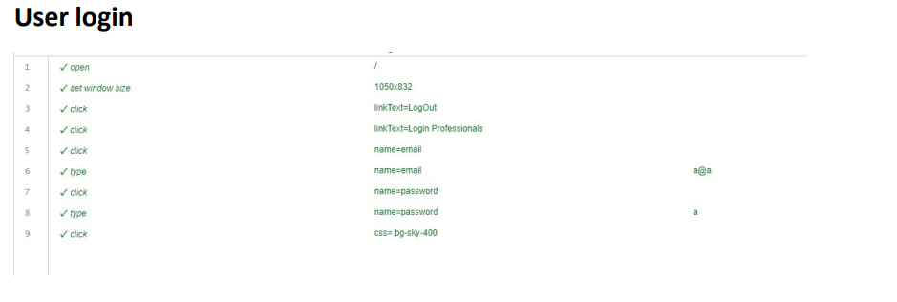

**Test Case 2. Provider Registration**

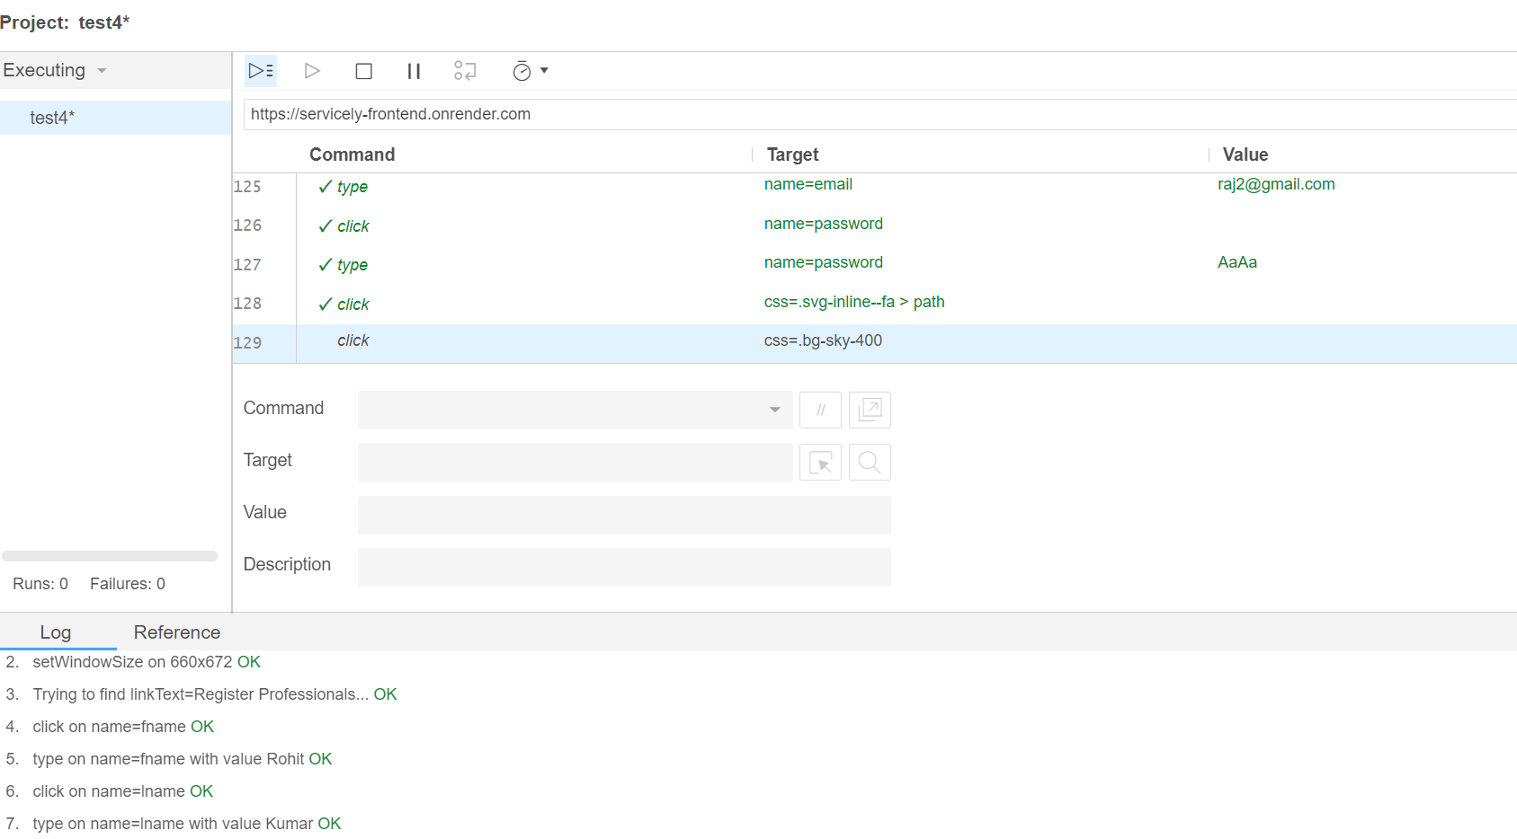

**Test Case 3 . Provider Login**

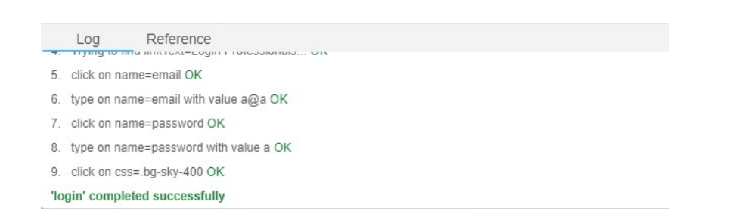

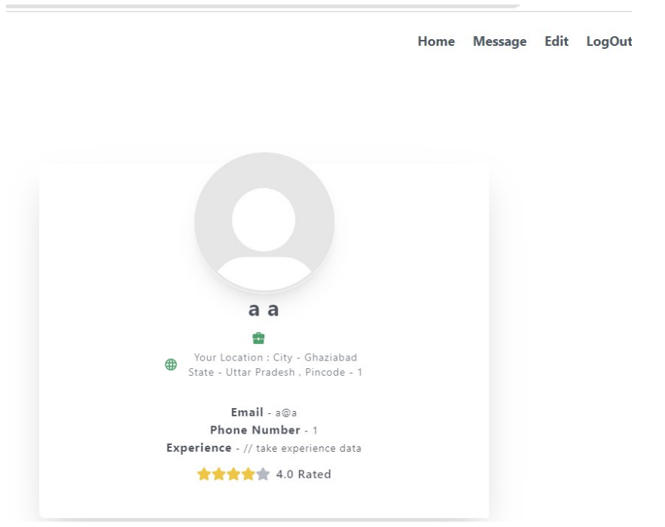

**Test Case 4 . Chat Dashboard**

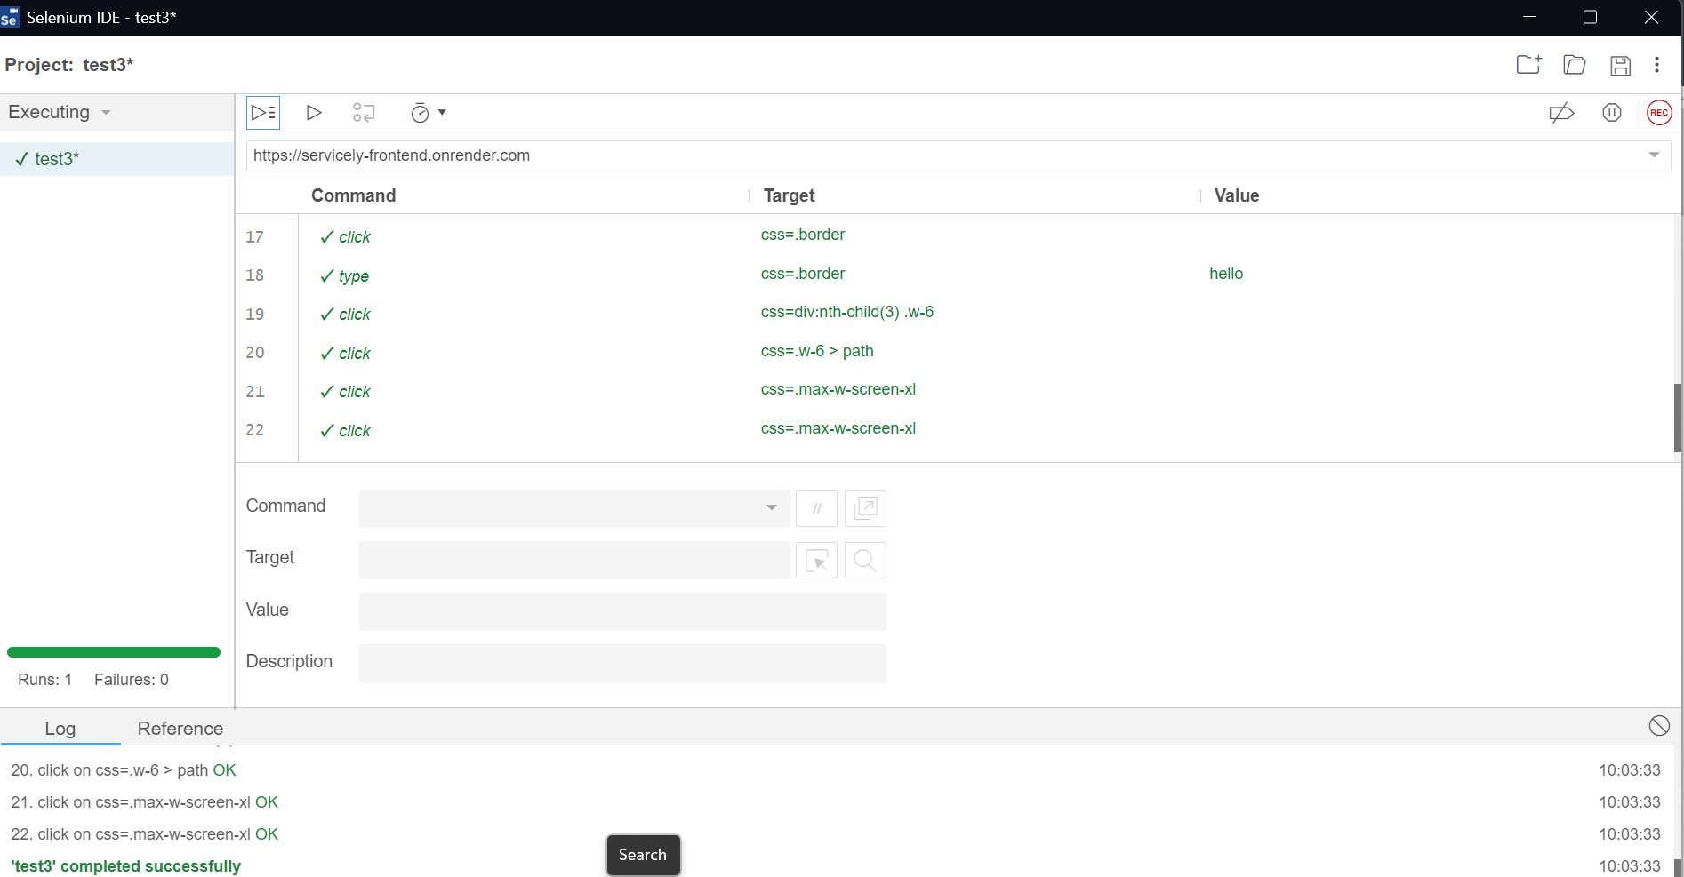

# Resource & Environment Needs

## Testing Tools

* Selinum - **Selenium** Testing. **Selenium** automates web browsers. Learn all about **Selenium** Testing to perform Automated Testing on your websites at scale and speed.
* Browser (Firefox or chrome)

## Test Environment

Hardware requirements for the test environment, especially those relevant to running Selenium tests.

Hardware Requirements:

• Processor: Dual-core or higher

• RAM: 4 GB or higher

• Hard Drive: 50 GB of free disk space

• Display: A monitor with a resolution of at least 1024x768

• Network: A stable internet connection for testing remote services or cloud-based

# Terms/Acronyms

Make a mention of any terms or acronyms used in the project

| TERM/ACRONYM | DEFINITION |
| --- | --- |
| API | Application Program Interface |
| Chat Functionality | The feature that enables real-time text-based communication between service providers and customers on the website. |
| User Authentication | The process by which users can log in to the website using their email and password. |
| Location Tracking | The capability to track and display the real-time location of service providers based on the location of the customer. |
| Selenium | A popular open-source automation testing framework used for automating web browser interactions. |
| Geolocation Services | Services or tools that provide simulated or real geographical location data for testing purposes. |