Project Synopsis

on

# REAL TIME CHAT APPLICATION

Submitted as a part of course curriculum for

**Bachelor of Technology**

in

## Computer Science



**Submitted by**

**Sachin Kushwaha**

**SachinVerma**

**Siddharth Kushwaha**

**Under the Supervision of**

Dr . Ajay kumar shrivastava

Designation

## KIET Group of Institutions, Ghaziabad Department of Computer Science

**Dr. A.P.J. Abdul Kalam Technical University**

**2022-2023**

### DECLARATION

We hereby declare that this submission is our work and that, to the best of our knowledge and belief, it contains no material previously published or written by another person nor material which to a substantial extent has been accepted for the award of any other degree or diploma of the university or other institute of higher learning, except where due acknowledgement has been made in the text.

Signature of Students

Name: : sachin kushwaha ,sachin verma , sidhartha kushwaha

Roll No.: 2000290120130,2000290120131,2100290129009

Date: 15/11/2022

### CERTIFICATE

This is to certify that Project Report entitled “**REAL TIME CHAT APPLICTION**” which is submitted by sachin kushwaha ,sachin verma , sidhartha kushwaha in partial fulfilment of the requirement for the award of degree B. Tech. in Department of Computer Science of Dr A.P.J. Abdul Kalam Technical University, Lucknow is a record of the candidates own work carried out by them under my supervision. The matter embodied in this report is original and has not been submitted for the award of any other degree.

**Date: 11/11/2022 Supervisor Signature**

Dr. Ajay kumar shrivastva

(Designation)

### ACKNOWLEDGEMENT

It gives us a great sense of pleasure to present the synopsis of the B.Tech Mini Project undertaken during B.Tech. Third Year. We owe a special debt of gratitude to Dr. Ajay kumar Shrivastava(HOD), Department of Computer Science, KIET Group of Institutions, Delhi- NCR, Ghaziabad, for his/her constant support and guidance throughout the course of our work. his sincerity, thoroughness and perseverance have been a constant source of inspiration for us. It is only her cognizant efforts that our endeavours have seen the light of the day.

We also take the opportunity to acknowledge the contribution of Dr. Ajay Kumar Shrivastava, Head of the Department of Computer Science, KIET Group of Institutions, Delhi- NCR, Ghaziabad, for his full support and assistance during the development of the project. We also do not like to miss the opportunity to acknowledge the contribution of all the faculty members of the department for their kind assistance and cooperation during the development of our project.

Last but not the least, we acknowledge our friends for their contribution to the completion of the project.

Signature:

Date : 11/11/2022

Name : sachin kushwaha ,sachin verma , sidhartha kushwaha Roll No: 2000290120130,2000230120131,2100290129009

### ABSTRACT

Chat application is an important tool for today’s world as it help’s everyone to contact from anywhere and talk with them at real time without any problem and this tool resolve the issue of calling every time for any query related anything about that work, Now with the help of chat application user can just send the message to the other user and resolve the issue or query without calling. The best part about the chat application is that we can send the same message to many users at a same time without any problem as we can make a group of so many people or even we can broadcast the message to selected users to whom the sender wishes to send the message. Chat application also provided us the best feature in this as you can share your current location with anyone at any time and even you can share the images or pdf or any other type of file using the application.

**Keywords:** Real Time Chat, Multiple-Platform, Multiple-User, Node.Js, Socket.Io, Chat Application.

|  |  |  |
| --- | --- | --- |
| **TABLE OF CONTENTS** | | Page No. |
| TITLE PAGE .................................................................................................................... | | 1 |
| DECLARATION .............................................................................................................. | | 2 |
| CERTIFICATE …........................................................................................................... | | 3 |
| ACKNOWLEDGEMENT.................................................................................................. | | 4 |
| ABSTRACT...................................................................................................................... | | 5 |
| LIST OF FIGURES ......................................................................................................... | | 6 |
| LIST OF ABBREVIATIONS ………..…………………………………………………. | | 7 |
| CHAPTER 1 INTRODUCTION | | 7-8 |
| 1.1. Introduction ……………………................................................... | |  |
| 1.2 Problem Statement .…………………….......................................  1.2. Objective………………………………………………………… | |  |
| 1.3. Scope…………………………………………………………….. | |  |
| CHAPTER 2 LITERATURE REVIEW…………………………………………….... | | 8-11 |
| CHAPTER 3 PROPOSED METHODOLOGY …………………………………........  3.1 Flowchart  3.2 Algorithm Proposed | | 11-12 |
| CHAPTER 4 TECHNOLOGY USED ………..………………………..……………….  CHAPTER 5 DIAGRAMS …...........................................................................................  CHAPTER 6 CONCLUSION ….......................................................................................  REFERENCES….............................................................................................................. | | 13  14  15  16 |
|  |

**CHAPTER 1**

## INTRODUCTION

As the time going on, the development of information and communication technology is growing so faster and playing very important role in the society. As with the help of the information and communication technologies we can facilitate the people to receive the information and communicate with each other from anywhere, anytime and faster than before. If we see the today’s scenario after the technology have been arrived most of the people don’t use newspaper for getting the information and even not much uses the news channel now a days for getting information, Majority is using the smart technology for receiving any type of information with the help of smart phones or other devices and if we talk about the chat application, in the chat application everyone is sharing many news there itself only about what’s going on around them or in any place in the world, as with the help of the chat application information is spreading so faster than before. Currently, the chat application has been developed by many developers and it has its own advantages and disadvantages as every other thing have, and it’s giving us more options to decide which thing is better for us and what features are really required in the application and what not, as the review of the users using the application tells a lot about the application and their experience towards the application. The Chat application is fully responsive as it means totally user friendly for every web-based or mobile or any other device users. It is built using Node.js, Socket.io, MongoDB, Passport.js, Auth2.0 and other JavaScript libraries.

**PROBLEM STATEMENT**

Private organizations often grapple with communication challenges when relying on generic, external chat applications that lack the requisite security and customization features. A critical issue emerges: the absence of a dedicated, secure, and adaptable real-time chat application specifically tailored for the unique demands of private organizations. This application must facilitate confidential, efficient internal communication while incorporating robust data encryption and seamless integration with organizational workflows. Creating such a real-time chat platform is pivotal for enhancing internal communication, safeguarding sensitive information, and fostering streamlined collaboration within the organization, ensuring the privacy and security of vital data.

## OBJECTIVE

The objective can be defined from the main problem given above is that to build a proper real-time multiplatform chat application which can be easily used by people to make their life easy to share the information and communicate with each other easily and faster.

**Easy to use GUI** (Graphical User Interface), hence any user with minimal knowledge of operating a system can use the software.

* **User Registration and Authentication:**Implement a secure user registration and authentication system to ensure that only authorized users can access the chat application.
* **Private and Group chat**: Enable both one-on-one private messaging and group chats. Users should be able to create, join, and manage group chats with multiple participants.
* **Search and Message History :** Provide a search feature to help users find and review their chat history easily.

• **Real-Time Communication**: The primary objective is to enable real-time messaging, where users can send and receive messages instantly. Achieving low-latency communication is essential.

* **Typing Indicators**: Show real-time typing indicators to let users know when someone is composing a message.

• **Push Notifications**: Send push notifications to devices to alert users about new messages or updates.

## Scope

The scope of application should be declared before moving towards the next step.

Application scope are as follows:

1. Design and construction of this chat application is responsive for every web-based or mobile or other device users.
2. This application is developed using Node.js, socket.io and other JavaScript libraries.
3. Database of the application is stored using MongoDB NOSQL Database.

Used by less than 100 people (for testing purpose

**Literature Review**

## 1) Development of Chat Application

**By:**

Dr. Abhay Kasetwar , Ritik Gajbhiye , Gopal Papewar , Rohan Nikhare , Priya Warade

**published** in International Journal for Research in Applied Science & Engineering

Technology (IJRASET) ISSN: 2321-9653; IC Value: 45.98; SJ Impact Factor: 7.538 Volume 10 Issue V May 2022- Available at www.ijraset.com

This research paper contains the information we have provided to maintain the security and protection of the request for a speech. We have identified many requirements for secure speech and make it more realistic by using modern day techniques and weight to provide speed and good assurance to its customers. XSalsa20 calculator is ideal for mobile phones due to its high security, high performance and battery life. Customers can be sure that no one can read their messages, even if the cell phone gets in the wrong hands, you can't access the app and you can't access local information.

This research paper contains that the chat app provides a better and more flexible program. for discussion. Developed with the latest technology in the way of providing a reliable system. The main advantages of the system are instant messaging, real-world communication, added security, group chat, etc. This app can find the best demand in the market for most organizations that aim to have private applications. Additional features will also be added to the program based on community needs that include conference call, video chat. Location sharing, etc. based on need.

This research paper contains that chat app should be a real-time forum and multi-site for use by many users. The programming language used to build the Node.js server with a clear framework and MongoDB website.

2) Chat Application

By: Manish Kolambe , Saurabh Sable , Venkatesh Kashivale , Prajkta Khaire.

Published in International Journal for Research in Applied Science & Engineering

Technology (IJRASET) ISSN: 2321-9653; IC Value: 45.98; SJ Impact Factor: 7.538 Volume 10 Issue IV Apr 2022- Available at www.ijraset.com

Today, in this world of social media there are many applications that enable us to share data between people who are distances apart. These social media applications run a variety of platforms. Our project is about a social media application through which we can chat and share files with other people living in different parts of the world which runs on a Desktop. Python programming language and its modules were used in this project. A client-server model and TCP protocol for communication are used in our project. It has a simple GUI interface implemented. Keywords: Chat application, Client-Server model, Social media app, TCP protocol, Multithreading

## 3) DECENTRALISED CHAT APPLICATION

### By

Uma Thakur, Abhishek Chichmalkar, Aditya Sambhare

**published** International Research Journal of Engineering and Technology (IRJET) eISSN: 2395-0056 Volume: 09 Issue: 02 | Feb 2022

When we wanted to buy a product like a watch on the internet, then suddenly we see ads related to the product on Facebook, Instagram, Google, etc this means they are accessing our every information even the messages we send to people on the Internet. There is a growing suspicion that the web is betraying and spying on us. As communication is an important part of an individual’s lifestyle, as each person communicates globally with the means of the internet every day and as in today’s world, different chat systems are almost working on centralized systems i.e., all the data is in a centralized server. Therefore, a major problem is if the central server fails then the whole network fails, and due to this major drawback is that there can be a loss of user’s data, information, and resources which is stored on the centralized server or even there can be a leak of user’s chat information that is stored on the server. Decentralized is the way to resolve this problem, it’s an internet hosted via a peer-to-peer network. The information will be distributed and stored around the world on multiple devices like phones, laptops, and even smart appliances. To achieve this, we are using Gun.js, a decentralized graph database that is real-time has Low latency, and also has security, encryption, and authorization for the data.

## 4) An end-to-end cryptography based real-time chat

### By

Tiezer Melos, António Barros, Mário Antunes.

**published** in School of Technology and Management, Polytechnic of Leiria, Leiria, Portugal 2200175@my.ipleiria.pt.

Encryption is widely used in applications and communications to ensure information confidentiality. Several group chat applications benefit from the use of some type of mechanism that guarantees the confidentiality of information. Some of the most used message exchange applications were chosen to identify and evaluate the characteristics and encryption mechanisms of these applications, to identify the most suitable ones to be used in the development of the application proposed in this paper.

### CHAPTER 3

**PROPOSED METHODOLGY ALGORITHM PROPOSED**

In a chat system, clients can be mobile applications or web applications. Clients do not communicate directly. Instead, each client connects to a chat service, which supports all of the features mentioned above. Let’s focus on the basic functionality. The chat service should support the following activities:

1) Get messages from other clients.

2)Find the right recipients of each message and pass the message on to the recipients. 3) If the recipient is offline, hold the recipient's messages on the server until they are online.

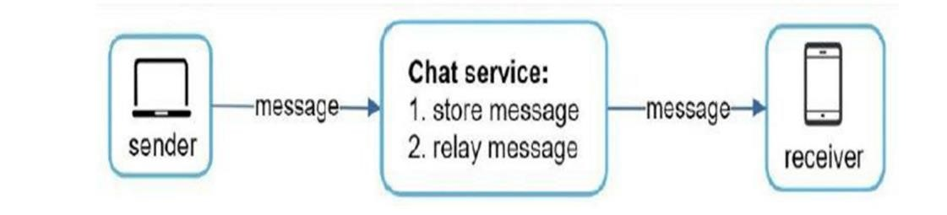

It shows the relationships between clients (sender and receiver) and the chat service.

If the client intends to start a conversation, it connects to the chat service using one or more network protocols. For chat service, network protocol selection is important. Applications are started by the client in most client / server applications. The same is true for the sender of a chat request. In Figure 12-2, when the sender sends a message to the recipient via chat service, he is using a time-tested HTTP protocol, which is the standard web protocol. In this case, the client opens the HTTP connection with the chat service and sends the message, notifying the service to send the message to the recipient. Keeping alive works well in this regard because the topic of keep alive allows the client to maintain ongoing communication with the chat service. It also reduces the amount of TCP handshake. HTTP is a good option on the sender's side, and many popular chat apps such as Facebook used HTTP in the beginning to send messages. However, the recipient side is much more complex. Since HTTP is client-initiated, it is no small feat to send messages from a server. Over the years, many techniques have been used to mimic server-initiated communication: voting, long voting, and WebSocket.

**FLOWCHART**

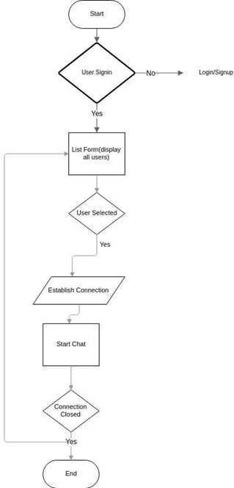

### DIAGRAMS

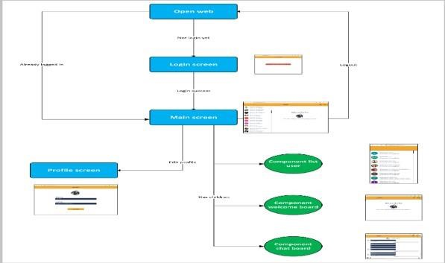

#### user design interface

Proposed Architecture we can see our system where the API servers allocates the right data to the authorized client server which will receive the data with full integrity on the lowest medium available on their device. Here the API servers does the wholesome job of data maintainability of data managing all the messages /content that are to be sent to the specific client.

Our system helps the client to connect with the receiver as fast as possible where the API then sub-divide the request as per the service required the Chat Engine API here is more faster than node JS and Mongodb providing the client with at most consistency in the network connection for sharing content, messages, data, document, etc.

### CONCLUSION AND RESULT

◆ The chat application provides a better and flexible system for chatting. It is developed with recent advanced technologies in a way to provide a reliable system. Main advantages of the system are instant messaging, realworld connectivity, adding security, group chat, etc. This application can find better need in the market for most of the organizations aim at having private applications for them. Additional features will also be included in the system based on the public need which includes conference call, video chat. Location share, etc. based on the need

**REFERENCES**

[1]. Dr. Abhay Kasetwar , Ritik Gajbhiye , Gopal Papewar , Rohan Nikhare , Priya Warade (2022),development of chat application.india.

[2] **.**Manish Kolambe , Saurabh Sable , Venkatesh Kashivale , Prajkta Khaire.(2022),chat application.

[3]. Uma Thakur, Abhishek Chichmalkar, Aditya Sambhare.(2022),decentralised chat applicaton,india.

[4]. Tiezer Melos, António Barros, Mário Antunes.(2021),An end-to-end cryptography based real-time chat, Leiria.