**Smart Method for Gas Fee Optimization in NFT Marketplaces**

**Nishant Varshney**

Department of Computer Science

KIET Group of Institutions, Delhi-NCR, Ghaziabad

Uttar Pradesh, India

nishant.2024cs1041@kiet.edu

**Avaneesh Singh**

Department of Computer Science

KIET Group of Institutions, Delhi-NCR, Ghaziabad

Uttar Pradesh, India

[avaneesh.2024cs1060@kiet.edu](mailto:avaneesh.2024cs1060@kiet.edu)

**Harsh Kumar**

Department of Computer Science

KIET Group of Institutions, Delhi-NCR, Ghaziabad

Uttar Pradesh, India

harsh.2024cs1187@kiet.edu

**Harsh Khatter**

Department of Computer Science

KIET Group of Institutions, Delhi-NCR, Ghaziabad

Uttar Pradesh, India

harsh.khatter@kiet.edu

**Abstract -** Gas fees pose a significant barrier to the widespread adoption of Non-Fungible Tokens (NFTs), particularly in decentralized marketplaces where transactions occur on blockchain networks such as Ethereum. This research paper introduces a novel approach to optimizing gas fees in NFT marketplaces through a smart method leveraging machine learning techniques and blockchain analytics. The proposed method aims to dynamically adjust gas fees based on network congestion, token value, and user preferences to ensure cost-effective and timely transactions for NFT buyers and sellers. By analyzing historical transaction data and real-time network conditions, the system predicts optimal gas fees for each transaction, balancing cost efficiency with transaction speed. Additionally, the method incorporates user-defined preferences, such as maximum acceptable gas fees and desired transaction confirmation times, to tailor the optimization process to individual user needs. Through simulations and empirical evaluations, we demonstrate the effectiveness and efficiency of the proposed smart method in reducing gas fees while maintaining transaction reliability and user satisfaction. This research contributes to addressing a critical challenge in NFT marketplaces, facilitating broader accessibility and usability of NFTs in the digital economy.

**Keywords used -** Blockchain analytics, Cost efficiency, Gas fees, Machine learning techniques, NFT Marketplaces, Non-Fungible Tokens, Optimization, Smart method, Transaction reliability

# INTRODUCTION

To get to know more about NFTs we need to understand blockchain. It is a distributed database or a ledger that is shared in a computer network. Information stored in this database is digitally verified in a distributed manner. Cryptocurrencies such as Bitcoin and Ethereum are based on this blockchain technology for the creation and maintenance of decentralized records of transactions. This blockchain removes the dependency on any particular organization or network and provides security in a decentralized manner.

NFTs, or non-fungible tokens, use this blockchain technology which creates a unique digital asset that can be bought, sold, and traded like physical assets. Each NFT is stored on a blockchain and is assigned a unique digital signature, which makes it different from other digital assets. This allows for the creation of one-of-a-kind digital art, collectibles, or other digital assets that are bought, sold, and traded in a way that is similar to physical assets. Additionally, blockchain allows for transparency and immutability of NFT ownership and transaction history.

NFTs have started a new revolution for digital creators. They have been increasingly adopted by the art world as a way to create, buy, sell, and trade digital art and other digital collectibles. Artists can use NFTs to mint unique digital versions of their work, which can then be bought and sold on various marketplaces. Because each NFT is unique and stored on the blockchain, the ownership and authenticity of a digital art piece can be proved. They have also allowed artists to create new forms of interactive and generative digital art that would be impossible with traditional mediums.

Another benefit of NFTs in art is that it allows for fractional ownership of artworks, meaning that a single piece of art can be owned by multiple people through NFTs, opening up the art market to a wider range of people who couldn't afford to own an original piece.

NFTs have also been adopted in the gaming industry as a way to create special, unique, collectible items that can be sold, bought, and traded like digital or physical assets. These NFTs can take the form of

in-game items such as weapons, armor, and vehicles, as well as virtual land and other digital assets. One of the benefits of using NFTs in gaming is that they allow players to truly own and sell their in-game items, rather than just having temporary access to them. This creates a secondary market for in-game items, where players can buy and sell items for real money.

Similarly, NFTs can be applied in various fields and can be utilized using a marketplace. There have been several high-profile NFT sales in recent years, with some of the most popular and expensive NFTs being digital artworks. In March 2021, the artist Beeple sold "Everyday: The First 5000 Days" for $69 million, setting a new record for the most expensive NFT ever sold. Other notable sales include "The Fabled Land" by Fvckrender for $6.6 million in December 2020, "Block 21" by Fewocious for $6.2 million in December 2020, "The First Supper" by Pak for $6.5 million in November 2020, and "CryptoPunk #7804," a pixelated image of a punk-looking character, which sold for

$11.8 million in May 2021.

NFTs have several advantages and disadvantages. One of the benefits of NFTs is that they allow for true ownership and provenance of digital assets, as each NFT is unique and stored on the blockchain.

Additionally, NFTs enable fractional ownership of artworks, making it possible for multiple people to own a single piece through NFTs. This opens up the market to a wider range of people who couldn't afford to own an original piece. NFTs also provide a new revenue stream for creators, such as artists, musicians, and game developers, who can sell NFTs of their work for much higher prices than traditional digital art.

On the other hand, the energy consumption associated with creating and trading NFTs can be significant, raising concerns about their environmental impact. There have also been instances of scam NFTs being sold, highlighting the lack of regulation in the market. Additionally, it can be challenging to determine the value of a digital artwork, leading to speculation and volatility in the market. Finally, not everyone has access to the technology or resources needed to create and trade NFTs, which can limit accessibility and inclusivity.

The Objectives determined by the following method are:

1. Enhance Understanding of NFTs: Explore the fundamentals of NFTs and their association with blockchain technology, emphasizing their unique digital asset creation and trading capabilities.
2. Address Transaction Costs: Mitigate the impact of gas fees on NFT transactions, aiming to optimize costs associated with buying, selling, and trading digital assets in decentralized marketplaces.
3. Improve Market Accessibility: Facilitate broader participation in NFT markets by reducing barriers related to transaction costs, thereby increasing inclusivity and democratizing access to digital assets.
4. Ensure Transparency and Security: Maintain the core principles of blockchain technology, such as transparency and immutability, to uphold the authenticity and ownership of NFTs in market transactions.
5. Foster Sustainable Growth: Balance the benefits of NFT adoption with environmental considerations, seeking to minimize energy consumption and mitigate potential environmental impacts associated with NFT creation and trading.
6. Enhance Market Efficiency: Utilize machine learning techniques and blockchain analytics to dynamically adjust gas fees based on network congestion, token value, and user preferences, thereby optimizing transaction efficiency and user satisfaction in NFT marketplaces.

# II. LITERATURE REVIEW

In this section, we outline the various challenges and opportunities we discovered after analyzing various research papers on NFTs and their marketplace implementation.

In the paper by Hamed Teherdoost. [1], the authors highlight the findings of a study that examines the potential problems in the NFT ecosystem. The research found that in NFT trades, anonymous users execute transactions without any physical asset to be transported, which makes money laundering schemes easier. Additionally, there are no measures for implementing Anti-Money Laundering (AML) or Know Your Customer (KYC) rules and Combating the Financing of Terrorism (CFT) measures. This means tracing the user's identity and background becomes difficult. However, another issue that they identified is the lack of Two-Factor Authentication (2FA) in NFT marketplaces, with some marketplaces supporting 2FA but not enabling it by default which could result in security breaches.

This issue of accidentally easing money laundering and fraud was also raised during the evolution of blockchain technologies and the rise of Bitcoin. Various governments, in turn, introduced harsh regulations on its use going as far as banning the use of technology entirely. A brief look into the evolution of blockchain can help us understand how this issue was tackled. Muhammed Nasir's paper on the survey of blockchain and its evolution [2] refers to this subject matter.

Blockchain 1.0 was the first application of the technology known as “The origin of modern blockchain”. The first generation of blockchain technology also called the Inception of modern blockchain is the most reduced form of a ledger that is decentralized and writes down transactions while saving the data across several devices. Then came the era of Ethereum which allowed developers to write “Smart Contracts” which allowed code execution on the chain. This technology is crucial in understanding how NFTs and their marketplace can be implemented. This code execution and data modification requires computation power which is quantified as a ‘gas’ fee. This cost can be a rising concern and is tackled in our implementation which we will discuss in the “NFT Marketplace Architecture” section.

NFT Certificates have the potential to play a significant role in the jewelry industry. It provides a unique way to establish authenticity and ownership of these unique pieces. The jewelry items are composed of premium-grade metals such as gold, silver, platinum, rubies, emeralds, etc.

Generally, the authenticity of these metals is issued using paper-based certifications which are subject to counterfeiting, loss, or theft. When jewelers create a unique piece of jewelry such as a ring or necklace, an NFT certificate can be issued using blockchain which contains relevant information such as the design of jewelry, materials used, and purity of metal, which are superior in terms of traceability, immutability, verifiability, and security. A system design and architecture are proposed with a sequence of diagrams covering key aspects like production, purchase, and sale along with algorithms related to auctioning, NFT mining, ownership management, and delivery. The smart contracts and script are available as open source on GitHub involving technologies like NFT, blockchain, Ethereum, etc. [3]

Metaverse, the buzzword of 2021, can only function and exist if NFT and blockchain technologies are implemented. Metaverse is a virtual reality space where people interact with each other in a virtual space. This concept has become popular in science fiction and is now becoming a reality using artificial intelligence, augmented reality, and blockchain. People create their avatars, explore virtual space, socialize, and experience various activities. Here, Kshetri and Voas [4] display the findings about the metaverse and its fusion with other major technologies like Blockchain and Artificial Intelligence by the investigations made via the studies across the digital currencies, AI applications, and metaverse components, in the virtual world.

The optimization techniques used in classical software engineering can be carried forward in the field of Ethereum smart contracts. These techniques have been explored and analyzed in the following paper. [5]

One of the major challenges faced while reducing gas fees is maintaining the deterministic, terminable, isolated, and immutable properties of the smart contract as outlined in the following study. [6]

Even while deploying smart contracts gas fees is an issue that needs to be dealt with. In the paper By Harbin University [7] they propose to use an optimization algorithm that reduces the gas fees while deploying significantly. However similar methods can be extended to the execution of smart contracts due to the implementation style of the algorithm and involvement of Petri nets.

The gas fee is an entity that cannot be precisely predicted and depends on the actual situation of the Ethereum blockchain at a time. Certain procedures can be followed to calculate the worst case or the highest gas fee that can be spent for a certain sequence of instructions.[8]

# **III. METHODOLOGY**

The research presents a comprehensive examination of gas fee optimization in NFT marketplaces, delving into the intricacies of Ethereum’s gas fee system and the architectural framework of decentralized applications (dApps) for NFT trading. In elucidating the Ethereum Gas Fee System, the study elucidates the role of the Ethereum Virtual Machine (EVM) in fee calculation, highlighting the variable nature of gas fee standards and the impact of different opcodes on transaction costs. The NFT marketplace Architecture section delineated the distinction between stateful and stateless events, categorizing them based on gas requirements and introducing cryptographic checks for maintaining transaction consistency. The optimization phase showcases significant gas fee reductions achieved through the proposed approach, as depicted in the gas fee comparison graph and comparative analysis table. Overall, the research underscores the efficacy of the smart method for optimizing the gas fees, offering substantial benefits for NFT transactions within large-scale marketplaces, thereby enhancing efficiency and cost-effectiveness in real-world scenarios.

1. ***3.1 Implementation***
2. *Ethereum Gas Fee System*

Every smart contract is a collection of instructions that are compiled into the bytecode. This bytecode when seen is analogous to the assembly language code we see. There are opcodes which can be compared to the mnemonics. There is a predefined set of opcodes that are used to execute all the instructions. At the lowest level, gas fees are attached to these opcodes and each opcode has a different amount attached to it. The gas fee standard is also subject to change and is a volatile entity that keeps changing regularly. Certain instructions like multiplication or MUL consume more gas than something like the difference of DIF.

|  |  |  |  |  |
| --- | --- | --- | --- | --- |
| **Author** | **Description** | **Advantage** | **Implementation** | **Drawback** |
| [9] Boris Kiselev (2020) | An Overview of Massive Open Online Course Platforms: Personalization and Semantic Web Technologies and Standards | Semantic Web enhances MOOC personalization, improving tailored learning experiences. | This paper examines how Semantic Web tech enhances personalization in MOOCs, revealing limited adoption in modern platforms. | The drawback of the overview is the limited utilization of Semantic Web technologies for personalization in the reviewed MOOC platforms. |
| [10] Carlos Flavian (2009) | Web Design: A key factor for the Website Success | Good web design drives positive outcomes and success in e-commerce | This study underscores the critical role of web design in shaping user perceptions and behaviors, crucial for e-commerce website success. | The drawback of the overview is the lack of specific examples or case studies to illustrate the impact of web design on website success. |
| [11] P. Kumari (2017) | Optimizing website dev with XAMPP/PHP. | XAMPP/PHP streamlines website development with efficient coding and secure local hosting. | This paper explores website optimization using XAMPP/PHP, emphasizing efficient development techniques and security features. | The paper lacks a detailed analysis of specific optimization techniques for website development using XAMPP/PHP. |
| [2] Amir A. Khwaja (2021) | Survey: Blockchain Evolution, Architecture, Security | Blockchain technology revolutionizes industries with secure, transparent, and decentralized solutions. | This paper explores blockchain technology, covering its evolution, architecture, security features, and its transformative impact across sectors. | The summary outlines blockchain technology, its evolution, architecture, and security aspects but lacks detailed examination of potential drawbacks or limitations. |
| [12] Ikkala, Esko(2021)` | Sampo UI: Full-stack JS for semantic portals | Sampo UI: Simplifies semantic portal development for cultural heritage domains, benefiting thousands of users. | This paper introduces Sampo UI, a JavaScript framework for semantic portal interfaces, utilizing linked data from SPARQL and RDF endpoints for improved development and user experience. | Lacks detailed examination of potential limitations or challenges associated with implementing Sampo UI in real-world scenarios. |
| [13] K. Saundariya (2021) | Handyman Booking: MongoDB, Express, React, Node Web App | The Handyman booking web app connects homeowners with workers seamlessly using the MERN stack for efficiency and scalability. | This paper introduces a web app for booking handyman services, utilizing MongoDB, ExpressJS, ReactJS, and NodeJS, to connect homeowners with workers for efficient repairs. | Lacks discussion on potential challenges or limitations in implementing the MERN stack for the web app service. |
| [14] Mantas Jurgelaitis (2022) | Solidity Code Generation: UML State Machines for Smart Contracts | Model-driven architecture streamlines Solidity smart contract generation from UML state machines for reliable blockchain development | This paper proposes a method to generate Solidity smart contract code from UML state machines, enabling efficient blockchain smart contract development. | Does not discuss potential limitations or challenges in implementing the proposed Solidity code generation approach from UML state machines. |
| [15] Noura Alnuaimi (2021) | NFT Certificates for Jewellery & Gemstone Delivery Proof | NFT certificates secure ownership and delivery for fine jewelry, leveraging blockchain for traceability. | This paper proposes using NFTs and the Ethereum blockchain for digital certification and proof of delivery for fine jewelry and gemstones, enhancing security and traceability. | This paper explores how NFTs and blockchain can replace paper certificates for fine jewelry, offering better security and traceability. |
| [16] Qinglin Yang (2022) | Survey: NFT, Blockchain, AI in Metaverse | The survey explores the fusion of Blockchain, AI, and Metaverse, inspiring interdisciplinary research for transformative digital realms. | This survey explores the fusion of Blockchain, AI, and the Metaverse, aiming to inspire interdisciplinary research efforts across academia and industry. | The summary lacks specific findings or insights into the practical applications and implications of the fusion of Blockchain, AI, and the Metaverse. |

# 

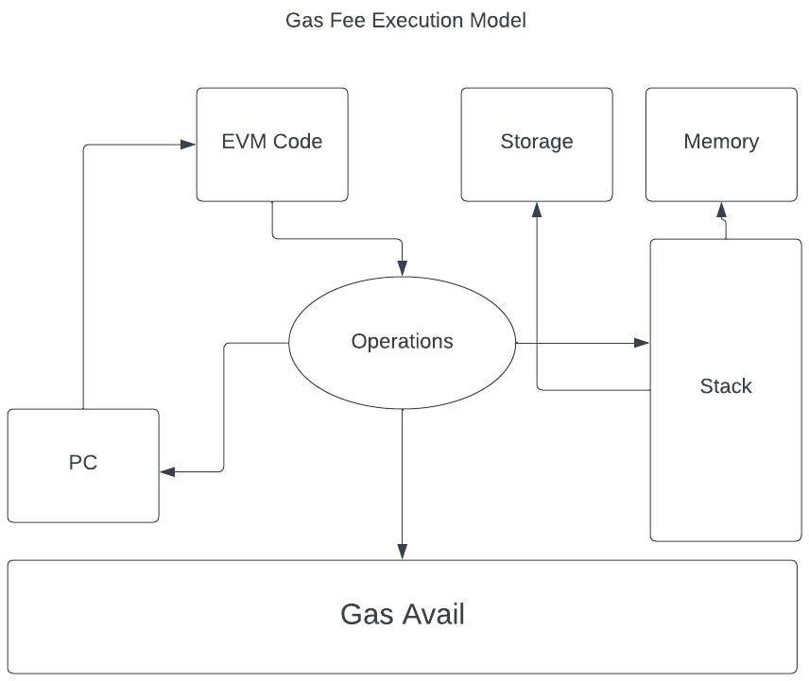

Figure 1. EVM Architecture

This gas fee is paid by the actor who initiates the instruction. This could be the user of our marketplace or our server according to the design of the application. The figure shows that we follow the architecture that makes the user pay for the transaction just like the industry standard. Ethereum blockchain also has a set amount of fee that is attached to each transaction irrespective of the instructions inside it.

Figure 1 shows how the Ethereum blockchain consisting of an Ethereum Virtual Machine or EVM is responsible for gas fee calculation. The EVM is a completely separate and isolated environment where the Smart contract's instructions can be executed line by line. Various types of storage or memory are provided and supported by the EVM. Stack (used for operation sequencing), Memory (used for random access), and Storage (which is used as a persistent memory). Optimal utilization of these three is required for the least amount of gas fee burn.

Certain urgency can also be attached to a transaction which increases the gas fee required to mine it but reduces the time.

1. *NFT Marketplace Architecture*

2. NFT Marketplace Architecture

The marketplace would be an application of smart contract technology of the Ethereum blockchain. Such applications are called dApps or decentralized applications.

Figure 2 shows that the dApp would be the layer that interacts with the blockchain and performs stateful actions. A user-facing frontend would be required that allows humans to use the marketplace.

The user does not interact with the smart contract layer, it uses the frontend interface which communicates to the smart contracts on their behalf. This imitates the client-server model usually followed by traditional web applications.

The following events will be available for users of the marketplace to perform: (a) Authentication and Authorization, (b) Minting, (c) Publishing (d) Trading.

Now each event falls into two categories: (a) Stateful and (b) Stateless.

A stateful event performs a transaction on the blockchain or modifies the actual data by adding another block to the chain. These events modify the chain cost computational power and hence ‘gas’.

Stateless Events only view the current state of the blockchain, they do not perform any modifications to the actual data. These events if also performed on the blockchain cost gas but if performed ‘off-chain’ would be completely free.

Our architecture therefore distinguishes between these events and has events divided into categories like gassy and gasless. Gasless events would require us to maintain a non-blockchain database that writes the event actions without communicating with the actual blockchain. This helps us avoid any additional cost and is thus completely free. Gassy events are traditional blockchain contracts that require computation which is bought in the form of Ethereum gas.

The consistency between these gassy and gasless events has to be maintained otherwise the marketplace would have a discrepancy. Therefore, we borrow the cryptographic check for on-chain and off-chain transactions and apply it to the gassy and gasless events in our architecture.

*C. Optimization*

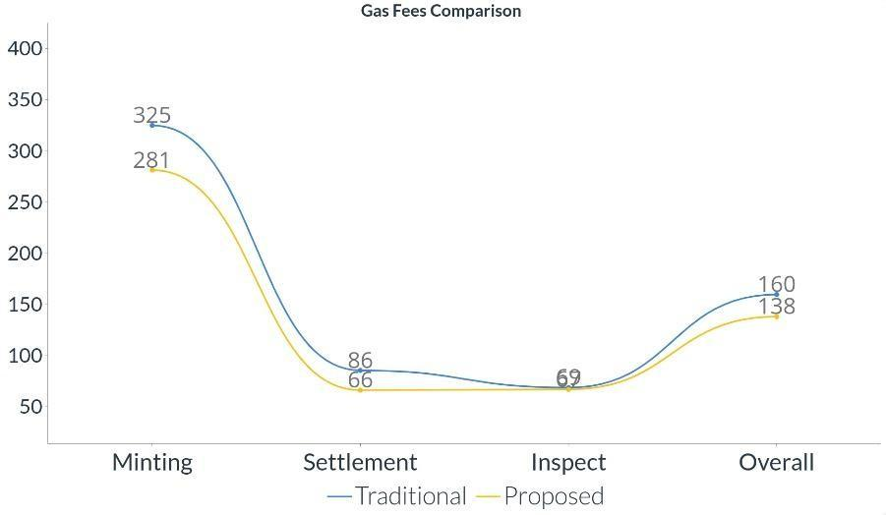

Figure 3. Gas fee comparison

The various techniques employed in the architecture of the marketplace design helped us reduce the gas fees required for certain operations.

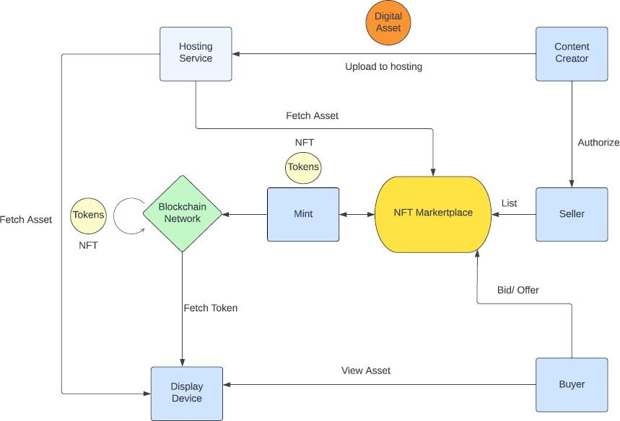

Figure

The approach was to minimize the amount of processing required to complete a transaction. This was achieved by the stateful and stateless paradigm we implemented as described in the above section.

The graph shown in Figure 3 represents the different gas fees required for different actions performed. For the y-axis each unit represents 10^3 gwei gas and 1 gwei = 10^-9 eth.

Figure 3 shows how our approach reduces the gas fee required for certain procedures that are necessary for an NFT marketplace.

Table 1. Gas Fee Comparison

|  |  |  |  |
| --- | --- | --- | --- |
| **Class** | **Traditional** | **Proposed** | **Saved** |
| Minting | 325,042 | 281,340 | 43,702 |
| Settlement | 85,645 | 66,317 | 19328 |
| Inspect | 68,815 | 67,056 | 1759 |

Referring to Table 1 we can observe that the proposed solution can help us save a significant amount of gas fees as compared to the traditional approach. The overall optimization can be estimated to be about 14.7%. This can be significant in terms of large-scale transactions that are executed daily in the massive NFT marketplaces currently being used in the real world.

# **IV. CONCLUSION**

To conclude, using the two-state approach and the stateless paradigm we reduce the amount of gas fees required by 14.7%.

This enables the NFT marketplaces to be more scalable and also save money which would otherwise be wasted away in extra computation and mining. NFTs are secured using blockchain technology, which ensures their authenticity and scarcity, making them valuable and collectible. The NFT ecosystem is rapidly growing, with a growing number of marketplaces and use cases emerging. However, there are still several challenges and risks associated with NFTs, including security, scalability, and regulation, which will need to be addressed to ensure the long-term success and growth of the NFT ecosystem.

NFT opens up a new revenue stream for digital creators, providing them with a new way to monetize their digital creations and showcase their work in a new and exciting way. By using NFTs, digital creators can sell their unique, one-of-a-kind digital assets, such as digital art, music, videos, and others, as well as build a community of fans and collectors around their work.

The Creation of NFT Marketplace takes special attention to creating a user experience for the user and the creator, implementing robust security measures, providing payment options, storage solutions, unique value propositions, and partnerships complying with all relevant laws and regulations. Overall, NFT marketplaces are an exciting new development in the digital world and are poised to play a significant role in shaping the future of digital ownership and commerce.

# **References**

1. Taherdoost, H. Non-Fungible Tokens (NFT): A Systematic Review. Information **2023**, 14, 26. <https://doi.org/10.3390/info14010026>
2. M. N. M. Bhutta et al., "A Survey on Blockchain Technology: Evolution, Architecture and Security," in IEEE Access, vol. 9, pp. 61048-61073, 2021, doi: 10.1109/ACCESS.2021.3072849.
3. Madine, Mohammad & Salah, Khaled & Jayaraman, Raja & Zemerly, Jamal. (2023). NFTs for Open-Source and Commercial Software Licensing and Royalties. IEEE Access. PP. 1-1. 10.1109/ACCESS.2023.3239403.
4. Kshetri, Nir & Voas, Jeffrey & Dwivedi, Yogesh & Torres, Diana & O’Keefe, Gayle. (2023). Metaverse’s Rise and Decline. Computer. 56. 77-82. 10.1109/MC.2023.3296779.
5. Hu, Wen & Fan, Zhipeng & Gao, Ye. (2019). Research on Smart Contract Optimization Method on Blockchain. IT Professional. 21. 33-38. 10.1109/MITP.2019.2923604.
6. Hu, Kai & Zhu, Jian & Ding, Yi & Bai, Xiaomin & Huang, Jiehua. (2020). Smart Contract Engineering. Electronics. 9. 2042. 10.3390/electronics9122042.
7. Laurent, Arnaud & Brotcorne, Luce & Fortz, Bernard. (2022). Transaction fees optimization in the Ethereum blockchain. Blockchain: Research and Applications. 3. 100074. 10.1016/j.bcra.2022.100074.
8. <https://www.investopedia.com/terms/g/gas-ethereum.asp>
9. Semantic Web Technologies and Standards, Procedia Computer Science, Volume 169, 2020, Pages 373-379, ISSN 1877-0509, <https://doi.org/10.1016/j.procs.2020.02.232>.
10. [Flavian, C.](https://www.emerald.com/insight/search?q=Carlos%20Flavian), [Gurrea, R.](https://www.emerald.com/insight/search?q=Raquel%20Gurrea) and [Orús, C.](https://www.emerald.com/insight/search?q=Carlos%20Or%C3%BAs) (2009), "Web design: a key factor for the website success", [*Journal of Systems and Information Technology*](https://www.emerald.com/insight/publication/issn/1328-7265), Vol. 11 No. 2, pp. 168-184. <https://doi.org/10.1108/13287260910955129>
11. Kumari, Punam, and Rainu Nandal. "A Research Paper On Website Development Optimization Using Xampp/PHP." *International Journal of Advanced Research in Computer Science* 8.5 (2017).
12. Ikkala, E., Hyvönen, E., Rantala, H., & Koho, M. (2022). Sampo-UI: A full stack JavaScript framework for developing semantic portal user interfaces. *Semantic Web*, *13*(1), 69-84.
13. K. Saundariya, M. Abirami, K. R. Senthil, D. Prabakaran, B. Srimathi and G. Nagarajan, "Webapp Service for Booking Handyman Using Mongodb, Express JS, React JS, Node JS," 2021 3rd International Conference on Signal Processing and Communication (ICPSC), Coimbatore, India, 2021, pp. 180-183, doi: 10.1109/ICSPC51351.2021.9451783.
14. M. Jurgelaitis, L. čeponienė and R. Butkienė, "Solidity Code Generation From UML State Machines in Model-Driven Smart Contract Development," in IEEE Access, vol. 10, pp. 33465-33481, 2022, doi: 10.1109/ACCESS.2022.3162227.
15. N. Alnuaimi, A. Almemari, M. Madine, K. Salah, H. A. Breiki, and R. Jayaraman, "NFT Certificates and Proof of Delivery for Fine Jewelry and Gemstones," in IEEE Access, vol. 10, pp. 101263-101275, 2022, doi: 10.1109/ACCESS.2022.3208698.
16. Q. Yang, Y. Zhao, H. Huang, Z. Xiong, J. Kang, and Z. Zheng, "Fusing Blockchain and AI With Metaverse: A Survey," in IEEE Open Journal of the Computer Society, vol. 3, pp. 122-136, 2022, doi:10.1109/OJCS.2022.3188249.