Project Synopsis

on

PLANT DISEASE RECOGNITION AND CLASSIFICATION USING DEEP LEARNING

Submitted as a part of course curriculum for

**Bachelor of Technology**

in

**Computer Science**



**Submitted by**

Saurabh Mishra (2000290120139)

Shakti Maddeshiya (2000290120141)

Shivanshu Singh (2000290120152)

**Under the Supervision of**

Prof. Raj Kumar (Assistant Professor & Addl. HOD)

**KIET Group of Institutions, Ghaziabad Department of Computer Science**

**Dr. A. P. J. Abdul Kalam Technical University**

**2022-2023**

**TABLE OF CONTENTS**

TITLE DECLARATION CERTIFICATE

ACKNOWLEDGEMENT ABSTRACT

LIST OF FIGURES

LIST OF ABBREVIATIONS

CHAPTER 1: INTRODUCTION

* 1. Introduction
  2. Problem Statement
  3. Objective
  4. Expected Outcome CHAPTER 2: LITERATURE REVIEW CHAPTER 3: PROPOSED METHODOLOGY CHAPTER 4: TECHNOLOGY USED CHAPTER 5: DIAGRAMS

CHAPTER 6: CONCLUSION REFERENCES

# TITLE

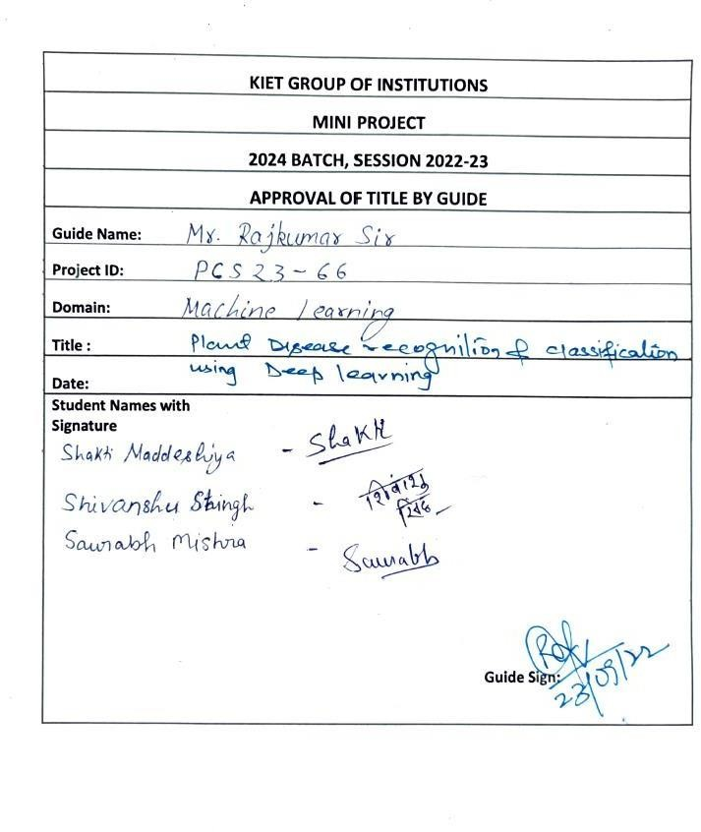

**DECLARATION**

We hereby declare that this submission is our work and that, to the best of our knowledge and belief, it contains no material previously published or written by another person nor material which to a substantial extent has been accepted for the award of any other degree or diploma of the university or other institute of higher learning, except where due acknowledgement has been made in the text.

Signature of Students:

Name: Saurabh Mishra, Shakti Maddeshiya, Shivanshu Singh Roll No.: 2000290120139, 2000290120141, 2000290120152

Date: 15/11/2022

# ACKNOWLEDGEMENT

It gives us a great sense of pleasure to present the synopsis of the project “*Plant Disease Recognition and Classification Using Deep Learning*” undertaken during B.Tech. Third Year. We owe a special debt of gratitude to Our guide Prof. Raj Kumar (Assistant Professor & Addl. Head, CS), KIET Group of Institutions, Delhi- NCR, Ghaziabad, for his constant support and guidance throughout the course of our work. His sincerity, thoroughness and perseverance have been a constant source of inspiration for us. It is only his cognizant efforts that our endeavours have seen the light of the day.

We also take the opportunity to acknowledge the contribution of Dr. Ajay Kumar Shrivastava, Head of the Department of Computer Science, KIET Group of Institutions, Delhi- NCR, Ghaziabad, for his full support and assistance during the development of the project. We also do not like to miss the opportunity to acknowledge the contribution of all the faculty members of the department for their kind assistance and cooperation during the development of our project.

Last but not the least, we acknowledge our friends for their contribution to the completion of the project.

Signature:

Name: Saurabh Mishra, Shakti Maddeshiya, Shivanshu Singh Roll No: 2000290120139, 2000290120141, 2000290120152

Date: 15/11/2022

# ABSTRACT

Our project “*Plant Disease Recognition and Classification Using Deep Learning*” is an application which will detect the different Plant diseases by providing just images of the plant and predict and recommend about possible disease to the users.

Initially the client can either click the image using mobile camera or upload the image of the diseased plant in the application.

Once the plant disease is matched with the existing data, then this recommend the possible (matched) disease and then the effective remedial measures such as what actions should they take about the disease is provided.

The image processed for the effective remedial measures using the machine learning InceptionV3 algorithm.

In it’s current form, out application would be as a preliminary tool that could assess the users by providing some remedial measures like what type of fertilizers to use and the measures to be taken by comparing it with the datasets provided in the database.

This comes with the simple mobile app for handy and easy to use this service. This helps even less technical (as normal farmers) users to use the application as they need this service.

# INTRODUCITON

Our India is second largest populated country in the world and most of people are farmers, but farmers are not so much educated so they do not identify the different diseases of plants. The agriculture field is the backbone of Indian economy. Plant diseases are biggest ongoing challenge for smallholder farmers. Our project was planned that to develop an application that simply take an image from user by clicking a photograph using mobile camera or just upload the image from mobile gallery with user’s permission and predict the best possible (matched from dataset) diseases that could possibly affecting that plant. So, user can get the proper information that what is the problem with the plant and what could be the reasons and could search for the proper cure that help to overcome the disease. It’ll be achieved by implementation of deep learning (in image processing) and some application building tools (for application). Inside the system the input image is examined by system that detect unhealthy regions of plant leaves, classification of plant leaf diseases using texture features to analyze the leaf infection (disease). We’ll make this service available on mobile app which can run on low configuration devices. Farmers experience great difficulties in switching form one disease control policy to another disease control policy. The naked eye observation of experts is the traditional approach, this method can be time consuming, expensive and inaccurate, so our purpose is to develop an easy to use mobile application which use deep learning to predict the disease on time with ease that can help farmers very much.

# PROBLEM STATEMENT

* Agriculture is an integral part of the Indian economy. The Indian agriculture sector employs nearly half of the country's workforce. India is the largest producer of pulses, rice, wheat, spices, and spice products in the world.
* Now a days there is a massive problem we are facing the regular increment in pollution that is affecting us and our environment.
* Our soil and environment is not that suitable and healthy for our crops as that is the only income resource for smallholder farmers, plant diseases are very common factors that can affect the crops.
* Problem statement for our project is to develop a plant disease recognition and classification system using deep learning.
* Farmers' economic growth is determined by the quality of the goods they make, which is dependent on plant growth and yield. As a result, in the field of agriculture, disease identification in plants is important. Plants are highly susceptible to diseases that inhibit plant development, which has an effect on the farmer's ecology.
* The use of an automated disease detection technique is advantageous in detecting a plant disease at an early stage. Plant diseases manifest themselves in various parts of the plant, such as the leaves. It takes a long time to manually diagnose plant disease using leaf photographs.
* As a result, computational methods must be developed to automate the process of disease detection and classification using leaf images.

# OBJECTIVE

The objective of our project is to design a system (application) that will be a prediction- based model using Deep Learning (in image processing) which will predict the possible plant disease by examine the image of the plant (leaf). That will be easy to use by even a non tech person (farmers).

Our main objectives are:

* + To build a plant disease prediction system using Deep Learning.
  + To detect unhealthy regions of plant leaves.
  + Classification of plant leaf diseases using features texture.
  + To analyze the plant diseases/infections.
  + To give remedy information to user.
  + To make this service available on mobile application that can run on low configuration devices.

# SCOPE

This project can be further extended by integrating with E-commerce in this project as the user is already getting the information about the disease and the possible remedies to overcome that disease. So, we can deliver the essential fertilizer and pesticides etc. at the doorstep of the user/farmer. This will make effective and easy way to get remedies on time and prevent further spread of the disease. This will also helpful for implementing advanced technologies in rural areas. That will help to get healthy crops in future and required suggestions for good health of the crops.

* We can forecast disease in early stage, so that appropriate measures can be taken to minimize the loss in crop.
* This will help farmers to detect diseases on there crops so that they can timely take proper cure for there plants.

# LITERATURE REVIEW

In this research paper author discussed about how plant disease is increasing day by day and late information and cure affect the overall crop yield badly. Plant diseases contribute to production loss, which can be tackled with continuous monitoring. Manual plant disease monitoring is both laborious and error-prone. Early detection of plant diseases using computer vision and artificial intelligence (AI) can help to reduce the adverse effects of diseases and also overcome the shortcomings of continuous human monitoring. For this work, they proposed the use of a deep learning architecture based on a convolutional neural network called EfficientNet on 18,161 plain and segmented tomato leaf images to classify tomato diseases. The performance of each of the experimental studies reported in this work outperforms in the literature.[1]

In this research paper the main discussion is about automated plant disease detection and classification using mobileNet based CNN. As Agriculture is the major occupation in India and it loses about 35% of the crop yield annually due to plant diseases. Earlier plant disease detection is a tedious process because of improper laboratory facilities and expert knowledge. Automated plant disease detection techniques are advantageous for reducing the laborious task of monitoring large crop farms and for identifying disease symptoms early as when they appear on plant leaves. For that they proposed OMNCNN model operates on different stages namely preprocessing, segmentation, feature extraction, and classification in this literature.[2]

In this research paper the discussion is about specifically tomato plants related disease predictions. Tomato plant suffers from various severe diseases and powdery mildew being one of them that is mainly discussed in this literature. As powdery mildew disease in tomato plant which in turn reduces the growth of tomato fruit. Hence, an accurate and timely detection of powdery mildew is necessary to extenuate the economic losses caused by the disease. This research paper ultimately aims to develop a hybrid of Support Vector Machine (SVM) and Logistic Regression (LR) algorithm to predict powdery mildew disease in tomato plant. SVM and LR algorithms have also been used individually for developing the prediction models. Results indicate that the proposed classifier performs 3.06% better than SVM and 5.35% better than LR with an accuracy of 92.37%.[3]

The main discussion in this research paper is about Most plant diseases show visible symptoms, and the technique which is accepted today is that an experienced plant pathologist diagnoses the disease through optical observation of infected plant leaves. The disease diagnosis process is slow to perform manually is the fact and another fact is that the success of the diagnosis is proportional to the pathologist’s capabilities that makes this problem an excellent application area for computerised diagnostic systems. In this paper, EfficientNet deep learning architecture was proposed in plant leaf disease classification. The results obtained in the test dataset showed that B5 and B4 models of EfficientNet architecture achieved the highest values in compare to other deep learning models in original and augmented datasets with around 99.91% and 99.97% respectively for accuracy and 98.42% and 99.39% respectively for precision.[4]

Plant diseases affect the growth of their respective species, therefore their early identification is very important. Many Machine Learning (ML) models have been employed for the detection and classification of plant diseases but, after the advancements in a subset of ML, that is, Deep Learning(DL), this area of research appears to have great potential in terms of increased accuracy. Many developed/modified DL architectures are implemented along with several visualization techniques to detect and classify the symptoms of plant diseases. Moreover, several performance metrics are used for the evaluation of these architectures/techniques.[5]

Agriculture is the most primary source to furnish national income of numerous countries including India. Diseases in plants/crops are the serious causes in degrading the production quantity and quality, which results in economy losses. Thus, identification of the diseases in plants is very important. Plant disease symptoms are evident in various parts of plants. However, plant leaves are most commonly used to detect the infection. Computer vision and soft computing techniques are utilized by several researchers to automate the detection of plant diseases using leaf images. Various aspects of such studies with their merits and demerits are summarized in this work. Common infections along with the research landscape at different stages of such detection systems are discussed. The modern feature extraction techniques are analyzed for identifying those that appear to work well covering several crop categories. The study would help the researchers to understand the applicability of computer vision in plant disease detection/classification**.[6]**

Deep neural networks has been highly successful in image classification problems. In this paper, we show how neural networks can be used for plant disease recognition in the context of image classification. We have used publicly available Plant Village dataset which has 38 classes of diseases. Hence, the problem that we have addressed is a multi class classification problem. We compared five different architectures including VGG16, ResNet50, InceptionV3, InceptionResNet and DenseNet169 as the backbones for our work. We found that ResNet50 achieves the best result on the test set. For evaluation, we used metrics: accuracy, precision, recall, F1 score and class wise confusion metric. Our model achieves the best of results using ResNet50 with accuracy of 0.982, precision of 0.94, recall of 0.94 and F1 score of 0.94.[7]

Deep learning enabled object detection model for multi-class plant disease has been proposed based on a state-of-the-art computer vision algorithm. While most existing models are limited to disease detection on a large scale, the current model addresses the accurate detection of fine-grained, multi-scale early disease detection. The proposed model has been improved to optimize for both detection speed and accuracy and applied to multi- class apple plant disease detection in the real environment. The mean average precision (mAP) and F1-score of the detection model reached up to 91.2% and 95.9%, respectively, at a detection rate of 56.9 FPS. The overall detection result demonstrates that the current algorithm significantly outperforms the state-of-the-art detection model with a 9.05% increase in precision and 7.6% increase in F1-score. The proposed model can be employed as an effective and efficient method to detect different apple plant diseases under complex orchard scenarios.[8]

plant disease is main cause of most plants’ damage, improving prediction plans for early detection of plant where it has disease or not is an essential interest of decision makers in the agricultural sector for providing proper plant care at appropriate time. Clustering and classification algorithms have proven effective in early detection of plant disease. Making clusters of plants with similar features is an excellent strategy for analyzing features and providing an overview of care quality provided to similar plants. Thus, in this article, we present an artificial intelligence (AI) model based on k-nearest neighbors (k-NN) classifier and k-efficient clustering that integrates k-means with k-medoids to take advantage of both k-means and kmedoids to improve plant disease prediction strategies. Objectives of this article are to determine performance of k-mean, k-medoids and k-efficient also we compare k-NN before clustering and with clustering in prediction of soybean disease for selecting best one for plant disease forecasting. These objectives enable us to analysis data of plant that help to understand nature of plant. Results indicate that k-NN with k-efficient is more efficient than other in terms of inter-class, intra-class, normal mutual information (NMI), accuracy, precision, recall, F-measure, and running time.[9]

climate change could alter stages and rates of development of the pathogen, modify host resistance, and result in changes in the physiology of host-pathogen interactions. The most likely consequences are shifts in the geographical distribution of host and pathogen and altered crop losses, caused in part by changes in the efficacy of control strategies. Recent developments in experimental and modeling techniques offer considerable promise for developing an improved capability for climate change impact assessment and mitigation. Compared with major technological, environmental, and socioeconomic changes affecting agricultural production during the next century, climate change may be less important; it will, however, add another layer of complexity and uncertainty onto a system that is already exceedingly difficult to manage on a sustainable basis. Intensified research on climate change–related issues could result in improved understanding.[10]

# METHODOLOGY

* + The project starts with importing **NumPY**, **Pandas**, **Matplotlib**, **Pylot, Tensorflow** and other libraries
  + Then we have to download the dataset of various images of infected leaves from

**kaggle website** by the help of which we can train our model

* + The data is than visualized using “imshow” which is used to show different types of leaves which are present in our dataset
  + Then we apply Train-Test split to split our dataset according to test ratio.
  + Then we apply Data augmentation to increase the number of labeled images. The classic data augmentation methods include vertical flipping, horizontal flipping, 90° counterclockwise rotation, 180° rotation, 90° clockwise rotation, random brightness decrease, random brightness increase.
  + Then we Build and Train a **CNN** model using various layers and kernel size.
  + Then we have to plot a training history graph.
  + Then we have to Export model to a file on disk.
  + Then we have to write fast API server around that model , which will help to generate working http server which we will be used in deployment in production.
  + At last we have to build a website using **Reactjs** where we can drag and drop the image of various plant leaf and predict it’s output whether it is healthy or not

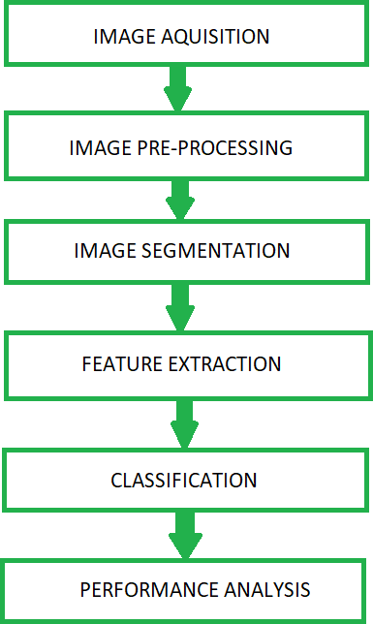

Fig.1 The basic proposed methodology

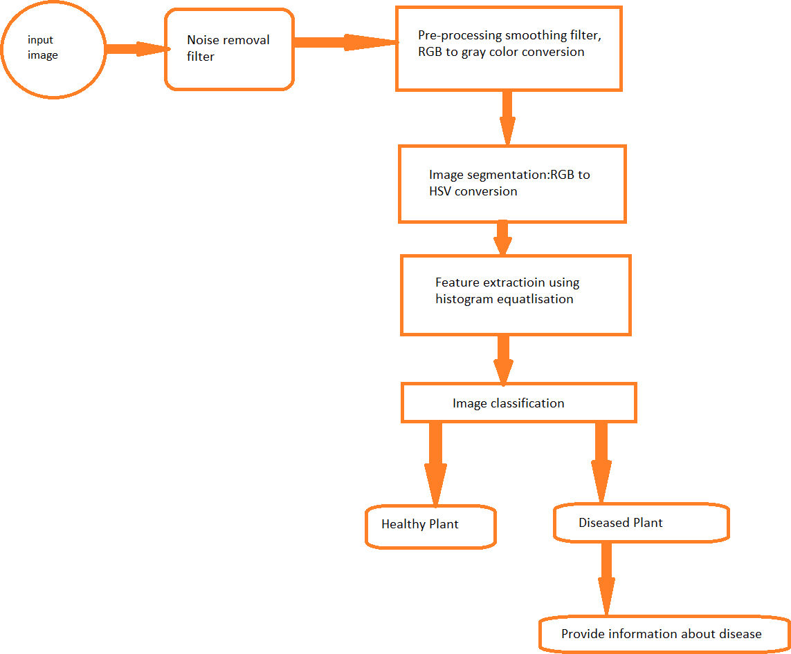

Fig.2 Block Diagram of Plant Leaf Disease Detection (Expected Model)

# TECHNOLOGY USED

**NumPY:** It is a python library which is used to work in domains of linear algebra and provides efficient results on multi-dimensional array.

**Pandas:** It is one of the crucial tool of Machine Learning which is mainly used for analysis and has various other features also such as cleaning, transforming and visualizing data.

**Matplotlib:** It is a comprehensive library for creating static, animated, and interactive visualizations in Python. Matplotlib makes easy things easy and hard things possible.

**Tensorflow:** It is an end-to-end open-source platform for machine learning. It has a comprehensive, flexible ecosystem of [tools](https://www.tensorflow.org/resources/tools), [libraries,](https://www.tensorflow.org/resources/libraries-extensions) and [community](https://www.tensorflow.org/community) resources that lets researchers push the state-of-the-art in ML and developers easily build and deploy ML- powered applications.

**CNN** : In [deep learning](https://en.wikipedia.org/wiki/Deep_learning), a **convolutional neural network (CNN/ConvNet**) is a class of [deep neural networks,](https://en.wikipedia.org/wiki/Deep_neural_network) most commonly applied to analyze visual imagery. Now when we think of a neural network we think about matrix multiplications but that is not the case with ConvNet. It uses a special technique called Convolution

**Reactjs:** ReactJS is a **declarative**, **efficient**, and flexible **JavaScript library** for building reusable UI components. It is an open-source, component-based front end library which is responsible only for the view layer of the application. It was initially developed and maintained by Facebook and later used in its products like WhatsApp & Instagram.

# EXPECTED OUTCOME

* The use of automated monitoring and management systems are gaining increasing demand with technological advancement.
* In the agricultural fields loss of yield mainly occurs due to widespread disease.
* Mostly the detection and identification of the disease is noticed when the disease advances to severe stage therefore, causing the loss in terms of yield, time and money.
* The proposed system is capable of detecting the disease at the earlier stage as soon as it occurs on the expert to a certain extent is possible.
* It can provide the help for a person having less knowledge about the disease, Depending on these goals, we have to extract the features corresponding to the disease.

# REFERENCES

1. Chowdhury, M.E.; Khandakar, A.; Ahmed, S.; Al-Khuzaei, F.; Hamdalla, J.; Haque, F.; Mamun, B.I.R.; Ahmed, A.S.; Nasser, A.E. Design, construction and testing of iot based automated indoor vertical hydroponics farming test-bed in Qatar. Sensors 2020, 20,5637.
2. R.N. Strange, P.R. Scott, Plant disease: a threat to global food security, Annu. Rev. Phytopathol. 43 (2005) (2005) 83–116.
3. W. B. Jones, S. V Thomson, and others, “Source of inoculum, yield, and quality of tomato as affected by Leveillula taurica.,” Plant Dis., vol. 71, no. 3, pp. 266– 268, 1987.
4. Sankaran, S., Mishra, A., Ehsani, R., Davis, C., 2010. A review of advanced techniques for detecting plant diseases. Comput. Electron. Agric. 72, 1–13.
5. McCulloch, W.S.; Pitts, W. A logical calculus of the ideas immanent in nervous activity. Bull. Math. Biophys.1943, 5, 115–133.
6. Abdulridha, J., Ampatzidis, Y., Ehsani, R., & de Castro, A. (2018). Evaluating the performance of spectral features and multivariate analysis tools to detect laurelwilt disease and nutritional deficiency in avocado. Computers and Electronics in Agriculture, 155, 203–211.
7. A. F. Agarap. Deep learning using rectifified linear units (relu). arXiv preprint arXiv:1803.08375, 2018.
8. Tyagi, A.C. Towards a second green revolution. Irrig. Drain. 2016, 65, 388– 389.
9. A. M. Abdu, M. M. M. Mokji, and U. U. U. Sheikh, “Machine learning for plant disease detection: an investigative comparison between support vector machine anddeep learning,” IAES Int. J. Artif. Intell., vol. 9, no. 4, pp. 670–683, Dec. 2020, doi:10.11591.
10. Adams RM, Fleming RA, Chang CC, McCarl BA, Rosenzweig C. 1995. A reassessment of the economic effects of global climate change on US agriculture. Clim. Change 30:147–67.