Project Synopsis

on

**Face recognition (Attendance Marker)**

Submitted as a part of the course curriculum for

**Bachelor of Technology**

in

**Computer Science**



**Submitted by**

SPARSH VERMA (2000290120164)  
SHAURYA AWASTHI(2000290120142)

TUSHAR SHARMA(2000290120177)

**Under the Supervision of**

Prof. Harsh Vardhan

Assistant Professor  
Department of Computer Science

**KIET Group of Institutions, Ghaziabad**

**Department of Computer Science**

**Dr. A.P.J. Abdul Kalam Technical University**

**2022-23**

**DECLARATION**

We hereby declare that this submission is our work and that, to the best of our knowledge and belief, it contains no material previously published or written by another person nor material which to a substantial extent has been accepted for the award of any other degree or diploma of the university or other institute of higher learning, except where due acknowledgment has been made in the text.

Signature of Students

Name: SPARSH VERMA

Roll No.: 2000290120164

Date:

Name: TUSHAR SHARM

Roll No.: 2000290120177

Date:   
  
Name: SHAURYA AWASTHI

Roll No.: 2000290120142

Date:

**CERTIFICATE**

This is to certify that the Project Report entitled “**Face Recoginition (Automatic Attendance Marker)”** which is submitted by **Sparsh Verma, Tushar Sharma, and Shaurya Awasthi** in partial fulfilment of the requirement for the award of degree B. Tech. in the Department of Computer Science of Dr. A.P.J. Abdul Kalam Technical University, Lucknow is a record of the candidates own work carried out by them under my supervision. The matter embodied in this report is original and has not been submitted for the award of any other degree.

**Date: Supervisor Signature**

Professor Harsh Vardhan

Assistant Professor

**Department of Computer Science**

**ACKNOWLEDGEMENT**

It gives us a great sense of pleasure to present the synopsis of the B.Tech Minor Project undertaken during B.Tech. Third Year. We owe a special debt of gratitude to Professor Harsh Khatter, Assistant Professor, Department of Computer Science, KIET Group of Institutions, Delhi- NCR, Ghaziabad, for his/her constant support and guidance throughout the course of our work. His sincerity, thoroughness, and perseverance have been a constant source of inspiration for us. It is only his/her cognizant efforts that our endeavours have seen the light of day.

We also take the opportunity to acknowledge the contribution of Dr. Ajay Kumar Shrivastava, Head of the Department of Computer Science, KIET Group of Institutions, Delhi- NCR, Ghaziabad, for his full support and assistance during the development of the project. We also do not like to miss the opportunity to acknowledge the contribution of all the faculty members of the department for their kind assistance and cooperation during the development of our project.

Last but not the least, we acknowledge our friends for their contribution to the completion of the project who had motivated us throughout.

Signature of Students

Name: Sparsh Verma

Roll No.: 2000290120164

Date:

Name: Shaurya Awasthi

Roll No.: 2000290120142

Date:   
  
Name: Tushar Sharma

Roll No.: 2000290120177

Date:

**ABSTRACT**

Face is the crucial part of the human body that uniquely identifies a person. Using the face characteristics as biometric, the face recognition system can be implemented. The most demanding task in any organization is attendance marking. In traditional attendance system, the students are called out by the teachers and their presence or absence is marked accordingly.

In this project, the Open CV based face recognition approach has been proposed. This model integrates a camera that captures an input image, an algorithm for detecting face from an input image, encoding and identifying the face, marking the attendance in a spreadsheet and converting it into PDF file. The training database is created by training the system with the faces of the authorized students. The cropped images are then stored as a database with respective labels. The features are extracted using LBPH algorithm.

.

**TABLE OF CONTENTS**

|  |  |
| --- | --- |
|  | Page No. |
| TITLE PAGE .................................................................................................................... | i |
| DECLARATION .............................................................................................................. | ii |
| CERTIFICATE …........................................................................................................... | iii |
| ACKNOWLEDGEMENT................................................................................................. | iv |
| ABSTRACT....................................................................................................................... | v |
| LIST OF FIGURES .......................................................................................................... | vi |
| LIST OF ABBREVIATIONS............................................................................................ | vii |
|  |  |
| CHAPTER 1 INTRODUCTION | 1-n |
| 1.1.          Introduction ……………………................................................... | 1 |
| 1.2 Problem Statement.……………………....................................... |  |
| 1.2.          Objective………………………………………………………… | 2 |
| 1.3.          Scope……………………………………………………………. | 3 |
| CHAPTER 2 LITERATURE REVIEW…………………………………………….... | 7-p |
| CHAPTER 3 PROPOSED METHODOLOGY …………………………………........ | 8-m |
| 3.1 Flowchart |  |
| 3.2 Algorithm Proposed | 10 |
| CHAPTER 4 TECHNOLOGY USED.…………………………………………………. | 12 |
| CHAPTER 5 DIAGRAMS …........................................................................................... |  |
| CHAPTER 6 CONCLUSION …...................................................................................... |  |
| REFERENCES….............................................................................................................. |  |

**INTRODUCTION**

1. Attendance maintenance is a significant function in all the institutions to monitor the performance of the students. Every institute does this in its own way. Some of these institutes use the old paper or file based systems and some have adopted strategies of automatic attendance using some biometric techniques. A facial recognition system is a computerized biometric software which is suited for determining or validating a person by performing comparison on patterns based on their facial appearances..
2. Face recognition is a powerful field of research which is a computer based digital technology. Face recognition for the intent of marking attendance is a resourceful application of attendance system. It is widely used in security systems and it can be compared with other biometrics such as fingerprint or eye iris recognition systems.

**PROBLEM STATEMENT**

The main objective to create this application and model is to minimize the margin of error in attendance marking.

The most demanding task in any organization is attendance marking. In the traditional attendance system, the students are called out by the teachers, and their presence or absence is marked accordingly but this system is not too reliable.

So, this face recognition model helps to mark attendance more accurately and effectively which reduces the time consumption and the hectic maintenance of daily records of attendance.

**OBJECTIVE**

* **The main objective to create this application and model is to minimize the margin of error in attendance marking.**
* **In traditional attendance system, the students are called out by the teachers and their presence or absence is marked accordingly.**
* **In this project, the Open CV based face recognition approach has been proposed. This model integrates a camera that captures an input image, an algorithm for detecting face from an input image, encoding and identifying the face, marking the attendance in a spreadsheet and converting it into PDF file.**
* **The training database is created by training the system with the faces of the authorized students. The cropped images are then stored as a database with respective labels. The features are extracted using LBPH algorithm.**

**LITERATURE REVIEW**

## Research Paper Summary

1. **Research Paper: Deep Residual Learning for Image Recognition**

**Authors: Kaiming He, Xiangyu Zhang, Shaoqing Ren, Jian Sun**

**Summary:**

There are several transfer learning models that are used by data scientists to achieve optimal results on a particular task. The AlexNet model was the first to be introduced to win an image processing challenge in 2012, and since then, transfer learning models like VGG-16 have been the most influential pieces of deep learning.

We will focus on the ResNet architecture for this article because the ResNet network manages to achieve slighter improvements than its counterparts. Another significant reason for considering the ResNet network is the fact that it has many variations depending on the type and number of residual blocks that you plan to include. Some of the ResNet structures are ResNet-18, ResNet-34, ResNet-50, ResNet-101, etc.

The ResNet architecture makes use of residual blocks. This concept is quite significant as it solves some of the issues of other shallower networks, which suffer from the problems of vanishing or exploding gradients. The residual blocks pass to compute the sum of the output of a previous block with a current and deeper layer in the model.

1. **You Only Look Once: Unified, Real-Time Object Detection**

**Authors:** **Joseph Redmon, Santosh Divvala, Ross Girshick, Ali Farhadi**

**Date of Publication:** 20 November 2020

**Publisher:** IEEE

**Summary:**

Object detection (alongside face recognition) has always been a catching point of deep learning models. Ever since the introduction of the YOLO model, we have been able to solve the complex problem of object detection by creating a bounding box around specific objects of significance that the model is trying to determine. The YOLO network makes use of a series of convolutional neural networks for learning how to detect objects in real-time during training.

The YOLO model has been improved and developed continuously since its original release in 2015. We have had substantial improvements to each of these methods with each version, such as YOLO-v2 and YOLO-v3. The most recent YOLO version, as of writing this article, is the YOLO-v6 mechanism. Each of these architectures has constantly progressed to make additional refinements to improve efficiency for the object detection tasks.

1. **DEEP LEARNING: A REVIEW**

**Authors: Rocio Vargas ,Amir Mosavi, Ramon Ruiz**

**Date of Publication:** 20 November 2020

**Publisher:** IEEE

**Summary:**

Deep learning is an emerging area of machine learning (ML) research. It comprises multiple hidden layers of artificial neural networks. The deep learning methodology applies nonlinear transformations and model abstractions of high level in large databases. The recent advancements in deep learning architec-tures within numerous fields have already provided significant contributions in artificial intelligence. This article presents a state of the art survey on the contributions and the novel applications of deep learning. The following review chronologically presents how and in what major applications deep learning algorithms have been utilized. Furthermore, the superior and beneficial of the deep learning methodology and its hierarchy in layers and nonlinear operations are presented and compared with the more conventional algorithms in the common applications. The state of the art survey further provides a general overview on the novel concept and the ever-increasing advantages and popularity of deep learning.

1. **Research Paper: U-Net: Convolutional Networks for Biomedical Image Segmentation**

**Authors: Olaf Ronneberger, Philipp Fischer, and Thomas Brox**

**Date of Publication:** 21 May 2020

**Publisher:** IEEE

**Summary:**

The task of segmenting involves categorizing similar parts of an image into a cluster. All the identical classes are classified and segmented into a particular entity. With the segmentation of images, most of the complexities of an image can be removed, allowing the user to make further computations for image processing and analysis.

Once the segmentation is performed on an image, it opens up numerous possibilities to interpret the data more effectively. One such model that performs this task effectively is the U-Net network. The U-Net model architecture, which comprises an encoder and decoder type network, accepts an input image that needs to be segmented.

Depending on the number of classes and the particular type of task, the image that is passed through the network goes through several stages of convolution, downsampling, and finally upsampling to meet the specific task. The network also makes use of skip connections to avoid any degradation problems and carry out the useful information in each downsampling to the upsampling stage.

1. **Research Paper on- Image Recognition Algorithm of Electrical Engineering Equipment Based on Machine Learning Method**

**Authors:** [Chakhung Yeung](https://ieeexplore.ieee.org/author/37088861904)

**Date of Publication:** 01 March 2021

**Publisher:** IEEE

**Summary:**

This paper propose an image classification to identify the massive images collected by the intelligent patrol system in substations. It is mainly based on Deep learning and Support Vector Machine(SVM). Based on the actual image, the convolution neural network (CNN) is improved to extract the image features of the training set. Finally, the SVM classifier is trained by using the depth features of the training set images, and the classification test is realized on the test set images. We use 8000 pictures collected by the patrol robot to verify the accuracy of the model, and the results show that the model has strong classification performance.

In order to solve the problem that a large number of images are stored in the electrical industry monitoring system but can not be accurately judged and recognized, an image classification model which combines deep learning and support vector machine is proposed.

**Steps**

* In this, process of the electrical equipment image classification model combined with deep learning network and SVM
* Data amplification- The image data set contains four types of electrical equipment, namely, transformer, cable port, current transformer and isolation switch.
* By extending the training set image, the over-fitting state of the classification system can be prevented and the performance of the network model can be effectively improved.
* Model building – It, a CNN deep learning network model is reconstructed, which is specially used for infrared thermal image classification scene of electrical equipment. The deep learning network structure consists of 9 layers. Among them, the first image input layer inputs the test picture into the network model and standardizes it to 3 × 227 × 227, that is, the specified picture size is 227 × 227, including three RGB channels.

**06. Facial Expression Recognition Using Facial Characteristic Points and Gini Index**

**Authors:** [Chakhung Yeung](https://ieeexplore.ieee.org/author/37088861904)

**Date of Publication:** 19 May 2021

**Publisher:** IEEE

**Summary:**

Facial expression information are mostly concentrated on facial expression information regions, so the, eyes, eyebrows, and mouth are extracted from the input image. When a face image is input the feature extraction is performed which help in detecting facial characteristic points.Facial animation parameters are calculated in order to recognize.

Step1. Input the template and the target image.

Step2. Convert the images into gray scale images.

Step3. Find the 2-d convolution of the target and template image.

Step4. Find the mean and variance of the template image.

Step5. Form the search image from the search region of the template size.

Step6. Calculate the correlation score ‘C’.

Step7. Find the pixel value from the search region having the highest value of the correlation score ‘C’. step7. Draw the bounding rectangles by using the index of the matched correlation score.

GINI index approach is a classification technique fall under the decision tree category.

In this classification each leaf node is assigned as a class label and non terminal nodes includes, the root and other internal nodes that contain attributes test condition to spilt the data set that have

Different characteristics.

Extensive efforts have been made over the past two decades in academia, industry, and government to discover more robust methods of assessing truthfulness, deception, and credibility during human interactions.

**07. Machine Learning: Algorithms, Real‑World Applications and Research Directions:**

**Authors: Sanidhya Pathak, Rajiv Das**

**Date of Publication:** 25 March 2021

**Publisher:** IEEE

**Summary:**

In the current age of the Fourth Industrial Revolution, the digital world has a wealth of data, such as Internet of Things (IoT) data, cyber security data, mobile data, business data, social media data, health data, etc. To intelligently analyze these data and develop the corresponding smart and automated applications, the knowledge of Artificial intelligence (AI), particularly, machine learning (ML) is the key. Various types of machine learning algorithms such as supervised, unsupervised, semi-supervised, and reinforcement learning exist in the area. Besides, the deep learning, which is part of a broader family of machine learning methods, can intelligently analyze the data on a large scale. In this paper, They  present a comprehensive view on these machine learning algorithms that can be applied to enhance the intelligence and the capabilities of an application. Thus, this study’s key contribution is explaining the principles of different machine learning techniques and their applicability in various real-world application domains, such as cyber security systems, smart cities, healthcare, e-commerce, agriculture, and many more. They also highlight the challenges and potential research directions based on our study. Overall, this paper aims to serve as a reference point for both academia and industry professionals as well as for decision-makers in various real-world situations and application areas, particularly from the technical point of view.

Some Applications of Machine Learning  :

·       Predictive analytics and intelligent decision-making.

·       Healthcare and COVID-19 pandemic.

·       Image, speech and pattern recognition.

**08.** **Image recognition using Machine learning**

**Authors: Rahul Tripathi, Dr. Kamal Nayak**

**Date of Publication:** 20 June 2021

**Publisher:** IEEE

**Summary:**

Image recognition is the necessary side of image processing for machine learning without involving any human support at any step. In this paper, we study how image classification is done using the imagery backend. A couple of thousands of images of each, cat and dog are taken and then distributed into the category of test dataset and training dataset for our learning model. The results are obtained using a custom neural network with the architecture of Convolution Neural Networks.

We selected a total of nearly 24,000 images of cats and dogs and also had rotations and scaling of many images as each scaled image is a new image for the model as input.

As we noticed, results do fluctuate a bit but according to the average, the accuracy was well around 90-95% per cent with a layer filter of 256, thus

more powerful hardware could achieve even higher results with a much-extended dataset for more categories than just two for training.

The testing of random images came out to be successful. The image dataset was pulled from the google repository directly. The convolutional neural network is used in hand with Keras for classification purposes. From the experiments, we observe that the images are classified correctly even if the same images were scaled in different sizes or trimmed or rotated to get an entirely new image for the input showing the effectiveness of the deep-learning algorithm.

**09. Image Recognition Technology Based on Machine Learning**

**Authors:** Lijuan Liu1, Wanle Chi, Yanping Wang

**Date of Publication:** 09 July 2021

**Publisher:** IEEE

**Summary:**

With the development of machine learning for decades, there are still many problems unsolved, such as image recognition and location detection, image classification, image generation, speech recognition, natural language processing and so on. In the field of deep learning research, the research on image classification has always been the most basic, traditional and urgent research direction. At the same time, computer intelligent image recognition technology is also conducive to gradually better respond to the development of international indicators, and promote the development and progress of various fields. Therefore, image processing technology based on machine learning has been widely used in feature image, classification, segmentation and recognition, and is a hot spot in various fields. However, due to the complexity of video images and the distribution of objects in different application backgrounds, the classification accuracy becomes important and difficult. In the paper transportation industry, image recognition technology is applied to license plate recognition to extract license plate from complex background, segment license plate characters and recognize characters, and construct a machine learning non license plate automatic generation algorithm, which may improve the efficiency of non license plate recognition. The diversity and high generation speed of license plate training sample set can achieve the purpose of effectively training strong classifier. By using genetic algorithm to optimize BP neural network to classify license plate information, the anti-interference ability and license plate recognition accuracy are improved to a certain extent.

**10. Machine Learning: Algorithms, Real‑World Applications and Research Directions**

**Author :** Iqbal H. Sarker

**Date of Publication:** 27 January 2021

**Summary**

In the current age of the Fourth Industrial Revolution (4IR or Industry 4.0), the digital world has a wealth of data, such as Internet of Things (IoT) data, cybersecurity data, mobile data, business data, social media data, health data, etc. To intelligently analyze these data and develop the corresponding smart and automated applications, the knowledge of artifcial intelligence (AI), particularly, machine learning (ML) is the key. Various types of machine learning algorithms such as supervised, unsupervised, semi-supervised, and reinforcement learning exist in the area. Besides, the deep learning, which is part of a broader family of machine learning methods, can intelligently analyze the data on a large scale. In this paper, we present a comprehensive view on these machine learning algorithms that can be applied to enhance the intelligence and the capabilities of an application. Thus, this study’s key contribution is explaining the principles of diferent machine learning techniques and their applicability in various real-world application domains, such as cybersecurity systems, smart cities, healthcare, e-commerce, agriculture, and many more. We also highlight the challenges and potential research directions based on our study. Overall, this paper aims to serve as a reference point for both academia and industry professionals as well as for decision-makers in various real-world situations and application areas, particularly from the technical point of view

**METHODOLOGY**

Automatic Attendance Marker is a model and web or android Application that helps in marking attendance. It takes less time than the traditional attendance marking system.

* IMAGE PROCESSING

The primary function of this step is to conclude whether the human faces emerge in a given image, and what is the location of these faces. The expected outputs of this step are patches which contain each face in the input image. In order to get a more robust and easily designable face recognition system.Face alignment is performed to rationalize the scales and orientation of these patches.

* FEATURE EXTRACTION

Following the face detection step the extraction of human face patches from images is done. After this step, the conversion of face patch is done into vector with fixed coordinates or a set of landmark points.

* FACE RECOGNITION

The last step after the representation of faces is to identify them. For automatic recognition we need to build a face database. Various images are taken foe each person and their features are extracted and stored in the database. Then when an input image is fed the face detection and feature extraction is performed and its feature to each face class is compared and stored in the database.

* SOFTWARE DESCRIPTION

**OpenCV**

Open CV (Open Source Computer Vision Library) is a open source computer vision software library for the purpose of machine learning. Open CV was developed to serve the purpose of computer vision applications and to stimulate the usage of machine perception in the commercially viable products.

A full-featured CUDA and Open CL interfaces are being progressively developed. There are over 500 algorithms and about 10 times functions that form or back those algorithms. Open CV is

* **Pandas**

Pandas is an open source Python package that caters diverse tools for data analysis. The package contains various data structures that can be used for many diverse data manipulation tasks. It also includes a range of methods that can be invoked for data analysis, which becomes feasible when working on data science and machine learning problems in Python.

* **Idle**

IDLE is Pythons Integrated Development and Learning Environment. IDLE is completely coded in Python, using the tkinter GUI toolkit. It works mostly uniformly on Windows, Unix and macOS. It has a Python shell window (interactive interpreter) with colorizing of error messages, code input and code output. There is a multi-window text editor with multiple undo, Python colorizing, smart indent, call tips, auto completion, and other features. Searching within any window, replacing within editor windows and searching through multiple files is possible. It also has configuration, browsers and other dialogs as well.

* **Microsoft Excel**

Microsoft Excel is a spreadsheet program incorporated in Microsoft Office suite of applications. Spreadsheets prompt tables of values arranged in rows and columns that can be mathematically manipulated using both basic and complex arithmetic functions and operations. Apart from its standard spreadsheet features, Excel also extends programming support via Microsofts Visual Basic for Applications (VBA), the capacity to access data from external sources via Microsofts Dynamic Data Exchange (DDE) and extensive graphing and charting abilities. Excel being electronic spreadsheet program can be used to store, organize and manipulate the data. Electronic spreadsheet programs were formerly based on paper spreadsheets used for accounting purpose. The basic layout of computerized spreadsheets is more or less same as the paper ones. Related data can be stored in tables – which are a group of small rectangular boxes or cells that are standardized into rows and columns.

**FLOW CHART**

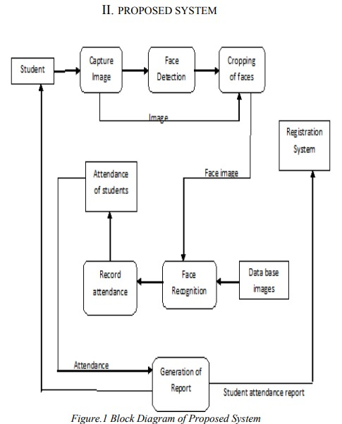

**DIAGRAMS**



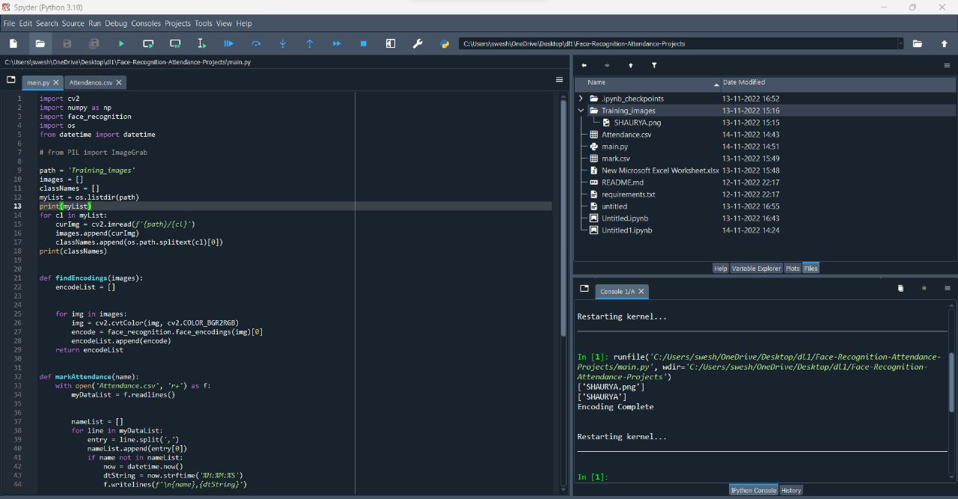

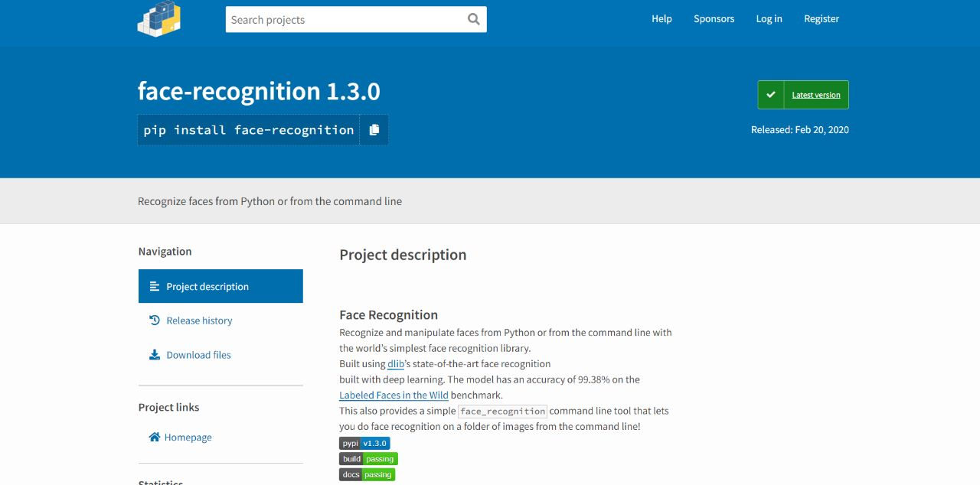



**CONCLUSION**

This paper features the most productive Open CV face recognition method accessible for Attendance Management. The system has been implemented using the LBPH algorithm. LBPH excels other algorithms by confidence factor of 2-5 and has least noise interference. The implementation of the Smart Attendance System portrays the existence of an agreement between the appropriate recognition rate and the threshold value. Therefore LBPH is the most authentic and competent face recognition algorithm found in Open CV for the identification of the students in an educational institute and marking their attendance adequately by averting proxies

**REFERENCES**

1. Smart Attendance System using Computer Vision and Machine Learning Dipti Kumbhar#1 , Prof. Dr. Y. S. Angal*2 # Department of Electronics and Telecommunication, BSIOTR, Wagholi, Pune,

India 1 diptikumbhar37@gmail.com , 2 yogeshangal@yahoo.co.in

1. ATTENDANCE SYSTEM USING MULTI-FACE RECOGNITION 1P. Visalakshi, 2Sushant Ashish 1Assistant Professor 1,2Department of Computer Science and Engineering SRM Institute of Science and Technology, Chennai, Tamil Nadu, INDIA
2. Face Recognition Based Student Attendance System with OpenCV CH. VINOD KUMAR1 , DR. K. RAJA KUMAR2 1 PG Scholar, Dept of CS& SE, Andhra University, Vishakhapatnam, AP, India. 2Assistant Professor, Dept of CS& SE, Andhra University, Vishakhapatnam, AP, India.
3. Automatic Attendance System Using Face Recognition. Ashish Choudhary1,Abhishek Tripathi2,Abhishek Bajaj3,Mudit Rathi4 and

B.M Nandini5 1,2,3,4,5 Information Science and Engineering, The National Institue of Engineering,

1. Face Recognition based Attendance Management System using Machine Learning Anushka Waingankar1, Akash Upadhyay2, Ruchi Shap, Nevil Pooniwala4, Prashant Kasambe5