Test plan for
Blind Image Restoration and Data Augmentation

ChangeLog

Version | Change Date | By | Description
version number | Date of Change | Name of person who made changes | Description of the changes made
001 | 30.10.2023 | Nandini Tyagi | Initial Draft
002 | 30.10.2023 | Avishi Tayal | Initial Draft
003 | 30.10.2023 | Piyush Gupta | Initial Draft

1 Introduction 2
1.1 Scope 2
1.1.1 In Scope 2
1.1.2 Out of Scope 2
1.2 Quality Objective 2
1.3 Roles and Responsibilities 2
2 Test Methodology 3
2.1 Overview 3
2.2 Test Levels 3
2.3 Suspension Criteria and Resumption Requirements 3
2.4 Test Completeness 4
3 Test Deliverables 4
4 Resource & Environment Needs 4
4.1 Testing Tools 4
4.2 Test Environment 4
5 Terms/Acronyms 5

Introduction
The present invention introduces an innovative method and system that harnesses the collaborative potential of Generative Adversarial Networks (GANs), specifically GFP-GAN (GFP Generative Adversarial Network), and StyleGAN, to significantly enhance image pixel quality, with a primary focus on facial images. Concurrently, it facilitates the streamlined creation of augmented datasets, fostering advancements in a multitude of applications. At its core, this invention embodies two pivotal functions: Leveraging the capabilities of GFP-GAN, this function orchestrates the intricate process of pixel-level detail restoration, imperfection rectification, and visual quality enhancement in facial imagery. The outcome is a transformative enhancement of pixel precision, revolutionizing the landscape of image processing. Seamlessly integrating StyleGAN with GFP-GAN's output, this function efficiently generates augmented datasets. These datasets, marked by their dynamism and complexity, emerge as indispensable assets in the realm of machine learning, powering applications ranging from facial recognition to object detection and image synthesis. The invention's inherent strengths encompass its ability to redefine image pixel enhancement, elevate the standards of facial imagery, and expedite the production of augmented datasets. It capitalizes on the harmonious synergy between GFP-GAN and StyleGAN, delivering a comprehensive and cohesive solution that transcends traditional image processing boundaries. In summary, this invention represents a pioneering leap forward in image processing and machine learning, offering an unprecedented combination of pixel enhancement and dataset augmentation capabilities, particularly in the context of facial imagery and its multifaceted applications.

Scope

In Scope

Functional Requirement:
1) Image should be Facial Image
2) Image pixel size should be greater than 512*512

Non Functional Requirement:
1) Internet Connection
2) One image file

Out of Scope

Out Of Scope defines the features, functional or non-functional requirements of the software that will NOT be tested
1) Only intend to take Facial Image no other type of image
2) No need to check on multiple faces in a image only single pose

Quality Objective

Here make a mention of the overall objevtie that you plan to achive withou your testing
Some objectives of your testing project could be
- Ensure the Application Under Test conforms to functional and non-functional requirements
- Ensure the AUT meets the quality specifications defined by the client
- Bugs/issues are identified and fixed before go live

Roles and Responsibilities
Detail description of the Roles and responsibilities of different team members like
- QA Analyst
- Test Manager
- Configuration Manager
- Developers
- Installation Team
Amongst others

Test Methodology

Overview

Mention the reason of adopting a particular test methodology for the project. The test methodology selected for the project could be
- WaterFall
- Iterative
- Agile
- Extreme Programming
The methodology selected depends on multiple factors. You can read about Test Methodology here

Test Levels

Test Levels define the Types of Testing to be executed on the Application Under Test (AUT). The Testing Levels primarily depends on the scope of the project, time and budget constraints.

Suspension Criteria and Resumption Requirements

Suspension criteria define the criteria to be used to suspend all or part of the testing procedure while Resumption criteria determine when testing can resume after it has been suspended

Test Completeness
Here you define the criterias that will deem your testing complete.
For instance, a few criteria to check Test Completeness would be
- 100% test coverage
- All Manual Test cases executed
- All open bugs are fixed or will be fixed in next release

Test Deliverables

Here mention all the Test Artifacts that will be delivered during different phases of the testing lifecycle.

Here are the sample deliverables
- Test Cases
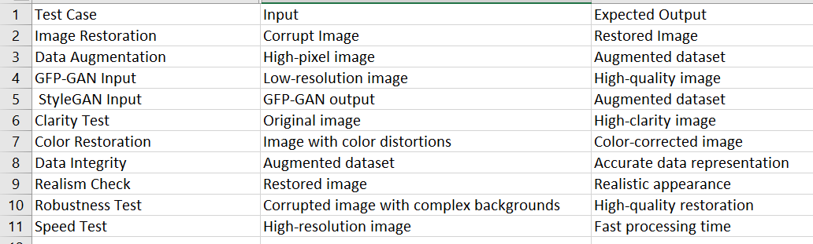

- Requirement Traceability Matrix :
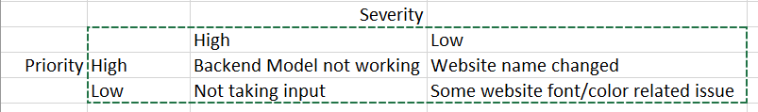

- Bug Report :
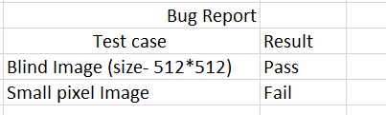

Resource & Environment Needs

Testing Tools
No usage of tools, only manual testing has been performed till now.

Test Environment
It mentions the minimum hardware requirements that will be used to test the Application.

Following software’s are required in addition to client-specific software.

- Windows 8 and above

Terms/Acronyms
Make a mention of any terms or acronyms used in the project

TERM/ACRONYM | DEFINITION
API | Application Program Interface
AUT | Application Under Test

