Revolutionizing Agriculture through Mobile Applications: A Comprehensive Study on Innovative Solutions for Farmers'

Empowerment

Shivam Sharma Computer Science

KIET Group of Institutions,

Delhi-NCR, Ghaziabad, India [Shivam.2024cs1013@kiet.edu](mailto:Shivam.2024cs1013@kiet.edu)

Shivam Nautiyal Computer Science

KIET Group of Institutions,

Delhi-NCR, Ghaziabad, India [Shivam.2024cs1078@kiet.edu](mailto:Shivam.2024cs1078@kiet.edu)

Ms. Mani Dwivedi

Assistant Professor

KIET Group of Institutions, Delhi-NCR, Ghaziabad, India mani.dwivedi@kiet.edu

Ayush Kumar Singh

Computer Science & Engineering  
KIET Group of Institutions,

Delhi-NCR, Ghaziabad, India [ayush.2024cse1037@kiet.edu](mailto:ayush.2024cse1037@kiet.edu)

Mr. Rahul Kumar  
Assistant Professor  
KIET Group of Institutions,  
Delhi-NCR, Ghaziabad, India

[Rahul.kumar@kiet.edu](mailto:Rahul.kumar@kiet.edu)

# Abstract

The research introduces an innovative mobile application, "KRISHIKOM," which stands at the forefront of agricultural technology. This application is meticulously designed to cater to the needs of farmers, empowering them to amplify their income while revolutionizing farming practices. Developed on the React Native platform, KRISHIKOM boasts an array of features encompassing weather monitoring, expert crop advice, augmented reality (AR)-based irrigation guidance, sustainable agriculture education, community building, shared farming equipment, global market trend analysis, financial inclusion, and startup collaborations. Its prime goal is to bridge the technological gap, ensuring ease of access for individuals with varying literacy levels. The technology stack includes React Native with Expo for application development, Node.js for server infrastructure, and Twilio for SMS services, enhancing seamless communication. KRISHIKOM aims to resolve the critical challenges faced by farmers, ultimately leading to improved financial well-being and sustainable agricultural practices.

**Keywords**—Agricultural Technology, Farmers' Mobile App, Sustainable Farming Practices, Financial Inclusion in Agriculture**.**

# Introduction

The "KRISHIKOM" mobile application stands as an innovation designed to revolutionize the farming landscape. Rooted in React Native technology, KRISHIKOM endeavors to empower farmers by providing a comprehensive suite of features that address the common hurdles faced in the agricultural sector. This user-friendly application amalgamates critical tools such as real-time weather monitoring, expert crop advice, augmented reality (AR)-based irrigation assistance, guidance on sustainable farming practices, community building, shared farming equipment, global market trend analysis, financial inclusion through strategic partnerships with financial institutions, and collaboration opportunities with startups.

In its core mission, KRISHIKOM aims to bridge the existing technological gap by offering an easily navigable interface tailored for individuals with varying levels of literacy. The application strategically incorporates server technologies like Node.js and integrates SMS services through platforms such as

Twilio to establish effective communication channels. The need for this innovation stems from the glaring challenges faced by farmers, aiming to uplift their financial stability and implement sustainable agricultural practices.

# Literature Overview

The agricultural sector is crucial for both global food security and economic development. However, small-scale and marginalized farmers often grapple with challenges in accessing necessary information and resources to enhance their agricultural productivity. Addressing these challenges is pivotal in increasing farmers' income and livelihood. To this end, several academic sources and real-world applications have been reviewed to comprehend the existing technological landscape in agricultural solutions.

Santosh G. Kirkhill and Sudarshan G. Ghuge presented a paper titled "A Modern Farming Techniques using Android Application." This paper elaborates on the development of a mobile phone-based solution that supports farm management, thereby improving agricultural yield. The authors emphasize that traditional farming methods necessitate substantial labor and several activities, whereas modern farming streamlines the process with the assistance of mobile devices, machines, and advanced technology. They proposed a system architecture for a farming application, encompassing operations like farmer registration, weather forecasting, news updates, multiple language support, and market trading.

Suporn Pongnumkul, Pimwadee Chaovalit, and Navaporn Surasvadi contributed to a systematic review titled "Applications of Smartphone-Based Sensors in Agriculture." Their research focuses on smartphone applications utilizing built-in sensors to provide diverse agricultural solutions. Categorized by specific agricultural functions, these applications cater to different areas, including disease detection and diagnosis, soil study, crop water needs estimation, HR management, and extension service applications. GPS and cameras are identified as the most common sensors employed in these smartphone applications for farming.

The research paper "Smart Agriculture Applications Using Deep Learning Technologies: A Survey" by Maha Altalak et al. presents a thorough examination of recent advancements in applying deep learning techniques, including convolutional neural networks (CNN) and recurrent neural networks (RNN), in agriculture. The paper highlights the significance of smart agriculture in addressing the food demands of a growing population and emphasizes the role of deep learning in optimizing agricultural processes. Through a systematic literature review spanning five years, the paper analyzes various research articles, discussing their contributions and the challenges they address. It explores how deep learning facilitates decision-making for farmers by leveraging data from IoT devices and other sources. Additionally, the paper proposes a novel hybrid deep learning model combining CNN and support vector machine (SVM) to enhance the early detection and classification of plant leaf diseases, addressing a key limitation in existing smart agriculture systems. Overall, the paper provides valuable insights into the applications of deep learning in agriculture and offers a promising direction for future research in the field.

**Table 1: The summary table of the reference mentioned in the literature review.**

|  |  |  |  |
| --- | --- | --- | --- |
| **S. No.** | **Author (Publishing Year)** | **Methodology** | **Remarks** |
| 1 | Santosh G. Karkhile and Sudarshan G. Ghuge | Develop an Android application for farm management using traditional.  farming knowledge and modern technology. | Integrating weather forecasts, news, market prices, and support in local languages enhances farmer productivity. |
| 2 | Suporn Pongnumkul, Pimwadee Chaovalit, Navaporn Surasvadi: | Reviewing smartphone applications utilizing built-in sensors for agriculture solutions. | Classifying sensor-based applications for farming activities, emphasizing GPS and camera  functionalities for better farming results. |
| 3 | Alcardo A. Barakabitze, Edvin  J. Kitindi | The study explores Information Communication Technologies (ICTs). | Assessing a broad spectrum of ICT tools available in ARIs for dissemination of agriculture-related information and practices. |
| 4 | Maha Altalak et al | Smart Agriculture Applications Using Deep Learning Technologies | The research paper provides a comprehensive overview of recent advancements in applying deep learning to agriculture, culminating in the proposal of a novel hybrid model to enhance disease detection, offering valuable insights for future.  research in smart agriculture. |

# Research Methodology

1. **Requirement Analysis**:

At the onset of the research project, a comprehensive understanding of farmers' needs and challenges is pursued. Stakeholder engagement, surveys, and interviews with farmers, agricultural experts, and other relevant parties aid in identifying critical requirements for the mobile application's development.

# Prototyping:

During the initial phase of development, the team focuses on creating detailed wireframes and prototypes that accurately depict the user interface and functionalities of the KRISHIKOM application. These visual representations serve as blueprints for the development process, ensuring that the final product aligns closely with user needs and expectations. By meticulously crafting wireframes and prototypes, the team can iteratively refine and enhance the application's design to maximize usability and user satisfaction.

# Technology Selection:

The selection of an appropriate technology stack is paramount for ensuring the success of the project. Following a meticulous assessment of the project's objectives and requirements, technologies such as React Native for app development,

Node.js for server infrastructure, and Twilio for SMS services are chosen due to their compatibility and proven effectiveness in aligning with project goals and facilitating seamless development and functionality.

# Development Phase:

* 1. Front-end Development: In the front-end development phase, the primary objective is to craft a visually appealing and intuitive user interface for the mobile application. This involves not only creating an aesthetically pleasing design but also ensuring that the interface is easy to navigate and interact with. Key functionalities such as weather monitoring, crop advice, AR-based irrigation support, and community building are seamlessly integrated into the front-end to enrich the user experience and foster engagement. By prioritizing user-centric design principles and incorporating these essential features, the front-end development team aims to enhance usability, accessibility, and overall satisfaction for KRISHIKOM users.
  2. Back-end Development: Meanwhile, in the back-end development phase, the focus shifts towards establishing a robust and scalable server infrastructure to support the functionality of KRISHIKOM. This involves setting up servers,

configuring databases and integrating application programming interfaces (APIs) to enable features such as real-time weather.

updates and market trend analysis. The back end serves as the backbone of the application, facilitating seamless communication and data management between the front-end interface and external data sources. By meticulously addressing these crucial components, the back-end development team ensures that KRISHIKOM operates smoothly and efficiently, delivering reliable access to essential information and services for its users.

# Testing Phase:

Thorough testing is crucial to guarantee that KRISHIKOM operates effectively, efficiently, and reliably. This process involves systematically evaluating each aspect of the application to identify and resolve any potential issues or bugs. Functionality testing ensures that all features perform as expected, usability testing assesses the user experience, and reliability testing verifies the stability and consistency of the application. Through rigorous testing, KRISHIKOM can deliver a seamless and reliable experience to its users.

# Deployment:

Once testing is successfully completed and all necessary refinements are implemented, the KRISHIKOM application undergoes the deployment process. This entails making the application available for farmers' use through various distribution channels, such as the Google Play Store or other relevant platforms. The deployment process involves ensuring compatibility with different devices and operating systems to maximize accessibility for users. Additionally, thorough documentation and user support resources are provided to assist farmers in seamlessly accessing and utilizing the application to optimize their farming practices.

# Evaluation:

Continuous monitoring of the application's performance, gathering feedback from users, and analyzing user analytics are essential components of the evaluation process to gauge the effectiveness of the KRISHIKOM application. This iterative approach allows for ongoing assessment of how well the application meets user needs and expectations. By continuously gathering feedback and analyzing user interactions, developers gain valuable insights into areas for improvement and refinement. These insights inform iterative updates and enhancements to the application, ensuring that it remains relevant, competitive, and aligned with evolving user preferences and technological advancements. Through this iterative process of improvement, KRISHIKOM can continuously enhance its functionality, usability, and overall user satisfaction, thereby maximizing its impact and effectiveness within the agricultural community.

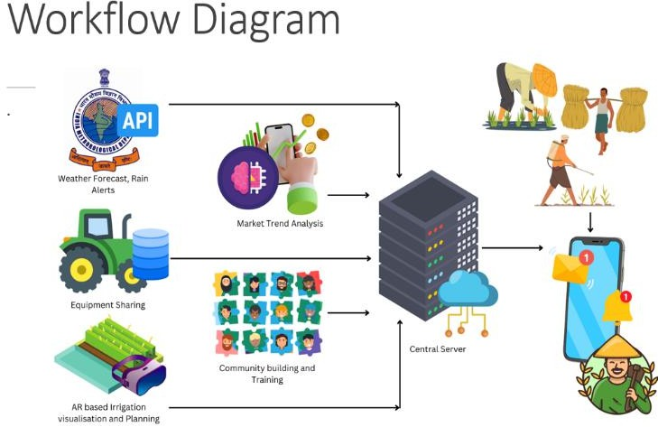 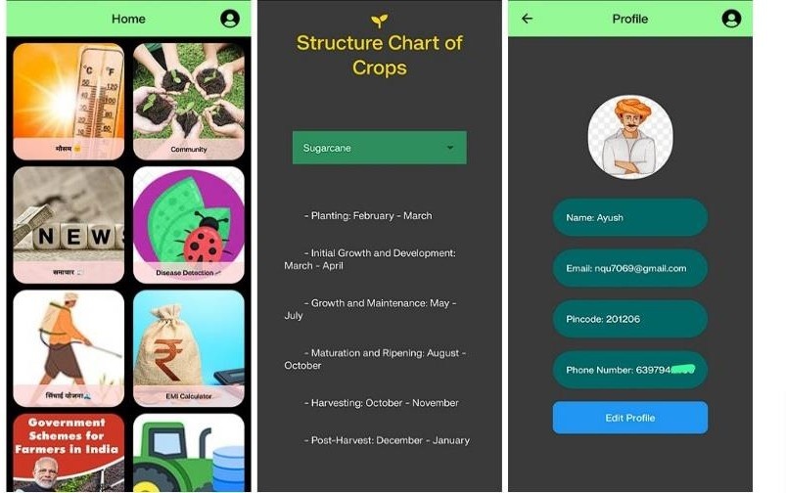

V. **FUTURE WORK**

1. Enhanced AI and Machine Learning Integration for predictive analysis of weather and crop advice.
2. Localization of language support and customization for personalized recommendations.
3. Expansion of partnerships with agri-tech startups, government agencies, and educational institutions.
4. Integration of features for real-time market analysis on market trends, pricing, and crop demand.
5. Continual improvements in AR-based technology for irrigation and crop management assistance.
6. Implementation of automation technologies throughout the development process for efficiency and user-friendliness.

# VI. CONCLUSION

The deployment of KRISHIKOM signifies a pivotal step in aiding small-scale farmers by addressing critical farming challenges. Through its innovative features and intuitive interface, it offers real-time weather monitoring, expert agricultural advice, AR irrigation support, and financial inclusion. By prioritizing farmers' needs, KRISHIKOM promotes sustainability and productivity while fostering prosperity in the agricultural sector. Its evolution promises transformative changes through technological innovation and strategic partnerships, ushering in a brighter future for agriculture globally.

# References

1. Adhiguru, P., Birthal, P. S., & Kumar, B. G. "Enhancing diverse agricultural information delivery systems in India." Agricultural Economics Review, 22, 71-80 (2009).
2. Ansari, M. A., & Pandey, N. "Evaluation of mobile phone potential in agriculture." Karnataka Journal of Agricultural Science, 26, 388-392 (2013).
3. Chhachhar, A. R., et al. "Role of information and communication technologies in agricultural development." Journal of Basic and Applied Scientific Research, 4(1), 281- 288 (2014).
4. Emerick, K., et al. "Technological advancements, risk management, and agricultural modernization." American Economic Review, 106(6), 1537-1561 (2016).
5. Ferroni, M., & Zhou, Y. "Progress and hurdles in agricultural extension services in India." Global Journal of Emerging Market Economies, 4(3), 319-346 (2012).
6. Hellstrom, J., & Troften, P. E. "Innovative mobile application usage in East Africa." Swedish International Development Cooperation Agency, Edita (2010).
7. "ITC e-Choupal 4.0 set for mid-2019 release; emphasizing mobile platform transition and supporting agricultural startups." Business Today, 24 Dec 2018. [Online]. Available: [link].
8. Jamaluddin, N. "Adoption of e-commerce by Indian farmers: A survey in Trichy District, Tamilnadu, India." Procedia Economics and Finance, 7, 140-149 (2013).
9. Kittur, N., Jain, R., & Kittur, P. "Exploring the potential of M-commerce for agricultural inputs in Kolar, Karnataka, India." Research Journal of Recent Sciences, 5(7), 1-10 (2016).
10. Mittal, S., Gandhi, S., & Tripathi, G. "Socio-economic implications of mobile phone usage in Indian agriculture." Working Paper No. 246, 2010. [Online]. Available: [link].
11. "National Policy on Education," National Policy on Education, 2–189. [Online]. Available: [link].
12. Ngai, E. W., & Gunasekaran, A. "Review of mobile commerce research and applications." Decision Support Systems, 43(1), 3-15 (2007).
13. Organisation for Economic Co-operation and Development. "Outlook on agricultural output growth and food

prices for the next decade." OECD-FAO Agricultural Outlook 2019-2028, 2019. [Online]. Available: [link].

1. PRS Legislative Research. "Summary of Economic Survey 2019-20." PRS Legislative Research. [Online]. Available: [link].
2. Saravanan, R., & Vincent, A. "Agricultural Extension and Advisory Systems in Tamil Nadu." Working Paper 3, MANAGE Centre for Agricultural Extension Innovations, Reforms and Agripreneurship, National Institute for Agricultural Extension Management (MANAGE), Rajendranagar, Hyderabad, India, 2020.
3. Seth, A., & Ganguly, K. "Impact of digital technologies on Indian agriculture." The Global Innovation Index, 105-111 (2017).
4. Singh, A., & Kumar, M. "Assessment of M-commerce impact on Agriculture." International Journal of Advanced Research and Development, 3(2), 342-345 (2018).
5. Tata Consultancy. mKRISHI Platform.