Project Synopsis

On

**Whatsapp chat analyser**

Submitted as a part of course curriculum for

**Bachelor of Technology**

in

**Computer Science**



**Submitted by**

Shivam Sharma (2000290120150)

Shivam Nautiyal (2000290120149)

**Under the Supervision of**

Prof. Pooja Sharma

**KIET Group of Institutions, Ghaziabad**

**Department of Computer Science**

**Dr. A.P.J. Abdul Kalam Technical University**

**2022-2023**

**DECLARATION**

We hereby declare that this submission is our work and that, to the best of our knowledge and belief, it contains no material previously published or written by another person nor material which to a substantial extent has been accepted for the award of any other degree or diploma of the university or other institute of higher learning, except where due acknowledgement has been made in the text.

Signature of Students:

Name: Shivam Sharma , Shivam Nautiyal

Roll No.: 2000290120150, 2000290120149

Date:

**CERTIFICATE**

This is to certify that Project Report entitled “**Whatsapp chat analyser**” which is submitted by **Shivam Sharma** in partial fulfilment of the requirement for the award of degree B. Tech. in Department of Computer Science of Dr A.P.J. Abdul Kalam Technical University, Lucknow is a record of the candidates own work carried out by them under my supervision. The matter embodied in this report is original and has not been submitted for the award of any other degree.

**Date: Supervisor Signature**

Supervisor Name : Prof. Pooja Sharma

**ACKNOWLEDGEMENT**

It gives us a great sense of pleasure to present the synopsis of the B.Tech Mini Project undertaken during B.Tech. Third Year. We owe a special debt of gratitude to Prof. Pooja Sharma, Department of Computer Science, KIET Group of Institutions, Delhi- NCR, Ghaziabad, for his/her constant support and guidance throughout the course of our work. Her sincerity, thoroughness and perseverance have been a constant source of inspiration for us. It is only his/her cognizant efforts that our endeavours have seen the light of the day.

We also take the opportunity to acknowledge the contribution of Dr. Ajay Kumar Shrivastava, Head of the Department of Computer Science, KIET Group of Institutions, Delhi- NCR, Ghaziabad, for his full support and assistance during the development of the project. We also do not like to miss the opportunity to acknowledge the contribution of all the faculty members of the department for their kind assistance and cooperation during the development of our project.

Last but not the least, we acknowledge our friends for their contribution to the completion of the project.

Signature:

Date :

Name : Shivam Sharma , Shivam Nautiyal

Roll No: 2000290120150, 2000290120149

**ABSTRACT**

This Web App gives a detailed report about the whatsapp group chats as well as individual chats.

It takes the chats text file generate by Whatsapp export (without media), preprocesses the data , deletes the file uploaded, and generates the stats report. Libraries Used are Pandas, Matplotlib , Regex , Seaborn, Wordcloud , urlextract, emoji. Basically Whole project is developed by python and libraries provided by python. This Application is deployed on streamlit cloud for free. It provide statistics of chat like most active users, Daily timeline, monthly timeline , Activity map, most busy day, Most busy month, Weekly activity map, Wordcloud, most common word, emoji analysis. This is kind of fun app for the people who are curious about their, also this function can be add directly to an whatsapp app by just one update.

This is designed to assist in strategic planning, and will help you ensure that your organization is equipped with the right level of information and details for your future goals. Also, for those busy executive who are always on the go, our systems come with remote access features, which will allow you to manage your workforce anytime, at all times. These systems will ultimately allow you to better manage resources. **This Application is deployed on streamlit cloud for free. It provide statistics of chat like most active users, Daily timeline, monthly timeline , Activity map, most busy day, Most busy month, Weekly activity map, Wordcloud, most common word, emoji analysis. This is kind of fun app for the people who are curious about their, also this function can be add directly to an whatsapp app by just one update.**

INTRODUCTON

**This Web App gives a detailed report about the whatsapp group chats as well as individual chats.It takes the chats text file generate by Whatsapp export (without media), preprocesses the data , deletes the file uploaded, and generates the stats report.** In the era of digital world, traditional art of writing is being replaced by digital art. Digital art refers to forms of expression and transmission of art form with digital form. Relying on modern science and technology is the distinctive characteristics of the digital manifestation. **Libraries Used are Pandas, Matplotlib , Regex , Seaborn, Wordcloud , urlextract, emoji. Basically Whole project is developed by python and libraries provided by python.** Every online chat application has different Online chat needs, therefore we design exclusive employee management system that are adapted to your management requirements. This is designed to assist in strategic planning, and will help you ensure that your organization is equipped with the right level of information and details for your future goals. Also, for those busy executive who are always on the go, our systems come with remote access features, which will allow you to manage your workforce anytime, at all times. These systems will ultimately allow you to better manage resources. **This Application is deployed on streamlit cloud for free. It provide statistics of chat like most active users, Daily timeline, monthly timeline , Activity map, most busy day, Most busy month, Weekly activity map, Wordcloud, most common word, emoji analysis. This is kind of fun app for the people who are curious about their, also this function can be add directly to an whatsapp app by just one update.**

Problem Statement

Developing an chat an chat analyser which works on whatsapp chat and provides statitistics of chat like most busy days, most busy user in graphical format.

Objective

* To develop a streamlit webapp
* To work on cleaning of unnessessary part of chat.
* To apply the data in graphical or visual format
* To deploy the project on streamlit cloud.

SCOPE

• This project can furthermore used to apply sentimental analysis.

• Apply more machine learning on data

• **Also it can also give suggestion to person that how his/her chat feels(angry, sad, happy) .**

**Summary Report of Research Paper**

1->The Role of Responsive Design in Web Development (2017)

->This paper discusses about role of responsive website.

* Responsive design allows software developers to build a Web page that can dynamically adapt to the size of the devices.

The evolution of Web paradigm: -

* The first phase of the Web, known as Web 1.0, is characterized by static content publishing, in which users had the power to only consume the content placed by companies. At that time, there was no bidirectional communication between the client and a company, and email emerged as the primary form of digital contact between these two entities. Web 1.0 is characterized by its low interactivity
* Web 2.0 includes a large and diverse panoply of services, such as social networks, blogs and wikis, that promote collaboration and the fast exchange of information among users. Andriole (2010) states that Web 2.0 has helped companies to become more competitive and position themselves in the marketplace. The main advantage associated with Web 2.0 is its potential in establishing collaboration, and the main disadvantage is the loss of control of the shared information.
* W eb 3.0 emerged as a new paradigm that allowed companies to explore this information about users, to identify trends and optimize their experiences on the Web. With the appearance of the Web 3.0 has become much easier to find relevant information on a given subject. However, as a major disadvantage, it can appear security issues, such as unauthorized access and manipulation of data.
* Web 4.0 proposes a new model of interaction that is more complete, dynamic, and personalized, in which there is a symbiotic interaction between humans and machines.

2-> Journal of Engineering Design (2007)

• According to the research paper, Virtual reality (VR) is a tool that today is used by experts in the performance of mechanical engineering and industrial design. VR has especially found its use in the automotive industry. • This research paper focuses on what is needed for the use of already existing VR files as web applications with the aim of spreading the use of VR applications to a wider group of people than engineers and designers. • A natural way to reach more stakeholders is by taking advantage of the Internet and the development of so-called content management systems (CMS) for the administration of web pages with VR applications. • Technically, a CMS is placed on a web server in parallel with the public web page. Thus, the CMS is computer independent as long as an Internet connection exists to the PC/Laptop in use. • A few of the benefits from combining VR and the web are: i. When a new product concept is developed combining VR and the web, different ideas can be tested and judged faster using web technology than would otherwise be the case. ii. VR also provides us with a greater range of opportunities when presenting information. iii. By using VR applications over the web the understanding gap can be reduced as well as the transfer cost from one production situation to another iv. VR as a communication tool can also be valuable in the marketing and selling of standard products and turn-keyproducts • The research paper showed that by combining a content management system and a VR file transformed as a compressed VR file, the VR application can be used as an ordinary web application.

**3->** Research on HTML5 in Web Development. (2017)

HTML5 is everywhere these days. HTML5 is the new and elegant standard for HTML that provides web users and developers enhanced functionality. The older versions of HTML, HTML 4.01, which came in 1999, and the web development have changed notably since then. HTML 4, XHTML, CSS and the HTML DOM Level 2 are now replaced with HTML5. It was brought to deliver rich content without the need for additional plug-ins and proprietary technologies. The new power of HTML5 supplies the user everything from animation to graphics, music to movies, and can also be used to build complicated web applications and supports cross-platform. HTML5 standard initiates the development of real-time collaborations in web browsers, which leads to less work for web developers.

HTML5 introduces new elements and features that allow developers to improve interoperability, handling elements in a precise way saving time and costs. HTML5 is an awesome technology and has the possibility to make the web even more predominant and extensive as it is today from desktop computers to mobile devices and in the future maybe even domestics appliances. The potential of HTML5 will soften the line between desktop and online applications.

**4->** The Mungi Single-Address-Space Operating System (1988)

• This paper presents the Mungi system. The basic abstractions provided by Mungi are capability, object, task, thread, and protection domain. • Mungi is a pure SASOS in that it provides no inter-process communication facility other than shared memory (plus semaphores for synchronisation). Furthermore, there are no explicit system calls to support I/O in Mungi. • The Mungi API is implemented as an L4 userlevel server. The main role of the server is to maintain the Mungi attributes of tasks, threads and objects. As well, it is responsible for enforcing the Mungi protection and addressing model. • The implementation of Mungi (written almost entirely in C) is easily portable between different hardware architectures (and L4 implementations). As the number of L4 implementations increases, so do the platforms on which Mungi is available. • Experience with L4 implementations suggested high-performance approaches to issues such as context switching, scheduling, thread creation and destruction etc. This significantly reduced the time spent in developing the lowest software levels. • The paper shows that Mungi clearly outperforms UNIX operating systems on some of the most important basic operations, as well as on an IPC-intensive benchmark of database operations.

5-> New technologies for web design. (2010)

The paper gives an overview of the new features of web technologies. The general idea of the new version of HTML (Hyper Text Markup Language), i.e. HTML5, and other tools presented in this paper is the formal specification and the establishment of uniform solutions for technologies and functionalities which have already been in use through various hacks and plug-ins proposed by web developers. Many of these functionalities will now be implemented in browsers. The applications can access these functionalities through newly defined application programming interfaces. The latter include support for multimedia, dynamic graphic rendering, geolocation, multithreading, local data storage etc. HTML5 also introduces semantic markup, which can be used for marking the document structure as well as its elements and data. The new version of HTML enforces strict separation of the page content from its style. The styling can only be done using CSS (Cascading Style Sheets) language. The new CSS version, i.e. CSS3, has a modular structure, in which different modules define different styling features. The development cycles of the individual modules are independent as well as their support and implementation in various browsers.

6- >A Systematic Literature Review on Cloud Computing Security (2021)

Cloud computing has become a widely exploited research area in academia and industry. Cloud computing benefits both cloud services providers (CSPs) and consumers. The security challenges associated with cloud computing have been widely studied in the literature. This systematic literature review (SLR) is aimed to review the existing research studies on cloud computing security, threats, and challenges. This SLR examined the research studies published between 2010 and 2020 within the popular digital libraries. We selected 80 papers after a meticulous screening of published works to answer the proposed research questions. The outcomes of this SLR reported seven major security threats to cloud computing services. The results showed that data tampering and leakage were among the highly discussed topics in the chosen literature. Other identified security risks were associated with the data intrusion and data storage in the cloud computing environment. This SLR’s results also indicated that consumers’ data outsourcing remains a challenge for both CSPs and cloud users. Our survey paper identified the blockchain as a partnering technology to alleviate security concerns. The SLR findings reveal some suggestions to be carried out in future works to bring data confidentiality, data integrity, and availability.

7-> RESEARCH PAPER ON CLOUD COMPUTING (2006)

Cloud Computing has come of age later Amazons introduce the first of its kind of cloud services in2006. It is particularly suitable to Hong Kong because of the unbelievable amounts of the data that are being processed here daily in several sectors, and there are signs that subscription to cloud services by the local companies will soon be on a skyrocket course, despite a slow start in beginning years. As a research theme, cloud computing now easily tops any schedule of topics in a computer science because of its far-reaching suggestion in many sector in computing, especially a big data which without cloud computing is at the great concept. The current creation of a main cloud R&D centre in Hong Kong by Lenovo (January 2015) attests to this fact

8->Sensing Methodologies in Agriculture for Soil Moisture and Nutrient Monitoring (2009)

Development and deployment of sensing technologies is one of the main steps in achieving sustainability in crop production through precision agriculture. Key sensing methodologies developed for monitoring soil moisture and nutrients with recent advances in the sensing devices reported in literature using those techniques are overviewed in this article. The soil moisture determination has been divided into four main sections describing soil moisture measurement metrics and laboratory-based testing, followed by in-situ, remote and proximal sensing techniques. The application, advantages and limitations for each of the mentioned technologies are discussed. The nutrient monitoring methods are reviewed beginning with laboratory-based methods, ion-selective membrane based sensors, bio-sensors, spectroscopy-based methods, and capillary electrophoresis-based systems for inorganic ion detection. Attention has been given to the core principle of detection while reporting recent sensors developed using the mentioned concepts. The latest works reported on the different sensing methodologies point towards the trend of developing low-cost, easy to use, field-deployable or portable sensing systems aimed towards improving technology adoption in crop production leading to efficient site-specific soil and crop management which in turn will bring us closer to reaching sustainability in the practice of agriculture.

9-> Research on Web Instant Messaging Using REST Web Service (2021)

With the development of Web Service, Web Instant Messaging is becoming more and more common in our life. On the other hand, REST Web Service sets off a revolution. It changes the traditional structure of web Service, which makes the service uniformed as resources to use. This paper firstly analyzes and compares the existing web instant messaging technology. Then introduces REST web service and gives an example of a REST-based instant messaging application

10-> Enhancing Security of Health Information Using Modular Encryption Standard in Mobile Cloud Computing

(2020)

Despite the numerous and noticeable inherited gains of Mobile Cloud Computing (MCC) in healthcare, its growth is being hindered by privacy and security challenges. Such issues require the utmost urgent attention to realize its full scale and efficient usage. There is a need to secure Health Information worldwide, regionally, and locally. To fully avail of the health services, it is crucial to put in place the demanded security practices for the prevention of security breaches and vulnerabilities. Hence, this research is deliberated on to provide requirement-oriented health information security using the Modular Encryption Standard (MES) based on the layered modeling of the security measures. The performance analysis shows that the proposed work excels, compared to other commonly used algorithms against the health information security at the MCC environment in terms of better performance and auxiliary qualitative security ensuring measures.

Conclusion

This Web App gives a detailed report about the whatsapp group chats as well as individual chats.

It takes the chats text file generate by Whatsapp export (without media), preprocesses the data, deletes the file uploaded, and generates the stats report.

This Application is deployed on streamlit cloud for free. It provide statistics of chat like most active users, Daily timeline, monthly timeline , Activity map, most busy day, Most busy month, Weekly activity map, Wordcloud, most common word, emoji analysis.

This is kind of fun app for the people who are curious about their, also this function can be add directly to an whatsapp app by just one update.

Furthermore this can sentimental analysis can also be applied on this using simple machine learning. Also it can also give suggestion to person that how his/her chat feels(angry, sad, happy) .

Technology used

Basically whole application is developed using python.

**Libraries Used are:**

**Pandas**

**Matplotlib**

**Regex**

**Seaborn**

**Wordcloud**

**Urlextract**

**Emoji**

**Streamlit**

Diagram

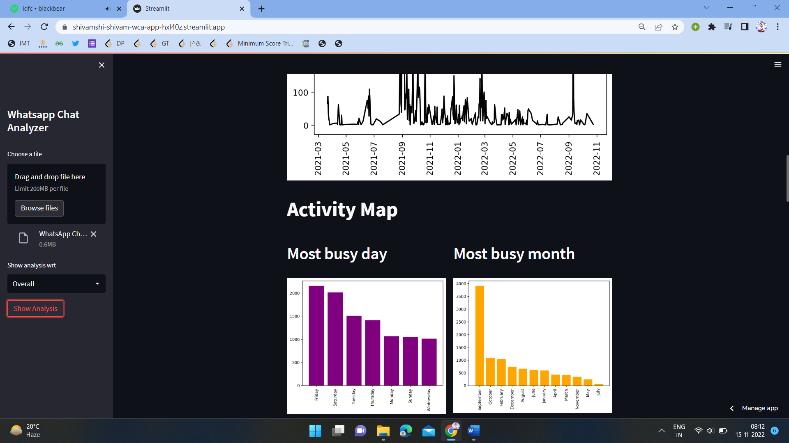

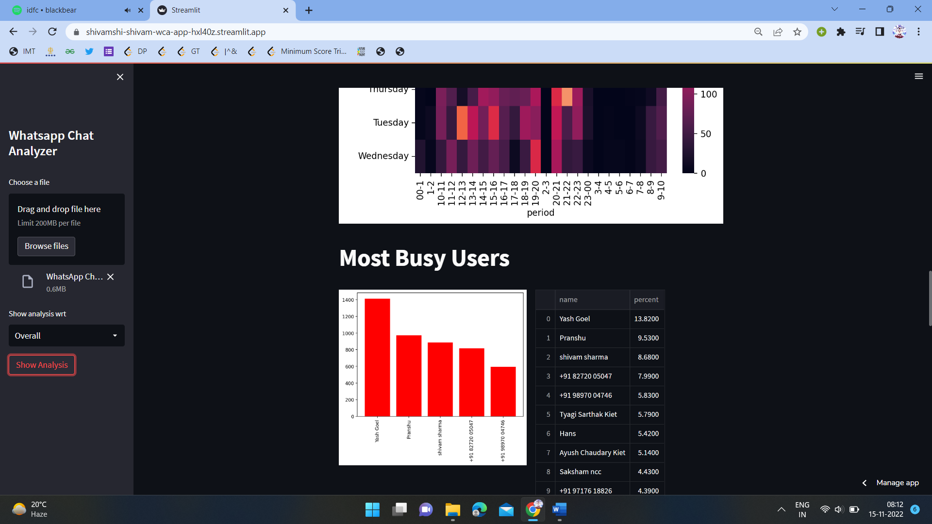

**REFRENCES**

1¬> Ariponnammal, S. and Natarajan, S. “Transport Phonomena of Sm Sel – X Asx”, Pramana – Journal of Physics Vol.42, No.1, pp.421-425, 2011

.2¬> Barnard, R.W. and Kellogg, C. “Applications of Convolution Operators to Problems in Univalent Function Theory”, JSER., Vol.27, pp.81–94, 1987.

3¬> Shin, K.G. and McKay, N.D. “Open Loop Minimum Time Control of Mechanical Manipulations and its Applications”, Proc. Amer. Contr. Conf., San Diego, CA, pp. 1231-1236, 1984.

4¬> Crockford, Douglas. JavaScript: The Good Parts, O'Reilly & Associates, 2008.

5¬> Castro, Elizabeth and Hyslop . HTML5, and CSS, Eight Edition: (Visual QuickStart Guide), Peachpit Press, 2013

6¬> W3 Schools , Stack overflow