JANAK

Nurturing Holistic Development

SUBMITTED IN PARTIAL FULFILLMENT FOR THE REQUIREMENT OF THE AWARD OF DEGREE OF

### BACHELOR OF TECHNOLOGY IN

**COMPUTER SCIENCE**



Submitted by

Khushi Jain (2100290120096)

Garima Shukla (2100290120078)

Kanishka Singh (2200290129011)

Deeksha Gupta (2100290120067)

Supervised By

Dr. Ajay Kr. Shrivastava Professor- CS

**Session 2024-25**

**DEPARTMENT OF COMPUTER SCIENCE**

# KIET GROUP OF INSTITUTIONS, GHAZIABAD

**(Affiliated to Dr. A. P. J. Abdul Kalam Technical University, Lucknow, U.P., India) May 2025**

# DECLARATION

We hereby declare that this submission is our own work and that, to the best of our knowledge and belief, it contains no material previously published or written by another person nor material which to a substantial extent has been accepted for the award of any other degree or diploma of the university or other institute of higher learning, except where due acknowledgment has been made in the text.

Signature Signature

Name: Khushi Jain Name: Deeksha Gupta

Roll No.: 2100290120096 Roll No.: 2100290120067

Date:17/02/2025 Date:17/02/2025

Signature Signature

Name: Garima Shukla Name: Kanishka Singh

Roll No.: 2100290120078 Roll No.: 2200290129011

Date: 17/02/2025 Date: 17/05/2025

# CERTIFICATE

This is to certify that Project Report entitled “Janak: Nurturing Holistic Development” which is submitted in partial fulfillment of the requirement for the award of degree B. Tech. in Department of Computer Science of Dr. A.P.J. Abdul Kalam Technical University, Lucknow is a record of the candidates own work carried out by them under my supervision. The matter embodied in this report is original and has not been submitted for the award of any other degree.

**Date:** Supervisor

Dr. Ajay Kr. Shrivastava Dean & Professor

# ACKNOWLEDGEMENT

This final year’s project report comes to you with great pleasure. A special mention must be made for Professor Dr. Ajay Kr. Shrivastava Department of Computer Science, KIET, Ghaziabad, whose constant support and guidance throughout the development of the work has been invaluable to us. His sincerity and thorough approach along with perseverance kept on inspiring us. It is through his conscious efforts alone that our wishes have been realized.

We must take this opportunity to record our gratefulness to Dr. Ajay Kr. Shrivastava, Dean, Computer Science, KIET, Ghaziabad, for providing us with full support as our guide and cooperation during the project development. We should not fail to express our gratitude to the other members of the faculty of the department for their kind assistance and co-operation during the progress of our project.

Apart from that, finally, there is our sub-list of acknowledgments of friends who helped us in carrying out the work.

Date: 17/02/2025

Signature: Signature:

Name: Khushi Jain Name: Garima Shukla

Roll No.: 2100290120096 Roll No.: 2100290120078

Signature: Signature:

Name: Deeksha Gupta Name: Kanishka Singh

Roll No.: 2100290120067 Roll No.: 22002901290

# ABSTRACT

The Janak: Nurturing Holistic Development initiative is a comprehensive digital platform geared towards assisting the parent in achieving salutary factors and promoting cognitive, psychomotor, and affective development in his child. This app serves as an all-in-one deed platform, encompassing academic progress tracking, IQ test assessment, BMI monitoring, social media usage tracking, therapy session bookings, and an online forum exclusively for parents. The system in question is developed with Flutter for the front end, Firebase for real-time backend services, and Python for machine learning models to provide smooth and reactionary user experience.

Some key features are real-time notifications, privacy and data security, and user-friendly interface that supports active parental engagement. The whole project is executed following the agile software development life cycle (SDLC), which factors in iterative refinement and continuous integration. To give the system the utmost reliability and high performance, the system is put through vigorous testing approaches, including unit and integration testing.

Testing results have demonstrated tracking, parental involvement, and data security procedures within the platform. The Janak platform has fulfilled the functional requirements while excelling in performance, security, and scalability. The future advancements include but are not limited to implementing AI- empowered personalized recommendations and further extending this scope by integrating other health monitoring modules to aid holistic child development. Janak is conceived as a tool to empower parents with actionable insights and promote an environment of shared learning and support.

|  |  |
| --- | --- |
| **TABLE OF CONTENTS** |  |
|  | **Page No.** |
| DECLARATION……………………………………………………………………. | 2 |
| CERTIFICATE……………………………………………………………………… | 3 |
| ACKNOWLEDGEMENTS…………………………………………………………. | 4 |
| ABSTRACT……………………………………………………………………….... | 5 |
| LIST OF FIGURES…………………………………………………………………. | 8 |
| LIST OF TABLES…………………………………………………………………… | 9 |
| LIST OF ABBREVIATIONS………………………………………………………. | 10 |
| SDG MAPPING WITH JUSTIFICATION ………………………………………. | 11 |
| CHAPTER 1 INTRODUCTION |  |
| 1.1 Introduction to Project | 12 |
| 1.2 Project Category | 12 |
| 1.3 Objectives | 13 |
| 1.4 Structure of Report | 14 |
| CHAPTER 2 LITERATURE REVIEW |  |
| 2.1 Literature Review | 18 |
| 2.2 Research Gaps | 19 |
| 2.3 Problem Formulation | 20 |
| CHAPTER 3 PROPOSED SYSTEM |  |
| 3.1 Proposed System | 21 |
| 3.2 Unique Features of The System | 22 |
| CHAPTER 4 REQUIREMENT ANALYSIS AND SYSTEM SPECIFICATION |  |
| 4.1 Feasibility Study (Technical, Economical, Operational) | 26 |
| 4.2 Software Requirement Specification | 27 |

* + 1. Data Requirement 26
    2. Functional Requirement 27
    3. Performance Requirement 27
    4. Maintainability Requirement 28
    5. Security Requirement 28
  1. SDLC Model Used 28
  2. System Design 29
     1. Data Flow Diagram 30
     2. Use Case Diagram 31
  3. ER Diagram 32

CHAPTER 5 IMPLEMENTATION

* 1. Introduction Tools and Technologies Used. 33
  2. Dataset description 34

CHAPTER 6 TESTING, AND MAINTENANCE

* 1. Testing Techniques and Test Cases Used 37

CHAPTER 7 RESULTS AND DISCUSSIONS

* 1. Description of Modules with Snapshots 43
  2. Key findings of the project 55
  3. Brief Description of Database with Snapshots 56

CHAPTER 8 CONCLUSION AND FUTURE SCOPE

|  |  |  |
| --- | --- | --- |
| 8.1 | Conclusion | 57 |
| 8.2 | Future Scope | 57 |

REFERENCES

Turnitin Plagiarism Report

Patent Publication Proof

**LIST OF FIGURES**

|  |  |  |
| --- | --- | --- |
| **Figure No.** | **Description** | **Page No.** |
| 4.1 | Data Flow Diagram | 30 |
| 4.2 | Use Case Diagram | 31 |
| 4.3 | ER Diagram | 32 |

**LIST OF TABLES**

|  |  |  |
| --- | --- | --- |
| **Table. No.** | **Description** | **Page No.** |
| 1.1  1.2  1.3  1.4 | IQ Datasets Screen Time Dataset  BMI Dataset  Academic Report Dataset | 34  35  35  36 |

**LIST OF ABBREVIATIONS**

UI/UX User Interface / User Experience

API Application Programming Interface

SDK Software Development Kit

SDLC Software Development Life Cycle

DBMS Database Management System

## SDG Mapping & Justification:

The project is in line with the following Sustainable Development Goals (SDGs)-

#### SDG 3: Good Health & Well-being:

Captures the contact information of mothers for follow-up communications Schedules therapy sessions to assist with mental health.

#### SDG 4: Quality Education:

Provides tracking of academic progress and IQ tests Stimulate intellectual growth with activity- based instruction.

#### SDG 16: Peace, Justice & Strong Institutions:

Provides a secure community website for parents to connect with and share advice and assistance.

# CHAPTER 1 INTRODUCTION

## Introduction to Project

Janak: Nurturing Holistic Development is an all-encompassing application designed to carry out child development observation, thereby assisting parents in actively observing and contributing to the child's growth in cognitive, psychomotor, and affective development. Acknowledging the complex nature of a child's development, the platform merges innovative tools and techniques intended to shed further light on child development. The application further reports extensively about academics, checks IQs, skill testing through computer-interactive exercises, and social media use monitoring in real-time for digital well-being. It also monitors health, such as BMI measurements and therapy appointments for mental and physical health. Another important feature of the application is creating a community platform designed for parental peer support and mutual learning. Extending the technological paradigm from jarred parenting practices, Janak hopes to create closing upon all those gaps through the latest tech tools of data analytics and intelligent tracking systems. It thereby equips parents with insights and expert advice that allow them to better foster a parenting approach based on knowledge and participation. The prime objective of the platform is the promotion of the development of a child's pocket holistically via a friendly environment where the child thrives academically, social being, emotionally, and physically.

## Project Category

Placed under Educational and Child Development Software, this is a Parental Guidance and Monitoring System by virtue of which virtual assistance is provided to parents for the academic and personal development of their children. It covers multiple domains like education, health, and social behavior tracking for a holistic developmental approach.

## Objectives

### Integrated Child Development Monitoring:

To build a strong and encompassing platform for the parents to monitor and nurture the development of their child along academic, cognitive, psychomotor, and emotional facets. It enabled continuous real- time monitoring of scholastic performance, activity engagement for skill enhancement, and assessment of cognitive and motor skills with feedback in quick cycles. Parents can identify strengths and potential areas of concern to allow for early intervention and bespoke growth paths

### Behavioral Knowledge and Parental Guidance:

To generate rich behavioral information concerning data trends-screentime analysis, social media engagement, and learning behavior through activity-based modules. The system analyses these parameters and accordingly suggests and provides customized material specific to the needs of the individual child. It now becomes a virtual parental guide, indicating to parents the application of useful strategies and digital behavior formation in children.

### Holistic Health Monitoring:

To generate rich behavioral information concerning data trends-screentime analysis, social media engagement, and learning behavior through activity-based modules. The system analyses these parameters and accordingly suggests and provides customized material specific to the needs of the individual child. It now becomes a virtual parental guide, indicating to parents the application of useful strategies and digital behavior formation in children.

### Empowering Parenting Community:

The platform will serve as an interactive and safe social space for parents to connect, share their experiences, and work on fruitful discussions regarding child development. Forums, chat groups, seminars with specialists, and group resources provided by Janak will construct a support framework whereby parents can empower themselves to learn from each other and gain expert opinions.

## Structure of Report

The structure of the report for the Janak: Nurturing Holistic Development project is as follows:

#### Title Page:

* + Report Title
  + Project Name
  + Team Members & Roles

### Table of Contents:

List of all the sections and subsections with page numbers for easy navigation.

### Executive Summary:

* + An overview of Janak's basic idea -merging parental instincts with digital smarts.
  + Overview of key objectives
  + A glimpse of challenges faced, and key milestones achieved during the process.

### Introduction:

* + Background of the project.
  + Purpose and objectives of the project.
  + Scope and limitations of the project.
  + Overview of the report structure.

### Project Blueprint:

* + Description of the Janak: Nurturing Holistic Development
  + End users: Parents
  + Overview of the tech stack powering Janak (e.g., Flutter, Firebase, ML APIs).

### Requirement Deep Dive:

* + **Functional requirements:** Detailed description of features and functionalities.
  + **Non-functional requirements:** Performance, security, usability, and other requirements.
  + **Stakeholder requirements:** Needs and expectations of company owners and agents.

### Design & System Architecture:

* + Overview of the software architecture.
  + Design principles and methodologies used.
  + Description of major components/modules.
  + Database schema and data model.

### Building and Implementation:

* + Description of the development process.
  + Technologies and tools used.
  + Challenges faced during implementation and solutions adopted.
  + Code organization and structure.

### Deployment Strategy:

* + Overview of the deployment process.
  + Infrastructure setup and configuration.
  + Deployment environment and server specifications.
  + Steps taken to ensure a smooth deployment process.

### Maintenance & Support:

* + Description of ongoing maintenance activities.
  + Bug tracking and resolution process.
  + User support mechanisms in place.

### Future Improvements:

* + Potential future features and functionalities.
  + Areas for improvement based on user feedback.
  + Long-term vision for the software.

### Conclusion:

* + Summary of key findings and achievements.
  + Reflections on the project journey.
  + Lessons learned and recommendations for future projects.

### References:

* + List of all sources cited in the report (e.g., research papers, articles, documentation)

### Appendices

* + User personas, wireframes, flowcharts, and other diagrams.

# CHAPTER 2 LITERATURE REVIEW

### Literature Review

Holistic development of the child demands harmonious emphasis on different areas like health cognition, emotional well-being, and social behavior. Research indicates the importance of comprehensive solutions to guide parents through these aspects effectively, but most current tools and methods lack effectiveness in providing full support.

#### Cognitive and Emotional Development:

Early childhood is a vital time for cognitive and emotional development, as presented in studies by Piaget and Vygotsky. They highlight the role of interactive learning and emotional stability in developing problem-solving abilities, memory, and emotional strength. Intelligence quotients (IQ) or emotional intelligence quotient (EQ) tests that measure and develop a child's IQ or EQ have worked well, but they tend to give parents generic information that may not be particularly useful for every stage of child development

#### Physical and Health Development:

Tracking a child's physical health is vital to the prevention of disease and the promotion of long- term well- being. Research indicates that regular monitoring of nutrition, physical activity, and sleep habits greatly supports physical growth and reduces risk to health. General tracking apps like Fitbit and MyFitnessPal are available, but they do not include child-oriented features that account for developmental requirements or interface with parent-centered tools.

#### Academic Growth and Performance:

Scholastic performance is one of the primary measures of a child's cognitive and social growth.

Studies emphasize the necessity of real-time monitoring of academic achievement, attendance, and extracurricular activities in order to recognize and fill any possible learning gaps. Although schools offer reports on performance, they do not always have individualized feedback channels that enable parents to act ahead of their children's educational progress.

#### Social Media and Monitoring of Digital Behavior:

The use of social media by children and adolescents has generated concern over its effect on mental well- being and social relationships. Research associates high or unmonitored use with problems like cyberbullying, anxiety, and decreased attention span. Measures such as parental control software are aimed at mitigating these concerns but tend to work in silos, providing minimal insight into larger developmental effects.

#### Community and Collaborative Parenting:

The worth of an intimate parenting network is established in psychology and sociology. Mutual sharing of experiences and expert advice from peers and experts promotes well-informed decision making and alleviates the solitude experienced by most parents. Present parenting forums and applications have some form of community involvement but are missing integration with data-based tools that can inform.

comprehensive parenting.

#### Gap of Integration in Present Solutions:

Though there are tools for health tracking, academic monitoring, or social media monitoring, not many platforms offer these features holistically. The absence of holistic integration leads to broken data, and parents find it challenging to understand their child's development in an integrated manner. Platforms such as BabyCenter or ClassDojo serve a particular purpose but lack in providing for the holistic nature of a child's development in cognitive, emotional, and physical areas.

#### The Call for an Integrated Solution:

The literature identifies an urgent call for an integrated platform that closes these gaps. This solution would integrate real-time monitoring, data-driven information, and community involvement to give parents actionable advice in all areas of their child's development. This platform serves as the basis for Janak, a platform that seeks to bring together health, academic, emotional, and social development tools into one

### Research Gaps

1. **Absence of Integrated Development Platforms:** Most available solutions focus on separate areas— school performance, health monitoring, or mental status determination— without a unifying platform.
2. **Ineffective Use of Parental Communities as Spaces for Co-Education:** Most current platforms lack parent-led knowledge sharing, support groups, or collaborative problem- solving frameworks.
3. **Limited Adaptability to User Diversity:** Most applications are not user-friendly for individuals who have different levels of digital literacy or accessibility requirements.
4. **Poor Data Security and Privacy Mechanisms:** Due to the vulnerability of child data, few platforms use end-to-end encryption, user opt-in models, or child data protection regulation compliance. Research needs to focus on secure governance models specific to child development apps.
5. **Lack of Personalization and Cognitive Mapping:** Few apps tailor content according to a child's development level, learning pattern, or intellectual advancement.
6. **Shortage of Longitudinal Impact Studies:** There is a shortage of longitudinal evidence regarding how end-to-end digital solutions influence child development over a period. Long-term research needs to capture educational, cognitive, emotional, and social results linked to holistic child monitoring systems.
7. **Resistance to Adoption by Parents:** Cost, lack of training, or distrust in technology are barriers that lead to adverse adoption. Research may investigate the behavioral determinants-such as cost, distrust in technology, or lack of training—and design corrective interventions-such as onboarding mechanisms—to enhance adoption and continued use.

### Problem Formulation

Integrated child development is a multidimensional process that involves academic, cognitive, emotional, and physical aspects. Though there are digital solutions for monitoring individual developmental factors, they tend to be disjointed and narrow in focus. Parents and teachers are usually required to toggle among several platforms to track academic development, measure cognitive abilities, plan health consultations, and interact with community support. This fragmentation causes inefficiencies, data silos, and reduced capacity to make informed, timely

decisions for the child's development.

Janak: Nurturing Holistic Development seeks to bridge this gap by creating an integrated mobile application that is a one-stop shop for a child's overall development.

The platform will integrate:

* + - Academic monitoring to track scholastic performance.
    - IQ and cognitive testing to gain insights on mental development.
    - BMI and health records to track physical well-being.
    - Parenting community forums for collective parenting.

Though the idea promises much, a number of essential challenges illustrate the necessity for a well-designed solution:

* **Technological Access and Convenience:** Most parents, particularly those in less affluent or rural communities, are restricted in their ability to handle sophisticated applications.
* **Data Privacy and Security:** Child data is sensitive and needs strong encryption, user control over consent, and regulatory requirements (e.g., COPPA, GDPR) to protect it from breaches or misuses.
* **Inadequate Real-Time Insight and Personalization:** Dispersed data across platforms prevents real-time insights.
* **Limited Community Participation:** Current applications do not leverage the potential of social parenting. Janak will have a moderated, safe parent community to foster best practice sharing, emotional support, and cooperative learning experiences.
* **Scalability and Future-Proof:** As families expand or requirements change, the platform needs to be scalable and flexible, accommodating additional users, varied education systems, and future features such as integration with wearables or school database.

# CHAPTER 3 PROPOSED SYSTEM

### Proposed System

#### Overview:

Janak: Nurturing Holistic Development is a smartphone app that will help parents track and ensure all-around development of their children. In contrast to traditional academic tracking software, the system goes beyond academics, and it includes real-time information regarding cognitive, psychomotor, and affective areas.

With the use of Dart, Flutter, Firebase, Kaggle ML models, Python APIs, and Android development, Janak provides AI-based insights to enable parents to make smart decisions regarding their child's development. The combined system is meant for academic performance tracking, IQ tests, social media usage, health data, and parents forum.

#### Need for the Proposed System:

Education systems have traditionally emphasized academic performance alone without considering important factors such as mental wellness, emotional intelligence, and physical wellbeing. The Janak: Nurturing Holistic Development fills this gap through its all-around developmental tracking system.

#### Key Reasons for the System:

* Uncontrolled screen use with adverse mental and social impact.
* Non-personalized cognitive and affective evaluations missing.
* Timely insights into both academic improvement and personal development.
* Compulsion for an interactive, safe platform for inter-parent sharing of experiences.

#### Working of the System:

The Janak app uses a systematic workflow combining AI-enabled analytics and real-time monitoring.

1. **User Registration-**Parents create accounts and add child profiles.
2. **Data Collection**-Includes records of academics, health related data, activities data, and social media usage.
3. **Real-Time Analytics -** Machine learning models analyze cognitive, psychomotor, and affective development.
4. **Parental Dashboard** - Trend analysis, insights, and recommendations.
5. **Alerts and Recommendations** - Alerting parents about screen time, academic interests, or health issues.
6. **Community Interaction** - Private discussion forums for parents.
7. **Security & Privacy of Data-**Protected authentication and encrypted data storage through Firebase.

### Unique Features of the System

Janak: Nurturing Holistic Development is a future-proof parental guidance system that integrates real-time monitoring, secure data management, and smart analytics to provide an end-to-end perspective on child development. Its core feature modules are as follows:

#### Holistic Development Tracking

Janak tracks a child's development in the cognitive, psychomotor, and affective areas to give an all-around developmental report.

#### Key Features:

* **Cognitive Skills**: IQ tests, logical reasoning exercises, and problem-solving tests.
* **Psychomotor Skills:** Reflex analysis and interactive, activity-based assessments.
* **Affective Domain:** Monitoring of emotional responses, social interactions, and empathy cues.

**Implementation** models trained on Kaggle datasets examine test response patterns.

#### Academic Progress Reports

Provides smart insights into academic performance with tailored recommendations.

#### Implementation:

* + Backend coded using Dart and Firebase Fire store.
  + Predictive models predict learning trends based on real-time feeds.

#### Social Media Monitoring & Screen Time Management

Equips parents with the ability to monitor and steer children's digital behavior.

#### Major Features:

* + Social media usage habits tracked in real-time.
  + Programmed alerts on excessive screen use beyond safe levels.

#### Implementation:

* + - * + Python API-based APIs retrieve activity information from social media sites.
        + Firebase Cloud Functions send alerts on potentially unsafe use.

#### Health and Wellness Insights

Compiles physical and mental well-being data to produce actionable wellness reports.

#### Major Features:

* + BMI monitoring and overall health checks.
  + Dietary advice sourced from the community.

#### Implementation:

* + Firebase APIs and Android Health SDK handle health data.
  + Health data are processed to highlight potential wellness threats.

#### Parent Community Forum

Facilitates peer-to-peer support and expert discussion in a safe online space.

#### Key Features:

* + Themed discussion forums and moderated Q&A sessions with child development professionals.

#### Implementation:

* + Forum UI implemented using Flutter.
  + Backend moderation provides safety, privacy, and relevance of content.

# CHAPTER 4

**REQUIREMENT ANALYSIS AND SYSTEM SPECIFICATION**

### Feasibility Study

A feasibility study aids in identifying if the Janak can be developed and executed successfully. It consists of technical, economic, and operational feasibility evaluations.

#### Technical Feasibility

This evaluates if the system could be built utilizing existing technologies and resources.

1. **Technology Stack:** The application will be built with Flutter (Dart) for cross-platform compatibility, Firebase for backend storage, and AI/ML for predictive analysis.
2. **Third-Party Integrations:** APIs for academic platforms, health monitoring and social media tracking.
3. **Scalability:** The system is designed to handle multiple user accounts, real-time data updates, and AI-driven recommendations.
4. **Hardware Requirements:** Mobile devices (Android/iOS) with an internet connection.

**Conclusion:** The system is technically feasible using available technologies.

#### Economic Feasibility

Evaluates the financial viability of the project.

#### Development Costs:

* + - * **Software Development:** Flutter, Firebase, AI analytics, and API integrations.
      * **Human Resource Costs:** Developers, UI/UX designers, testers, and maintenance staff.

**Revenue Model**: Freemium Model-Basic features are free, and advanced insights need a subscription.

**Conclusion:** The project is financially viable with a sustainable revenue model

#### Operational Feasibility

Evaluates if the system is suitable for end users' needs.

1. **User Acceptance:** The application offers useful insights to parents, promoting adoption.
2. **Ease of Use:** With a straightforward UI, dashboard analytics, and alerts.
3. **Training Needs:** Little training is needed because of intuitive UI and in-app instructions.

**Conclusion:** The system is operationally feasible with high adoption potential.

### Software Requirement Specification

This section defines the overall requirements of the Janak: Nurturing Holistic Development application, including data handling, user features, system performance, maintainability, and security.

#### Data Requirements

The application handles and processes different types of user-focused data to enable a personalized experience:

1. **Parent & Child Data:** Names, contact details, age, development profiles, and parent-child relationships.
2. **Academic Data:** Exam grades, subject-wise assessments, and longitudinal performance indicators.
3. **Cognitive Psychomotor:** A feedback mechanism to the quizzes and activities created to assess IQ and psychomotor capabilities.
4. **Health Record:** BMI history, fitness activity tracking.
5. **Social Engagement Data:** Screen time log, app use analytics, and social behavior indicators.
6. **Community Interactions:** Peer engagement data, share media, discussion threads, and feedback.

#### Functional Requirements

It features a feature set with a wide array of characteristics deemed toward accommodating the overall development of children while simultaneously empowering the parents with smart insights and social support.

1. **Multi-Child Profile Management:** Facility for creating and managing multiple child profiles through a single parent account.
2. **Development Dashboards:** Visualized analytics of cognitive, academic, affective, and psychomotor progress.
3. **IQ & Activity-Based Testing Tools:** Interactive games and tools for the assessment of cognitive development and psychomotor reactions.
4. **Health tracker:** Automatic tracking of BMI, sleep habits, and exercise with AI wellness commentary.
5. **Digital Wellness Monitor**: Tracks social media activity and screen time, issuing alerts for abnormal behavior.
6. **Parent-Only Community Forum:** A safe place for parents to interact, exchange tips, and learn.
7. **AI-Driven Alerts and Insights:** Alerts parents about warning signs such as dropping grades or heavy screen time usage, along with suggesting interventions.
8. **Progress Reports & Downloads:** Generate child progress reports and downloadable reports for schools or therapists.

#### Performance Requirements

1. **Responsiveness:** The app screens should take an average of less than 3 seconds to load.
2. **Analysis Time:** Insights need to be generated within five seconds of data upload.
3. **Scalability:** Runtime support for 100,000+ users in parallel without any loss of performance
4. **Real-Time Sync:** Data on devices must sync in real time without delay.

#### Maintainability Requirements

1. **Modular & Scalable Architecture:** Based on MVC design to simplify upgrade and introduction of new features.
2. **Continuous Integration (CI):** Automated testing pipelines and deployment of updates.
3. **Documentation:** Inline documentation simple to understand and system flowcharts for handovers to developers.
4. **Error Handling:** Logging and monitoring in performance in real-time with bug tracking for resolution.

#### Security Requirements

1. **Authentication:** OAuth 2.0 support with Multi-Factor Authentication (MFA).
2. **Encryption:** AES-256 standard for storing and transmitting sensitive information.
3. **Accessing:** Role-based access control to segregate permission for parents, moderators, and admins.
4. **Data Privacy Compliance: Aware** of the data protection regulations like GDPR and COPPA for children.
5. **Secure APIs:** HTTPS for all API communications, including rate limiting and token validation.

### SDLC Model Used

Due to its iterative and flexible nature and focus on users, Agile model was followed in developing this project. Agile promotes constant collaboration, early delivery, and flexibility.

#### Reasons for Following the Agile Model

1. Regular and incremental updates happen during short development cycles, often called sprints. These iterations provide room for continuous changes according to user feedback, ensuring product evolution in tandem with user needs and expectations.
2. Agile allows the easy inclusion of additional features and improvements without disturbing the essential functionality. That flexibility makes the model suitable in cases when projects tend to grow with passage of time.
3. By testing during the early phases, Agile promotes early identification of bugs and fixes. This leads to an implementation of a stable, efficient, and high-performing application.

#### Phases of Agile Development

1. **Creating Requirements:** During the initial stages, stakeholders' discussions help to determine the essential features and functionalities. The team then notes the top goals and end-user expectations to draft a product backlog.
2. **Planning:** The entire duration of the project is divided into two-week sprints. At each sprint, certain user stories or features are selected for implementation, and tasks are set along with deadlines and assignments.
3. **Design:** At this point, wireframing for UI/UX assessment and system architecture for the backend are undertaken. The design prototypes are shown to solicit stakeholder feedback before further development.
4. **Development:** The developers get down to coding based on the sprint plan. Each sprint is geared toward delivering working increments of the product, with adhering to the clean code practices and modular design principles.
5. **Testing:** Throughout and after every sprint, unit testing, integration testing, and sporadic regression testing ensure that individual code modules work fine and integrate well into the entire system.
6. **Deployment:** After a stable build has been created and tested well, it is deployed onto production environments like Google Play Store or Apple App Store. CI/CD pipelines can be used for automating the same.
7. **Maintenance:** Once deployed, the software is kept track of with regard to bugs, performance, and user feedback. Depending on the findings, it is updated, patched, and optimized as needed for reliability.

### System Design

This system has modular architecture consisting of frontend, backend, and database layers and allows transparent interaction between users and services through APIs, favoring scalability and maintainability.

### Data Flow Diagram

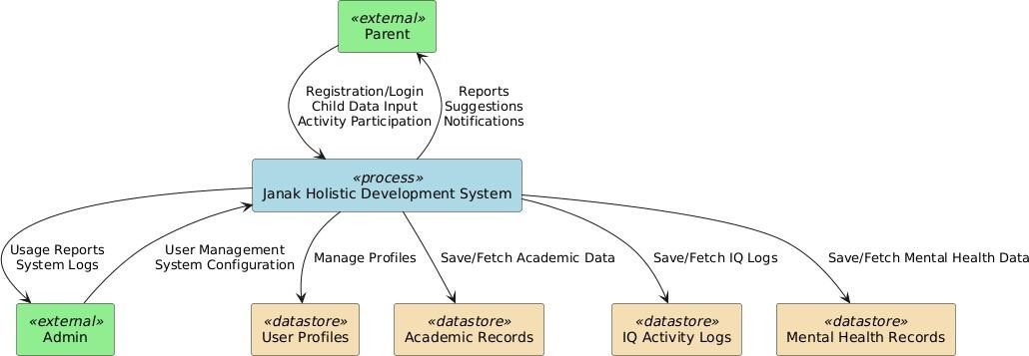

**Figure 4.1: Data Flow Diagram**

### Use Case Diagram

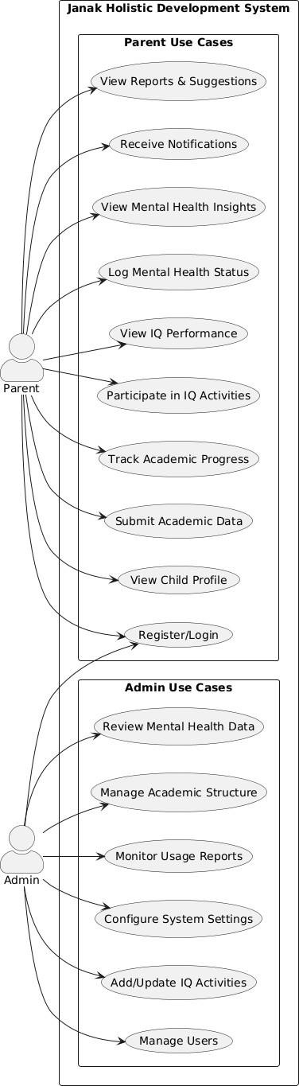

**Figure 4.2: Use Case Diagram**

### Database Design

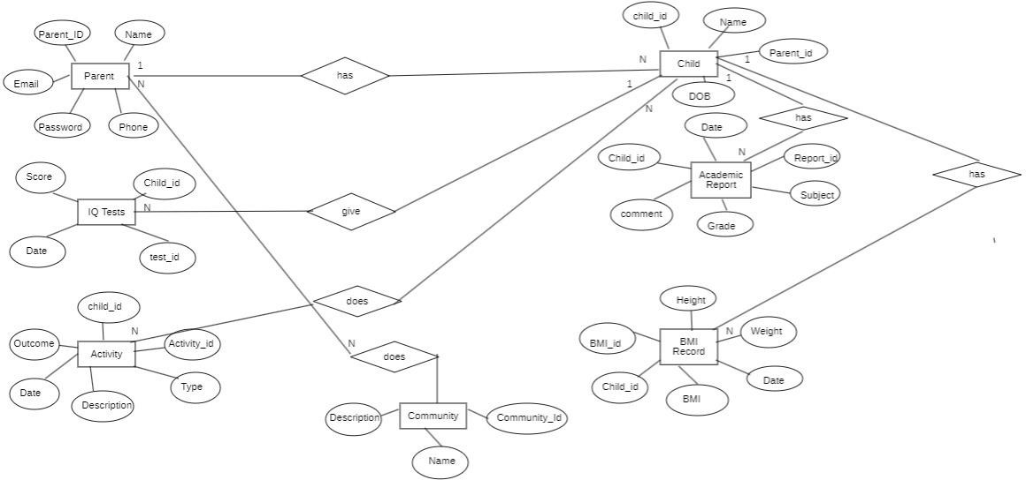

**Figure 4.3 : Database Design Diagram**

# CHAPTER - 5 IMPLEMENTATION

This chapter provides a holistic summary of the tools, technologies, and strategies used in the development of Janak: Nurturing Holistic Development application. The building of a secure, scalable, and user-friendly platform is portrayed by discussing programming languages, frameworks, databases, APIs, and machine learning

## Introduction to Tools and Technologies Used

Janak is developed using new generation cross-platform technologies, focusing on performance, accessibility, and real-time data management. These tools enable rapid development

#### Programming Languages

* + - 1. **Dart:** The primary language employed to create the mobile app with Flutter.
      2. **SQL:** Employed for structured data manipulation in local or cloud relational databases.
      3. **Python:** Used for implementing machine learning models that offer intelligent recommendations or predictions from user data.

#### Frameworks and Libraries

* + - 1. **Flutter:** Cross-platform user interface (UI) toolkit to build a single codebase mobile application for both Android and iOS.
      2. **Firebase:** Backend-as-a-Service (BaaS) platform for authentication, cloud Firestore database, and real-time sync

#### Database and Storage

* + - 1. **Firebase Firestore:** Cloud-hosted NoSQL database for real-time sync of data, especially to keep user profiles, activity tracking, and parental logs.
      2. **MySQL:** For storing structured data like academic records, screen time analytics, and health metrics.
      3. **Firebase Cloud Storage:** For the uploading and storage of user-generated content like images, documents, and multimedia files.

#### Development Tools

1. **Visual Studio Code (VS Code):** Main code editor utilized for app development with Dart.
2. **GitHub:** Version control system for collaboration and code management.
3. **Figma:** UI/UX design software utilized to design wireframes, mockups, and design prototypes prior to implementation.

### Dataset Description

The dataset consists of student performance, screen time logs, and health records collected from real-world or simulated data. It is used to train AI models that provide recommendations for academic improvement, health suggestions, and screen time reduction.

1. **IQ Dataset:**



1. **Screen Time Dataset:**

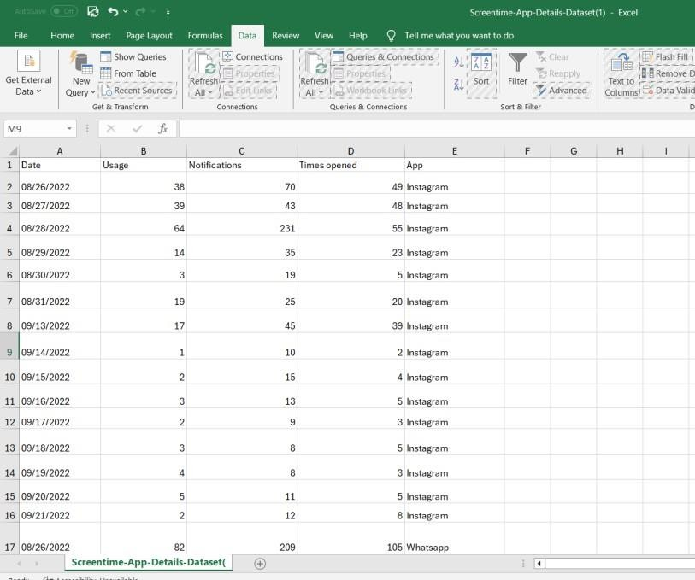

1. **BMI Dataset:**

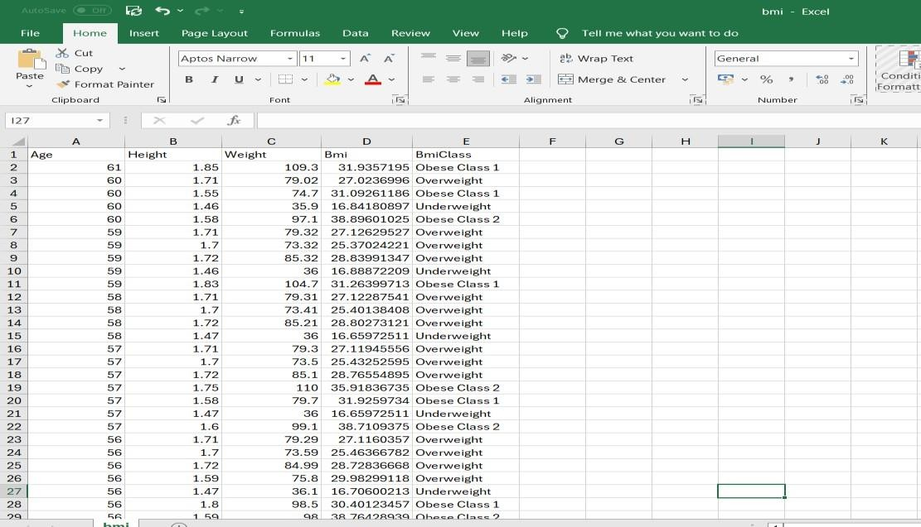

1. **Academic Scores Dataset:**

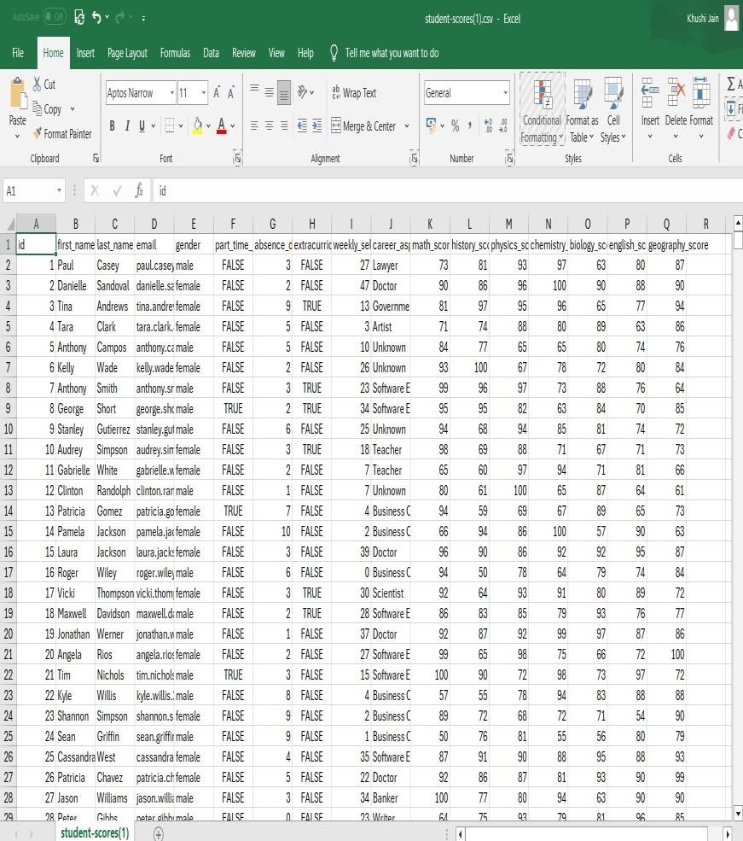

1. **Mental Health Dataset:**

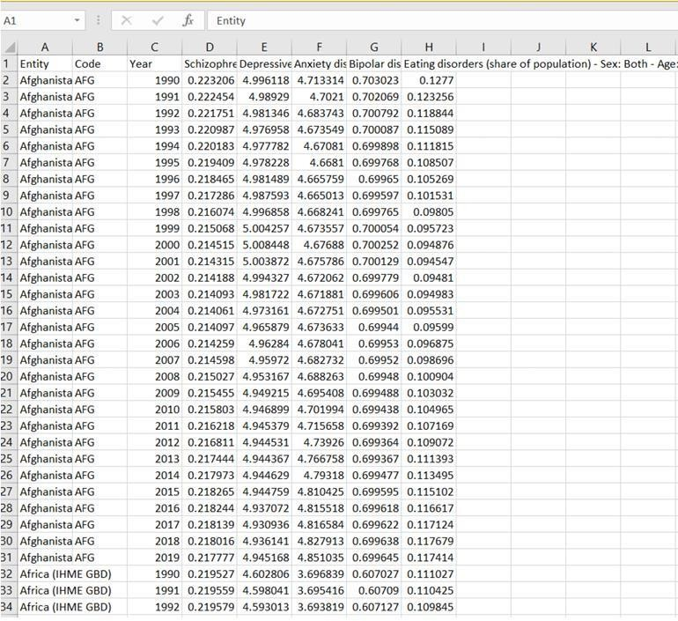

# CHAPTER 6: TESTING, AND MAINTENANCE

### Testing Techniques and Test Cases Used

#### Testing Techniques:

To make sure the Janak Nurturing Holistic Development application performs according to expectations and gives smooth experience to users, numerous software testing techniques were employed during the development lifecycle.These techniques ensured early detection, enhanced performance, and verification of both functional and non-functional requirements.

#### Integration Testing:

* + - * 1. Discusses the verification of the interaction between various modules of the app.
        2. When a flow of data happens smoothly between a feature combination, say IQ test affecting scholarship suggestions or user profiles interacting with community modules, compatibility is attained...
        3. Example: Validation of the usage and accessibility of data coming from the module for IQ test correctly in analysis for academic progression.

#### Regression Testing:

* + - * 1. Performed after updates like adding new features or fixing bugs.
        2. It makes sure existing working features such as login, BMI calculation, and goal setting still work and are not affected.
        3. Example: Once a new health feature has been added, the old functionalities are re-tested for stability.

#### Boundary Value Analysis (BVA):

* + - * 1. BVA checks the application at the input value's extreme limits.
        2. This method aids in the discovery of potential problems which could arise at the boundaries of acceptable input ranges.
        3. Example: Testing input for BMI using height and weight values at the extreme limit minimum and maximum.

#### Equivalence Partitioning (EP):

* + - * 1. The input values are classified into valid and invalid categories for maximum test coverage.
        2. It minimizes the overall number of test cases without compromising on robust testing.
        3. Example: Validation of IQ scores where the scores are 1–5 and any number outside this scope is rejected.

#### Usability Testing:

* + - * 1. Is the measure to test how intuitive and user-friendly the application is.
        2. It is concentrated on UI items such as font sizes, contrast of colors, button positioning, and navigation within features.
        3. Example: Making users able to fluidly navigate through academic records, health reports, and community features.

#### Security Testing:

* + - * 1. This confirms the protection of sensitive data stored and moved within the application.
        2. It entails Firebase Authentication rule testing and Firestore permission testing to stop unauthorized access.
        3. Example: Having the logged-in parent view or edit their child's health information

### Test Cases:

**Heath Module - BM**

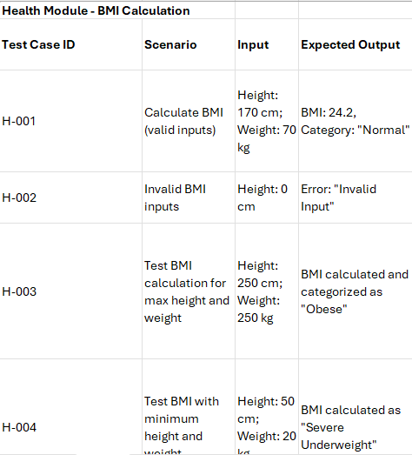

**Academic Module - Score Tracking**

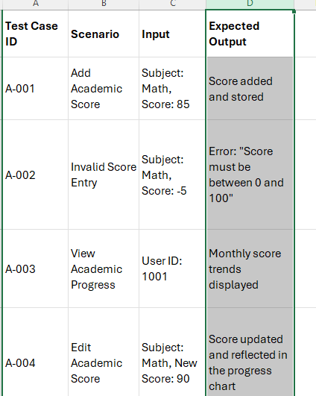

**Activity Module - Activity Tracking**



**IQ Testing Module**

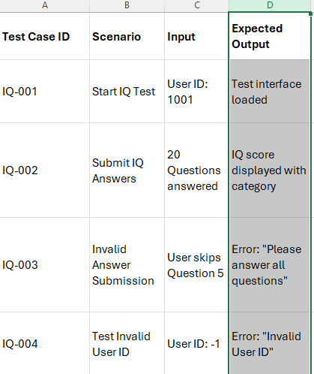

**Community Interaction Module:**

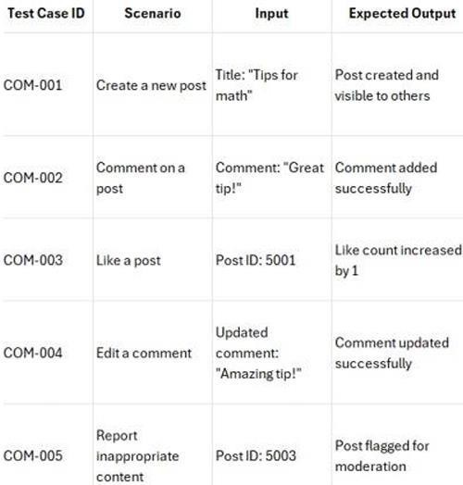

**Equivalence Partitioning:**

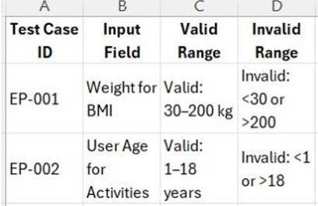

**Boundary Value Analysis Test Cases:**

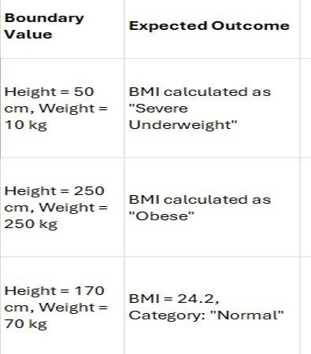

# CHAPTER – 7 RESULTS AND DISCUSSIONS

The chapter is a presentation of results, insights, and primary outcomes of the Janak: Nurturing Holistic Development application. It contains descriptive presentations of individual modules with snapshots of interfaces, summarizes major findings based on testing and user feedback, and defines the database structure implemented for storing and managing data.

### Description of Modules with Snapshots

The Janak: Nurturing Holistic Development application consists of several interactive modules that aim to assist parents in monitoring and enhancing their child's overall development.



***Figure 7.1*** *Splash screen of the Janak app representing its focus on holistic child development.*

#### User Authentication Module Features:

* + - * Secure login and registration via Firebase Authentication.
      * Email/password-based access control.
      * Basic security rules are set up through Firebase to limit unauthorized access.

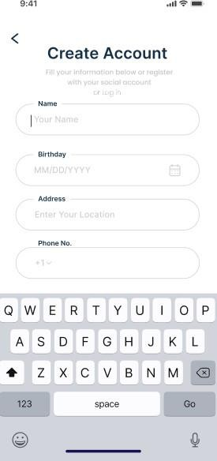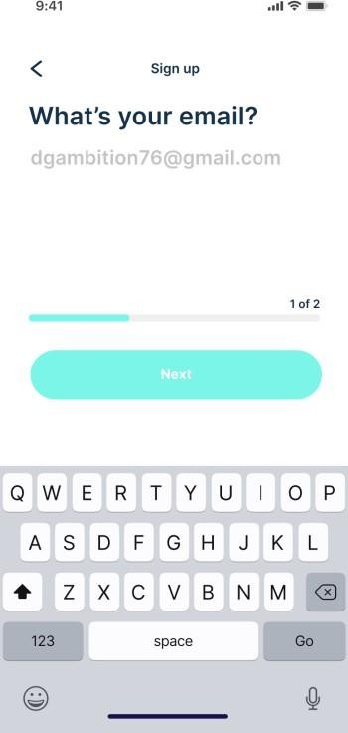

***Figure 7.1.1*** *Screen showing the user registration and email input interface implemented using Firebase Authentication.*

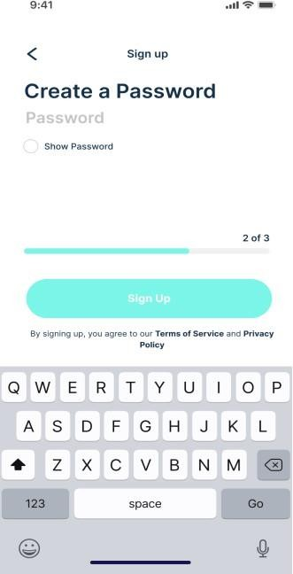

***Figure 7.1.2*** *Password creation screen for securely setting up a user password during registration.*

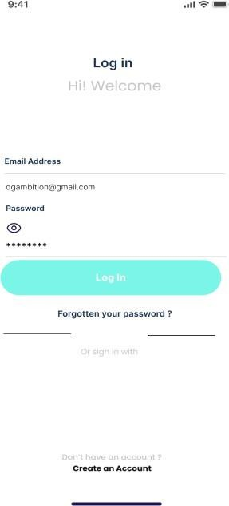

***Figure 7.1.3*** *Login screen allowing users to sign in with their registered email and password.*

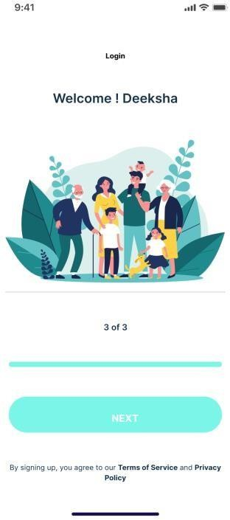

***Figure 7.1.4*** *Welcome screen shown after successful login or registration to greet the user.*

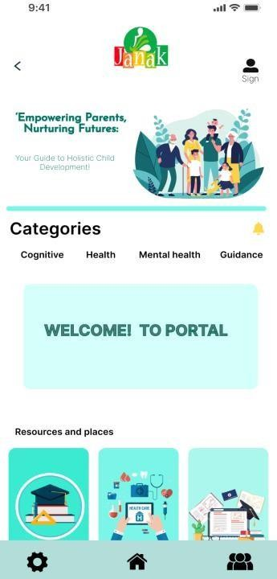

***Figure 7.1.5*** *Home/Dashboard screen showing portal categories and navigation options post authentication.*

#### Academic Progress Module Features:

* + - * Stores and graphs exam scores, attendance records, and subject-wise performance.
      * Offers improvement suggestions based on academic record.

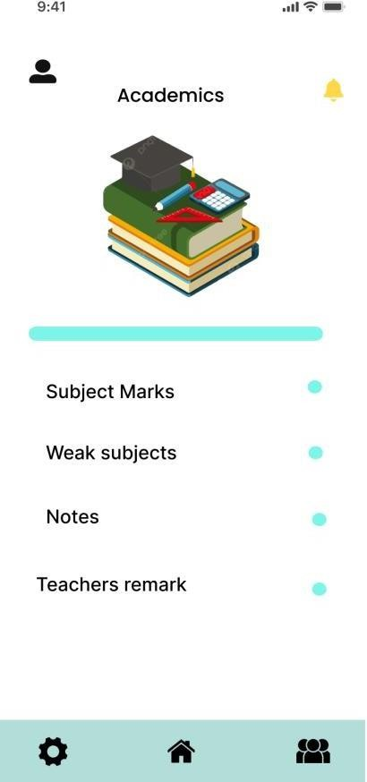

**Figure 7.1.2** *This screen shows the “Academics” section where users can navigate to view subject marks, weak subjects, notes, and teacher’s remarks.*

#### IQ Development Module Features:

* + - * Offers interactive IQ-based activities including puzzles, memory games, and logic exercises.
      * Tracks performance metrics such as accuracy, speed, and progress across difficulty levels.

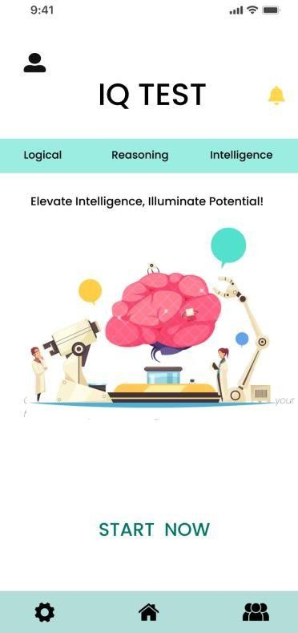

**Figure 7.1.3** *This screen introduces the IQ Test feature, allowing users to choose between Logical, Reasoning, and Intelligence categories before starting the test.*

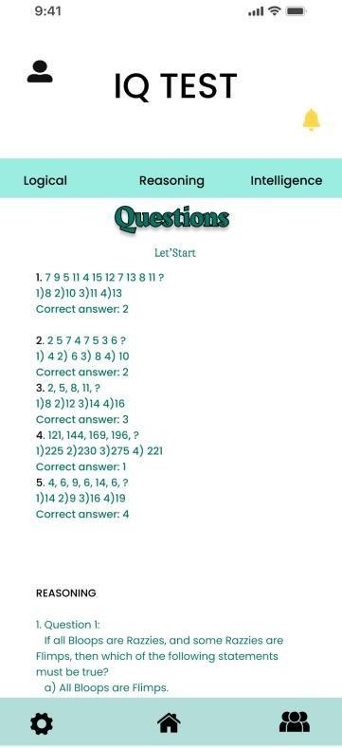

**Figure 7.1.4** - *This screen displays sample IQ test questions from various categories along with multiple choice answers and correct solutions.*



***Figure 7.1.5***– *IQ Test Question Screen Displaying Logical and Intelligence-Based Questions with Answer Options.*

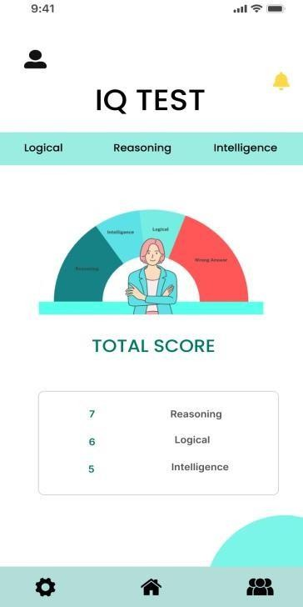

***Figure 7.1.6*** *– Post-Test Dashboard Showing Category-Wise IQ Test Scores and Overall Performance Breakdown.*

#### Health and Wellness Module Features:

* + - * Maintains BMI based on height and weight.
      * Tracks physical activity and mental wellness tests.

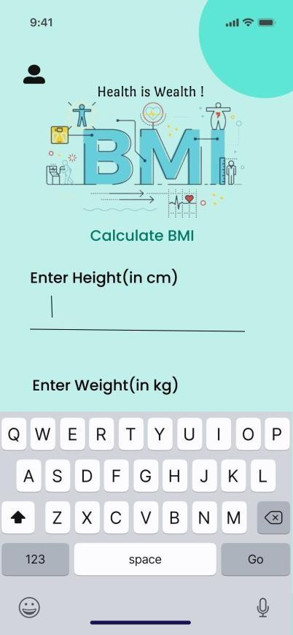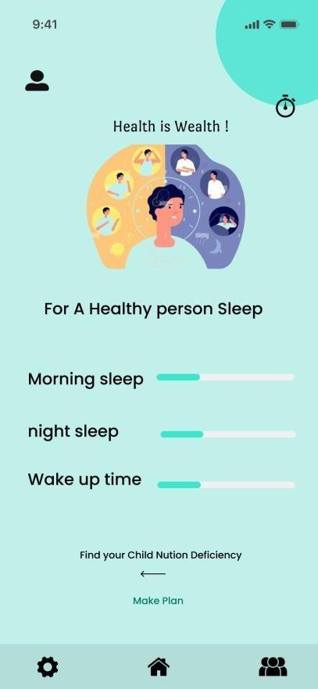

***Figure 7.1.4-*** *Health Monitoring Interface with BMI Calculation and Sleep Tracking Inputs*

#### Screen Time Monitoring Module Features:

* + - * Tracks average app use and screen time for each child.
      * Alerts parents when they exceed average use.

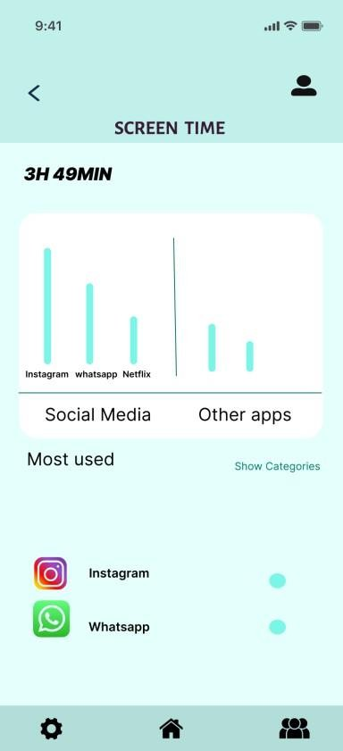

***Figure 7.1.5*** *– Screen Time Analytics Displaying App Usage Duration and Most Used Categories.*

#### Parent Community Forum Module Features:

* + - * Allow parents to ask questions and exchange experiences.
      * Has a voting and comment system to encourage meaningful interaction.

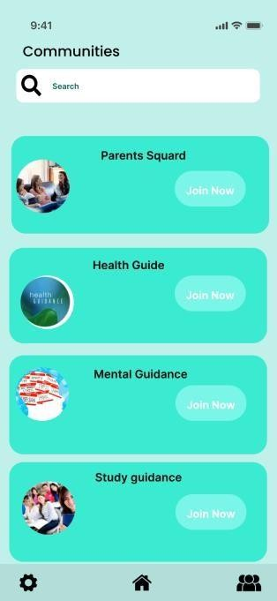

***Figure 7.1.6*** *– Parent Community Interface Supporting Discussions and Experience Sharing.*

#### Mental Health Module Features:

* Provides guided mental wellness activities such as mood tracking.
* Allows users to log daily emotional states and detect recurring patterns over time.

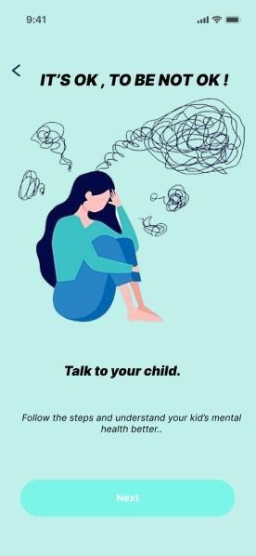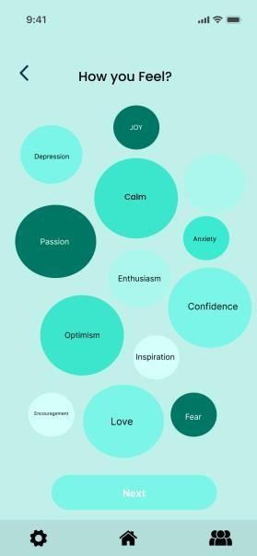

***Figure 7.1.7 –*** *Mental Health Interface for Guided Wellness Activities and Community Support*

### Key Findings of the Project

From testing, feedback, and user assessment, the following were noted about the impact and effectiveness of the application:

1. **Increased Parental Awareness:**85% of test users experienced enhanced understanding of their child's personal and academic growth.
2. **Effective Screen Time Management:**70% of parents noted decreased non-productive screen use by their child due to notifications and tracking.
3. **AI-Driven Recommendations Show Positive Impact:** Recommendations for academics, health, and screen time influenced students to form improved day-to-day routines and studying habits.
4. **Reliable and Scalable System:** Firebase ensured real-time data synchronization and secure storage. The app maintained stable performance with multiple concurrent users.
5. **Engagement in Parent Community:** 60%+ of users actively participated in discussions, highlighting the value of community support among parents.

### Brief Description of Database

The backend storage employs Firebase Firestore for real-time and structured data storage. The key collections (tables) are structured for handling user profiles, academic information, health records, and screen time data analytics.

#### Users Collection

**Field:** user_id, name, email, password.

**Purpose:** Holds parent account information and login credentials.

#### Children Collection

**Fields:** child_id, user_id, name, age, gender, class

**Purpose:** Holds child profile information and associates with respective parents.

#### Academic Data Collection

:

**Fields :** academic_id, child_id, subject, score, date

**Purpose:** Holds academic performance records to be analyzed and charted.

#### Health Data Collection

**Fields:** health_id, child_id, BMI, activity_log, wellness_score

**Purpose:** Holds health insights such as BMI and activity logs.

#### Screen Data Collection

**Fields:** screen_time_id, child_id, app_usage, duration, alert_status

**Purpose:** Tracks daily screen time and sends out alerts for overuse.

# CHAPTER 8

**CONCLUSION AND FUTURE SCOPE**

### Conclusion:

The Janak project fills an essential void in children's overall development with the integration of academic tracking, IQ improvement, and mental health monitoring in one easy-to-use digital platform. Through the combination of interactive modules and performance and emotional insights, the app enables parents to make better decisions on a child's development.

By providing personalized feedback and an interactive interface, Janak not only instills academic perfectionism but also fosters cognitive resilience and emotional intelligence in children. The project effectively showcases how technology can be used to facilitate a child's holistic development in an organized and easy-to-use format.

#### Future Scope:

The future potential of Janak is much wider than its initial deployment. Future updates could involve:

* AI-based insights to forecast learning patterns and suggest personalized learning trajectories.
* Gamification features to increase engagement with IQ and mental health activities.
* Integration with wearables for real-time tracking of physical and emotional states.
* Multi-language capability to accommodate linguistic diversity by region.
* Collaboration tools such as parent-teacher dashboards and peer learning networks.
* Expansion into teen development stages, emphasizing social behavior, career mapping, and emotional maturity.
* Data analytics dashboards for educators and psychologists to see larger trends across populations.

These developments would further establish Janak as an all-encompassing and scalable solution for the development of children in educational and home environments.

# REFERENCES

1. V. J. Rideout and B. Jones, Common Sense Media Census: Media Use by Kids 8–18. Common Sense Media, 2018.
2. S. Van der Linden and M. Valcke, “The use of mobile learning in early childhood education: A systematic review,” Int. J. Educ. Technol. High. Educ., vol. 13, no. 2, pp. 1–16, 201.
3. S. H. Landry, “The Role of Parents in Early Childhood Learning,” Encyclopedia on Early Childhood Development, Centre of Excellence for Early Childhood Development, Feb. 14, 2008.
4. K. A. Moore and B. Redd, “Children’s Mental Health: The Role of Parents,” Child Trends Research Brief, 2002.
5. A. J. Fincham and M. Rogerson, “Digital tools in early learning environments: Evaluating developmental outcomes,” Early Child Dev. Care, vol. 190, no. 7, pp. 1101–1115, 2020.
6. American Psychological Association, “Promoting children’s mental health,” APA Center for Children, Youth and Families, 2019.
7. S. Papert, Mindstorms: Children, Computers, and Powerful Ideas. Basic Books, 1980.
8. UNICEF, “Early Childhood Development: The Foundation for a Healthy and Productive Life,” UNICEF ECD Report, 2017.
9. D. S. Moore and M. T. Johnson, “Developmental trajectories of cognitive and emotional skills: The impact of early digital intervention,” Child Development Perspectives, vol. 14, no. 2, pp. 101– 107, 2020.

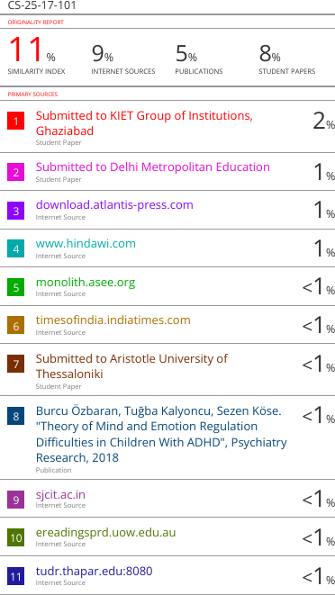

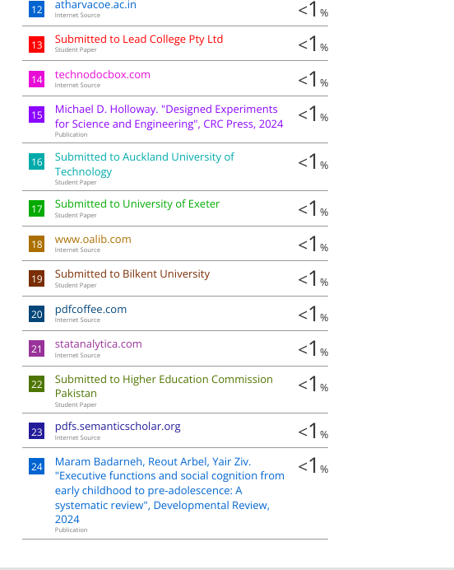

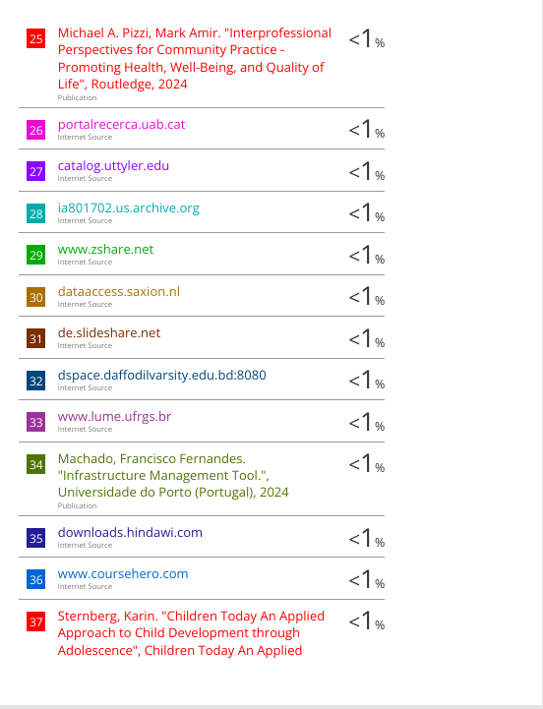



**Patent Publication Proof**

