**[PATENT NUMBER]**

**FORM 2**

THE PATENTS ACT, 1970 (39 of 1970)

&

THE PATENT RULES, 2003

Title of invention:

**NFT ArtHub :**

**An E-Commerce Platform for Buying and Selling Digital Art**

**Applicants :**

Ayush Mishra

Aniket Singh

Annu

Ankit Kumar Mishra

The following specification describes the invention and the manner in which it is to be performed.

**CROSS-REFERENCE TO RELATED APPLICATIONS AND PRIORITY**

[01] The present application does not claim priority from any patent application.

**TECHNICAL FIELD**

[02] The present disclosure relates to secure online marketplaces. More particularly, the invention pertains to a system and method for facilitating the buying, selling, and trading of digital art through a secure and decentralized e-commerce platform, ensuring financial empowerment for artists and transparency for buyers.

**BACKGROUND**

[03] In today's digital age, artists around the world are increasingly turning to online platforms to monetize their work. However, the lack of a secure, unified platform that caters to both international and national markets has posed significant challenges. Artists often face difficulties in ensuring their work is fairly compensated and securely transacted, while buyers struggle with confidence in the authenticity and value of the digital art they purchase.

[04] The advent of Non-Fungible Tokens (NFTs) offers a promising solution by allowing digital art to be securely tokenized and traded on blockchain networks. However, existing platforms often fall short in providing the necessary security measures and streamlined functionality needed for artists to effectively monetize their work on a global scale. Additionally, buyers require transparency and trust to confidently invest in digital art.

[05] The need for a single, secure platform that facilitates both international and national transactions is crucial. Current solutions lack the comprehensive features necessary to support secure monetization, artist empowerment, and buyer confidence. There is a demand for a platform that not only addresses these concerns but also incentivizes artists and enhances the overall integrity of the marketplace.

**SUMMARY**

[06] This summary introduces key aspects of a secure, decentralized e-commerce platform for digital art, named "NFT ArtHub." The platform is designed to offer artists a robust and secure means of monetizing their digital art, ensuring transparency and trust for buyers. This summary does not identify essential features of the claimed subject matter nor is it intended for use in determining or limiting the scope of the claimed subject matter.

[07] In one embodiment, NFT ArtHub provides a secure environment where artists can mint, list, and sell their digital art as NFTs. The platform integrates advanced security protocols to protect the integrity of transactions, ensuring that all sales are conducted with the highest level of trust. It supports multiple blockchain networks, enabling artists to reach a broad audience seamlessly and securely.

[08] A key focus of NFT ArtHub is the financial empowerment of artists. The platform equips artists with the tools to directly monetize their digital art, allowing them to mint NFTs, list their works for sale, and securely receive payments. Smart contracts are employed to automate royalty payments for secondary sales, ensuring artists benefit from their work over time.

[09] To build buyer confidence, NFT ArtHub ensures transparency throughout the transaction process. Each transaction is recorded on a blockchain, making the history of every digital artwork verifiable. Buyers can trust the authenticity of the art they purchase and feel secure in their investments.

[10] NFT ArtHub serves as a unified marketplace for digital art, eliminating the need for multiple platforms. This streamlined approach simplifies the process of buying, selling, and trading digital art, providing a comprehensive and accessible platform for artists and collectors alike.

[11] Beyond securing transactions, NFT ArtHub incentivizes artists by fostering a fair and transparent marketplace. Features such as automated royalty distribution, artist recognition programs, and community engagement tools are included to maintain marketplace integrity and promote collaboration and trust among users.

**BRIEF DESCRIPTION OF DRAWINGS**

[0010] The detailed description is described with reference to the accompanying figures. In the figures, the left-most digit(s) of a reference number identifies the figure in which the reference number first appears. The same numbers are used throughout the drawings to refer like features and components.

[0011] Figure 1 illustrates a network implementation of a system for managing and authenticating digital art and NFTs on a digital art platform.

[0012] Figure 2 illustrates the system components for securely managing and authenticating digital art and NFTs.

[0013] Figure 3 illustrates a data flowchart for managing and authenticating digital art , NFTs and website.

**DETAILED DESCRIPTION**

[0014] The present subject matter relates to a system for managing and authenticating digital art and Non-Fungible Tokens (NFTs) on a digital art platform. The system is configured to facilitate the creation, storage, and exchange of digital art assets securely via blockchain technology. It is designed to ensure the authenticity, ownership, and provenance of digital art by leveraging smart contracts and decentralized networks.

[0015] Figure 1 illustrates a network implementation of a system for managing and authenticating digital art and NFTs on a digital art platform. The system is designed to be implemented on a server, but it can also be deployed in various computing environments, including laptops, desktop computers, or cloud-based platforms. The system communicates with user devices (such as portable computers, smartphones, or tablets) through a network. These user devices interact with the system to create, buy, sell, or authenticate digital art and NFTs. The system is also connected to a blockchain network, which serves as the underlying infrastructure for verifying and recording transactions. Additionally, the system interacts with external data sources (such as digital art repositories or marketplaces) to pull in data relevant to the digital assets.

[0016] Figure 2 illustrates the system components in accordance with an embodiment of the present subject matter. The system includes at least one processor, an input/output (I/O) interface, and a memory. The processor is responsible for executing smart contracts and other blockchain-related operations. The I/O interface facilitates user interactions with the platform, allowing users to upload, view, or transact digital art. The memory stores various modules and data, including the smart contract execution module, the digital asset management module, and the NFT minting module. The system also contains a repository for storing metadata about the digital art and NFTs, as well as the transaction history associated with each asset.

[0017] Figure 3 illustrates Figure 3 depicts the data flowchart for user interactions on the NFT ArtHub platform, encompassing item viewing, transaction processing, and approval procedures. Users log into the platform to browse and view digital art items from the repository, with metadata and provenance details fetched from the blockchain. When selecting an item to purchase, the system initiates a secure transaction through the integrated payment gateway.

Before finalizing the transaction, an approval mechanism verifies the buyer's credentials, the NFT's authenticity, and compliance with platform requirements. Upon approval, the smart contract executes, transferring NFT ownership and recording the transaction on the blockchain. The new owner’s repository is updated with the NFT and its metadata, while the seller is notified and artist royalties are processed automatically.

[0018] Blockchain Integration and Security Features,The system is designed to operate in a decentralized environment, which eliminates the need for a central authority to oversee transactions. By utilizing blockchain technology, the system ensures that all transactions are secure, transparent, and tamper-proof. The integration of smart contracts further automates processes such as royalty payments to artists, ensuring they receive fair compensation upon the resale of their digital art. The platform's blockchain infrastructure also supports provenance tracking, enabling buyers to verify the authenticity and ownership history of digital artworks, thus enhancing the value and resale potential of these assets.

[0019] Artist Empowerment and Market Transparency,NFT ArtHub places a strong emphasis on empowering artists by providing them with tools to directly monetize their digital art. Artists can mint NFTs, list their works for sale, and securely receive payments without the interference of intermediaries. The platform’s smart contract system automates royalty payments, ensuring that artists continue to benefit financially from their work over time. For buyers, NFT ArtHub ensures transparency in every transaction by recording all relevant data on the blockchain. This allows buyers to verify the authenticity and provenance of the digital art they purchase, fostering confidence and trust in the marketplace.

[0020] User-Friendly Interface and Global Reach,The platform is designed with a user-friendly interface that caters to both artists and buyers, making the process of minting, listing, buying, and selling digital art seamless and accessible. NFT ArtHub supports multiple blockchain networks, allowing users to engage in transactions on a global scale, reaching a broader audience and maximizing their market potential. The platform’s comprehensive features make it a one-stop solution for all digital art transactions, eliminating the need for multiple platforms and streamlining the entire process.

[0021] Scalability and Interoperabilit,NFT ArtHub is built with scalability in mind, ensuring that the platform can handle an increasing number of users, transactions, and digital art assets as it grows. The system is designed to be interoperable with various blockchain networks and protocols, allowing for flexibility and adaptability as new technologies emerge. This ensures that the platform remains relevant and capable of supporting the evolving needs of the digital art market

**WE CLAIM:**

1. A system for managing a decentralized e-commerce platform for digital art, comprising:

a memory; and

a processor coupled to the memory, wherein the processor is configured to execute program instructions stored in the memory for:

securing digital art transactions through a tokenization algorithm that protects against piracy and unauthorized distribution;

implementing a provenance tracking system to enhance the value and resale potential of digital artworks;

generating, minting, and listing digital artworks as NFTs on the platform;

recording transaction data to ensure transparency and trust within the marketplace;

executing smart contracts to automate royalty payments, ensuring fair compensation for artists upon resale;

facilitating secure, transparent, and fair transactions through blockchain integration.

2. The system of claim 1, wherein the platform is decentralized and designed to eliminate financial barriers imposed by high fees, thereby providing artists with control over their intellectual property and ensuring timely payments.

3. The system of claim 1, wherein the processor is configured to:

* enable buyers to verify the authenticity and rarity of digital art pieces using blockchain-based provenance and transparency features;
* prevent unauthorized duplication of digital artworks by utilizing blockchain technology and decentralized storage.

4. The system of claim 1, wherein the platform includes an automated royalty distribution feature via smart contracts, incentivizing artists and fostering a sustainable ecosystem.

5. A method for managing a decentralized e-commerce platform for digital art, comprising processor-implemented steps of:

* generating and minting digital artworks as NFTs on a decentralized platform;
* recording transaction data and provenance information to ensure transparency and trust;
* executing smart contracts to automate royalty payments and ensure financial empowerment for artists;
* utilizing blockchain technology to prevent unauthorized duplication and enhance the integrity of digital artworks;

providing a user-friendly interface for artists to mint, list, and sell digital art, and for buyers to browse, purchase, and verify the authenticity of digital artworks.

6. The method of claim 5, wherein the platform supports secure and transparent transactions through the integration of multiple blockchain networks, allowing artists and buyers to engage seamlessly in a global marketplace.

7. The method of claim 5, wherein the platform includes features that empower artists by ensuring fair compensation through automated royalty payments and offering tools for managing intellectual property rights.

8. A computer program product having embodied thereon a computer program for managing a decentralized e-commerce platform for digital art, comprising:

* program code for generating and minting digital artworks as NFTs;
* program code for recording transaction and provenance data to ensure transparency and trust in the marketplace;
* program code for executing smart contracts to automate royalty payments and enforce intellectual property rights;
* program code for utilizing blockchain technology to prevent unauthorized duplication and enhance marketplace integrity.

9. The computer program product of claim 8, wherein the program further includes code for implementing a user-friendly interface that enhances engagement and satisfaction for both artists and buyers.

Dated this 06th Day of September 2024

**ABSTRACT**

**SYSTEM AND METHOD FOR SECURE TRANSACTIONS AND TRANSPARENCY IN DIGITAL ART MARKETPLACES**

The present disclosure relates to system(s) and method(s) for managing a decentralized e-commerce platform for digital art, specifically focusing on ensuring secure transactions, financial empowerment, and transparency. The system is designed to facilitate the minting, listing, and trading of digital artworks as NFTs (Non-Fungible Tokens). It includes functionality for generating and maintaining secure records of digital art transactions and provenance information. The system records transaction data to enhance transparency and verify the authenticity of digital artworks. Additionally, it is configured to execute smart contracts that automate royalty payments, ensuring fair compensation for artists upon each resale. The system further compares and validates transaction records to ensure accuracy and integrity within the digital art marketplace. This approach supports the creation of a robust, transparent, and artist-friendly ecosystem for digital art transactions.

**Figure1.**

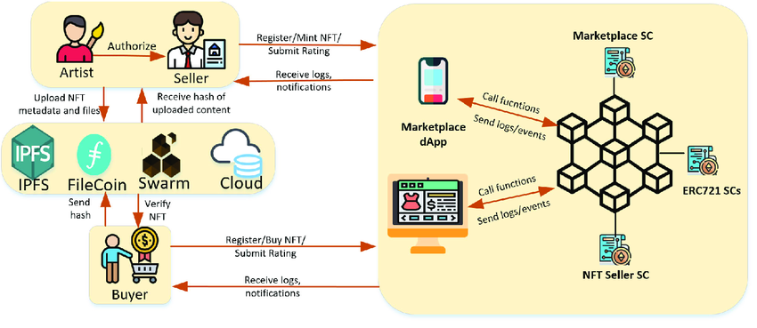

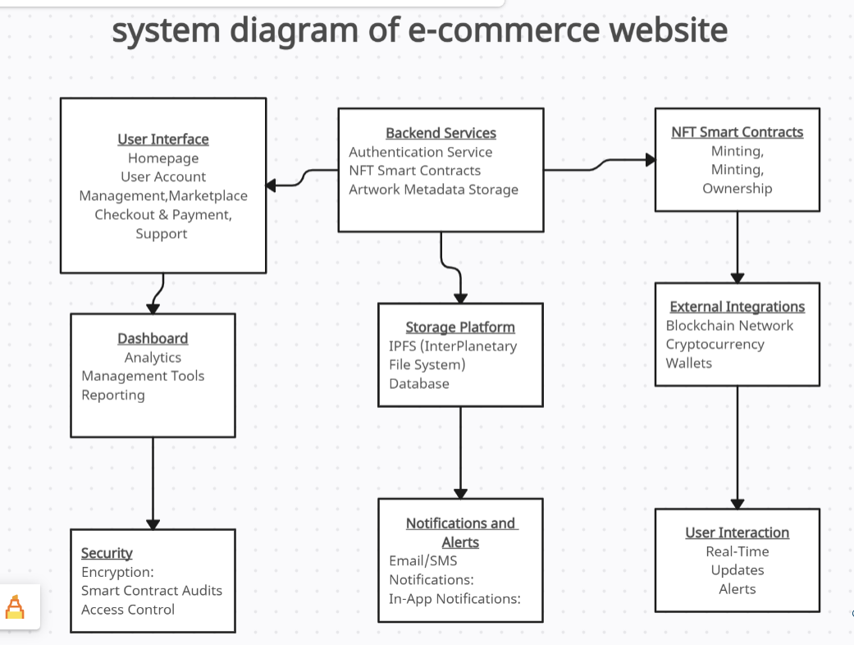**Figure 2: system component diagram for website**

**Figure 3: Data flow diagram**



