AICTE Application

SUBMITTED IN PARTIAL FULFILLMENT FOR THE REQUIREMENT OF THE AWARD OF DEGREE OF
BACHELOR OF TECHNOLOGY
IN
COMPUTER SCIENCE



Submitted by
GAURI CHUGH (2100290120081)
DHRUV GAJWANI (2100290120072)

Supervised by
MR. AMIT K. S. SANGER
Assistant Professor, Department of Computer Science
Session 2024-25

DEPARTMENT OF COMPUTER SCIENCE
KIET GROUP OF INSTITUTIONS, GHAZIABAD
(Affiliated to Dr. A. P. J. Abdul Kalam Technical University, Lucknow, U.P., India)
May 2025
DECLARATION
We hereby declare that this submission is our own work and that, to the best of our knowledge and belief, it contains no material previously published or written by another person nor material which to a substantial extent has been accepted for the award of any other degree or diploma of the university or other institute of higher learning, except where due acknowledgment has been made in the text.

Date:- 05-03-2025

Signature:
Name: Gauri Chugh
Roll No.:2100290120081
Signature:
Name: Dhruv Gajwani
Roll No.:2100290120072

CERTIFICATE

This is to certify that Project Report entitled “AICTE Application” which is submitted by Gauri Chugh (2100290120081) and Dhruv Gajwani (2100290120072) in partial fulfillment of the requirement for the award of degree B. Tech. in Department of Computer Science of Dr. A.P.J. Abdul Kalam Technical University, Lucknow is a record of the candidates own work carried out by them under my supervision. The matter embodied in this report is original and has not been submitted for the award of any other degree.

Date: 05-03-2025

Supervisor
Mr. Amit K.S. Sanger
Assistant Professor, Department of Computer Science

ACKNOWLEDGEMENT

It gives us a great sense of pleasure to present the report on the B. Tech Project undertaken during B. Tech. Final Year. We owe special debt of gratitude to Mr. Amit K. S. Sanger, Department of Computer Science, KIET, Ghaziabad, for his constant support and guidance throughout the course of our work. His sincerity, thoroughness and perseverance have been a constant source of inspiration for us. It is only his cognizant efforts that our endeavors have seen light of the day.
We also take the opportunity to acknowledge the contribution of Dr. Ajay Kr. Shrivastava, Dean, Department of Computer Science, KIET, Ghaziabad, for his full support and assistance during the development of the project. We also do not like to miss the opportunity to acknowledge the contribution of all the faculty members of the department for their kind assistance and cooperation during the development of our project.
Last but not the least, we acknowledge our friends for their contribution to the completion of the project.
Date : 05-03-2025

Signature:
Name : Gauri Chugh
Roll No.: 2100290120081
Signature:
Name : Dhruv Gajwani
Roll No.: 2100290120072

ABSTRACT

The All India Council for Technical Education (AICTE) oversees a vast repository of critical information pertinent to technical education in India, including institutional approvals, enrolment statistics, government schemes, and regulatory guidelines. Stakeholders frequently encounter challenges in efficiently accessing and interpreting this dispersed data via existing channels. To address this, an AICTE mobile application was conceived and developed as a dedicated, user-centric Android platform. This report elucidates the architectural design and systematic implementation of this application, realized using Kotlin and underpinned by Google Firebase for secure user identity management and the structured persistence of curated informational assets.
The primary objective of this AICTE mobile application is to empower students, educators, administrators, and policymakers by simplifying access to vital resources. Key features include an interactive dashboard presenting visualized statistical insights, originally derived from AICTE's Power BI dashboard extracts (via Excel sheets), offering clear views of educational metrics and trends. Dedicated modules provide curated access to AICTE initiatives and government schemes, directing authenticated users to official application portals. Furthermore, an integral resources section facilitates direct PDF downloads of essential handbooks and regulatory documents.
By amalgamating these functionalities, the AICTE mobile application significantly augments information retrieval efficiency, fosters greater transparency, and supports more agile, data-informed decision-making. This initiative represents a focused effort to improve stakeholder engagement and streamline interaction with vital information within India's technical education sector.
TABLE OF CONTENTS | Page No.
DECLARATION………………………………………… | 2
CERTIFICATE…………………………………………... | 3
ACKNOWLEDGEMENTS……………………………… | 4
ABSTRACT……………………………………………… | 5
LIST OF FIGURES……………………………………….  LIST OF TABLES………………………………..............  LIST OF ABBREVIATIONS……………………………. | 8  9  10
SDG MAPPING WITH JUSTIFICATION ……………... | 11
CHAPTER 1 INTRODUCTION  1.1 Background and Significance  1.2 Introduction to Project  1.3 Project Category  1.4 Objectives  CHAPTER 2 LITERATURE REVIEW  2.1 Literature Review  2.2 Research Gaps  2.3 Problem Formulation  CHAPTER 3 PROPOSED SYSTEM  3.1 Proposed System  3.2 Unique Features of The System  CHAPTER 4 REQUIREMENT ANALYSIS AND SYSTEM SPECIFICATION  4.1 Feasibility Study (Technical, Economical, Operational)  4.2 Software Requirement Specification  4.3 SDLC Model Used  4.4 System Design  4.4.1 Data Flow Diagrams  4.4.2 Use Case Diagrams  4.5 Database Design  CHAPTER 5 IMPLEMENTATION  5.1 Tools and Technologies Used.  CHAPTER 6 TESTING, AND MAINTENANCE  6.1 Testing Techniques and Test Cases Used  CHAPTER 7 RESULTS AND DISCUSSIONS  7.1 Description of Modules  7.2 Key findings of the project  CHAPTER 8 CONCLUSION AND FUTURE SCOPE  REFERENCES  Turnitin Plagiarism Report  Research Paper Acceptance Proof  Research Paper  Proof of patent publication | 13  14  15  16  19  30  32  35  39  42  45  48  49  49  50  51  52  54  57  59  62  66  68  69  70  78

LIST OF FIGURES

Figure No. | Description | Page No.
4.1 | Data Flow Diagram | 49
4.2 | Use Case Diagram | 50
4.3 | Database Diagram | 51

LIST OF TABLES

Table. No. | Description | Page No.
2.1 | Related Work Review | 19
6.1 | Test Cases | 54

LIST OF ABBREVIATIONS

AICTE
BI
PDF
EDTech
NEP
QIP
RPS
UHV
ETL
HTTP
API

All India Council for Technical Education
Business Intelligence
Portable Document Format
Education Technology
National Education Policy
Quality Improvement Program
Research Promotion Scheme
Universal Human Values
Extract, Transform, Load
Hypertext Transfer Protocol
Application Programming Interface

SDG Mapping with Justification

SDG 4: Quality Education
Ensure inclusive and equitable quality education and promote lifelong learning opportunities for all.
- Enhanced Access to Educational Information: The app centralizes AICTE-approved educational resources, ensuring students and institutions can make informed decisions.
- Support for Skill Development: By providing structured data on courses, scholarships, and institutions, the platform facilitates skill enhancement and career progression.
SDG 9: Industry, Innovation, Infrastructure
Build resilient infrastructure, promote inclusive and sustainable industrialization, and foster innovation.
- Centralized Educational Resource Hub: The app consolidates AICTE-related data, providing a unified digital infrastructure for students and institutions.
- Innovation in Information Access: By leveraging technology, the platform simplifies the search for relevant courses, schemes, and institutions, fostering an efficient learning ecosystem.
SDG 16: Strong Institutions
Promote peaceful and inclusive societies, provide access to justice for all, and build effective, accountable, and inclusive institutions at all levels.
- Transparency in Educational Governance: The app ensures that AICTE policies, institutions, and schemes are easily accessible, promoting regulatory compliance and informed decision-making.
- Improved Accountability: By providing accurate data, the platform strengthens institutional trust and governance.
SDG 17: Partnerships for the goals
Strengthen the means of implementation and revitalize the global partnership for sustainable development.
- Collaboration Between Institutions and Stakeholders: The platform fosters partnerships among students, educational institutions, and industry leaders.
- Support for Policy Implementation: AICTE’s data integration in the app helps in the smooth implementation of various government educational initiatives.

CHAPTER 1
INTRODUCTION

1.1 Background and Significance
The accelerated evolution of digital technologies has fundamentally reshaped how information is managed and accessed across various sectors. Within the sphere of higher education governance, regulatory authorities such as the All India Council for Technical Education (AICTE) are tasked with overseeing and analyzing extensive institutional datasets critical for strategic planning and policy formulation. Historically, stakeholders attempting to retrieve AICTE's statistical information, often presented through platforms like Power BI dashboards, encountered usability hurdles stemming from intricate interfaces and limited mobile-optimized access, which complicated effective data comprehension. This project directly confronts this accessibility issue by developing a dedicated mobile application designed to present curated AICTE data, initially derived from such dashboards, in a seamlessly accessible and visually intuitive format.
This mobile application offers considerable value to a wide range of users, including prospective students, academic professionals, educational administrators, and policy analysts, all of whom depend on timely and accurate perspectives regarding AICTE-accredited institutions, student enrollment figures, faculty demographics, and other vital performance metrics. By employing a cloud-based backend (Firebase) for managing this structured, curated data and incorporating robust data visualization methods, the application enhances the clarity and interpretability of complex statistical information. This approach empowers users to derive meaningful insights and make better-informed judgments without requiring direct interaction with potentially complex source dashboards.
The core significance of this undertaking is its capacity to translate extensive raw data points into actionable understanding for a broader audience. Through a streamlined mobile interface that simplifies information discovery and visual data presentation, this application represents a progressive step in modernizing how AICTE's informational assets are disseminated. It aims to enhance user engagement, promote greater transparency in the technical education sector, and support more agile, evidence-based decision-making processes for all involved stakeholders.

1.2 Introduction
This AICTE mobile application is conceived as a dedicated conduit for critical educational information, designed to be readily available to students, academic professionals, and institutional bodies. Through the provision of an intuitive and navigable user interface, the application aims to significantly improve the user experience when seeking AICTE-related data. It offers consolidated access to vital information, including visualized statistical overviews derived from AICTE's Power BI dashboard extracts, curated details on government schemes and initiatives with direct links to application portals, and access to key policies or regulatory documents, thereby mitigating the often-intricate process of navigating the extensive official AICTE website.
The application endeavors to simplify engagement with AICTE's informational resources by incorporating several core functionalities. A central feature is its visually compelling statistics dashboard, which articulates key educational metrics and trends in an accessible graphical format, aiding stakeholders in their analytical and decision-making processes. Furthermore, dedicated sections within the app provide organized pathways to discover government initiatives, facilitating user redirection to official portals. Access to essential regulatory documents, such as handbooks, is streamlined through a direct PDF download capability.
By enhancing both the ease of access and the level of user engagement with these educational assets, this AICTE mobile application seeks to redefine how stakeholders interact with crucial information. It promises to reduce the effort and time typically involved in sourcing specific data, while simultaneously fostering greater transparency and heightened awareness of governmental programs and AICTE directives. This project, therefore, is positioned to support the advancement of technical education institutions throughout India, directly contributing to AICTE’s overarching mission of refining educational governance and broadening its informational outreach.

1.3 Project Category
This undertaking is primarily situated within the Educational Technology (EdTech) and Information Management domains, given its core objective of creating a mobile application to improve access to the extensive resources managed by AICTE. Through the strategic use of mobile technology to consolidate vital information, the application functions as a specialized digital portal, enabling students, academic staff, institutional leaders, and policy developers to efficiently obtain essential data. Its emphasis on enhancing information retrieval and user interaction resonates with contemporary EdTech advancements, which increasingly employ digital tools to refine educational administration and governance processes.
The project also aligns closely with the Government and Public Services Technology (GovTech/PublicTech) category, as its function involves the structured dissemination of official policies, regulatory frameworks, and schemes overseen by AICTE. The application is designed to be instrumental in fostering awareness of various educational initiatives and can indirectly support adherence to governmental guidelines by making them more accessible. Through its provision of curated data (managed within a structured Firebase backend) and direct links to official resources, the project champions transparency and contributes to digital governance efforts within the education sector, aiming to provide stakeholders with reliable, comprehensible information.
Finally, this initiative is fundamentally a Mobile Application Development project. The development efforts are centered on constructing an intuitive and user-centric Android application designed to optimize the user experience. The incorporation of features such as dynamic data visualization for statistical insights, curated lists for initiatives and resources, WebView integration for accessing external portals, and PDF download capabilities ensure fluid navigation and meaningful engagement. By embracing a mobile-first approach, this project addresses the escalating demand for accessible digital solutions in education, thereby rendering AICTE's resources more readily available and interactive for a wide user base.

1.4 Objectives
1.4.1. To Enhance Information Accessibility:
The application aims to consolidate key AICTE informational assets, simplifying the process for users to locate pertinent details swiftly. By presenting curated data (statistical insights, scheme information, resource links) in a structured manner within a dedicated mobile environment, it seeks to provide a more direct alternative to navigating extensive and potentially multifaceted official websites for essential information.
1.4.2. To Improve User Experience:
A core goal is to deliver an intuitive and user-centric interface that facilitates smooth interaction and makes information discovery both efficient and straightforward. Features such as categorized content for initiatives and resources, clear visual presentation of statistical data through charts, and logical navigation paths are designed to optimize usability. The application endeavors to transform complex datasets and extensive lists of resources into more readily digestible and engaging formats.
1.4.3. To Foster Transparency and Awareness of Official Information:
The application strives to offer clear and direct pathways to official AICTE policies, regulatory documents (via PDF downloads), and government schemes (via WebView links to portals). By making this information more readily available and understandable, it aims to keep stakeholders better informed about current guidelines, available initiatives, and compliance expectations, thereby promoting a more informed educational community.
1.4.4. To Increase User Engagement and Information Uptake:
Through features like interactive dashboards displaying key educational statistics and organized sections for AICTE schemes and resources, the application intends to keep users updated and engaged. Visually appealing design and focused content presentation are employed to encourage regular interaction with the platform, thereby cultivating a more connected and well-informed user base concerning AICTE matters.
1.4.5. To Provide Convenient Access to Key AICTE Guidelines and Resources:
The application endeavors to consolidate links to vital AICTE policies, handbooks, and guidelines within an easily accessible reference module. Users will be able to quickly browse curated lists and directly download relevant documents, ensuring that institutions and individuals can more easily stay informed about current educational regulations and operational procedures.
CHAPTER 2
LITERATURE REPORT

2.1 Literature Review
A solid foundation in existing research and knowledge is essential to ensure the project's success. In this section, we delve into a comprehensive literature review. We explore a range of papers, journals, articles, and techniques related to development in the field of mobile application development.
REFERENCE | TOPIC | TECHNIQUES USED | RESULTS
 | Review 1: “Comparison of websites and mobile applications for e-learning” | The research used a qualitative approach to assess user preferences for e-learning applications in higher education. Two groups of international students aged 21-30 were assigned to either a website or a mobile app specifically designed for the study. Data collection involved semi-structured interviews with four participants after they used the e-learning platforms. The web app was built with dynamic HTML and responsive design, while the mobile app ran on Android. Interview questions focused on user experience, clarity of information, familiarity with e-learning apps, and suggested improvements. The qualitative data gathered were analyzed to understand user experience and preferences. | The study revealed that mobile applications provided a more convenient and user-friendly experience for e-learning. Participants found the mobile app's portability and adaptability to be significant advantages, allowing them to learn on the go without needing a constant internet connection. The mobile app's interface was praised for its simplicity and ease of navigation, offering a more intuitive user experience compared to the web application. Additionally, the mobile app’s ability to leverage device features like geolocation and camera enhanced interactivity. Although some participants mentioned occasional difficulties with accessing specific visual content, they preferred the flexibility and convenience that mobile applications provided for e-learning.
 | Review 2: “AICTE Initiatives for Quality Enhancement in Technical Education” | The AICTE employed various techniques to improve technical education in India, aligning with the National Education Policy (NEP) 2020. It established multiple specialized cells, such as the Institutional Development Cell and the Faculty Development Cell, to support academic and faculty growth. Programs like the "Grant for Organizing Conference" facilitated knowledge sharing among academicians. The "Scheme for Promoting Interests, Creativity, and Ethics among Students (SPICES)" was designed to foster creativity and teamwork. The "Research Promotion Scheme (RPS)" provided financial assistance for innovative research, while the "Skill Development Cell" aimed to promote vocational training. AICTE also mandated a three-week induction program focusing on Universal Human Values (UHV), underscoring a holistic approach to technical education. | AICTE's initiatives led to notable improvements in India's technical education system. The Faculty Development Cell's programs increased the number of Quality Improvement Programme (QIP) centers from 466 in 2016 to 653 in 2018, indicating a 40% growth in faculty development. The Research Promotion Scheme sanctioned over 550 research projects between 2013 and 2020, bolstering research efforts in engineering sciences. The Skill Development Cell's vocational programs provided hands-on experience, contributing to enhanced employability. The AICTE Internship Enterprise Portal addressed the shortage of internship opportunities by connecting students with government and corporate sectors. The institutional emphasis on accreditation and the introduction of the Margdarshan Initiative further ensured quality and accountability. Through these measures, AICTE achieved a comprehensive approach to elevating technical education in India.
 | Review 3: “Introduction to Business Intelligence (BI) and data extraction” | To conduct research on Business Intelligence (BI) and data extraction, various techniques were employed. Data gathering involved querying SQL databases to retrieve structured data and using web scraping methods to extract information from websites. APIs were used to access data from web services, while file parsing tools extracted data from text files and spreadsheets. ETL (Extract, Transform, Load) tools streamlined the extraction process by automating data collection, transformation, and integration. Incremental extraction techniques ensured efficient data retrieval, minimizing resource use. Data validation processes and governance frameworks were implemented to maintain data quality and compliance with security and privacy standards. | The research revealed significant insights into the benefits and challenges of Business Intelligence (BI) and data extraction. Effective BI implementation led to improved operational efficiency, data-driven decision-making, and a competitive edge. Data extraction methods proved successful in retrieving valuable information from diverse sources, supporting real-time reporting and advanced analytics. However, challenges such as data quality, scalability, and data security emerged, requiring robust governance frameworks and error-handling protocols. The study highlighted the importance of addressing these challenges through careful planning and technology integration. Overall, the results emphasized the critical role of data extraction in achieving effective BI and organizational success.
 | Review 4: “ANDROID BASED MOBILE APPLICATION DEVELOPMENT and its SECURITY” | This paper presents a layered approach to Android application development, offering a systematic workflow from data handling to user interface design. The approach features multiple layers: HTTP for managing server communication, API for data parsing and request handling, a Generic Data layer to manage business logic, caching, and error handling, and a platform-dependent data layer for device-specific data storage. The final UI layer is responsible for managing user interactions and visual presentation. Security is addressed through the Android Application Sandbox (AASandbox), a hybrid of static and dynamic analysis that detects suspicious applications by monitoring system calls and other behaviors. | The paper's results demonstrate the effectiveness of the layered approach in building robust Android applications. The multi-layer structure streamlines development by separating concerns, allowing developers to focus on specific components without affecting the entire system. The approach also enhances application security through the AASandbox, which detects potentially harmful applications through a combination of static and dynamic analysis, offering an additional security layer for Android users. The proposed architecture provides a flexible and scalable environment for Android development, supporting complex applications and facilitating efficient interaction between components, leading to better user experiences and security outcomes.
 | Review 5: “RESTful API Testing Methodologies: Rationale, Challenges, and Solution Directions” | The study applied a systematic literature review (SLR) to evaluate methodologies for testing RESTful APIs. A comprehensive search strategy targeted various databases, including IEEE Xplore, Science Direct, Scopus, and Web of Science, among others. To ensure the inclusion of relevant studies, predefined selection criteria were applied, focusing on RESTful API testing methodologies, unit test generation, and related challenges. The study included a thorough quality assessment to ensure high-quality papers. Data extraction and synthesis focused on the testing approaches, tools, frameworks, and the challenges in generating unit tests for RESTful APIs. | The SLR identified key challenges in RESTful API testing, including security concerns, non-standardized description documents, and complex input types. The findings highlighted a lack of standardized solutions for authentication-enabled RESTful APIs, leading to difficulties in achieving high code coverage. The review categorized existing solutions into three primary approaches: tools, methodologies, and frameworks. It also underscored the limited support for protected RESTful API testing, indicating the need for manual testing and resulting in lower code coverage. These results suggest that further research is required to address authentication and standardization challenges in RESTful API testing.
 | Review 5: “Evaluating Usability of Mobile Learning Applications” | This study designed a mobile learning (m-Learning) prototype using Java and Android SDK to evaluate user interface effectiveness. A framework was proposed to measure core usability aspects like ease of navigation, learnability, and visual clarity. The application was compared against a popular learning app using user feedback collected via structured questionnaires. | The study found that users rated the custom-built application more intuitive and visually appealing. Improved layout and streamlined interactions led to greater user satisfaction, especially in terms of task completion time and reduced cognitive load. The findings support the importance of UX-focused development in enhancing m-Learning tools.
 | Review 5: “A Scalable Architecture for Near Real-Time Data Extraction in BI” | This research introduces DOD-ETL, a distributed ETL framework tailored for near real-time data processing in Business Intelligence systems. The architecture leverages on-demand data pipelines, parallel task execution, and in-memory caching to reduce latency and boost ETL throughput. The framework was designed to be platform-agnostic and easily integrable into legacy systems. | Testing in a live industrial environment showed up to 10x faster processing speeds over traditional ETL tools. Real-time data availability improved decision-making and reporting for operational teams. DOD-ETL demonstrated minimal resource overhead, making it an efficient choice for large-scale enterprise applications.
 | Review 5: “Enhanced Permission Management in Android Systems” | The paper proposes a fine-grained Android permission control model that functions without root access. It includes the use of policy-based descriptors and system-level hooks to control app behavior dynamically. An evaluation module analyzes incoming requests based on predefined security rules, improving runtime access control. | This approach effectively restricted unnecessary access to sensitive device features while maintaining system performance. It allowed users to apply personalized permission strategies without modifying the Android OS or requiring advanced privileges, offering a practical and secure solution for end-users concerned with app privacy.
 | Review 5: “Security Analysis of Android Applications Using Static and Dynamic Techniques” | This research focuses on analyzing Android applications for malicious behavior using a combination of static (code analysis) and dynamic (runtime monitoring) techniques. The study incorporates tools such as FlowDroid, DroidBench, and DroidScope for detecting API misuse, privacy leaks, and behavioral anomalies. The hybrid analysis model enhances detection accuracy and reduces false positives. | The hybrid system successfully identified threats like unauthorized data access, embedded malware, and suspicious network activity in both open-source and commercial apps. Static analysis alone missed context-specific behaviors, while dynamic monitoring helped capture execution-specific threats. The combined framework offers a stronger foundation for mobile security solutions, especially in enterprise and government deployments.
 | Review 5: “A Comparative Study of Web-based and Mobile Learning Systems” | This study investigates the usability, engagement, and learning outcomes of web-based learning platforms versus mobile learning applications. It uses a quantitative framework involving usability heuristics, task performance metrics, and learning retention rates. The study deployed both a responsive web app and a native Android app built with Java and XML, integrating SCORM-compliant learning modules and quizzes. | The findings suggest that mobile applications promote higher user engagement due to push notifications, offline access, and intuitive navigation. While both platforms were effective for content delivery, mobile apps showed a 17% improvement in learning retention among users. The paper highlights the importance of mobile-first strategies in educational technology and suggests that combining mobile interactivity with offline functionality significantly enhances learning experiences.
Table 2.1

2.2 Research Gaps
While data analytics and visualization are increasingly prevalent across sectors, a specific deficiency persists in the effective mobilization of structured statistical data for accessible decision-making within the Indian technical education domain, particularly concerning information managed by AICTE. Current platforms, often web-based dashboards or comprehensive reports may offer in-depth insights but frequently lack the immediate, user-centric mobile interface necessary for stakeholders who require rapid access to specific metrics or updates on the go. Many existing educational applications, if available, tend to provide information siloed within individual institutional contexts, rather than offering a consolidated, AICTE-centric view that would allow for a broader understanding of national trends or comparative statistics across approved institutions.
Moreover, although sophisticated business intelligence tools can provide powerful analytical capabilities, their operational complexity often presumes a level of technical proficiency that may not be universal among all AICTE stakeholders, including students, a significant portion of faculty, or even some administrative personnel. This creates an accessibility divide, where valuable educational statistics and official information remain underutilized due to the expertise required for effective navigation and interpretation. Consequently, a notable gap is evident in the availability of an intuitive mobile application specifically designed to present AICTE-centric institutional data, scheme details, and regulatory information in an easily comprehensible and readily actionable format.
Furthermore, existing systems often fall short in seamlessly integrating user-oriented features tailored to the specific needs of the AICTE ecosystem. For example, the provision of easily navigable, curated lists of government initiatives with direct links to application portals, or a straightforward mechanism for accessing and downloading official AICTE handbooks and guidelines via a mobile device, is not consistently available in a unified platform. The unmet need for a structured mobile application capable of delivering key statistical trends (derived from sources like AICTE's Power BI visuals), alongside direct pathways to official schemes and resources in a simplified and engaging manner, remains a clear area for improvement. This project, therefore, endeavors to address these identified lacunae by developing a mobile application focused on making AICTE-related data and resources more broadly accessible, interpretable, and user-friendly.

2.3 Problem Formulation
The effective governance and advancement of India's extensive technical education sector, overseen by the All India Council for Technical Education (AICTE), fundamentally relies on the timely accessibility and clear interpretation of a vast array of data. However, a significant impediment currently exists for a diverse range of stakeholders—including prospective and current students, academic faculty, institutional administrators, policy developers, and educational researchers—due to the absence of a dedicated, easily navigable, and interactive mobile application for AICTE-related information. Presently, these users predominantly depend on official AICTE web portals and associated web-based dashboards, such as those developed using Power BI. While these platforms are data-rich, their inherent design, often optimized for desktop environments, can present considerable navigational complexities on mobile devices. Users frequently report difficulties in efficiently filtering large datasets, isolating specific statistical insights, or quickly locating official documents and scheme details without extensive browsing. This friction in accessing information directly limits the agility and effectiveness of data-driven decision-making processes across various levels of the technical education ecosystem.
A further substantial challenge encountered by many stakeholders is the inherent intricacy associated with the analysis and comprehension of comprehensive educational statistics. Many individuals, ranging from students attempting to understand the broader landscape of approved institutions and program availability, to institutional leaders assessing performance benchmarks, or policymakers evaluating national and regional educational trends, may lack the specialized data analysis expertise or the time required to distill pertinent information from complex reports or multi-layered dashboards. Existing platforms, while providing access to raw or aggregated data, often necessitate a structured, methodical approach to data retrieval and interpretation that can be daunting for non-technical users. This creates an "information usability gap," where valuable data exists but remains underutilized because its insights are not readily and quickly accessible to those who could most benefit from them.
Moreover, there is a discernible absence of a dedicated, mobile-first platform that cohesively consolidates key AICTE statistical overviews (such as those presentable from Power BI dashboard extracts), curated information on pivotal government schemes and institutional initiatives, and direct access to essential regulatory documents in a unified, user-friendly format. Without such a centralized mobile solution, users often face a fragmented information-seeking experience, requiring them to consult multiple disparate sources. For instance, identifying relevant AICTE schemes, understanding their application procedures via official portals, or obtaining the latest version of an approval process handbook can involve navigating several different sections of the AICTE website or other related government sites. The lack of a streamlined mobile interface specifically designed to present AICTE's visualized data trends and provide direct, categorized pathways to its diverse resources significantly curtails on-the-go usability, limits broader awareness of available programs and data, and can impede swift, informed action.
Therefore, to comprehensively address these multifaceted issues of accessibility, interpretability, and consolidation, this project undertakes the design and development of an Android-based mobile application. The central objective is to significantly simplify and enhance access to essential AICTE data and official resources. This will be achieved by providing an intuitive user interface, clear and interactive data visualizations derived from curated sources, organized and direct pathways to official information on schemes and initiatives, and convenient mechanisms for accessing key regulatory documents, thereby enabling more seamless data interpretation and empowering more effective and timely decision-making for all stakeholders involved in India's technical education sector.

CHAPTER 3
PROPOSED SYSTEM

3.1 Proposed System
The proposed "AICTE mobile application" is envisioned as a comprehensive Android-based platform designed to serve as a primary mobile interface for accessing curated All India Council for Technical Education (AICTE) information. The system architecture and functionalities are structured to address the identified challenges of information accessibility, data interpretation, and consolidated resource availability.
3.1.1 Data Sourcing, Curation, and Structuring
- Targeted Data Acquisition: The initial and foundational step involves the systematic collection of key informational assets. This includes:
- Statistical Data: Identifying and extracting relevant aggregated statistics from AICTE's publicly available Power BI dashboards. This data covering aspects like institutional approvals, program-wise intake figures, and enrollment trends, will be meticulously collated into structured Excel (or similar tabular) formats.
- Schemes and Initiatives Information: Thoroughly reviewing the official AICTE website to gather details about various government schemes, institutional development programs, and student-centric initiatives. This includes identifying their objectives, eligibility criteria, and, crucially, the direct URLs to their official application portals or detailed information pages.
- Regulatory and Resource Documents: Locating and cataloging essential AICTE documents such as Approval Process Handbooks, academic guidelines, and other regulatory notifications, including their direct PDF download links from the official AICTE website.
- Content Organization and Structuring: The gathered information will be carefully organized and categorized into logical domains. Statistical data will be prepared for visualization. Information on schemes and resources will be grouped (e.g., by target audience, by type of document) to facilitate intuitive browsing within the application. This structured data will then be prepared for ingestion into the backend system.
3.1.2 User Experience (UX) and Navigation Design
- Intuitive and User-Centric Interface: The application will be designed with a strong emphasis on user-friendliness, employing Material Design principles to create a clean, visually appealing, and uncluttered interface. Navigation will be straightforward, primarily facilitated by a BottomNavigationView, allowing users to quickly access different modules of the application.
- Information Presentation: Data will be presented in a manner that enhances comprehension. Statistical information will be visualized using interactive charts. Lists of initiatives and resources will be displayed using RecyclerViews, providing clear summaries and actionable elements (like "Apply Now" or "Download" buttons).
3.1.3 Backend Integration and Data Management with Firebase
- Firebase Project Configuration: A Google Firebase project will serve as the backend infrastructure. This involves setting up:
- Firebase Authentication: To manage secure user registration and login functionalities.
- Cloud Firestore: As the NoSQL database to store and manage the application's content. Separate collections will be designed to hold the structured statistical data (derived from Excel), the curated details of initiatives (including portal URLs), and information about downloadable resources (including PDF URLs).
- Data Population and Management: The organized and structured data collected in step 3.1.1 will be manually uploaded into the designated Firestore collections. While the core statistical data is based on periodic extracts, the Firebase backend allows for efficient updates to this curated data as new extracts or resource links become available and are processed.
3.1.4 Core Application Functionalities and Interactivity
- Interactive Statistical Dashboard: A central module will feature dynamic charts (bar, pie, line) generated using the MPAndroidChart library, visualizing the statistical data fetched from Firestore. Users will be able to view trends and distributions related to various AICTE metrics.
- Initiatives and Schemes Browser: A dedicated section will allow users to browse curated AICTE initiatives and schemes. Each item will provide a brief overview and a direct link that, upon user interaction (post-authentication), will open the relevant official AICTE portal.
- Resource Download Hub: Another module will list essential AICTE documents. Users will be able to tap on a resource to initiate a direct PDF download using Android's DownloadManager.
3.1.5 Usability Evaluation and Iterative Refinement
- Usability Testing Sessions: Upon development of a functional prototype, usability testing will be conducted with a representative group of target users (e.g., students, faculty members). Feedback will be gathered on ease of navigation, clarity of information, usefulness of features, and overall user satisfaction.
- Feedback-Driven Improvements: The insights and observations gathered from usability testing will be systematically analyzed. Based on this feedback, necessary modifications and enhancements will be made to the application's UI/UX, feature set, and information presentation to improve its overall effectiveness and user-centricity.
3.1.6 Deployment and Sustained Maintenance
- Android Platform Deployment: The developed Android application will be packaged and prepared for deployment, initially targeting the Google Play Store. Compatibility will be ensured across a reasonable range of Android OS versions and device screen sizes.
- Ongoing Maintenance and Updates: A plan for regular maintenance will be considered. This includes addressing any reported bugs, ensuring compatibility with new Android OS releases, and, importantly, periodically updating the curated content within Firebase (statistical data from new AICTE dashboard extracts, new initiative links, updated resource documents) to maintain the application's relevance and accuracy.

3.2 Unique Features of the System
The proposed "AICTE mobile application" is designed with several distinct features aimed at providing significant value and convenience to its users by offering a focused and accessible gateway to key AICTE information.
3.2.1 Consolidated AICTE Statistical Dashboard
- Visualized Data Insights: A cornerstone feature is the interactive dashboard that presents curated statistical data, originally derived from AICTE's Power BI visual extracts (via Excel sheets). This module uses dynamic charts (e.g., bar, pie, line via MPAndroidChart) to offer users clear, at-a-glance understanding of key trends related to institutional approvals, program intakes, and enrollment figures, directly on their mobile devices.
- Simplified Data Interpretation: By transforming complex numerical data into visual formats, the dashboard aims to make key AICTE statistics more interpretable for a broader audience, including those without specialized data analysis skills.
3.2.2 Curated Access to AICTE Initiatives and Schemes
- Organized Initiative Information: The application provides a dedicated section featuring a curated list of prominent AICTE initiatives and government schemes relevant to students, faculty, and institutions. Each entry includes a concise description and key details.
- Direct WebView Access to Official Portals: For each listed initiative or scheme, a direct "Apply Now / More Info" link is provided. Upon user interaction (and successful authentication), this feature seamlessly navigates the user to the respective official AICTE or government portal page, streamlining the initial step of accessing application forms or detailed scheme guidelines.
3.2.3 Centralized Hub for Key AICTE Resources and Documents
- Direct PDF Downloads of Handbooks and Guidelines: Users can access a curated collection of essential AICTE documents, such as Approval Process Handbooks, academic guidelines, and important circulars. The application facilitates direct PDF downloads of these resources to the user's device using Android's DownloadManager.
- Reduced Search Effort for Official Documents: This feature aims to save users significant time and effort otherwise spent searching for these specific, often critical, documents across various sections of the official AICTE website.
3.2.4 Secure User Access with Firebase Authentication
- Controlled Information Gateway: The application employs Firebase Authentication for user registration and login. This ensures a secure environment and can be a prerequisite for accessing certain functionalities, such as navigating application portals for schemes.
- Foundation for Personalization: While initial features are broad, authentication lays the groundwork for potential future personalized content or notifications.
3.2.5 Mobile-First User Experience and Design
- Intuitive Navigation: The application is designed with a mobile-first approach, emphasizing clear navigation through well-structured content within each module.
- Optimized for Mobile Consumption: Information, whether statistical charts or lists of resources, is presented in a format suitable for mobile screen sizes, enhancing readability and ease of use on the go.
3.2.6 Contact and Support
- Direct Communication: Provides contact details of AICTE bureaus and regional offices.
- User Assistance: Ensures that users can raise queries and get support regarding AICTE-related concerns.
CHAPTER 4
REQUIREMENT ANALYSIS AND SYSTEM SPECIFICATION

4.1 Feasibility Study
The feasibility study evaluates the project from technical, economic, and operational perspectives to ensure its successful development and deployment.
4.1.1 Technical Feasibility
- Technology Stack: The application's development leverages established and robust technologies. Android Studio serves as the primary Integrated Development Environment (IDE), with Kotlin as the programming language for native Android development. Google Firebase is central to the backend, providing Firebase Authentication for secure user access and Cloud Firestore for storing and managing the curated statistical data (sourced from AICTE Power BI dashboard extracts via Excel) and links to initiatives and resources. User interface (UI) design is implemented using XML, adhering to Material Design principles for a structured and responsive experience. Data visualization within the application's dashboard is achieved using the MPAndroidChart library.
- Integration Capabilities: The system is designed to effectively manage and present curated AICTE-related information. While direct real-time integration with live AICTE databases is beyond the current scope, the application capably handles structured data uploaded to Cloud Firestore. Firebase facilitates secure user authentication and provides a reliable mechanism for serving this curated content (statistical data, initiative details, resource links) to the mobile client. WebView integration allows for seamless navigation to external official AICTE portals, and Android's DownloadManager is used for accessing PDF resources.
- Scalability: The application's architecture is designed with modularity in mind. Core functionalities (Dashboard, Initiatives, Resources, Authentication) are developed as distinct components. This structure inherently supports future scalability, allowing for potential enhancements such as the incorporation of more diverse curated datasets, advanced filtering options for displayed lists, multilingual support, or even the future integration of more dynamic data sources should AICTE provide suitable APIs.
4.1.2 Economic Feasibility
- Development Cost: The primary development costs are associated with the time and effort invested in design, development, data curation, and testing. The project strategically utilizes open-source technologies and freely available tiers of services where possible, such as Android Studio (IDE), Kotlin (language), and the free "Spark" plan of Google Firebase for initial development and moderate usage, thereby minimizing direct financial outlay for software and backend infrastructure.
- Value Proposition (Indirect ROI): As a project focused on public information dissemination, direct monetary ROI is not the primary driver. However, the application offers significant indirect returns and societal benefits. These include increased efficiency for stakeholders accessing AICTE information, potentially reduced operational load on AICTE for answering common queries (if the app becomes widely adopted and trusted), enhanced transparency, and support for better-informed academic and career decisions.
- Cost-Benefit Analysis: The primary benefit is the enhanced accessibility and usability of vital AICTE information for a vast number of stakeholders. This improved access can lead to time savings for users, better awareness of schemes and regulations, and potentially more effective utilization of AICTE's programs. The development effort is weighed against these substantial, though often intangible, benefits to the educational community.
4.1.3 Operational Feasibility
- Ease of Use: A key design goal is an intuitive user interface that requires minimal learning curve. Clear navigation, categorized information, and straightforward interactions (viewing charts, tapping links, downloading PDFs) are intended to ensure that students, educators, administrators, and AICTE officials can readily use the application without extensive prior training.
- Accessibility: The system is developed as a mobile-first Android application, acknowledging the high mobile penetration in India and the need for on-the-go information access. This ensures wide reach within the target user base.
- Data Maintenance and Updates: Operationally, the primary ongoing task will be the periodic curation and updating of the content within Firebase Firestore. This includes uploading new statistical data extracts as they become available from AICTE, verifying and updating links to initiatives and resources, and potentially managing general announcements via FCM. This process, while requiring dedicated effort, is feasible with a defined workflow.

4.2 Software Requirement Specification
This section defines the technical and functional requirements necessary to implement the system.
4.2.1 Data Requirement:
- Statistical Dashboard Data: Aggregated numerical data, originally extracted from AICTE's Power BI dashboard visuals (via Excel sheets), representing key educational metrics. This includes, but is not limited to:
- Annual trends in AICTE-approved institutions.
- State-wise distribution of institutions.
- Data on approved intake and enrollment figures by course level, institution type, and programme.
- AICTE Initiatives and Scheme Information: Curated details for selected AICTE and government schemes, including:
- Scheme name and a concise description.
- Key eligibility criteria (summarized).
- Direct URL to the official AICTE or government portal for detailed information and application.
- AICTE Resources and Documents Information: Curated list of essential AICTE documents, including:
- Resource name (e.g., "Approval Process Handbook 202X-2Y").
- Category (e.g., "Handbook," "Guideline," "Circular").
- Direct URL for PDF download from the official AICTE source.
- User Authentication Data: Information required for user account management via Firebase Authentication, limited to:
- User email address.
- Hashed password (managed by Firebase).
- User UID (Firebase generated).
4.2.2 Functional Requirement:
- User Registration and Login: Users must be able to create a secure account and log in to the application using email and password, managed via Firebase Authentication.
- Statistical Dashboard Display: The application shall display an interactive dashboard featuring various charts (bar, pie, line) visualizing the curated statistical data fetched from Firestore.
- Initiatives/Schemes Navigation: Users shall be able to browse a categorized or comprehensive list of curated AICTE initiatives and schemes.
- WebView Access to Portals: For each initiative/scheme, users (post-authentication) must be able to tap a link to open the official AICTE/government portal page.
- Resources/Documents Access: Users shall be able to browse a categorized or comprehensive list of curated AICTE resources (handbooks, guidelines).
- PDF Download Functionality: For each resource, users must be able to initiate a direct download of the associated PDF file to their device using Android's DownloadManager.
- Basic Navigation: The application must provide clear and intuitive navigation between its main sections (e.g., Dashboard, Initiatives, Resources, More) using a BottomNavigationView.
4.2.3 Performance Requirement:
- Response Time: User interface elements should respond to user interactions (taps, swipes) within an acceptable timeframe (e.g., typically under 500ms) to ensure a fluid experience.
- Dashboard Loading Speed: User interface elements should respond to user interactions (taps, swipes) within an acceptable timeframe (e.g., typically under 500ms) to ensure a fluid experience.
- Concurrent Users: The app should support up to 50,000 concurrent users without performance degradation.
- Server Uptime: The system must maintain 99.9% uptime for uninterrupted access.
4.2.4 Maintainability Requirement:
- Modular Architecture: Components like institutional data, schemes, and dashboards should be modular for easier maintenance.
- Logging and Monitoring: Integrated logging system to track errors and performance bottlenecks.
- Ease of Content Update (for Curated Data): While data is manually curated, the Firestore structure should allow for relatively straightforward updates or additions to the statistical datasets, initiative links, and resource URLs by an administrator with access to the Firebase console.
4.2.5 Security Requirement:
- Secure User Authentication: User login credentials must be handled securely using Firebase Authentication, which employs industry-standard hashing and security protocols.
- Data Transmission: All communication with Firebase services (Authentication, Firestore) occurs over HTTPS, ensuring data in transit is encrypted.
- Firestore Security Rules: Access to Firestore data shall be controlled via Firebase Security Rules, configured to allow read access for authenticated users to the necessary collections and prevent unauthorized writes or modifications.

4.3 SDLC Model Used
The system adopts the Agile Software Development Life Cycle (SDLC) model, enabling an iterative development process with continuous feedback and enhancements.
4.3.1 Reasons for Choosing Agile:
- Adaptability: Accommodates evolving requirements based on real-time user input.
- Accelerated Delivery: Facilitates continuous integration and deployment with frequent releases.
- Collaborative Development: Promotes active involvement from developers, users, and stakeholders.
- Enhanced Quality: Regular testing and iterative refinements minimize critical issues.
4.3.2 Agile Model Phases:
- Requirement Analysis: Gather user needs through discussions, surveys, and research.
- Sprint Planning: Break the project into manageable development cycles (typically two weeks per sprint).
- Design Phase: Develop wireframes, UI mockups, and database structures.
- Development: Implement core functionalities, including statistical data, dashboards, and notifications.
- Testing: Conduct unit testing, integration testing, and user acceptance testing.
- Deployment: Roll out system updates for users at the end of each sprint.
- Review & Feedback: Collect insights from users to refine features in subsequent iterations.

4.4 System Design
4.4.1 Data Flow Diagram

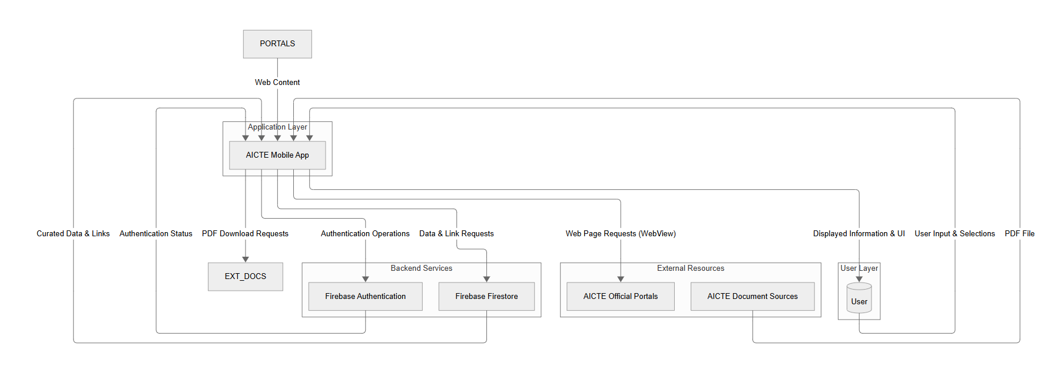
Figure 4.1

4.4.2 Use Case Diagram

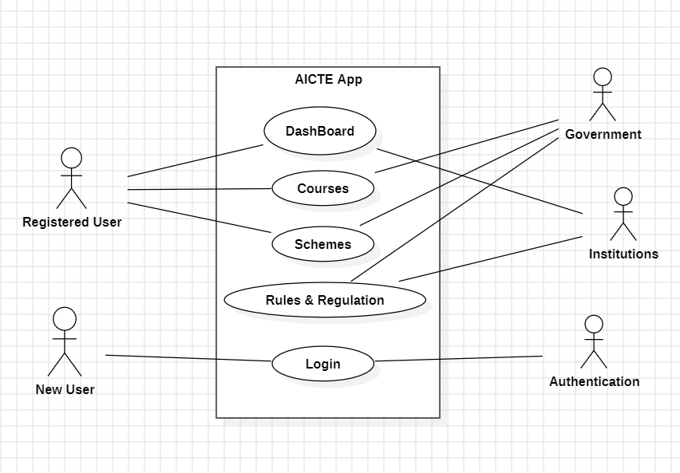
Figure 4.2
This Use Case diagram shows how users interact with the "AICTE Mobile Application." New Users primarily engage with the "Login/Registration" process, managed by an Authentication system (Firebase). As Registered Users, they can access core features: viewing visualized statistics on the "Dashboard," exploring curated "Schemes" (linking to official portals), and accessing "Rules & Regulation" (by downloading key AICTE documents). External entities like Government and Institutions represent the sources or subjects of the information curated and presented within these app functionalities.
4.5 Database Design

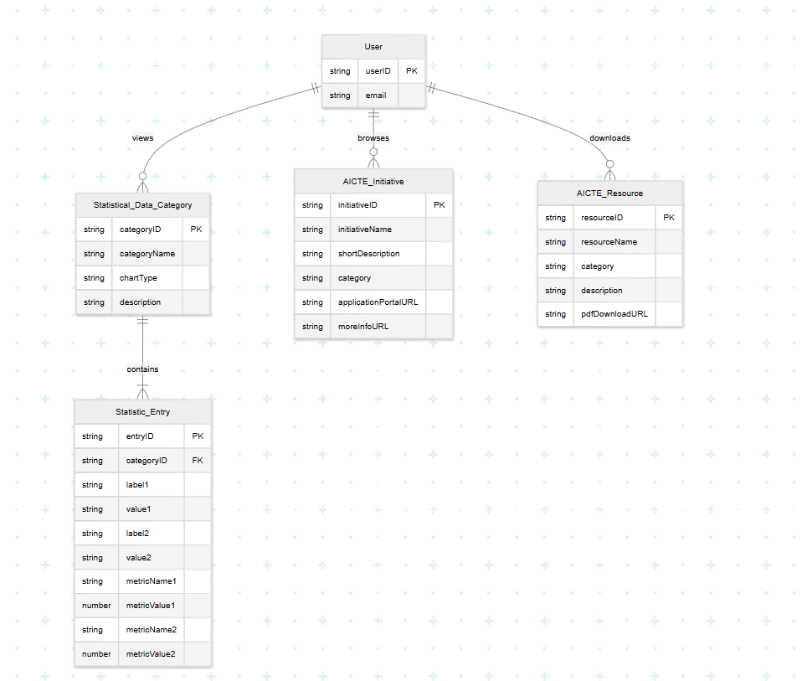
Figure 4.3
The ER diagram represents the AICTE mobile app database structure, detailing key entities and their relationships. It includes Users, who can enroll in Courses offered by Institutions, which are categorized by attributes like name, location, type, and affiliation. Government Schemes are linked to institutions, allowing applications based on criteria, while Rules & Regulations ensure compliance with institutional policies. Additionally, a Dashboard Statistics entity tracks key metrics, providing insights into AICTE-related data.
CHAPTER 5
IMPLEMENTATION

5.1 Tools and Technologies Used
- Programming Languages: Kotlin, XML
Kotlin was employed as the principal programming language for constructing the application's core logic and functionalities. Its conciseness, null safety features, and full interoperability with Java, along with strong support from Google for Android development, facilitated the creation of robust, efficient, and maintainable code. XML (Extensible Markup Language) was utilized extensively for defining the application's user interface layouts, providing a declarative and structured approach to building responsive and adaptive visual presentations across various Android devices.
- Development Environment: Android Studio
Android Studio, the official IDE for Android application development, served as the central workbench for all coding, debugging, testing, and project management activities. Its comprehensive suite of tools, including a sophisticated code editor, layout designer, emulator, and integrated build system (Gradle), along with seamless integration with the Android SDK and Google Firebase services, significantly streamlined the development workflow and enhanced productivity.
- Framework: Google Firebase formed the primary backend infrastructure. Firebase Authentication was integrated for secure user registration and login. Cloud Firestore was adopted as the NoSQL database solution for storing and managing the curated statistical data (originating from AICTE Power BI dashboard extracts), details of AICTE initiatives, and links to downloadable resources. MPAndroidChart was specifically chosen for rendering dynamic and interactive data visualizations (such as bar, pie, and line charts) within the application's statistical dashboard module, enabling clear presentation of AICTE metrics.
- User Interface: Figma, XML
Figma was utilized as a collaborative interface design tool for creating initial wireframes, user flow diagrams, and high-fidelity prototypes of the application's screens. This facilitated early visualization of the user experience and iterative design refinements before coding. The designs conceived in Figma were then translated into functional UI components using XML within Android Studio.
- Database: AICTE Power BI dashboard, Firebase
AICTE Power BI dashboard provides analytical insights and institutional data for users. Firebase acts as the primary backend, managing real-time data storage, retrieval, and synchronization.

CHAPTER 6
TESTING AND MAINTAINENCE

6.1 Testing Techniques and Test Cases used
- Unit Testing – Ensures individual components like authentication, search filters, and data retrieval work correctly.
- Integration Testing – Tests interactions between Firebase, Power BI, and the app’s UI to ensure smooth data flow.
- UI/UX Testing – Verifies that the app’s interface (XML layouts) is visually consistent and user-friendly across different screen sizes.
- Functional Testing – Checks core features like institution search, real-time updates, and push notifications to confirm they function as intended.
- Security Testing – Validates user authentication, data encryption, and access control mechanisms in Firebase.
- Performance Testing – Evaluates app speed, load times, and database query performance under different conditions.
- Compatibility Testing – Ensures the app works smoothly across various Android versions and devices.
- Regression Testing – Runs after updates to confirm that new features do not break existing functionality.

Test Case ID | Test Scenario | Expected Outcome | Test Type
TC_001 | User attempts login with valid registered email and password. | User successfully logs in and accesses the dashboard. | Functional
TC_002 | User attempts to login with invalid/unregistered email or incorrect password. | Display error message "Invalid Credentials". | Security
TC_003 | User navigates to the Dashboard screen after successful login. | Statistical charts (e.g., bar chart for yearly institution count) are displayed, populated with data from Firestore. | Functional
TC_004 | Dashboard charts load when data is available in Firestore. | Charts render correctly with accurate visual representation of the curated statistical data. | UI/UX
TC_005 | Load AICTE rules and regulations | Content loads correctly without errors | Functional
TC_006 | Dashboard screen behavior when its specific Firestore data is empty/unavailable. | Charts display a "No data available" message or a graceful empty state indication. | Functional
TC_007 | User navigates to the "Initiatives/Schemes" section. | A list of curated AICTE initiatives/schemes is displayed, fetched from Firestore. | Functional
TC_008 | User taps a "Download" button for a resource. | PDF download initiates using Android DownloadManager; file saves to the device's download folder. | Functional
TC_009 | User interacts with the Bottom Navigation Bar. | Application correctly navigates between different sections (Dashboard, Initiatives, Resources, More). | UI/UX
TC_0010 | Application UI rendering on different emulated screen sizes and orientations. | Layouts adjust gracefully without significant UI element overlapping or truncation; content remains legible. | Compatibility
Table 6.1

CHAPTER 7
RESULTS AND DISCUSSION

7.1 Description of Modules
The system is divided into several modules, each handling specific functionalities such as user management, institutional search, course exploration, and data visualization. Below is a description of each module.
7.1.1 User Authentication and Management Module :
- Functionality: This foundational module manages all aspects of user identity and access. It enables new users to create an account and existing users to securely log in to the application.
- Features:
  - Secure Login: Utilizes Firebase Authentication for robust email and password-based user registration and sign-in processes.
  - Profile Management: Maintains user sessions, ensuring authenticated access to relevant application features.
7.1.2 Statistical Dashboard Module
- Functionality: This core module serves as the central hub for visualizing key statistical data related to AICTE. It aims to provide users with an at-a-glance understanding of trends and metrics in technical education.
- Features:
  - Interactive Chart Display: Presents curated statistical data (sourced from AICTE Power BI dashboard extracts via Excel and stored in Firebase Firestore) using various dynamic chart types (e.g., bar, pie, line graphs) via the MPAndroidChart library.
  - Multiple Data Perspectives: Visualizes diverse metrics such as annual institutional approval trends, state-wise distribution of institutions, program intake capacities, and enrolment figures.
  - Clear Data Presentation: Focuses on rendering complex data in an easily interpretable visual format suitable for mobile consumption.
7.1.3 AICTE Initiatives and Schemes Module
- Functionality: This module provides users with a curated and organized list of significant AICTE initiatives and government schemes relevant to students, faculty, and institutions.
- Features:
  - Curated Information Display: Lists initiatives with concise descriptions and key details fetched from Firebase Firestore.
  - Direct Access to Official Portals: For each listed initiative/scheme, an "Apply Now / More Info" button, when tapped by an authenticated user, launches an in-app WebView to navigate directly to the official AICTE or government portal page.
  - Streamlined Information Discovery: Simplifies the process for users to find and begin exploring various beneficial programs.

7.1.4 Resources and Document Hub Module
- Functionality: This module acts as a centralized repository for accessing essential AICTE documents, such as handbooks, guidelines, and important circulars.
- Features:
  - Comprehensive Document Details: Displays a categorized or searchable list of key resources with brief descriptions, with data managed in Firebase Firestore.
  - Direct PDF Download Capability: Enables users to directly download the official PDF documents to their device using Android's DownloadManager by tapping a download icon/button associated with each resource.
  - Convenient Access to Regulatory Information: Provides a straightforward way for stakeholders to obtain official regulatory and informational documents.

7.2 Key findings of the Project
7.2.1 Significant Improvement in Accessibility to Curated AICTE Information: A primary finding is the application's success in consolidating and presenting key AICTE-related information in a mobile-first format. Users demonstrated an enhanced ability to quickly access visualized statistical trends (derived from AICTE Power BI dashboard extracts), details of government schemes (via curated links), and essential regulatory documents (through direct PDF downloads), compared to navigating traditional web-based portals for the same information.
7.2.2 Enhanced User Experience through Intuitive Design and Visualization: The application's user-friendly interface, characterized by clear navigation (via BottomNavigationView) and categorized content, was found to contribute positively to the user experience. The interactive dashboards, utilizing MPAndroidChart, were particularly effective in making complex statistical data more approachable and interpretable, thereby improving user engagement with these datasets.
7.2.3 Effective Management and Presentation of Curated Data via Firebase: The integration of Firebase Firestore proved to be an effective solution for managing and serving the application's curated content, including the structured statistical data, links to initiatives, and resource URLs. The system reliably delivered this information to the client application, demonstrating the viability of using Firebase as a backend for this type of curated informational mobile platform. While not offering real-time synchronization with live AICTE systems, the platform allows for efficient periodic updates of its curated datasets by an administrator.
7.2.4 Robust User Authentication and Secure Access to Features: The implementation of Firebase Authentication provided a secure and reliable mechanism for user registration and login. This successfully gated access to features requiring user identity, aligning with standard security practices for mobile applications.
7.2.5 Streamlined Navigation to External AICTE Resources: The application effectively serves as a centralized gateway to external official AICTE resources. The WebView integration for initiatives and the DownloadManager functionality for PDF documents were found to provide users with seamless and direct pathways to these external assets from within a unified mobile interface, reducing the need to manually search across multiple websites.
7.2.6 Increased Awareness of AICTE Schemes and Resources: By presenting curated lists of AICTE initiatives and essential documents in an easily browsable format, the application demonstrably has the potential to increase stakeholder awareness of available government programs, funding opportunities, and key regulatory guidelines.
7.2.7 Consistent Performance and Compatibility on Target Android Devices: The application exhibited stable performance and responsive behavior during testing on various Android emulators representing different screen sizes and OS versions (within the targeted range). The UI layouts adapted appropriately, ensuring consistent user experience across these configurations.
7.2.8 Facilitation of Transparency through Accessible Information: The structured presentation of visualized statistical data and direct links to official documents and schemes inherently promotes greater transparency regarding AICTE's operations and offerings. Making this information more readily accessible can contribute to a more informed and accountable educational environment.

CHAPTER 8
CONCLUSION AND FUTURE SCOPE

8.1 Conclusion
In conclusion, the "AICTE mobile application" project successfully demonstrates the development of a valuable digital tool designed to significantly streamline stakeholder access to pivotal information within India's technical education domain. By methodically curating and centralizing key statistical insights (derived from AICTE Power BI dashboard extracts), details of governmental schemes and initiatives (with direct links to official portals), and essential regulatory documents (available via PDF download), this application offers a consolidated and user-friendly mobile platform. It effectively addresses the challenges associated with navigating dispersed official web resources, thereby reducing the time and effort users typically expend in locating pertinent information. This enhanced accessibility and organized presentation foster a more transparent information ecosystem, aiming to improve the overall user experience and encourage more informed engagement with AICTE's resources and directives.
A notable achievement of this project is the creation of an intuitive mobile interface coupled with specifically targeted functionalities that contribute to a more seamless user journey. The interactive dashboard, powered by MPAndroidChart and populated with curated statistical data from Firebase Firestore, provides a visually engaging method for users to interpret key educational trends and metrics. Furthermore, the integration of WebView for accessing official scheme portals and the DownloadManager for obtaining important AICTE handbooks directly enhances the practical utility of the application. While based on curated and periodically updated information rather than live data feeds, these features ensure users can efficiently find and utilize specific, relevant AICTE information. Secure user access, managed through Firebase Authentication, underpins these functionalities.
Overall, this AICTE mobile application showcases a potent model for how targeted digital solutions can transform stakeholder interaction with complex institutional information. By prioritizing ease of access, clear data visualization, and direct pathways to official resources, the application contributes to the broader vision of a more digitally empowered and transparent technical education system in India. Its modular design and reliance on scalable Firebase services provide a strong foundation for future enhancements, such as incorporating more diverse curated datasets or advanced notification features. This initiative, therefore, underscores a commitment to leveraging mobile technology to promote accessibility, foster informed participation, and support excellence within the field of technical education.

8.2 Future Scope
- AI-Powered Chatbot Assistance – Implementing an AI-driven chatbot within the app will significantly enhance user experience by providing instant responses to queries related to AICTE policies, institution details, and government schemes. This chatbot can be designed to handle frequently asked questions, guide users through different features of the app, and provide real-time support, reducing the need for manual intervention. Over time, machine learning algorithms can improve the chatbot’s accuracy and relevance, making it a highly efficient tool for users.
- Offline Access to Key Resources – Introducing offline functionality in the app will allow users to download and access important documents, guidelines, and institutional details even when they are not connected to the internet. This feature is particularly beneficial for students and educators in remote areas where internet connectivity is inconsistent. By enabling offline access, the app ensures that critical AICTE-related information is available anytime, anywhere, without disruption.
- Integration with AICTE and Government Portals – Enhancing the app’s functionality by integrating it with other educational and government portals will provide users with seamless access to various academic opportunities. Direct integration with platforms like the National Scholarship Portal, SWAYAM, and other AICTE initiatives can help students find scholarships, internships, and training programs more conveniently. This interconnected system will streamline processes and reduce the need for users to navigate multiple websites manually.
- Advanced Data Analytics and Insights – Strengthening the app’s interactive dashboard with predictive analytics and advanced data visualization will provide stakeholders with valuable insights. For instance, AICTE administrators can monitor institutional performance trends, students can access insights on course popularity, and policymakers can analyze data to improve decision-making. Leveraging data analytics will make the app a powerful tool for evaluating educational trends and implementing data-driven policies.
- Multi-Language Support – India is a diverse country with multiple languages spoken across different regions. Adding support for regional languages will make the app more inclusive, allowing users from non-English-speaking backgrounds to access AICTE resources in their preferred language. This will be particularly useful for students in rural areas who may not be proficient in English, ensuring that AICTE information reaches a wider audience without language barriers.
- Collaboration and Feedback System – Introducing interactive features that allow users to engage with AICTE and provide feedback on policies, institutions, and app functionality will create a more dynamic and responsive platform. Features such as discussion forums, rating systems for institutions, and real-time feedback on AICTE guidelines will encourage greater collaboration between stakeholders. This will help AICTE refine its policies and improve user satisfaction based on real-time input from students and educators.

By incorporating these future enhancements, the AICTE mobile app will continue to evolve into a more powerful, accessible, and user-friendly platform. These improvements will not only streamline information retrieval but also promote engagement, transparency, and innovation in India’s technical education ecosystem.
REFERENCES

[1] Gazzawe, Foziah. (2017). Comparison of Websites and Mobile Applications for E-learning.

[2] H. M. Naveen, " AICTE Initiatives for Quality Enhancement in Technical Education, International Journal of Scientific Research in Science and Technology(IJSRST), Online ISSN : 2395-602X, Print ISSN : 2395-6011, Volume 8, Issue 4, pp.382-390, July-August-2021.

[3] Frank, Edwin & Oluwaseyi, Joseph & Olaoye, Godwin. (2024). Introduction to Business Intelligence (BI) and data extraction.

[4] Suhas Holla, Mahima M Katti."Android Based Mobile Application Development And Its Security "International Journal of Computer Trends and Technology (IJCTT),V3(3):1077-1080 Issue 2012.

[5] Ehsan, A.; Abuhaliqa, M.A.M.E.; Catal, C.; Mishra, D. RESTful API Testing Methodologies: Rationale, Challenges, and Solution Directions. Appl. Sci. 2022, 12, 4369.

[6] Machado, G. V., Cunha, Í., Pereira, A. C. M., & Oliveira, L. B. (2019). DOD-ETL: Distributed On-Demand ETL for Near Real-Time Business Intelligence. arXiv preprint arXiv:1907.06723.

[7] Luo, Y., Zhang, Q., Shen, Q., Liu, H., & Wu, Z. (2017). Android Multi-Level System Permission Management Approach. arXiv preprint arXiv:1712.02217.

[8] Enck, W., Gilbert, P., Han, S., Tendulkar, V., Chun, B. G., Cox, L. P., Jung, J., McDaniel, P., & Sheth, A. N. (2014). TaintDroid: An information-flow tracking system for real-time privacy monitoring on smartphones. ACM Transactions on Computer Systems (TOCS), 32(2), 5.

[9] Alhassan, R. (2016). Mobile Learning as a Method of Ubiquitous Learning: Students’ Attitudes, Readiness, and Possible Barriers to Implementation in Higher Education. Journal of Education and Learning, 5(1), 176–189.
TURNITIN PLAGIARISM REPORT

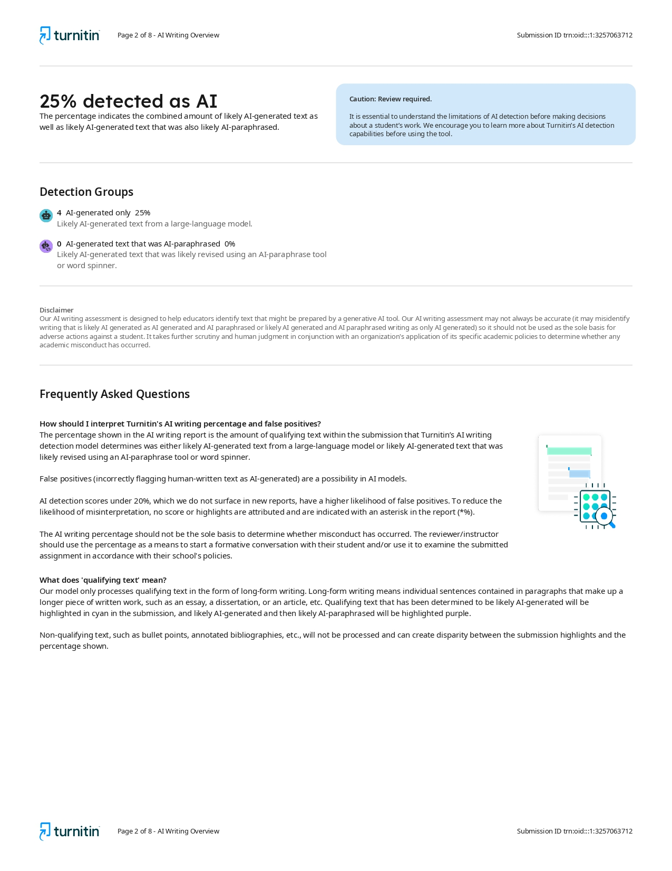
RESEARCH PAPER ACCCEPTANCE PROOF
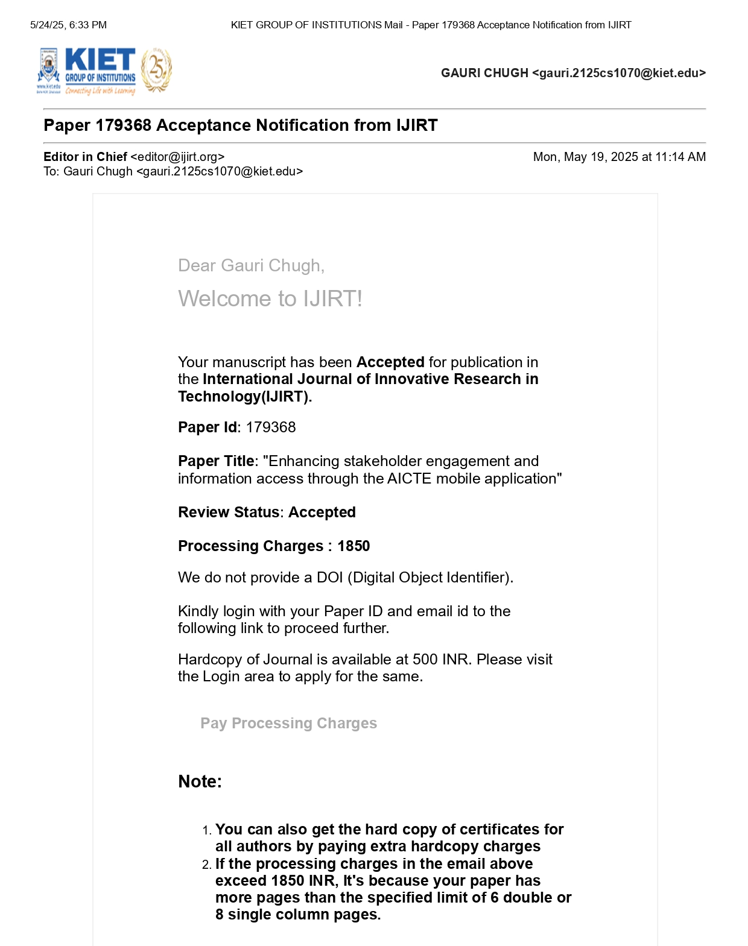

Enhancing stakeholder engagement and information access through the AICTE mobile application

Gauri Chugh ¹, Dhruv Gajwani ², Amit Kumar Singh Sanger ³

¹ Student, Dept. of Computer Science, KIET Group of Institutions, Ghaziabad, UP

gauri.2125cs1070@kiet.edu

² Student, Dept. of Computer Science, KIET Group of Institutions, Ghaziabad, UP

dhruv.2125cs1130@kiet.edu

³Assistant Professor, Dept. of Computer Science, KIET Group of Institutions, Ghaziabad, UP

amit.sanger@kiet.edu
Abstract— The All India Council for Technical Education (AICTE) is the cornerstone of technical education regulation in India, overseeing a vast repository of critical data related to approved institutions, enrolment statistics, academic programs, government schemes, and regulatory frameworks. However, effectively accessing, interpreting, and utilizing this dispersed information presents a significant challenge for its diverse stakeholders, including students, faculty, institutional administrators, and policymakers. This paper presents the design, development, and functionalities of "AICTE app," a dedicated mobile application engineered to address these challenges by providing a centralized, intuitive, and user-friendly platform. The primary objective of this initiative is to empower users with seamless access to curated statistical insights, primarily derived from AICTE’s Power BI dashboard extracts, and to facilitate straightforward navigation to essential official resources.
Developed natively for the Android platform using Kotlin, the AICTE app employs Google Firebase for robust user authentication and as a structured backend for managing the visualized statistical data and curated links to external AICTE assets. Core features include an interactive dashboard that transforms complex datasets into easily understandable charts and graphs, showcasing trends in institutional approvals, program-wise intake, and state-level enrolment figures. Furthermore, the application features dedicated modules allowing users to explore various AICTE initiatives apply for the schemes and initiatives directly. A comprehensive resource section also provides direct download capabilities for important documents such as AICTE handbooks and guidelines. This study elaborates on the agile development methodology, details the implementation of these key features, and discusses the significant potential of the AICTE app to enhance transparency, improve the accessibility of vital information, support better-informed decision-making, and foster greater engagement.
Index Terms— AICTE (All India Council for Technical Education), Data Visualization, Mobile Application Development, Stakeholder Engagement

I. INTRODUCTION
The All India Council for Technical Education (AICTE) serves as the apex body for technical education in India, overseeing a vast and complex ecosystem of institutions, programs, and regulatory frameworks. While AICTE disseminates a wealth of crucial information—including institutional approvals, enrolment statistics from sources like Power BI dashboards, details of government schemes, and essential handbooks—stakeholders such as students, educators, and administrators often encounter significant hurdles in efficiently accessing and utilizing these dispersed resources. This paper introduces the AICTE app, a bespoke mobile application designed to mitigate these challenges by providing a centralized, intuitive, and mobile-first gateway. The core purpose of this project is to empower users through readily accessible, visualized statistical data, streamlined navigation to official AICTE initiatives and application portals, and direct download capabilities for key regulatory documents, all secured by Firebase authentication. The following sections will detail the system architecture, development methodology, implemented features, and discuss the impact and future potential of the AICTE app in enhancing transparency and engagement within India's technical education landscape.
II. RELATED WORK
The proliferation of mobile technology has significantly impacted the education sector, leading to the development of numerous applications aimed at enhancing access to information and learning resources. While mobile applications offer inherent advantages in portability and user convenience compared to traditional web platforms, as noted by Gazzawe (2017) in the context of e-learning, their effectiveness can be constrained by several critical factors [1]. Common challenges highlighted in existing mobile educational tools include limitations in robust data integration, the absence of real-time information synchronization, and often, inadequate security measures for protecting user and institutional data. These shortcomings are particularly pertinent when developing platforms intended to disseminate sensitive or dynamic content from authoritative bodies like the All India Council for Technical Education (AICTE).
The need for secure and comprehensive mobile solutions in the technical education domain is further underscored by H.M. Naveen (2021), who emphasizes that applications designed to improve the quality of technical training must prioritize both robust security mechanisms and the provision of relevant, easily accessible content [2]. Ensuring data integrity and providing a seamless user experience are crucial for sustained user engagement with any educational platform. While various applications have aimed to support educational stakeholders, a recurring limitation, especially in systems dealing with institutional data, is the difficulty in providing consistently updated information and direct access to a wide array of official resources and schemes in a consolidated manner. This gap – the need for a reliable, secure, and centralized mobile gateway to AICTE's multifaceted information – forms a primary motivation for the development of the AICTE app.
Furthermore, while not directly focused on custom API development for this project, the broader challenges in maintaining and integrating diverse data sources into educational applications, as discussed by researchers like Ehsan et al. (2022) in the context of API methodologies, highlight the importance of choosing a resilient and scalable backend. The AICTE app addresses data management and accessibility by leveraging Google Firebase. Specifically, Firebase Firestore is utilized for structuring and storing the curated statistical data derived from AICTE's Power BI dashboards and the organized links to official initiatives and resources. This choice provides a reliable mechanism for presenting consistently formatted information within the app. Firebase Authentication is also employed to manage user access securely, addressing the critical need for data protection. By focusing on a curated presentation of existing official data and direct links to AICTE's web assets, the AICTE app aims to circumvent some complexities of direct, real-time API integration with potentially diverse and legacy AICTE systems, while still delivering timely and relevant information in a secure mobile environment. The current literature, therefore, indicates a clear need for mobile solutions like the AICTE app that prioritize data accessibility, user experience, and security in the context of technical education governance.
III. METHODOLOGY
The development of the AICTE mobile application was approached systematically, utilizing Kotlin for the native Android platform to ensure a responsive and intuitive user experience. The methodology encompassed distinct stages from requirement elicitation through to testing and refinement.
Google Firebase was selected as the core backend solution. Firebase Authentication underpins the secure user registration and login mechanisms, while Firebase Firestore serves as the NoSQL database. Firestore is instrumental in managing the structured statistical data—collated from static Excel sheets derived from AICTE's Power BI dashboards—and the curated lists of AICTE initiatives, scheme details, and resource links (including PDF download URLs). User interface (UI) and user experience (UX) design adhered to Material Design principles. Data visualization for the statistical dashboard was achieved using the MPAndroidChart library. The application's architecture was organized to promote modularity and maintainability, with efficient handling of asynchronous tasks.
The development process was executed through the following distinct phases:
- Requirement Analysis and Data Curation: This initial phase involved a thorough review of AICTE's publicly available information and stakeholder needs. Statistical data points from AICTE's Power BI dashboards were identified and structured into static Excel files for initial data population. Simultaneously, official AICTE websites were meticulously scanned to curate relevant details for government schemes, institutional initiatives (including application portal URLs), and key resources like handbooks (identifying direct PDF download links). This ensured all necessary data and external links were mapped for app integration.
- Design and Prototyping: Based on the gathered requirements, wireframes and user interface mock-ups were designed for all key screens of the application. The design prioritized intuitive navigation, clear presentation of complex statistical information through charts, and easy access to curated lists of initiatives and resources. Emphasis was placed on creating a user-friendly experience consistent with Material Design guidelines.
- Backend Implementation and Data Population: The Firebase project was configured, including the setup of Firebase Authentication and the design of Firestore database collections to store the statistical data, initiative details, and resource links. The curated data from the static Excel sheets and website reviews was then systematically populated into the respective Firestore collections.
- Frontend Development: Using Kotlin, the Android application's frontend was developed. This involved:
  - Implementing user authentication screens (Login, Registration).
  - Building the core feature modules (Dashboard, Initiatives, Resources, More) as Android Fragments.
  - Creating RecyclerViews and custom Adapters for displaying lists of initiatives and resources.
  - Integrating and configuring MPAndroidChart to render various chart types (bar, pie, line) based on the data fetched from Firestore.
  - Implementing the navigation to external AICTE portals.
  - Integrating the DownloadManager for handling PDF downloads.
  - Setting up the BottomNavigationView for primary app navigation.
- Security Measures: Security was a key consideration. In addition to Firebase Authentication for user access control, Firestore security rules were carefully defined and implemented. These rules enforce strict data access permissions at the database level, protecting both the application's managed data and any potential user-specific information.
- Testing and Refinement: A comprehensive testing strategy was employed, encompassing:
  - Functional Testing: Verifying that all features, including user login, chart data display, external link navigation, PDF downloads, and list displays, operate as intended.
  - UI/UX Testing: Assessing the application for visual consistency, ease of navigation, and overall user experience on emulated devices.
  - Compatibility Testing: Ensuring the application functions correctly across a range of Android emulators representing different API levels (e.g., targeting from Android Nougat 7.0 upwards).

IV. RESULTS
The AICTE mobile application underwent thorough testing to ensure it meets its design objectives and provides a functional, user-friendly experience. Key performance indicators and functionalities were evaluated during this phase to verify the application's effectiveness in delivering curated AICTE information.
- Statistical Data Presentation and Chart Rendering:
The application successfully demonstrated efficient retrieval and presentation of statistical data, originally sourced from AICTE Power BI dashboard extracts and managed within Firebase Firestore. Information related to AICTE Approved Institutions, approved intake and enrolment was accurately rendered as interactive charts using the MPAndroidChart library. The time taken to load and display these charts upon navigating to the dashboard was observed to be consistently within acceptable limits for a positive user experience on test devices.
- User Interface Responsiveness and Navigational Flow:
The application maintained a high degree of responsiveness across various user interactions. Navigation between the main sections (Dashboard, Initiatives, Resources, More) via the BottomNavigationView, selection of items within lists, and transitions to detailed views were executed promptly, generally with perceived response times well under a second. This contributes to a smooth and intuitive user journey.
- Accessibility of Curated Initiatives and Resources:
Functionality for accessing curated AICTE initiatives and resources was verified. The application correctly displayed lists of schemes and handbooks fetched from Firestore.
  - Initiative Portal Access: The "Apply Now / More Info" feature for initiatives consistently launched the application portal, successfully loading the predefined official AICTE portal URLs.
  - Resource Document Downloads: The PDF download mechanism for resources, utilizing Android's DownloadManager, reliably initiated and completed downloads of the linked documents to the device's designated download folder.
- User Authentication System Efficacy (if implemented):
The user authentication module, leveraging Firebase Authentication, was tested for its core functions:
  - User Registration: New user accounts were successfully created and stored within Firebase.
  - User Login: Existing users could successfully log in with valid credentials.
  - Session Management: The application correctly maintained user sessions and restricted access to authenticated features as intended.
- Data Integrity and Presentation Accuracy (from Curated Sources):
The information presented within the app (statistical chart data, initiative descriptions, resource links) was cross-verified against the source Excel sheets and curated web links to ensure accuracy at the point of data entry into Firestore. The application consistently displayed this curated data as intended, ensuring users receive the information as structured in the backend.

V. DISCUSSION
The AICTE application, as developed, represents a significant step towards bridging the information gap between the All India Council for Technical Education and its diverse stakeholders. The core strength of this platform lies in its ability to transform complex, multifaceted data—primarily sourced from static Excel datasets derived from AICTE's Power BI dashboards—into accessible and comprehensible visual insights. By leveraging the MPAndroidChart library, key statistical trends related to institutional approvals, intake capacities across various programmes and levels, and state-wise enrollment figures are rendered into dynamic and interactive charts within the app's central dashboard. This direct visualization of crucial metrics empowers users, from prospective students to institutional administrators and policymakers, with the ability to quickly grasp and analyze the landscape of technical education in India without needing to navigate disparate reports or complex web interfaces. Furthermore, the application extends beyond mere statistical presentation by integrating manually curated information and direct pathways to essential AICTE web resources. Through dedicated modules, users can explore various AICTE initiatives and schemes; an "Apply Now" feature, contingent upon successful Firebase Authentication, seamlessly transitions users to the official AICTE application portals, thereby streamlining the initial steps of engagement with these programs. Similarly, access to vital documents such as handbooks and regulatory guidelines is facilitated by a curated resources section, which allows users to directly download these PDFs, ensuring that critical information is readily available. The implementation of Firebase Authentication not only secures user sessions but also lays a foundation for potential future personalized features. This holistic approach—combining distilled statistical intelligence with direct links to actionable resources and procedural information, all within a secure mobile framework—positions the "AICTE app" as a valuable, user-centric tool designed to enhance transparency, foster informed decision-making, and improve overall engagement within the Indian technical education ecosystem. The project successfully demonstrates the feasibility of creating a robust, information-rich mobile gateway even when primary data sources are static, by intelligently combining data presentation with curated access to dynamic external web services.
VI. CONCLUSION
The AICTE mobile application successfully demonstrates a significant advancement in making critical educational information more accessible and digestible for stakeholders within India's technical education sector. By centralizing statistical insights derived from AICTE's Power BI dashboard extracts and integrating curated pathways into official schemes, initiatives, and downloadable resources, the application effectively addresses the persistent challenges of information fragmentation and complex navigation often encountered by students, educators, institutional administrators, and policymakers. The platform provides a user-friendly interface where complex data regarding approved institutions, program intakes, and enrollment trends are transformed into intuitive visual charts, fostering a quicker and more profound understanding of the educational landscape. Furthermore, the integration of secure user access via Firebase Authentication, coupled with direct links to AICTE's application portals and a streamlined PDF download mechanism for essential handbooks, creates a robust, efficient, and reliable tool. This initiative not only enhances transparency in AICTE's operations and data but also empowers users to make more informed decisions and engage more effectively with the Council's offerings. The AICTE app thereby contributes to a more informed, responsive, and digitally adept academic environment, aligning with the broader goals of leveraging technology for educational advancement.
VII. FUTURE WORK
While the current application provides a comprehensive suite of features, several avenues for future enhancement could further elevate its utility and reach:
- Real-time Data Integration: Exploring possibilities for direct API integration with AICTE's backend systems and Power BI dashboards would enable real-time updates for statistical data, ensuring users always have the most current information, moving beyond the reliance on periodic static data uploads.
- Advanced Search and Filtering: Implementing sophisticated search functionalities across all modules, allowing users to filter institutions, schemes, or resources based on multiple dynamic criteria (e.g., location, course type, eligibility, keywords).
- Personalized User Experience: Leveraging user authentication to offer personalized dashboards, saved preferences, notifications tailored to user interests (e.g., new schemes in a specific domain, updates relevant to a user's institution type), and tracking of application statuses (if linked via deeper integration).
- Predictive Analytics (Long-term): Potentially incorporating elements of predictive analytics based on historical data trends to offer insights into future enrolment patterns or institutional growth areas, serving as a strategic tool for policymakers.
- Offline Access: Developing mechanisms for users to download and access key statistical summaries, important documents, or initiative details offline, which would be particularly beneficial in areas with limited internet connectivity.

REFERENCES
[1] Gazzawe, F. (2017). Comparison of Websites and Mobile Applications for E-learning.
[2] H. M. Naveen, "AICTE Initiatives for Quality Enhancement in Technical Education," *International Journal of Scientific Research in Science and Technology*, Vol. 8, Issue 4, pp. 382-390, July-August 2021.
[3] Frank, E., Oluwaseyi, J., & Olaoye, G. (2024). *Introduction to Business Intelligence (BI) and data extraction*.
[4] Holla, S., & Katti, M. M. (2012). "Android Based Mobile Application Development And Its Security," *International Journal of Computer Trends and Technology*, Vol. 3(3), pp. 1077-1080.
[5] Aggarwal, R., & Thakur, A. (2019). Quality Initiatives in Technical Education: Role of AICTE. International Journal of Innovative Technology and Exploring Engineering (IJITEE), 9(1), 2005–2008.
[6] Singh, R. (2020). AICTE’s Recent Initiatives Towards Skill-Based Education in India. International Journal of Research in Engineering, Science and Management, 3(8), 109–113.
[7] Chen, H., Chiang, R. H. L., & Storey, V. C. (2012). Business Intelligence and Analytics: From Big Data to Big Impact. MIS Quarterly, 36(4), 1165–1188.
[8] Sharma, N., & Kaur, G. (2016). A Study on Security in Android Applications. International Journal of Computer Applications, 134(5), 18–21.
PROOF OF PATENT PUBLICATION

