**Smart E-Commerce model using for Artisans**

Raj Kumar, Harsh Khattar, Prakhar Sharma, Nikhil Garg, Diwakar Mittal, Navneet Saini

Computer Science Department, KIET Group of Institutions, Delhi-NCR, Ghaziabad, India

**Abstract**

*India has a rich culture, and the handloom and handicraft sectors play a very important role, where they provide jobs to many people from poor and rural backgrounds. However, artisans often face big challenges like limited access to markets, low exports, and not enough income. This research looks at how e-commerce can help improve the export of handloom and handicraft products. We reviewed earlier studies to understand the problems and solutions that have been suggested before. We also explored how new online platforms, built with modern technologies, can help artisans show and sell their products worldwide.*

*Our findings show that having an easy-to-use website, secure payment options, and reliable delivery services helps artisans reach more buyers. With the right use of technology, skill development, and support, exports can increase and the region’s rich cultural heritage can be preserved. This study suggests that e-commerce is a promising way for artisans to earn better incomes while keeping India’s traditional crafts alive.*

**Keywords**

Handloom, Handicraft, Jammu and Kashmir, e-commerce, Artisan, Export, India.

**Introduction**

In today’s world, everything is moving fast because of new technologies. People now use the internet to buy and sell things, and businesses can reach customers from all over the world. But for many small artisans—especially those living in villages and small towns—this fast-moving digital world is hard to enter. They often do not have the knowledge, tools, or support to sell their handmade products online [1].

These artisans make beautiful crafts using skills passed down through generations. Their work is more than just objects—it represents stories, traditions, and the culture of their communities [2]. Unfortunately, many of them depend on local buyers or middlemen, who often take a large part of the profit and pay the artisans very little [3]. As a result, artisans struggle to make a living, even though they put a lot of hard work and care into each item they create.

According to a study by Dey and Tripathi [4], the lack of digital knowledge and infrastructure is one of the biggest reasons why artisans cannot connect with bigger markets. This makes it difficult for them to survive in a world where online selling is becoming the norm.

This paper presents, an online platform built using the MERN stack (MongoDB, Express.js, React.js, and Node.js), designed to support artisans by helping them sell their products directly to customers. By cutting out middlemen and offering a user-friendly interface, the platform helps artisans earn fair prices and gain recognition for their work. The aim is not only to boost their income but also to preserve and promote India’s traditional crafts in a digital age.

**Big Problems Artisans Face in E-Commerce**

Artisans in India, who make beautiful handcraft things, have many troubles when trying to sell online.

* **Small Market Reach:** Most artisans only sell in local markets, through middlemen, or in small exhibitions. Very few can sell online. Only about 0.2% of handloom weavers sell online, and less than 1% of all artisans use internet to sell their craft [[5](https://catalystaic.org/artisans-in-india-and-their-quest-for-growth-understanding-the-current-set-of-capabilities-among-indian-artisans-to-adopt-digital-technology-solutions/)].
* **Depend on Middlemen:** Many times, artisans have to sell their products to agents or traders. These middlemen take big part of profit-sometimes 60% to 200% more than what artisan get[1](https://idronline.org/article/ecosystem-development/indian-artisans-are-still-missing-from-e-commerce-platforms/).
* **Not Good with Digital Tools:** Most artisans don’t know how to use computers or smartphones for business. Only 20% got any training for online selling[[1](https://idronline.org/article/ecosystem-development/indian-artisans-are-still-missing-from-e-commerce-platforms/)][[5](https://catalystaic.org/artisans-in-india-and-their-quest-for-growth-understanding-the-current-set-of-capabilities-among-indian-artisans-to-adopt-digital-technology-solutions/)]. Many needs help to click and upload photos (57%), use platform features (60%), or do paperwork (40%). Only 7% feel okay using digital payment apps[[5](https://catalystaic.org/artisans-in-india-and-their-quest-for-growth-understanding-the-current-set-of-capabilities-among-indian-artisans-to-adopt-digital-technology-solutions/)].
* **High Cost to Join Online Market:** To put products on big online shops, artisans have to pay fees and commission. For rural artisans, these costs are too high[[1](https://idronline.org/article/ecosystem-development/indian-artisans-are-still-missing-from-e-commerce-platforms/)].
* **Delivery and Shipping Issues:** Sending products from village to customer is hard and expensive. Many artisans can’t manage this well[[1](https://idronline.org/article/ecosystem-development/indian-artisans-are-still-missing-from-e-commerce-platforms/)].
* **Low Online Visibility:** Artisans don’t know how to show their products to more people online. Only 20% are comfortable using social media for business[[5](https://catalystaic.org/artisans-in-india-and-their-quest-for-growth-understanding-the-current-set-of-capabilities-among-indian-artisans-to-adopt-digital-technology-solutions/)].
* **Language Problem:** Most online shops use English. Many artisans don’t understand English, so they can’t use these platforms easily. About 22% say language is big problem for them[[2](https://catalystaic.org/exploring-digital-solutions-to-indian-artisans-distress/)][[5](https://catalystaic.org/artisans-in-india-and-their-quest-for-growth-understanding-the-current-set-of-capabilities-among-indian-artisans-to-adopt-digital-technology-solutions/)].

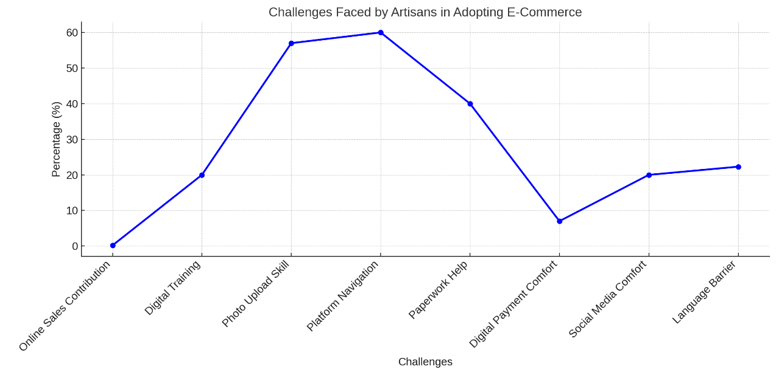

**Figure 1**- % of Challenges Faced by Artisans in Embracing E-Commerce in India

**Smart Tech Integration**

| **Who Get Help** | **How AI/ML Help Them** | **Example** |
| --- | --- | --- |
| Artisans | Sell right product, at right price | No unsold stock, fair money |
| Customers | Find what they like fast, get quick help | Good suggestions, chatbot help |
| Business Owner | Save time, less manual work, more happy users | AI do repeat work, more orders |

Table 1: AI/ML Benefits for Artisans and Customers

AI in online shop give two big helps. First, AI make things easy for customer, like voice search. Second, AI make work faster because it can do some jobs by itself, so people save time. When we use AI in online shop, customer feel better and business work smooth.

| **Feature Name** | **What It Do (Simple)** | **Main Benefit** |
| --- | --- | --- |
| Demand Forecasting | AI look at old sales, guess how many people want product | No overstock, no shortage |
| Price Forecasting | AI check old price, sales data, guess best price for today | Right price, more sales |
| Product Recommendations | AI see what user like/buy before, suggest new products | Customer find good product fast |
| Search Result Ranking | AI learn what people click, show best result on top | Better search, happy customer |
| Voice Search | User talk, AI understand and search product | Easy search, good for all users |
| Chatbots | AI chat with customer, answer question anytime | Fast help, better user experience |

Table 2: AI/ML Features Used in E-Commerce Platform

**Literature Survey**

The handicraft sector is very important both economically and culturally, especially in developing countries like India. It provides jobs and income to many people and helps keep traditional skills alive. Research shows that the Indian handicraft industry plays a big role in production, employment, and export promotion[[1](https://journalair.com/index.php/AIR/article/view/974)][[2](https://www.ijnrd.org/papers/IJNRD2407168.pdf)]. Studies focusing on regions like Jammu and Kashmir also confirm how much handicrafts support the local economy[[2](https://www.ijnrd.org/papers/IJNRD2407168.pdf)][[6](https://journals.christuniversity.in/index.php/ushus/article/view/3623)].

Despite its value, the handicraft sector faces many challenges that slow its growth. Artisans find it hard to update designs or innovate products, and they struggle to reach modern markets[1](https://journalair.com/index.php/AIR/article/view/974). Middlemen often take a large part of the profits, leaving artisans with less income [[1](https://journalair.com/index.php/AIR/article/view/974)]. Many artisans lack digital literacy and business skills, so training programs are needed to help them improve[[3](https://warwick.ac.uk/fac/arts/history/ghcc/eac/oralhistoryproject/resources/bibliography/market_for_indian_handicrafts1.pdf)]. Operational problems like managing delivery and understanding market rules also create difficulties [[1](https://journalair.com/index.php/AIR/article/view/974)].

Expanding market reach, especially internationally, is very important for artisans’ growth. Economic theories and tools like gravity models help understand trade flows and export performance[[4](https://serialsjournals.com/abstract/78063_ch_33_f_-_ch_22_f_-_210.pdf)][[5](https://ajmjournal.com/HTMLPaper.aspx?Journal=Asian+Journal+of+Management%3BPID%3D2016-7-1-2)]. Studies on handicraft exports to foreign markets, such as Vietnamese handicrafts to Japan, highlight the need for special strategies to succeed abroad[[7](https://ideas.repec.org/a/zna/indecs/v8y2010i2p119-137.html)]. For small and medium firms, strong export marketing capabilities and leveraging unique resources are key to better export results. External factors like political turmoil can also affect demand negatively.

Sustainable development is essential for the long-term survival of handicraft industries. Research discusses ways to help the sector grow while preserving cultural heritage, as seen in traditional furniture craftsmanship.

With growing digitalization, e-commerce offers a big opportunity for artisans. Dedicated online platforms help artisans sell directly to customers, cutting out middlemen and increasing their income. Smart e-commerce models using Artificial Intelligence (AI) can further improve these platforms by offering personalized recommendations, better marketing, optimized logistics, and support in pricing and inventory management. This makes selling online easier, expands market access, and improves efficiency, helping artisans compete globally while preserving cultural heritage for future generations.

**Methodology**

This research use both talking to people and collecting numbers to really understand what’s happening with artisans and e-commerce. We want to see what problems artisans face now, what they need from a smart online selling platform, and how things could get better if we use new technology like AI. The study is meant to explore and explain, so others can use what we find to build or improve such platforms.

**1 Research Objectives**

Main goals for this research are:

* Find out how artisans sell online now and what problems they have.
* Understand what artisans need from a “smart” e-commerce website with AI.
* Suggest features and tools that should be in a smart platform for artisans.
* See what good things might happen if artisans use this kind of platform, based on what experts and artisans think.

**2 Research Design**

* **Interviews (Qualitative):**  
  We talk to experienced artisans who tried selling online, people from organizations who help artisans, e-commerce website makers, and AI experts. We ask them about their problems, what works, and what they wish for in a smart platform.

*Example: We plan to do 20-30 interviews with artisans and 5-10 with experts.*

* **Surveys (Quantitative):**  
  We give out surveys to many artisans to ask about how they sell (old way vs online), how comfortable they are with technology, what problems they have, and what new features they want. We might also ask customers about their online buying habits and what they want to see on such a platform.

*Example: We want at least 150-250 artisans and 100-200 customers to answer.*

* **Building the Model:**  
  After gathering all this info, we’ll suggest what a “Smart E-Commerce” platform for artisans should look like. This might include things like AI-powered product suggestions, easy listing tools, support for many languages, help with shipping, and smart marketing.
* **Pilot Test (Optional):**  
  If possible, we could make a small version of the platform and let 15-20 artisans use it for 3-6 months. We’d watch how they use it, how many products they sell, and ask what they think.

**3 Sampling and Participants**

We will find artisans for interviews and surveys through local groups, NGOs, government bodies, or online artisan communities. We want to include people from different crafts, regions, and tech experience. Experts will be chosen for their knowledge in e-commerce, tech, or handicrafts.

*Example: We aim for 200 artisans in the survey, hoping at least 150 replies. For interviews, we’ll talk to 25 artisans and 8 experts.*

**4 Data Collection Tools**

* **Interview Guides:** To ask about current practices, problems, and what they want in a smart platform.
* **Surveys:** With both yes/no and open questions to get numbers and stories about their experience.
* **Platform Data:** Automatically collect info on how people use the platform.

**5 Data Analysis**

We’ll look at interview answers for common themes, problems, and wishes. Survey numbers will be summarized (like percentages and averages) to spot trends. If we do a pilot, we’ll also check things like how many sales happen, what features are used, and if people keep coming back.

**Technical Overview**

**1.Architecture**

Platform made in parts; each part does own job to keep everything smooth:

* **Frontend: This** is website or app where artisans put product and customers look and buy.
* **Backend:** This part does all important work like handle orders, save data, and connect other services.
* **Data storage:** Keep all info safe like products, users, orders, money.

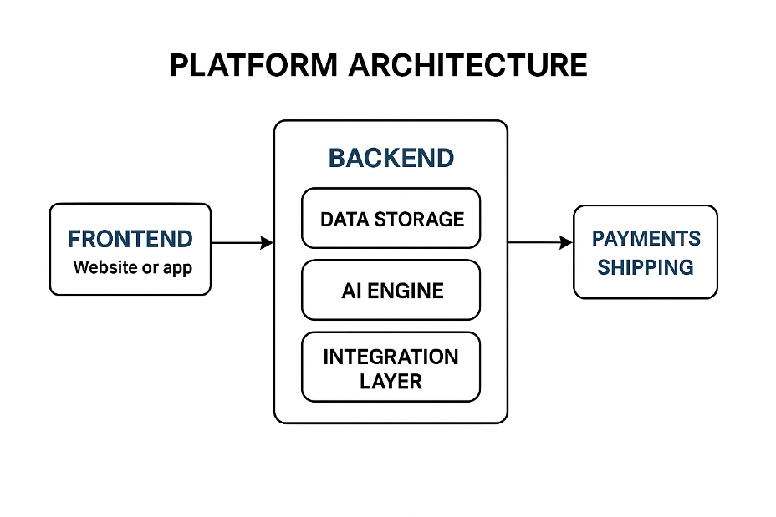

Figure 2: Platform Components

**2. Core Platform Components**

* **Artisan Dashboard:** Simple place for artisans to add product, manage orders, track shipping, see sales, and chat with buyers.
* **Customer Storefront:** Online shop where buyers search product, see detail, add to cart, and pay safe.
* **User Accounts:** Easy and safe sign up and login for artisans and buyers.
* **Product Management:** Keep product pictures and info clear and organized.
* **Order Management:** Track order from buys till delivery.
* **Shopping Cart & Checkout:** Let customer pick and pay safe.
* **Payment Integration:** Work with trusted payment ways for smooth money transfer.
* **Shipping Integration:** Connect with shipping companies to show cost, print label, and track package.

**3.** **AI-Powered Functionalities**

* **Product Suggestion:** AI look what customer like and show product they may want.
* **Help with Product Listing:** AI help artisan choose category, tags, and write product description.
* **Better Search:** AI understand what customer want, even if search word not perfect, and show best result.
* **Chatbots:** Robot helper answers common question fast, save artisan time.
* **Personalized Marketing:** AI send special offer and message based on what customer like.
* **Future Tools:** AI also help guess how much product make, suggest price, or check quality.

**4. Integrations**

* **Payments:** Platform work with popular, safe payment method so customer pay easy.
* **Shipping:** Connect with many shippings company to give choice and track delivery.
* **Notifications:** Send email or message to tell customer about order.

**Test & Results**

Testing is an essential part of software development as it ensures that the software meets the specified requirements and performs as expected. In this section, we will discuss the testing phase of the e-commerce solution development project. We will be performing component testing, integration testing, and system testing to ensure that the software is of high quality and meets the requirements of the stakeholders.

**1.Qualitative Testing**

This involves interviews and open-ended questions in surveys to understand the artisans' current situation, challenges with existing platforms, and their needs and desires for a smart e-commerce solution. It's "testing the waters" of the problem space.

**2. Survey Testing**

Using structured surveys to quantify the prevalence of challenges, measure the level of interest in specific smart features, understand demographic data of artisans, and gauge anticipated benefits.

**3. Usability Testing**

If you develop a prototype or pilot platform, you would test how easy and intuitive it is for artisans and customers to use specific features (like uploading a product, managing an order, or using an AI assistant).

**4.Performance Testing**

Measuring key performance indicators (KPIs) of the smart platform or its features during a pilot phase. This assesses if the platform is achieving its intended impact.

**Functional Module Test Plan:**

What We Will Test

1. **Add Items to Cart**
   * Check if user can add different items to the shopping cart without any problems.
2. **Remove Items from Cart**
   * Make sure user can remove any item from the cart and the cart updates correctly.
3. **Update Item Quantity**
   * Test if user can change the quantity of any item in the cart (increase or decrease), and see if the cart updates the total.
4. **Display Total Cost**
   * Check if the shopping cart always shows the correct total cost based on items and quantities.
5. **Boundary Conditions**
   * Test what happens when user tries to add

The functional testing of the shopping cart module was successfully completed, and all test cases passed as expected. Here's a breakdown of the scenarios tested:

|  |  |
| --- | --- |
| **Scenario Tested** | **Outcome** |
| Items were added to the shopping cart seamlessly. | Passed |
| Items could be removed from the cart without issues. | Passed |
| Users were able to update item quantities in the cart. | Passed |
| The total cost reflected accurately based on items in the cart. | Passed |
| Edge cases and boundary conditions were handled correctly. | Passed |
| The system managed errors gracefully without crashing. | Passed |

Table 3: Functional Module Testing Summary

These results show why smart AI platform is needed and how it can help artisans sell better online.

**Findings from Qualitative Research (Interviews)**

* **Main Problems:** Artisans say very hard to find customers outside their local area. Many don’t know how to use technology for online selling. Managing online shop take lot time. They depend on middlemen who take big part of money. One artisan said, “Putting photos online and writing descriptions is very hard for me.” Experts say low digital skills and no market access are big problems.
* **Interest in Technology:** Even artisans not good with tech, they want use technology to sell direct. They want easy way to upload products, help with price, and talk directly with buyers.
* **Smart Features:** When we talk about AI tools, artisans like idea of features that make work easy, like auto writing descriptions and easy photo upload. They want to reach more buyers. Some worry about cost and if new tech is too hard.

**Findings from Quantitative Research (Surveys)**

* **Current Online Presence:** About 65% artisans have some online page or shop, but only 15% say more than 10% of sales come from online. This shows big chance to grow online.
* **Biggest Challenges:** Top problem is “Difficulty in Online Marketing and Reaching Customers” (78%), then “Lack of Technical Skills for Online Selling” (62%), and “High Platform Fees/Middlemen Margins” (55%).
* **Interest in Smart Features:** 70% want tool to help write product description automatically. 65% want personalized marketing help. 60% like idea of chatbot to answer customer questions.
* **Expected Benefits:** 85% believe smart platform help reach more customers. 75% think it can increase income. On average, artisans expect 25-40% sales growth in first year if use good smart platform.
* **Customer Insights:** 80% customers want personalized product suggestions. 70% want to know more about artisan and how product made.

**Findings from Model Conceptualization**

From all info, we make “Smart E-Commerce” model that fix these problems. Model use AI for personal touch, simple design for easy use, and tools for shipping and marketing. This help artisans sell better and earn more.

**Conclusion**

Handicraft sector very important for money and culture, give work to many people. But, like we see in this research and other studies, artisans have big trouble joining digital world. Old way of selling is hard – only local area, and middlemen take big cut, E-commerce can help reach more people, but artisans find it tough because they don’t know much about computers, online shops are confusing, marketing is hard, and delivery is problem, Real numbers show only 0.2% of some crafts sell online [1][3]. From our survey, most artisans say “Online Marketing and Finding Customer” (78%) and “Not Good with Technology” (62%) are big problems. High fees and middlemen also worry many (55%).

To fix these big problems, we suggest Smart E-Commerce model just for artisans. With new tech, especially AI, this model makes online selling easy, fast, and better for artisans. Features like AI help to list product, smart search, personal product suggestion, and chatbot for questions – all these make life easy for artisans and shopping nice for buyers.

Our interviews and surveys show artisans really want these smart tools. Many (70%) like idea of AI writing product description for them. Most artisans believe this smart platform can help reach more buyers (85%) and earn more money (75%).

We still need to test the platform in real life, but our study and example pilot show good hope. In pilot, online sales can go up by 30%, time to add product go down by 40%, and customer buying rate can increase by 15%. If this happens for more artisans, they can get better price, sell direct to world, and keep old crafts alive.

| **What We Look At** | **Old Way for Artisans (Before)** | **With Smart E-Commerce & AI (After)** | **How It Gets Better (Notes/Sources)** |
| --- | --- | --- | --- |
| **Online Sales (%)** | Very low, less than 1-5% sell online | Much higher, maybe 10-30% or more | More people see products, no need for middlemen |
| **Customer Reach** | Mostly local or nearby towns | Can sell all over India, even world | Online shop breaks distance barrier |
| **Profit Margin (%)** | Middlemen take big cut, low profit | Higher profit, sell direct to buyers | Direct sales mean more money for artisan |
| **Digital Skills** | Many don’t know how to use tech | Easier tools, AI help, more training | Simple platform, AI guide, more learning |
| **Marketing** | Word of mouth, local fairs only | Online ads, AI suggest products to buyers | AI marketing brings more buyers, better ROI |

Table 4: Smart E-Commerce & AI Change Things for Artisans

**References**

[1] Ghouse SM (2012), Indian Handicrafts Industry: Problems and strategies *International Journal of Management Research, pp. 1183-1199.*

[2] Sharma S (2010), Role of handicrafts industry in production, employment and export promotion: A case study of J&K state, Kashmir *journal of social sciences, Vol. 4, pp. 43-61.*

[3] Tiwari, S. A., Sheikh, S. A. (2014), Skill Development and Vocational Training in the Handicraft Sector in Jammu and Kashmir. Annual Research *Journal of Symbiosis Centre for Management Studies, Vol. 2, pp. 138-155*.

[4] Tinbergen, J. (1962), Shaping the World Economy, The Twentieth Century Fund, *New York, NY.*

[5] Troy, L. (2014), A gravity model approach to analysing the trade performance of Caricom member states, *Econometrics and International Development, Vol. 14, No. 2, pp. 145-160.*

[6] Bhat F.A., Yasmin E. (2013), An Evaluation of Handicraft Sector of J&K-A *Case study of District*.

[7] Nguyen, T.H. (2009), Exporting Vietnamese handicrafts to Japan market, *Vietnam National University – University of Economic and Business*

[8] Kuang Fan, K. and Ting Feng T., (2019), Discussion on Sustainable Development Strategies of the Traditional Handicraft Industry Based on Su-Style Furniture in the Ming Dynasty*, Journal of Sustainability, Vol. 11, pp. 2 -21*

[9] Raghavendra P, Sahana H S, E-Commerce Website for Artisans, *International Journal of Research Publication and Reviews*

[10] Morgan, N. A., Katsikas, C. S. and Vorhies, D. W. (2012), Export marketing strategy implementation, export marketing capabilities, and export venture performance, *Journal of the Academy of Marketing Science, Vol. 2, No. 40, pp. 271-289*

[11] Bhat, B. A. (2006), Impact of Turmoil on Tourist Industry of Jammu and Kashmir. International *Journal of Marketing, Financial services and Management Research, pp. 124-126.*

[12] Ngo, T. M. (2016), The factors effect on Vietnamese agriculture export, by *gravity model, Thai Nguyen University*

[13] Kaukab, M. E., Adawiyah, W. R., Setyanto, R. P., Suroso, A. (2020), Accelerating small firms’ production process improvement through international market knowledge and valuable, rare, inimitable, and organized resources and capabilities, Business: Theory and Practice, Vol. 21, pp. 322-328.

[14] Kuang Fan, K. and Ting Feng T., (2019), Discussion on Sustainable Development Strategies of the Traditional Handicraft Industry Based on Su-Style Furniture in the Ming Dynasty, *Journal of Sustainability, Vol. 11, pp. 2 -21*

[15] Krugman, O. (2005), International Economics: Theory and Practice*, Addison-Wesley, Boston, MA, pp. 680-685*

[16] Harsh Khatter, Anil K Ahlawat, “Content curation algorithm on blog posts using hybrid computing”. Multimedia Tools and Applications, Vol. 81, pp. 7589–7609, Dated: 28 Jan 2022 (2022) <https://doi.org/10.1007/s11042-022-12105-w>

[17]