**Lab - 4**

**ER Diagram**

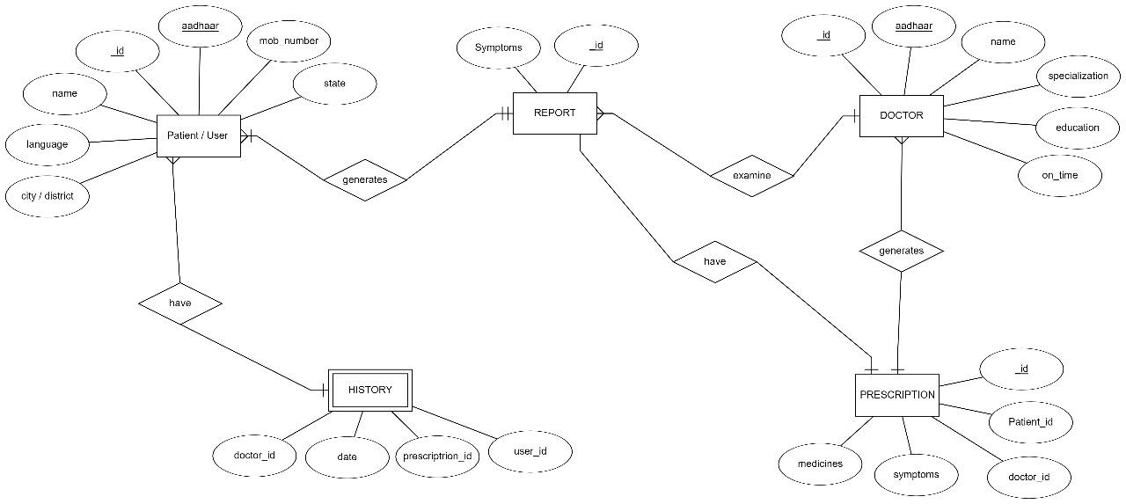

**Entities:**

1. **Patient:**
   * Represents patients registered in the system.
   * Attributes: AadharID (Primary Key), Name, Age, Gender, Contact, Address.
2. **Symptom:**
   * Represents symptoms collected from patients.
   * Attributes: SymptomID (Primary Key), Description.
3. **Doctor:**
   * Represents doctors available for consultation.
   * Attributes: DoctorID (Primary Key), Name, Specialization.

**Relationships:**

* **Patient-Symptom (Many-to-Many):**
  + Represents the relationship between patients and symptoms.
  + A patient can have multiple symptoms, and a symptom can be associated with multiple patients.
  + Attributes: PatientID (Foreign Key), SymptomID (Foreign Key), Date, Severity.

This ER diagram illustrates the entities (Patient, Symptom, Doctor) in the Meta Avatar system and their relationships. The Patient-Symptom relationship is represented as a many-to-many relationship because a patient can have multiple symptoms, and a symptom can be associated with multiple patients.

**.**