Project Synopsis

on

**Sanjeevani**

Submitted as a part of course curriculum for

**Bachelor of Technology**

in

**INFORMATION TECHNOLOGY**

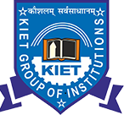

**Submitted by**

SOUMYA GUPTA (2100290120164)

ADITYA AGARWAL(2100290130010)

ANURAG CHAUDHARY(2100290130035)

BHAVISHYA CHAUDHARY(2100290130057)

**Under the Supervision of**

JITENDRA K SETH

Asst. Professor

**KIET Group of Institutions, Ghaziabad**

**Department of Computer Science**

**Dr. A.P.J. Abdul Kalam Technical University**

**2022-2023**

**ACKNOWLEDGEMENT**

It gives us a great sense of pleasure to present the synopsis of the B.Tech Mini Project undertaken during B.Tech. Third Year. We owe a special debt of gratitude to Jitendra Kumar, Department of Information Technology, KIET Group of Institutions, Delhi- NCR, Ghaziabad, for his constant support and guidance throughout the course of our work. His sincerity, thoroughness and perseverance have been a constant source of inspiration for us. It is only his/her cognizant efforts that our endeavours have seen the light of the day.

We also take the opportunity to acknowledge the contribution of Dr. Ajay Kumar Shrivastava, Head of the Department of Computer Science, KIET Group of Institutions, Delhi- NCR, Ghaziabad, for his full support and assistance during the development of the project. We also do not like to miss the opportunity to acknowledge the contribution of all the faculty members of the department for their kind assistance and cooperation during the development of our project.

Last but not the least, we acknowledge our friends for their contribution to the completion of the project.

Signature: Guide Name & Signature

Student’s Name: Soumya Gupta

Roll No: 2100290120164

**ABSTRACT**

**Revolutionizing Rural Healthcare: AI-Assisted Telemedicine Robotic Kiosk**

In rural India, accessing quality healthcare remains a formidable challenge due to various factors, including geographical remoteness, limited healthcare infrastructure, and linguistic barriers. To address these challenges, we propose a transformative solution: the deployment of AI-powered avatars, known as Meta Avatars, in conjunction with Telemedicine Kiosks. These avatars are uniquely designed to engage individuals in their native language and accent, facilitating effective communication and comprehension during medical consultations.

The Meta Avatars excel in data collection, utilizing interactive conversations to gather comprehensive information about an individual's health status. Through this process, they facilitate precise health assessments, enabling healthcare providers to make well-informed decisions. Moreover, the avatars possess advanced diagnostic capabilities, allowing them to analyse symptoms and provide preliminary diagnoses to users.

Beyond diagnostics, Meta Avatars also play a crucial role in medical consultations. Leveraging their vast knowledge base and computational abilities, they offer personalized recommendations and treatment plans tailored to individual needs. This integrated approach ensures that rural populations receive timely and accurate medical guidance, mitigating the impact of limited access to healthcare professionals.

Our mission is twofold: firstly, to deploy AI-assisted Telemedicine Kiosks equipped with Meta Avatars across rural India, thereby extending expert medical guidance to underserved communities. Secondly, we aim to break down linguistic barriers by enabling seamless communication between individuals and healthcare providers, fostering a compassionate and inclusive healthcare system.

Looking towards the future, we envision a healthcare landscape where rural India effortlessly connects with advanced medical expertise through AI and Meta Avatars. By overcoming traditional barriers to healthcare access, we strive to strengthen the well-being of rural communities, empowering them to lead healthier and more fulfilling lives. Through this innovative approach, we aspire to redefine healthcare delivery in rural India and beyond, ensuring equitable access to quality medical services for all.

**Introduction**

Accessing quality healthcare services in rural India presents a formidable challenge, compounded by factors like geographical isolation, insufficient infrastructure, and language barriers. These hurdles frequently lead to delays or inadequacies in medical care, widening the already prevalent health disparities among rural communities. However, the emergence of technology heralds a promising opportunity to overhaul healthcare delivery and effectively tackle these pressing challenges.

One promising solution is the integration of AI-powered avatars, known as Meta Avatars, within Telemedicine Kiosks deployed across rural areas. These avatars represent a breakthrough in healthcare innovation, as they are adept at engaging individuals in their local language and accent, thereby overcoming linguistic barriers that hinder effective communication during medical consultations.

The Meta Avatars are not only proficient in language comprehension but also excel in data collection and analysis. Through interactive conversations, they gather comprehensive information about an individual's health status, facilitating accurate and timely health assessments. Moreover, these avatars leverage advanced diagnostic algorithms to analyse symptoms and provide preliminary diagnoses, empowering individuals with valuable insights into their health condition.

Beyond diagnostics, Meta Avatars play a vital role in medical consultations by offering personalized recommendations and treatment plans tailored to individual needs. This integrated approach ensures that rural communities receive the same level of expert medical guidance as their urban counterparts, bridging the healthcare gap and promoting equitable access to healthcare services.

This paper explores the transformative potential of Meta Avatars in revolutionizing rural healthcare delivery in India. By deploying AI-assisted Telemedicine Kiosks equipped with Meta Avatars, we aim to extend expert medical guidance to underserved communities, break down linguistic barriers, and foster a compassionate and inclusive healthcare system. Through this innovative approach, we envision a future where rural populations seamlessly connect with advanced healthcare expertise, leading to improved health outcomes and strengthened well-being for all.

**Problem Statement**

In rural India, accessing quality healthcare services is a major challenge due to several factors. Firstly, many rural areas are far away from hospitals and clinics, making it difficult for people to reach medical facilities when they need them. Secondly, the infrastructure in these areas often lacks proper medical equipment and trained healthcare professionals, leading to limited healthcare options. Additionally, language barriers further complicate matters, as many rural residents may not speak the same language as healthcare providers, hindering effective communication and diagnosis.

As a result of these obstacles, rural communities often experience delays in receiving medical treatment, which can exacerbate health issues and lead to poorer health outcomes overall. This healthcare disparity between rural and urban areas widens existing health inequalities and leaves rural residents at a disadvantage.

Traditional healthcare delivery models have struggled to effectively address these challenges, leaving many rural residents underserved and unable to access the care they need. There is a pressing need for innovative solutions that can bridge the gap in healthcare access and provide equitable medical services to rural populations.

To overcome these obstacles, it is essential to leverage technology to develop new approaches to healthcare delivery in rural India. By implementing telemedicine solutions, for example, rural residents can access medical consultations and advice remotely, reducing the need for physical travel to healthcare facilities. Additionally, AI-powered tools can help improve diagnostic accuracy and streamline healthcare delivery processes, making it easier for rural residents to receive timely and appropriate medical care.

Furthermore, efforts to address language barriers through the use of multilingual communication tools and translation services can help ensure that rural residents can effectively communicate with healthcare providers and receive accurate diagnoses and treatment recommendations.

**Objectives**

* Enhance access to quality healthcare services for rural populations by deploying AI-assisted telemedicine kiosks equipped with Meta Avatars in underserved areas.
* Minimize delays in medical treatment by providing timely and remote consultations through telemedicine, ensuring that rural residents receive prompt medical attention when needed.
* Utilize AI-powered diagnostic algorithms to improve the accuracy and efficiency of medical diagnoses, enabling early detection and intervention for health conditions among rural populations.
* Address language barriers by deploying Meta Avatars capable of conversing fluently in local languages and accents, facilitating effective communication between healthcare providers and rural residents.
* Promote equity in healthcare access by ensuring that rural communities have access to the same level of expert medical guidance and services as urban areas, regardless of geographical location.
* Empower local healthcare workers, such as Asha workers, by providing them with training and support to facilitate the seamless delivery of medical services and follow-up care in rural communities.
* Utilize telemedicine kiosks and Meta Avatars to disseminate health education and awareness campaigns, empowering rural residents with knowledge and resources to make informed decisions about their health.
* Foster community engagement and participation in healthcare initiatives by involving local leaders and stakeholders in the planning and implementation of telemedicine services and programs.
* Implement robust privacy and security measures to safeguard sensitive health information collected through telemedicine consultations, ensuring confidentiality and trust among rural residents.
* Continuously monitor and evaluate the impact of telemedicine interventions on health outcomes and healthcare access in rural communities, iterating and improving strategies based on feedback and data-driven insights.

Top of Form

**Scope**

* Extending telemedicine services to remote rural areas.
* Facilitating effective communication in multiple local languages and accents.
* Leveraging AI and telecommunication infrastructure for efficient medical consultations.
* Involving local stakeholders to ensure sustainability and relevance.
* Training local healthcare workers to utilize telemedicine tools effectively.
* Disseminating health awareness campaigns through telemedicine platforms.
* Implementing robust measures to protect patient confidentiality.
* Continuously assessing the impact and optimizing services.
* Developing a scalable model for widespread adoption.
* Advocating for supportive policies to integrate telemedicine into healthcare

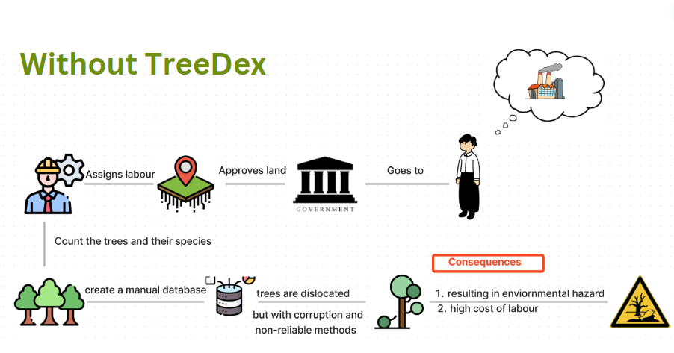 **Flow Charts**

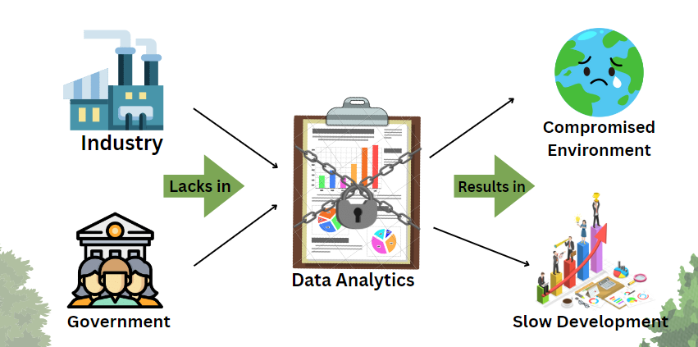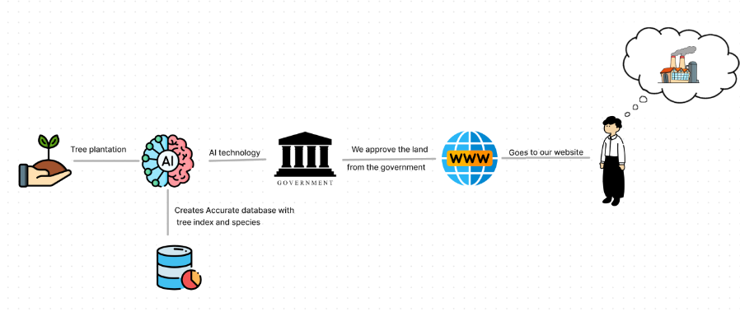

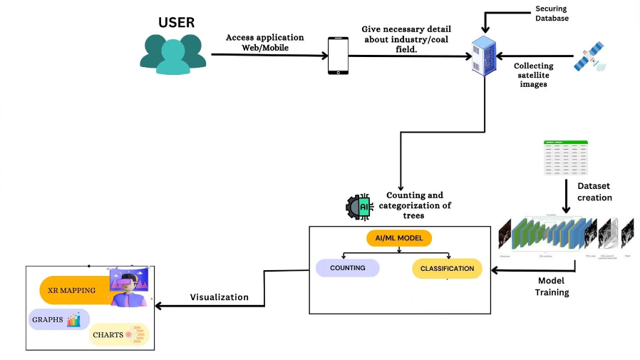

**Technology used**

* Blender
* OpenAI
* ElevenLabs
* MERN Stack

**ER Diagram**

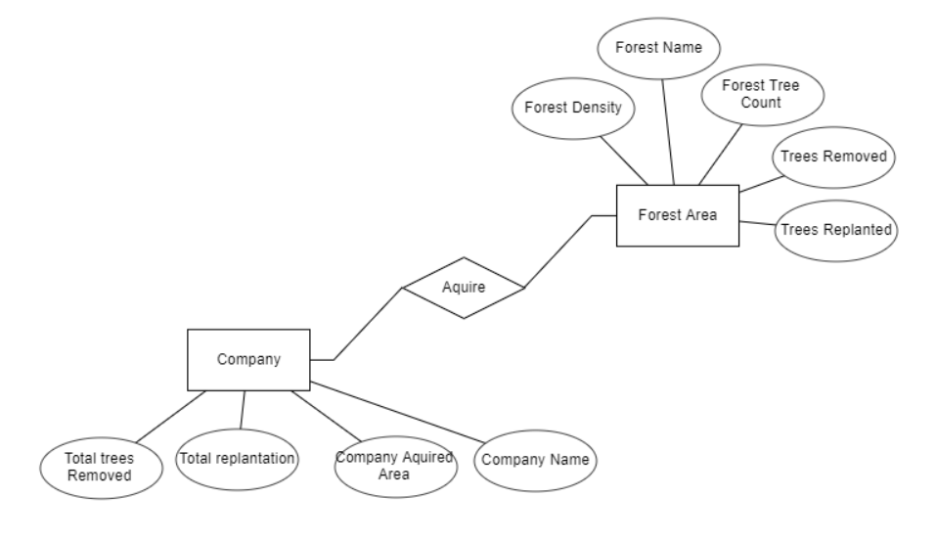

**Conclusion**

In conclusion, the deployment of AI-assisted telemedicine kiosks with Meta Avatars presents a promising solution to address the healthcare challenges faced by rural communities in India. By leveraging technology, language adaptability, and community engagement, this project aims to improve healthcare access, enhance diagnostic capabilities, and empower local healthcare workers. The scope of the project encompasses geographical reach, technology integration, capacity building, and policy advocacy, with a focus on scalability, sustainability, and privacy. Through collaborative efforts and continuous evaluation, we can strive towards achieving equitable healthcare access for all, bridging the gap between rural and urban healthcare and fostering healthier communities across India.

Top of Form