**Project Synopsis**

on

EduBridge

Submitted as a part of course curriculum for

# Bachelor of Technology

in

# Computer Science

PROJECT ID PCS(25-35)



### Submitted by

Kashish Tyagi (2100290120094)

Kaushiki Verma (2100290120095)

Dewansh Gupta (2100290120070)

### Under the Supervision of

Asst Prof. Arushi Gupta

# KIET Group of Institutions, Ghaziabad Department of Computer Science

**Dr. A. P. J. Abdul Kalam Technical University**

**2022-2023**

# TABLE OF CONTENTS

|  |  |  |
| --- | --- | --- |
|  | | Page  No. |
| TITLE PAGE .................................................................................................................... | | i |
| ACKNOWLEDGEMENT.................................................................................................. | | iii |
| ABSTRACT...................................................................................................................... | | iv |
| LIST OF FIGURES ......................................................................................................... | | vi |
| LIST OF ABBREVIATIONS ………..…………………………………………………. | | vii |
| CHAPTER 1 INTRODUCTION | | 1-6 |
| 1.1. | Introduction ……………………................................................... | 5 |
| 1.2 | Problem Statement………………………………………………. | 5 |
| 1.3. | Objective………………………………………………………… | 5 |
| 1.4. | Scope…………………………………………………………….. | 6 |
| CHAPTER 2 LITERATURE REVIEW…………………………………………….... | | 6-9 |
| CHAPTER 3 PROPOSED METHODOLOGY …………………………………........ | | 10 |
| 3.1 | Needs Assessment………………………………………………. | 10 |
| 3.2 Platform development…………………………………………… | | 10 |
| 3.3 | Content Curation………………………………………………… | 10 |
| 3.4 User Testing and Feedback……………………………………… | | 10 |
| 3.5 Scalability and Sustainability……………………………………. | | 10 |
| 3.6 | Evaluation………………………………………………………... | 10 |
| 3.7 Documentation and Communication…………………………….. | | 10 |
| CHAPTER 5 FLOW CHART .......................................................................................... | | 11 |
| CHAPTER 6 TECHNOLOGY USED …………………………………………………. | | 11 |
| CHAPTER 7 ER DIAGRAM …………………………………………………………... | | 12 |
| CHAPTER 8 USE CASE DIAGRAM………………………………………………….. | | 13 |
| REFERENCES….............................................................................................................. | | 14 |

**ACKNOWLEDGEMENT**

It gives us a great sense of pleasure to present the synopsis of the B.Tech Major Project undertaken during B.Tech. Third Year. We owe a special debt of gratitude to Ms. Arushi Gupta, Department of Computer Science, KIET Group of Institutions, Delhi- NCR, Ghaziabad, for her constant support and guidance throughout the course of our work. Her sincerity, thoroughness and perseverance have been a constant source of inspiration for us. It is only her cognizant efforts that our endeavours have seen the light of the day.

We also take the opportunity to acknowledge the contribution of Dr. Ajay Kumar Shrivastava, Head of the Department of Computer Science, KIET Group of Institutions, Delhi- NCR, Ghaziabad, for his full support and assistance during the development of the project. We also do not like to miss the opportunity to acknowledge the contribution of all the faculty members of the department for their kind assistance and cooperation during the development of our project.

Last but not the least, we acknowledge our friends for their contribution to the completion of the project.

Guide Name & Signature

Student’s Name: Ms. Arushi Gupta

(Assistant Professor)

Kashish Tyagi (2100290120094)

Dewansh Gupta (2100290120070)

Kaushiki Verma (2100290120095)

# ABSTRACT

The modern educational landscape is characterized by a plethora of academic activities scattered across various platforms, leading to fragmentation and difficulty in accessing pertinent information. "Edubridge" is proposed to address the lack of centralized information about academic activities. The project aims to provide a unified platform that aggregates information about events, seminars, competition, projects, and announcements.

The problem statement revolves around the challenge faced by students, mentors, and educational institutions in accessing and managing academic activities efficiently. Despite the abundance of educational resources and activities available online, there is a notable absence of a unified platform that consolidates this information, leading to confusion and inefficiency.

Edubridge seeks to streamline the process of discovering, participating in, and managing academic engagements for students, mentors, and institutions. Key features include a comprehensive database of academic activities, a user-friendly interface, personalized recommendations, and collaboration tools for students and mentors.

The implementation of Edubridge will follow a phased approach, encompassing requirements gathering, design, development, testing, deployment, and ongoing maintenance. Through iterative feedback and continuous improvement, Edubridge aims to evolve into a robust and indispensable tool for the academic community.

The problem statement revolves around the challenge faced by students, educators, and educational institutions in accessing and managing academic activities efficiently. Despite the abundance of educational resources and activities available online, there is a notable absence of a unified platform that consolidates this information, leading to confusion and inefficiency.

In conclusion, Edubridge represents a promising solution to the challenge of fragmented academic engagement by providing a centralized platform that fosters collaboration, enhances accessibility, and promotes meaningful interactions within the educational ecosystem.

# Introduction

## Introduction

In today's digital age, education is undergoing a significant transformation, with online resources and virtual platforms becoming increasingly prevalent. However, despite the abundance of educational content available, there remains a critical issue: the lack of a centralized platform for accessing information about academic activities. This introduction sets the stage for discussing the proposed solution, Edubridge, which aims to address this pressing challenge.

## Problem Statement

The educational landscape is marked by a fragmentation of information, with academic activities dispersed across multiple platforms so to address the lack of academic activities on a single platform. Students, mentors, and institutions often struggle to access and manage these activities efficiently due to the absence of a centralized repository. This fragmentation leads to confusion, missed opportunities, and inefficiencies in educational engagement. The problem statement highlights the need for a unified platform like Edubridge to consolidate information about lectures, seminars, workshops, assignments, and announcements, providing a single point of access for all stakeholders.

* 1. **Objective**

1. **Enhance Student Engagement**: Encourage first and second-year students to actively participate in campus life by providing easy access to information about college clubs and activities through Edubridge.
2. **Promote Campus Involvement**: Facilitate the discovery of diverse club offerings to help students explore their interests, develop new skills, and build connections within the college community.
3. **Streamline Club Management**: Simplify the process for club leaders to create profiles, update event calendars, and communicate with members through the Edubridge platform.
4. **Increase Awareness**: Raise awareness among first and second-year students about the availability and benefits of joining college clubs and participating in extracurricular activities.
5. **Foster Community Building**: Create opportunities for students to engage with peers who share similar interests, fostering a sense of belonging and camaraderie within the college environment.
6. **Support Personal Growth**: Encourage students to step out of their comfort zones, explore new interests, and develop leadership skills through active involvement in college clubs and organizations and establish effective communication.

## Scope

The scope of Edubridge encompasses the development of a platform that caters to the needs of students, mentors, and educational institutions. The focus and direction of Edubridge is to revolutionize academic engagement and enhance the educational experience for all students.

# Literature Review

### Paper 1: A Research Study on the ERP System Implementation and Current Trends in ERP

The literature review navigates the historical underpinnings and contemporary dynamics of Enterprise Resource Planning (ERP) systems. It traces ERP's inception back to the 1970s, elucidating its formalization in the 1990s with the introduction of SAP R/3 and the pivotal resolution of Y2K concerns. Contemporary ERP trends encompass the paradigm shift towards cloud-based deployment, fusion with Artificial Intelligence (AI) technologies, ubiquitous mobile accessibility, and industry-specific customization. Highlighted challenges in ERP implementation underscore the risks of regressing to outdated practices, the imperative of steadfast senior leadership support, and the pressing need to fortify data security. Proposed solutions advocate for meticulous project scoping, comprehensive user training initiatives, and proactive strategies for future scalability. The review integrates these key points to provide a comprehensive understanding of ERP's historical journey, current trends, challenges, and proposed solutions, offering insights valuable for organizations navigating the complex terrain of ERP system implementation and optimization.

### Paper 2: Success Factors for ERP Implementation: a Systematic Literature Review

Enterprise Resource Planning (ERP) systems have become indispensable tools for organizations seeking to enhance operational efficiency and gain competitive advantages in today's dynamic business environment. However, the successful implementation of ERP systems remains a formidable challenge, with many projects failing to achieve their intended objectives. Understanding the critical success factors (CSFs) associated with ERP implementation is essential for organizations to navigate through the complexities of the implementation process and maximize the benefits of these systems. ERP systems integrate various business functions into a unified platform, enabling organizations to streamline processes, enhance data visibility, and improve decision-making. Despite the potential benefits of ERP systems, their implementation is often fraught with challenges, including cost overruns, schedule delays, and organizational resistance to change. To address these challenges, organizations must identify and prioritize the CSFs that significantly impact the success of ERP projects.

Past research has emphasized the importance of CSFs in ERP implementation, with scholars advocating for a systematic approach to identifying and addressing these factors. While some researchers argue for the universality of CSFs across different organizational contexts, others highlight the importance of context-specific factors that

may influence ERP project success. This study seeks to build upon existing literature by conducting a comprehensive review of empirical studies on CSFs in ERP implementation.

The research methodology involves a systematic literature review of refereed papers published between 2006 and 2018, focusing on qualitative studies that examine factors influencing ERP implementation in organizations. By synthesizing the findings of these studies, the study aims to identify key CSFs and assess their significance in different organizational settings. The findings of this study are expected to provide valuable insights for practitioners and researchers in the field, enabling organizations to better plan, execute, and manage ERP implementation projects.

In conclusion, ERP implementation represents a significant undertaking for organizations, requiring careful planning, resource allocation, and stakeholder engagement. By understanding the critical success factors associated with ERP implementation, organizations can mitigate risks, overcome challenges, and increase the likelihood of project success. This study contributes to the existing body of knowledge on ERP implementation by offering practical recommendations for improving the effectiveness and efficiency of ERP projects.

### Paper 3: The integration of college students' employment resources. By -Jun, Guo & Yong-jie, Chen. (2011).

The integration of college students' employment resources from the perspective of e- Government. 10.1109/ICEBEG.2011.5882726. Student employment is one of the key issues concerned in our country. And the problem of how to raise the employability of college students is an important issue that is faced by the government, universities, society and students themselves. Based on the perspective of e-government, this paper will firstly analyze the key factors of student employment and set up the “S-S-G“ interactive model; secondly make a comprehensive analysis which contains many aspects such as the e-government running by the government in the policy of public employment, the services of public employment, the platform of public employment as well as the e-university running by universities in the employment service systems, the platform of employment information, the resources of alumnus, and the resources of university cooperation; finally find a path that is an integration of student employment resources.

### Paper 4: Developing entrepreneurship and e-government in India By – Saxena, Anant. (2013).

Developing entrepreneurship and e-government in India: Role of common service centers. Journal of E-Governance. 36. 92-100. 10.3233/GOV-130340. Developing e- Governance and entrepreneurship in rural India is the biggest challenge for Indian government. Number of initiatives has been taken by government to boost both entrepreneurship and e-Governance, one of which is Common Service Center (CSC) project. CSC project is an ambitious project of Indian government based on PPP framework to boost entrepreneurship and e governance in Rural India. Very few studies have focused on the role of Common Service Centers (CSC) in development of Rural India. This study tries to fill this gap by throwing light on the benefits derived from the CSC project and some of the major bottlenecks of the project. The study concludes with major recommendations to overcome these bottlenecks to increase the impact in the field of e-governance and entrepreneurship.

### Paper 5: DEVELOPMENT OF AN E-LEARNING WEB PORTAL: The Foss

**Approach**

This paper provides an overview of e-Learning and the open source domain as well as discusses how open source can be used to speedily realizes the development of an eLearning application in a web environment using an adaptive process. Specifically, the authors described their preliminary experiment of implementing an open source eLearning platform by adapting free PHP source code and MySQL database to suit an electronic class bulletin board.

With the vast development of various technologies, learning today is no longer confined to classrooms with lecture delivery as the only method of conveying knowledge, rather, an electronic means of learning has continued to evolve. Electronic learning (e- Learning), which facilitates education using communications networks, has made learning possible from anywhere at anytime using the Internet, wide area networks or local area networks. Notably, e-Learning applications which have now become central to the learning process may be developed using proprietary programming tools and the process of acquiring and using them to develop large software application is not only complex but require a huge sum of money. A viable alternative is to utilize the open source software platform that allows software engineers and institutions the right to reuse, study, distribute and localize to satisfy user’s requirements.

### Paper 6: The Impacts of Establishing Enterprise Information Portals

The Enterprise Information Portal (EIP) provides access - a single point of personalized, on-line access - to business information and knowledge sources, and real-time access to core application and processes. EIP is defined as an ultimate window that presents e- business fruitful results. Our research focuses on investigating the relationship between organizational characteristics and whether EIP is adopted in the business operations and the relationship among the function application degree, implementation type, integration ability, and users of EIP and e-Business performances. The result of our study shows that: (1) Between those organizations have and those have not adopted EIP, there are significant differences in the maturity and familiarity of information technologies, and organizational size; (2) In the way of implementation EIP, the relationship among function application degree, implementation type, integration ability, and e-Business performance are also significantly influence; (3) The impact between function application degree of EIP and e-Business performance will be enhanced by high e-business degree; (4) The impact between implementation type of EIP and e-Business performance will be intervened by e-business degree; (5) The implementation time of EIP has no significant impact on the relationship between implementation EIP and e-Business performance.

### Paper 7: Impact of web portals on e-learning

A. Tella and M. T. Bashorun, "Impact of web portals on e-learning," Fourth International Conference on the Applications of Digital Information and Web Technologies (ICADIWT 2011), Stevens Point, WI, USA, 2011, pp. 161-166, doi: 10.1109/ICADIWT.2011.6041424.

The study examined the undergraduate students' satisfaction with their web portals, consider the benefits of using the portal and the problems they are encountering using

the portal in order to identify levels for improvement. A pure quantitative method using descriptive survey approach was embarked upon. Questionnaire was used for data collection. A statistical package for social sciences (SPSS) was used to code the data while methods of analysis included: percentages and frequency count; multiple correlation and regression. The results revealed that students were generally satisfied with the e-portal system at the University. Overall, 89.3% were adequately satisfied, satisfied, and moderately satisfied; while on the other hand, 11.1% were less satisfied or not satisfied. Information/content quality, system quality, ease of use and other dimensions were indicated to have the capacity to determine users' satisfaction with e- portal system. Furthermore, the results demonstrated that the entire user satisfaction dimension positively and significantly correlate with and adequately predicted satisfaction with e-portal.

### Paper 8: Examining the impact of possible antecedents on service usage: An empirical study on Macao e-government

Tang, Hung-Lian & Chung, Sock & Se, Chun. (2009). Examining the impact of possible antecedents on service usage: An empirical study on Macao e-government. EG. 6. 97-109. 10.1504/EG.2009.022595. This research investigated Macao citizens' intention of usage of e-government services. In the past, information technology (IT) adoption in private companies has been studied extensively. However, most of previous studies on the adoption of e-government are not enough for a base to build on further extensions. This research introduced a framework with five major factors that may affect the intention of usage of e-government services. They are: 1) perceived usefulness; 2) perceived ease of use; 3) technology characteristics; 4) trust; 5) persuasion. The results indicated that the factors of perceived usefulness, trust and persuasion exert the influence on the intention of usage of e-government, but the factors of perceived ease of use and technology characteristics do not.

### Paper 9: Enterprise Resource Planning (ERP) System Implementation: A case for User participation

The literature review examines the complexities of Enterprise Resource Planning (ERP) system implementation, emphasizing the critical role of user participation. ERP systems, integrating technology and organizational processes, demand substantial financial resources and organizational commitment. Despite promises of integration and efficiency, ERP implementation faces challenges including technical issues and human obstacles. Failures in ERP projects often stem from human factors, underscoring the importance of user involvement. However, research on user participation in ERP implementation remains limited. Past studies have focused on factors contributing to ERP success, identifying critical success factors (CSFs) such as user involvement. User participation during implementation is crucial for eliciting system requirements and fostering positive user attitudes. This paper aims to address this gap by reviewing literature on ERP systems, particularly focusing on the role of user participation. Through a thematic analysis, it explores various research streams within the ERP domain, with a specific emphasis on implementation challenges and the significance of user involvement.

# Proposed Methodology

The implementation of Edubridge involves several key steps and activities to realize its objectives and scope effectively. The proposed methodology outlines the approach to be followed in developing and deploying the platform.

## Needs Assessment:

Conduct surveys, interviews, and focus groups with students, mentors, and institutions to gather requirements and preferences. Analyze the data to identify common pain points and needs.

## Platform Development:

Assemble a multidisciplinary team including developers, designers, and education specialists. Utilize agile development methodologies for iterative improvements.

## Content Curation:

Collaborate with educators to identify key learning materials and resources. Develop mechanisms for ongoing content updates and quality assurance.

## User Testing and Feedback:

Gather feedback on user experience, functionality, and feature preferences. Iterate on design and functionality based on user input.

## Scalability and Sustainability:

Evaluate the scalability of the platform architecture and infrastructure. Develop a growth strategy to expand the platform to additional institutions and users. Explore revenue models such as subscription fees, partnerships, or grants to ensure sustainability.

## Evaluation:

Assess the effectiveness of the platform in meeting user needs and objectives. Measure key performance indicators such as user satisfaction, engagement, and academic outcomes.

## Documentation and Communication:

Maintain comprehensive documentation of project activities, decisions, and outcomes. Establish regular communication channels with stakeholders to provide updates and gather feedback.

By following this methodology and implementing the outlined activities, the Edubridge project can effectively address the lack of academic activities on a single platform while ensuring user satisfaction, engagement, and long-term sustainability.

## Flow Chart

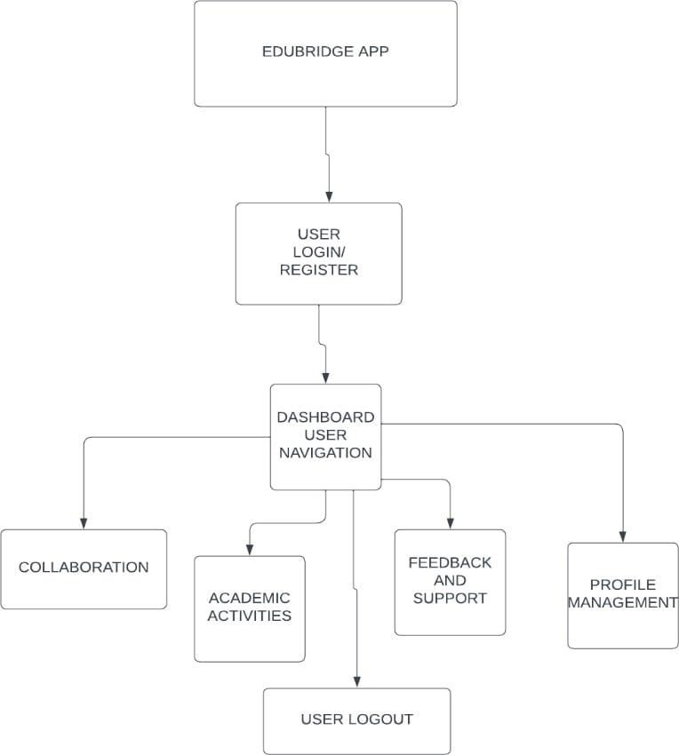

**Tech Stack used:**

* Programming Language : Java , XML
* Development Environment: Android Studio
* User Interface Design: XML & Figma
* Backend services: Firebase
* Database: Firebase realtime DB.
* Push notifications: Firebase Cloud messaging
* Testing and debugging: Robolectric

**ER DIAGRAM**

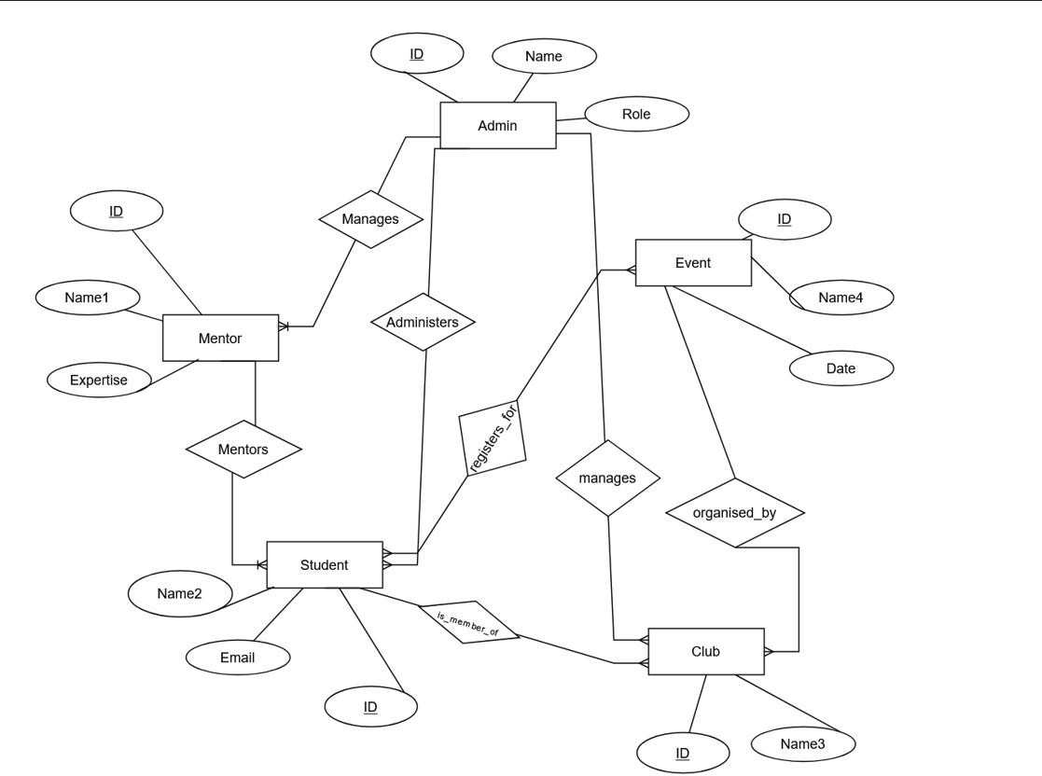

## Use case Diagram

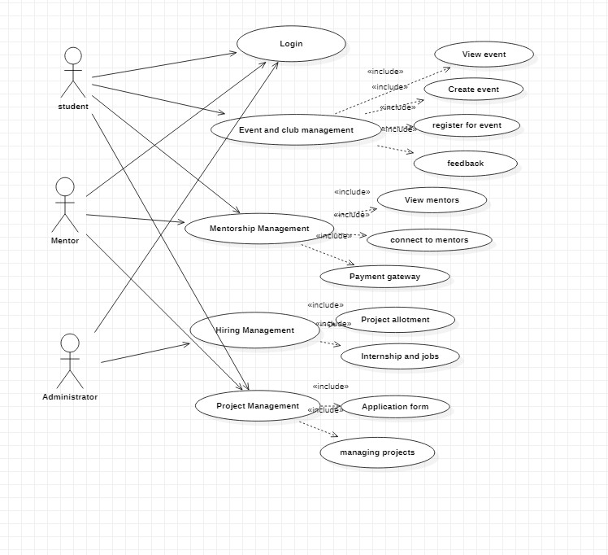

### REFERENCES

1. Kenge, Rohit. (2020). A Research Study on the ERP System Implementation and Current Trends in ERP. Shanlax International Journal of Management. 8. 34-39. 10.34293/management.v8i2.3395.
2. Tang, Hung-Lian & Chung, Sock & Se, Chun. (2009). Examining the impact of possible antecedents on service usage: An empirical study on Macao e-government. EG. 6. 97-109. 10.1504/EG.2009.022595.
3. Mahraz, Mohamed-Iliasse & Berrado, Abdelaziz & Benabbou, Loubna. (2019). Success Factors for ERP Implementation: a Systematic Literature Review.
4. R. Patel and S. Gupta, "Node.js: A Platform for Scalable Backend Development," IEEE Software, vol. 28, no. 3, pp. 22-33.
5. Wang T, Li S. Relationship between employment values and college students' choice intention of slow employment: A moderated mediation model. Front Psychol. 2022 Aug 11;13:940556. doi: 10.3389/fpsyg.2022.940556. PMID: 36033039; PMCID: PMC9404505.
6. Saxena, Anant. (2013). Developing entrepreneurship and e-government in India: Role of common service centers. Journal of E-Governance. 36. 92-100. 10.3233/GOV-130340.
7. Azeta, Ambrose & Oyelami, Olufemi & Ayo, Charles. (2008). Development of an E-learning web portal: The foss approach. The Turkish Online Journal of Distance Education.
8. Al-Mashari, M. 2003. Enterprise resource planning (ERP) systems: A research agenda. Industrial Management & Data Systems, Vol. 103/1, pp. 22-27.
9. Adeyinka, Tella & Bashorun, M.. (2011). Impact of web portals on E-learning. 4th International Conference on the Applications of Digital Information and Web Technologies, ICADIWT 2011. 10.1109/ICADIWT.2011.6041424.