Lab - 4

ER Diagram

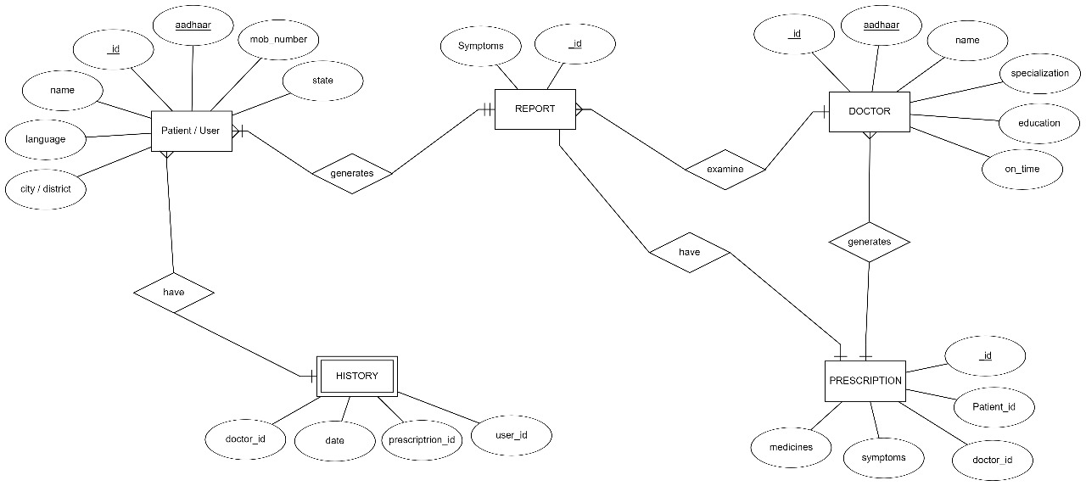
Entities:
- Patient:
  - Represents patients registered in the system.
  - Attributes: AadharID (Primary Key), Name, Age, Gender, Contact, Address.
- Symptom:
  - Represents symptoms collected from patients.
  - Attributes: SymptomID (Primary Key), Description.
- Doctor:
  - Represents doctors available for consultation.
  - Attributes: DoctorID (Primary Key), Name, Specialization.
Relationships:
- Patient-Symptom (Many-to-Many):
  - Represents the relationship between patients and symptoms.
  - A patient can have multiple symptoms, and a symptom can be associated with multiple patients.
  - Attributes: PatientID (Foreign Key), SymptomID (Foreign Key), Date, Severity.
This ER diagram illustrates the entities (Patient, Symptom, Doctor) in the Meta Avatar system and their relationships. The Patient-Symptom relationship is represented as a many-to-many relationship because a patient can have multiple symptoms, and a symptom can be associated with multiple patients.
.

