Test plan for
WATER FOOTPRINT CALCULATION

Made By:
Shikha Kushwaha (2200290129017) Section-A
Shivanshu Srivastava (2100290120061) Section-C
Sumit Tiwari (2100290120168) Section-C
Suraj Jain (2100290120170) Section-C

Test Manager:
Prof. Kalpana Sagar

ChangeLog

Version | Change Date | By | Description
001 | 19.11.2024 | Shikha Kushwaha | Intitial Draft
002 | 02.12.2024 | Shikha Kushwaha | Complete Draft

1 Introduction 2
1.1 Scope 2
1.1.1 In Scope 2
1.1.2 Out of Scope 2
1.2 Quality Objective 2
1.3 Roles and Responsibilities 2
2 Test Methodology 3
2.1 Overview 3
2.2 Test Levels 3
2.3 Bug Triage 3
2.4 Suspension Criteria and Resumption Requirements 3
2.5 Test Completeness 4
3 Test Deliverables 4
4 Resource & Environment Needs 4
4.1 Testing Tools 4
4.2 Test Environment 4
5 Terms/Acronyms 5

Introduction

The Water Footprint project calculates the water consumption associated with various goods and items used in daily life. Users can scan an item, and the app analyzes its water footprint using preloaded data. This provides insights into the water resources utilized in the production and lifecycle of the item. The project aims to raise awareness about water usage and promote sustainable consumption habits. It combines frontend development in Flutter with data analysis to deliver a user-friendly experience.

Test Strategies
The Water Footprint Project followed a systematic testing approach to ensure a reliable and efficient user experience for the Flutter-based frontend:
- Requirement-Based Testing
Tests were aligned with project requirements to ensure functionality, usability, and compliance with project goals.
- Functional Testing
Verifying all frontend features like input forms, visualization tools, and navigation worked as intended.
- Usability Testing
Focused on evaluating the user interface to ensure ease of use and accessibility for end-users.
- Integration Testing
Ensured seamless communication between the Flutter frontend and backend services or APIs.
- Performance Testing
Verified the responsiveness and stability of the application under different scenarios.

Testing Process
- Planning Phase
  - Identifying key features to be tested based on the project scope.
  - Preparing test cases aligned with user stories and project requirements.
- Test Case Design
  - Writing detailed test cases covering all functionalities of the Flutter frontend.
  - Prioritizing test cases for core features like input validation, data visualization, and navigation.
- Test Execution
  - Running the designed test cases on various devices to ensure compatibility and responsiveness.
  - Documenting any defects or discrepancies for review.

- Defect Reporting and Resolution
  - Logging identified bugs into a tracking system.
  - Collaborating with the development team for fixes and retesting.
- Regression Testing
  - Ensuring that recent changes didn’t introduce new bugs or break existing features.
- Final Acceptance Testing
  - Conducting end-to-end testing to verify the project met all requirements before delivery.

Workflow
The testing workflow was iterative and followed these steps:
- Development of Features
  - Each module of the frontend was developed and tested incrementally.
- Build and Deployment
  - Continuous integration tools were used for automated builds and testing pipelines.
- Testing Cycles
  - Testing occurred in sprints, coinciding with the Agile development cycle.
- Feedback Loop
  - Regular feedback was collected from stakeholders for iterative improvements.

Methodologies
- Agile Testing
  - Testing integrated into each sprint to deliver a high-quality product incrementally.
- Black-Box Testing
  - Focused on testing the application from an end-user perspective without knowledge of internal code.
- Exploratory Testing
  - Performed to identify any edge cases or hidden defects that predefined tests might miss.
- Cross-Platform Testing
  - Ensured compatibility of the Flutter app on both Android and iOS devices.
- Automation Testing
  - Leveraged tools for repetitive testing tasks like regression and performance checks to save time and improve accuracy.

Scope

In Scope

Functional Requirements to be Tested
- User Interface (UI)
  - Validation of input forms for water footprint data.
  - Proper rendering of charts, graphs, and data visualizations.
  - Smooth navigation between application screens.
- Data Handling
  - Accuracy in fetching and displaying data from APIs or backend.
  - Input validations to ensure correct and logical user entries.
  - Ensuring that uploaded or entered data is processed as intended.
- Core Features
  - Calculation of water footprint based on user-provided data.
  - Presentation of water consumption metrics in meaningful visualizations.
  - Export and sharing options for reports or data.
- User Account Management
  - User registration and login functionality.
  - Secure storage and retrieval of user data.
- Cross-Platform Compatibility
  - Ensuring consistency of the application’s behavior across Android and iOS devices.
- Integration with Backend Services
  - Verification of API calls for data retrieval and submission.
  - Handling of error responses from backend services.

Non-Functional Requirements to be Tested
- Performance Testing
  - Load testing to ensure stability under varying user loads.
  - Responsiveness and app behavior under low network conditions.
- Usability Testing
  - Evaluating user experience for intuitiveness, accessibility, and ease of use.
  - Ensuring compliance with design guidelines and best practices.
- Security Testing
  - Verification of secure handling of user inputs and data.
  - Protection against vulnerabilities like unauthorized access or data leaks.
- Scalability Testing
  - Testing the app’s ability to handle an increasing number of users or data inputs.
- Compatibility Testing
  - Verifying the app’s performance across different devices, screen sizes, and operating systems.
- Error Handling
  - Ensuring meaningful error messages are displayed for invalid actions or inputs.
  - Recovery mechanisms for interrupted operations, such as API calls or network issues.

Out of Scope

Features and Functional Requirements NOT to Be Tested
- Backend Development Details
  - Testing of backend systems such as database design, server configuration, or API implementation logic.
  - Internal operations of third-party APIs or external data sources used in the project.
- Data Analytics or Machine Learning
  - Validation of complex analytical models, algorithms, or calculations beyond their integration with the app.
  - Performance and accuracy of any external tools or libraries used for data analysis.
- Advanced User Management
  - Features such as role-based access control (RBAC) or multi-factor authentication (MFA) if not included in the current scope.
- Cross-Browser Testing
  - Functionality and layout checks in desktop or web browsers unless explicitly part of the Flutter project.
- Offline Functionality
  - Offline data storage and synchronization, if not a stated requirement of the project.
- Complex Reporting Features
  - Advanced reporting or analytics capabilities that go beyond generating simple summaries or visualizations.

Non-Functional Requirements NOT to Be Tested
- Infrastructure Performance
  - Load and stress testing of backend infrastructure such as servers, databases, or network bandwidth.
  - Scalability testing for server-side systems.
- Third-Party Service Dependencies
  - Reliability or performance testing of third-party APIs or external services.
- Advanced Security Measures
  - Penetration testing or in-depth vulnerability assessments of backend systems or network configurations.
  - Compliance testing for specific security standards like ISO 27001 or GDPR, unless required.
- Localized Content Testing
  - Verification of multi-language support or regional customizations unless explicitly included in the requirements.

Quality Objective

Some objectives of your testing project could be

- Ensure the Application Under Test conforms to functional and non-functional requirements
- Ensure the AUT meets the quality specifications defined by the client
- Bugs/issues are identified and fixed before go live

Roles and Responsibilities
- QA Analyst- As the QA Analyst, Shivanshu Srivastava was responsible for identifying and documenting defects, creating and executing detailed test cases, and ensuring the application adhered to functional and non-functional requirements. He conducted end-to-end testing, validated the app's usability, and collaborated with the development team to resolve issues effectively.

- Test Manager- As the test Manager, Kalpana Sagar oversaw the testing process by defining the testing strategy, planning test schedules, and ensuring resource allocation. He coordinated between stakeholders and the QA team, monitored progress, and ensured the delivery of a high-quality application aligned with project objectives.

- Configuration Manager- As the Configuration Manager, Sumit Tiwari was responsible for managing and controlling the configuration of the software, ensuring that the correct versions of code, documentation, and other project artifacts were maintained. He coordinated configuration changes, ensured consistency across different environments, and managed version control systems to prevent issues during development and deployment.

- Developers- As Developers, Shikha Kushwaha and Suraj Jain were responsible for designing, coding, and implementing the application’s core functionalities. They ensured the application adhered to the specified requirements, fixed reported issues during testing, and collaborated with other team members to deliver a robust and efficient product.

- Installation Team- As the Installation Team, Vivek Kumar Sharma was responsible for deploying and configuring the application in the target environment. They ensured the setup was seamless, addressed any deployment challenges, and verified the application’s functionality post-installation to guarantee readiness for end-users.

Test Methodology

Overview
Reason for Adopting Agile Test Methodology for the Water Footprint Project

1-Flexibility and Adaptability
- Agile allows for continuous feedback and adjustments, enabling the project to accommodate changing requirements or priorities throughout the development cycle. This flexibility is essential for ensuring that the final product aligns with user needs and business goals.
2-Incremental Delivery
- By breaking the testing into smaller, manageable iterations (sprints), Agile enables early identification of defects and faster delivery of core features. This iterative approach ensures that key functionalities can be tested and refined early in the process.
3-Collaboration and Communication
- Agile fosters strong communication between cross-functional teams, such as developers, testers, and stakeholders, ensuring that all parties are aligned on expectations and requirements. This close collaboration helps in addressing any issues promptly and ensures that the project progresses smoothly.
4-Continuous Improvement
- Agile promotes continuous improvement by encouraging regular retrospectives. This helps identify areas for process enhancement, testing optimization, and the overall development workflow, leading to better product quality over time.
5-Early and Frequent Testing
- With Agile, testing is integrated early and often throughout each sprint, ensuring that defects are detected and resolved promptly. This proactive approach minimizes risks and improves the overall stability and functionality of the application.

Test Levels

Test Levels define the Types of Testing to be executed on the Application Under Test (AUT).

1. Unit Testing
- Objective: Validate individual components or functions of the application to ensure that each part performs correctly in isolation.
- Focus Areas:
  - Core functionality such as water footprint calculation and data processing.
  - Backend services or API endpoints.
- Tools/Techniques:
  - Frameworks like JUnit for Java and Kotlin testing.
  - Flutter's test package for unit testing Flutter code.

2. Integration Testing
- Objective: Ensure that different modules or components work together as expected when integrated.
- Focus Areas:
  - Communication between the frontend (Flutter app) and backend services (APIs).
  - Data exchange, such as sending user inputs and receiving calculated water footprint results.
- Tools/Techniques:
  - Postman for API testing.
  - Mocking tools for external services and dependencies.

3. System Testing
- Objective: Validate the complete system's behavior and ensure that it functions as intended in the integrated environment.
- Focus Areas:
  - Full application functionality, including user interactions, data processing, and system integrations.
  - Usability, performance, and security aspects of the entire system.
- Tools/Techniques:
  - Selenium for web-based automation.
  - Manual testing for end-to-end user flows.

4. Regression Testing
- Objective: Ensure that new code changes or feature additions do not negatively impact existing functionality.
- Focus Areas:
  - Verify that previously tested functionality continues to work after new features are implemented.
  - Ensure stability across different versions of the application.
- Tools/Techniques:
  - Selenium, Flutter Integration tests for automated regression testing.

Test Completeness

Here you define the criterias that will deem your testing complete.
For instance, a few criteria to check Test Completeness would be

- 100% test coverage

- All Manual & Automated Test cases executed

- All open bugs are fixed or will be fixed in next release

Test Deliverables

Here mention all the Test Artifacts that will be delivered during different phases of the testing lifecycle.

- Test Cases- Design test cases through the selenium.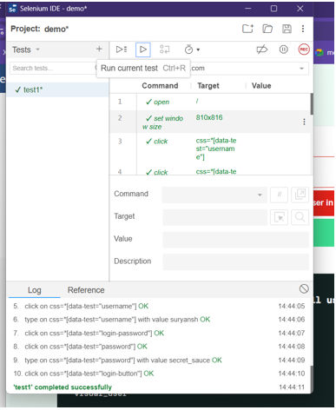

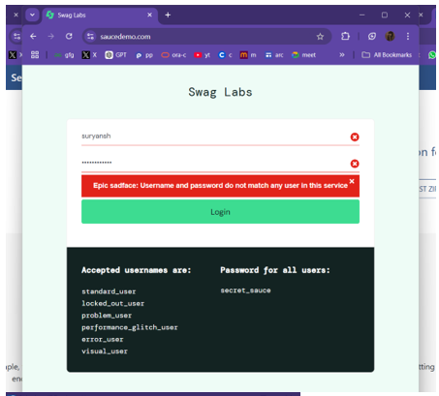

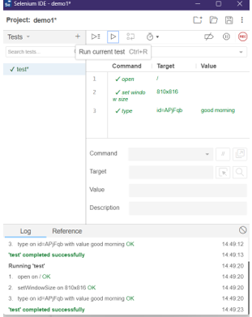

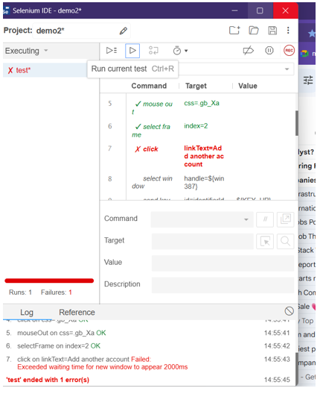

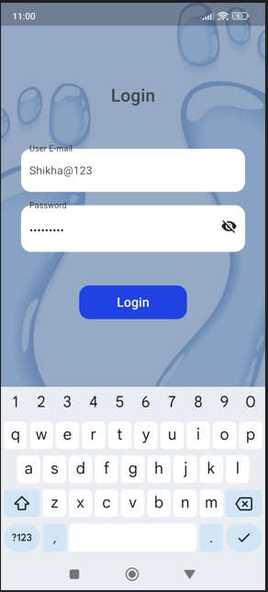

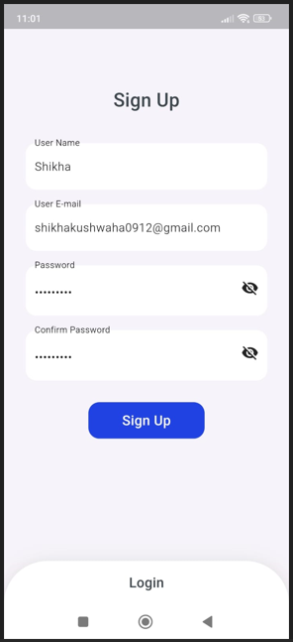

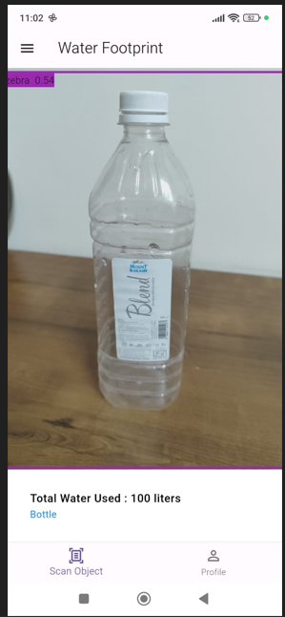

Boundary Value analysis:

1. Input: Daily Water Usage (liters)

Range: 0 to 10,000 liters.

TEST CASES:-

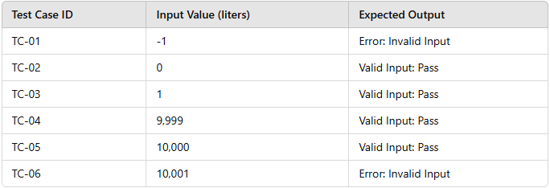

Bug Report:- Design a bug report through Mantis BT.

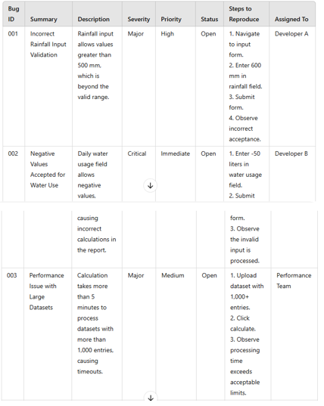

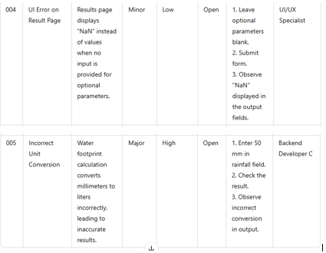

Requirement Traceability Matrix (RTM):-

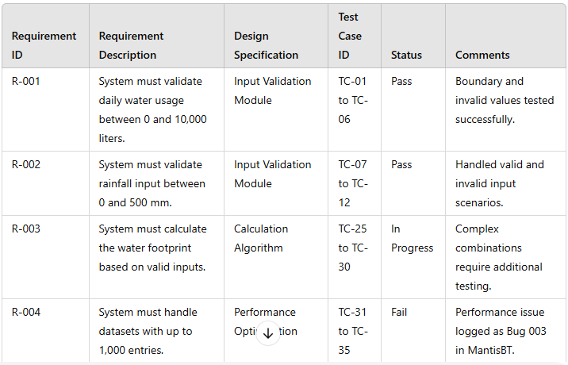
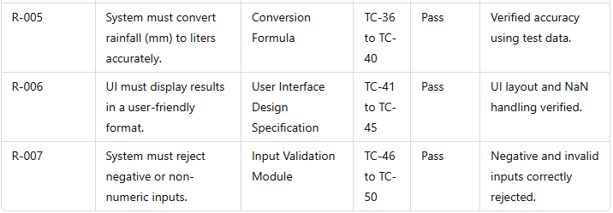

3.Resource & Environment Needs

Testing Tools

- Bug Tracking Tool- Mantis BT
- Automation Tools- Postman, Selenium.

Test Environment
It mentions the minimum hardware requirements that will be used to test the Application.

Following software’s are required in addition to client-specific software.

- Windows 10 and above
- Android Studio (2022.3.1) and above
- VS Code 2022 and above.

Terms/Acronyms
Make a mention of any terms or acronyms used in the project

TERM/ACRONYM | DEFINITION
API | Application Program Interface
AUT | Application Under Test

