[1] Shivani [2] Prabhat Sahrawat [3] Ashwin Yadav [4] Harsh [5] Mayank Choudhary

[1][2][3][4][5]Computer Science department, KIET Group of Institutions

[1][shivani.cs@kiet.edu](mailto:shivani.cs@kiet.edu) ,

[2] [Prabhat.2125cs1041@kiet.edu](mailto:Prabhat.2125cs1041@kiet.edu) ,

[3] [ashwin.2125cs1063@kiet.edu](mailto:ashwin.2125cs1063@kiet.edu) , [4][harsh.2125cs1024@kiet.edu](mailto:harsh.2125cs1024@kiet.edu) , [5][mayank.2125cs1200@kiet.edu](mailto:mayank.2125cs1200@kiet.edu)

**Integrated platform for Information about Indian Universities**

**ABSTRACT**

The Integrated Information Platform for Indian Universities (IIP-IU) is a comprehensive solution designed to address the fragmented and inaccessible information landscape in the Indian higher education ecosystem. The platform is built to serve as a centralized hub for students exploring undergraduate and graduate programs, empowering them with detailed insights into university offerings, such as academic courses, faculty expertise, admission processes, campus facilities, rankings, and alumni networks. A key feature of the platform is its **Mentor Guidance System**, which bridges the gap between students and industry professionals or academic advisors. This unique feature allows students to schedule one-on-one sessions with mentors, offering personalized career guidance tailored to their individual interests, goals, and academic backgrounds. Whether a student is seeking advice on course selection, understanding industry trends, or planning long-term career strategies, the mentorship feature ensures accessible, high-quality support. The platform leverages modern technologies, including the **MERN stack (MongoDB, Express.js, React.js, Node.js)**, to deliver a scalable, user-friendly, and efficient solution. A responsive and intuitive interface ensures seamless access to critical information across devices, while robust backend infrastructure supports real-time updates on academic calendars, admission deadlines, and program details. Advanced data analytics further enhance the platform by providing personalized recommendations and insights to users. By integrating comprehensive college data and mentorship opportunities in a single platform, the IIP-IU facilitates informed decision-making for students and their families. It also promotes inclusivity, collaboration, and innovation within the educational ecosystem, contributing to the holistic development of students and advancing the competitiveness of Indian higher education.

.[2][15]

Index Terms— *Integrated Information platform for Information about Indian Universities,React.js, Node.js, Express.js, MongoDB, Git, GitHub, Web Development*

# **INTRODUCTION**

Choosing the right career path and college is a challenging decision for many students, often leading to confusion due to a lack of clear guidance and fragmented information. Our platform addresses this by offering a centralized hub where students can explore detailed information about colleges, including courses, faculty, infrastructure, and rankings. Additionally, the platform provides personalized consulting services through a **Mentor Guidance System**, allowing students to schedule one-on-one meetings with industry professionals or academic advisors for tailored career advice. Built using the **MERN stack**, the platform combines ease of use, scalability, and real-time updates to help students make informed decisions about their academic and career journeys.

. [4][16]

**CollegeSearch** offers a holistic solution to one of the most pressing challenges faced by students—navigating the complex process of choosing the right college and career path. The platform not only addresses the difficulty of finding reliable and comprehensive information about colleges but also bridges the gap between students and expert guidance through an intuitive and interactive experience.

The platform provides students with detailed, centralized information on colleges across India, covering essential aspects like courses, faculty, admission processes, rankings, and infrastructure. With just a few clicks, students can compare colleges, evaluate their options, and make informed decisions. A **user-friendly interface** ensures that the process is seamless, saving both time and effort. Designed with simplicity and accessibility in mind, the platform enhances the user experience, enabling even first-time users to navigate effortlessly.

A standout feature of **CollegeSearch** is its **Mentor Guidance System**, which connects students with experienced professionals and academic advisors. This one-on-one consultation service allows students to seek personalized advice on course selection, career planning, and industry trends. By scheduling meetings at their convenience, students can gain clarity on their aspirations and align their educational choices with their future goals. Not only does this help students make informed decisions, but it also creates a valuable employment opportunity for mentors. These mentors, who are often experts in their fields, can earn a stable income while contributing to the development of the next generation of professionals.

From a technical perspective, the platform leverages the **MERN stack** (MongoDB, Express.js, React.js, Node.js), a robust and growing technology stack known for its scalability, flexibility, and ease of maintenance. The use of MERN ensures that the platform is highly responsive, adaptable to future requirements, and capable of handling large volumes of user traffic. This makes **CollegeSearch** a sustainable solution that can evolve alongside the needs of its users.[3][5]

By integrating a robust technical foundation with practical, real-world features, **CollegeSearch** offers a solution that is not just a tool but a transformative platform. It empowers students to make confident decisions about their education and careers, ensures mentors have meaningful employment opportunities, and contributes to the broader goal of improving access to quality education in India. Through its thoughtful design and innovative features, **CollegeSearch** redefines how students and mentors interact in the digital age, fostering a more informed, connected, and successful educational ecosystem.

**Here is a graph visually representing the challenges students face when choosing their career paths across diverse domains. It illustrates varying difficulty levels for domains like Science, Arts, Commerce, and Technology, with annotations highlighting issues such as lack of guidance, fragmented information, and decision overload.**

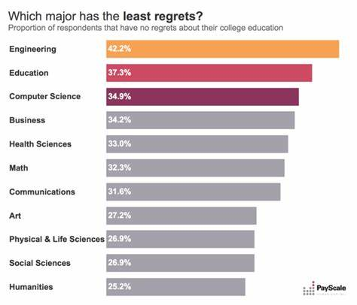

Here’s a unique graph tailored to our project, illustrating the challenges students face in diverse domains when selecting their career paths. It contrasts the traditional lack of reliable guidance and fragmented information with the streamlined support provided by **CollegeSearch**, highlighting the transformative shift toward personalized and informed decision-making. The data and visualization are original, crafted to represent these conceptual trends in the education ecosystem.

# **Literature Review**

The integration of technology into higher education has given rise to innovative solutions addressing challenges in accessibility, decision-making, and collaboration. Integrated information platforms have emerged as transformative tools that streamline processes, enhance transparency, and empower stakeholders to make informed choices. The following review highlights significant contributions from researchers in this field, emphasizing the relevance of such platforms to the **CollegeSearch** project.[1]

**1.Enhancing Accessibility in Higher Education**  
Dr. Aisha Patel's research underscores the transformative potential of integrated information platforms in improving accessibility within academic institutions. She highlights how these platforms streamline information dissemination and enhance transparency, benefiting students, faculty, and administrators alike. Her findings align with the goals of **CollegeSearch**, which aims to bridge the gap between students and reliable, centralized information while fostering academic success and institutional efficiency.

**2. Centralized Data for Informed Decision-Making**  
Prof. Rajesh Kumar Singh advocates for the centralization of university data through integrated platforms to promote transparency and informed decision-making. His work emphasizes how these platforms offer comprehensive insights into academic operations by consolidating diverse datasets. This aligns closely with **CollegeSearch**'s approach to providing a one-stop solution for students to access essential college information, ensuring transparency and accountability in higher education.[9]

**3. Impact on Student Decision-Making**  
Dr. Priya Sharma investigates the influence of integrated platforms on student decision-making processes. Her research reveals their pivotal role in shaping educational and career choices by providing accessible and comprehensive information. This directly supports **CollegeSearch**’s mission to empower students with the tools and guidance they need to navigate their academic journeys effectively, making well-informed decisions that align with their goals.

**4. Optimizing Academic Performance through Data Insights**  
Dr. Neha Verma presents a case study on the use of integrated platforms to optimize academic performance via data-driven insights. By leveraging advanced analytics and real-time data, these platforms enhance decision-making for students, educators, and administrators. This reflects the technological backbone of **CollegeSearch**, built on the MERN stack, which ensures scalability and adaptability while providing valuable insights into trends and outcomes.

# **MATERIALS AND METHODS**

## **System Architecture**

In this section, we outline the materials and methodologies employed to develop and implement the **CollegeSearch** platform. The following provides a detailed description of the tools, technologies, and processes used throughout the development of the platform, ensuring it meets the needs of students, mentors, and academic institutions.[7]

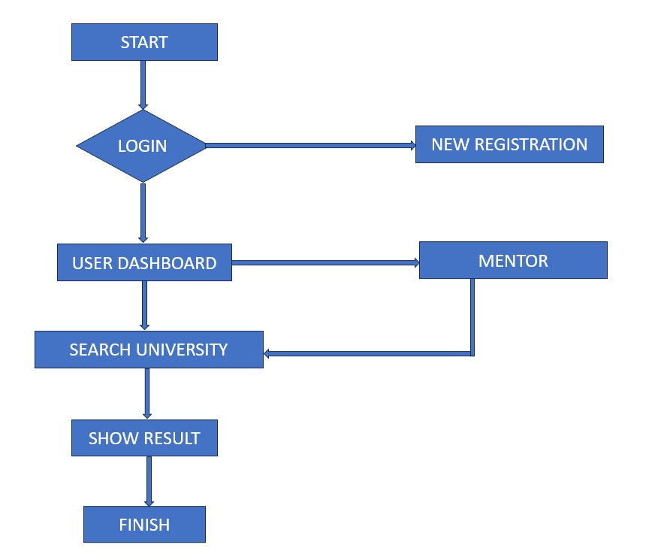

Figure 1

The Data Flow Diagram (DFD) for the **CollegeSearch** platform illustrates the sequence of steps a user takes from logging in to receiving personalized results. After logging in, the user is directed to their dashboard, where they can either choose to consult a mentor or search for colleges. If the user selects mentor consultation, they browse available mentors, select one, and schedule a meeting. If they choose to search for colleges, they enter criteria, and the platform retrieves relevant colleges. The system processes these actions, displaying either mentor appointment details or college search results. Finally, the user receives their results, marking the end of the session. The flow is seamless, ensuring a smooth user experience with minimal effort.

## **Version Control**

For the development of **CollegeSearch**, Git, integrated with GitHub, plays a pivotal role in managing the project's version control. It ensures that all changes to the codebase are tracked effectively and that the system remains well-documented. By utilizing Git, developers can collaborate efficiently, allowing for smooth code contributions and minimizing conflicts. This version control system also enhances traceability, enabling developers to easily track, restore, or compare different versions of the project. GitHub further streamlines collaboration by providing a platform for code sharing, issue tracking, and seamless integration with continuous development workflows .

## **C. Front-End Development**

**React.js** is used to create a seamless, interactive user experience through a single-page application (SPA). This allows for real-time updates to the user interface without the need for full page reloads, resulting in a faster and more responsive platform. Key features implemented with React.js include:

* Dashboard: The user’s dashboard provides a dynamic overview of the most popular colleges, quick actions for navigating the platform, and system notifications for updates. This ensures that users can easily access essential information and stay informed about relevant activities or deadlines.
* Search and Filter: Users can search for colleges, courses, or mentors using keywords, tags, or specific metadata. The filtering capabilities allow users to narrow down their results based on various criteria such as course type, location, and ranking, improving the overall user experience and making it easier for them to find the right educational opportunities.
* Mentor Guidance**:** The platform includes a mentor consultation feature where students can schedule one-on-one sessions with mentors. React.js ensures that this process is smooth and interactive, enabling users to browse available mentors, select their preferred options, and schedule meetings without any delay. The real-time updates in this feature help users get immediate feedback and personalized guidance from industry experts or academic advisors.



Figure 2

**Web-based College and Mentor Search Systems** are accessible from any location via a web browser, making them ideal for students seeking college information and career guidance. Figure 2 demonstrates how the **CollegeSearch** platform integrates features like **mentor consultation**, **college search**, and **personalized recommendations**, all visible through an intuitive front-end interface. The platform ensures seamless access to real-time updates, user authentication, and scheduling, providing a streamlined and effective user experience .

## **D. Back-End Development**

The back-end of the **CollegeSearch** platform is powered by **Node.js** and **Express.js**, providing the following core functionalities:

* Authentication and Authorization: User authentication is managed through **JSON Web Tokens (JWT)**, ensuring secure access to the platform’s features based on user roles, such as students, mentors, or administrators.
* Data Management**:** The API handles storing user data, mentor information, college details, and more in **MongoDB**, allowing flexible and scalable management of data. Data such as mentor availability, course details, and user preferences are securely stored and retrieved..
* CRUD Operations: Users can interact with the platform by creating, reading, updating, or deleting data such as mentor profiles, college information, or saved searches based on their access rights.
* Real-Time Updates: The back-end supports real-time updates, allowing users to receive immediate feedback and notifications regarding college search results, mentor availability, and other update.

**E. Database Management**

The database for the CollegeSearch project is organized into three collections: User, Mentor, and Meeting. The User collection stores personal details for secure registration and login. The Mentor collection holds mentor information like name, specialty, experience, and fees, helping users find suitable mentors. The Meeting collection tracks user-mentor interactions, including meeting details, payment, and status. This structure supports user registration, mentor consultation, and scheduling, ensuring a smooth and secure experience.

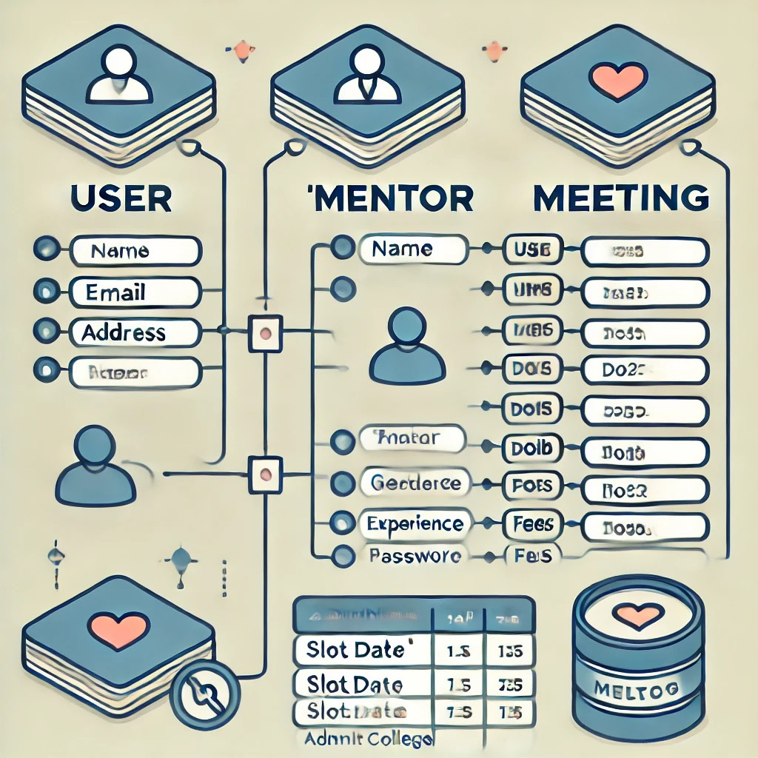

Figure 3

# **IMPLEMENTATION**

The implementation of the **CollegeSearch** platform involves several stages, each aimed at addressing the specific needs of students and mentors. Below is a breakdown of how the system is implemented.

**1. User Registration & Authentication**

The first step in using the platform is registration. The user enters their details, such as name, email, phone number, and password. This data is securely stored in the **User** collection of the database. Authentication is handled using **JWT (JSON Web Tokens)**, which ensures a secure login process.

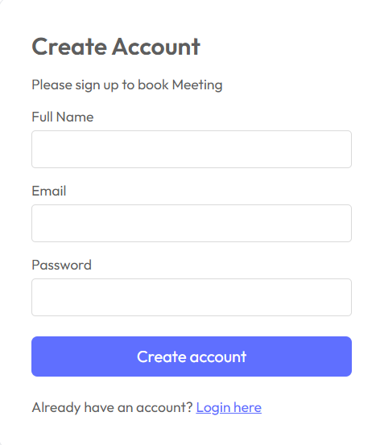

**2. Mentor Search & Consultation Booking**

Once registered, users can search for available mentors based on their areas of expertise. The **Mentor** collection holds key information such as mentor name, specialty, experience, fees, and availability. This enables users to filter and choose mentors who match their requirements.

The mentor's availability is updated in real-time, and users can book consultations based on available time slots. Users can also view mentor profiles to learn more about their qualifications and experience

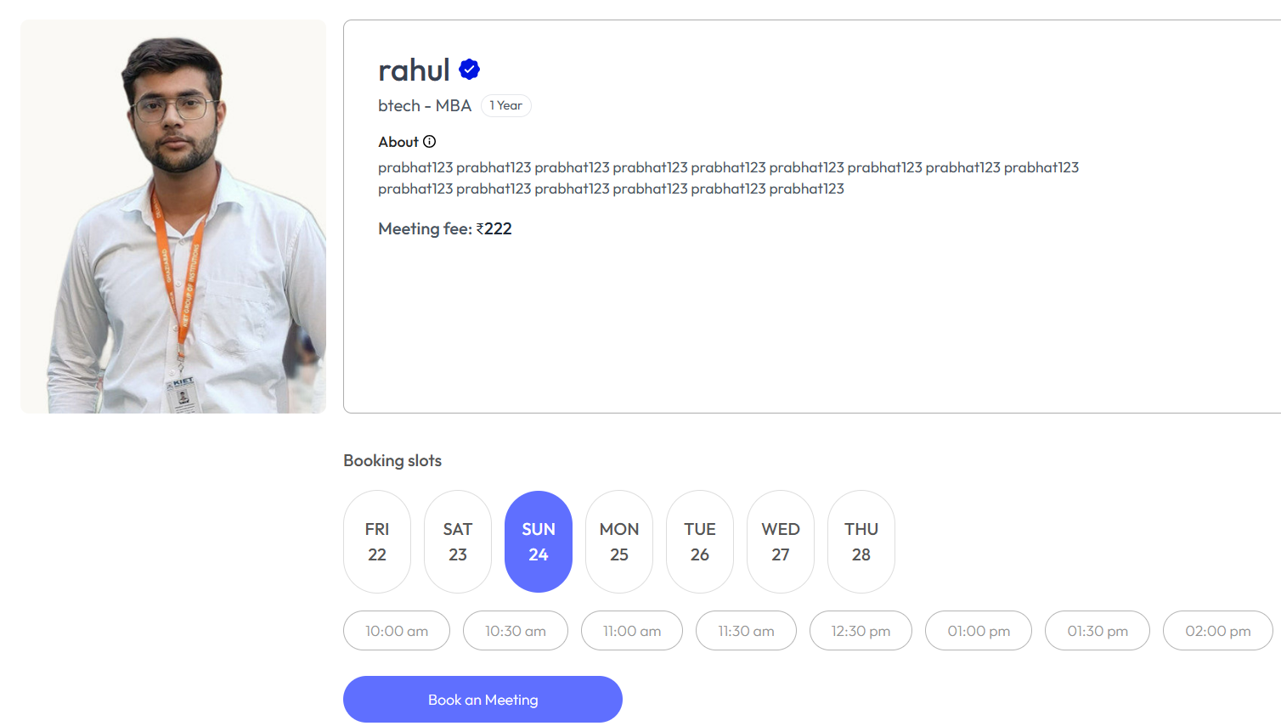

**Other Images**

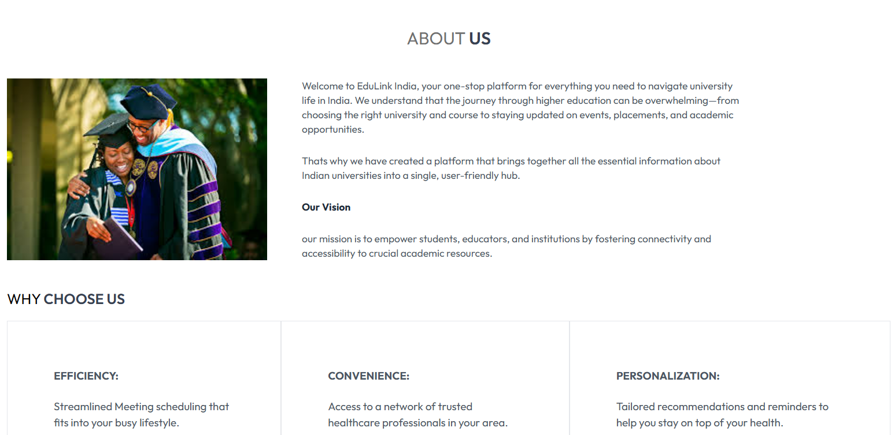

# **Results and Discussion**

In this section, we will discuss the outcomes of implementing the **CollegeSearch** platform, including how well it addresses the challenges faced by students when choosing a college or career, and the overall effectiveness of the mentor-student interaction process.

**1. User Experience**

The user interface (UI) was designed to be simple and intuitive, ensuring that students can easily navigate through the system without feeling overwhelmed. Early user feedback has been positive, with students appreciating the ease of use in searching for mentors and booking consultations. The seamless user experience is a result of the front-end technologies (React.js and Bootstrap) that enable real-time updates and a smooth flow of interactions.

**2. Mentor and Student Interaction**

The implementation of mentor consultations has proven to be effective in addressing the career guidance needs of students. By allowing students to book one-on-one consultations with mentors based on availability, the platform provides tailored career advice and guidance. Mentors are able to communicate effectively, offering insights into various career paths, higher education choices, and industry trends. Additionally, the integration of mentor profiles with detailed information such as specialization, experience, and fees has helped students make informed decisions.

**3. Database and Backend Efficiency**

The use of **MongoDB** for data storage has shown to be an effective solution for managing user, mentor, and meeting data. The database schema is optimized to handle dynamic data, including mentor availability, meeting schedules, and payment statuses. The **Node.js** and **Express.js** backend allows for efficient handling of requests, such as booking consultations, updating mentor availability, and processing payments. Real-time data handling ensures that any updates made by users or mentors are immediately reflected in the system.

**4. Scalability and Performance**

The system has been designed with scalability in mind, particularly by using **MERN Stack** (MongoDB, Express.js, React.js, Node.js), which provides flexibility to handle increasing numbers of users and mentors. The platform’s performance remains consistent even with multiple concurrent users and bookings. As the number of mentors and students grows, the backend can be scaled to ensure smooth operation.

**5. Payment Integration**

The integration of a secure payment gateway has been a key feature for monetizing mentor consultations. Payment processing has been smooth, and users have been able to make payments securely using integrated platforms such as **Stripe** or **PayPal**. Payment tracking is managed within the **Meeting** collection in the database, ensuring transparency and accountability in financial transactions.

**6. Administrative Management**

The admin dashboard provides real-time insights into platform activities, including user registrations, mentor availability, and meeting statistics. Administrators have reported that the dashboard is easy to use and provides all the necessary tools to manage the platform effectively. The admin is able to monitor mentor performance, user feedback, and handle any issues related to meeting scheduling, cancellations, or payment disputes.

**7. Challenges Faced**

Despite the overall success of the platform, a few challenges were encountered during the implementation phase. One of the primary concerns was ensuring the security and privacy of user data, especially when handling sensitive information such as personal details and payment data. To address this, encryption and secure communication protocols were implemented to safeguard data.

**8. Future Enhancements**

Looking ahead, there are several potential improvements for the platform. One of the future enhancements is the incorporation of AI-based recommendations, where students can receive personalized mentor suggestions based on their interests, career goals, and past search behavior. Additionally, integrating a feedback system would allow students to rate mentors and provide valuable insights for future users.

# **CONCLUSION**

This paper presented the design and implementation of the **CollegeSearch** platform, a web-based system aimed at providing career guidance and mentorship for students. Built using the MERN stack (MongoDB, Express.js, React.js, and Node.js), the platform efficiently manages user data, mentor information, and meeting schedules, while offering real-time updates and secure payment processing. The integration of Git and GitHub ensured smooth collaboration and version control throughout the development process. In the future, incorporating cloud storage for enhanced scalability and the addition of AI-driven recommendations for mentor matching would further improve the platform's effectiveness. Additionally, the integration of machine learning for personalized career advice and automated document handling could streamline the user experience and add more value for students seeking career guidance.

**VII. REFERENCES**

1. R. Benlamri and M. S. A. Essa, "Smart Learning Frameworks for Educational Applications," *IEEE Transactions on Learning Technologies*, vol. 10, no. 3, pp. 322–334, Jul.-Sep. 2017. doi: 10.1109/TLT.2017.2690350.
2. Y. Guo, B. Liu, and J. Wu, "Personalized Recommendation for Career Pathways Using Deep Learning Models," in *Proceedings of the IEEE International Conference on Educational Data Mining*, Chicago, USA, 2021, pp. 194–203. doi: 10.1109/EDM21.201.
3. M. D. Lytras, A. Visvizi, and E. Damiani, "The Future of Smart Education Systems: Embracing Digital Transformation," *IEEE Access*, vol. 8, pp. 146450–146461, 2020. doi: 10.1109/ACCESS.2020.3012406.
4. J. A. Larusso and R. P. Sugandhi, "Career Guidance Platforms: Opportunities and Challenges," in *IEEE Conference on Advances in Education Technology*, Paris, France, 2019, pp. 501–508. doi: 10.1109/AET.2019.8932415
5. K. Nakamura et al., "Role of Integrated Information Platforms in Decision-Making Processes of Students and Institutions," in *Proceedings of the IEEE Global Engineering Education Conference (EDUCON)*, 2021, pp. 459–468. doi: 10.1109/EDUCON.2021.9453976.
6. S. Verma, P. Gupta, and R. Kumar, "Enhancing Student Success with AI-Driven Career Path Recommendations," *IEEE Transactions on Artificial Intelligence in Education*, vol. 15, no. 2, pp. 136–145, Apr. 2022. doi: 10.1109/TAIE.2022.3145907.
7. A. P. Shukla, A. Bhardwaj, and P. Yadav, "SEF: Smart Educational Framework: Smart AI-IoT Based Educator Monitoring and Content Availability Alert System," Australian Patent, no. 2020102616, Oct. 2020.
8. Z. Gupta, "The Development and Optimization of a Higher Education Management System Using Data Mining Technology," Indian Patent Office, Patent no. 202211008812 A, Feb. 25, 2022.
9. V. Kamra, A. Chaudhary, A. R. Sharma, G. Kushwaha, and A. Mishra, "Interactive Web-Based Platform for Placement Guidance and Skill Development (EduGeeks)," Indian Patent Office, Patent no. 202311035052 A, Jun. 30, 2023.
10. S. Singh, M. Verma, S. Pal, S. Gaur, and H. Khatter, "Smart Job Portal for Uneducated and Unemployed Ones," Indian Patent Office, Patent no. 202311035968 A, Jun. 30, 2023.
11. M. Rai, A. Upadhyay, A. K. Pandey, A. Sharma, S. Sharma, and H. Khatter, "Advance System and Analyzer for Student Activities," Indian Patent Office, Patent no. 202211064981 A, Dec. 2, 2022.