**Personalized Quiz Generator Agent**

**Team Members:**

B.Aishwarya 22B21A4323 [LEAD]

S.Naga Balaji 22B21A4342

S.Gloria 22B21A4309

S.Naga Purna Vara Prasad 22B21A4399

K.Mohan Sai 22B21A4360

**Department:** Department of Computer Science and Artificial Intelligence

**Institution:** Kakinada Institute of Engineering and Technology

**Academic Year:** 2022–2026

**Abstract:**

This project focuses on designing a **Personalized Quiz Generator Agent**, which automatically creates quizzes based on user preferences, difficulty levels, and learning history. The system leverages **Natural Language Processing (NLP)** and **Machine Learning (ML)** techniques to analyze study material or uploaded content and generate relevant questions in multiple formats, including **Multiple Choice Questions (MCQs), Fill-in-the-Blank, and Short Answer questions**.

By tracking user performance and learning patterns, the system provides **adaptive feedback**, allowing quizzes to dynamically adjust in difficulty and focus on areas where the learner needs improvement. This personalized approach enhances **knowledge retention**, promotes **self-paced learning**, and encourages active engagement.

Furthermore, the system reduces **teacher workload** by automating the creation of high-quality, contextually relevant quizzes, ensuring consistent assessment while supporting diverse learning needs. The integration of AI-driven analytics also allows educators and learners to monitor progress and identify knowledge gaps efficiently, making it a **comprehensive tool for modern education**.

## **Introduction & Problem Statement:**

### **Background of the Problem**

Traditional methods of learning and assessment are designed in a **one-size-fits-all approach**, where the same set of quizzes and exams are given to all students regardless of their learning pace, strengths, or weaknesses. While this approach simplifies evaluation, it fails to capture the **individual differences in understanding and knowledge retention** among learners. With the rise of digital learning platforms and e-learning applications, there is a growing demand for **personalized and adaptive assessments** that can help learners identify gaps in knowledge and improve at their own pace.

Recent advancements in **Artificial Intelligence (AI)** and **Natural Language Processing (NLP)** have made it possible to automatically generate content, including educational assessments. This opens up opportunities for creating **intelligent quiz systems** that adapt to each student’s needs, provide meaningful feedback, and encourage active participation in the learning process.

### **Why It Is Important:**

Personalized learning is critical in modern education because:

* It helps **students learn at their own pace**, improving understanding and retention.
* Teachers save time and effort otherwise spent on manually preparing quizzes.
* Adaptive quizzes **keep students motivated** by adjusting difficulty levels according to their performance.
* It enables **continuous self-assessment**, allowing learners to monitor their progress and focus on weak areas.

## **Proposed Methodology:**

### **Approach**

The **Personalized Quiz Generator Agent** integrates **Natural Language Processing (NLP)** and **Machine Learning (ML)** techniques to generate and personalize quizzes. The system follows a pipeline that ensures questions are relevant, adaptive, and effective for learning. The main steps include:

1. **Data Collection** – Course materials, textbooks, or uploaded text by the user serve as the source data.
2. **Preprocessing** – Text is cleaned, tokenized, and keywords or important concepts are extracted using NLP techniques.
3. **Question Generation** – The system uses AI/NLP models (e.g., Hugging Face Transformers, NLTK, or T5-based models) to generate different types of questions:
   * Multiple Choice Questions (MCQs)
   * Fill-in-the-Blank Questions
   * Short Answer Questions
4. **Evaluation and Feedback** – The learner’s responses are analyzed, and feedback is generated. This feedback influences future quizzes, ensuring **continuous learning improvement.**

### **Tools and Technologies**

* **Programming Languages:** Python (backend, AI/ML), JavaScript (frontend, optional UI)
* **Frameworks/Libraries:** Hugging Face Transformers, NLTK, TensorFlow/PyTorch,spaCy.
* **Database:** MongoDB (to store user data, quiz questions, and results)
* **Frontend:** React.js for creating an interactive user interface
* **Visualization Tools:** Matplotlib/Chart.js for progress tracking and analytic

**Developing Model From Scratch**

**Data Collection:** Collect course notes, PDFs, and public QA datasets.

**Preprocessing:** Clean text, tokenize, apply POS tagging & NER.

**Feature Extraction:** Convert text to vectors using Bag Of Words (BoW), Term Frequency – Inverse Document Frequency (TF-IDF), or custom embeddings.  
**Model Building**: Build a model that generates questions from text, like the S2S model.

**Architecture:**

* **Encoder:** Takes input text (sentence/paragraph) → encodes into a vector representation.
* **Decoder:** Takes encoded vector → generates a questions
* **Implementation:** Use Python+Numpy

**Model Training:** Teach the model to map input text to output questions.

* Split your dataset into **training**, **validation**, and **test** sets.
* Convert text to **numerical sequences** using tokenization and embeddings.
* Train the model using **cross entropy loss** for word prediction.
* Adjust hyperparameters: learning rate, batch size, number of epochs.

**Model Testing:** Test the model’s ability to generate accurate and context-relevant questions.

* Provide unseen text input from the **test dataset**.
* Generate questions using the trained model.

**Model Evaluation:** Measure the performance and quality of generated questions.

**Automatic Metrics:**

* BLEU Score (Bilingual Evaluation Understudy): Measures similarity between generated and reference questions.

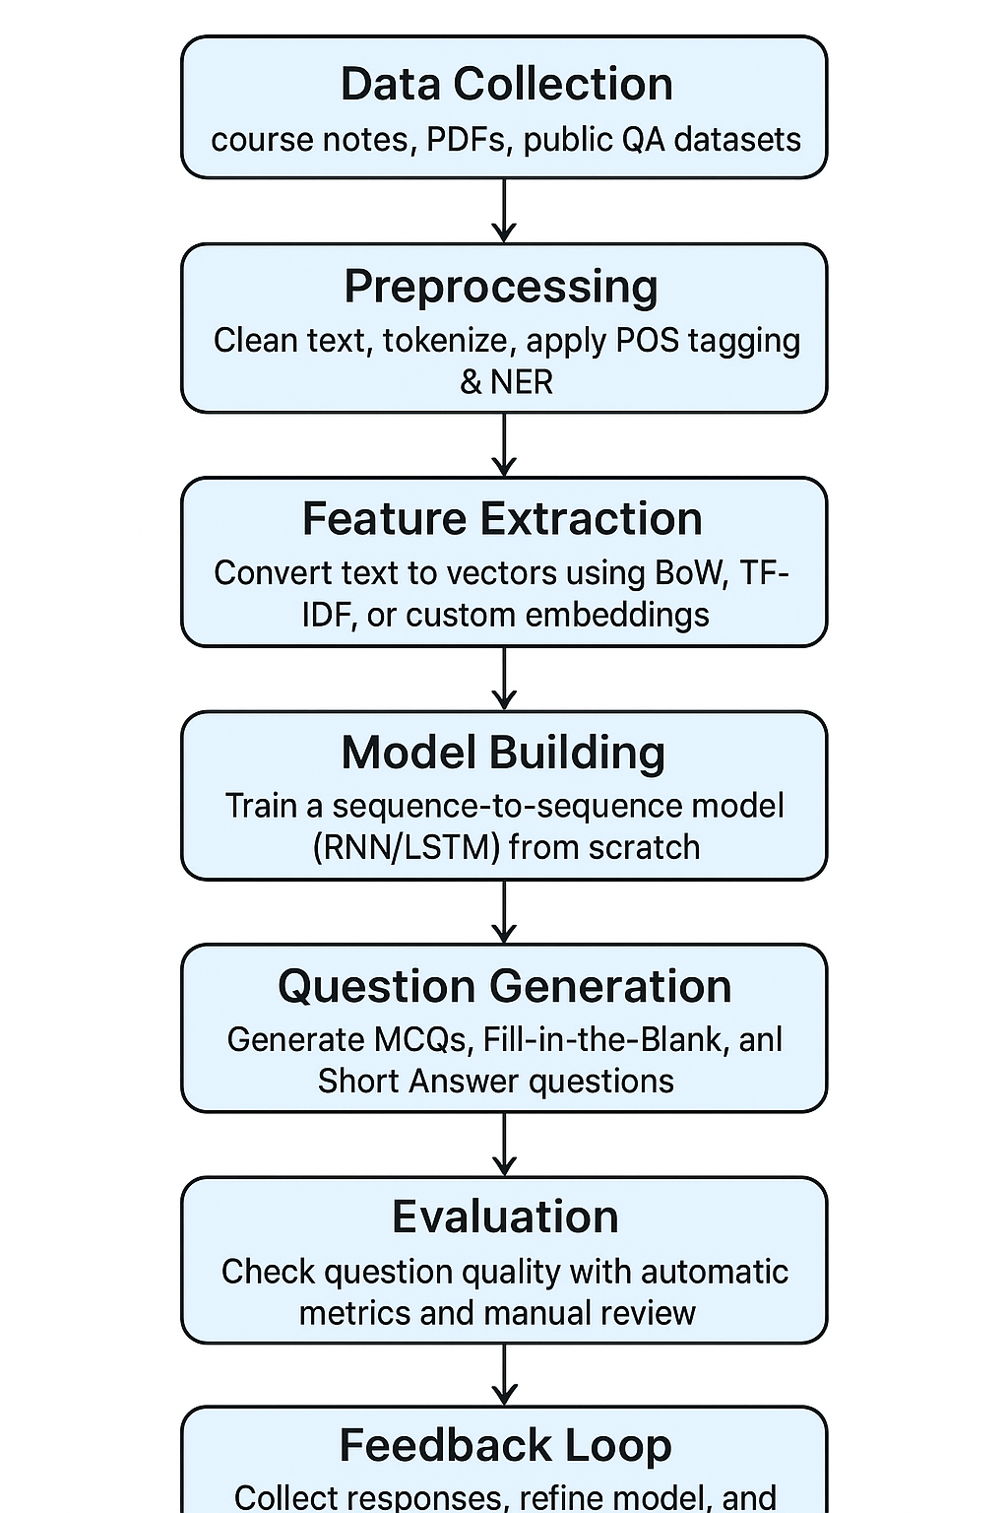

### **Expected Working of the Project**

1. The user uploads study material or selects a subject/topic.
2. The system preprocesses the text (cleaning, tokenization, keyword extraction).
3. The **Question Generation module** creates context-relevant quiz questions (MCQs, blanks, short answers).
4. The user takes the quiz, and responses are evaluated.
5. Feedback is provided to the learner, highlighting strengths and weaknesses.
6. Future quizzes are refined, ensuring **adaptive learning and progressive improvement**.

**Conclusion:**

The Personalized Quiz Generator Agent uses NLP and Machine Learning to create adaptive quizzes tailored to learners. It saves time for educators, improves knowledge retention, and enhances personalized, self-paced learning.

**References:**

* **IJRPR (2025). *Personalized Quiz Generator using Artificial Intelligence*. International Journal of Research Publication and Reviews, Vol. 6, Issue 5.**

**👉** [**PDF Link**](https://ijrpr.com/uploads/V6ISSUE5/IJRPR46511.pdf)

* **Akgün, C. K. (2025). *AI Powered Quiz Generation with Multi-Agent Systems*. Medium.**

**👉** [**Read the article**](https://medium.com/@cerenkaya07/building-intelligent-quiz-generation-with-ai-agents-a-deep-dive-into-llamaindex-and-openai-948dabe71f03)