# COMP 1536 – Lab 3

**Due:** Following week, at the beginning of class, for marks!

**This assignment must be done individually.**

# Objective

Explore CSS’ features for creatively expressing typography choices.

This lab exercise requires you to become familiar with the types of things that you can and can’t do – or can’t do as easily using CSS.

**Note:** *There are always interesting hacks that clever web developers and designers will come up in order to solve a particular problem. For now, we’re interested in the basics.*

Using the CSS properties that we’ve gone over, create the following layouts and font choices displayed in the following figures. Create the same sort of layout and typography to the closest you can.

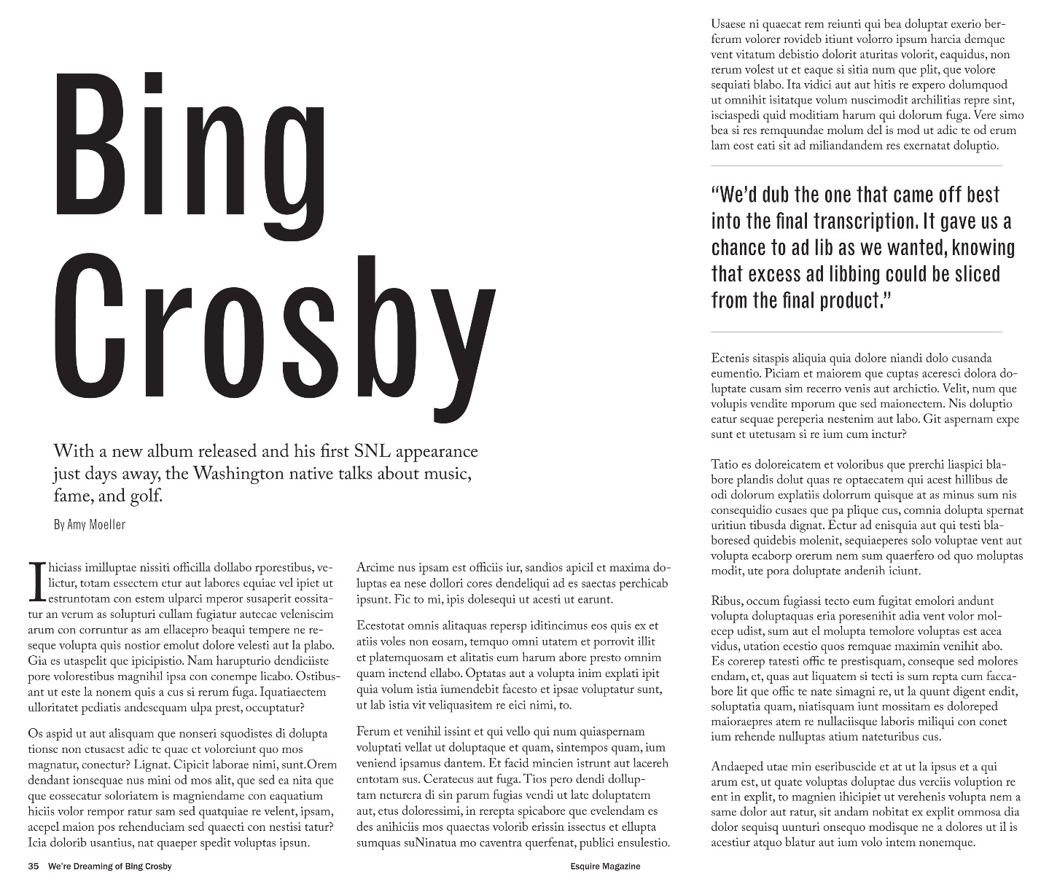

Figure 1

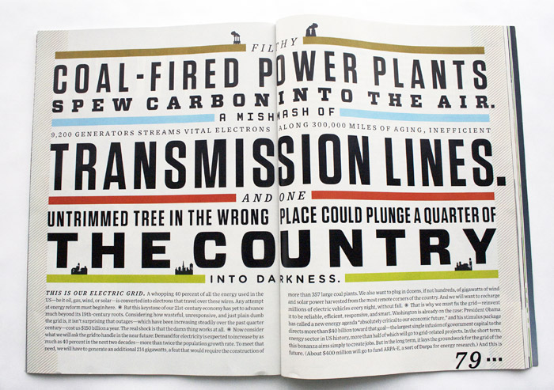

Figure 2

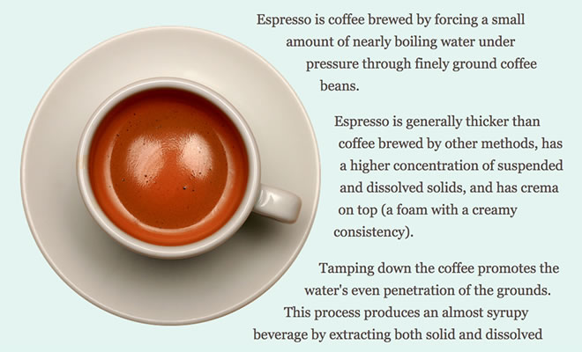

Figure 3

**Note:** *You can replace the images and the textual content with something else (e.g., your resume, a project that you’re working on, etc.)*

**Hints:** *Refer to the useful sites for Web Dev 2015 file for links to fonts and font generators.*