# COMP 1536 – Lab 4

**Due:** Two weeks from when it’s assigned, at the beginning of class, for marks!

**This assignment must be done individually.**

## Objective

Again, using the display property, float, clear, and media queries, create an initial prototype design of what you want your overall layout to look like.

Create the following containers using most of the following elements:

* footer
* header
* section
* aside
* div

When using the div elements, use the id attribute to uniquely select them with CSS. Make your layout look like figure 1.

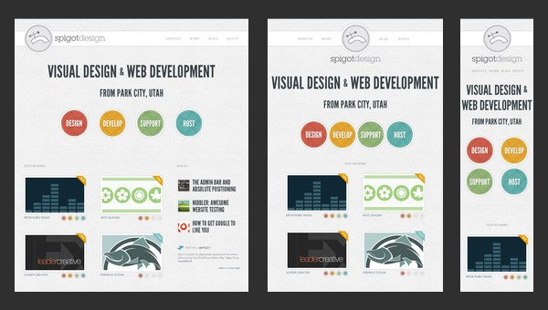

Figure 1

Note that you don’t have to use the colors in figure 1 but you do have to lay your content out as such. You can use images or text for them. If you use images, use [www.dummyimage.com](http://www.dummyimage.com) for your placeholders.

Again, adjust to the different resolutions of:

* 400 pixels
* 800 pixels
* 1280 pixels

Also note that the layout changes for each of the resolutions shown. Make yours do the same.

## Requirements

Demonstrate to your instructor the following week.