**Beginning JavaScript**

**Due Date: Two weeks – demo in class (late results in zero)**

**Done individually**

Lab exercises to show your instructor for marks:

## Part A

Using JQuery calls (at least one of each – but you should use many of them):

* append
* prepend
* before
* after
* css
* addClass

Recreate one of the following three layouts using JQuery:

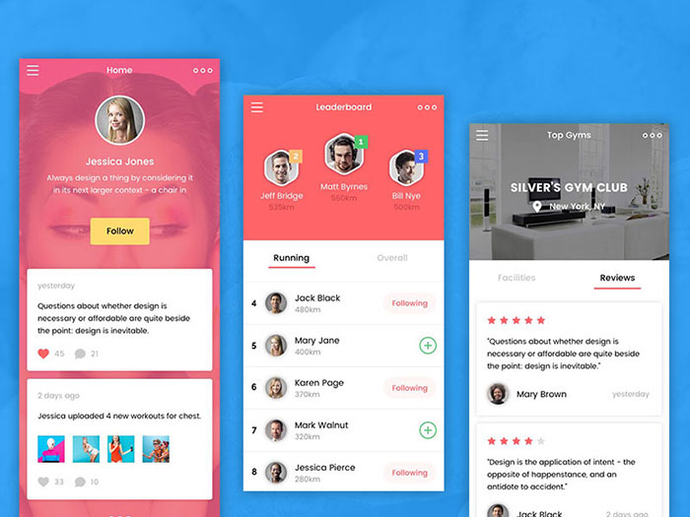

A few notes:

* It doesn’t have to look exactly the same but should look quite similar
* Your media query directives can be added to the style element of your HTML document or can be found inside of an external stylesheet that you link to
* All HTML (other than the html, head, and body elements) should be added programmatically utilizing JQuery
* The layout should be responsive

Hints:

* Use Shift-Ctrl-M to switch to mobile device resolution mode in the developer tools