Flux
Discussion brief · first supervision meeting with Paul Tennent
Hanze Jin · 30 September 2026

At a glance
Flux is a browser MIDI workbench for arranging: a musician plays a melody, confirms the chords, and auditions AI accompaniment on separate tracks that never overwrite their own notes.
The question behind it: can explicit, reversible control over harmony make AI accompaniment usable for musicians?
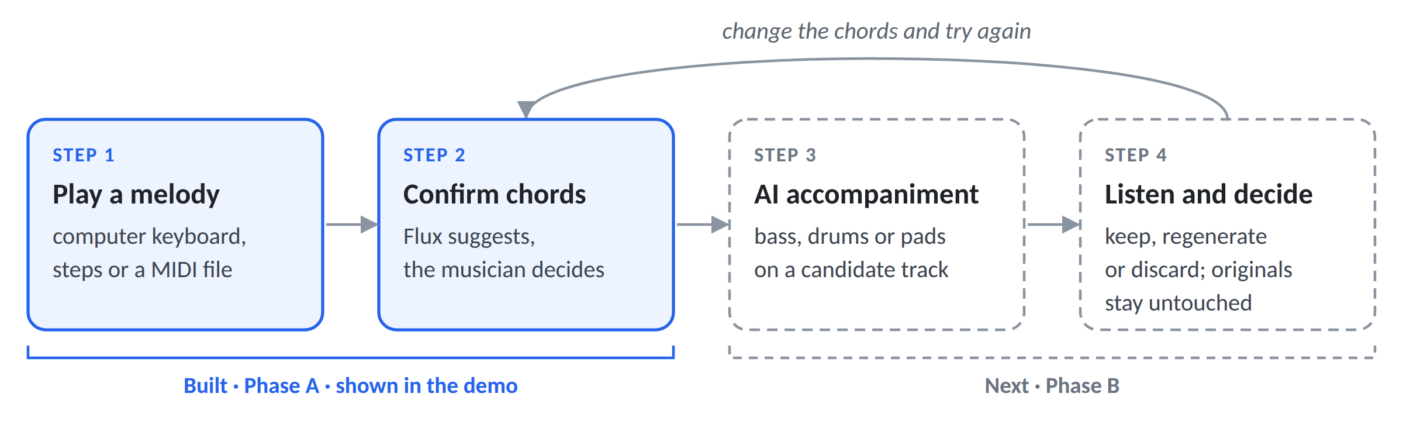
I first tried a pretrained model, the Anticipatory Music Transformer (AMT). Its accompaniment sounded poor, so I built a workbench where generation can be heard, controlled and compared properly.
Three things I would like to settle with you
- The contribution: which research question and scope to commit to.
- A user study: whether a small study with musicians is feasible; it was ruled out earlier on ethics timing.
- What “done” looks like: in early December, for my graduate applications, and at Easter.

What exists today
A browser workbench with General MIDI sound, keyboard recording, multi-track editing, MIDI import and export, and chord recognition with key and Roman-numeral analysis (rule-based, not a trained model). There is no AI generation yet.
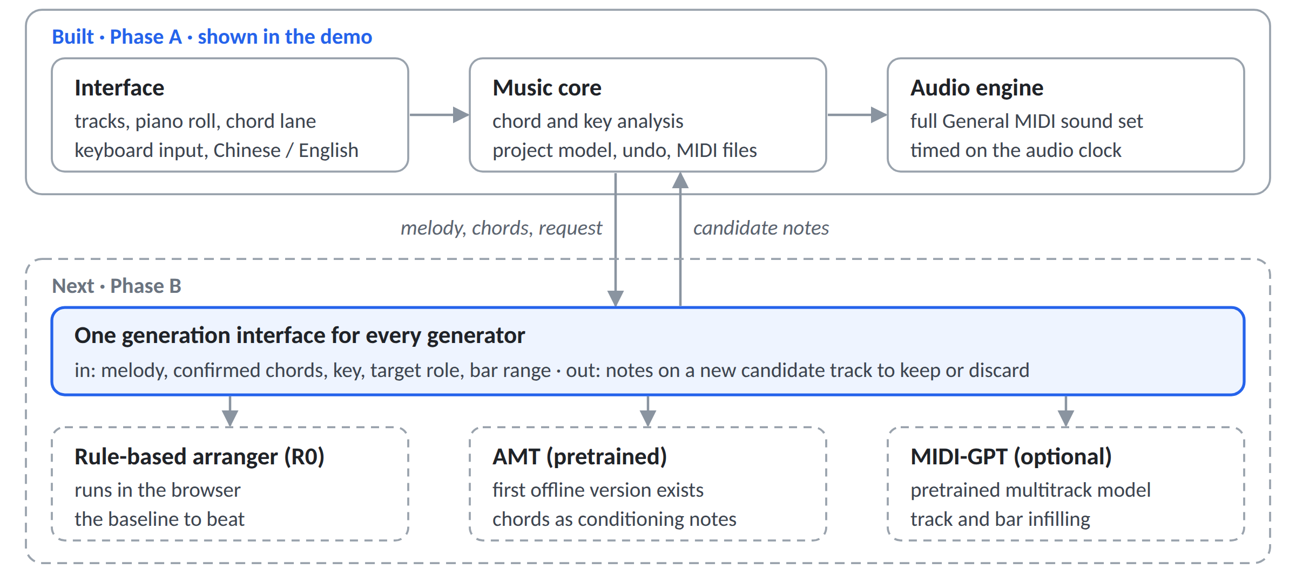

Where I could take it
Ideas I have considered:
- Rule-based arranger: the chord track drives bass, drums and pad patterns; the baseline to beat.
- Learned generators behind the same interface: AMT with a corrected pipeline; MIDI-GPT for bar infilling; Aria for piano continuation.
- Chords as conditioning, so that note-based models can follow the confirmed harmony.
- LoRA fine-tuning on pop data, only if comparisons show a clear style gap.
- An LLM as arrangement planner that operates these tools rather than writing notes.
Three ways to frame the dissertation:
- Controllable generation. Does a confirmed chord track make AI accompaniment more usable? Start with one task, such as a bass part under a melody, and compare a rule-based arranger with a pretrained model, using ablations to show which controls matter.
- Human–AI co-creation. How do musicians use chord-level control and separate candidate tracks, and does it change their sense of control and ownership?
- Both, with the first as the core and a small study alongside.
I lean towards the third. Flux is also a product I want to keep building, but for the dissertation I would treat it mainly as a research instrument.

What I hope to have
- Early December, for my graduate applications: generation working in Flux, a first controlled comparison, a short report and a demo video.
- Easter: the dissertation, with a user study if approved.

Questions I would value your view on
- Scope? A system, a controlled comparison with ablations and a small study, or should I narrow to one? My instinct: the comparison as the core; the study if ethics allows.
- User study? Is a small study with 8–12 musicians realistic if I apply for ethics in late October? If not, would a practice-led evaluation or an expert walkthrough work?
- Listening tests? Can others rate clips blind in November, before ethics approval, or should those ratings be mine alone?
- AI depth? For a Computer Science with AI degree, is comparing pretrained generators under explicit control enough, or should I plan to fine-tune one? My instinct: decide in December, on the evidence.
- Publication? Is a short paper realistic this winter, for example the CHI 2027 Student Research Competition (21 January), or Creativity & Cognition or NIME 2027?
- Meetings? Would 30 minutes every two weeks, with a short written update beforehand, suit you?

