

**Smart Digital Library**

**Metaverse Dido**

**Software requirement Specification**

2021.11.13.

**Introduction to Software Engineering**

**TEAM 15 (Metaverse Dido)**

|  |  |
| --- | --- |
| Team Leader | Keunha Kim |
| Team Member | Minsu Kim |
| Team Member | Gyeonghyeon Cho |
| Team Member | Ukcheol Choe |
| Team Member | Aizat Hamizuddin Bin Azlan |
| Team Member | Fatdzirul Izzat Bin Abdul Radzi |
| Team Member | Dasol Lee |
|  |  |

CONTENTS

CONTENTS 2

1. Introduction 7

1.1. Purpose 7

1.2. Scope 7

1.3. Definitions, Acronyms, and Abbreviation 8

1.4. References 8

1.5. Overview 9

2. Overall Description 9

2.1. Product perspective 9

2.1.1. Market status 10

2.1.2. Overall structure 12

2.2. Product functions 12

2.2.1. VRCHAT 12

2.2.2. Metaverse Dido 13

2.2.3. DVD room 13

2.2.4. Meeting room 13

2.2.5. Reading room 13

2.2.6. Chatter bot 13

2.3. User Classes and Characteristics 14

2.3.1. User 14

2.3.2. System Manager 14

2.4. Operating Environment 14

2.4.1. System requirements 14

2.5. Design and Implementation Constraints 15

2.6. User Documentation 15

2.7. Assumptions and Dependencies 15

3. Specific Requirements 16

3.1. External Interface Requirements 16

3.1.1. User Interfaces 16

3.1.2. Hardware Interfaces 22

3.1.3. Software Interfaces 22

3.1.4. Communication Interfaces 23

3.2. Functional Requirements 23

3.2.1. Use Case 23

3.2.2. Use Case Diagram 28

3.2.3. Data Dictionary 28

3.2.4. Data Flow Diagram 31

3.3. Performance Requirements 31

3.3.1. Static numerical requirement 31

3.3.2. Dynamic numerical requirement 32

3.4. Logical Database Requirements 32

3.5. Design Constraints 32

3.6. Standards Compliance 32

3.7. Organizing the Specific Requirements 33

3.7.1. Context Model 33

3.7.2. Process Model 33

3.7.3. Interaction Model 33

3.7.4. Behavior Model 34

3.8. System Architecture 35

3.9. System Evolution 35

3.9.1. Limitation and Assumption 35

3.9.2. Evolutions of Smart Library 36

4. System Features 36

4.1. DVD Room 36

4.1.1. Description and Priority 36

4.1.2. Stimulus/Response Sequences 36

4.1.3. Functional Requirements 36

4.2. Reading Room 37

4.2.1. Description and Priority 37

4.2.2. Stimulus/Response Sequences 37

4.2.3. Functional Requirements 37

4.3 Meeting Room 37

4.3.1. Description and Priority 37

4.3.2. Stimulus/Response Sequences 38

4.3.3. Functional Requirements 38

4.4 ChatterBot 38

4.4.1. Description and Priority 38

4.4.2. Stimulus/Response Sequences 38

4.4.3. Functional Requirements 38

5. Nonfunctional Requirements 39

5.1. Performance Requirements 39

5.2. Safety Requirements 39

5.3. Security Requirements 39

5.4. Software Quality Attributes 40

6. Document History 40

**LIST OF FIGURE**

[Figure 1]numbers of online meeting users 10

[Figure 2] number of users of the reading app [5] 11

[Figure 3] overall structure 12

[Figure 4] Use Case Diagram 28

[Figure 5] Entity Relationship Diagram 30

[Figure 6] Data flow diagram 31

[Figure 7] Context Model 33

[Figure 8] Sequence Diagram 34

[Figure 9] System Architecture 35

**LIST OF TABLES**

[Table 1] Explanation of acronyms, abbreviations, terms 8

[Table 2] DVD room Interface 16

[Table 3] DVDs list search Interface 16

[Table 4]Meeting room Interface 17

[Table 5] Reservation system of Meeting room Interface 18

[Table 6] Reading room Interface 19

[Table 7] Reservation system of Reading room Interface 20

[Table 8] ChatterBot Interface 21

[Table 9] Hardware Interface 22

[Table 10] Software Interface 22

[Table 11] Communication Interface 23

[Table 12] Use case of enter/leave the DVD room 23

[Table 13] Use case of view a DVDs list 24

[Table 14] Use case of meeting room 25

[Table 15] Use case of reservation system of meeting room 25

[Table 16] Use case of reading room 26

[Table 17] Use case of seat reservation system of reading room 26

[Table 18] Use case of ChatterBot 27

[Table 19] User 28

[Table 20] User’s data 28

[Table 21] Database List 29

[Table 22] E-book List 29

[Table 23] Document History 40

# 1. Introduction

## 1.1. Purpose

This document is a software requirement specification for 'Smart Digital Library Metaverse Dido'. Those who read this document are assistant teachers and professors, centering on 'SWE 15 Team'. The document will contain detailed information about the overall project. The goal of the project is to create a digital library in Metabus. Currently, Sungkyunkwan University's digital library not only serves as a library, but also has various facilities. There are various cultural spaces such as Meeting room, reading room, and DVD room, and the overall purpose of the project is to implement them in metaverse. Therefore, it will consist of a total of four sub-systems (Meeting room, DVD room, Reading room, Chatbot) to provide the function of a digital library in a virtual space. In this document, Each system is shown in detail using various diagrams and models. Representative functions of each system are as follows : There are basic functions necessary for the conference room, the ability to watch videos together, the ability to read books, and the ability to obtain school information through chatbots.

## 1.2. Scope

Currently, many people are suffering from distancing in the COVID-19 pandemic. In particular, college students sometimes graduate without even going to school. It can be said that it is very important to provide an opportunity to interact with people in such a situation. In the metaverse of virtual reality, system provide the following functions with VRCHAT. It will provide opportunities to indirectly experience college life and make friends by providing the function of meeting with others, reading books, enjoying videos together, and obtaining school information.

## 1.3. Definitions, Acronyms, and Abbreviation

[Table 1] Explanation of acronyms, abbreviations, terms

| **Acronyms& Abbreviations&Terms** | **Explanation** |
| --- | --- |
| VRCHAT | VRCHAT is a platform that provides an environment in which virtual world can be uploaded to perform various activities in the world. Based on Unity, it provides an SDK that can create its own character and world. |
| UNITY | Unity is a game engine that provides a development environment for video games. It supports 3D-based development and makes characters and worlds workable in VRCHAT by using VRCHAT SDK. |
| Metaverse Dido | The name of the project is a combination of "Dido," which means SKKU's digital library, and metaverse |
| Udon | “VRChat Udon is a programming language built completely in-house by the VRChat Development Team. It is designed to be secure, performant, and easy to use via the VRChat Udon Node Graph, a built-in visual programming interface that uses nodes and wires (we call them “noodles”) to connect flow, inputs, and outputs.”[3] |
| GUI | Graphical User Interface |
| UI | User Interface |
| HTTP | Hypertext Transfer Protocol |
| SDK | Standard development kit |
| URL | Uniform Resource Locator |

## 1.4. References

* [1]IEEE Std 830-1998 IEEE Recommended Practice for Software Requirements Specifications, In IEEEXplore Digital Library  
  http://ieeexplore.ieee.org/Xplore/guesthome.jsp
* [2]Team 1. “Software Requirement Specification”. SKKU, Last Modified: May. 15, 2020.  
  https://github.com/skkuse/2020spring_41class_team1/blob/master/docs/SRS_TEAM1.docx
* [3] <https://docs.vrchat.com/docs/what-is-udon>
* [4] <https://www.newstomato.com/ReadNews.aspx?no=1064868>
* [5]<https://www.techm.kr/news/articleView.html?idxno=82679>
* [6]https://help.vrchat.com/hc/en-us/articles/1500002378722-System-Requirements

## 1.5. Overview

In the situation of COVID-19, the need for a virtual environment has grown, and several platforms have been produced. Among them, the purpose of the project is to implement a digital library in Metaverse using VRCHAT, which will provide people with various functions and opportunities to meet.

Except for the introduction of this document, a total of three chapters remain. The next chapter will introduce the overall composition of the ongoing project. It includes the purpose of the project, the market condition, and the overall structure. It describe the function and operating environment of the system and the scope and characteristics of the user. Next, detailed subsystems(Meeting room, DVD room, Reading room, Chatbot) are described. Since the purpose of this document is to understand the user's requirements and restrictions in detail for project. The structure and function of each system are described through the diagram and model in detail.

# 2. Overall Description

## 2.1. Product perspective

This product is made for college students who do not enjoy campus life at Corona Pandemic. Among them, the function of the digital library, the pride of Sungkyunkwan University campus, is provided through a virtual environment. The overall system is difficult to provide, but it offers a variety of functions and opportunities to meet people through subsystems (Meeting Room, DVD Room, Reading Room, Chatbot) in the digital library.

### 2.1.1. Market status

It provides four functions to enjoy campus life through a virtual environment in the COVID-19 pandemic situation. The first is the conference room. With COVID-19, the online meeting system was activated on 3.3. Rather, there is an evaluation that it is more comfortable than the existing meeting system, but it provides a different environment from actual meeting. When people used it as a presenter to hold meetings through chatting, video, or screen sharing, it was difficult to check the responses of people on the 2D screen and they felt like they were talking alone. Therefore, if create an environment such as a conference room in a virtual environment, this can make people to have an experience close to an existing meeting or meeting.

[Figure 1]numbers of online meeting users

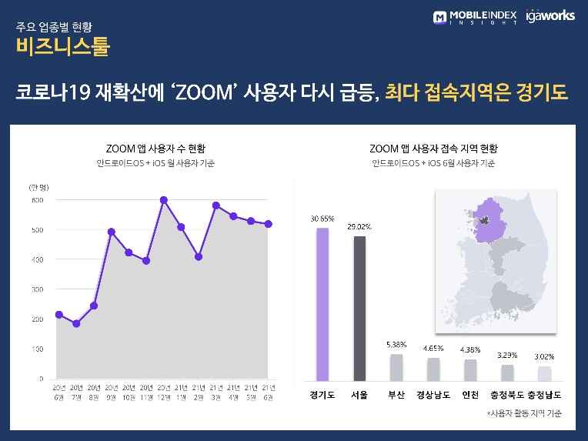

Second, it is the function of reading books in the basic library. The number of people using eBook has tripled due to COVID-19. The market is becoming large, and it is important to provide the functions of electronic libraries.

[Figure 2] number of users of the reading app [5]

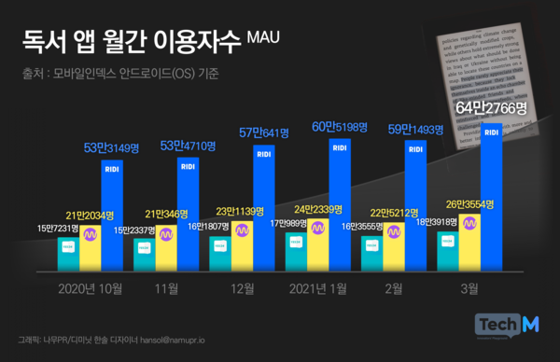

Third, it is a system where you can enjoy videos together. COVID-19 has significantly reduced the number of people watching movies in cinema. As a result, the number of users of platforms where they can enjoy movies at home has increased significantly. The new feature on Netflix and Watcha is the party function. It added the function of sharing opinions while chatting with each other while watching the movie at the same speed. As such, video materials such as movies are not only enjoyed alone, but there is a demand from people who want to enjoy with others. Therefore, it will provide a function of communicating with others by playing videos like a movie theater.

Finally, it is a system that obtains school information, an important function as a student. These days, most of the announcements have been made through each website. There is a kingo bot that can ask about curious information. Therefore, there is a need for a system that provides school information by creating bots in a virtual environment.

### 2.1.2. Overall structure

[Figure 3] overall structure

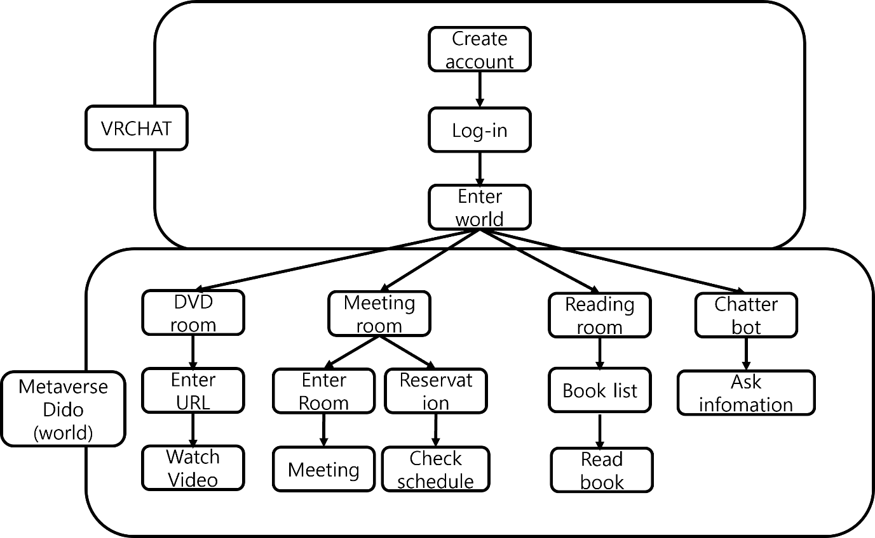

## 2.2. Product functions

### 2.2.1. VRCHAT

#### 2.2.1.1 Install VRCHAT

The first thing a user needs to do is to install VRCHAT. It can be downloaded from Steam and Oculus. It only supports Windows.

#### 2.2.1.2 Make account, log-in and enter world

The first thing to do to use VRCHAT is to sign up and log in. When the program is installed and logged in, it becomes available by accessing VRCHAT. VRCHAT provides basic Home to each player. You can search or upload a world map to access our system and receive functions.

### 2.2.2. Metaverse Dido

When you access the world provided by VRCHAT, there is a room in charge of each function, and it is the world that integrates it into one. There is a portal leading to a room in charge of the basic structure and functions of each function.

### 2.2.3. DVD room

A place that makes streaming services. Type the YouTube videos, such as URL, who played for that movie on a big screen in place. Many of the seats through a variety of people and culture can enjoy together.

### 2.2.4. Meeting room

It's a place for a meeting. Only the desired person can access, and through this, the confidentiality of the meeting is guaranteed. Basically, it provides necessary functions for meetings, such as boards for necessary writing. There is a system that manages the meeting schedule.

### 2.2.5. Reading room

It is a space where you can read books.

### 2.2.6. Chatter bot

Enter predetermined questions and deliver school information. Implement the functions of KingoBot as much as possible. The goal is to deliver academic information like GLS.

## 2.3. User Classes and Characteristics

### 2.3.1. User

First of all, users are limited to college students attending Sungkyunkwan University. It is difficult to manage the number of people from other schools, and if other users come in, it can be a problem for students' communication and security problems. As it has the function of providing information on Sungkyunkwan University, users are limited to students and employees of Sungkyunkwan University.

### 2.3.2. System Manager

Managers in two areas are needed. First, system manager exists as an engineer. The main cause is the software system, and there are various bugs, so if a bug is found, they fix the bug or reboot the world. Since the platform is limited to VRCHAT, a clear understanding of VRCHAT is needed. Next, system manager exists as a student manager at Sungkyunkwan University. The manager should basically have knowledge of the school and have information to determine whether the user is a student at Sungkyunkwan University. Due to the nature of the platform, stranger can be possible to enter the world through passwords, so system manager should be possible to change the password and notify the information for SKKU student.

## 2.4. Operating Environment

### 2.4.1. System requirements

If VRCHAT can be driven, the system can be used. The minimum PC specification provided by VRCHAT is as follows.

[6]Minimum PC Specifications:

OS: Windows 8.1, Windows 10

Processor: Intel® i5-4590 / AMD FX 8350 equivalent or greater

Memory: 4 GB RAM

Graphics: NVIDIA GeForce® GTX 970 / AMD Radeon™ R9 290 equivalent or greater

DirectX: Version 11

Network: Broadband Internet connection (25+ megabit preferred)

Storage: 21.5GB (~1.5GB for application, remaining for content cache)

## 2.5. Design and Implementation Constraints

This system was built based on VRCHAT. Therefore, many Design and Implementation Constraints are related to VRCHAT.

* Consider the VRCHAT’s limitation for security.
* User needs headphones for communication
* Develop with VRCHAT SDK3
* Develop with Unity version (2019.4.30f1 (64-bit) )

## 2.6. User Documentation

All functions are manufactured based on VRCHAT's SDK. Users need to know basic functions for VRCHAT. VRCHAT provides basic tutorials, so there is no need for a separate user manual. However, users need to know what things are provided in this world and how they work, so they describe how to use basic introductions and functions in the world.

## 2.7. Assumptions and Dependencies

The system will be designed by Unity development tool and operating on VRCHAT platform for PC. For VRCHAT, use Unity version (2019.4.30f1), programmed with C#.

# 3. Specific Requirements

## 3.1. External Interface Requirements

### 3.1.1. User Interfaces

[Table 2] DVD room Interface

|  |  |
| --- | --- |
| **Name** | **Customization Interface 5 – DVD room** |
| Purpose/Description | User can enter to DVD room by choosing it from main page. |
| Input source/ Output destination | Client/ Server  Server/Client |
| Range/  Accuracy/  Margin of error | N/A |
| Unit | Screen |
| Time/ Velocity | Asynchronous user input/ Instant execution of a user instruction |
| Relationship with other input/outputs | The user's movement and behavior are input in real time, and the output corresponding to the input is processed and provided |
| Format and configuration of screen | 1. User can move freely in the DVD room and do whatever he/she wants    2. User can check available seats in DVD room.    3. User can select watching either DVD or video on internet.    4. User can see DVD lists by seating on the available seat.    5. User can exit and go to main page by selecting exit door bottom. |
| Format and configuration of window | N/A |
| Data type | N/A |
| Instruction type | Instruction mapped to the button |
| Exit message | “Are you sure to exit from DVD room?”/  “Exit succeeds!!” |

[Table 3] DVDs list search Interface

|  |  |
| --- | --- |
| **Name** | **Search Interface 1 – Showing user requested DVD lists** |
| Purpose/Description | User can get DVD information by searching what he/she wants and clicking buttons.  Server will show list of DVDs related with user request. |
| Input source/ Output destination | Server/Client  Client/Server |
| Range/  Accuracy/  Margin of error | Range: the number of DVD lists on the screen/  Accuracy: accuracy probability of search result/  Margin of error: real user requests |
| Unit | Screen |
| Time/ Velocity | Asynchronous user input/ Communication time of a user instruction |
| Relationship with other input/outputs | After receiving user input, server processing the input data and request desired output data. |
| Format and configuration of screen | 1. User can click button above the screen or type text in search widget to get DVD information.    2. Server shows DVD lists based on constructed search engine.    3. When user click one of DVD on the list, server shows name and information of target.    4. When user click double one of the targets, user select the DVD and the screening begins. |
| Format and configuration of window | N/A |
| Data type | Image, Text |
| Instruction type | N/A |
| Exit message | N/A |

[Table 4]Meeting room Interface

|  |  |
| --- | --- |
| **Name** | **Customization Interface 5 – Meeting room** |
| Purpose/Description | User can use meeting room. |
| Input source/ Output destination | Client / Server  Server / Client |
| Range/  Accuracy/  Margin of error | N/A |
| Unit | Screen |
| Time/ Velocity | Asynchronous user input / Communication time of a user instruction |
| Relationship with other input/outputs | Check other students’ white board using status, and make sure it doesn’t collide each other. |
| Format and configuration of screen | 1. User can enter to the meeting room with password.    2. User can leave the meeting room.    3. User can modify settings of the meeting room.    4. User can use white board in the meeting room. |
| Format and configuration of window | N/A |
| Data type | Image, Text, Widget |
| Instruction type | N/A |
| Exit message | N/A |

[Table 5] Reservation system of Meeting room Interface

|  |  |
| --- | --- |
| **Name** | **Reserve Interface 1 – Reserve the Meeting room** |
| Purpose/Description | User can reserve meeting. |
| Input source/ Output destination | Server / Client  Client / Server |
| Range/  Accuracy/  Margin of error | N/A |
| Unit | Screen |
| Time/ Velocity | Asynchronous user input / Communication time of a user instruction |
| Relationship with other input/outputs | Each answer by user affects the result of reservation. |
| Format and configuration of screen | 1. Linear layout that shows meeting room which is available.    2. User can reserve the meeting room, determine the usage time, and set password to enter it. |
| Format and configuration of window | N/A |
| Data type | Image, Text |
| Instruction type | N/A |
| Exit message | N/A |

[Table 6] Reading room Interface

|  |  |
| --- | --- |
| **Name** | **Customization Interface 5 – Reading room** |
| Purpose/Description | User can enter to Reading room |
| Input source/ Output destination | Client / Server  Server / Client |
| Range/  Accuracy/  Margin of error | N/A |
| Unit | Screen |
| Time/ Velocity | Asynchronous user input / Instant execution of a user instruction |
| Relationship with other input/outputs | Server records reservation status of all seats, and reads the data to avoid double reservations. |
| Format and configuration of screen | 1. User can enter to reading room and can move freely in the reading room.  2. User can search book by giving keywords(I.e. title) of book in order to get information about e-book.  3. User can reserve empty seat to sit.  4. User can leave from the reading room. |
| Format and configuration of window | N/A |
| Data type | Text, Image |
| Instruction type | N/A |
| Exit message | N/A |

[Table 7] Reservation system of Reading room Interface

|  |  |
| --- | --- |
| **Name** | **Reserve Interface 2 – Reserve seat in the Reading room** |
| Purpose/Description | User can reserve seat in the reading room |
| Input source/ Output destination | Client / Server  Server / Client |
| Range/  Accuracy/  Margin of error | N/A |
| Unit | Screen |
| Time/ Velocity | Asynchronous user input / Communication time of a user instruction |
| Relationship with other input/outputs | User can reserve empty seat that other people didn’t reserve, and seat reserved by someone cannot be reserved by others. |
| Format and configuration of screen | 1. A layout similar to the seating arrangement displays which seats are available for reservation.  2. User can select appropriate seat from that and reserve it. |
| Format and configuration of window | N/A |
| Data type | Text, Image |
| Instruction type | N/A |
| Exit message | N/A |

[Table 8] ChatterBot Interface

|  |  |
| --- | --- |
| **Name** | **Customization Interface 5 – ChatterBot in Chat Room** |
| Purpose/Description | User can enter to chat room and interact with ChatterBot, given a selection of questions that it will respond to. |
| Input source/ Output destination | Client/ Server  Server/Client |
| Range/  Accuracy/  Margin of error | N/A |
| Unit | Screen |
| Time/ Velocity | N/A |
| Relationship with other input/outputs | N/A |
| Format and configuration of screen | 1. User enters the room and can see the ChatterBot  2. User can select messages to ask ChatterBot in chat room  3. User can see chat content and history  4. User can exit and go to chat room list by click button by left bottom. |
| Format and configuration of window | N/A |
| Data type | Image, Text, Widget |
| Instruction type | N/A |
| Exit message | N/A |

### 3.1.2. Hardware Interfaces

[Table 9] Hardware Interface

| **Name** | **Applicable device for the system** |
| --- | --- |
| Purpose/Description | Enable users to take advantage of the service provided by the VRChat platform |

### 3.1.3. Software Interfaces

[Table 10] Software Interface

| **Name** | **Real-time Database server** |
| --- | --- |
| Purpose/Description | Query input/output for managing multimedia/meta data |
| Input source/ Output destination | Host server/ User, User/Host server, User/User |
| Range/  Accuracy/  Margin of error | Depends on the performance of the Flask |
| Unit | Query |
| Time/ Velocity | Instant reaction |
| Relationship with other input/outputs | Related to all inputs/outputs from server |
| Format and configuration of screen | N/A |
| Format and configuration of window | N/A |
| Data type | Query |
| Instruction type | Query statement |
| Exit message | N/A |

### 3.1.4. Communication Interfaces

[Table 11] Communication Interface

| **Name** | **Client and Host** |
| --- | --- |
| Purpose/Description | Each client(services) requests the connection to the host(server), requesting a list of results of searching for DVDs or books, or a status of reservation of the meeting room or reservation of seats in the reading room.  Host provides a DVD list, book list, and list of reservation status of meeting room or seats in the reading room. |
| Input source/  Output destination | User/Host server |
| Unit | packet |
| Time/ Velocity | At least 10Mbps |
| Relationship with other input/outputs | Related to all inputs/outputs from server |
| Format and configuration of screen | N/A |
| Format and configuration of window | N/A |
| Data type | Query |
| Instruction type | Query statement |
| Exit message | N/A |

## 3.2. Functional Requirements

### 3.2.1. Use Case

**<DVD room>**

[Table 12] Use case of enter/leave the DVD room

|  |  |
| --- | --- |
| **Use case name** | **Enter/Leave the chat room** |
| Actor | Registered user |
| Description | This is the process by which the user selects a desired library facility from the main page, enters and leaves the DVD room. |
| Normal Course | <Enter the DVD room>   1. The user clicks the place mark and sees the available seats in the place. 2. The user can select the seat in DVD room to watch a DVD. 3. The user can search on DVD lists to find the desired one. 4. The user can watch DVD or video on internet.   <Leave the chat room>   1. The user can leave the DVD room by clicking the door exit button. |
| Pre-condition | The user is registered, and logged-in the system.  The user searched the facility that he/she wants. |
| Post-condition | <Enter the DVD room>  The user can choose an available seat in the DVD room and choose the desired and audiovisual material or DVD.  <Leave the chat room>  The user exit and the information in DVD room is deleted. |
| Assumptions | N/A |

[Table 13] Use case of view a DVDs list

|  |  |
| --- | --- |
| **Use case name** | **View a DVDs list** |
| Actor | Registered user |
| Description | This is the process by which the user can see a list of the DVDs list that he/she is requested. |
| Normal Course | 1. The user selects the available seat in DVD room. 2. The user can check the list of DVD lists that pre-constructed. 3. The user can search the DVD that he/she wants using search engine. 4. When the user selects the desired DVD, the DVD plays immediately. |
| Pre-condition | The user is registered, and logged-in the system. |
| Post-condition | The user can watch the selected DVD. |
| Assumptions | N/A |

**<Meeting Room>**

[Table 14] Use case of meeting room

|  |  |
| --- | --- |
| **Use case name** | **Student ID confirmation** |
| Actor | Registered user |
| Description | This is the process by which the user selects a desired library facility from the main page, enters and leaves the meeting room. And also can use white board. |
| Normal Course | 1. User can enter to the meeting room with password.  2. User can leave the meeting room.  3. User can modify settings of the meeting room.  4. User can use white board in the meeting room. |
| Pre-condition | The user is registered, and logged-in the system.  The user is entered in the meeting room. |
| Post-condition | The user can use white board.  The user can leave the meeting room. |
| Assumptions | N/A |

[Table 15] Use case of reservation system of meeting room

|  |  |
| --- | --- |
| **Use case name** | **Reported user confirmation** |
| Actor | Registered user |
| Description | This is the process by which the user can see a list of the meeting room list that is now available. |
| Normal Course | 1. Linear layout that shows meeting room which is available.  2. User can reserve the meeting room, determine the usage time, and set password to enter it. |
| Pre-condition | The user is registered, and logged-in the system. |
| Post-condition | The meeting room reservation is successful. |
| Assumptions | N/A |

**<Reading Room>**

[Table 16] Use case of reading room

|  |  |
| --- | --- |
| **Use case name** | **Student ID confirmation** |
| Actor | Registered user |
| Description | This is the process by which the user selects a desired library facility from the main page, enters and leaves the reading room. User can sit on chair and read books. |
| Normal Course | 1. User can enter to the reading room freely.  2. User can search book.  3. User can reserve empty seat.  4. User can read books.  5. User can leave from the reading room. |
| Pre-condition | The user is registered, and logged-in the system.  The user is entered the reading room. |
| Post-condition | The user can reserve seat and sit on it.  The user can leave the meeting room. |
| Assumptions | N/A |

[Table 17] Use case of seat reservation system of reading room

|  |  |
| --- | --- |
| **Use case name** |  |
| Actor | Registered user |
| Description | This is the process by which the user can see a reservation state of the seats. |
| Normal Course | 1. User can see seat reservation status, thus can see which are available.  2. User can select appropriate seat from that and reserve it. |
| Pre-condition | The user is registered, and logged-in the system. |
| Post-condition | The seat reservation has been successful, and the user can sit there. |
| Assumptions | N/A |

**<ChatterBot>**

[Table 18] Use case of ChatterBot

|  |  |
| --- | --- |
| **Use case name** | **ChatterBot** |
| Actor | Registered user |
| Description | This is the process by which the user can interact with the ChatterBot |
| Normal Course | User can enter chat room that contains the ChatterBot  User can ask ChatterBot questions based on selection of messages |
| Pre-condition | The user is registered, and logged-in the system. |
| Post-condition | <Enter the room>   1. The user can interact with the ChatterBot. 2. An interface should appear with the choices of questions to ask the ChatterBot. 3. The ChatterBot will respond on the interface. 4. User can see the chat history with the ChatterBot.   <Leave the chat room>  The user can leave the room. |
| Assumptions | N/A |

### 3.2.2. Use Case Diagram

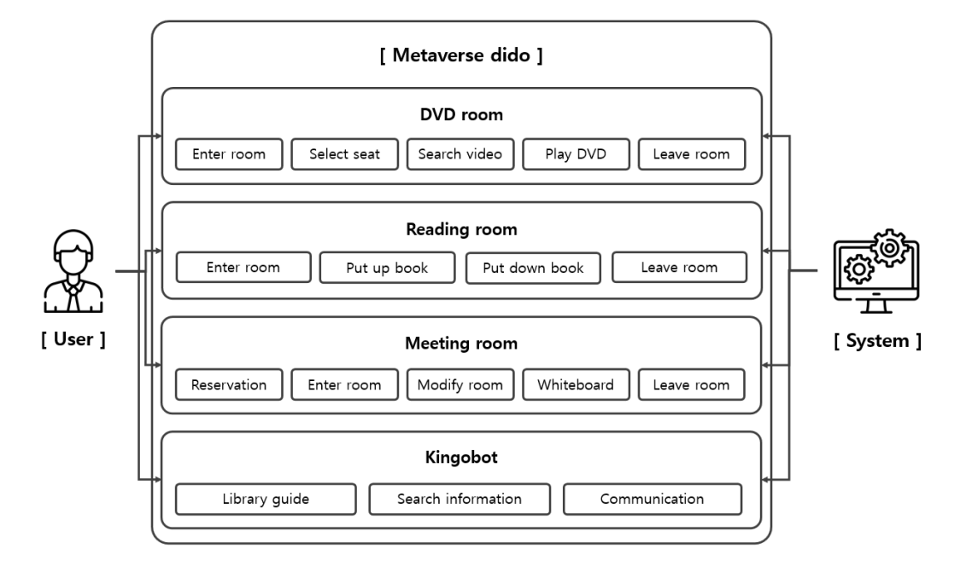

[Figure 4] Use Case Diagram

### 3.2.3. Data Dictionary

[Table 19] User

|  |  |  |  |
| --- | --- | --- | --- |
| Field | Key | Constraint | Description |
| user_id | PK | Not Null | User id |
| user_pw |  | Not Null | User password |

[Table 20] User’s data

|  |  |  |  |
| --- | --- | --- | --- |
| Field | Key | Constraint | Description |
| user_id | PK | Not Null | Id of logged in user |
| user_name |  | Not Null | Name of logged in user |
| user_email |  | Not Null | Email of logged in user |
| user_major |  | Not Null | Course or major of logged in user |
| report[] |  |  | List of any report made by the user on any features of the system |

[Table 21] Database List

|  |  |  |  |
| --- | --- | --- | --- |
| Field | Key | Constraint | Description |
| user_id | PK, FK | Not Null | Id of logged in user |
| db_list | FK | Not Null | Name of a specific external database |
| db_desc |  |  | Description or explanation of the database (if there is any) |
| db_link |  | Not Null | Link that redirect to the database |

[Table 22] E-book List

|  |  |  |  |
| --- | --- | --- | --- |
| Field | Key | Constraint | Description |
| user_id | PK, FK | Not Null | Id of logged in user |
| db_list | FK | Not Null | Name of a specific e-book |
| db_desc |  |  | Description or explanation of the e-book (if there is any) |
| db_link |  | Not Null | Link that redirect to the e-book |

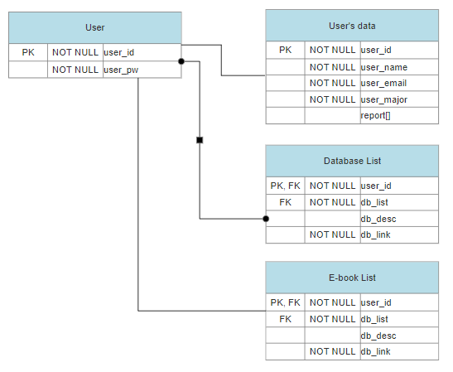

[Figure 5] Entity Relationship Diagram

### 3.2.4. Data Flow Diagram

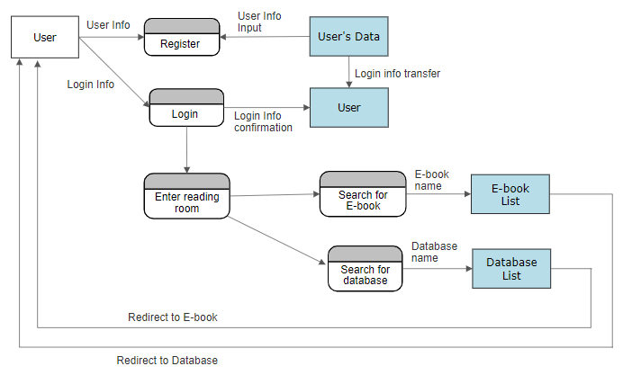

[Figure 6] Data flow diagram

## 3.3. Performance Requirements

The following requirements are based on estimates and can be changed while the system is running.

### 3.3.1. Static numerical requirement

- The system can only be accessed by one user at a time per PC, and should be disconnected to use another account.

- The system should be run on a PC with at least 4 GB of RAM, an INTEL I5 4670 CPU, and AMD r9 290 GPU.

### 3.3.2. Dynamic numerical requirement

- The initialization and connection of the system should be performed within 5 seconds.

- The world and environment objects in VRC SDK3 should be performed within 10 seconds.

- The system should be built for up to 100 users at the same time.

## 3.4. Logical Database Requirements

The system manages user information through a database called MySQL, an open source relational database management system. The system stores user information and audiovisual materials information in a database. The database is managed so that it can have basic performance for processing information through the database.

## 3.5. Design Constraints

The system should not contain components that are not covered under the license. The system should be accessible from the Unity environment using VRC SDK3. Administrators should be able to access and manage the system's servers and databases. The system should be designed to use MySQL’s database.

## 3.6. Standards Compliance

All programs in the system are written according to VRC SDK3 and Unity standards. Function and variable names in the program use camel notation and underscore notation apply to the database. System management tools follow the HTML5 standard.

## 3.7. Organizing the Specific Requirements

This section allows finding out specific system model for requirements. The system model uses a graphical notation based on UML (Unified Modeling Language) and tabular format.

### 3.7.1. Context Model

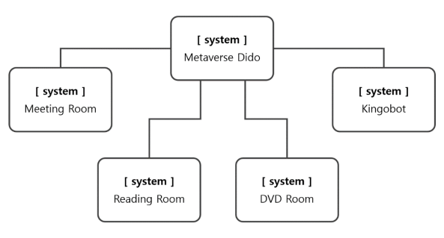

[Figure 7] Context Model

### 3.7.2. Process Model

See 3.8 System Architecture

### 3.7.3. Interaction Model

See 3.2.2 Use Case Diagram

### 3.7.4. Behavior Model

#### 3.7.4.1. Sequence Diagram

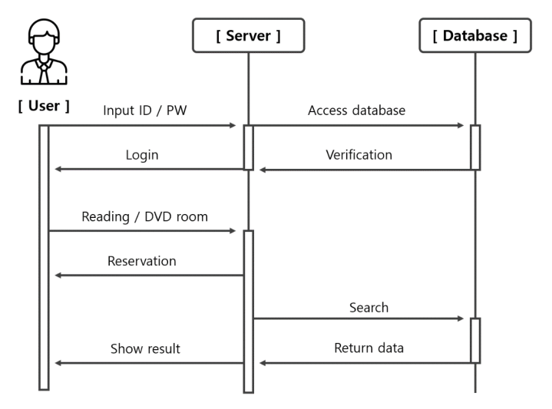

[Figure 8] Sequence Diagram

#### 3.7.4.2. Data Flow Diagram

See 3.2.4 Data Flow Diagram

## 3.8. System Architecture

This section describes the relationship and functionality between system modules.

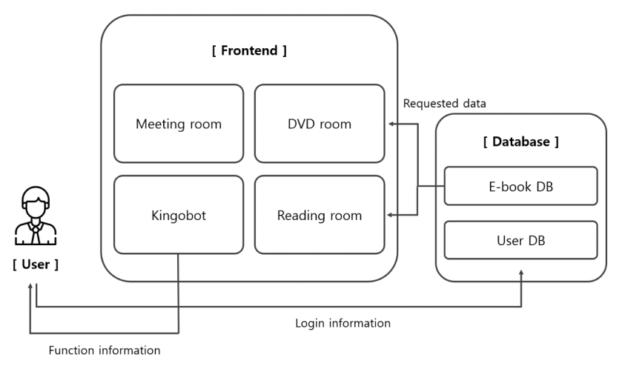

[Figure 9] System Architecture

## 3.9. System Evolution

This section covers system changes that will benefit system designers. Also, this section describes changes to the system caused by advances in hardware and changes in requirements.

### 3.9.1. Limitation and Assumption

The database contains only materials within the Sungkyunkwan University Academic Information Center in the first version, but more diverse audiovisual materials including various categories should be supplemented while servicing. In addition, if there are functions that users need or want to supplement, including various functions included in the first version, they should be continuously updated.

### 3.9.2. Evolutions of Smart Library

Smart library is a smart media-based system that can use current library information services. Among the currently commercialized smart libraries, RFID is supported throughout the system, and a digital content management system has been established using it. Accordingly, in the later version, the function of a cultural space that can be used by various users, including the above functions, should be performed.

# 4. System Features

## 4.1. DVD Room

### 4.1.1. Description and Priority

The DVD room system provides a function for the user to find and view the audiovisual material they want after entering. This system has a high priority as one of the basic functions of a smart library.

### 4.1.2. Stimulus/Response Sequences

• Enter the DVD room

• Search the audiovisual material to watch and play it on the screen

• Leave the DVD room after watching

### 4.1.3. Functional Requirements

Other system features include:

1. Database: The DVD room is connected to the database of the smart library to deliver the desired material quickly and accurately.

2. Client/Server System: A client/server system is a distributed system in which, all the data resides at the server sites and all applications execute at the client sites The server sends the information entered by the user to the database.

## 4.2. Reading Room

### 4.2.1. Description and Priority

The reading room system provides a function for the user to find and view the book they want after entering. This system has a high priority as one of the basic functions of a smart library like the DVD room.

### 4.2.2. Stimulus/Response Sequences

• Enter the reading room

• Search the book to read and show it on the screen

• Leave the reading room after watching

### 4.2.3. Functional Requirements

Other system features include:

1. Database: The reading room is connected to the database of the smart library to deliver the desired material quickly and accurately.

2. Client/Server System: A client/server system is a distributed system in which, all the data resides at the server sites and all applications execute at the client sites The server sends the information entered by the user to the database.

## 4.3 Meeting Room

### 4.3.1. Description and Priority

The meeting room system provides a function that allows users to reserve a space they want and use a whiteboard for purposes such as meetings. It is an additional system that is not an essential function of the library and has a relatively low priority.

### 4.3.2. Stimulus/Response Sequences

• Reserve the meeting room and enter

• Use the whiteboard function

• Leave the meeting room after the meeting

### 4.3.3. Functional Requirements

Other system features include:

1. Whiteboard: Display the user's input on the screen and share it with the other people in the meeting room

2. Client/Server System: A client/server system is a distributed system in which, all the data resides at the server sites and all applications execute at the client sites The server sends the information entered by the user to the database.

## 4.4 ChatterBot

### 4.4.1. Description and Priority

The chatterbot system is an interface that is created in the metaverse to interact with the user and provide useful information related to education, school life and academic-related inquiry. This system has a very high priority as a guide within the smart library.

### 4.4.2. Stimulus/Response Sequences

• Get information of total credit time, status of final year project, bus schedule, canteen menu, roadmap of major, academic calendar, and location of building

• Answer to frequently asked questions

### 4.4.3. Functional Requirements

Other system features include:

1. Database: The chatterbot is connected to the database of the smart library to deliver the information quickly and accurately.

2. Client/Server System: A client/server system is a distributed system in which, all the data resides at the server sites and all applications execute at the client sites The server sends the information entered by the user to the database.

# 5. Nonfunctional Requirements

This section describes non-functional requirements that are categorized as performance requirements, safety requirements, security requirements, and software quality attributes. Software system characteristics are revealed through non-functional requirements.

## 5.1. Performance Requirements

Normalization is utilized to perform the implementation of smart library database. The purpose of normalization is to increase the size of the entire data by reducing redundant information and eliminating wasted storage space. Normalization is the process of breaking down a table into smaller tables. So that each table deals with a single theme. There are three different kinds of modifications of anomalies and formulated the first, second and third normal forms is considered sufficient for most practical purposes. It should be considered only after a thorough analysis and complete understanding of its implications.

## 5.2. Safety Requirements

If there is extensive damage to a wide portion of the database due to catastrophic failure, such as a disk crash, the recovery method restores a past copy of the database that was backed up to archival storage and reconstructs a more current state by reapplying or redoing the operations of committed transactions from the backed up log, up to the time of failure.

## 5.3. Security Requirements

The security system should have separate database storage. Vendors should choose their database partners carefully because of the special requirements of the security market.

## 5.4. Software Quality Attributes

• Availability: It should be possible to reserve and use a designated space since many users can use the library's features at the same time.

• Correctness: The system should find the audiovisual material or book that the user wants exactly in the database.

• Maintainability: Administrators should ensure the correct operation of the function.

• Usability: The library system should satisfy a maximum number of customers’ needs.

# 6. Document History

[Table 23] Document History

| **Date** | **Version** | **Description** | **Writer** |
| --- | --- | --- | --- |
| 2021/11/10 | 1.0 | overview | Keunha Kim |
| 2021/11/12 | 1.1 | Addition 1,2 | Keunha Kim |
| 2021/11/14 | 1.2 | Add parts of 3.1.1 and 3.1.2 relevant to DVD room | Dasol Lee |
| 2021/11/14 | 1.3 | Add parts of 3.1.1 and 3.1.2 relevant to reading room | Ukcheol Choe |
| 2021/11/15 | 1.4 | Add parts of 3.1.1 and 3.1.2 relevant to meeting room | Minsu Kim |
| 2021/11/14 | 1.5 | Add parts of 3.1.1 and 3.1.2 relevant to chatterbot | Aizat Hamizuddin |
| 2021/11/17 | 1.6 | Add 3.3~ | Gyeonghyeon Cho |
| 2021/11/17 | 1.7 | Add 3.2.3~2.3.4 | Fatdzirul Izzat Bin |
| 2021/11/20 | 1.8 | Add 3.1.3~3.1.4 | Ukcheol Choe |
| 2021/11/20 | 2.0 | Documentation update | Keunha Kim |