项目技术设计书

项目概述

1.1 项目背景
本项目旨在利用AI模型调用扣子技术创建的一个AI教育网站，提供了智能辅导，在线答题AI评估，AI可视化视图，系统采用Spring Cloud微服务架构，采用前后端分离的开发模式，以提高系统的可扩展性，可维护性和容错能力，使用了MySQL作为数据库进行数据储存等。

1.2 项目目标
- 提供AI智能辅导，个性化学习路线，可以根据题目图片上传AI答疑
- 实现在线答题，AI评估，AI问答，支持个人成绩图表
- 支持视频课程，观看视频，会员课看付费视频课程

1.3 项目适用人群
身份 | 描述
学生 | 学生可以在本网站与AI交换，答题，免费课程升级会员可以观看付费课程，签到可得双倍积分。
教务人员 | 可以发布课程，修改，添加课程，视频上传等。
管理员 | 管理用户模块，课程模块审核，视频模块等等。

技术架构

2.1 总架构图
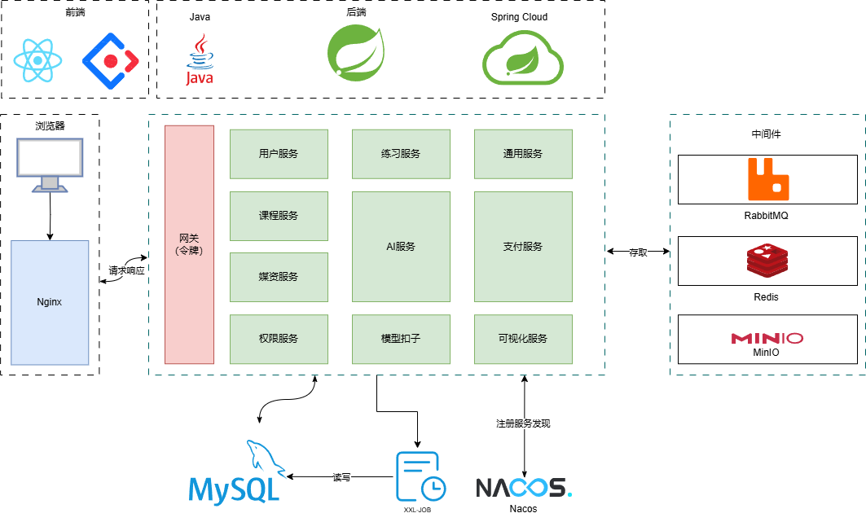

2.2 技术选型
- 后端：Spring Boot、Spring Cloud、Spring Gateway、MyBatis、Maven
- 前端：React、TypeSctript、Ant-Design
- 数据储存：MySQL、Redis、MinIO
- 消息中间件：RabbitMQ
- 缓存：Redis、Caffeine
- 其他：Nacos、XXL-JOB

数据库设计

3.1 用户服务
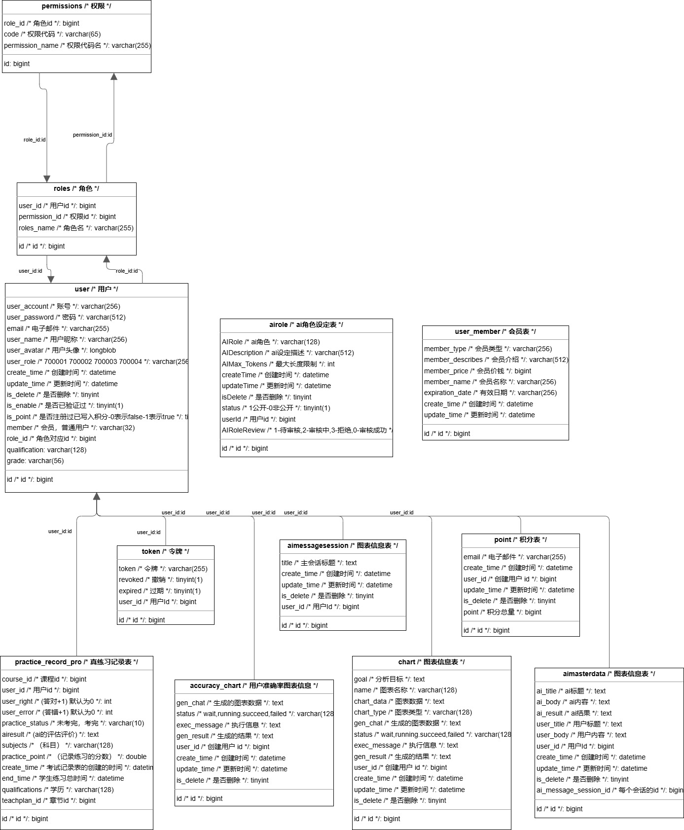

3.2 课程服务
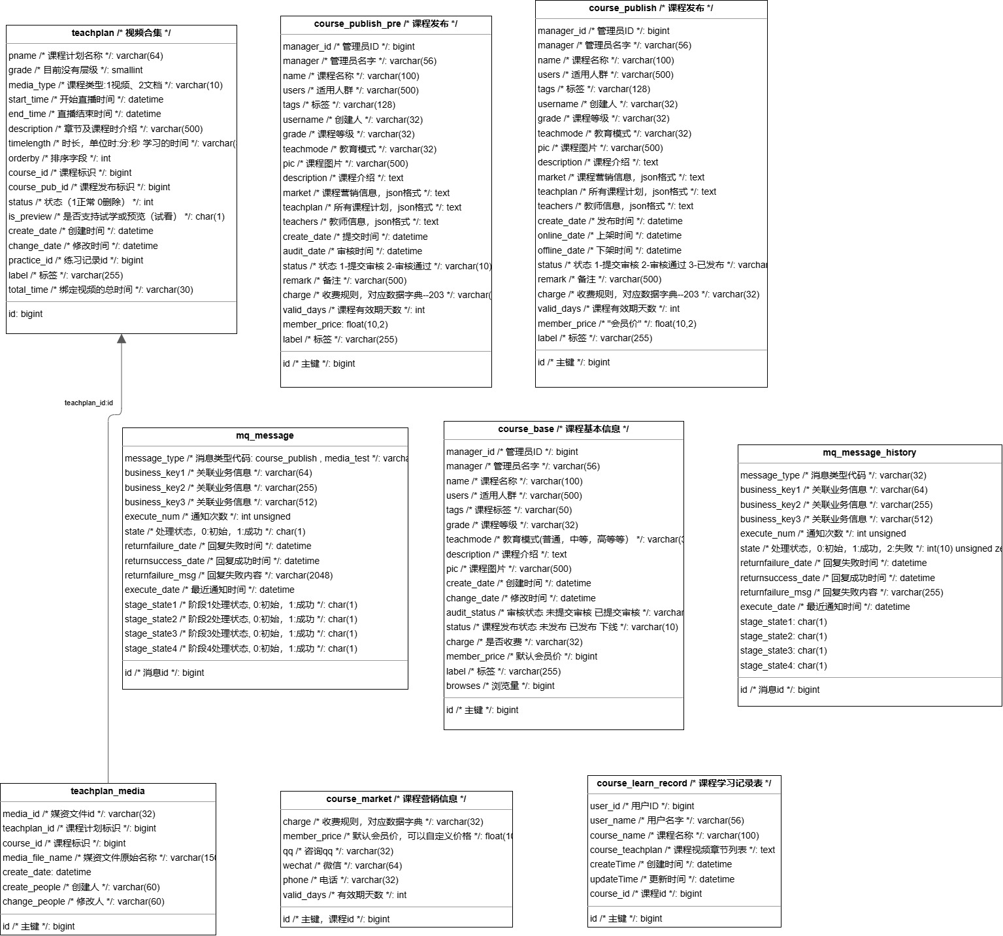

3.3 媒资服务
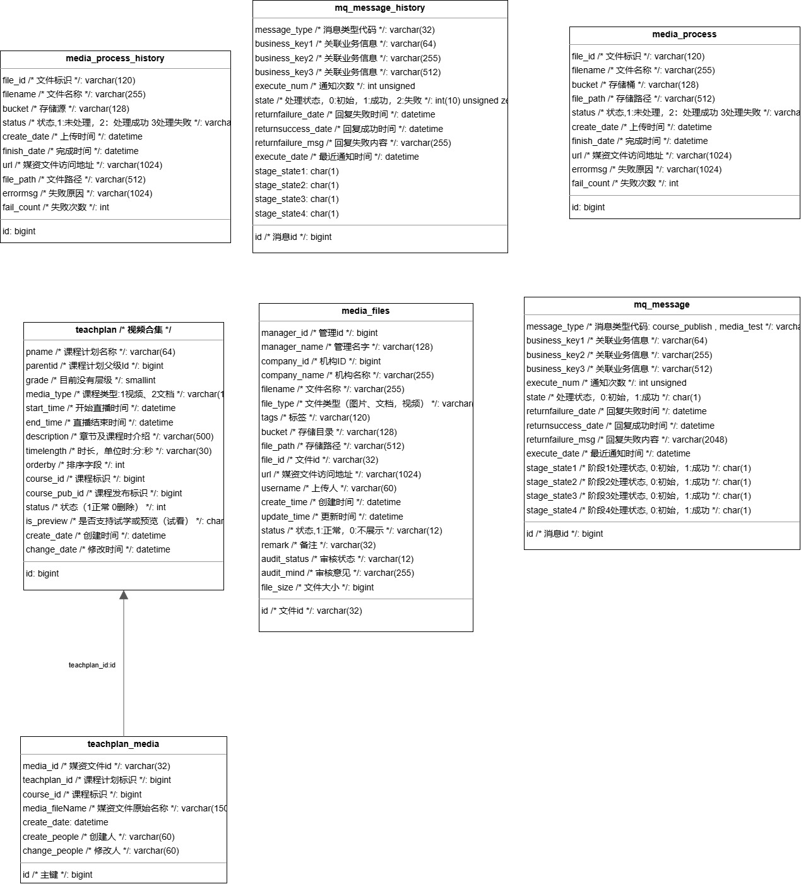

3.4 支付服务
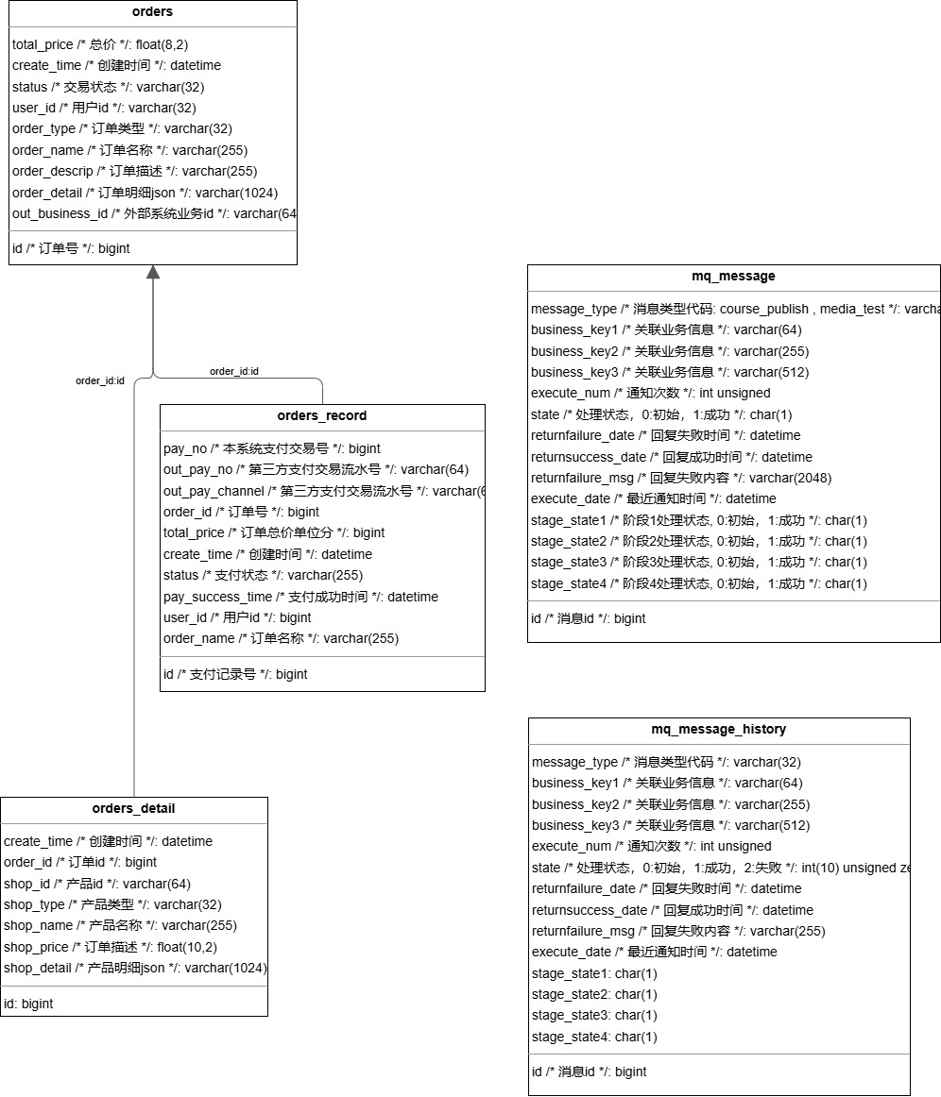

3.5 练习服务
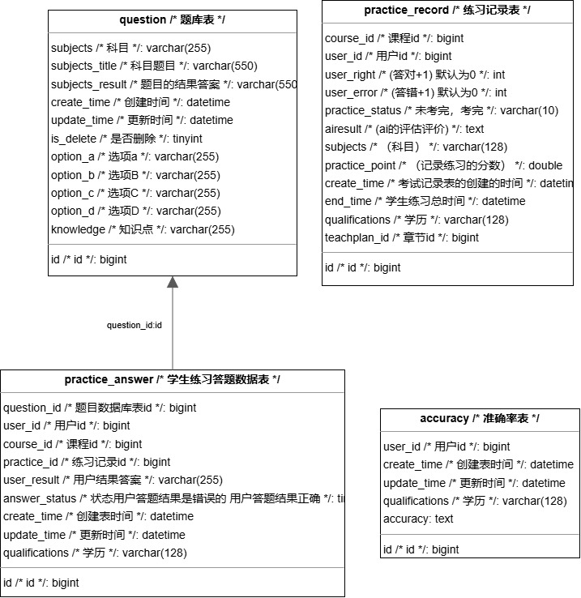

3.6 其他
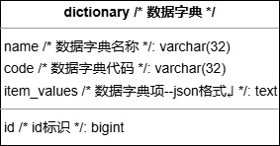

微服务模块设计

4.1 用户服务

4.1.0 用户架构图（该架构图是之前项目开始的时候设计的,项目现在增加了一些功能）
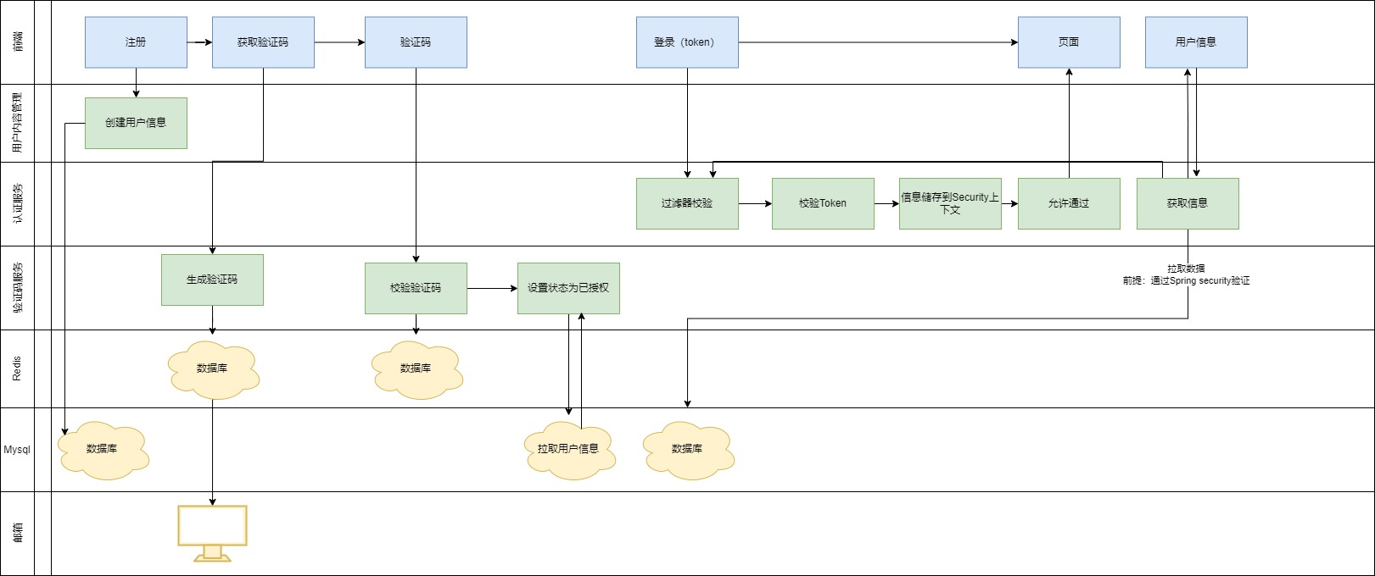
功能：用户注册、登录、权限验证、添加用户、修改用户、删除用户、获取用户列表、用户签到、用户积分
技术：Spring Boot、JWT、MyBatis
数据库：MySQL
储存：MinIO用于储存用户头像

4.1.1 关键代码
使用电子邮件协议发送验证码到邮箱上，并将验证码储存在Redis中设置有效期1分钟

4.1.2 接口定义
/**
* 发送验证码
* @param userPublishEventRequest
* @return trye或false
*/
@PostMapping("/publish")
public BaseResponse<Boolean> getPublishEvent(@RequestBody UserPublishEventRequest userPublishEventRequest, HttpServletRequest request){
ThrowUtils.throwIf(userPublishEventRequest.getId() <= 0,ErrorCode.OPERATION_ERROR);
ThrowUtils.throwIf("".equals(userPublishEventRequest.getEmail()),ErrorCode.OPERATION_ERROR);
ThrowUtils.throwIf(userPublishEventRequest.getEmail() == null,ErrorCode.OPERATION_ERROR);
if(StringUtils.isBlank(userPublishEventRequest.getEmail())){
throw new BusinessException(ErrorCode.PARAMS_ERROR,"请输入电子邮箱");
}
return ResultUtils.success(userService.isPublishEvent(userPublishEventRequest));
}

4.1.3 接口服务实现
@Override
public Boolean isPublishEvent(UserPublishEventRequest userEmailAndId) {
QueryWrapper<User> queryWrapper = new QueryWrapper<>();
queryWrapper.eq(SqlConstants.CHART_ID, userEmailAndId.getId());
queryWrapper.eq(SqlConstants.EMAIL_NAME,userEmailAndId.getEmail());
User user = userMapper.selectOne(queryWrapper);
UserDto userDto = new UserDto();
BeanUtils.copyProperties(user,userDto);
if(user != null){
checkCodeClient.getPublishEvent(userDto, redisVerificationUtil.generateVerification());
return true;
}
return false;
}

4.1.4 生成验证码
public String generateVerification(){
return String.valueOf((int) ((Math.random() * 9 + 1) * 100000));
}

4.1.5 事件定义
@Setter
@Getter
public class RegistrationCompleteEvent extends ApplicationEvent {

private UserDto user;
private String verificationCode;

public RegistrationCompleteEvent(UserDto user,String verificationCode) {
super(user);
this.user = user;
this.verificationCode = verificationCode;
}

}

4.1.6 发布事件
@Override
public void Publish(UserDto userDto, String code) {
publisher.publishEvent(new RegistrationCompleteEvent(userDto, code));
}

4.1.7 监听事件并发送电子邮件并存储在Redis

@Slf4j
@Component
public class RegistrationCompleteEventListener implements ApplicationListener<RegistrationCompleteEvent> {

@Autowired
private RedisTemplate<String,String> redisTemplate;

// @Autowired
// private JwtService jwtService;

@Value("${spring.mail.username}")
private String masterEmail;
private final Integer SECONDS = 180;

@Autowired
private JavaMailSender mailSender;

private UserDto theUser;

@Override
public void onApplicationEvent(RegistrationCompleteEvent event) {
theUser = new UserDto(); // 初始化 theUser 对象
BeanUtils.copyProperties(event.getUser(),theUser);
redisTemplate.opsForValue().set(RedisConstant.KEY_UTIL+theUser.getId(),event.getVerificationCode(), SECONDS, TimeUnit.MINUTES);
String verificationEmail = event.getVerificationCode();
try {
sendVerificationEmail(verificationEmail);
}catch (MessagingException | UnsupportedEncodingException | jakarta.mail.MessagingException e){
throw new BusinessException(ErrorCode.EMAIL_ERROR);
}
log.info("以下是你的电子邮件验证码："+ verificationEmail);

}
public void sendVerificationEmail(String verificationEmail) throws MessagingException, UnsupportedEncodingException, jakarta.mail.MessagingException {
String subject = "验证你的电子邮件";
String senderName = "验证码";
String mailContent = "<p>来自Asouli的问候：</p><br />" +
"<p>感谢你注册Asouli账户。为确保当前是你本人操作,请你输入此邮件中提到的验证码以完成注册。如你无需注册Asouli账户，请忽略该信息</p>"
+ "<br />" + senderName + "<br />" + verificationEmail + "<br />" + "<p>(此验证码将在发送后1分钟过期)</p>" + "<br />" + "<hr />" +
"Asouli不会通过邮件让你公开或验证你的密码或银行账号号码。如果你收到带有更新账户信息链接的可疑电子邮件，请不要点击该链接，而是应该将该电子邮件报告给Asouli进行调查" + "<br />" + "<hr />";

MimeMessage message = mailSender.createMimeMessage();
var messageHelper = new MimeMessageHelper(message);
messageHelper.setFrom(masterEmail, senderName);
messageHelper.setTo(theUser.getEmail());
messageHelper.setSubject(subject);
messageHelper.setText(mailContent, true);
mailSender.send(message);
}
}

4.2 课程管理服务

4.2.0 课程管理架构图
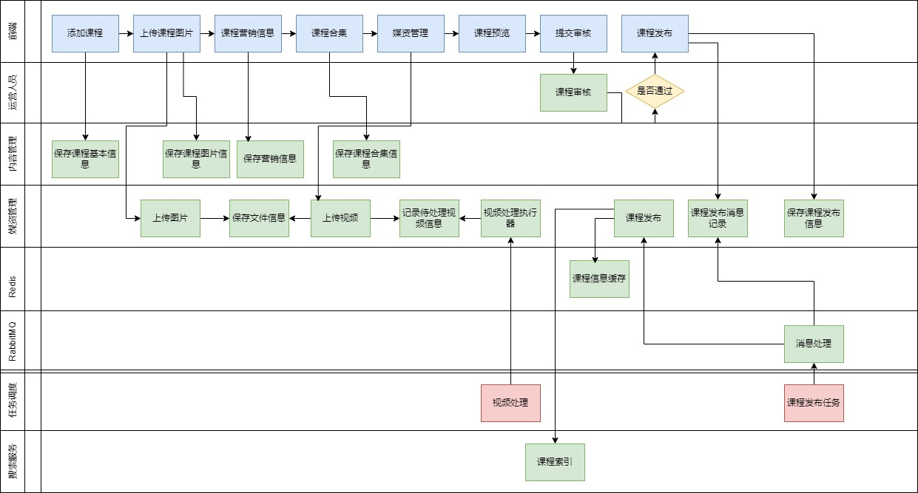
功能：课程创建与管理、章节管理
技术：Spring Boot、MyBatis、RabbitMQ
数据库：MySQL
存储：Redis、Caffeine

4.2.1 关键代码
使用Redis + Caffeine 多级缓存，将课程信息，营销信息，章节列表，用户信息储存在Redis 和 Caffeine（只存了课程信息，营销信息）

4.2.2 接口定义
/**
* 获取课程的完整预览信息
*
* @param courseId 课程Id
* @return 返回课程预览信息 DTO
*/
@PostMapping("/course/whole/{courseId}")
public BaseResponse<CoursePreviewDto> getPreviewInfo(@PathVariable("courseId") Long courseId, CourseLearnRecordDto courseLearnRecordDto, HttpServletRequest request) {
//获取课程预览信息
CoursePreviewDto coursePreviewInfo = coursePublishService.getCoursePreviewInfo(courseId,request,courseLearnRecordDto);
return ResultUtils.success(coursePreviewInfo);
}

4.2.3 接口实现
@Override
public CoursePreviewDto getCoursePreviewInfo(Long courseId,HttpServletRequest request,CourseLearnRecordDto courseLearnRecordDto) {
// //获取用户信息

UserDto userDtoForRedisOrLock = courseBaseService.getUserDtoForRedisOrLock(request, SecurityConstants.AUTHORIZATION_HEADER);
ThrowUtils.throwIf(userDtoForRedisOrLock == null,ErrorCode.NOT_LOGIN_ERROR);
Long userId = userDtoForRedisOrLock.getId();

//课程基本信息、营销信息
CourseBaseInfoDto courseBaseInfo = courseBaseInfoService.getCourseBaseInfo(courseId);

//判断是否收费是否会员
String charge = courseBaseInfo.getCharge();
ThrowUtils.throwIf(userDtoForRedisOrLock.getMember() == null,ErrorCode.OPERATION_ERROR);
if(charge.equals("201001") && userDtoForRedisOrLock.getMember().equals("605003")){
throw new BusinessException(ErrorCode.IS_NOT_MEMBER);
}

String courseBroweseId = CourseConstant.COURSE_BROWSES + userId + courseBaseInfo.getId();
// //课程浏览加+1
addCourseBrowses(courseBroweseId,userId,courseBaseInfo.getId());

// 课程计划信息
List<TeachplanListDto> teachplanTreeRedis = courseBaseInfoService.findTeachplanTreeRedis(courseId);

CoursePreviewDto coursePreviewDto = new CoursePreviewDto();
coursePreviewDto.setCourseBase(courseBaseInfo);
coursePreviewDto.setTeachplans(teachplanTreeRedis);
return coursePreviewDto;

}

4.2.4 获取用户信息（Redis）
@Override
public UserDto getUserDtoForRedisOrLock(HttpServletRequest request,String type){
UserDto userDto = new UserDto();
Object user = servletUtils.getHeaderRedisForUser(request, type);

if (user == null) {
String headerKey = servletUtils.getHeaderKey(request, type);
String redis_user_key = CAFFEINE_USER + headerKey;
if (StringUtils.isNotBlank(headerKey)) {
RLock lock = redissonClient.getLock(CAFFEINE_USER_LOCKED + headerKey);
boolean isLocked = false;
try {
// 尝试获取锁，等待10秒，锁超时1秒自动释放
isLocked = lock.tryLock(10, 1, TimeUnit.SECONDS);
if (isLocked) {
String username = servletUtils.getHeader(request, type);
userDto = userClient.GobalGetLoginUser(username);
// 如果成功获取锁，进行数据库查询和缓存更新
if (userDto == null) {
// 将空值写入redis 防止缓存穿透
redisTemplate.opsForValue().set(redis_user_key, "", 1L, TimeUnit.HOURS);
throw new BusinessException(ErrorCode.USER_IS_NOT); // 返回 null 表示没有找到课程
}
syncToRedis(redis_user_key,userDto);
}
} catch (InterruptedException e) {
throw new BusinessException(ErrorCode.SYSTEM_ERROR);
}finally {
if (isLocked){
lock.unlock();
}
}
}

}else {

BeanUtils.copyProperties(user,userDto);

}
return userDto;
}

private void syncToRedis(String cacheKey, Object data) {
if (data != null) {
String serializedData = serialize(data);
redisTemplate.opsForValue().set(cacheKey, serializedData, 1, TimeUnit.HOURS); // 同步到 Redis 缓存
}
}

4.2.4 获取课程信息、营销信息
//根据课程id查询课程基本信息，包括基本信息和营销信息
@Override
public CourseBaseInfoDto getCourseBaseInfo(Long courseId) {
CourseBaseInfoDto courseBaseInfoDto = new CourseBaseInfoDto();
String caffeineCourseIdKey = CAFFEINE_COURSE + courseId;
String caffeineCourseMarketKey = CAFFEINE_COURSE_MARKET + courseId;

// 从 Caffeine 或 Redis 获取缓存数据
CourseBase courseBaseCache = (CourseBase) getFromCaffeineOrRedis(caffeineCourseIdKey, CourseBase.class);
CourseMarket courseMarketCache = (CourseMarket) getFromCaffeineOrRedis(caffeineCourseMarketKey, CourseMarket.class);

if (courseBaseCache != null) {
BeanUtils.copyProperties(courseBaseCache, courseBaseInfoDto);
}
if (courseMarketCache != null) {
BeanUtils.copyProperties(courseMarketCache, courseBaseInfoDto);
}

if (courseBaseCache == null || courseMarketCache == null){
RLock lock = redissonClient.getLock(CAFFEINE_COURSE_MARKET_LOCKED + courseId);
boolean isLocked = false;
try {
// 尝试获取锁，等待10秒，锁超时1秒自动释放
isLocked = lock.tryLock(10, 1, TimeUnit.SECONDS);
if (isLocked) {
// 如果成功获取锁，进行数据库查询和缓存更新
fetchAndUpdateCourseData(courseId, courseBaseInfoDto, caffeineCourseIdKey, caffeineCourseMarketKey);
}
} catch (InterruptedException e) {
// Thread.currentThread().interrupt(); // 重置中断状态
throw new BusinessException(ErrorCode.SYSTEM_ERROR);
}finally {
if (isLocked){
lock.unlock();
}
}
}
return courseBaseInfoDto; // 返回最终结果
}

// 从 Caffeine 或 Redis 获取数据，支持不同类型
private <T> Object getFromCaffeineOrRedis(String cacheKey, Class<T> clazz) {
Object data = commonCaffeine.getIfPresent(cacheKey);
if (data == null) {
// 如果 Caffeine 没有，查 Redis
String redisData = redisTemplate.opsForValue().get(cacheKey);
if(StringUtils.isNotBlank(redisData)){
data = deserialize(redisData, clazz);
commonCaffeine.put(cacheKey, data); // 同步到 Caffeine 缓存
return data;
}
// 判断命中的是否是空值
if (redisData != null) {
// 返回一个错误信息
return null;
}

}
return data;
}

private void fetchAndUpdateCourseData(Long courseId, CourseBaseInfoDto courseBaseInfoDto, String caffeineCourseIdKey, String caffeineCourseMarketKey) {

CourseBase courseBase = courseBaseMapper.selectById(courseId);
if (courseBase == null) {
// 将空值写入redis 防止缓存穿透
redisTemplate.opsForValue().set(caffeineCourseIdKey, "", 1L, TimeUnit.HOURS);
return; // 返回 null 表示没有找到课程
}
BeanUtils.copyProperties(courseBase, courseBaseInfoDto);

CourseMarket courseMarket = courseMarketMapper.selectById(courseId);
if (courseMarket != null) {
// 将空值写入redis防止缓存穿透
redisTemplate.opsForValue().set(caffeineCourseMarketKey, "", 1L, TimeUnit.HOURS);
BeanUtils.copyProperties(courseMarket, courseBaseInfoDto);
}

// 更新缓存
syncToCache(caffeineCourseIdKey, courseBase);
syncToCache(caffeineCourseMarketKey, courseMarket);
}

// 同步数据到 Redis 和 Caffeine
private void syncToCache(String cacheKey, Object data) {
if (data != null) {
String serializedData = serialize(data);
redisTemplate.opsForValue().set(cacheKey, serializedData, 1, TimeUnit.HOURS); // 同步到 Redis 缓存
commonCaffeine.put(cacheKey, data); // 同步到 Caffeine 缓存
}
}

4.2.5 获取课程章节
@Override
public List<TeachplanListDto> findTeachplanTreeRedis(Long courseId) {
String redis_teachplan = REDIS_COURSE_TEACHPLAN + courseId;
List<TeachplanListDto> teachplanListDtos = getFromRedisByte(redis_teachplan);
if (teachplanListDtos != null){
return teachplanListDtos;
}
RLock lock = redissonClient.getLock(CAFFEINE_COURSE_MARKET_LOCKED + courseId);
boolean isLocked = false;
try {
// 尝试获取锁，等待10秒，锁超时1秒自动释放
isLocked = lock.tryLock(10, 1, TimeUnit.SECONDS);
if (isLocked) {
// 如果成功获取锁，进行数据库查询和缓存更新
List<TeachplanListDto> teachplanTree = teachplanService.findTeachplanTree(courseId);
if (teachplanTree == null) {
// 将空值写入redis 防止缓存穿透
redisTemplate.opsForValue().set(redis_teachplan, "", 1L, TimeUnit.HOURS);
return null;
}

// 更新缓存
syncToCacheForCompress(redis_teachplan, teachplanTree);
return teachplanTree;
}
} catch (InterruptedException e) {
// Thread.currentThread().interrupt(); // 重置中断状态
throw new BusinessException(ErrorCode.SYSTEM_ERROR);
}finally {
if (isLocked){
lock.unlock();
}
}
return List.of();
}

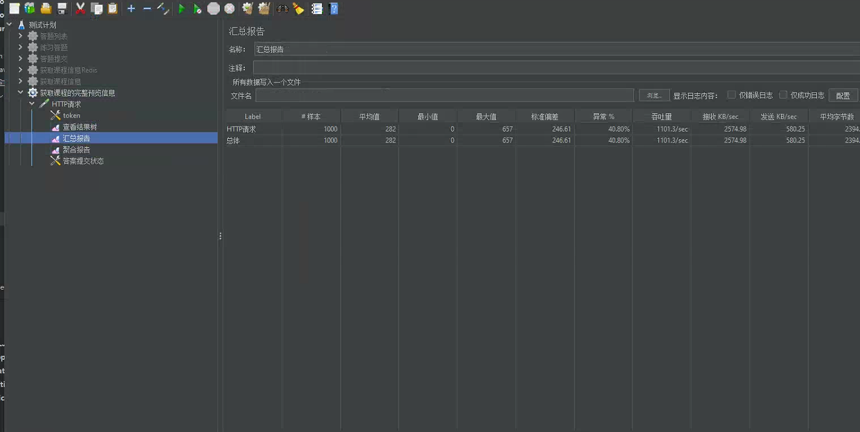
测试高并发1000个线程后吞吐量每秒达到1000以上甚至更快会到2600（亲测过的）

4.3 视频服务

4.3.0 视频服务架构图（图中的视频处理在项目中还未实现）
功能：视频上传于管理、视频绑定章节管理
技术：Spring Boot、MyBatis、MinIO
数据库：MySQL
存储：Redis、Caffeine、MinIO

4.3.1 关键代码
大文件实现分块上传，断点续传（由于做的模块有点多，对于视频这个服务暂时没大优化）

4.3.2 上传前的检测
/**
* 文件上传前检查
* @param fileMd5
* @return
* @throws Exception
*/
@PostMapping("/upload/checkfile")
@PermissionMethod(permission = "media_manager_course_read")
public BaseResponse<Boolean> checkfile(
@RequestParam("fileMd5") String fileMd5
) throws Exception {
BaseResponse<Boolean> booleanRestResponse = mediaFileService.checkFile(fileMd5);
return booleanRestResponse;
}

@Override
public BaseResponse<Boolean> checkFile(String fileMd5) {
//查询文件信息
MediaFiles mediaFiles = mediaFilesMapper.selectById(fileMd5);
if (mediaFiles != null) {
//桶
String bucket = mediaFiles.getBucket();
//存储目录
String filePath = mediaFiles.getFilePath();
//文件流
InputStream stream = null;
try {
stream = minioClient.getObject(
GetObjectArgs.builder()
.bucket(bucket)
.object(filePath)
.build());

if (stream != null) {
//文件已存在
return ResultUtils.success(true);
}
} catch (Exception e) {

}
}
//文件不存在
return ResultUtils.success(false);
}

4.3.3 分块文件检测
/**
* 视频分块检查
*
*
*/
@PostMapping("/upload/checkchunk")
@PermissionMethod(permission = "media_manager_course_read")
public BaseResponse<Boolean> checkchunk(@RequestParam("fileMd5") String fileMd5,
@RequestParam("chunk") int chunk) throws Exception {
BaseResponse<Boolean> booleanRestResponse = mediaFileService.checkChunk(fileMd5, chunk);
return booleanRestResponse;
}

@Override
public BaseResponse<Boolean> checkChunk(String fileMd5, int chunkIndex) {

//得到分块文件目录
String chunkFileFolderPath = getChunkFileFolderPath(fileMd5);
//得到分块文件的路径
String chunkFilePath = chunkFileFolderPath + chunkIndex;

//文件流
InputStream fileInputStream = null;
try {
fileInputStream = minioClient.getObject(
GetObjectArgs.builder()
.bucket(bucket_video)
.object(chunkFilePath)
.build());

if (fileInputStream != null) {
//分块已存在
return ResultUtils.success(true);
}
} catch (Exception e) {

}
//分块未存在
return ResultUtils.success(false);
}

4.3.4 上传分块文件
/**
* 分块上传
*
*
*/
@PostMapping("/upload/uploadchunk")
@PermissionMethod(permission = "media_manager_course_update")
public BaseResponse uploadchunk(@RequestParam("file") MultipartFile file,
@RequestParam("fileMd5") String fileMd5,
@RequestParam("chunk") int chunk) throws Exception {

return mediaFileService.uploadChunk(fileMd5, chunk, file.getInputStream());
}
@Override
public BaseResponse uploadChunk(String fileMd5, int chunk, InputStream fileStream) {
//得到分块文件的目录路径
String chunkFileFolderPath = getChunkFileFolderPath(fileMd5);
//得到分块文件的路径
String chunkFilePath = chunkFileFolderPath + chunk;
//mimeType
String mimeType = getMimeType(null);
//将文件存储至minIO
boolean b = addMediaFilesToMinIO(fileStream, mimeType, bucket_video, chunkFilePath);
if (!b) {
log.debug("上传分块文件失败:{}", chunkFilePath);
return ResultUtils.error(ErrorCode.FILE_CHUNK_ERROR);
}
log.debug("上传分块文件成功:{}",chunkFilePath);
return ResultUtils.success(true);
}

4.3.5 合并分块

/**
* 合并分块
*
*
*/
@PostMapping("/upload/mergechunks")
@PermissionMethod(permission = "media_manager_course_add")
public BaseResponse mergechunks(@RequestParam("fileMd5") String fileMd5,
@RequestParam("fileName") String fileName,
@RequestParam("chunkTotal") int chunkTotal,HttpServletRequest request) throws Exception {
Long companyId = 1232141425L;

UploadFileParamsDto uploadFileParamsDto = new UploadFileParamsDto();
uploadFileParamsDto.setFileType("video");
uploadFileParamsDto.setTags("课程视频");
uploadFileParamsDto.setFilename(fileName);

return mediaFileService.mergechunks(companyId,fileMd5,chunkTotal,uploadFileParamsDto,request);

}

@Override
//todo
public BaseResponse mergechunks(Long companyId, String fileMd5, int chunkTotal, UploadFileParamsDto uploadFileParamsDto,HttpServletRequest request) {
// String username = servletUtils.getHeader(request, SecurityConstants.AUTHORIZATION_HEADER);
// UserDto userDto = userClient.GobalGetLoginUser(username);
// String managerId = userDto.getId().toString();
String id = "1794941858414170113";
//=====获取分块文件路径=====
String chunkFileFolderPath = getChunkFileFolderPath(fileMd5);
//组成将分块文件路径组成 List<ComposeSource>
List<ComposeSource> sourceObjectList = Stream.iterate(0, i -> ++i)
.limit(chunkTotal)
.map(i -> ComposeSource.builder()
.bucket(bucket_video)
.object(chunkFileFolderPath.concat(Integer.toString(i)))
.build())
.collect(Collectors.toList());
//=====合并=====
//文件名称
String fileName = uploadFileParamsDto.getFilename();
//文件扩展名
String extName = fileName.substring(fileName.lastIndexOf("."));
//合并文件路径
String mergeFilePath = getFilePathByMd5(fileMd5, extName);
try {
//合并文件
ObjectWriteResponse response = minioClient.composeObject(
ComposeObjectArgs.builder()
.bucket(bucket_video)
.object(mergeFilePath)
.sources(sourceObjectList)
.build());
log.debug("合并文件成功:{}",mergeFilePath);
} catch (Exception e) {
log.debug("合并文件失败,fileMd5:{},异常:{}",fileMd5,e.getMessage(),e);
return ResultUtils.error(ErrorCode.FILE_MERGE_CHUNKS_ERROR);
}

// ====验证md5====
byte[] mergedFileData = downloadFileFromMinIO(bucket_video, mergeFilePath);
if (mergedFileData == null) {
log.debug("下载合并后文件失败, mergeFilePath: {}", mergeFilePath);
return ResultUtils.error(ErrorCode.FILE_DOWNLOAD_MERGE_CHUNKS_ERROR);
}

// 验证 MD5
try (InputStream newFileInputStream = new ByteArrayInputStream(mergedFileData)) {
// minio 上文件的 md5 值
String md5Hex = DigestUtils.md5Hex(newFileInputStream);
// 比较 md5 值，不一致则说明文件不完整
if (!fileMd5.equals(md5Hex)) {
return ResultUtils.error(ErrorCode.FILE_MERGE_CHUNKS_ERROR);
}
// 文件大小
uploadFileParamsDto.setFileSize((long)mergedFileData.length); // 使用字节数组的长度
} catch (Exception e) {
log.debug("校验文件失败, fileMd5: {}, 异常: {}", fileMd5, e.getMessage(), e);
return ResultUtils.error(ErrorCode.FILE_DOWNLOAD_MERGE_CHUNKS_ERROR);
}

//文件入库
currentProxy.addMediaFilesToDb(id,companyId,fileMd5,uploadFileParamsDto,bucket_video,mergeFilePath);
//=====清除分块文件=====
clearChunkFiles(chunkFileFolderPath,chunkTotal);
return ResultUtils.success(true);
}

4.4 权限服务
功能：权限管理、会员管理
技术：Spring Boot、MyBatis、AOP
数据库：MySQL

4.4.1 关键代码
利用AOP的动态代理GCLB的原理和注解来实现的权限服务
@Override
//todo
public BaseResponse mergechunks(Long companyId, String fileMd5, int chunkTotal, UploadFileParamsDto uploadFileParamsDto,HttpServletRequest request) {
// String username = servletUtils.getHeader(request, SecurityConstants.AUTHORIZATION_HEADER);
// UserDto userDto = userClient.GobalGetLoginUser(username);
// String managerId = userDto.getId().toString();
String id = "1794941858414170113";
//=====获取分块文件路径=====
String chunkFileFolderPath = getChunkFileFolderPath(fileMd5);
//组成将分块文件路径组成 List<ComposeSource>
List<ComposeSource> sourceObjectList = Stream.iterate(0, i -> ++i)
.limit(chunkTotal)
.map(i -> ComposeSource.builder()
.bucket(bucket_video)
.object(chunkFileFolderPath.concat(Integer.toString(i)))
.build())
.collect(Collectors.toList());
//=====合并=====
//文件名称
String fileName = uploadFileParamsDto.getFilename();
//文件扩展名
String extName = fileName.substring(fileName.lastIndexOf("."));
//合并文件路径
String mergeFilePath = getFilePathByMd5(fileMd5, extName);
try {
//合并文件
ObjectWriteResponse response = minioClient.composeObject(
ComposeObjectArgs.builder()
.bucket(bucket_video)
.object(mergeFilePath)
.sources(sourceObjectList)
.build());
log.debug("合并文件成功:{}",mergeFilePath);
} catch (Exception e) {
log.debug("合并文件失败,fileMd5:{},异常:{}",fileMd5,e.getMessage(),e);
return ResultUtils.error(ErrorCode.FILE_MERGE_CHUNKS_ERROR);
}

// ====验证md5====
byte[] mergedFileData = downloadFileFromMinIO(bucket_video, mergeFilePath);
if (mergedFileData == null) {
log.debug("下载合并后文件失败, mergeFilePath: {}", mergeFilePath);
return ResultUtils.error(ErrorCode.FILE_DOWNLOAD_MERGE_CHUNKS_ERROR);
}

// 验证 MD5
try (InputStream newFileInputStream = new ByteArrayInputStream(mergedFileData)) {
// minio 上文件的 md5 值
String md5Hex = DigestUtils.md5Hex(newFileInputStream);
// 比较 md5 值，不一致则说明文件不完整
if (!fileMd5.equals(md5Hex)) {
return ResultUtils.error(ErrorCode.FILE_MERGE_CHUNKS_ERROR);
}
// 文件大小
uploadFileParamsDto.setFileSize((long)mergedFileData.length); // 使用字节数组的长度
} catch (Exception e) {
log.debug("校验文件失败, fileMd5: {}, 异常: {}", fileMd5, e.getMessage(), e);
return ResultUtils.error(ErrorCode.FILE_DOWNLOAD_MERGE_CHUNKS_ERROR);
}

//文件入库
currentProxy.addMediaFilesToDb(id,companyId,fileMd5,uploadFileParamsDto,bucket_video,mergeFilePath);
//=====清除分块文件=====
clearChunkFiles(chunkFileFolderPath,chunkTotal);
return ResultUtils.success(true);
}

4.5 在线练习服务
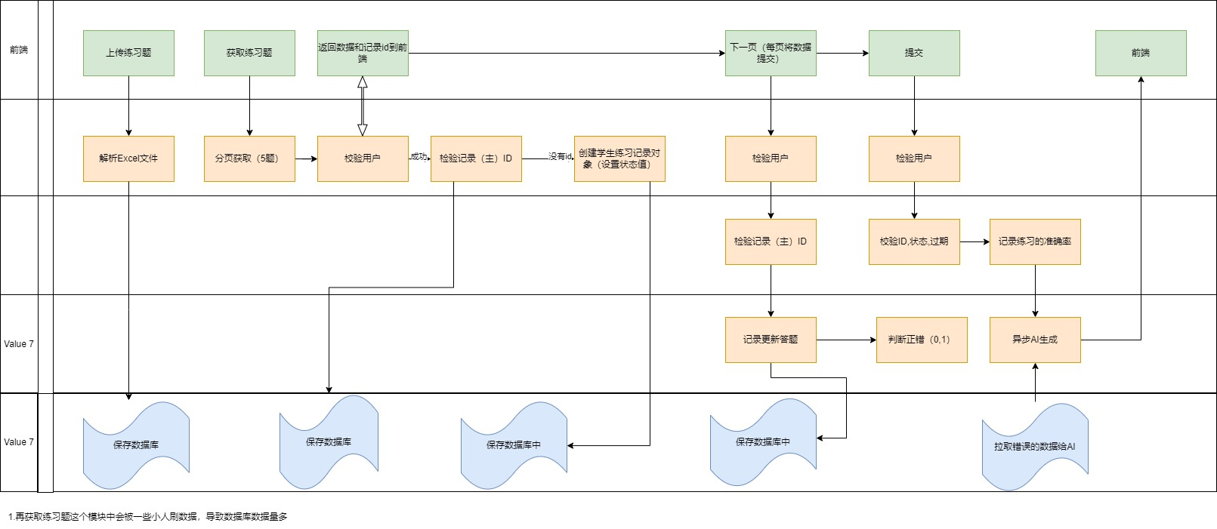
功能：练习管理、AI评估
技术：Spring Boot、MyBatis、RabbitMQ、扣子
数据库：MySQL、Redis

4.5.1 关键代码
在提交答案的时候使用异步多线程优化性能

4.5.2 接口定义
/**
* 提交结果（增加练习记录）
*
* @param answerAddResultRequest
* @param
* @return
*/
@PostMapping("/add/answer/result")
public BaseResponse<BiResponse> addQuestionResultOverall(@RequestBody AnswerAllResultRequest answerAddResultRequest, HttpServletRequest request) throws Exception {

if (answerAddResultRequest == null) {
throw new BusinessException(ErrorCode.PARAMS_ERROR);
}

BiResponse biResponse = answerService.generateAnswer(answerAddResultRequest, request);

return ResultUtils.success(biResponse);
}

@Override
public BiResponse generateAnswer(AnswerAllResultRequest answerAddResultRequest, HttpServletRequest request) {
//（没用多线程异步化的代码注解）
// String username = servletUtils.getHeader(request, SecurityConstants.AUTHORIZATION_HEADER);
// UserDto userDto = userClient.GobalGetLoginUser(username);
// ThrowUtils.throwIf(userDto == null, ErrorCode.NOT_LOGIN_ERROR);
// log.debug("UserDto: {}", userDto);
// Long practiceId = answerAddResultRequest.getPracticeId();
// ThrowUtils.throwIf(practiceId == null, ErrorCode.RECORD_NOT_FOUND);
// Long expire = redisTemplate.getExpire(practiceId.toString());
// ThrowUtils.throwIf(expire == null, ErrorCode.EXAM_TIMEOUT);
// ThrowUtils.throwIf(expire == -1, ErrorCode.EXAM_NOT_FOUNT);
// PracticeRecord record = practiceRecordMapper.selectById(practiceId);
// ThrowUtils.throwIf(record == null, ErrorCode.NOT_FOUND_ERROR);
// log.debug("PracticeRecord: {}", record);
// QueryWrapper<Accuracy> queryWrapper = new QueryWrapper<>();
// queryWrapper.eq("user_id", userDto.getId());
// Accuracy accuracy = accuracyMapper.selectOne(queryWrapper);
// Integer userRight = record.getUserRight();
// Integer userError = record.getUserError();
// int total = userError + userRight;
// ThrowUtils.throwIf(total == 0, ErrorCode.COURSE_NOT_FOUND);
//
// double result = ((double) userRight / total) * 100;
// record.setPracticePoint(userRight * 5.0);
// updateAccuracyForSubject(accuracy, answerAddResultRequest.getSubjects(), result);
// String allPracticeAnswers = getAllPracticeAnswers(userDto.getId(), practiceId, answerAddResultRequest.getCourseId(), record);
// BiResponse response = new BiResponse();
// response.setGenChart(allPracticeAnswers);
// response.setGenResult(record.getPracticePoint());
// return response;
//自定义线程池
ExecutorService executorService = new ThreadPoolExecutor(
24,48,60L,
TimeUnit.SECONDS,new LinkedBlockingQueue<Runnable>(150),
new ThreadPoolExecutor.CallerRunsPolicy()
);
try {
// 获取当前用户
CompletableFuture<UserDto> userDtoCompletableFuture = CompletableFuture.supplyAsync(() -> {
String username = servletUtils.getHeader(request, SecurityConstants.AUTHORIZATION_HEADER);
UserDto userDto = userClient.GobalGetLoginUser(username);
ThrowUtils.throwIf(userDto == null, ErrorCode.NOT_LOGIN_ERROR);
log.debug("UserDto: {}", userDto);

return userDto;
}, executorService);

Long practiceId = answerAddResultRequest.getPracticeId();
Long courseIds = answerAddResultRequest.getCourseId();
Long teachplanId = answerAddResultRequest.getTeachplanId();
ThrowUtils.throwIf(practiceId == null || practiceId <= 0, ErrorCode.RECORD_NOT_FOUND);
ThrowUtils.throwIf(courseIds == null || courseIds <= 0, ErrorCode.RECORD_NOT_FOUND);
ThrowUtils.throwIf(teachplanId == null || teachplanId <= 0, ErrorCode.RECORD_NOT_FOUND);
CompletableFuture<Long> practiceCompletableFuture = userDtoCompletableFuture.thenApplyAsync(userDto -> {
// 检查有效期

String practiceRecordId = courseIds + ":" + teachplanId + ":" + userDto.getId() + ":" + practiceId;
Long expire = redisTemplate.getExpire(practiceRecordId);
ThrowUtils.throwIf(expire == null, ErrorCode.EXAM_TIMEOUT);
ThrowUtils.throwIf(expire == -1, ErrorCode.EXAM_NOT_FOUNT);
return expire;
}, executorService);

// 异步获取用户答题记录
CompletableFuture<PracticeRecord> recordFuture = CompletableFuture.supplyAsync(() -> {
PracticeRecord record = practiceRecordMapper.selectById(practiceId);
ThrowUtils.throwIf(record == null, ErrorCode.NOT_FOUND_ERROR);
log.debug("PracticeRecord: {}", record);

return record;
}, executorService);

// 异步获取用户准确率
CompletableFuture<Accuracy> accuracyFuture = userDtoCompletableFuture.thenApplyAsync(userDto -> {
QueryWrapper<Accuracy> queryWrapper = new QueryWrapper<>();
queryWrapper.eq("user_id", userDto.getId());
return accuracyMapper.selectOne(queryWrapper);
}, executorService);

// 计算准确率和分数，并返回IntermediateResult
CompletableFuture<BiResponse> responseFuture = userDtoCompletableFuture.thenCombine(recordFuture, (userDto, record) -> {
Integer userRight = record.getUserRight();
Integer userError = record.getUserError();
int total = userError + userRight;
ThrowUtils.throwIf(total == 0, ErrorCode.COURSE_NOT_FOUND);

double result = ((double) userRight / total) * 100;
record.setPracticePoint(userRight * 5.0);

return new IntermediateResult(userDto, record, result);
}).thenCombine(accuracyFuture, (intermediateResult, accuracy) -> {
updateAccuracyForSubject(accuracy, answerAddResultRequest.getSubjects(), intermediateResult.getResult());
log.debug("Accuracy: {}", accuracy);
log.debug("IntermediateResult: {}", intermediateResult);
return intermediateResult;
}).thenCompose(intermediateResult -> {
// 调用AI评估接口
return CompletableFuture.supplyAsync(() ->
getAllPracticeAnswers(intermediateResult.getUserDto().getId(), practiceId, answerAddResultRequest.getCourseId(),answerAddResultRequest.getTeachplanId(), intermediateResult.getRecord()),
executorService
).thenApply(practiceAnswer -> {
BiResponse response = new BiResponse();
response.setGenChart(practiceAnswer);
response.setGenResult(intermediateResult.getRecord().getPracticePoint());
return response;

});

}).exceptionally(ex -> {
// 处理异常
System.out.println(ex.getMessage());
log.error("Exception occurred", ex);
throw new BusinessException(ErrorCode.SYSTEM_ERROR);
});

return responseFuture.join(); // 等待完成并返回结果
} finally {
executorService.shutdown(); // 确保关闭线程池
}
}
private void updateAccuracyForSubject(Accuracy accuracy, String subject, double result) {
String accuracyList = null;
try {
accuracyList = updateAccuracyList(accuracy.getAccuracy(), subject, result);
} catch (JsonProcessingException e) {
throw new BusinessException(ErrorCode.JSON_PROCESSING_EXCEPTION);
}
accuracy.setAccuracy(accuracyList.toString());
accuracyMapper.updateById(accuracy);
accuracyChartProducer.sendMessage(accuracy);
}

private String updateAccuracyList(String accuracyJson, String subject, double result) throws JsonProcessingException {
ObjectMapper objectMapper = new ObjectMapper();
List<Map<String, String>> list;

// 反序列化 JSON
if (!StringUtils.isEmpty(accuracyJson)) {
list = objectMapper.readValue(accuracyJson, new TypeReference<List<Map<String, String>>>() {});
} else {
list = new ArrayList<>();
}

list.stream()
.filter(item -> item.containsKey(subject))
.findFirst()
.ifPresentOrElse(
item -> {
String existingValue = item.get(subject);
// 检查值是否为空或为非数字字符串
if (StringUtils.isEmpty(existingValue)) {
item.put(subject, String.valueOf(result));
} else {
try {
double updatedValue = (Double.parseDouble(existingValue) + result) / 2;
item.put(subject, String.valueOf(updatedValue));
} catch (NumberFormatException e) {
// 处理非数字字符串的情况，将其替换为新计算的结果
item.put(subject, String.valueOf(result));
}
}
},
() -> {
// 若不存在该科目的记录，新增一条记录
Map<String, String> newItem = new HashMap<>();
newItem.put(subject, String.valueOf(result));
list.add(newItem);
}
);

// 将 list 转换为 JSON 字符串
String jsonOutput = objectMapper.writeValueAsString(list);
System.out.println("Updated accuracy list in JSON format: " + jsonOutput);

return jsonOutput;
}

private String getAllPracticeAnswers(Long userId, Long practiceId, Long courseId,Long teachplanId, PracticeRecord record) {

String practiceRecordId = courseId + ":" + teachplanId + ":" + userId + ":" + practiceId;
List<Map<String, String>> practiceAnswers = new ArrayList<>();
ChartDataRequest chartDataRequest = new ChartDataRequest();

Map<Object, Object> entries = redisTemplate.opsForHash().entries(practiceRecordId);

// 反序列化 JSON 字符串为 Map
ObjectMapper objectMapper = new ObjectMapper();
// for (String json : jsonList) {
// try {
// Map<String, String> practiceAnswer = objectMapper.readValue(json, new TypeReference<Map<String, String>>() {});
// practiceAnswers.add(practiceAnswer);
// } catch (JsonProcessingException e) {
// e.printStackTrace();
// }
// }
// 遍历 Redis 中的题目数据并反序列化为 Map
for (Map.Entry<Object, Object> entry : entries.entrySet()) {
String jsonString = (String) entry.getValue();
if(entry.getKey().toString().equals("测试键值对")){
continue;
}
try {
// 反序列化 JSON 字符串为 Map<String, String>
Map<String, String> questionData = objectMapper.readValue(jsonString, new TypeReference<Map<String, String>>() {});
practiceAnswers.add(questionData);
} catch (JsonProcessingException e) {
e.printStackTrace(); // 处理反序列化异常
throw new BusinessException(ErrorCode.JSON_PROCESSING_EXCEPTION);
}
}

PracticeRecordDto records = new PracticeRecordDto();
BeanUtils.copyProperties(record,records);

chartDataRequest.setChartData(practiceAnswers.toString());
ChartDataForRecord chartDataForRecord = new ChartDataForRecord();
chartDataForRecord.setPracticeRecord(records);
chartDataForRecord.setChartDataRequest(chartDataRequest);
practiceChartProducer.sendMessage(chartDataForRecord);
practiceRecordMapper.updateById(record);
return practiceAnswers.toString();
}

测试结果图片如下：
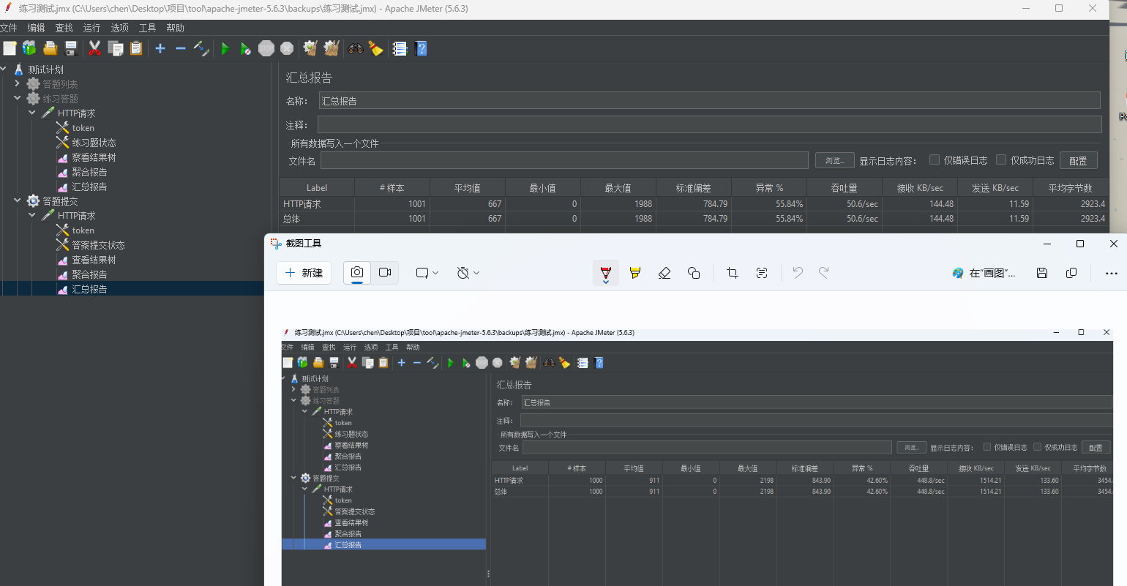

4.6 AI服务
功能：AI问答、智能辅导、学习计划路线推荐
技术：Spring Boot、MyBatis、RabbitMQ、扣子
数据库：MySQL

4.1.1 关键代码
此项目暂时没有优化，只是调用第三方扣子生成AI问答，评估，智能辅导等，使用了消息队列来实现的各个接口，详细请到源码查看

4.7 可视化图表服务（在练习服务有写到）

功能：AI可视化
技术：Spring Boot、MyBatis、RabbitMQ、扣子
数据库：MySQL

4.1.1 关键代码
此项目暂时没有优化，只是调用第三方扣子，实现了可视化图表，使用了消息队列来实现的各个接口，详细请到源码查看

4.8 支付服务

4.8.0 支付服务架构图
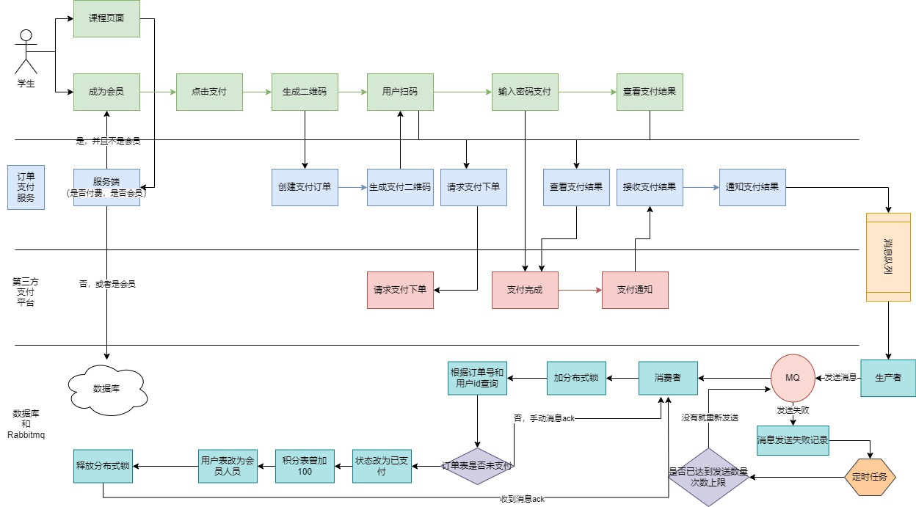
功能：成为会员，使用支付宝支付
技术：Spring Boot、MyBatis、RabbitMQ
数据库：MySQL、Redis

4.1.1 关键代码

5. 服务间通信

5.1 服务注册与发现
- Nacos 用于服务注册和配置管理。
- 使用FeignClient进行服务之间的通信。
- 使用OKHttpClient进行发送请求到扣子。

5.2 消息通信
RabbitMQ 用于异步消息处理，数据处理、可视化视图等。

5.3 数据缓存
Redis 和 Caffeine 缓存用于减少数据库访问，提高响应速度。

6. 测试
本项目只用了PostMan和部分使用单元测试Junit4，以下是使用Postman的测试截图

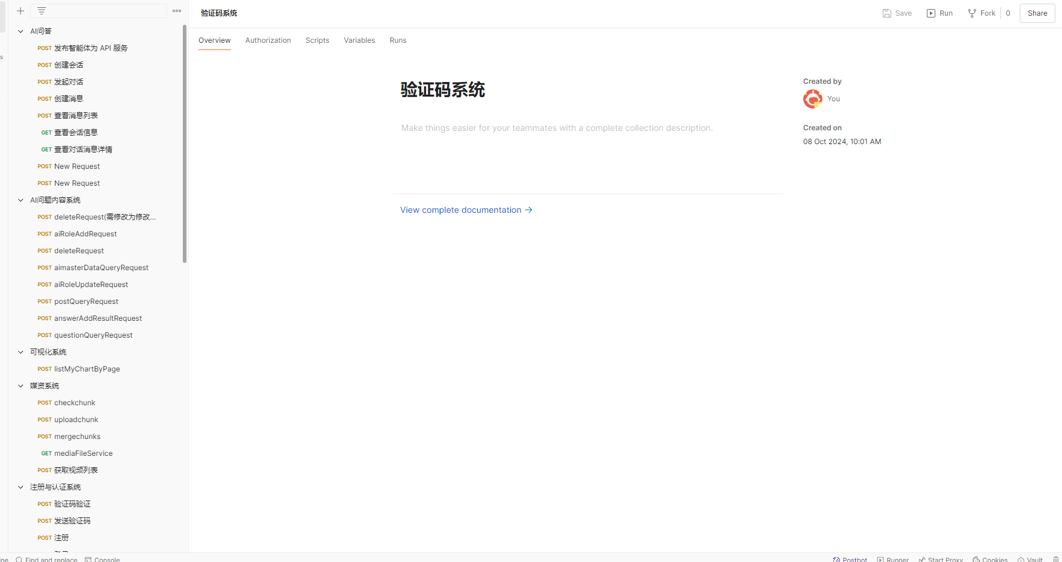

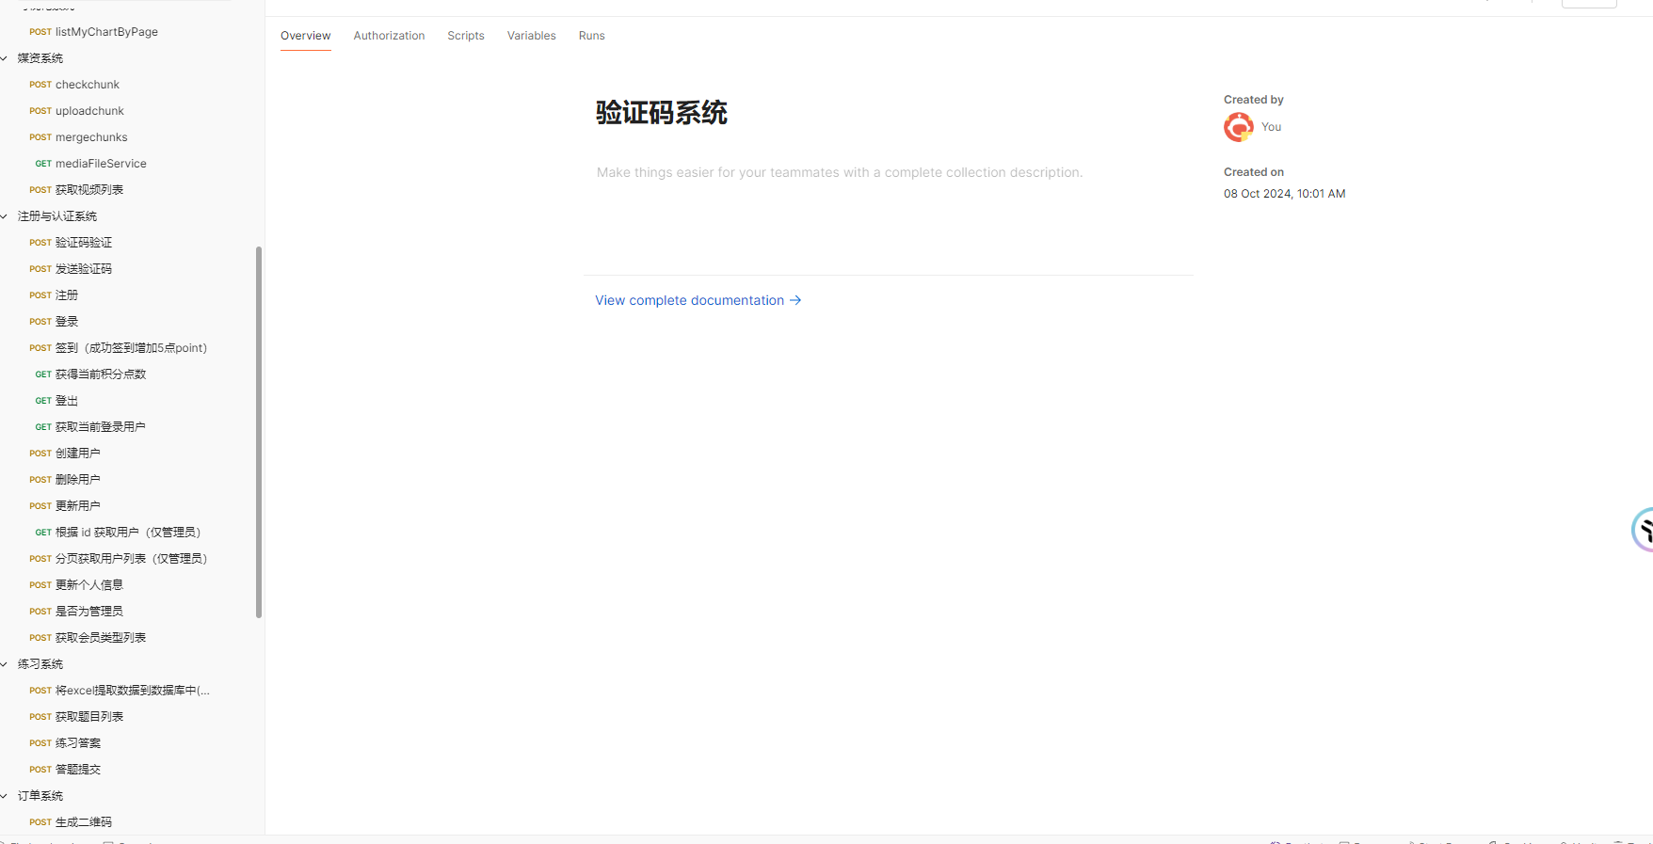
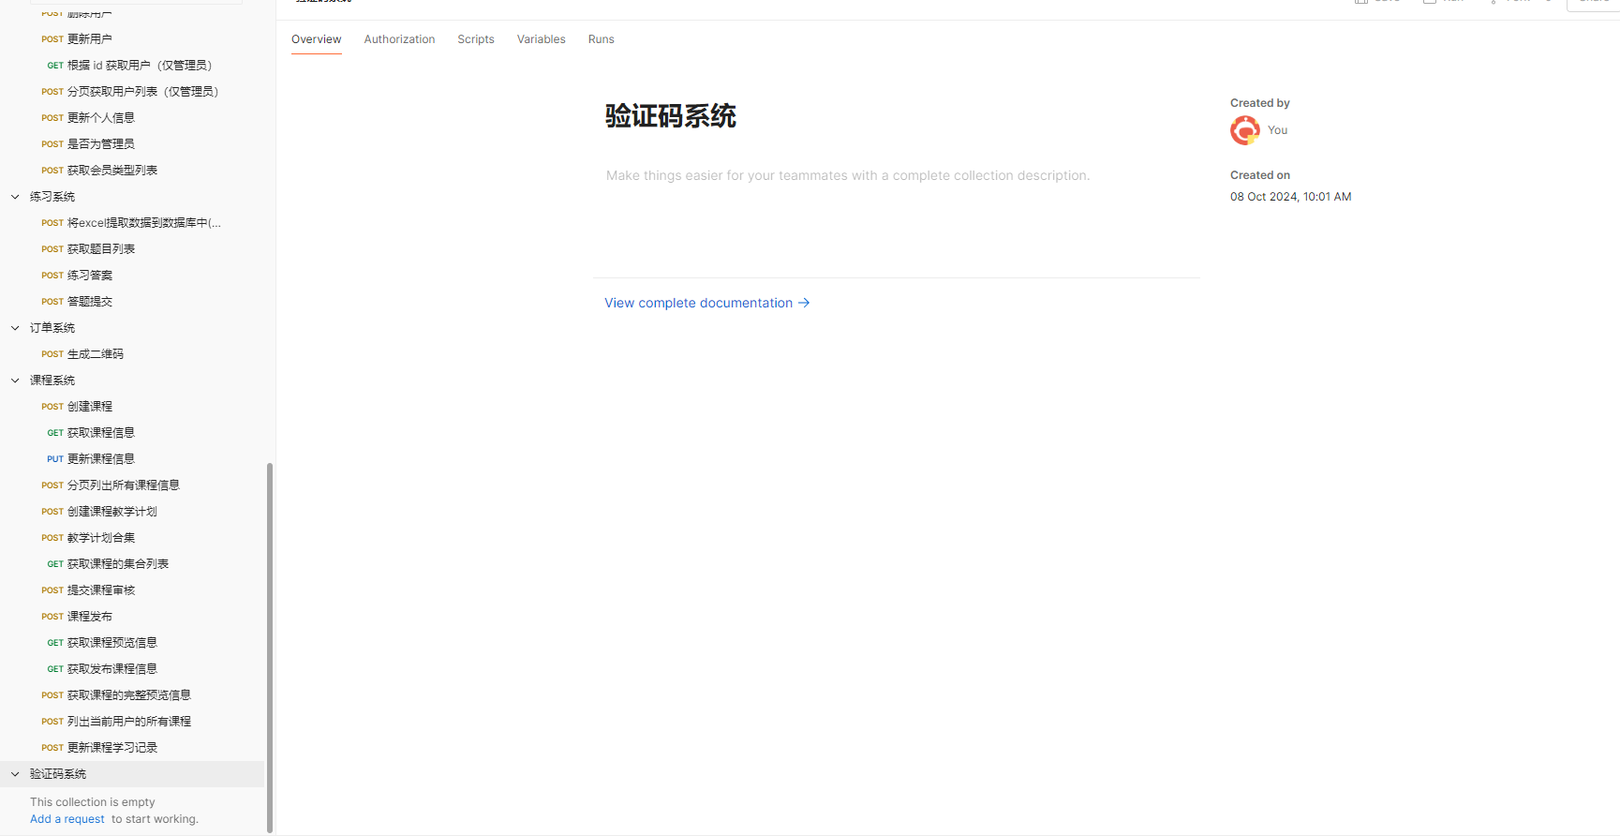

7. 性能优化
- 使用Spring Cloud 微服务
- 使用了Redis缓存和本地缓存对多模块进行优化性能
- 在在线练习模块使用异步多线程进行性能优化
- 使用MySQL索引进行优化性能

运维

8.1 搭建Docker（安装中间件）
此内容在Docker（集成）pdf文件下。

