
Copilot
SONARQUBE REPORT RESOLVING AND CODE COMMIT
USER GUIDE

Prepared by:
HO IT&HI CP14 Team
Version 1.0
Last updated: 23 JULY 2025

Amendment History

Version No. | Amendment Date | Prepared by | Change Log
1.0.0 | 23/07/2025 | Brian Law | Initial draft

Contents
Overview 4
Key Benefits 4
Prerequisites 4
IDE and Copilot Proxy Setup 4
Visual Studio Code 4
GitHub Copilot Chat Agent Mode 4
LLM Model Suggestion 5
NPM Installation 5
Setup SonarQube MCP Server Instructions 6
Install SonarQube MCP SERVER 6
Generate the SonarQube API Token 6
Setup SonarQube MCP in VS Code 7
Setup GitHub MCP Server Instructions 8
Install GitHub MCP SERVER (Windows User) 8
Generate the GitHub PAT Token 8
Setup GitHub MCP in VS Code 10
Setup and Implement Instructions 11
Step 1: Create Instructions Directory 11
Step 2: Configure Copilot Instructions 11
Step 3: Initialize and Implement in Copilot Chat 11
SonarQube Report Resolving And Code Commit Prompt 12
Instructions for Copilot 12
Remarks 15
Conclusion 16

Overview
This document provides comprehensive guidance for integrating SonarQube MCP and GitHub MCP to establish AI-driven code quality management and automated pull request workflows.
By leveraging the Model Context Protocol (MCP), development teams can seamlessly connect SonarQube’s static code analysis with GitHub’s repository and CI/CD capabilities
The system monitors SonarQube Quality Gate status, identifies failing conditions, and employs AI agents to automatically generate targeted fixes and submit pull requests, thereby streamlining the remediation process and accelerating delivery cycles.

Key Benefits
- Automated Code Remediation
AI agents analyze failed Quality Gate conditions and generate targeted code fixes, significantly reducing manual effort while improving consistency across the codebase.
- Continuous Quality Enforcement
Quality Gates function as real-time checkpoints, ensuring that only clean, secure, and maintainable code is merged into production environments.
- Improved Developer Productivity
By automating repetitive tasks such as code review, issue triage, and pull request submission, development teams can deliver software faster with fewer errors.

Prerequisites

IDE and Copilot Proxy Setup
- IDE Setup - Visual Studio Code
- IDE Setup - IntelliJ IDEA

Visual Studio Code
- Version 1.99 or above required
- Latest version recommended for optimal performance

GitHub Copilot Chat Agent Mode
- Ensure Agent Mode is enabled for code editing
- If unavailable, enable by setting `chat.agent.enabled` in VS Code settings (Ctrl + ,)
- Start a new Copilot Chat session before running unit test generation

LLM Model Suggestion
- Use GPT-4.1 or other latest model for optimal results

NPM Installation
- SonarQube MCP requires NPM, If not installed yet, please download and install NPM from https://nodejs.org/en/download/

Setup SonarQube MCP Server Instructions

Install SonarQube MCP SERVER
- Download the ha-sonarqube-mcp-server from HA Artifactory
https://artifactrepo.server.ha.org.hk:55743/artifactory/int-npm-dev-cms/%40ha/ha-sonarqube-mcp-server-1.3.2.tgz
- Install the ha-sonarqube-mcp-server on your instance:
npm install -g ha-sonarqube-mcp-server-1.3.2.tgz

Generate the SonarQube API Token
- Log in to the HA SonarQube Server
- Navigate to My Account settings
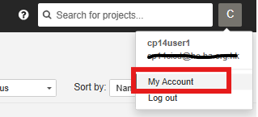
- Select the Security tab and generate a User token
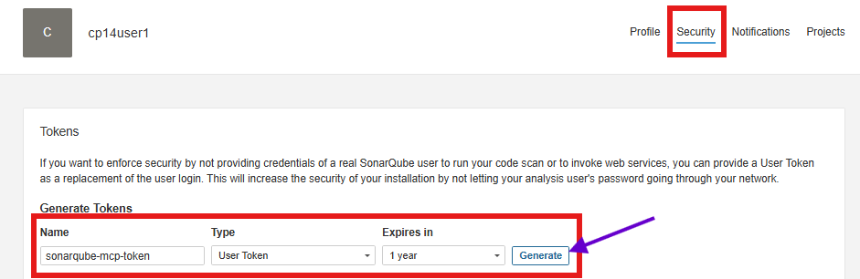
- Copy the generated token for use in the VS Code SonarQube MCP setup
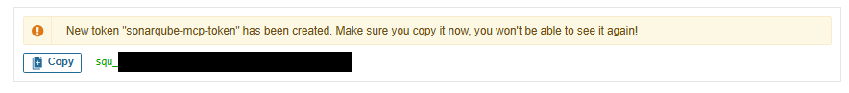

Setup SonarQube MCP in VS Code
- Open the VS Code MCP settings.json file (Ctrl + ,)
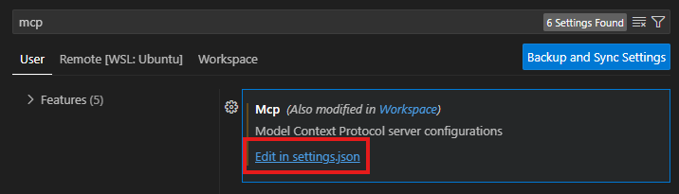
- Insert the following configuration to establish the SonarQube MCP server connection
- Upon successful configuration, you should observe the SonarQube server starting and displaying the number of available tools
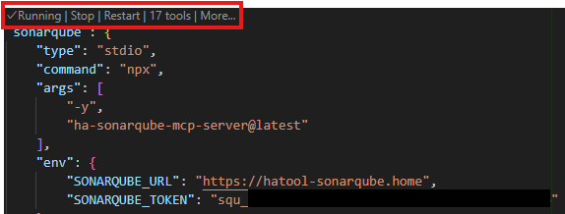

Setup GitHub MCP Server Instructions

Install GitHub MCP SERVER (Windows User)
- Visit the official release page: https://github.com/github/github-mcp-server/releases
- Download the file: github-mcp-server_Windows_x86_64.zip
- Extract the downloaded .zip archive to your preferred installation directory
  - Ensure the folder is accessible and does not require administrative permissions for execution
- Add the GitHub MCP server path to your system’s environment variable:
  - Open System Properties → Environment Variables
  - Under System Variables, locate and select Path, then click Edit
  - Add the full path of the GitHub MCP server executable (e.g., C:\tools\github-mcp-server\bin)
- Click OK to save changes and close all dialogs
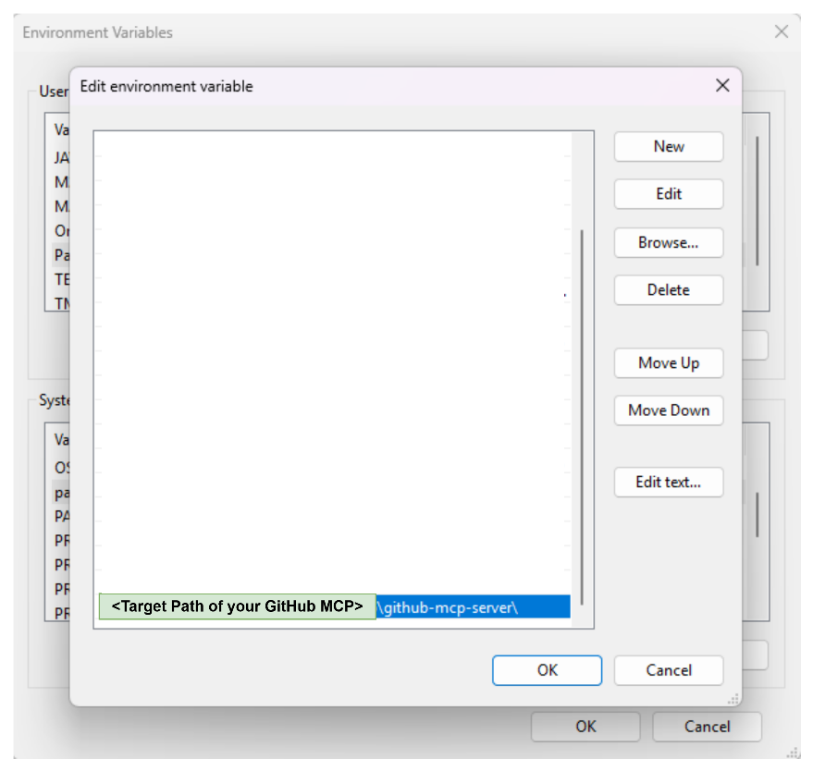
- Once the GitHub MCP server has been successfully added to your system’s environment path:
  - Launch Windows PowerShell
  - Execute the command github-mcp-server –version
  - If configured correctly, PowerShell should recognize the command and return the current version of the GitHub MCP server

Generate the GitHub PAT Token
- Log in to HA GitHub
- Click your profile to access Settings and Developer settings
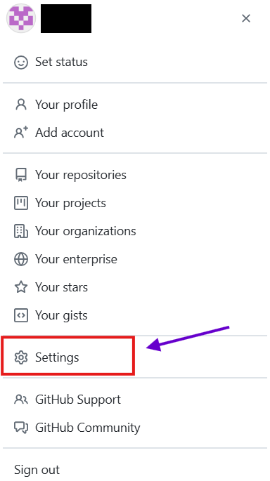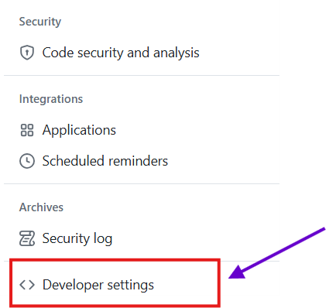
- Select Tokens(classic) to Generate new token (classic)
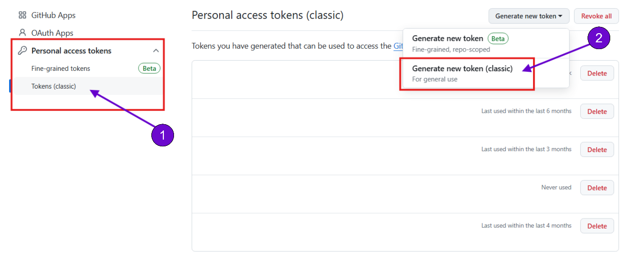

- Select the corresponding scopes to create the personal access token
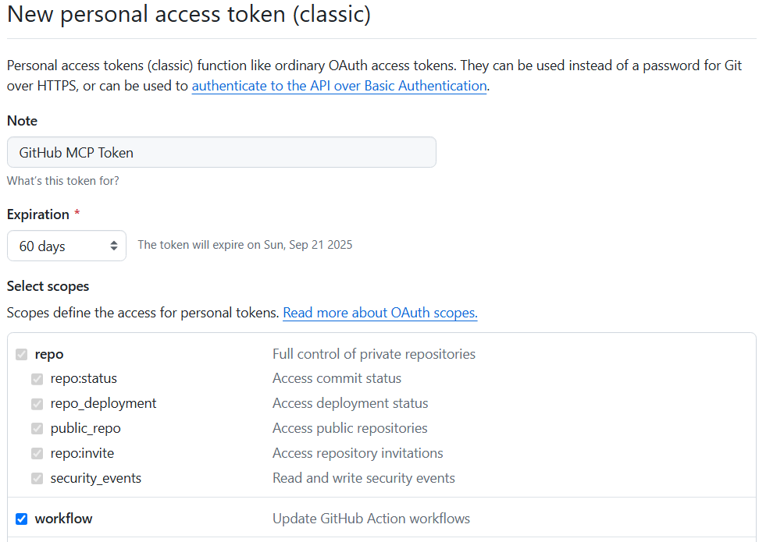
- Copy the generated token for use in the VS Code GitHub MCP setup
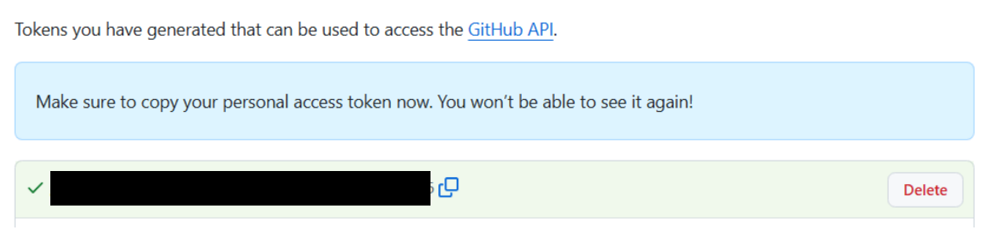

Setup GitHub MCP in VS Code
- Open VS Code MCP settings.json file (Ctrl + ,)

- Insert the following configuration to establish the GitHub MCP server connection
- Upon successful configuration, you should observe the GitHub MCP server starting and displaying the number of available tools
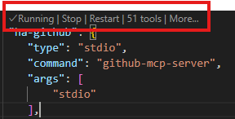

Setup and Implement Instructions

Step 1: Create Instructions Directory
- Navigate to your project root directory
- Create the folder `.github/instructions` if it does not exist. This folder will house your Copilot instructions

Step 2: Configure Copilot Instructions
Cerate a new markdown file in `.github/instructions` with the sonarqube-report-resolving prompt provided at below
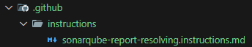

Step 3: Initialize and Implement in Copilot Chat
- Start a new Chat in Copilot
- Ensure Agent Mode is active
- Click Configure Tools to verify that if the required MCPs enabled
- Import the instruction file to Copilot (Click `Add Context` -> Click `Instructions` -> Click the instruction file you created). After import, you should see your instruction included in Copilot Chat
- Press `Enter` to run the prompt
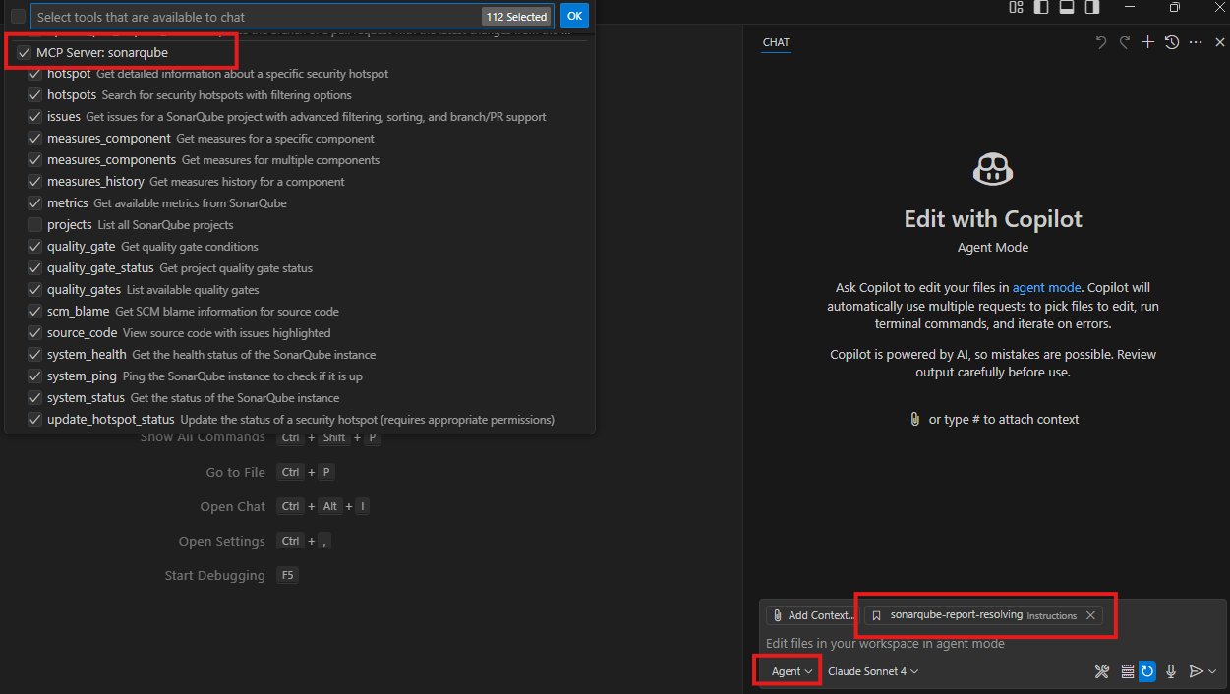
Note: Some commands suggested by Copilot may require manual confirmation by clicking `Continue` for execution.

SonarQube Report Resolving And Code Commit Prompt

Instructions for Copilot
Step1: Save the following markdown file into your `.github/instructions` folder
Step2: Configure the SonarQube project name and Pull Request (PR) target branch within the markdown file
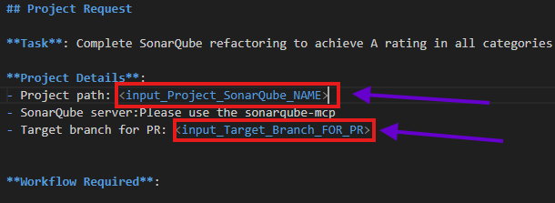

Prompt Breakdown and Explanation

Section 1: Define Task Mission
## Project Request

**Task**: Complete SonarQube refactoring to achieve A rating in all categories (Reliability, Security, Maintainability)

**Project Details**:
- Project path: <SonarQube_Project_Name>
- SonarQube server:Please use the sonarqube-mcp
- Target branch for PR: <Target Branch Would like to Merge For PR>
Purpose: Establishes the AI’s objective and working context
- Task Objective: Perform refactoring to achieve SonarQube “A” rating across all metrics
- Service Scope: Focus exclusively on the <SonarQube_Project_Name> microservice
- SonarQube Source: Obtain standardized scan results via sonarqube-mcp server
- GitHub Flow: Submit final code to the <Target Branch Would like to Merge For PR> branch

Section 2: Define Issues to Resolve from the SonarQube Report
**Workflow Required**:

1. **Analysis & Issue Identification**
- Run SonarQube current measures analysis to identify current issues
- Query quality gate status and categorize issues by type:
- Critical/Blocker bugs (Reliability)
- Vulnerabilities and Security Hotspots (Security)
- Code Smells (Maintainability)

2. **Fix Issues Systematically**
- **Blocker Issues**: Fix immediately - these prevent deployment
- **Critical Issues**: High priority fixes - major bugs and security vulnerabilities
- **Major Issues**: Important fixes - code smells, maintainability issues
Purpose: Guides the ai through issue discovery and triage
- Scan & Categorize: Analyze SonarQube output and prioritize issue types
- Fix Strategy: Apply resolution based on severity and impact
- Quality Gate Awareness: Ensure fixes align with organizational policies

Section 3: Define Code Standards
3. **Code Standards**
- Follow existing code style and conventions
- Ensure changes don't break functionality

4. **Testing & Validation**
- Run `mvn test` after each major change to ensure no regressions
- Verify all tests pass before proceeding
Purpose: Enforces style consistency and validates change stability
- Code Hygiene: Respect codebase formatting and logic integrity
- Regression Safety: Prove non-breakage via automated tests
- Testing Discipline: Make mvn test mandatory after each major change

Section 4: Define Submission Method After Fix
5. **Git Operations**
- Create new branch: `sonarqube-fix/refactor_` with datetimestamp at the end
- Commit changes with descriptive messages
- Push branch to remote
- Create Pull Request to target branch with comprehensive description

6. **Final Verification**
- Update PR with final summary
Purpose: Establishes a structured and auditable workflow for code delivery
- Branching Convention: Ensure reproducible and timestamped work logs
- Commit Discipline: Use meaningful messages for future traceability
- PR Review Process: Finalize with clear summaries and checks

Section 5: Define Success and Stop Requirements for the Task
# Testing
mvn test and mvn compile

**Success Criteria**:
- ✅ All tests passing
- ✅ Pull Request created with detailed description
- ✅ Please confirm both mvn test and mvn compile is success after code change, if fail,please fix it before commit to github
Purpose: Defines metrics for successful execution and delivery
- Test Pass Requirement: mvn test must be successful
- Compile Check: Code must build without failure
- Completion Checklist: Validates all operational steps before PR

Section 6: Define Mandatory Actions for the AI Agent
**Important Notes**:
- Always run tests after significant changes
- Use proper exception handling and resource management
- Follow the existing project's coding standards
- Document all changes in commit messages and PR description
Purpose: Communicates mandatory operating rules
- Validation Practices: Mandatory testing and exception management
- Style Enforcement: Consistent formatting and structure
- Traceability: Require documentation at every change checkpoint

Remarks
Below are some cases you may encounter during unit test generation.

1. Copilot iterate
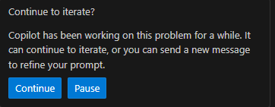
Solution: Click `Continue` to proceed with iterate

Conclusion
This guide presents a robust and scalable methodology for enhancing SonarQube code quality ratings through the strategic implementation of GitHub Copilot Chat with SonarQube MCP.

By adhering to the outlined framework, development teams can achieve meaningful improvements in code reliability, security, and maintainability while preserving the governance and precision required for enterprise-grade software delivery. The workflow emphasizes structured issue triage, consistent Git operations, and thorough pull request documentation, fostering clarity, accountability, and long-term codebase health.

This disciplined approach not only minimizes technical debt but also accelerates delivery velocity and enables teams to adapt seamlessly to dynamic project demands. For continued support or deeper integration guidance, refer to the MCP or SonarQube documentation, or consult platform engineering and support channels.

