**CHAPTER ONE**

**1.1 INTRODUCTION**

Plantain belongs to the genus *Musa* of the family *Musaceae*. Plantain (*Musa paradisiaca L*.) is a tropical fruit that constitute a staple food crop in Central and West Africa. Plantain is a green to yellow boat- shaped fruit (shade of colour depends on stage of ripening) of a large shrub called Musa paradisiaca. It is a close relative of banana, but it is bigger, longer and has thicker skin and often needs to be cooked before eaten. It is sometimes called plantain banana, excellent for weight control, slow energy release and good for diabetics (unripe plantain), with surpassing nutritional value. Plantain is grown in 52 countries of the world with production capacity of 33 million metric tons per annum. It is a major starchy staple in the sub-Saharan Africa providing more than 25% of the carbohydrates and 10% of the daily calorie intake for more than 70 million people in the continent.

Data from FAO sources put the world production of plantain at about 60 million tons. However, in West Africa, plantain production increased at an average annual rate of between 2.3- 2.6% (FAO, 2004). Higher production figures for plantain have been attributed to the cheaper and easier methods of growing once the plant has established vegetative cover. Plantain is often grown alongside other crop plants with similar requirements. In Nigeria annual production is estimated at 2.11 million metric tons thus making Nigeria the world’s largest producer and consumer of plantain (10.5 million tones per annum). This accounts for approximately 10% of total global production. In Nigeria and other parts of Africa, plantain (*Musa paradisiaca*) serves as a major staple food and is particularly desired for the variability in its stages of ripeness and cooking methods. In Ghana, plantain is ranked fourth in the agricultural sector and constitutes about 13% of her agricultural gross domestic product with national production of 2.00 million tones.

Plantain can be unripe (green), half ripe (yellow green) or ripe (yellow) and can be consumed boiled, roasted, grilled or fried; the ripe plantain can be eaten fresh. Unripe plantain is low in sugar and usually consumed by Nigerian diabetic patients to reduce post pyramidal glucose level. Plantain is employed in the management of diseases such as ulcer, wound healing and have anti-ulcerogenic, antimicrobial, anti-urolithiatic and analgesic properties. Plantain has diversity of minerals like calcium, iron and iodine, but notably high in potassium and low in sodium. This makes it suitable for the control of blood pressure and muscle cramp. Baiyeri *et al* (2011) observed significantly high levels of Nitrogen, Phosphorus, Potassium, Magnesium, and Calcium in fully ripe plantain pulp, but low levels of Fe, Cu, Zn, and Na. Plantains are good source of vitamins A, B1, B2, B3, B6 and C, thus, it is often recommended for people who are intolerant to salt. Various literatures have varying chemical compositions of plantains which are associated with the level of maturity, degree of ripeness, soil type, variety and climate (Zakpaa *et al*, 2010).

There is literature documentation on high consumption pattern of unripe plantain as a source of energy among people suffering from diabetes mellitus. This is because starch is the main component of unripe plantain compared to ripe that has more sugar. Plantain contains a high fibre content, and thus is capable of lowering cholesterol and helps to relieve constipation and hence prevention of colon cancer. Ajasis *et al* (2014) observed that both ripe and unripe plantain have some nutritional values as it contains about 3.80% and 3.24% crude protein respectively. Therefore, this study aimed at providing comparative data on nutritional values of ripe and unripe plantains and their benefits in human diet.

**1.2 AIM AND OBJECTIVES**

**1.2.1 Aim**

The main of this research work is to examine the preparation and analysis of soap from plantain.

**1.2.2 Objectives**

The following are the objectives of this research work;

i. To understand the process and analysis of soap production from plantain.

ii. To understand the properties of soap production from plantain

**1.3 SCOPE AND DELIMITATIONS OF THE STUDY**

**1.3.1 Scope of the Study**

This research work is conducted within Birnin Kebbi metropolis, Kebbi State

**1.3.2 Delimitation of the Study**

This research work is limited due to the following factors:

i. **Lack of Sufficient Funds**: This research is limited because the researcher has no sufficient funds to carry out the research efficiently and effectively due to high cost of some materials and reagents to be used in carrying out the research.

ii. **Time**: This is research is limited because the researcher did not have enough time to carrying out this research work

iii. **Unavailability of Materials**: The researcher did not have enough materials to make proper findings and to have accurate results because most of the materials are either been sold or unavailable to researcher

**1.4 SIGNIFICANCE OF THE STUDY**

This research work will be a profitable material and serve as a guide to the other researchers or students who have similar or relevant topics and also it will enlighten many individuals on the benefits and advantages of plantain to mankind.

**CHAPTER TWO:**

**LITERATURE REVIEW**

**2.1 INTRODUCTION**

Plantain (*Musa paradisiaca L.)* is one of the most important food crops widely produced and consumed in sub-Saharan Africa. In Cameroon, where production is about 3 million tons per year, plantain occupies a predominant place in households and plays an important role in the food security of the population. In this respect, the consumption of plantain has been estimated at 150 kg/capita/year in Cameroon. Regarding the nutrient content, it has been reported that 100 g of plantain contain about 35.5 g of carbohydrates, 1.3 g of protein, 0.3 g of fat and 5.8 g of fiber and provide 122 kcal. In addition, mature plantain contains many bioactive molecules, including carotenoids (4680 μg/100 g), vitamin C (11.7 mg/100 g), minerals, and phenolic compounds. Thus, its regular consumption may be an effective way to fight against oxidative stress, which may be the cause of many chronic diseases, such as some cancers, diabetes, cardiovascular diseases, renal, neurological and chronic respiratory diseases. Despite this nutritional importance and the bioactive potential of plantain, its use is limited by post-harvest losses of more than 20 to 40% in Cameroon. Indeed, after harvesting, ripe green fruits undergo rapid ripening resulting in the appearance of black spots on the surface of their skin 10 to 12 days later. (Assemand *et al*, 2012)

Beyond this stage of ripening, it loses its technological properties and even its market value. There is no real method of preservation or transformation into finished or semi-finished products that would allow long-term storage of plantain. In rural areas, plantain pulp is often dried in the sun and consumed as a delicacy, but there is no provision for long-term storage of this product. This dried pulp, very rich in sugars, rehydrates quickly if not packaged and the development of yeasts and molds leads to rotting which makes it unfit for consumption. Studies for the transformation of plantain into improved traditional products are underway and will eventually lead to the development of stabilized flours. Studies have made it possible to partially substitute wheat flour with non-bread flours (rice, cassava, legumes, etc.) to make cakes. These different studies have shown that it is possible to substitute wheat flour up to 50%, with other products, to obtain cakes with similar characteristics to those prepared with 100% wheat flour. Plantain cakes exist, but are not well known. Some work has shown that bread and cookies can be made by substituting wheat flour with plantain flour. Formulations using between 20 and 40% plantain flour for bread and cookies, respectively, yielded acceptable products. (Agri-stat, 2017).

**2.2 BIOLOGY AND ECOLOGY OF PLANTAIN**

Plantain is native to Southeast Asia, where it is found from India to Polynesia and its center of diversification seems to be Malaysia or Indonesia. It spread to West Africa at least 2500 years ago. For thousands of years, human migrations and exchange of plant material have introduced banana in very different ecological situations on all continents. Banana plants belong to the order *Scitaminales*, or *Zingiberales*, and to the family Musaceae. They are monocotyledons with floral parts in threes or multiples of three, asymmetrical zygomorphic with secondary venation of the parallel blades with an absence of secondary vascular formation in the stem and roots. The family Musaceae has three genera, namely: Musella, which is very little represented and localized in Asia, Ensete, which has no parthenocarpic species, and Musa, which has a high variability and is characterized by inflorescences with bracts inserted separately from the flowers, unlike the genus Ensete. (Favier, 2013).

**2.2.1. Description of the Plantain**

Plantain (*Musa paradisiaca L*.) is a tropical herbaceous perennial monocot plant. The underground part of the banana plant is composed of a bulb or true stem, provided with numerous adventitious roots which appear successively during its development. The terminal meristem of the stem produces a series of 20 to 30 leaves of increasing size every 6 to 15 days according to the conditions of temperature, hydrometry and insolation. The number of leaves thus varies according to the cultivar and environmental conditions. Plantain is a berry containing seeds with a reduced pulp. The cycle length is about 10 to 18 months depending on ecological conditions and cultivars. The description of the banana plant, in general, has been made by several authors. (Kwa and Temple, 2017). The following Figure 2 illustrates the botanical description of banana.

**2.3 PLANTAIN PRODUCTION**

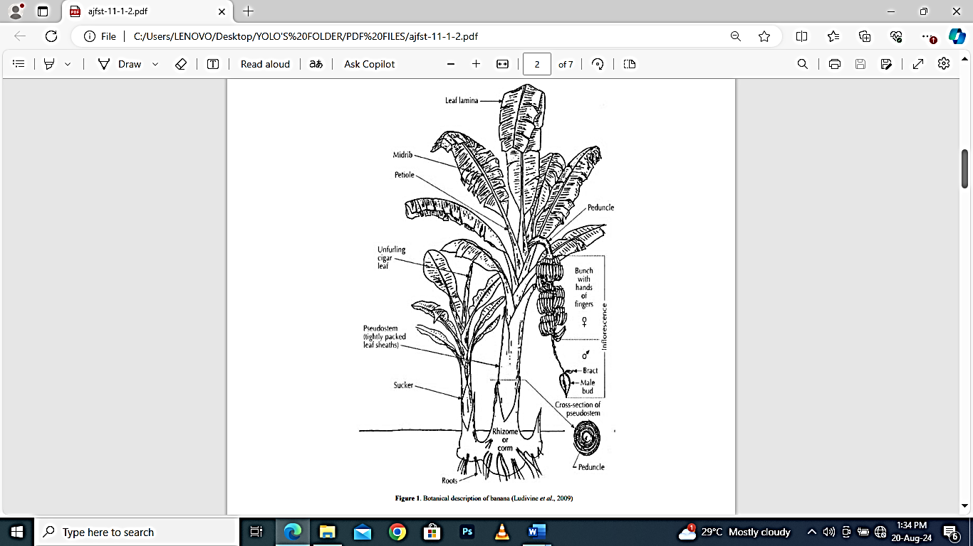

**2.3.1 Edaphic Factors**

The cultivation of plantain requires a pH that varies between 5.5 and 6.5. A good texture and structure that is to say a good balance between clay, silt, sand, organic matter and structure that must be lumpy and of good porosity. This is why forest soils are favorable for banana cultivation. The defects for the culture are the lack of manure, the bad drainage, the compactness of the soil. However, soils with a hardened or gravelly horizon and a too shallow water table are unsuitable for banana cultivation. (Yerima *et al*, 2014).

**2.3.2 Nutrient Requirements**

Plantain requires large amounts of nitrogen, potassium, phosphorus, calcium and magnesium. In addition to the ecological and environmental problems that it causes, mineral fertilization alone does not make it possible to maintain soil fertility. Its exclusive use leads to an increase in acidity, a degradation of the physical status and a decrease in soil organic matter. In addition, their production and transport contribute to the emission of greenhouse gases. In such a context, organic fertilization could be an appropriate solution for restoring soil fertility and improving plantain productivity. Organic farming practices aim to increase biodiversity and biological activity of soils. In this way, they help to achieve optimal natural systems that are socially, ecologically and economically sustainable. Numerous studies have shown that plant residues and organic manures such as chicken droppings, which are byproducts of animal husbandry, contribute to plant growth through their beneficial effects on the physical, chemical and biological properties of soils. The periodic replenishment of soil reserves in these elements to maintain good crop productivity is thus essential. Given its availability in urban areas, dried and ground plantain peel, used alone or mixed with chicken manure compost, could be an alternative to the use of mineral fertilizers. (Kader, 2013).

**2.3.3 Harvesting, Storage and Preservation**

Fruit ripening is characterized by a set of biochemical and physiological changes leading to the state of ripeness and giving the fruit its organoleptic characteristics. Under normal conditions of ambient temperature (30°C), plantain ripens between 5 and 9 days after harvest, if physiological maturity is reached. This time interval is reduced by faulty storage and lack of care during various post-harvest handling (transport, market display, etc.). There is no real preservation method for long-term storage of plantain. Even in periods of high production, plantain bunches do not wait more than 3 to 4 days before being marketed. Losses therefore occur at the production site, due to the lack of preservation or evacuation of the products to the marketing centers. The use of poplantainthylene bags is a simple way to achieve controlled atmospheres. Studies on the effect of poplantainthylene packaging on the preservation of plantain at 4°C, 12°C and 25°C, have been able to maintain green plantain for 20 days between 12 and 25°C; but preservation beyond this time is detrimental to the quality of the fruit. The use of poplantainthylene bags can create a CO2-rich, O2-poor microenvironment in the storage medium that delays ripening. Poplantainthylene bags of 100 µm thickness can preserve plantain at room temperature after treatment with gibberellic acid or imazalil sulfate. Plantain is a highly perishable fruit, with post-harvest losses of 30-40%. Methods to extend fruit shelf life include harvesting bunches a few days before they reach full maturity, storage at reduced temperatures (about 15°C), storage in a modified atmosphere of enriched CO2 at low O2 (3-4%), packaging in film bags to prevent weight loss, pretreatment with fungicides, and skin coating [51]. For cultivars sensitive to high levels of CO2, an alternative storage method is vacuum packing. (Folefack *et al*, 2017).

2.4 **NUTRITIONAL IMPORTANCE, MEDICAL AND THERAPEUTIC VALUE OF PLANTAIN**

**2.4.1 Nutritional Importance of Plantain**

Plantain is used as a cheap source of calories. It is one of the most important sources of food energy in West and Central Africa, where about 70 million people obtain more than 25% of their carbohydrates from plantains. Plantain is an “indigenous” product used in many culinary preparations. Consumption of this product is often linked to important events in the life of Cameroonian families: weddings, funerals, reunions and festivals. In some cases, the presence of a specific plantain dish is even mandatory. Plantain is an energy food that provides 120 kcal or 497 kJ per 100 g of fresh material, contributing about 70% of the food energy supply provided by plantains and cooking bananas in the world. Plantain is consumed in several forms: boiled, grilled, fried, kneaded, sautéed, braised and mashed. The plantain is consumed raw but very often cooked. It is ubiquitous in African cuisine in its natural state, roasted, stewed, mashed, crisped, or even in the form of beer. In Cameroon, the plantain is one of the most consumed starchy foods. It is a basic product of income and self-consumption, which often accompanies meat and fish for which it serves as a complement. In addition, it is known as a snack product, together with rice, because of the speed with which it is cooked compared to other starchy foods. (Akubor *et al*, 2013).

**2.4.2 Medical and Therapeutic Value**

Eating a banana can help digestion because of its high vitamin A content. Gastro-intestinal disorders like diarrhea and vomiting can be treated with plantain. Studies conducted suggest that plantain diet is good for diabetic patients, those with gallbladder disease and colon cancer. Its sodium level is low and therefore it is recommended in the formulation of low sodium diet. In the green stage, the liquefied fruit is used in Brazil to treat dehydration in infants, as its tannins tend to protect the lining of the intestinal tract from further fluid loss. In general, plantains are suitable for consumption when a low-fat, low-sodium, and/or cholesterol-free diet is required, making plantains particularly recommended for people with cardiovascular or kidney problems, arthritis, gout, or gastrointestinal ulcers. Bananas and plantains contain complex carbohydrates capable of replacing glycogen as well as important vitamins (especially B6 and C) and minerals (potassium, calcium, magnesium, iron). Some varieties are very rich in provitamin A. Ripe fruits have been used to treat asthma and bronchitis. Boiled and crushed ripe fruits (especially mixed with other plant substances) are cited as a good remedy for constipation. These many purported remedies are not well documented and would require further investigation. Banana pseudotrunc is cooked in India as a khich khach dish, taken monthly to prevent constipation. The juice extracted from the male bud is considered good for the stomach. The fresh leaves have been used medicinally for a range of ailments from headaches to urinary tract infections, and the stem juice was considered a remedy for gonorrhea. The peel of ripe bananas has antiseptic properties and can be used to prepare a poultice for wounds or applied directly in an emergency. (Ngoh, *et al*, 2018).

**2.5 FOOD PRODUCTS DERIVED FROM PLANTAIN**

Some people cannot tolerate gluten from wheat and other grains such as oats, rye and barley because it causes celiac disease. It severely impairs intestinal absorption and can lead to severe malnutrition. Therefore, research efforts in tropical countries are currently aimed at identifying non-wheat sources that could be used as an alternative to wheat flours, thus affecting the foreign exchange economy by limiting wheat imports. These non-wheat flours are obtained from other cereals, legumes, tubers and roots, for example maize, rice, soybean, sorghum, cassava, sweet potato, potato and plantain. Plantain processing creates significant added value for stakeholders. However, the agro-industrial development of plantain processing is embryonic. (Fongang *et al*, 2016).

The main processing products currently known are: chips, baby food, cossettes, flours from green pulp (unsweetened flour) and ripe pulp (sweetened flour), standardized fries, braised ripe plantain, dried ripe pulp, frozen pulp. They also involve small and medium-sized artisanal enterprises specializing in reconstituted products for local dishes (ntouba, foutou, etc.), pancakes made from plantain flour, the manufacture of bread, cakes, doughnuts and various bakery products entirely or partially formulated from plantain flour. Among these processed products, the products most encountered on Cameroonian markets remain chips, braised plantains and sold in the streets of large urban areas. However, plantain is gradually finding applications in the formulation of weaning foods and compound meal preparations. Banana beer is reserved for celebrations and other events marking social life. Fermented banana drinks, usually called banana wines, can also be prepared. Fermentation takes place in the open air and lasts about 3 days. Cakes, breads and cookies are made using 100% plantain flour have yielded acceptable products. Plantain fritters are also obtained from the pulp of ripe plantains pounded and mixed with a small amount of wheat or other local cereal flour (about 1/4 of the weight of the dough) and salted to form a homogeneous paste. Pancakes made from 100% plantain flour and jam made from a plantain hybrid, spaghetti have been popular with consumers. (Ngoh *et al*, 2020).

**CHAPTER THREE**

**3.0 MATERIALS AND METHODS**

**3.1 Reagents**

**Table 3.1 Reagents**

|  |  |  |  |
| --- | --- | --- | --- |
| **S/N** | **Reagents** | **Company Name** | **Purity Specification** |
|  | Potassium Iodide |  |  |
|  | Starch Solution |  |  |
|  | Hydrochloric Acid |  |  |
|  | Iodine |  |  |
|  | Hexane |  |  |
|  | Ethanol |  |  |
|  | Potassium Hydroxide (KOH) |  |  |
|  | Vitamin A Standard |  |  |

**3.2 Equipments**

**Table 3.2 Equipments**

|  |  |  |  |
| --- | --- | --- | --- |
| **S/N** | **Equipments** | **Company Name** | **Purity Specification** |
|  | Retort Stand |  |  |
|  | Burrette |  |  |
|  | 20ml Pipette |  |  |
|  | 100ml Volumetric Flask |  |  |
|  | 10ml and 100ml Measuring Cylinder |  |  |
|  | 250ml conical Flask |  |  |
|  | Vortex Mixer |  |  |
|  | Rotary Evaporator |  |  |
|  | Separating Funnel |  |  |

**3.3 Preparation of Reagents**

**3.3.1 Sample Collection**

The sample (ripe and unripe plantain) was collected from the Birnin Kebbi Central Market, Kebbi State.

**3.3.2 Sample Preparation**

After which the sample (ripe and unripe plantain) has been purchased from the market, it was then dried at room temperature, after which it has dried up, it was then pounded into powdery form before taking out the major procedures.

**3.4 Procedure for Vitamin C**

According to AOAC (2015), alternatively, the 100g sample (ripe and unripe plantain) was blended in a food processor together with some distilled water. After blending, the pulp was strained through cheesecloth washing it with 10ml portion of distilled water and the solution of 100ml was extracted in a volumetric flask.

**3.4.1 Titration**

20ml of the sample solution was pipette into a 200ml conical flask and 150ml of distilled water was added then, 5ml of 0.6mol-1­­­­­ potassium iodide, 5ml of 1mol-1 hydrochloric acid and also 1ml of starch indicator solution was added.

The sample was then titrated with the 0.002mol/l-1 potassium iodide solution, the endpoint of the titration is the first permanent trace of a dark blue-black color due to the starch iodide complex. The titration was repeated with further all quarts of sample solution until concordant results are been obtained.

**3.4.2 Formula for Vitamin C Determination**

Vitamin C [mg] = $\left(A-B\right)×C × \frac{1000}{W}$

Where B = Volume of iodine solution use in blank ml

A = Volume of iodine solution added in titration (ml)

W = Weight of sample used

C = Concentration of KI solution in mol/l

**3.5 Procedure for Vitamin A**

**3.5.1 Extraction and Saponification**

According to National Institute of Health (2020), 1.5g sample was weighed into a centrifuge tube, 10ml of hexane and 20ml of ethanol was added, the it was mixed with vortex mixer for 1 minute, after which it was centrifuged at 3000rpm for 5 minutes, then the hexane layer was separated. After which 2ml of KOH (10% w/v) was added to the hexane layer, then vortex mix for 1 minute, then it was incubated at 600C for 30minutes.

**3.5.2 Extraction of Retinol**

10ml of hexane and 2ml of water was added, then vortex mix for 1 minute, then the hexane layer was separated.

**3.5.3 Titration**

1ml of starch solution (1% w/v) was added to the hexane layer, then it was titrated with iodine (0.01m) until blue colour persists, after which the volume of iodine used was recorded.

**3.5.3 Formula for Vitamin A Determination**

Vitamin A = $\left(ml\right)= \frac{V× N × F}{W × 1000}$

Where V = Volume of sodium thiosulphate used

N = Normality of sodium thiosulphate

F = Factor of Vitamin A

W = Weight of sample used

**CHAPTER FOUR**

**4.0 RESULT, DISCUSSION, CONCLUSION AND RECOMMENDATION**

**4.1 Result for Vitamin A and C**

|  |  |  |
| --- | --- | --- |
| **Sample** | **Vitamin A Concentration** | **Vitamin C Concentration** |
| Ripe Plantain | 2.501ml | 80mg |
| Unripe Plantain | 1.403ml | 50mg |

**4.2 Discussion**

In Nigeria and other parts of Africa and in many other places in the world, plantain (*Musa paradisiaca*) serves as a major staple food and is particularly desired for the variability in the stages of ripeness and in cooking methods. In this survey, the comparative study of unripe and ripe plantain was investigated. The phytochemical analysis showed the presence of alkaloids, tannins, saponoids, flevonoids and phenols. These compounds have various pharmacological and nutritional benefits. Although some of these bioactive agents occur in low quantities, saponin and phenols occur in appreciable quantities and were richer in the ripe than the unripe. The proximate composition showed ripe plantain is richer than the unripe. The ripe showed higher proximate values than the unripe. This could be as a result of the decrease in the starch contents as the plantain ripens; which is due to the conversion of starch to sugar that leads to increase in the sugar contents of the ripe plantain. Unripe plantain is very high in starch which makes it useful in industrial production of starch. The ripe plantain on the other hand, is very high in sugar content and because of this; ripe plantain is not recommended for diabetic patients. High moisture content in ripe plantain results in storage problems, thereby limiting its usage in food industry.

Plantain is also rich in minerals and vitamins. The mineral contents include calcium, potassium, magnesium, phosphorus, sodium and iron. The presence of these minerals will play vital roles in the formation of strong bones and teeth, muscle action, blood clotting, proper heart function, cell metabolism and general growth [37-38]. The vitamin contents include thiamine (B1), riboflavin (B2), niacin (B3), tocopherol (E) and carotene (vitamin precursor in plants). These vitamins, apart from helping in growth also play important roles in promoting resistance to diseases and delay in aging. B1, B2 and B3 are required for normal growth and heart function. The significant variations that existed in the phytochemicals, proximate, mineral and vitamin contents of the fruit following ripening suggest that nutritional qualities of plantain fruits vary with the stage of ripeness. Other factors that could influence variations in nutritional composition of plantain include variety, cultivar, maturity, climate and geographical condition of production, handling during and post-harvest, processing and storage, species genotype, growing conditions and the interaction between genotype and environmental characteristics. All these directly influence the composition of the fruit.

**4.3 Conclusion**

Plantain is a nutritious food that is commonly consumed in Africa and other tropical zones of the world. It is rich in phytochemicals, proximate, mineral and vitamin contents. It could be consumed ripe or unripe. However, the results from this work have shown that ripe plantain has more nutritional values than unripe. Ripening increases the sugar content and thus unfit for diabetics.

**4.4 Recommendations**

Based on my findings in this research work, this study recommends that

1. The government should organize seminars that will educate individuals on the effective and efficient use of plantain.
2. Other researchers that would want to indulge in this kind of research, should try as much as possible to look for other procedure and other raw materials that could enable kind of research more easier and efficient

**REFERENCES**

Adopo, N.A. (1991a). Commodity chain organization and postharvest losses of plantain. Fruits, 48: 125-132.

Agri-stat. (2017). National Institute of Statistics, Statistical Yearbook of Cameroon, 2017 edition.

Akesowan, A. (2009). Quality of reduced-fat chiffon cakes prepared with erythritol-sucralose as replacement for sugar. Pakistan Journal of Nutrition, 8 (9): 1383-1386.

Akubor, E. L., Ouattara, G., Tuo, S., Zeli, T. F. and Aké, S. (2013). Effect of plantain peel and chicken droppings compost mixture on nursery growth of plantain flake offsets, Big Ebanga variety. Journal of Applied Biosciences, 130: 13126-13137.

Aline, P. and Marcelo, M. (2014). Banana (Musa spp) from skin to pulp ethnopharmacology, source of bioactive compounds and its relevance to human health. Journal of Ethnopharmacology, 160: 149-163.

Aowad, M. and Mohamed, A. (2009). The effect of bio-organic and mineral fertilization on productivity of sunflower seed and oil yields, Kafr El Sheikh University, Journal of Agricultural Research, 35 (4): 1013-1027.

Assemand, K.R., Camara, B. and Dick, E. (2012). Evaluation of physicochemical changes characterizing ripening during storage of three banana varieties Musa spp. (AAB, Cv. Horn 1; AAA, Cv. Poyo and, AA, Cv. Sweet Fig). Science and Nature, 7: 155-163.

AOAC (2015) Official method of analysis Modified atmosphere storage of tropical fruits. In: post-harvest handling of tropical fruits. Proceedings International Conference, Chiang Mai, Thailand 36-20.

Bayeri, K.P. *et al* (2011). Variable light transmission through four poplantainthylene colours used for plantain Musa sp. AAB fruits storage as influencing its postharvest and culinary qualities. International Agrophysics, 19: 19-25

Bonet, A., Oliete, B., Rosell, C.M., Pando, V. and Fernandez, E. (2008). Study on cake quality made of wheat-chickpeas flour blends. Journal of Food Science and Technology, 41 (9): 1701-1709.

Chaiya, B. and Pongsawatmanit, R. (2011). Quality of batter and sponge cake prepared from wheat - tapioca flour blends. Kasetsart Journal of Social Sciences, 4: 305-313.

Daniells, J., Jenny, C., Karamura, D. and Tomekpe, K. (2001). Diversity in the genus Musa. INIBAP, Montpellier, France.

Dick, E and Yao, K.A. (1997). Effect of poplantainthylene packaging on the preservation of plantain stored at low temperature. African Agronomy, 9 (3): 163-169.

FAO, 2010. Plantain consumption in Cameroon. [35] Yerima, B.P.K., Tiamgne, A.Y and Van Ranst, E. (2014). Response of two sunflower (Helianthus sp.) varieties to chicken droppings fertilization on a Hapli-Humic Ferralsol at Yongka Western Highlands Research Garden Park (YWHRGP) NkwenBamenda. Cameroon, Central Africa. Tropicultura, 32: 168-176.

FAO. (2011). Food and Agriculture Organization of the United Nations: production product by country. Rome, Italy.

Favier, A. (2013). Oxidative stress: concept and experimental relevance for understanding disease mechanisms and therapeutic approaches. Chemical News, 8 (6): 108-115.

Folefack, B., Moango Manga, A. and Swennen, R. (2017). The cultivation of banana and plantain trees in the Democratic Republic of Congo. Support didactique, Saint Paul, Kinshasa: 85p.

Fongang, E.A., El-Beltagy, A.E. and Gaafar, A.M. (2016). Production and quality evaluation of low calorie cake. American Journal of Food Technology, 6 (9): 827-834.

Hemeda, H.M. and Mohamed, E.F. (2010). Functional attribute of chickpea and defatted soybean flour blends on quality characteristics of shortening cake. European Journal of Applied Sciences, 2 (2): 44-50.

IITA (2000) International Institute of Tropical Agriculture. Project 2: Improvement of Plantain and Banana Dominant Systems Annual Report 2000.

IRAD/CARBAP. (2012). Sustainable improvement of the productivity and competitiveness of the plantain sector in Cameroon through the use of innovative technologies, C2d/Agronomic Research Support Programme. Project 1: Plantain.

Jujes, W. and Jean, P.G. (2009). Study of the incidence of black leaf streak disease on banana cultivation during the rainy season (April-October) in the plain of Arcahaie Quisqueya University (Uniq); 14 pages.

Kader, A.A. (2013). Modified atmosphere storage of tropical fruits. In: post-harvest handling of tropical fruits. Proceedings International Conference, Chiang Mai, Thailand 239-249.

Kobenan, K., Ake, S. and Kone, D. (1997). Study of the responses of banana roots Musa (AAA) cv “Grande Naine” to artificial lesions. Infomusa, 6 (1): 21-23.

Kwa, M and Temple, L. (2017). Plantain Socio-economic and technical issues, experiences in intertropical Africa. Editions Quæ, CTA, agronomic presses of Gembloux.

Kwa, M. (1993). Architecture, morphogenesis and anatomy of some banana cultivars. Doctoral thesis. University of Montpellier II, pp 222-224; 244-250.

Mepba, H.D., Eboh, L. and Nwojigwa, S.U. (2007). Chemical composition, functional and baking properties of wheat-plantain composite flours. African Journal of Food Agriculture Nutrition and Development, 7 (1): 1-22.

Moughli, L. (2000). Mineral fertilizers; Characteristics and Uses. Bulletin mensuel d'information et de liaison du Programme National de Transfert de Technologie en Agriculture (PNTTA), Institut Agronomique et Vétérinaire Hassan II, September 72, 4 p.

Mulaji, K.C. (2011). Use of household biowaste composts for fertility improvement of acidic soils in Kinshasa province (Democratic Republic of Congo).

Ndife, J., Abdulraheem, L.O. and Zakari, U.M. (2011). Evaluation of the nutritional and sensory quality of functional breads produced from whole wheat and soybean flour blends. African Journal of Food Science, 5 (8): 466-472.

Ngoh, K.A., Koffi, D.M., Irié, Z.B. and Niamke, S.L. (2018). Conservation of plantain (Musa AAB) in green state by using poplantainthylene films of different thicknesses. Journal of Animal &Plant Sciences, 23 (3): 3677-3690.

Sery, D.G. (2004). Plantain cultivation in West and Central Africa. The extension worker's manual, FAO, Rome, 29 p.

Simmonds, N.W. (1962). The evolution of bananas. Longman Group Ltd, London, United Kingdom. 170 p.

Soudain, P., Dessaux, C., Yao, K.A. and Simonet, P. (1987). Yam and plantain in Côte d'Ivoire: new processing and preservation technologies. International Journal of Refrigeration, 12: 155-160.

Yerima, (2014). Study of the growth characteristics, in relation to flowering, of Musa corniculata L. State doctorate thesis in Natural Sciences. University of Côte d'Ivoire, n°62, 207 p.

Yin, X., Quan, J. and Kanazawa, T. (2008). Banana prevents plasma oxidative stress in healthy individuals. Plant Foods for Human Nutrition, 63(2): 71-76.

Zakpaa, E., Camera, F., Kouame, F., Konan, V. and Kouame, L.P. (2010) Biochemical characterization of plantain (Musa paradisiaca) variety 'Agnrin' fruits in Côte d'Ivoire and sensory evaluation of its derivatives. Journal of Applied Biosciences, 60: 4438-444.

**APPENDIX A**

**Result for Vitamin A**

**Ripe**

Titre Value = $\frac{25 + 25 + 25.00}{3}=25.01$

Vitamin A (ml) = $\frac{25.01 × 0.01 × 1000}{0.1 × 1000}$

$= \frac{250.1}{100}=2.501$

**Unripe**

Titre Value = $\frac{20.00 + 20.00 + 20.1}{3}=14$.03

Vitamin A (ml) = $\frac{14.03 × 0.01 × 1000}{0.1 × 1000}$

$= \frac{140.3}{100}=1.403$

**Result for Vitamin C**

**Ripe**

Vitamin C [mg] = $\left(A-B\right)×C × \frac{1000}{W}$

Blank B = 2.2

A = 3.5

W = 10g

C = 0.6

= (3.5 – 2.2) $×0.6 × \frac{1000}{10}$

= $1.3 ×0.6×100$

= $0.8 ×100=80$

Vitamin C (mg) = 80

**Unripe**

Vitamin C [mg] = $\left(A-B\right)×C × \frac{1000}{W}$

Blank B = 2.2

A = 3.0

W = 10g

C = 0.6

$$=\left(3.00-2.2\right)×0.6 × \frac{1000}{10}$$

$$=0.8 ×0.6×100$$

$$=0.5×100=50$$

Vitamin C (mg) = 50

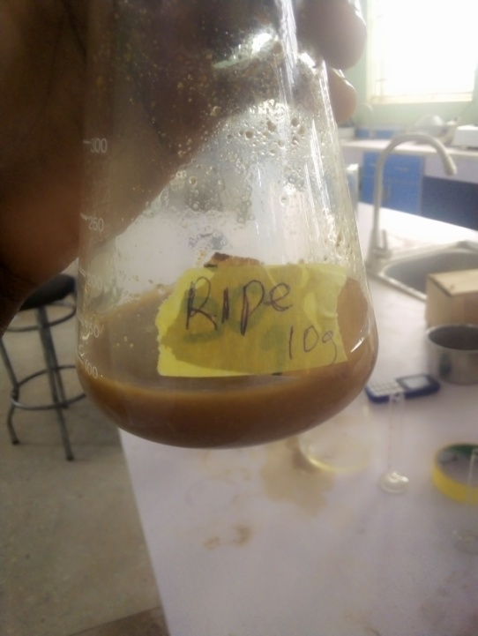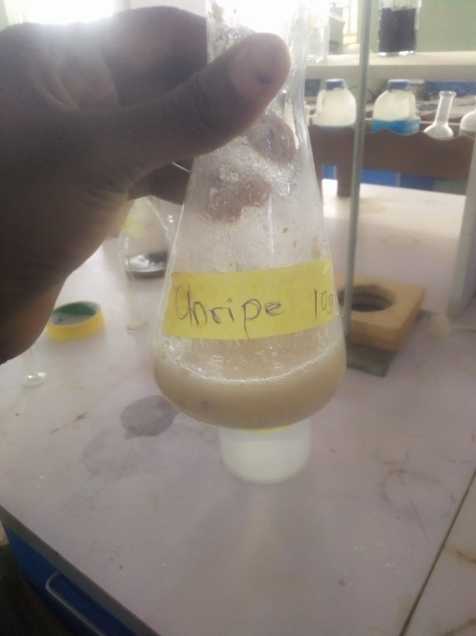**APPENDIX B**

