ADVANTA AFRICA LTD
Smarter, Faster Messaging
Bulk SMS · Short Codes · SMS APIs · USSD · WhatsApp APIs · VRBT
HUAWEI SUPPLIER AUDIT EVIDENCE PACK
Quality Organisation
Appointment, job description and operating model of the Quality Management Responsible Person
PROJECT: Video Ring Back Tune (VRBT) Service

Document Number | AA-VRBT-QM-2.1.1
Questionnaire Reference | Quality Management System — No. 2.1.1
Evidence Addresses | Establish a quality management organisation, define roles and responsibilities, and operate it on a routine basis. Evidence: appointment letter and job description of the Quality Management Responsible Person; organisation diagrams.
Document Version | 1.0 | Issued for Audit
Document Date | 17 August 2026
Effective Date | 01 August 2026
Next Review Date | 31 July 2027
Classification | Confidential — Restricted to Advanta Africa, Huawei TQC/CEG and authorised auditors
Prepared For | Huawei Technologies · Reviewer: TQC / CEG · Method: Document Verification
Prepared By | Quality Management Office, Advanta Africa Ltd
Approved By | Lawrence Muriuki, Chief Executive Officer and Founder
Owner | Quality Management Responsible Person (QMRP)
Related Contract | Huawei content / VAS cooperation for DIY Audio, Video, Game and E-book scenarios, as applied to VRBT
Western Heights, 6th Floor, Karuna Road, Westlands, Nairobi, Kenya
P.O. Box 1035-00200, City Square, Nairobi · Tel: +254 111 139 000 · www.advantasms.com | www.advanta.africa

Document Control and Revision History
Version | Date | Author / Authority | Description
0.1 | 15 Jul 2026 | Quality Office | Draft framework for VRBT Huawei evidence pack
0.9 | 05 Aug 2026 | QMRP / DPO / Content Compliance | Internal review against questionnaire key review points
1.0 | 17 Aug 2026 | CEO | Issued for Huawei TQC/CEG document verification

1. Purpose and questionnaire mapping
This document demonstrates that Advanta Africa Ltd has established a quality management organisation for the VRBT programme, has appointed a Quality Management Responsible Person (QMRP), has issued a job description for that office, and operates the organisation on a routine basis. It is the evidence attachment for questionnaire item 2.1.1 (Reviewer: TQC/CEG; Method: Document Verification).
Key review point | Where addressed in this file
Appointment letter or relevant documents for the Quality Management Responsible Person | Section 4 — Appointment Letter AA-HR-QMRP-001
Job description for the Quality Management Responsible Person | Section 5 — Job Description AA-HR-JD-QMRP-001
Organisation defined and operated routinely | Sections 3, 6 and 7 — charts, RACI, Quality Committee cadence

2. Scope
This organisation covers all Advanta activities that create, license, review, encode, publish, market, bill, support or retire VRBT audio and video content, including USSD and digital-channel journeys, and the handling of personal data arising from those activities. It interfaces with Huawei TQC/CEG and with the mobile-network operator or enterprise customer. Game and e-book cooperation controls are applied analogously to interactive or narrative VRBT content.
3. Quality organisation
3.1 Internal team
The internal quality organisation is sponsored by the Chief Executive Officer. The QMRP is independent of day-to-day content production for audit decisions and has a direct reporting line to the CEO for quality and compliance escalation. The Data Protection Officer and the Content Compliance Officer (questionnaire 2.4.1) sit alongside product delivery so that privacy and content-risk reviews cannot be bypassed.
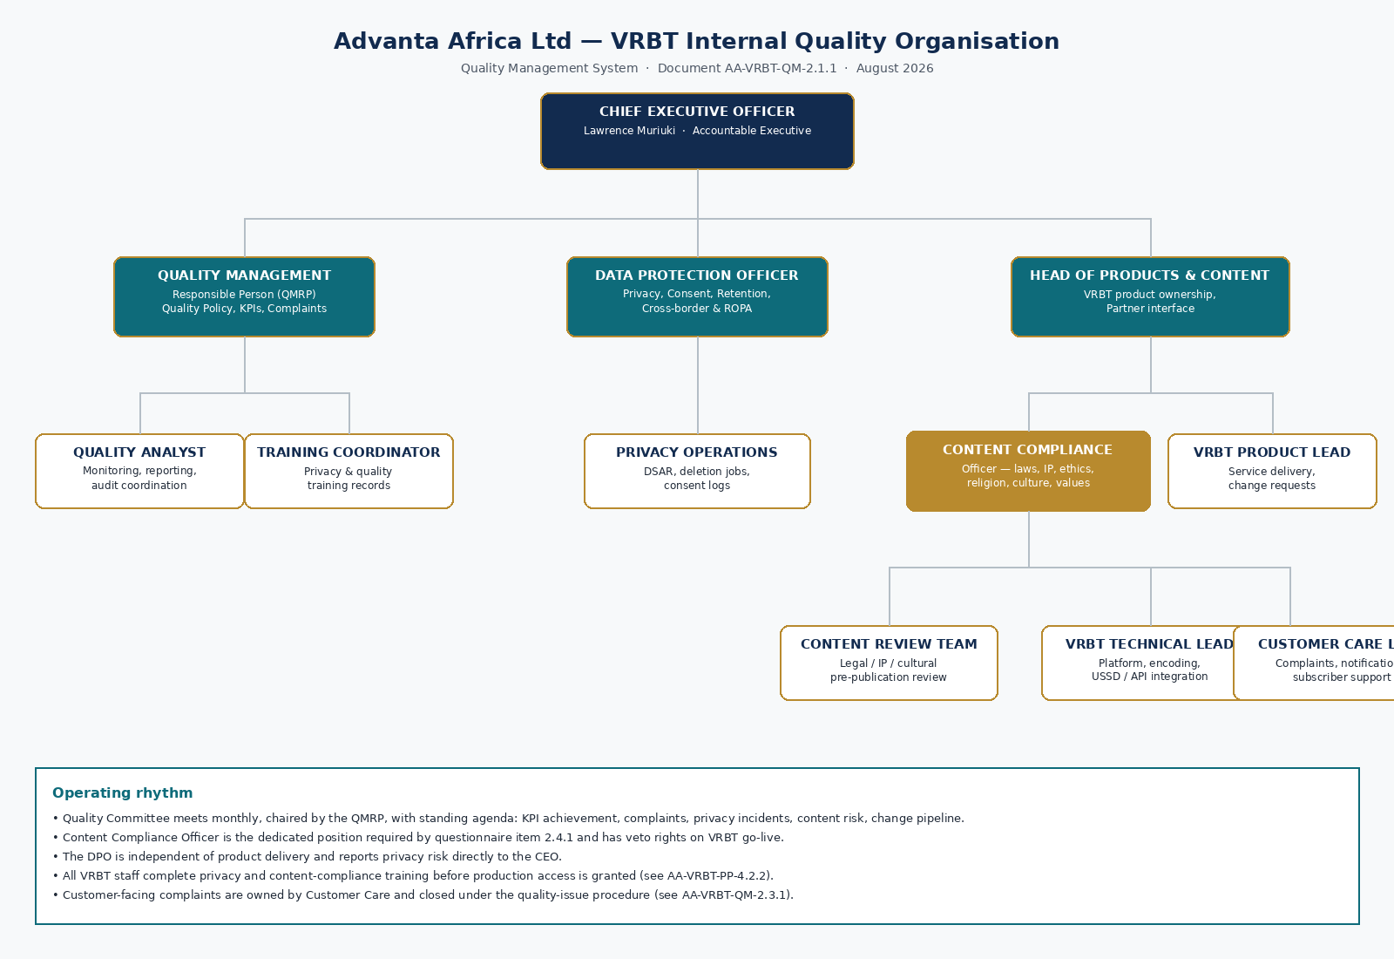
Figure 1. Advanta Africa VRBT internal quality organisation.
3.2 Customer and partner team
The customer-side organisation is a three-party model: Huawei (platform, TQC/CEG audit and technical baseline), Advanta Africa (content operations, USSD/VAS delivery, quality and privacy controls), and the Operator or enterprise customer (subscriber relationship, tariffs and network channels). A Joint VRBT Governance Committee meets monthly.
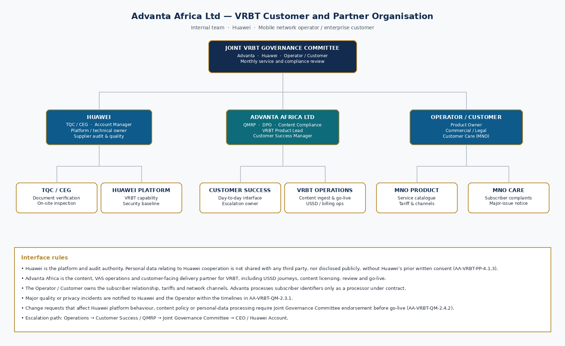
Figure 2. Advanta Africa VRBT customer and partner organisation.
4. Appointment letter — Quality Management Responsible Person
CONTROLLED RECORD · AA-HR-QMRP-001 · EFFECTIVE 1 AUGUST 2026
The letter below is the appointment instrument required by the questionnaire. It is issued on Advanta Africa Ltd letterhead and takes effect on signature by the Chief Executive Officer.

ADVANTA AFRICA LTD
Smarter, Faster Messaging
Western Heights, 6th Floor, Karuna Road, Westlands, Nairobi · P.O. Box 1035-00200 · +254 111 139 000
Ref: AA-HR-QMRP-001 Date: 1 August 2026
APPOINTMENT LETTER — QUALITY MANAGEMENT RESPONSIBLE PERSON
To: The appointed Quality Management Responsible Person
Office: Quality Management Responsible Person (QMRP) for the Video Ring Back Tune (VRBT) programme and related DIY audio, video, game and e-book content operations
Reporting line: Directly to the Chief Executive Officer for quality, audit and compliance matters; dotted line to the Head of Products and Content for operational coordination
I, Lawrence Muriuki, Chief Executive Officer and Founder of Advanta Africa Ltd, hereby appoint you as the Quality Management Responsible Person of Advanta Africa Ltd with immediate effect from 1 August 2026. This appointment is made to satisfy Huawei supplier quality requirements and Advanta’s own quality policy, and shall remain in force until revoked in writing by the CEO or until you cease to be employed by the Company in a capacity compatible with the office.
By this appointment you are authorised and required to:
1. Establish, maintain and continually improve the Quality Management System (QMS) for VRBT and related content services.
2. Define quality objectives and KPIs, publish achievement reports, and drive improvement where targets are not met.
3. Chair the monthly Quality Committee and report quality status to the CEO and to the Joint VRBT Governance Committee.
4. Own the customer-complaint and quality-problem closure process, including notification of major issues to Huawei and the Operator.
5. Ensure that a dedicated Content Compliance function reviews legal, intellectual-property, ethics, morality, religious-culture and values risks before go-live.
6. Ensure that change management is applied to content and platform changes, including content-change reviews and go-live reviews.
7. Coordinate Huawei TQC/CEG audits, on-site inspections and document verification, and keep the evidence repository complete and current.
8. Escalate, independently of product management, any quality, privacy or content-compliance risk that you consider material.
You shall perform the duties in the attached Job Description (AA-HR-JD-QMRP-001) and shall have unrestricted access to records, systems and personnel reasonably required for those duties. The Company will provide training, tools and a quality analyst resource. This appointment does not alter your contract of employment except as to the additional authorities stated here.
Please sign the acknowledgement below and return a copy to Human Resources for the personnel file and to the Quality Office for the controlled QMS file.
Yours faithfully,
_________________________________
Lawrence Muriuki
Chief Executive Officer and Founder
Advanta Africa Ltd
Acknowledgement of appointment
I accept the office of Quality Management Responsible Person, I have read Job Description AA-HR-JD-QMRP-001, and I understand the independence, duties and escalation rights of the office.
Signature: ___________________________ Name: ___________________________ Date: _______________
5. Job description — Quality Management Responsible Person
Document | AA-HR-JD-QMRP-001 · Version 1.0 · 1 August 2026
Job title | Quality Management Responsible Person (QMRP)
Function | Quality, audit and supplier-compliance management
Location | Nairobi, Kenya, with support to East African operations
Reports to | Chief Executive Officer (quality independence line)
Direct reports | Quality Analyst; dotted-line Training Coordinator for QMS curricula
Grade | Senior management · designated management representative for the QMS

5.1 Purpose of the role
To provide independent leadership of Advanta Africa’s quality management organisation for VRBT and related content services, so that contractual, legal, Huawei TQC/CEG and customer requirements are met, evidenced and continually improved.
5.2 Key accountabilities
Accountability | Principal activities | Success measure
QMS design and operation | Maintain quality policy, processes, templates and the controlled document register. Run the Quality Committee. | QMS current; no overdue controlled-document reviews
Quality objectives | Set annual KPIs with the CEO; monitor monthly; initiate improvement for unmet targets. | KPI pack issued monthly; improvement actions closed on time
Complaints and quality issues | Own severity classification, RCA, closure and customer notification of major issues. | Closure SLA met; no repeat major issue without systemic fix
Content and change governance | Ensure 2.4.1 risk review and 2.4.2 change/go-live reviews occur before production. | Zero unreviewed VRBT go-lives
Huawei audit readiness | Map questionnaire items to evidence; host document verification and on-site inspection. | Fully Met self-assessment sustained
Competence | Ensure staff in VRBT operations complete quality, privacy and content-review training. | 100% of in-scope staff trained before production access
Independence | Escalate to the CEO any attempt to bypass quality, privacy or content-compliance gates. | Escalations logged and closed

5.3 Authority
• Stop-ship / stop-go-live authority jointly with the Content Compliance Officer where quality or compliance criteria are not met.
• Access to VRBT platforms, USSD configuration, content repositories, complaint logs, privacy logs and training records.
• Authority to require root-cause analysis and to verify effectiveness of corrective action.
• Authority to represent Advanta Africa to Huawei TQC/CEG on quality matters.
5.4 Competence
• Demonstrable experience in telecoms VAS, content services or ISO-style quality systems.
• Working knowledge of Kenya Data Protection Act 2019, CA consumer-protection and content-service rules, copyright/IP, and Huawei supplier quality expectations.
• Ability to write controlled documents, chair cross-functional reviews and deal with auditors.
5.5 Interfaces
Interface | Nature
CEO | Monthly quality report; immediate escalation of major incidents
Data Protection Officer | Joint ownership of privacy KPIs and incident handling
Content Compliance Officer | Joint go-live gate; alignment of content policy with QMS
VRBT Product Lead / Technical Lead | Change pipeline, defect data, SLA performance
Customer Care Lead | Complaint intake, subscriber communication, major-issue notices
Huawei TQC/CEG and Account | Audit evidence, corrective action, contract quality clauses
Operator / Customer Product Owner | Service quality, notifications, joint RCA

6. RACI for the quality organisation
Activity | CEO | QMRP | DPO | CCO | Product | Care
Quality policy and QMS | A | R | C | C | I | I
Quality KPIs and achievement reports | A | R | C | C | C | C
Complaint / quality-issue closure | I | A | C | C | C | R
Privacy statement, consent, deletion, ROPA | I | C | A/R | I | C | I
Content legal / IP / ethics / culture review | I | C | I | A/R | C | I
Change and go-live approval | I | A | C | R | R | I
Huawei audit response | A | R | C | C | C | I
Staff privacy and quality training | I | A | R | C | C | C

R = Responsible, A = Accountable, C = Consulted, I = Informed. CCO = Content Compliance Officer.
7. Routine operation
7.1 Quality Committee
The Quality Committee is the routine operating forum of the quality organisation. It is chaired by the QMRP and is quorate when the QMRP plus at least the DPO or Content Compliance Officer and one operations representative are present.
Item | Cadence | Output
Quality Committee | Monthly (first working Wednesday) | Minutes, KPI pack, action log
Joint VRBT Governance Committee with Huawei / Operator | Monthly | Service and compliance minutes
Content go-live board | As required, before each production release | Go-live record (2.4.2)
Management review with CEO | Quarterly | Management-review minutes and resource decisions
Internal QMS self-check | Quarterly, ahead of any Huawei review | Self-assessment against this questionnaire
Training refresh | At induction, then at least annually, and on material law or contract change | Attendance register and minutes

7.2 Standing agenda of the Quality Committee
1. Review of previous actions.
2. Quality KPI achievement versus target, including customer-complaint rate and major quality/compliance incident rate.
3. Open complaints and quality problems; overdue closures; major-issue notifications sent.
4. Privacy: consent exceptions, deletion-job results, DSARs, cross-border requests.
5. Content-risk reviews completed, rejected or pending; IP or cultural incidents.
6. Change pipeline: RFCs, emergency changes, failed go-lives.
7. Huawei / Operator communications and audit actions.
8. Resource, competence and training gaps.
9. Any other business and date of next meeting.
7.3 Quality policy (statement)
QUALITY POLICY — VRBT PROGRAMME
Advanta Africa Ltd shall deliver VRBT content and related VAS that are lawful, rights-cleared, culturally respectful, technically reliable and protective of personal data. We will meet Huawei contractual quality requirements, Kenya law and operator rules the first time, measure what matters, close complaints without delay, and never allow commercial pressure to override an independent quality, privacy or content-compliance decision. Every person who touches VRBT content or personal data is competent, authorised and accountable.

8. Evidence of routine operation (specimen)
The following extract demonstrates that the organisation is not a paper structure only. Full minutes are retained in the Quality Office repository under reference AA-QMS-MIN-YYYYMM.
Meeting | Date | Chair | Decision (extract)
Quality Committee QC-2026-08 | 5 August 2026 | QMRP | Issued QMS v1.0 for Huawei evidence; confirmed CCO go-live veto; approved August KPI pack
Joint Governance JG-2026-08 | 12 August 2026 | Advanta Customer Success / Huawei Account | Agreed document-verification date; confirmed no public disclosure of Huawei-related personal data
Management review MR-2026-Q3 | 15 August 2026 | CEO | Confirmed QMRP appointment, 2026 KPI targets and training budget

9. Records retained
• Appointment letter AA-HR-QMRP-001 and any successor appointment.
• Job description AA-HR-JD-QMRP-001.
• Organisation charts (internal and customer) at current version.
• Quality Committee and Joint Governance minutes and action logs.
• Controlled document register.
Document Approval
This document is issued under the authority of Advanta Africa Ltd for the VRBT programme. Wet-ink or authorised electronic signatures below confirm that the content is accurate, that the described controls are in operation, and that the document may be presented to Huawei TQC/CEG.
PREPARED BY  Signature: ____________________  Name: Quality Management Responsible Person  Date: 17 August 2026 | REVIEWED BY  Signature: ____________________  Name: Data Protection Officer / Content Compliance Officer  Date: 17 August 2026 | APPROVED BY  Signature: ____________________  Name: Lawrence Muriuki, Chief Executive Officer and Founder  Date: 17 August 2026

Distribution List
Copy | Recipient | Purpose
Master | Quality Management Office (controlled repository) | Document of record
1 | Huawei TQC / CEG auditor | Supplier document verification
2 | Advanta Africa CEO / Management | Accountability and sponsorship
3 | Data Protection Officer | Privacy and cross-border controls
4 | Content Compliance Officer | Content, IP, ethics and go-live review
5 | VRBT Product and Operations | Day-to-day implementation

