**EXPERIMENT 2: INTERRUPTS AND TIMERS IN ATMEL AVR ATMEGA8**

**EE20B056 – KATHIR PAGALAVAN**

**TARGET:** Implement interrupts to flash an LED with 50% duty cycle for 10seconds when a push button emulator is pressed

FLOWCHART:

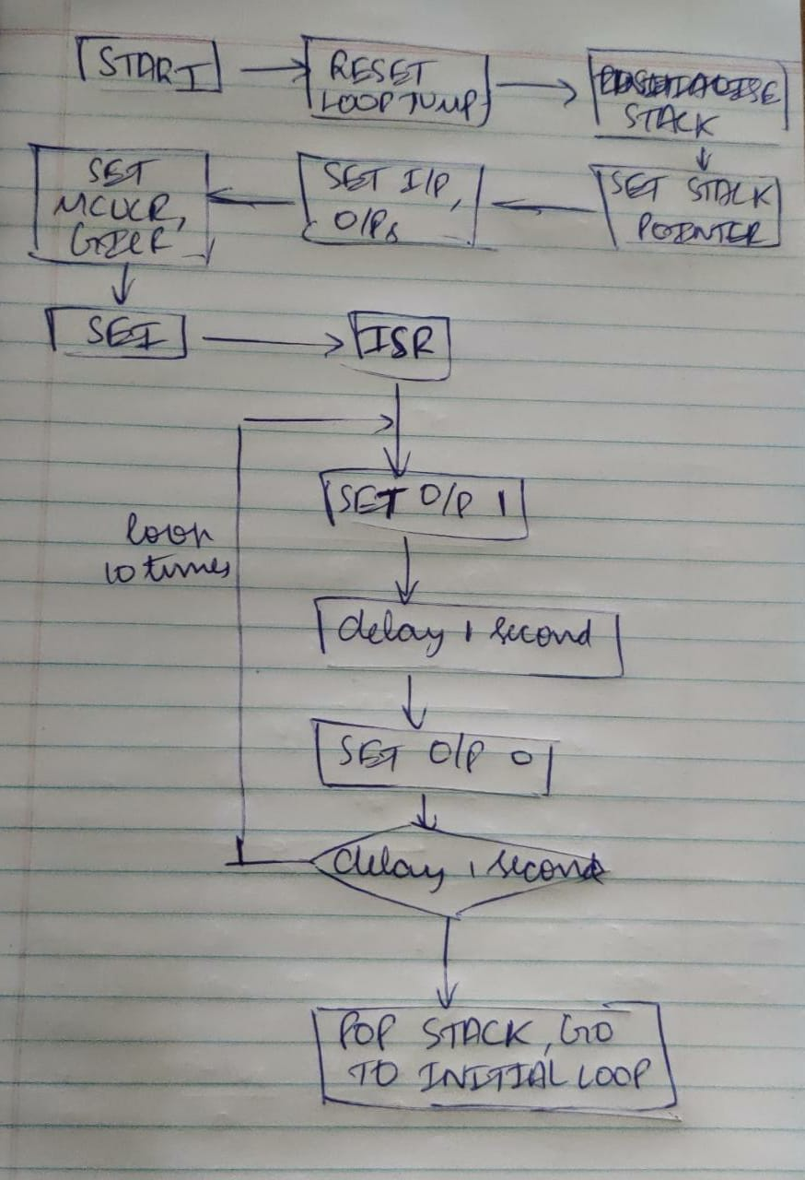

CODES:

ASM PROGRAM WITH INT1 INTERRUPT

.org 0x0000

rjmp reset

.org 0x0004

rjmp int1_ISR

.org 0x0100

reset:

;Loading stack pointer address

LDI R16,0x70

OUT SPL,R16

LDI R16,0x00

OUT SPH,R16

LDI R16,0X01 ;Interface port B pin0 to be output

OUT DDRB,R16 ;so to view LED blinking

LDI R16,0x00

OUT DDRD,R16

LDI R16,0X00 ;Set MCUCR register to enable low level interrupt

OUT MCUCR,R16

LDI R16,1<<INT1 ;Set GICR register to enable interrupt 1

OUT GICR,R16

LDI R16,0x00

OUT PORTB,R16

SEI

ind_loop:rjmp ind_loop

int1_ISR:

IN R16,SREG

PUSH R16

LDI R16,0x0A

MOV R0,R16

;Modify below loops to make LED blink for 1 sec

c1: LDI R16,0x01

OUT PORTB,R16

LDI R16,4

a1: LDI R17,200

a2: LDI R18,250

a3:

NOP

NOP

DEC R18

BRNE a3

DEC R17

BRNE a2

DEC R16

BRNE a1

LDI R16,0x00

OUT PORTB,R16

LDI R16,4

b1: LDI R17,200

b2: LDI R18,250

b3:

NOP

NOP

DEC R18

BRNE b3

DEC R17

BRNE b2

DEC R16

BRNE b1

DEC R0

BRNE c1

POP R16

OUT SREG, R16

RETI

C PROGRAM WITH INT1 INTERRUPT

#define F_CPU 1000000 // clock frequency

#include <avr/io.h>

#include <util/delay.h>

#include <avr/interrupt.h>

ISR (INT1_vect)

{

int i;

for (i=1;i<=10;i++) // for 10 times LED blink

{

PORTB=0x01;

_delay_ms(1000); // delay of 1 sec

PORTB=0x00;

_delay_ms(1000);

}

}

int main(void)

{

DDRD=0x00; //Set appropriate data direction for D

DDRB=0x01; //Make PB0 as output

MCUCR=0x00; //Set MCUCR to level triggered

GICR=0x80; //Enable interrupt 1

PORTB=0x00;

sei(); // global interrupt flag

while (1) //wait

{

}

}

ASM PROGRAM WITH INT0 INTERRUPT

.org 0x0000

rjmp reset

.org 0x0002

rjmp int0_ISR

.org 0x0100

reset:

;Loading stack pointer address

LDI R16,0x70

OUT SPL,R16

LDI R16,0x00

OUT SPH,R16

LDI R16,0X01 ;Interface port B pin0 to be output

OUT DDRB,R16 ;so to view LED blinking

LDI R16,0x00

OUT DDRD,R16

LDI R16,0X00 ;Set MCUCR register to enable low level interrupt

OUT MCUCR,R16

LDI R16,1<<INT0 ;Set GICR register to enable interrupt 0

OUT GICR,R16

LDI R16,0x00

OUT PORTB,R16

SEI

ind_loop:rjmp ind_loop

int0_ISR:

IN R16,SREG

PUSH R16

LDI R16,0x0A

MOV R0,R16

; below loops to make LED blink for 1 sec

c1: LDI R16,0x01

OUT PORTB,R16

LDI R16,4

a1: LDI R17,200

a2: LDI R18,250

a3:

NOP

NOP

DEC R18

BRNE a3

DEC R17

BRNE a2

DEC R16

BRNE a1

LDI R16,0x00

OUT PORTB,R16

LDI R16,4

b1: LDI R17,200

b2: LDI R18,250

b3:

NOP

NOP

DEC R18

BRNE b3

DEC R17

BRNE b2

DEC R16

BRNE b1

DEC R0

BRNE c1

POP R16

OUT SREG, R16

RETI

C PROGRAM FOR INT0 INTERRUPT

#define F_CPU 1000000 // clock frequency

#include <avr/io.h>

#include <util/delay.h>

#include <avr/interrupt.h>

ISR (INT0_vect)

{

int i;

for (i=1;i<=10;i++) // for 10 times LED blink

{

PORTB=0x01;

_delay_ms(1000); // delay of 1 sec

PORTB=0x00;

_delay_ms(1000);

}

}

int main(void)

{

DDRD=0x00; //Set appropriate data direction for D

DDRB=0x01; //Make PB0 as output

MCUCR=0x00; //Set MCUCR to low level triggered

GICR=0x40; //Enable interrupt 0

PORTB=0x00;

sei(); // global interrupt flag

while (1) //wait

{

}

}

INFERENCES:

NOP instructions can be used to make deliberate 1 cycle delays to time the loops to 1 second exactly

Interrupt execution response lasts 4 clock cycles