**EE2016 LAB EXPERIMENT 3 – ARM BASICS**

**EE20B056**

**TASK 1 – FACTORIAL:**

Compute the factorial of a given number using ARM processor through assembly programming

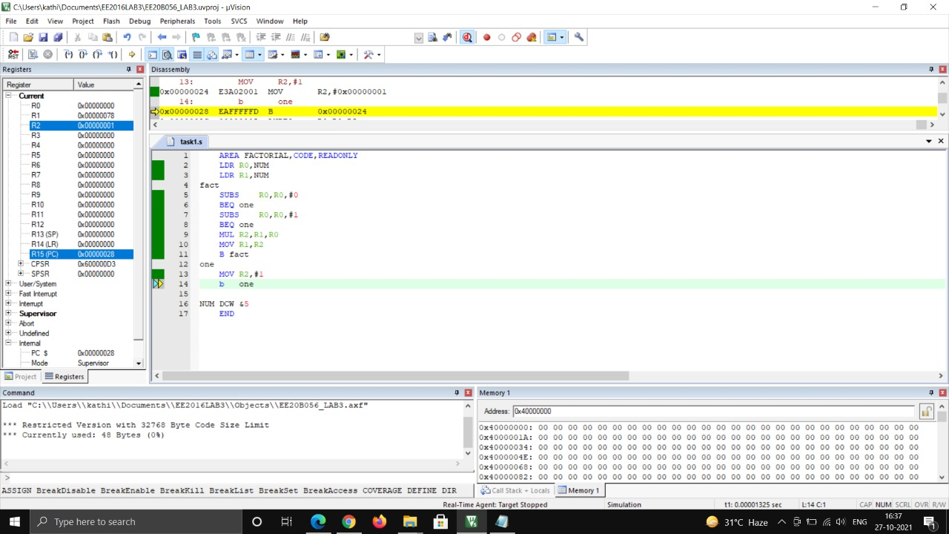

**CODE:**

AREA FACTORIAL,CODE,READONLY

LDR R0,NUM

LDR R1,NUM

fact

SUBS R0,R0,#0

BEQ one

SUBS R0,R0,#1

BEQ one

MUL R2,R1,R0

MOV R1,R2

B fact

one

MOV R2,#1

b one

NUM DCW &5

END

**LOGIC:** Given number is put in R0 and R1, firstly we check if given number is 1 if true, we jump to ‘one’ label meaning the factorial is 1, if given number is not 1 , we subtract the value in R0 by 1 and multiply with the value in R1 and put it in R2, and we copy this value back to R1 and proceed the same way. For a given value the process is shown below

[R0,R1,R2] : [5,-,-] 🡪 [5,5,-] 🡪 [4,5,-] 🡪 [4,5,20] 🡪 [4,20,20] 🡪 [3,20,20] 🡪 [3,20,60] 🡪 [3,60,60] 🡪 [2,60,60] 🡪 [2,60,120] 🡪 [2,120,120] 🡪 [1,120,120] 🡪 [1,120,1]

**TASK 2 – 16-bit HALFWORD:**

Combine the low four bits of each of the four consecutive bytes beginning at LIST into one 16-bit halfword. The value at LIST goes into the most signicant nibble of the result. Store the result in the 32-bit variable RESULT.

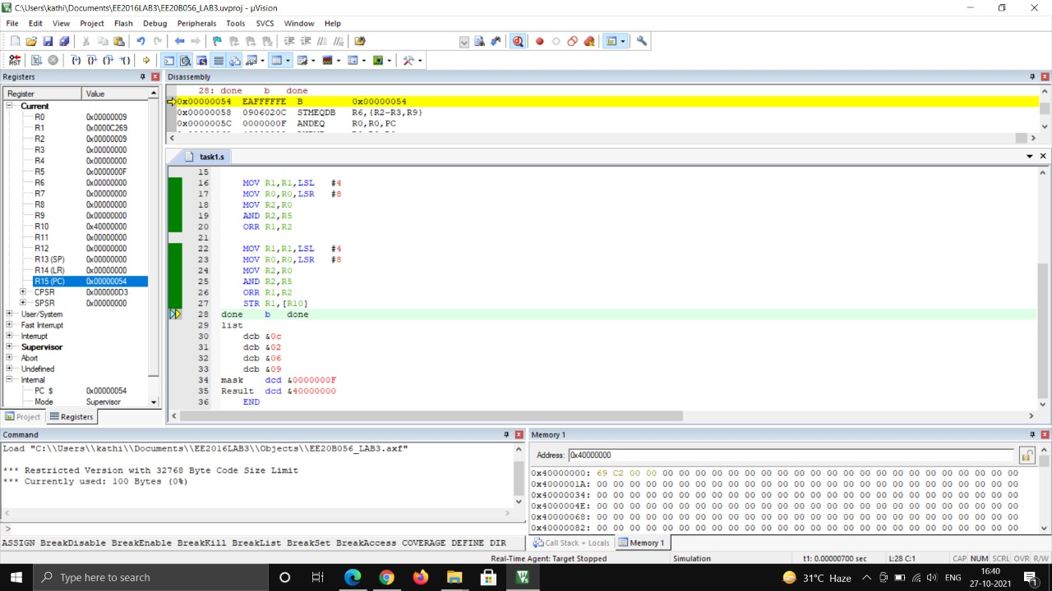

**CODE:**

AREA Program ,CODE,READONLY

LDR R0, list ; four consecutive bytes as defined below

LDR R5, mask ; 4 LSB bits alone are kept as 1s to be used as mask

LDR R10, Result ; the address being labelled as result is copied to this register

MOV R1,R0

AND R1,R5 ; the first 4 lsb bits alone are kept

MOV R1,R1,LSL #4 ; the four bits are shifted to left,

MOV R0,R0,LSR #8 ; eight bits here are shifted to the right so that the MSB half byte is removed

MOV R2,R0

AND R2,R5 – mask the other bits than the lower half byte of the next byte alone

ORR R1,R2

MOV R1,R1,LSL #4

MOV R0,R0,LSR #8

MOV R2,R0

AND R2,R5

ORR R1,R2

MOV R1,R1,LSL #4

MOV R0,R0,LSR #8

MOV R2,R0

AND R2,R5

ORR R1,R2

STR R1,[R10]

done b done

list

dcb &0c

dcb &02

dcb &06

dcb &09

mask dcd &0000000F

Result dcd &40000000

END

**LOGIC:**

R0 – LIST – 4 bytes sequenced as a single 32 bit

R1 – output - LSBs of the given 4 bytes in list

R2 – used to take the lower byte one by one by masking with R0 with R5

R5 – 0x0000000F – mask, when masked with this produces 4 bit LSBs alone

The above registers are used as mentioned in the comments in the code

**TASK 3 – ODD OR EVEN:**

Given a 32-bit number, identify whether it is an even or odd. (You implementation should not involve division).

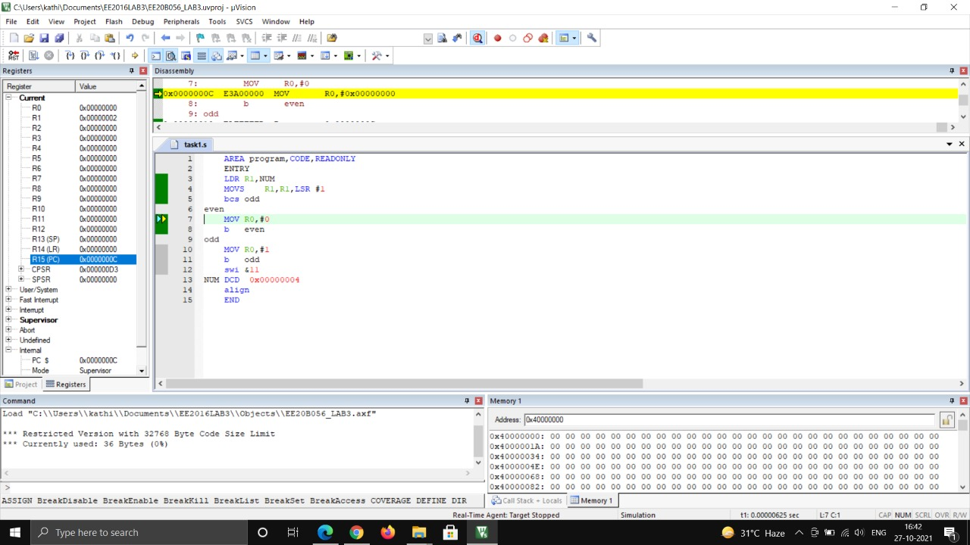

**CODE:**

AREA program,CODE,READONLY

ENTRY

LDR R1,NUM

MOVS R1,R1,LSR #1

bcs odd

even

MOV R0,#0

b even

odd

MOV R0,#1

b odd

swi &11

NUM DCD 0x00000004

align

END

**LOGIC:**

Given number is taken in R1

R1 is logically shifted to right , if it is odd carry is set, if it is even carry is not set – in both cases it jumps to either of the loops corresponding to the case.