Optimizing the Household Waste Segregation Policy in the Municipality of Bacolod: An Agent-based Modeling and Deep Reinforcement Learning Approach
Jemar John J. Lumingkit  Department of Computer Science  Mindanao State University – Iligan Institute of Technology  Iligan City, Philippines  jemarjohn.lumingkit@g.msuiit.edu.ph | Hussam M. Bansao  Department of Computer Science  Mindanao State University – Iligan Institute of Technology  Iligan City, Philippines  hussam.bansao@g.msuiit.edu.ph | Dante D. Dinawanao  Department of Computer Science  Mindanao State University – Iligan Institute of Technology  Iligan City, Philippines  dante.dinawanao@g.msuiit.edu.ph

Abstract—The persistent challenge of low household compliance with the Philippine Ecological Solid Waste Management Act (R.A. 9003) significantly hampers municipal solid waste operations. Existing Local Government Unit (LGU) strategies rely on static incentives and penalties that often fail to address heterogeneous household behaviors and the severe logistical constraints faced by frontline barangay implementers. To address this gap, this study proposes a novel framework coupling an Agent-Based Model (ABM) with Deep Reinforcement Learning (DRL) to optimize policy interventions within a decentralized, dual-budget governance architecture. Baseline simulations reveal that the prevailing "Status Quo" strategy of equitable resource distribution fails to overcome community-wide behavioral inertia. Global Sensitivity Analysis demonstrates that the physical "Cost of Effort" is the primary driver of non-compliance, accounting for 79% of the variance. Guided by safety-critical heuristics, the DRL agent successfully optimized a "Sequential Saturation" strategy. The model proves that sequentially concentrating municipal funds to trigger localized social norm "tipping points" is vastly superior to a simultaneous, equal distribution across the municipality.
Keywords—Agent-Based Modeling, Deep Reinforcement Learning, Municipal Solid Waste Management, Theory of Planned Behavior, Polycentric Governance, Policy Optimization.

Introduction (Heading 1)
The management of Municipal Solid Waste (MSW) remains a critical environmental and public health challenge in the Philippines. Despite the landmark Ecological Solid Waste Management Act of 2000 (R.A. 9003), which mandates segregation at source, compliance at the household level is inconsistent. Between 2023 and 2024, the Philippines recorded significant growth in mandated facilities like Material Recovery Facilities (MRFs); however, reported illegal dumpsites surged by 84%, demonstrating the "MRF paradox" where the primary bottleneck is source waste segregation rather than mere infrastructure.
Local Government Units (LGUs) operate under a system of trial-and-error, experimenting with behavioral policy instruments such as "No Segregation, No Collection" punitive measures and incentive programs. However, LGUs face severe financial and logistical constraints. For instance, the frontline barangays serve as the primary implementers of R.A. 9003 but operate on meager baseline budgets, forcing the overarching municipal body to bridge the gap with a separate augmentation fund.
Existing static policy frameworks and traditional mathematical models fail to capture the non-linear, adaptive nature of human behavior under decentralized governance [1]. To address this "implementation deficit," this study introduces a coupled Agent-Based Modeling (ABM) and Deep Reinforcement Learning (DRL) approach. By integrating the Theory of Planned Behavior (TPB) into the ABM, we developed a Heuristic-Guided DRL (HuDRL) agent representing the municipal Mayor. This study aims to dynamically optimize limited budget allocations across punitive, incentive, and educational levers to systematically overcome the physical "Convenience Barrier" to household segregation.

Related works
Designing effective and cost-efficient waste segregation policies requires models grounded in established psychological theory. The Theory of Planned Behavior (TPB) posits that an individual's intention to perform a behavior is a function of Attitude, Subjective Norms, and Perceived Behavioral Control [2]. However, in waste management, positive intentions are easily overridden by logistical friction, recognized as the "Cost of Effort" or the convenience barrier [3].
Furthermore, behavioral change often relies on social tipping points. Once a committed minority reaches a tipping point (historically approximated at 25%-40%), they trigger a rapid cascade of adoption across the remaining majority, transitioning behaviors from calculated decisions into ingrained cultural inertia [4].
Traditional optimization methods in solid waste management, such as Linear Programming, assume perfect rationality and homogeny, failing to evaluate social hysteresis [1]. Recent shifts advocate for Agent-Based Models (ABM) as virtual laboratories for socio-environmental systems [5]. However, standard ABMs require manual scenario testing. The integration of Deep Reinforcement Learning (DRL), formalizing the ABM as a Markov Decision Process (MDP), allows AI agents to autonomously discover complex, adaptive allocation strategies in high-dimensional state spaces [6]. Still, standard DRL in policy faces the "Sparse Reward Problem," which requires heuristics and safety-critical action masking to prevent "lazy" convergence [7].
The work of Jimenez on using ABM and DRL in simulating the equity of citizen waste segregation in Costa Rica was the closest usage of the technology, however, in her study it was a distinct comparison between the technology to find the friction that causes the behavior of citizen’s to segregate.

Methodology
The study used a Computational Simulation Research Design thats uses computational framework of two coupled systems: the Multi-Level ABM that simulates the subject locale, and the HuDRL agent that represents the municipal Mayor acting as the central policy-maker.
Data gathered through Key Informant Interviews with Municiapl Environment and Natural Resources Head (MENRO) and 7 Component Barangay Officials serviced by the municipal garbage collection, used as audit and baseline of the simulation. Synthesis of data from regional literature was also used to support the baseline data and other variables that are pertinent in the simulation.
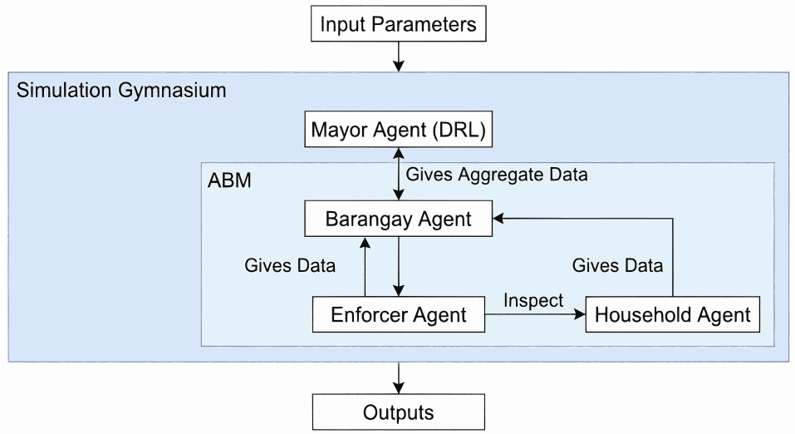
Figure 1: System Architecture

The simulation was developed using the MESA ABM library and the Stable-Baselines3 Python framework. It operates on a spatially explicit, non-toroidal 50×50 grid, utilizing a dual-clock temporal resolution: daily micro-ticks for households and quarterly 90-day epochs for the Mayor Agent's policy execution.

Multi-Level Agent-Based Modeling
Household agents represent the citizens of Bacolod's seven bThe environment follows a polycentric governance structure. The base layer contains 4,022 Household Agents geographically partitioned into 7 distinct Barangay Agents, governed by a central Mayor Agent.
The Household agents decision-making is governed by a modified Theory of Planned Behavior utility function [2]:
U_{seg} = (w_{A}(t)A) + (w_{SN}(t)SN_{local}) + (w_{PBC}(t)PBC) − C_{Net} + ϵ
The contribution in modifying this equation is taking on the psychological physical thought friction defined as Cost of Effort (C_{Effort}) and the socioeconomic sensitivity to LGU incentives and fines. To simulate Cultural Inertia, a state-dependent piecewise function provides a "Social Norm Shield" that locks in compliance if local segregation crosses 70%.
Enforcement Agent Enforcement operates under bounded rationality with limited line-of-sight spatial queries.
Barangay Agents: Barangay Agents continuously execute static micro-budgets while serving as meso-level data aggregators

Heuristic-Guided Deep Reinforcement Learning
The Mayor Agent is formalized as a Markov Decision Process (MDP), observing a 17-dimensional state vector (S_{t}) and outputting a continuous 21-dimensional action vector (A_{t}∈[−1,1]21) indicating the budget allocations across Enforcement, Incentives, and Information/Education Campaign (IEC) for all 7 barangays.
The system employs Proximal Policy Optimization (PPO) utilizing Actor-Critic Multi-Layer Perceptrons to calculate budget distributions. The raw output is processed through a Temperature-Scaled Softmax function (τ=5.0) to polarize confident investments and mathematically bound spending.
To overcome the sparse reward problem, the HuDRL utilizes a 70% Graduation Mechanism (slashing budget allocations to saturated barangays by 99%) and a Phase-Shift Crisis Guardrail (enforcing worst-first triage for crashing sectors). This heuristic guidance accelerates AI training and prevents unrealistic policy starvation [7]

Results

Calibration and Global Sensitivity Analysis (GSA)
Using empirical Knowledge, Attitude, and Practices (KAP) data [Pagailaan, 2025], the ABM was initialized at an exact 12.5% global compliance baseline, matching real-world municipal waste characterization audits. A variance-based Sobol GSA evaluated the structural validity of psychosocial traits. The GSA revealed that the physical "Cost of Effort" is the absolute dominant parameter driving system variance, yielding a Total-Order index (ST​) of 1.06. Conversely, internal "Attitude" exhibited near-zero sensitivity (S1​≈0.01). This computationally proved the Intention-Action Gap, suggesting that public awareness campaigns (IEC) suffer diminishing returns unless structural friction is resolved.
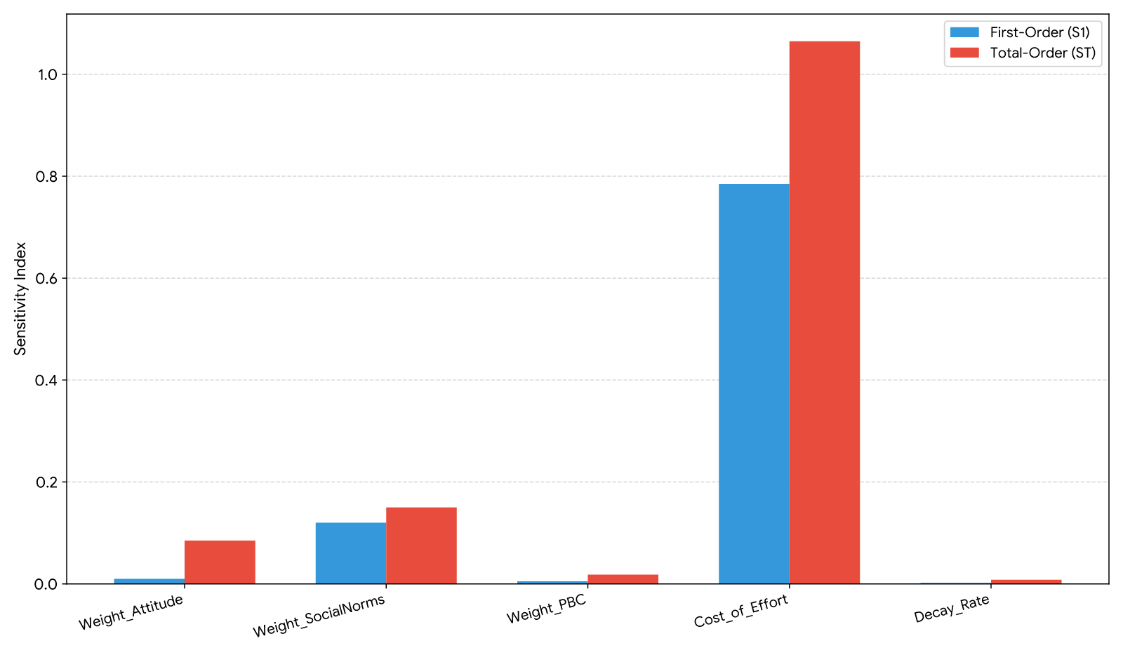
Figure 2: General Sensitivity Analysis

Comparative Convergence
Standard, unguided PPO failed to overcome the massive search space, stagnating at ∼20% global compliance. In contrast, the HuDRL effectively navigated the non-convex space, converging to a near-saturation global compliance rate (>90%) within 6 quarters, driven strictly by the applied action masking.
Comparative Policy Scenarios
The simulation evaluated four distinct strategies over a 3-year (12-quarter) horizon:
Baseline Status Quo: Dividing the P375,000 quarterly budget equally across all barangays for IEC campaigns. Due to the "Dilution Effect," high-density urban areas absorbed the funds without effect. Global compliance stagnated permanently at 30.18%.
Pure Enforcement (The Draconian Trap): Pumping 100% of the budget into militant inspection yielded a violent spike in compliance (91.17%). However, extreme fine issuance plummeted the Mayor's public approval, forcing a "Political Collapse" (simulation termination) by Quarter 2.
Pure Incentives (The Transactional Trap): Financial subsidies triggered rapid budget exhaustion. At a 500 PHP reward per claim, funds drained instantly, causing a "Perceived Unfairness" penalty among households unable to claim rewards. Compliance flatlined at 15.91%.
The HuDRL Strategy (Sequential Saturation): By dynamically concentrating funds, the HuDRL achieved an S-curve logistic growth, peaking at 92.79% in Year 1 and attaining asymptotic maintenance stability at 90.45% by Quarter 12. It balanced the budget without breaching the political collapse threshold.
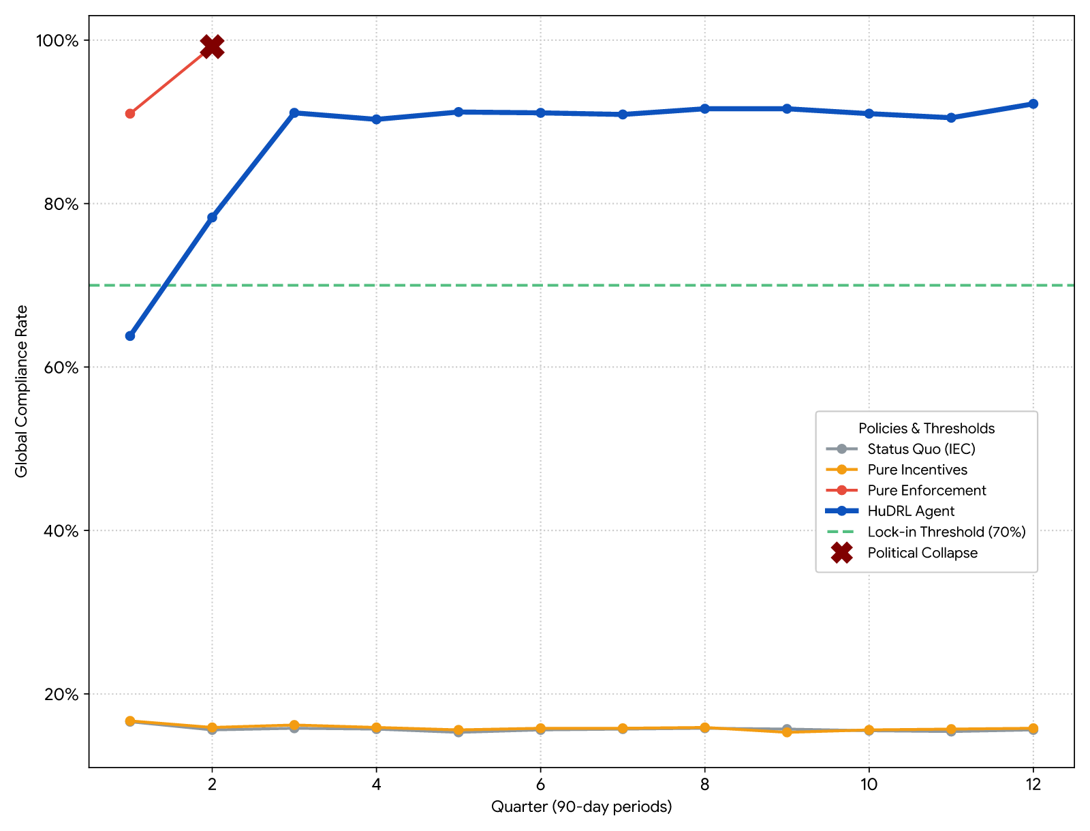
Figure 2: Comparison of Tested Policy Strategies

Discussion and policy implication
The computational trajectories dismantle the viability of static, equal-distribution policies in municipal governance. By spreading limited funds equally regardless of population size or socioeconomic friction, LGUs execute mathematical equality but fail entirely at equity.
The success of the HuDRL agent lies in its discovery of the "Sequential Saturation" strategy. Rather than maintaining simultaneous but ineffectual fairness, the AI sequentially concentrates capital to artificially induce a behavioral tipping point in highly resistant urban nodes. Once the 70% Social Tipping Point is breached, the "Social Norm Shield" (cultural hysteresis) locks in the behavior. This graduation effect enables the LGU to pivot its finite capital to the next failing node without the initial sector experiencing behavioral collapse [4].
Based on the algorithm, a "Smart Governance Framework" is proposed, urging LGUs to implement Algorithmic Resource Targeting and Predictive Policy Prototyping. By formally decoupling policy instruments to target physical friction directly, municipalities can engineer self-sustaining compliance ecosystems.

Conclusion
This study validates that the failure of Solid Waste Management is not merely a problem of insufficient total funding, but a severe failure of spatial and temporal resource allocation. The coupled ABM-DRL architecture revealed that static policies are prone to the dilution effect, transactional traps, or political collapse. The optimal solution is a phased, algorithmic resource targeting model that sequentially saturates demographic bottlenecks. Future research should integrate continuous Geographic Information Systems (GIS) for route optimization and expand agent diversity to include commercial actors.

Acknowledgment
The authors would like to thank Prof. John Gieveson Iglupas, MPA of the Department of Political Science, MSU-IIT, on his invaluable insights in the policy analysis guidance of this research. The MENRO Head Engr. Zamora and the barangay officials of the 7 compenent barangays for the cooperation.

Use of Generative AI
The authors used Gemini 3 Pro to improve grammatical and spelling corrections. All data and methods are validated by the authors

References
- X. Tian et al., "Agent-based modeling in solid waste management: Advantages, progress, challenges and prospects," Environ. Impact Assess. Rev., vol. 110, p. 107723, 2024.
- A. Ceschi et al., "The theory of planned behavior in pro-environmental behavior," 2021.
- B. Moeini et al., "Effect of household interventions on promoting waste segregation behavior at source: A systematic review," Sustainability, vol. 15, no. 24, p. 16546, 2023.
- D. Centola et al., "Experimental evidence for tipping points in social convention," Science, vol. 360, pp. 1116-1119, 2018.
- V. M. de Souza, J. Bloemhof, and M. Borsato, "Assessing the eco-effectiveness of a solid waste management plan using agent-based modelling," Waste Manage., vol. 125, pp. 235–248, 2021.
- S. Zheng et al., "The AI Economist: Taxation policy design via two-level deep multiagent reinforcement learning," Sci. Adv., vol. 8, no. 18, 2022.
- M. Andrychowicz et al., "Hindsight experience replay," in Advances in Neural Information Processing Systems, 2017.

