Before co-relation SJ (KNN)

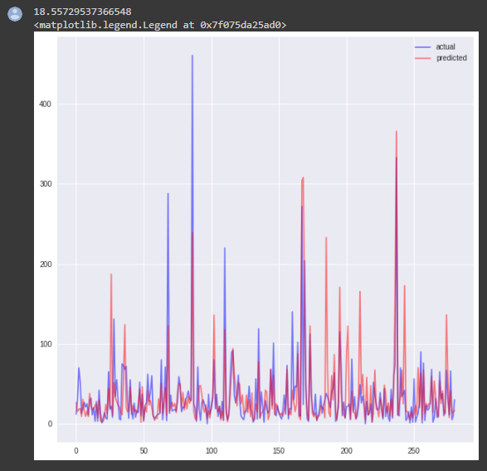

Before co-relation SJ (RF)

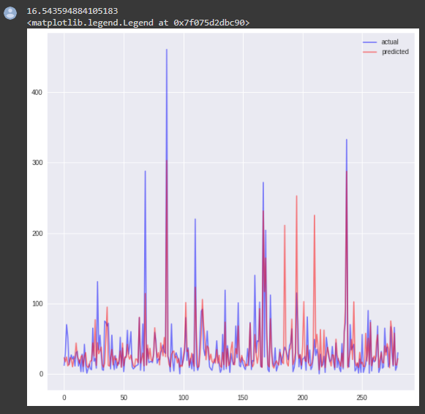

Before co-relation SJ (GB)

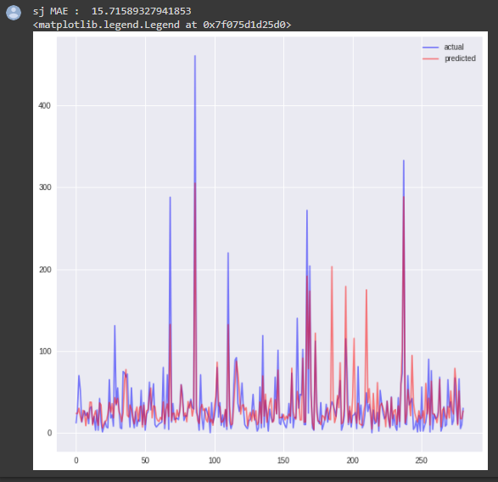

Before co-relation SJ (SVR)

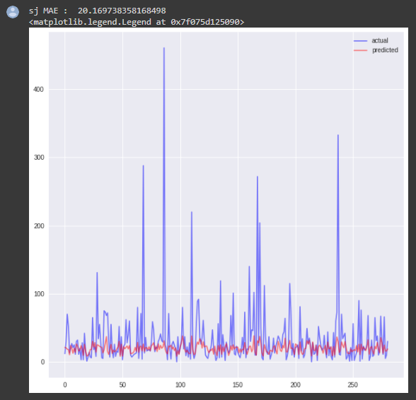

Before co-relation IQ (KNN)

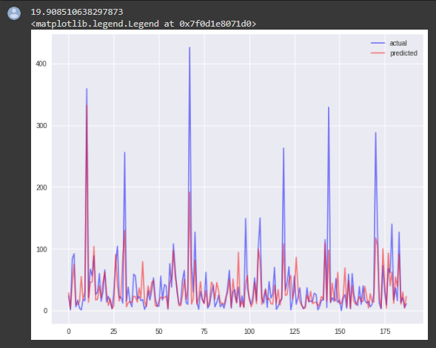

Before co-relation IQ (RF)

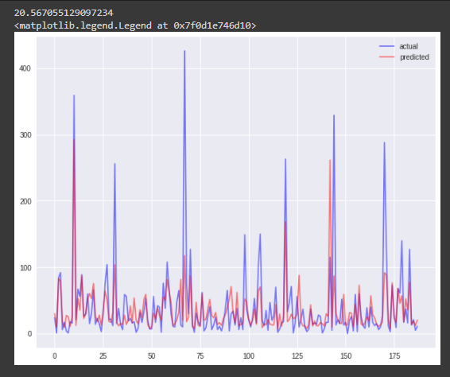

Before co-relation IQ (GB)

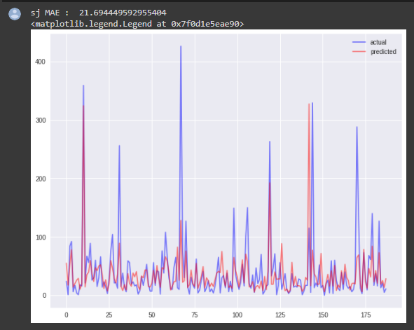

Before co-relation IQ (SVR)

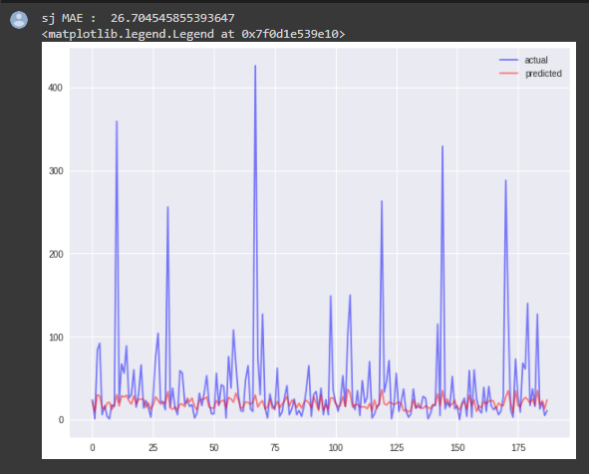

After co-relation SJ (KNN)

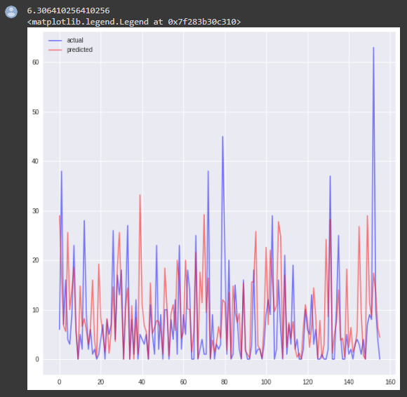

After co-relation SJ (RF)

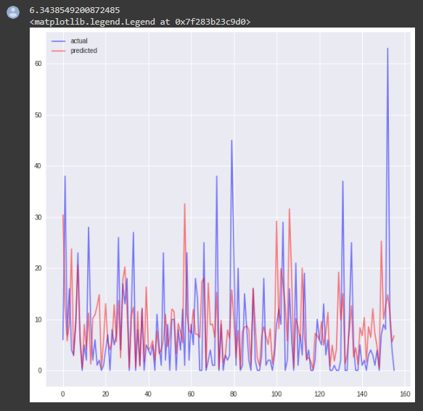

After co-relation SJ (GB)

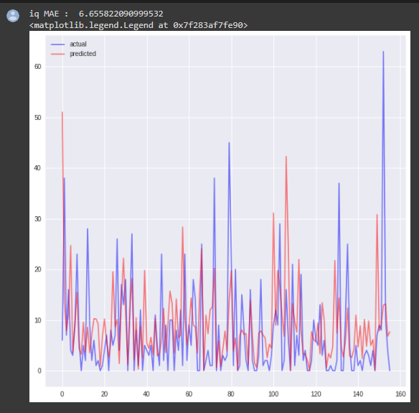

After co-relation SJ (SVR)

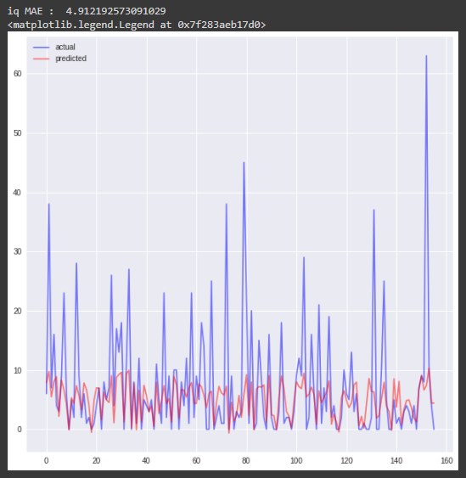

After co-relation IQ (KNN)

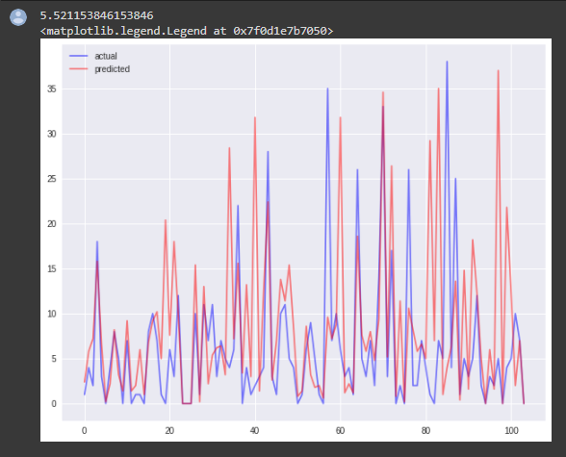

After co-relation IQ (RF)

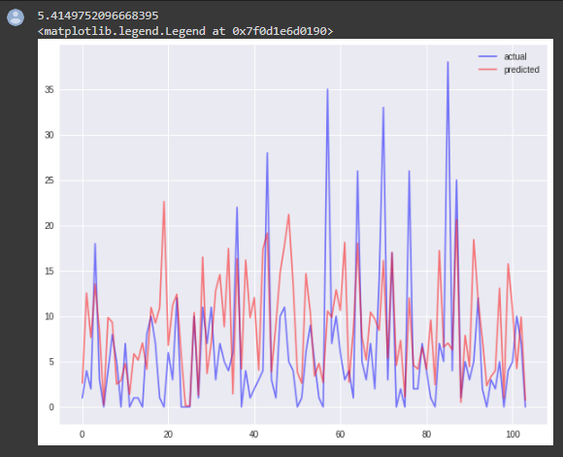

After co-relation IQ (GB)

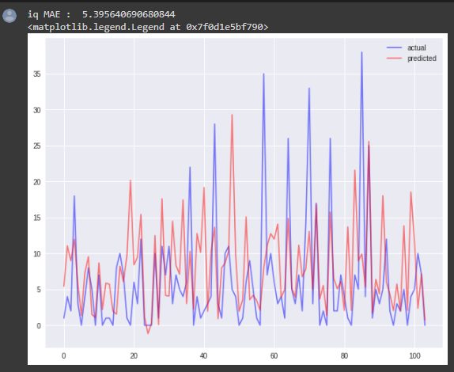

After co-relation IQ (SVR)

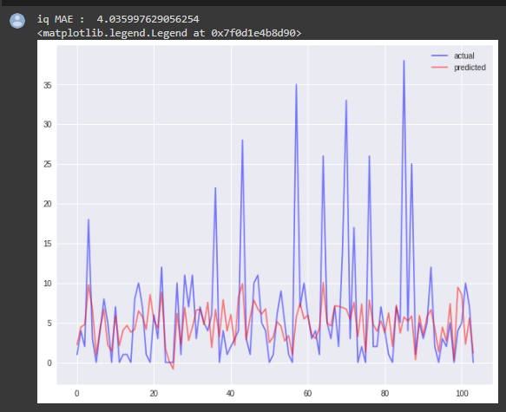

Comparaison

1. <https://www.ncbi.nlm.nih.gov/pmc/articles/PMC7567393/>

Weekly dengue forecasts in Iquitos, Peru; San Juan, Puerto Rico; and Singapore

***Result*** - ML models had 21% and 33% less error than regression and time series models respectively. ***using weather data only, ML models did not demonstrate a practical advantage***.

***Models***- ML models (i.e., **Random Forest [RF]** and **Random Forest-Univaraite Flagging Algorith** [RF-UFA]) forecast dengue, relative to commonly used prediction models (i.e., **Poisson regression**, **Logistic regression** and **autoregressive integrated moving average** [ARIMA] models)

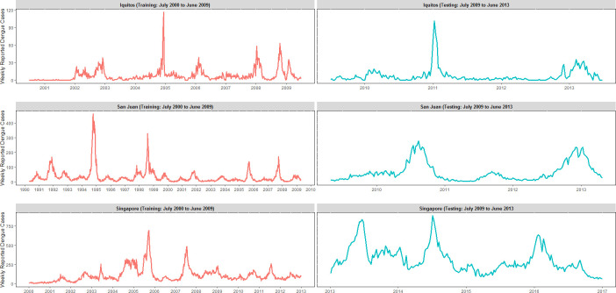

[*https://www.ncbi.nlm.nih.gov/core/lw/2.0/html/tileshop_pmc/tileshop_pmc_inline.html?title=Click%20on%20image%20to%20zoom&p=PMC3&id=7567393_pntd.0008710.g002.jpg*](https://www.ncbi.nlm.nih.gov/core/lw/2.0/html/tileshop_pmc/tileshop_pmc_inline.html?title=Click%20on%20image%20to%20zoom&p=PMC3&id=7567393_pntd.0008710.g002.jpg)

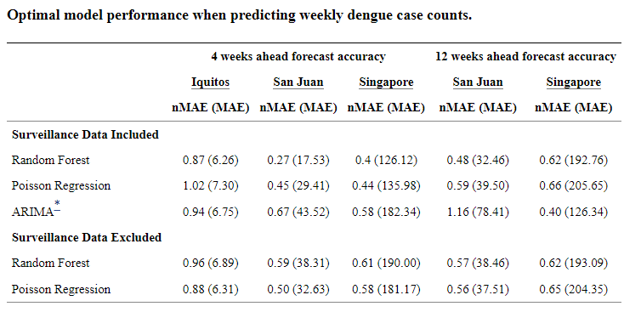

[*https://www.ncbi.nlm.nih.gov/pmc/articles/PMC7567393/table/pntd.0008710.t002/?report=objectonly*](https://www.ncbi.nlm.nih.gov/pmc/articles/PMC7567393/table/pntd.0008710.t002/?report=objectonly)

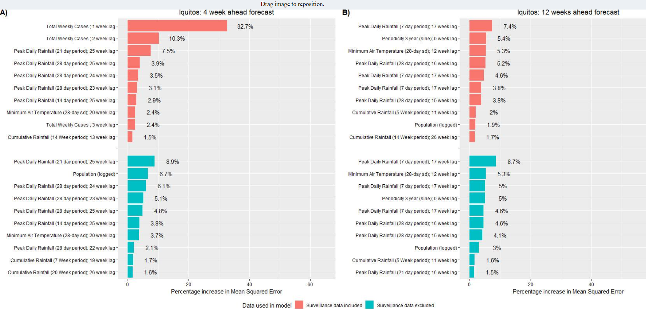

[*https://www.ncbi.nlm.nih.gov/core/lw/2.0/html/tileshop_pmc/tileshop_pmc_inline.html?title=Click%20on%20image%20to%20zoom&p=PMC3&id=7567393_pntd.0008710.g006.jpg*](https://www.ncbi.nlm.nih.gov/core/lw/2.0/html/tileshop_pmc/tileshop_pmc_inline.html?title=Click%20on%20image%20to%20zoom&p=PMC3&id=7567393_pntd.0008710.g006.jpg)

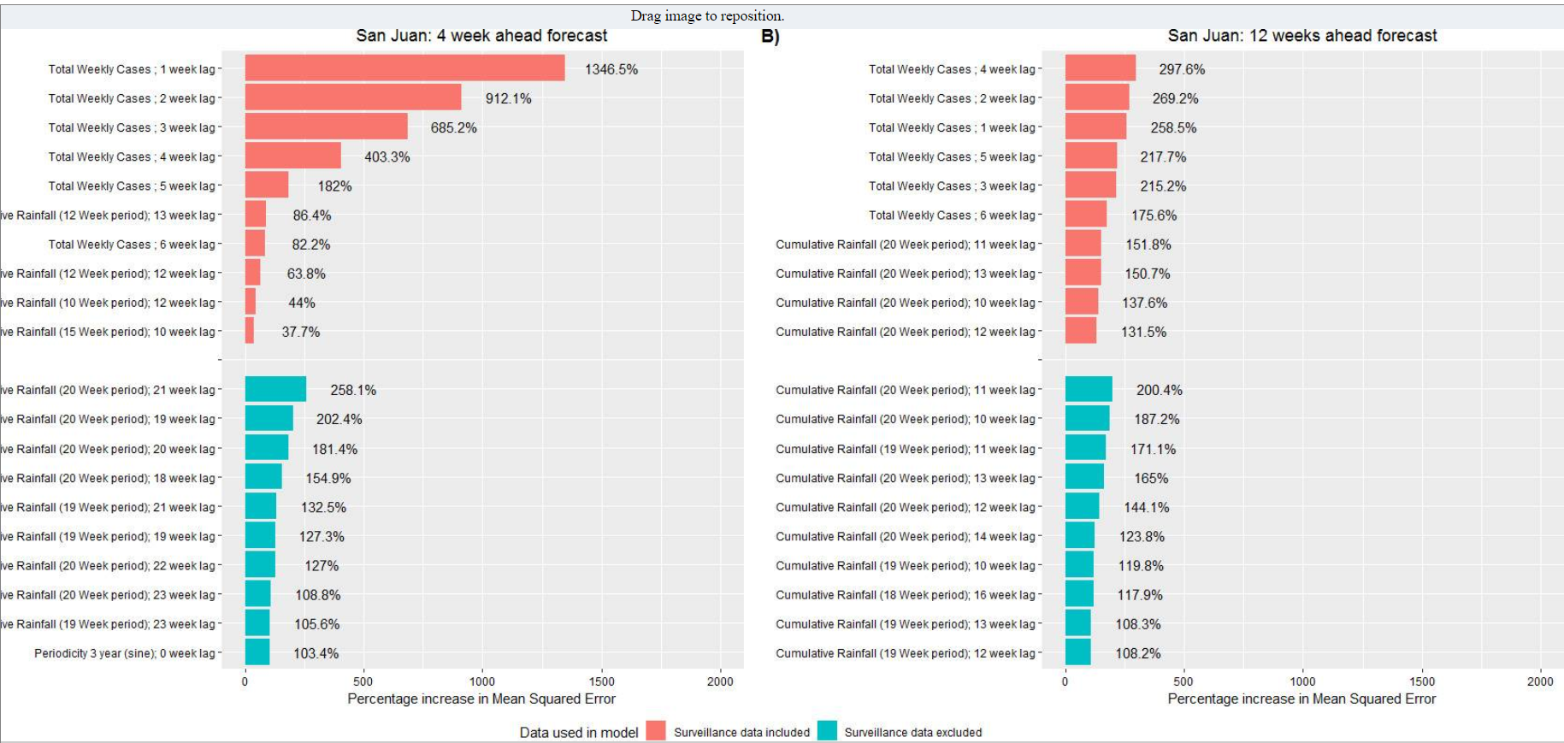

[*https://www.ncbi.nlm.nih.gov/core/lw/2.0/html/tileshop_pmc/tileshop_pmc_inline.html?title=Click%20on%20image%20to%20zoom&p=PMC3&id=7567393_pntd.0008710.g007.jpg*](https://www.ncbi.nlm.nih.gov/core/lw/2.0/html/tileshop_pmc/tileshop_pmc_inline.html?title=Click%20on%20image%20to%20zoom&p=PMC3&id=7567393_pntd.0008710.g007.jpg)