**Kubernetes Project-1 Deploying a Flask Application on Kubernetes with Auto-Scaling & Load Testing**

**STEP-1️. Building & Containerizing the Flask Application**

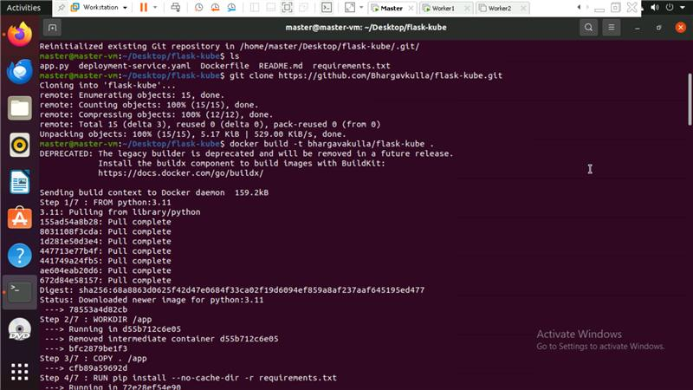

**STEP-2️. Deploying Flask App on Kubernetes**

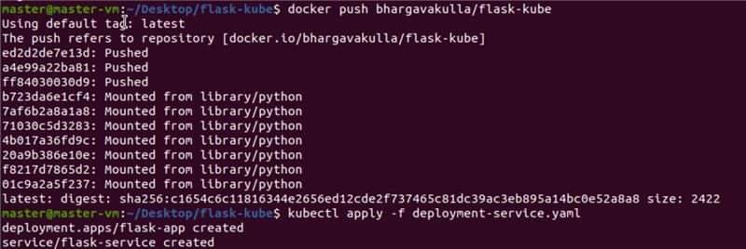

**STEP-3️. Fixing Docker Hub Rate Limits (Authentication Issue)**

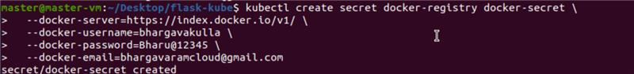

**STEP-4️. Installing & Troubleshooting Metrics Server**

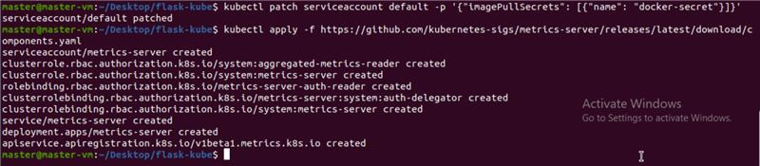

**STEP-5️. Enabling HPA (Horizontal Pod Autoscaler)**

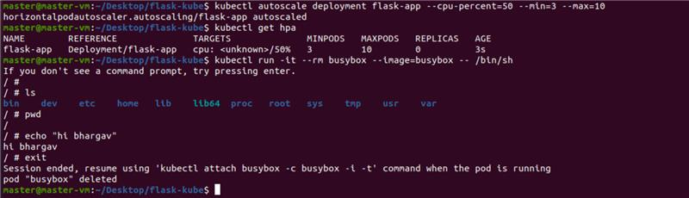

**STEP-6️. Load Testing & Debugging NodePort Issues**



**STEP-7️. Simulating Load for HPA**

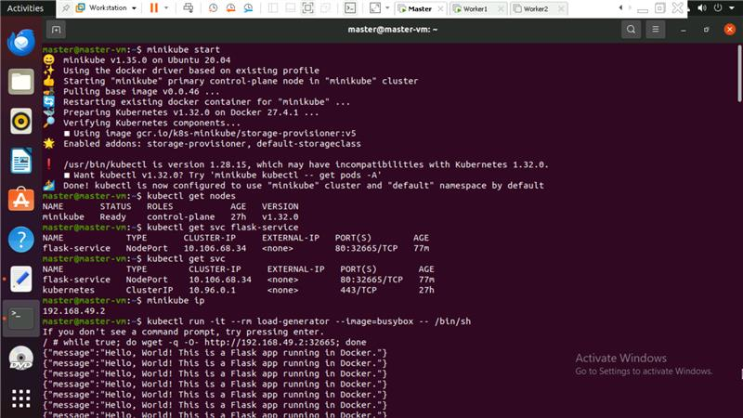

**OUTPUT:**

