**Kubernetes Project 2 - Kubernetes multi-Tenant Project**

**Step 1: Check if Any Worker Node is Ready**

Run the following command to check the status of worker nodes:

**kubectl get nodes**

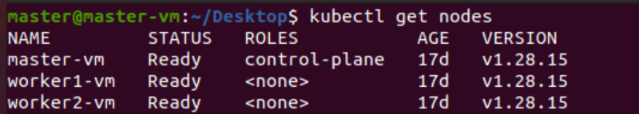

**Step 2: Create Namespaces for Tenants**

To isolate tenants, create separate namespaces:

**kubectl create namespace tenant-a**

**kubectl create namespace tenant-b**

**Step 3: Create Folder Structure for YAML Files**

Create the folder structure to organize YAML files for each tenant:

**mkdir -p ~/k8s-multi-tenant/tenant-a**

**mkdir -p ~/k8s-multi-tenant/tenant-b**

**cd ~/k8s-multi-tenant**

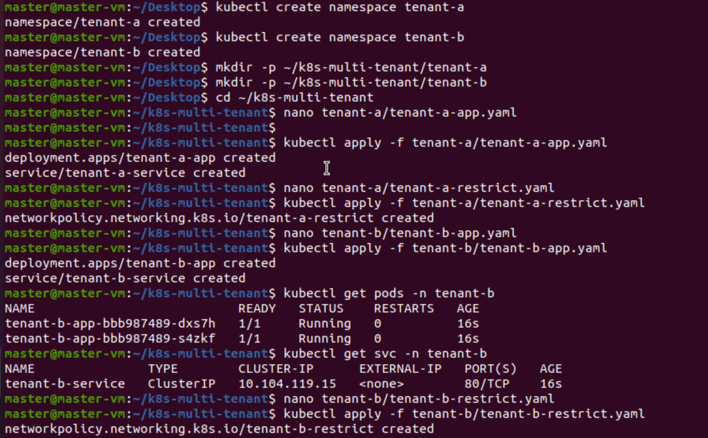

**Step 4: Create Deployment and Service for Tenant A and Tenant B**

**Step 5: Restrict Network Access for Tenant A and Tenant B**

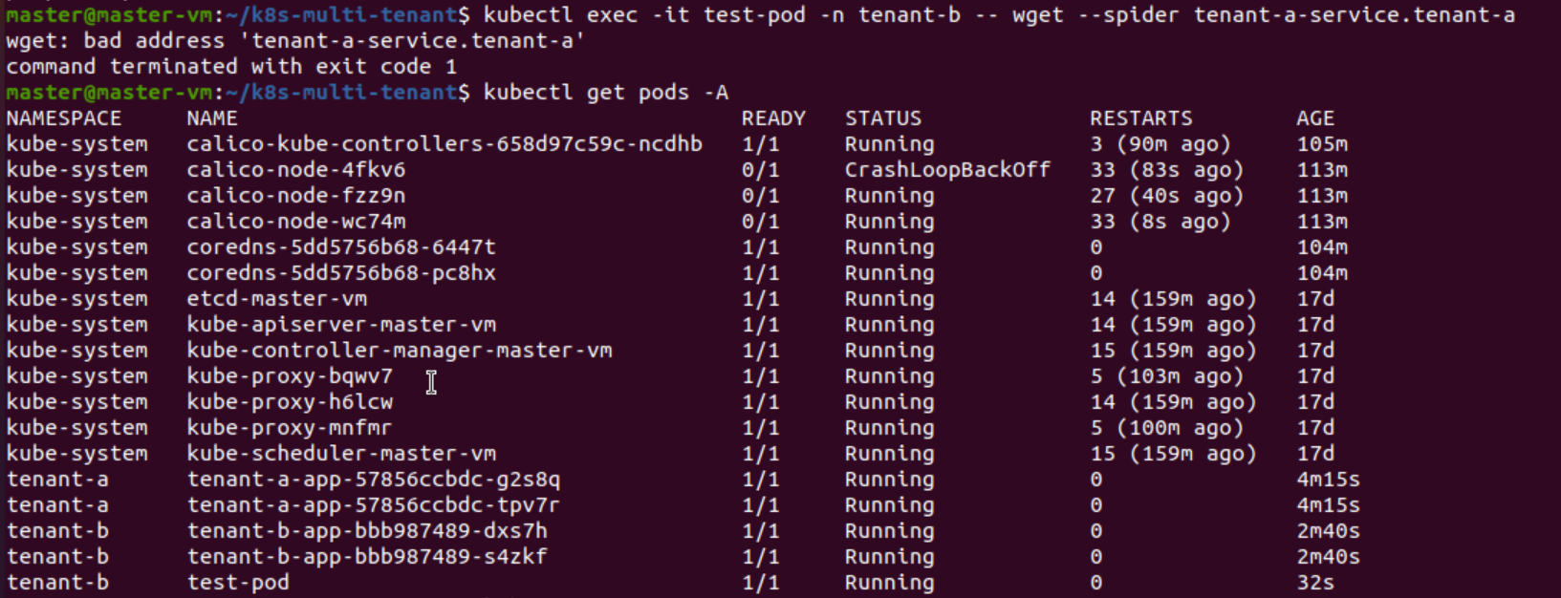

**Step 6: Verify Network Policy**

**Step 7: Test Tenant Isolation**

