MULTIMODAL MACHINE LEARNING FRAMEWORK FOR EARLY WARNING OF DISSOLVED-OXYGEN DETERIORATION IN RIVERS
Jackroshan J  Student  B. Tech Computer Science and Engineering,  SRM Institute of Science and Technology,  Ramapuram, Chennai -600089  Email: [add email] | Yagnesh C  Student  B. Tech Computer Science and Engineering,  SRM Institute of Science and Technology,  Ramapuram, Chennai -600089  Email: [add email] | Kirithikji A  Student  B. Tech Computer Science and Engineering,  SRM Institute of Science and Technology,  Ramapuram, Chennai -600089  Email: [add email] | Dr. Sahaya Sakila V  Assistant Professor  Department of Computer Science and Engineering,  SRM Institute of Science and Technology,  Ramapuram, Chennai -89  Email: sahayasv2@srmist.edu.in

Abstract - Dissolved oxygen (DO) below 5 mg/L causes hypoxic stress and fish kills in rivers, yet conventional sensor-based monitoring reports low DO only after it has occurred. This paper proposes a multimodal machine learning framework for the early warning of dissolved-oxygen deterioration in rivers. Hourly in-situ sensor records from 30 United States Geological Survey (USGS) river stations in 15 states (2023–2025, 789,120 station-hours) are fused with ERA5 meteorological reanalysis and CAMS air-quality data to construct 211 strictly causal features. For forecast horizons of 6, 12, 24 and 48 hours, the framework predicts the DO concentration (regression) and the water condition as Low (< 5 mg/L), Medium (5–7 mg/L) or Good (> 7 mg/L) (classification). Three machine learning models (Random Forest, XGBoost and LightGBM) and two deep learning models (BiLSTM and CNN-LSTM) are combined through a stacking ensemble, termed FLiX-BiC, which uses a Ridge meta-learner for regression and a multinomial logistic meta-learner for classification. A probability-threshold warning rule then issues an alert when the predicted probability of the Low class exceeds a horizon-specific threshold chosen to keep false alarms below 2%. The models were trained on 2023 data, every design choice was made on 2024, and the complete system was frozen before being evaluated once on the unseen 2025 test year. At the 24-hour horizon, the proposed ensemble achieved an R² of 0.951, an RMSE of 0.672 mg/L (11.1% lower than persistence), an accuracy of 90.39%, a macro F1-score of 88.60% and a Low-class recall of 94.09% at a false-alarm rate of 1.50%. Of the 230 low-DO events recorded in 2025, 51.7% were warned in advance with a median lead time of 20 hours. The ensemble obtained the lowest regression error at every horizon, while its classification scores were statistically comparable to the strongest tree-based models, and the warning rule provided the largest gain in early detection. The results demonstrate the potential of multimodal ensemble learning for anticipatory river water-quality management.
I. Introduction
Dissolved oxygen (DO) is one of the most direct indicators of whether a river can sustain aquatic life. Its concentration reflects the balance between atmospheric reaeration, photosynthesis by aquatic plants and algae, and the oxygen consumed by respiration and the decomposition of organic matter. When DO falls below approximately 5 mg/L, fish and invertebrates experience physiological stress, and prolonged hypoxia can lead to fish kills and a deterioration of downstream water sources. Continuous in-situ sensors are now widely deployed to monitor DO, but a sensor reports only the present condition. An operator who relies on the sensor reading learns of a low-oxygen episode after it has already begun, leaving little time for preventive measures such as aeration, flow release or the control of discharges.
Forecasting DO is challenging because its behaviour is governed by several interacting processes. DO follows a strong daily cycle driven by photosynthesis and respiration, decreases with rising water temperature, and responds to flow, turbidity, rainfall and organic loading. These relationships are non-linear, seasonal and specific to each river. Consequently, the problem is both predictable and deceptive: a trivial persistence forecast, which assumes that DO will remain unchanged, is a strong baseline at a 24-hour horizon because the daily cycle repeats, but it can never anticipate a change of condition. Any claim of predictive skill must therefore be measured against such a baseline, and a system intended for early warning must be evaluated on the transitions into the Low condition that matter most to operators.
Data-driven approaches have been increasingly applied to DO prediction. Zhi et al. [1] investigated whether a long short-term memory (LSTM) network driven by hydrometeorological data could predict river DO at the continental scale across the United States. Barzegar et al. [2] proposed a hybrid CNN–LSTM model for short-term water-quality variable prediction, while Moon et al. [3] applied machine learning models to predict DO in an urban river. Rocha et al. [4] introduced graph-based and transformer deep learning models for river DO forecasting, and Pant et al. [5] developed a decomposition-based CEEMDAN-AdaBoost-BiLSTM-LSTM model for multi-step DO forecasting in the River Ganga. Granata et al. [6] evaluated advanced ensemble machine learning models for DO forecasting in the Mississippi River, and Shadkani et al. [7] proposed hybrid temporal pattern attention networks for riverine DO. These studies demonstrate that both tree-based ensembles and recurrent networks can learn DO dynamics from monitoring data.
A related line of work treats low oxygen as an event to be detected rather than a value to be estimated. Cerqueira et al. [8] studied the forecasting of ocean hypoxia in salmonid fish farms, and Simonetti et al. [9] combined hydrodynamic modelling with random forest classifiers to predict hypoxia in coastal lagoons. Zhao and Chen [10] examined multi-source data with various machine learning coupling models for river DO. Explainable and ensemble approaches have also been explored: Merabet et al. [11] compared global and local SHAP explanations for gradient boosting water-quality models, Choudhary et al. [12] used stacked ensemble regression for water quality index prediction, Singha et al. [13] applied hybrid stacking ensembles to urban surface-water quality, and Chen et al. [14] proposed explainable ensemble learning for DO prediction in estuaries.
Despite this progress, several gaps remain. Most studies predict either the DO value or a hypoxia class, usually with a single algorithm at one or a few sites. Many evaluations use random or block-wise data splits, in which temporally adjacent and highly correlated observations appear in both the training and test sets, producing optimistic results. Aggregate metrics such as RMSE or overall accuracy do not reveal whether a model can anticipate the onset of low DO, which is the event an operator cannot read from the sensor. In addition, the contribution of meteorological and air-quality data to river DO forecasting is rarely quantified through controlled ablation.
To address these challenges, this paper proposes a Multimodal Machine Learning Framework for Early Warning of Dissolved-Oxygen Deterioration in Rivers. The framework fuses hourly USGS water-quality sensor data with ERA5 weather and CAMS air-quality variables for 30 river stations, and from a single causal feature set produces both a DO forecast and a Low/Medium/Good classification at horizons of 6, 12, 24 and 48 hours. Three machine learning models (Random Forest, XGBoost and LightGBM) and two deep learning models (BiLSTM and CNN-LSTM) are combined through a stacking ensemble, termed FLiX-BiC (Forest–LightGBM–XGBoost–BiLSTM–CNN-LSTM). A Ridge meta-learner combines the five DO forecasts, and a multinomial logistic meta-learner combines the fifteen class probabilities. A warning rule then converts the probability of the Low class into an actionable alert, with a threshold tuned to a fixed false-alarm budget.
The framework is evaluated with a strictly chronological protocol: 2023 is used for training, 2024 for every modelling decision, and 2025 is reserved as a test year that was scored only once, after all hyperparameters, ensemble weights, thresholds and model-file hashes had been frozen. Regression performance is assessed using R², RMSE, MAE, NSE and skill relative to persistence, and classification performance using accuracy, macro precision, macro recall, macro F1-score and ROC-AUC, together with class-wise metrics, onset recall, false-alarm rate and warning lead time. A multimodal ablation study and blocked cross-validation are also conducted to assess the contribution of each data source and the stability of the models across seasons.
II. Related Work
Zhi et al. [1] presented “From Hydrometeorology to River Water Quality: Can a Deep Learning Model Predict Dissolved Oxygen at the Continental Scale?” in 2021. The study trained an LSTM network on hydrometeorological inputs from a large number of watersheds across the United States to predict river DO. It demonstrated that a single deep learning model can learn DO dynamics across diverse catchments using widely available forcing data. However, the study focused on daily-scale prediction of DO values and did not address the anticipation of low-oxygen events or the issuing of warnings, which require evaluation on threshold crossings rather than on average error.
Barzegar et al. [2] proposed “Short-Term Water Quality Variable Prediction Using a Hybrid CNN–LSTM Deep Learning Model” in 2020. The authors combined convolutional layers, which extract local temporal patterns, with LSTM layers, which model longer dependencies, and compared the hybrid model with standalone deep learning and conventional machine learning models for predicting water-quality variables including DO. The work motivates the use of CNN–LSTM architectures for sensor time series. Nevertheless, the study considered a single water body and a regression objective, leaving open whether such models generalise across many stations and support classification of water condition.
Moon et al. [3] presented “Urban River Dissolved Oxygen Prediction Model Using Machine Learning” in 2022. The study applied machine learning models to predict DO in an urban river using water-quality and environmental variables. It highlights the practical relevance of data-driven DO prediction for urban water management, where pollution loads and hydrological conditions change rapidly. However, the evaluation was limited to a specific urban setting, and the models were assessed as point predictors rather than as components of an early-warning system with controlled false-alarm rates.
Rocha et al. [4] proposed “New Graph-Based and Transformer Deep Learning Models for River Dissolved Oxygen Forecasting” in 2023. The study introduced graph neural network and transformer-based architectures for DO forecasting and compared them with established deep learning models. Their work shows the interest in modern sequence architectures for river water-quality forecasting. However, more complex architectures require larger training budgets and do not by themselves address the evaluation questions of temporal leakage, onset detection and the comparison against a persistence baseline.
Pant et al. [5] presented “Multi-Step Forecasting of Dissolved Oxygen in River Ganga Based on CEEMDAN-AdaBoost-BiLSTM-LSTM Model” in 2024. The authors decomposed the DO series with complete ensemble empirical mode decomposition and combined boosting with bidirectional and unidirectional LSTM networks for multi-step forecasting. The study supports the use of BiLSTM components and multi-step horizons for DO. However, signal decomposition applied to a full series can introduce information from future values if it is not performed causally, and the work focused on a single river and on regression accuracy.
Granata et al. [6] proposed “Dissolved Oxygen Forecasting in the Mississippi River: Advanced Ensemble Machine Learning Models” in 2024. The study evaluated ensemble machine learning models for DO forecasting using monitoring data from the Mississippi River and showed that ensemble methods can improve forecast accuracy over individual learners. This is directly relevant to the stacking approach adopted in this paper. Nevertheless, the evaluation addressed DO values at a limited number of sites and did not combine the ensemble with a decision layer for issuing warnings.
Shadkani et al. [7] presented “Enhanced Predictive Modeling of Dissolved Oxygen Concentrations in Riverine Systems Using Novel Hybrid Temporal Pattern Attention Deep Neural Networks” in 2024. The study combined attention mechanisms with deep recurrent networks to capture temporal patterns relevant to DO. Attention-based models can emphasise informative time steps, which is useful for non-stationary water-quality series. However, the study concentrated on concentration prediction, and the benefit of additional exogenous modalities such as weather and air quality was not isolated through ablation.
Cerqueira et al. [8] investigated “Forecasting Ocean Hypoxia in Salmonid Fish Farms” in 2024. The study framed low oxygen as an operational forecasting problem in aquaculture, where advance notice allows farm operators to intervene. It is closely related to the early-warning objective of this paper. However, its marine aquaculture setting differs from riverine systems, where DO is affected by flow, rainfall and catchment processes, and its findings must be verified on river monitoring networks.
Simonetti et al. [9] examined “On the Use of Hydrodynamic Modelling and Random Forest Classifiers for the Prediction of Hypoxia in Coastal Lagoons” in 2024. The study coupled process-based hydrodynamic simulation with random forest classifiers to predict hypoxic conditions. It shows that classification of oxygen condition is a useful complement to regression. However, the approach depends on a calibrated hydrodynamic model for each water body, which limits its transfer to large networks of river stations where only sensor and reanalysis data are available.
Zhao and Chen [10] presented “Prediction of River Dissolved Oxygen (DO) Based on Multi-Source Data and Various Machine Learning Coupling Models” in 2025. The study combined multiple data sources with coupled machine learning models for river DO prediction. Its emphasis on multi-source inputs is consistent with the multimodal design of the present work. Nevertheless, the marginal value of each source should be quantified by controlled ablation with the same model and settings, so that differences are attributable to the data rather than to the model.
Merabet et al. [11] proposed “Predicting Water Quality Variables Using Gradient Boosting Machine: Global Versus Local Explainability Using SHapley Additive Explanations (SHAP)” in 2025. The study used gradient boosting to predict water-quality variables and analysed feature contributions at the global and individual-prediction levels. It reinforces the suitability of gradient-boosted trees for tabular environmental data. However, explainability analyses do not by themselves establish forecast reliability, which must be assessed on data that are temporally separated from training.
Choudhary et al. [12] presented “Predicting Water Quality Index Using Stacked Ensemble Regression and SHAP Based Explainable Artificial Intelligence” in 2025. The study combined several base regressors through a stacked ensemble to predict a water quality index. Singha et al. [13] similarly applied hybrid stacking ensembles to predict urban surface-water quality scenarios in Howrah, India, in 2024. Both studies support stacking as an effective way to combine heterogeneous learners. However, they targeted aggregate indices rather than high-frequency DO forecasting, and neither combined tree-based and recurrent deep learning members in a single stacked model.
Chen et al. [14] proposed “Water Quality Parameters-Based Prediction of Dissolved Oxygen in Estuaries Using Advanced Explainable Ensemble Machine Learning” in 2025. The study applied explainable ensemble learning to estimate DO from other water-quality parameters in estuarine systems. It demonstrates the predictive value of co-measured water-quality variables for DO. However, estimating DO from simultaneous measurements is a different task from forecasting future DO, which can use only information available at the time of prediction.
The reviewed studies demonstrate progress in DO prediction using machine learning, deep learning, ensemble learning and explainable methods. However, they generally address a single task, a single model family or a limited number of sites, and rarely evaluate the anticipation of low-oxygen onsets under a leakage-free temporal protocol. These observations motivate the proposed framework, which integrates three data modalities, combines three machine learning and two deep learning models through stacking, jointly addresses regression and classification at four horizons, and evaluates warnings using onset recall, false-alarm rate and lead time on an untouched test year.
III. Proposed Methodology
The proposed methodology presents a multimodal machine learning framework for forecasting river DO and issuing early warnings of deterioration. The framework combines multi-source data integration, preprocessing, causal feature engineering, five base learning models, a stacking ensemble and a probability-threshold warning rule. For each station s and forecast time t, the system predicts DO at t + h for h ∈ {6, 12, 24, 48} hours, classifies the water condition at t + h, and decides whether to issue a warning, using only information available at or before t.
3.1 System Architecture Diagram
The overall system architecture is shown in Fig. 3.1. Hourly records from three sources are harmonised onto a common station-hour grid and passed through quality control, missing-value flagging and limited forward filling. Causal features are then derived from the water, weather, air-quality, time and station attributes, together with regression and classification targets for the four horizons.
The processed data are used to train five base models: Random Forest, XGBoost and LightGBM as machine learning models, and BiLSTM and CNN-LSTM as deep learning models. Each model predicts the DO concentration and the class probabilities for every horizon. The stacking layer combines the member outputs using a Ridge meta-learner for DO and a multinomial logistic meta-learner for class probabilities, and the warning rule converts the probability of the Low class into a binary warning. Model development follows a chronological split, in which 2023 is used for training, 2024 for validation and design decisions, and 2025 for a single final test, followed by deployment through a Streamlit and FastAPI application.
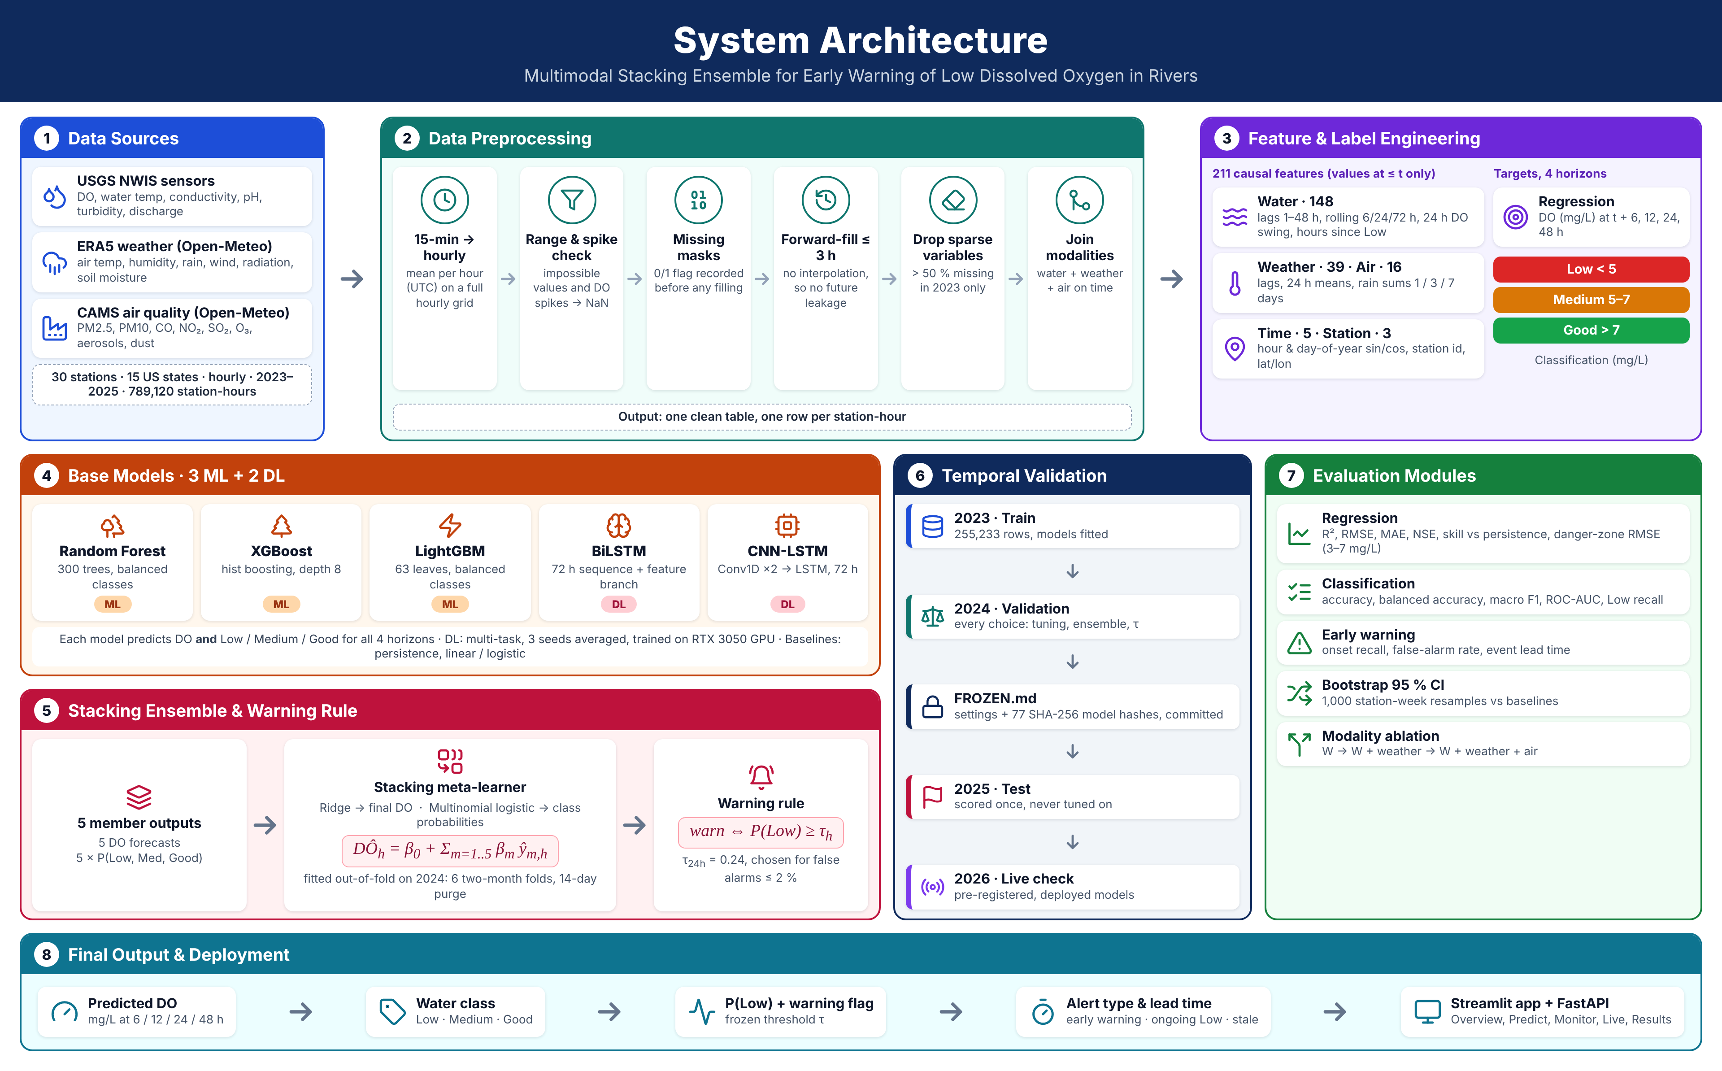
Fig 3.1. System Architecture Diagram
3.2 Dataset and Data Preprocessing
The framework uses hourly data from 30 continuous-monitoring river stations of the USGS National Water Information System [15] located in 15 states of the United States, covering 1 January 2023 to 31 December 2025 (789,120 station-hours). Meteorological and air-quality variables were obtained for each station's coordinates through the Open-Meteo service [16], which provides the ERA5 reanalysis [17] and Copernicus Atmosphere Monitoring Service (CAMS) data [18]. The three modalities are summarised in Table 3.1.

Source | Variables | Access
USGS water sensors | DO, water temperature, conductivity, pH, turbidity, discharge | USGS NWIS
ERA5 weather | Air temperature, humidity, rainfall, pressure, wind, radiation, soil moisture, evapotranspiration | Open-Meteo
CAMS air quality | PM10, PM2.5, CO, NO₂, SO₂, ozone, aerosol optical depth, dust | Open-Meteo
Table 3.1. Data Sources and Variables
Stations were selected to have continuous DO, water temperature and conductivity, at least 80% DO coverage in every year, and genuine low-oxygen episodes in at least two of the three years. Raw sensor readings, reported at 15-minute intervals, were averaged to hourly values on a complete UTC grid. Physically impossible values and isolated DO spikes were set to missing, and a binary missing-value flag was recorded for each variable before any filling.
Gaps of up to three hours were filled by carrying the last observation forward. Linear interpolation was deliberately not used, because an interpolated value at time t would contain information from later observations that a real-time system would not possess. A water-quality variable that was more than 50% missing at a station during the training year was removed for that station, with this decision based on 2023 alone so that later years could not influence it. Negative discharge values were retained, because at tidal stations they represent genuine upstream flow that is physically related to DO.
The DO concentration was mapped to three classes, Low (< 5.0 mg/L), Medium (5.0–7.0 mg/L) and Good (> 7.0 mg/L), following the widely used criterion that DO below 5 mg/L is harmful to aquatic life [19]. A low-DO event begins when DO falls below 5.0 mg/L after at least 24 hours at or above it, and an onset is a forecast case in which the water is not Low at time t but is Low at t + h. The data were divided chronologically by year, without shuffling, as shown in Table 3.2.

Year | Role | Hours with DO | Low (%) | Medium (%) | Good (%)
2023 | Training | 258,025 | 19.1 | 27.3 | 53.6
2024 | Validation | 254,425 | 20.4 | 24.2 | 55.4
2025 | Test | 253,699 | 19.7 | 24.9 | 55.5
Table 3.2. Chronological Data Split and Class Distribution
The class distribution is stable across years, with the Low class representing approximately one fifth of all hours. Individual stations, however, differ substantially: some are Low for more than half of the year, while others rarely experience low DO. The chronological split ensures that the test year is never seen during training or model selection.
3.3 Feature Engineering
Feature engineering is performed to represent the recent history and the environmental drivers of DO using only information available at the time of prediction. All features are strictly causal, meaning that every feature at time t is computed from values at or before t. The tree-based models and the meta-learners use 211 engineered features, grouped as shown in Table 3.3.

Group | Features | Examples
Water | 148 | DO and water-quality lags of 1–48 h; rolling mean, minimum, maximum and standard deviation over 6, 24 and 72 h; 24 h DO swing; DO saturation; hours since last Low
Weather | 39 | Air temperature, radiation and wind; 24 h means; lagged and accumulated rainfall over 1, 3 and 7 days
Air quality | 16 | PM10, PM2.5, gases and their rolling means
Time | 5 | Sine and cosine of hour of day and day of year
Station | 3 | Station identifier, latitude, longitude
Table 3.3. Engineered Feature Groups (211 features)
The 24-hour DO swing, defined as the difference between the maximum and minimum DO over the previous 24 hours, captures the amplitude of the daily photosynthesis–respiration cycle, while the number of hours since the last Low observation summarises recent oxygen stress. Cyclic encodings represent diurnal and seasonal patterns without introducing artificial discontinuities. The recurrent members receive, in addition, the hourly sequence of the previous 72 hours of water variables, missing-value flags, DO saturation, eight weather variables, eight air-quality variables and time encodings, together with a branch for the engineered features. Scalers are fitted on training data only.
3.4 Base Learning Models
Five base models are trained for every horizon. Each model produces a DO forecast and a probability distribution over the three classes, so that the ensemble receives five DO forecasts and fifteen class probabilities.
3.4.1 Random Forest
Random Forest [20] is an ensemble of decision trees trained on bootstrap samples with random feature subsets, whose outputs are averaged. It is robust to noisy features and provides stable probability estimates. The model uses 300 trees, a minimum of 20 samples per leaf, 30% of features considered at each split and balanced class weights computed on each bootstrap sample to counter the imbalance of the Low class.
3.4.2 XGBoost
Extreme Gradient Boosting (XGBoost) [21] builds trees sequentially, each one correcting the residual errors of the previous ensemble, with regularisation of tree complexity. The model uses histogram-based tree construction, a learning rate of 0.05, a maximum depth of 8 and a subsampling ratio of 0.8.
3.4.3 LightGBM
LightGBM [22] is a gradient boosting framework that grows trees leaf-wise using histogram-based splitting, which allows efficient training on large tabular datasets. The model uses a learning rate of 0.05, 63 leaves, a minimum of 50 samples per leaf, balanced class weights and the station identifier as a categorical feature. The number of boosting rounds for each task and horizon was fixed from the 2024 validation results, for example 252 rounds for regression at 24 hours.
3.4.4 BiLSTM
The bidirectional LSTM model applies LSTM cells [23] in both directions over the 72-hour input window [24], so that each position in the window is represented using its preceding and following hours within the past. The sequence representation is concatenated with an embedding of the engineered features. The network is trained in a multi-task configuration that predicts all four horizons for both tasks, with the regression head predicting the change in DO relative to the current value. A hidden size of 32 and a dropout rate of 0.3 are used.
3.4.5 CNN-LSTM
The CNN-LSTM model applies two one-dimensional convolutional layers to the 72-hour window to extract local temporal patterns such as rapid oxygen declines, followed by an LSTM layer that models longer-range dependencies [25]. It shares the feature branch, multi-task heads and regularisation settings of the BiLSTM model. The two deep learning models were trained on an NVIDIA RTX 3050 GPU, and each was averaged over three random seeds (42, 43 and 44) to reduce run-to-run variability.
3.5 Proposed Stacking Ensemble (FLiX-BiC)
The proposed framework combines the five base models through stacked generalisation [26]. Instead of selecting the output of a single model, a meta-learner learns how much to trust each member from their predictions on data that the members did not see during training. Separate meta-learners are fitted for regression and classification at each horizon.
Let ŷ_{m,h}(x) denote the DO forecast of member m ∈ {1, …, 5} at horizon h for input x. The ensemble DO forecast is obtained using a Ridge regression meta-learner [27]:
${DÔ}_{h}(x) = β_{0} + \sum_{m=1}^{5}{β_{m}ŷ_{m,h}(x)}$ (1)
where the coefficients β are estimated by minimising the regularised squared error over the validation predictions:
$min\sum_{i}{{\left(y_{i} − β_{0} − \sum_{m}{β_{m}ŷ_{m,i}}\right)}^{2}} + λ\sum_{m}{β_{m}^{2}}$ (2)
For classification, the fifteen member probabilities are concatenated into a vector z = [p̂_{1,h}, …, p̂_{5,h}], and a multinomial logistic meta-learner estimates the probability of each class c ∈ {Low, Medium, Good}:
$p_{h}(c | x) = \frac{exp({w_{c}}^{T}z + b_{c})}{\sum_{k}{exp({w_{k}}^{T}z + b_{k})}}$ (3)
The meta-learners are fitted on the 2024 predictions of members trained on 2023, so that the meta-learners never see predictions made on training data. To estimate their performance honestly, they were first cross-fitted on six two-month folds of 2024, with 14 days removed on both sides of each held-out fold to cover the 48-hour target and the longest look-back window. The Ridge meta-learner can assign larger weights to members that are accurate near the 5 mg/L boundary, while the logistic meta-learner learns calibrated class probabilities from the combined evidence of tree-based and recurrent members, whose errors are only partially correlated.
3.6 Early-Warning Decision Rule
A conventional classifier assigns the class with the highest probability (argmax). At a 24-hour horizon, however, the most likely class is rarely Low even when the risk of a low-oxygen episode is substantial. The proposed framework therefore issues a warning whenever the predicted probability of the Low class reaches a horizon-specific threshold τ_{h}:
$W_{h}(x) = 𝟙[ p_{h}(Low | x) ≥ τ_{h} ]$ (4)
The threshold is selected on the out-of-fold 2024 probabilities as the value that maximises onset recall subject to a false-alarm rate (FAR) of at most 1.8%:
$τ_{h} = arg \max_{τ} OnsetRecall(τ) s.t. FAR(τ) ≤ 0.018$ (5)
The 1.8% internal budget is deliberately tighter than the 2% false-alarm rate promised to users, because during development a threshold tuned exactly to the limit exceeded it on unseen data. The resulting thresholds for the stacking ensemble are τ = 0.27, 0.24, 0.24 and 0.35 for the 6, 12, 24 and 48-hour horizons, respectively. When a warning is issued, the predicted class is set to Low; otherwise, the argmax class is retained.
3.7 Model Training and Validation
The base models were trained on the 2023 data, and all hyperparameters, numbers of boosting rounds and training epochs, ensemble configuration and warning thresholds were selected on 2024. The deep learning models were optimised with AdamW [28] and dropout [29], and were tuned in four steps (regularisation, hybrid input, 72-hour window and smaller hidden size) selected by validation loss. Because the final members are retrained without early stopping, the number of boosting rounds and epochs (two to four) was fixed from the 2024 results.
Temporal dependence makes random cross-validation unsuitable for time series, since neighbouring hours are nearly identical [30], [31]. Validation was therefore performed with blocked folds and a purge gap, as described in Section 3.5. Before any 2025 target was read, the complete configuration, together with a SHA-256 hash for each of the 77 model files, was written to a freeze file and committed to version control, and an automated test verifies these hashes. The members were then retrained on 2023 and 2024 with the frozen settings and evaluated once on 2025. Uncertainty in the test results was estimated with 1,000 station-week block bootstrap resamples [32], so that autocorrelation within a station-week does not narrow the confidence intervals. The system was implemented in Python using scikit-learn [33], XGBoost, LightGBM and PyTorch [34].
3.8 Baseline Models
Two baseline models were implemented to establish a performance reference for the proposed ensemble. The persistence model assumes that the DO value and class at t + h are equal to those at time t; it is a strong baseline for a variable with a regular daily cycle but, by construction, cannot predict any change of condition. Linear regression and multinomial logistic regression on the same 211 features serve as linear baselines for the regression and classification tasks, respectively. In addition, each of the five base models is evaluated individually. All classifiers use the same warning rule with their own thresholds selected on 2024, so the comparison is like for like. Table 3.4 reports the classification performance on the 2025 test year at the 24-hour horizon.

Model | Accuracy (%) | Macro Precision (%) | Macro Recall (%) | Macro F1-Score (%)
Persistence | 90.07 | 88.06 | 88.06 | 88.06
Logistic Regression | 88.72 | 86.24 | 88.53 | 87.22
Random Forest | 90.57 | 88.08 | 89.55 | 88.75
XGBoost | 90.46 | 87.89 | 89.55 | 88.64
LightGBM | 90.47 | 87.93 | 89.59 | 88.69
BiLSTM | 89.63 | 87.23 | 88.79 | 87.95
CNN-LSTM | 89.36 | 86.54 | 88.73 | 87.53
Proposed Stacking (FLiX-BiC) | 90.39 | 87.78 | 89.60 | 88.60
Table 3.4. Baseline and Base Model Classification Performance on the Test Dataset (24 h)
The results show that the learned models outperform the linear baseline on every metric, and that the tree-based models and the proposed ensemble form a closely matched group. Random Forest achieved the highest accuracy of 90.57% and the highest macro F1-score of 88.75%, while the proposed ensemble achieved the highest macro recall of 89.60%, an accuracy of 90.39% and a macro F1-score of 88.60%. Persistence achieves a competitive accuracy of 90.07% because DO usually remains in the same class 24 hours later, which illustrates why overall accuracy alone is insufficient for evaluating an early-warning system.
3.9 Performance Evaluation Metrics
For regression, let y_{i} and ŷ_{i} denote the observed and predicted DO for N test cases, and ȳ the mean observed DO. The root mean square error, mean absolute error and coefficient of determination are:
$RMSE = \sqrt{\frac{1}{N}\sum_{i=1}^{N}{{\left(y_{i} − ŷ_{i}\right)}^{2}}}$ (6)
$MAE = \frac{1}{N}\sum_{i=1}^{N}{|y_{i} − ŷ_{i}|}$ (7)
$R^{2} = 1 − \frac{\sum_{i}{{\left(y_{i} − ŷ_{i}\right)}^{2}}}{\sum_{i}{{\left(y_{i} − ȳ\right)}^{2}}}$ (8)
The Nash–Sutcliffe efficiency (NSE), widely used in hydrology, has the same form as Equation (8) and therefore coincides numerically with R² on the pooled test data; it is reported for comparability with the hydrological literature. The skill score measures the relative improvement over the persistence baseline:
$Skill = 1 − \frac{{RMSE}_{model}}{{RMSE}_{persistence}}$ (9)
For classification, accuracy is the proportion of correctly classified cases. For each class c, precision, recall and F1-score are defined from the true positives (TP), false positives (FP) and false negatives (FN):
$P_{c} = \frac{{TP}_{c}}{{TP}_{c} + {FP}_{c}}, R_{c} = \frac{{TP}_{c}}{{TP}_{c} + {FN}_{c}}$ (10)
${F1}_{c} = \frac{2P_{c}R_{c}}{P_{c} + R_{c}}$ (11)
Macro-averaged precision, recall and F1-score are the unweighted means of the class-wise values over the three classes, which gives the Low class the same weight as the more frequent Good class. The macro one-versus-rest ROC-AUC measures the ranking quality of the predicted probabilities. Two warning-specific metrics are also reported. Onset recall is the proportion of onsets, i.e. cases that are not Low at time t but Low at t + h, for which a warning was issued. The false-alarm rate is the proportion of non-Low target hours on which a warning was issued. Finally, the lead time of a warned event is the number of hours between the first warning in the 24 hours preceding the event and the event onset.
IV. Result & Discussion
4.1 Regression Performance
The regression performance of the baseline models, the five base models and the proposed stacking ensemble on the 2025 test year at the 24-hour horizon is presented in Table 4.1 and Fig. 4.1. All learned models outperformed persistence, which obtained an RMSE of 0.7553 mg/L. Among the individual models, LightGBM achieved the lowest RMSE of 0.6822 mg/L, followed by the CNN-LSTM model at 0.6860 mg/L. The proposed stacking ensemble achieved the best result of all models, with an R² of 0.9505, an RMSE of 0.6718 mg/L, an MAE of 0.4074 mg/L and a skill of 11.1% relative to persistence.

Model | R² | RMSE (mg/L) | MAE (mg/L) | NSE | Skill
Persistence | 0.9375 | 0.7553 | 0.4569 | 0.9375 | –
Linear Regression | 0.9471 | 0.6950 | 0.4294 | 0.9471 | +0.080
Random Forest | 0.9475 | 0.6924 | 0.4189 | 0.9475 | +0.083
XGBoost | 0.9471 | 0.6951 | 0.4207 | 0.9471 | +0.080
LightGBM | 0.9490 | 0.6822 | 0.4158 | 0.9490 | +0.097
BiLSTM | 0.9480 | 0.6887 | 0.4197 | 0.9480 | +0.088
CNN-LSTM | 0.9484 | 0.6860 | 0.4159 | 0.9484 | +0.092
Proposed Stacking | 0.9505 | 0.6718 | 0.4074 | 0.9505 | +0.111
Table 4.1. Regression Performance on the Test Dataset (24 h)
The deep learning models were individually competitive with the tree-based models in regression, with R² values of 0.9480 for BiLSTM and 0.9484 for CNN-LSTM. The gain of the ensemble over the best single model is modest in absolute terms but consistent: a station-week block bootstrap shows that the RMSE improvement of 0.0104 mg/L over LightGBM at 24 hours has a 95% confidence interval of [−0.0165, −0.0051] mg/L, which excludes zero.
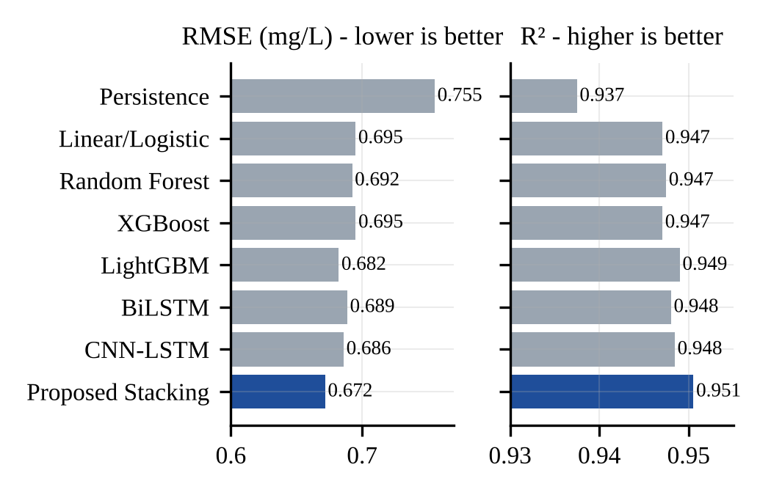
Fig. 4.1. Regression Performance of All Models (24 h)
4.2 Classification Performance
The classification performance at the 24-hour horizon is shown in Fig. 4.2, and additional warning-related metrics are reported in Table 4.2. The tree-based models and the proposed ensemble achieved macro ROC-AUC values between 0.9815 and 0.9823, indicating that their predicted probabilities rank the three classes almost equally well. The proposed ensemble recalled 94.09% of the Low hours, equal to XGBoost and higher than the remaining models, while keeping the lowest false-alarm rate (1.50%) among the models whose onset recall was close to 50%.
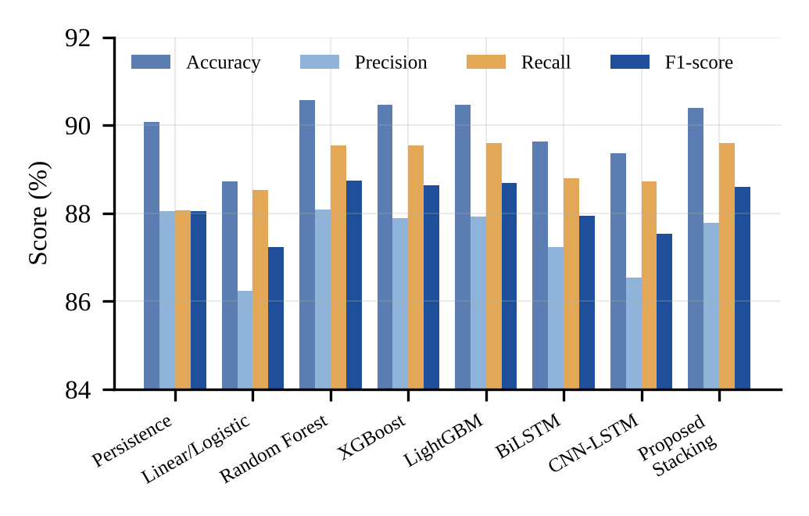
Fig. 4.2. Classification Performance of All Models (24 h)

Model | ROC-AUC | Low Recall (%) | Onset Recall (%) | False Alarm (%)
Persistence | – | 88.59 | 0.00 | 0.00
Logistic Regression | 0.9727 | 91.82 | 37.12 | 1.25
Random Forest | 0.9815 | 93.62 | 45.01 | 1.31
XGBoost | 0.9821 | 94.09 | 49.98 | 1.56
LightGBM | 0.9823 | 93.99 | 49.91 | 1.56
BiLSTM | 0.9783 | 91.36 | 42.41 | 1.32
CNN-LSTM | 0.9791 | 93.54 | 52.21 | 2.00
Proposed Stacking | 0.9815 | 94.09 | 49.58 | 1.50
Table 4.2. Warning-Related Classification Metrics (24 h)
Persistence obtains zero onset recall by construction, because it never predicts a change of condition. The CNN-LSTM model achieved the highest onset recall of 52.21%, but at a false-alarm rate of 2.00%, which reaches the limit promised to users. Random Forest produced fewer false alarms (1.31%) but caught only 45.01% of the onsets. The ensemble therefore offers a balanced operating point between detection and false alarms.
4.3 Class-Wise Performance
Class-wise precision, recall and F1-score of the proposed ensemble are reported in Table 4.3 for all four horizons, and the 24-hour confusion matrix is shown in Fig. 4.3. The Good class is recognised most reliably, with F1-scores between 92.91% and 95.94%, followed by the Low class, with F1-scores between 87.33% and 91.13%. Low-class recall remains above 90% at every horizon, which is the most important property for a warning system.

Horizon | Class | Precision (%) | Recall (%) | F1-Score (%)
6 h | Low | 87.62 | 94.93 | 91.13
 | Medium | 83.81 | 85.17 | 84.48
 | Good | 97.78 | 94.17 | 95.94
12 h | Low | 86.51 | 94.64 | 90.39
 | Medium | 82.88 | 83.68 | 83.28
 | Good | 97.35 | 93.67 | 95.47
24 h | Low | 85.34 | 94.09 | 89.51
 | Medium | 81.17 | 81.71 | 81.44
 | Good | 96.81 | 92.98 | 94.85
48 h | Low | 84.02 | 90.92 | 87.33
 | Medium | 74.56 | 78.83 | 76.63
 | Good | 95.63 | 90.33 | 92.91
Table 4.3. Class-Wise Performance of the Proposed Ensemble
The Medium class is the most difficult, with F1-scores between 76.63% and 84.48%, because it is bounded by two thresholds and its errors are divided between the neighbouring Low and Good classes. At 24 hours, 11.9% of the actual Medium hours were predicted as Low; this is partly a deliberate consequence of the warning rule, which accepts some Medium hours being flagged in exchange for a higher recall of the Low class. Only 0.5% of actual Low hours were predicted as Good and 0.4% of Good hours as Low, indicating that severe misclassifications between the extreme classes are rare.
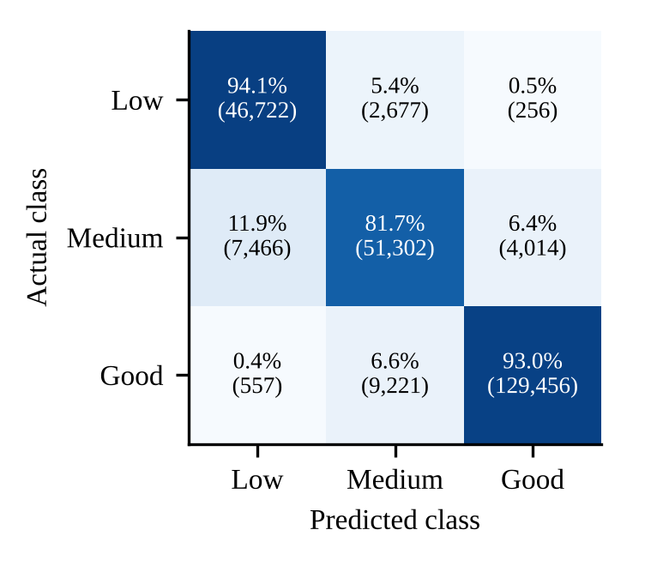
Fig. 4.3. Confusion Matrix of the Proposed Ensemble (24 h)
4.4 Performance Across Forecast Horizons
The performance of the proposed ensemble at each forecast horizon is summarised in Table 4.4 and Fig. 4.4. Forecast error increases smoothly with the horizon, from an RMSE of 0.5144 mg/L at 6 hours to 0.8535 mg/L at 48 hours, while R² decreases from 0.9710 to 0.9202. Classification accuracy decreases from 92.08% to 87.57% and the macro F1-score from 90.52% to 85.62%. The ensemble achieved the lowest RMSE of all models at every horizon.

Horizon | R² | RMSE | MAE | Accuracy (%) | Macro F1 (%) | Onset Recall (%)
6 h | 0.9710 | 0.5144 | 0.3125 | 92.08 | 90.52 | 86.10
12 h | 0.9621 | 0.5882 | 0.3557 | 91.37 | 89.72 | 86.08
24 h | 0.9505 | 0.6718 | 0.4074 | 90.39 | 88.60 | 49.58
48 h | 0.9202 | 0.8535 | 0.5558 | 87.57 | 85.62 | 48.53
Table 4.4. Proposed Ensemble Performance Across Horizons
Persistence behaves very differently across horizons. Its RMSE is 1.344 mg/L at 6 hours and 1.532 mg/L at 12 hours, but only 0.755 mg/L at 24 hours, because DO measured at the same hour on the following day is close to the present value. The skill of the ensemble over persistence is therefore large at 6 and 12 hours (61.7% and 61.6%) and smaller but still positive at 24 and 48 hours (11.1% and 15.3%). Onset recall shows the same pattern: approximately 86% of onsets are anticipated at 6 and 12 hours, compared with approximately 49% at 24 and 48 hours.
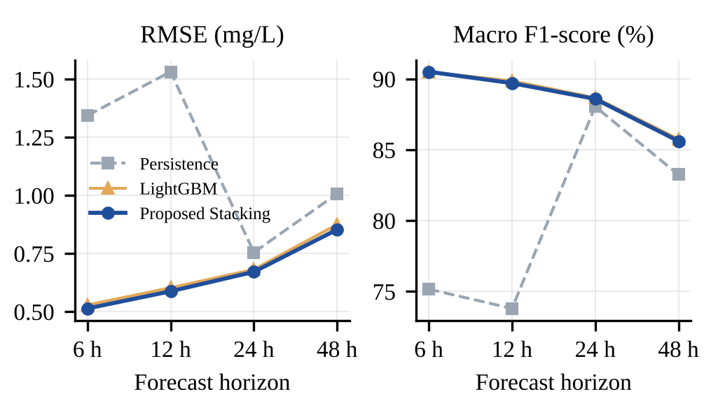
Fig. 4.4. Performance Across Forecast Horizons
4.5 Comparison Between Baseline and Proposed Models
The proposed ensemble outperformed persistence at every horizon on RMSE, macro F1-score and onset recall, with all 95% bootstrap confidence intervals excluding zero. Against the best single model, the ensemble achieved a statistically significant reduction in RMSE at all four horizons (0.0150, 0.0152, 0.0104 and 0.0217 mg/L at 6, 12, 24 and 48 hours). For classification, however, the differences in macro F1-score between the ensemble and the best single model were within ±0.001 and not statistically significant at any horizon, and onset recall was significantly higher only at 48 hours. Therefore, the current results establish the ensemble as the most accurate DO forecaster, but do not establish that it outperforms the strongest tree-based classifiers.
The analysis of member errors explains this behaviour. At 24 hours, the errors of the gradient-boosted tree models are highly correlated with each other (Pearson correlation 0.963–0.976), whereas the correlation between a deep learning model and a tree-based model is lower (0.905–0.955). Although each deep learning model is individually weaker than the best tree, it errs on different hours, and combining models with less correlated errors cancels more error. The two deep learning models are almost interchangeable (0.995), which indicates that adding a third recurrent model would contribute little.
4.6 Early-Warning Performance and Lead Time
Table 4.5 compares the onset recall and false-alarm rate of the ensemble when classes are assigned by argmax and when the warning rule is applied. At 24 hours, the warning rule raised onset recall from 28.5% to 49.6%, an increase of 21.1 percentage points (95% CI [19.4, 22.9]), so that 1.7 times as many onsets were caught, while the false-alarm rate increased from 0.46% to 1.50%. The false-alarm rate remained within the 2% budget at every horizon. This gain is an order of magnitude larger than the gain obtained by choosing the stacking ensemble over the best single model.

Horizon | Onset Recall Argmax (%) | Onset Recall Rule (%) | False Alarm Argmax (%) | False Alarm Rule (%)
6 h | 80.0 | 86.1 | 1.03 | 1.75
12 h | 79.5 | 86.1 | 0.96 | 1.73
24 h | 28.5 | 49.6 | 0.46 | 1.50
48 h | 38.0 | 48.5 | 0.70 | 1.33
Table 4.5. Effect of the Warning Rule on the Proposed Ensemble
At the event level, the 2025 test year contained 230 low-DO events across all 30 stations. Using the 24-hour warning rule, 119 events (51.7%) were preceded by at least one warning, with a median lead time of 20 hours and a mean of 14.6 hours. As shown in Fig. 4.5, the largest group of warned events received close to the full 24 hours of notice, which provides operators with sufficient time to prepare interventions.
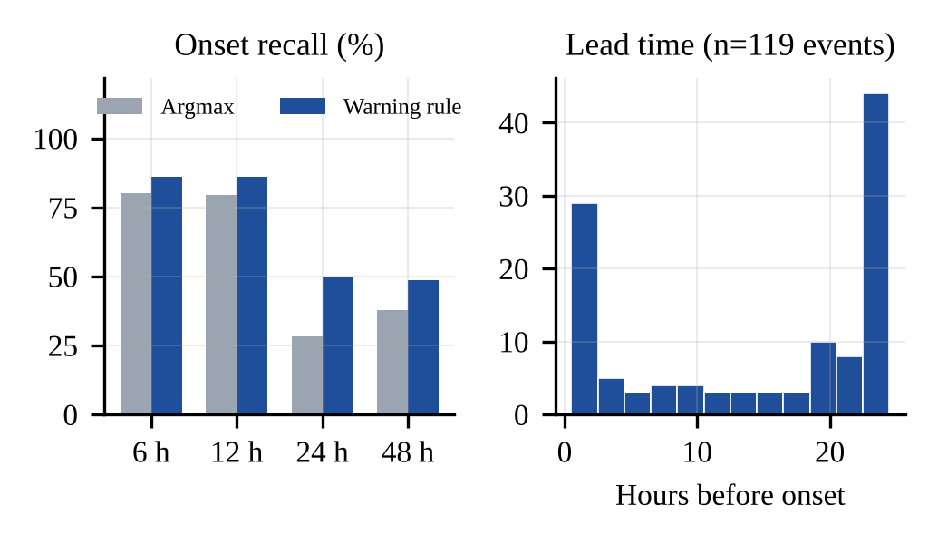
Fig. 4.5. Onset Recall With and Without the Warning Rule, and Lead-Time Distribution
4.7 Multimodal Ablation Study
To quantify the contribution of each data source, LightGBM was retrained with the frozen settings on three input sets: water, time and station features only (W); with weather features added (W+M); and with air-quality features added (W+M+A). Using a single model with identical settings ensures that the differences arise from the data rather than from the model. The results on the 2025 test year are reported in Table 4.6.

Input Set | Features | RMSE 24 h | R² 24 h | Macro F1 24 h (%) | RMSE 48 h
W | 156 | 0.7001 | 0.9463 | 88.70 | 0.8954
W+M | 195 | 0.6834 | 0.9488 | 88.83 | 0.8736
W+M+A | 211 | 0.6809 | 0.9492 | 88.79 | 0.8722
Table 4.6. Multimodal Ablation Results (LightGBM)
Water-quality sensors carry most of the predictive signal: the water-only model already achieved a macro F1-score of 88.70% at 24 hours. Adding weather features reduced the 24-hour RMSE by 2.4% (from 0.7001 to 0.6834 mg/L) and the 48-hour RMSE by 2.4%, confirming that meteorological forcing helps anticipate changes in DO. Adding air-quality features yielded a further small reduction in RMSE and raised onset recall at 24 hours from 48.80% to 49.44%, while the macro F1-score remained essentially unchanged. The value of the air-quality modality is therefore small but consistent, and should be weighed against the cost of acquiring such data in practical deployments.
4.8 Cross-Validation Results
Blocked six-fold cross-validation on the 2024 validation year was used to examine the stability of the models across seasons. In each fold, a two-month period was held out, the meta-learners were fitted on the remaining folds with a 14-day purge, and the base models, trained on 2023 only, had not seen any of the 2024 data. The per-fold results of the proposed ensemble at 24 hours are reported in Table 4.7 and compared with LightGBM in Fig. 4.6.

Fold | Accuracy (%) | Macro F1 (%) | R² | RMSE (mg/L)
Jan–Feb | 97.26 | 86.89 | 0.9622 | 0.5099
Mar–Apr | 92.20 | 88.99 | 0.9146 | 0.7372
May–Jun | 85.45 | 85.82 | 0.8950 | 0.6577
Jul–Aug | 82.15 | 81.93 | 0.8999 | 0.7597
Sep–Oct | 87.63 | 86.14 | 0.9345 | 0.6699
Nov–Dec | 93.59 | 88.76 | 0.9642 | 0.5244
Mean ± SD | 89.71 ± 5.62 | 86.42 ± 2.57 | 0.9284 ± 0.0303 | 0.6431 ± 0.1051
Table 4.7. Blocked Cross-Validation of the Proposed Ensemble on 2024 (24 h)
The ensemble achieved a mean accuracy of 89.71% ± 5.62 and a mean macro F1-score of 86.42% ± 2.57, close to the 2025 test results of 90.39% and 88.60%, indicating that the performance generalises across years. Performance was highest in the winter folds and lowest in July–August, when warm water and intense biological activity produce the largest and least predictable DO fluctuations. Across folds, the ensemble achieved the lowest mean RMSE (0.6431 mg/L) and the highest mean R² (0.9284) of all models, compared with 0.6499 mg/L and 0.9268 for LightGBM, 0.6571 mg/L for XGBoost and 0.6586 mg/L for Random Forest. The mean macro F1-scores of the ensemble and the tree-based models were within 0.12 percentage points of each other (86.42% for the ensemble and 86.54% for XGBoost), consistent with the test-year finding that their classification performance is statistically equivalent.
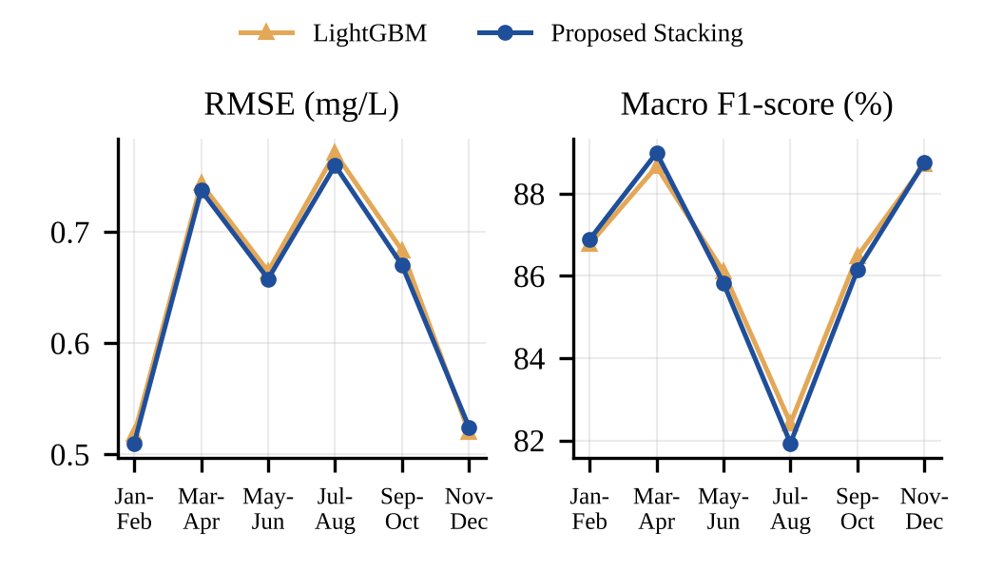
Fig. 4.6. Cross-Validation Results per Fold (2024, 24 h)
4.9 Discussion
The experimental results show that the proposed multimodal stacking ensemble provides the most accurate DO forecasts among all evaluated models, with the lowest RMSE at every horizon on the test year and the lowest mean RMSE in cross-validation. For classification, the ensemble, Random Forest, XGBoost and LightGBM form a closely matched group whose differences are smaller than the run-to-run variability of the deep learning members (a seed-to-seed standard deviation of up to 0.41 percentage points in macro F1-score). The results therefore support the use of the ensemble as a single system that is best in regression and on par with the best models in classification, rather than a claim of superiority on every metric.
The most valuable component for early detection is the decision layer. Converting class probabilities into warnings with a threshold tuned to a false-alarm budget nearly doubled the share of onsets caught at 24 hours, a substantially larger effect than any choice among ensemble methods. Two more complex ensemble methods, an adaptive threshold-aware weighting scheme and a context-aware LightGBM combiner, were also developed but were rejected on the 2024 validation year by decision rules written before their results were known. The strict chronological protocol also proved valuable after deployment: the deployed models, retrained on 2023–2025, were evaluated on 2026 data (1 January to 13 October, 28 of 30 stations) against a pre-registered plan and achieved an R² of 0.936, an RMSE of 0.738 mg/L, a macro F1-score of 87.2% and a false-alarm rate of 1.65% at 24 hours. The false-alarm promise held, but RMSE and macro F1-score fell outside the 2025 confidence intervals, indicating year-to-year variability that a single test year would not reveal.
Several limitations should be noted. Every test station also appears in the training data, so the results measure forecasting at monitored rivers rather than transfer to unmonitored ones. Approximately half of the onsets at the 24 and 48-hour horizons are still missed, and performance varies considerably between stations: at 24 hours, onset recall ranges from 90.6% at the best station to zero at stations with very few onsets. Pooled metrics can therefore conceal stations at which the system performs poorly, and station-specific thresholds may be required in operational use.
V. Conclusion
This study proposed a multimodal machine learning framework for the early warning of dissolved-oxygen deterioration in rivers. The framework fuses hourly USGS water-quality sensor data with ERA5 weather and CAMS air-quality data for 30 river stations, derives 211 strictly causal features, and jointly forecasts the DO concentration and its Low, Medium or Good class at horizons of 6, 12, 24 and 48 hours. Three machine learning models (Random Forest, XGBoost and LightGBM) and two deep learning models (BiLSTM and CNN-LSTM) were combined through the FLiX-BiC stacking ensemble, with a Ridge meta-learner for regression and a multinomial logistic meta-learner for classification, followed by a probability-threshold warning rule tuned to a 2% false-alarm budget. The system was trained on 2023, designed on 2024, frozen, and evaluated once on the unseen 2025 test year.
The experimental results showed that the proposed ensemble achieved an R² of 0.951, an RMSE of 0.672 mg/L, an accuracy of 90.39%, a macro F1-score of 88.60% and a Low-class recall of 94.09% at 24 hours, with R² ranging from 0.971 at 6 hours to 0.920 at 48 hours. The ensemble obtained the lowest regression error at every horizon, while its classification performance was statistically comparable to the strongest tree-based models. The warning rule caught 49.6% of 24-hour onsets at a false-alarm rate of 1.50%, and 51.7% of the 230 low-DO events in 2025 were warned in advance with a median lead time of 20 hours. The ablation study showed that water-quality sensors carry most of the predictive signal, with weather and air-quality data providing smaller but consistent improvements.
Overall, the findings emphasise that, for an early-warning system, the decision rule and a leakage-free evaluation protocol are as important as the choice of learning algorithm. Future work will focus on improving onset recall at longer horizons through onset-weighted training, replacing reanalysis weather with numerical weather forecasts for fully operational use, attaching explanations to each issued warning, extending the warnings to other parameters such as ammonia and turbidity, and adapting the framework to Indian rivers using real-time monitoring stations of the Central Pollution Control Board. Further evaluation on stations not used in training will also be necessary to assess the generalisability of the framework to unmonitored rivers.
REFERENCES
[1] W. Zhi, D. Feng, W.-P. Tsai, G. Sterle, A. Harpold, C. Shen, and L. Li, “From hydrometeorology to river water quality: Can a deep learning model predict dissolved oxygen at the continental scale?,” Environmental Science & Technology, vol. 55, no. 4, pp. 2357–2368, 2021, doi: 10.1021/acs.est.0c06783.
[2] R. Barzegar, M. T. Aalami, and J. Adamowski, “Short-term water quality variable prediction using a hybrid CNN–LSTM deep learning model,” Stochastic Environmental Research and Risk Assessment, vol. 34, pp. 415–433, 2020, doi: 10.1007/s00477-020-01776-2.
[3] J. Moon, J. Lee, S. Lee, and H. Yoon, “Urban river dissolved oxygen prediction model using machine learning,” Water, vol. 14, no. 12, Art. no. 1899, 2022.
[4] P. A. C. Rocha, V. O. Santos, J. Van Griensven Thé, and B. Gharabaghi, “New graph-based and transformer deep learning models for river dissolved oxygen forecasting,” Environments, vol. 10, no. 12, Art. no. 217, 2023.
[5] N. Pant, D. Toshniwal, and B. R. Gurjar, “Multi-step forecasting of dissolved oxygen in River Ganga based on CEEMDAN-AdaBoost-BiLSTM-LSTM model,” Scientific Reports, vol. 14, Art. no. 11199, 2024, doi: 10.1038/s41598-024-61910-w.
[6] F. Granata, S. Zhu, and F. Di Nunno, “Dissolved oxygen forecasting in the Mississippi River: Advanced ensemble machine learning models,” Environmental Science: Advances, vol. 3, pp. 1537–1551, 2024, doi: 10.1039/D4VA00119B.
[7] S. Shadkani, Y. Hemmatzadeh, A. Saber, and M. Mohammadi Sergini, “Enhanced predictive modeling of dissolved oxygen concentrations in riverine systems using novel hybrid temporal pattern attention deep neural networks,” Environmental Research, vol. 263, Art. no. 120015, 2024, doi: 10.1016/j.envres.2024.120015.
[8] V. Cerqueira et al., “Forecasting ocean hypoxia in salmonid fish farms,” Frontiers in Aquaculture, vol. 3, Art. no. 1365123, 2024.
[9] I. Simonetti, C. Lubello, and L. Cappietti, “On the use of hydrodynamic modelling and random forest classifiers for the prediction of hypoxia in coastal lagoons,” Science of the Total Environment, vol. 951, Art. no. 175424, 2024.
[10] Y. Zhao and M. Chen, “Prediction of river dissolved oxygen (DO) based on multi-source data and various machine learning coupling models,” PLOS ONE, vol. 20, no. 3, Art. no. e0319256, 2025.
[11] K. Merabet et al., “Predicting water quality variables using gradient boosting machine: Global versus local explainability using SHapley Additive Explanations (SHAP),” Earth Science Informatics, vol. 18, Art. no. 298, 2025.
[12] R. Choudhary et al., “Predicting water quality index using stacked ensemble regression and SHAP based explainable artificial intelligence,” Scientific Reports, vol. 15, Art. no. 31139, 2025.
[13] C. Singha, I. Bhattacharjee, S. Sahoo, K. Abdelrahman, M. G. Uddin, M. S. Fnais, A. Govind, and M. Abioui, “Prediction of urban surface water quality scenarios using hybrid stacking ensembles machine learning model in Howrah Municipal Corporation, West Bengal,” Journal of Environmental Management, vol. 370, Art. no. 122721, 2024, doi: 10.1016/j.jenvman.2024.122721.
[14] X. Chen, C. Zhao, J. Chen, H. Jiang, D. Li, J. Zhang, B. Han, S. Chen, and C. Wang, “Water quality parameters-based prediction of dissolved oxygen in estuaries using advanced explainable ensemble machine learning,” Journal of Environmental Management, vol. 380, Art. no. 125146, 2025, doi: 10.1016/j.jenvman.2025.125146.
[15] U.S. Geological Survey, “National Water Information System (NWIS) — instantaneous values web service.” [Online]. Available: https://waterservices.usgs.gov
[16] P. Zippenfenig, “Open-Meteo.com Weather API,” Zenodo, 2023, doi: 10.5281/zenodo.8112599.
[17] H. Hersbach et al., “The ERA5 global reanalysis,” Quarterly Journal of the Royal Meteorological Society, vol. 146, no. 730, pp. 1999–2049, 2020.
[18] A. Inness et al., “The CAMS reanalysis of atmospheric composition,” Atmospheric Chemistry and Physics, vol. 19, pp. 3515–3556, 2019.
[19] U.S. Environmental Protection Agency, Ambient Water Quality Criteria for Dissolved Oxygen, EPA 440/5-86-003, Washington, DC, USA, 1986.
[20] L. Breiman, “Random forests,” Machine Learning, vol. 45, no. 1, pp. 5–32, 2001.
[21] T. Chen and C. Guestrin, “XGBoost: A scalable tree boosting system,” in Proc. 22nd ACM SIGKDD Int. Conf. Knowledge Discovery and Data Mining, 2016, pp. 785–794.
[22] G. Ke et al., “LightGBM: A highly efficient gradient boosting decision tree,” in Advances in Neural Information Processing Systems, vol. 30, 2017, pp. 3146–3154.
[23] S. Hochreiter and J. Schmidhuber, “Long short-term memory,” Neural Computation, vol. 9, no. 8, pp. 1735–1780, 1997.
[24] M. Schuster and K. K. Paliwal, “Bidirectional recurrent neural networks,” IEEE Transactions on Signal Processing, vol. 45, no. 11, pp. 2673–2681, 1997.
[25] T. N. Sainath, O. Vinyals, A. Senior, and H. Sak, “Convolutional, long short-term memory, fully connected deep neural networks,” in Proc. IEEE Int. Conf. Acoustics, Speech and Signal Processing (ICASSP), 2015, pp. 4580–4584.
[26] D. H. Wolpert, “Stacked generalization,” Neural Networks, vol. 5, no. 2, pp. 241–259, 1992.
[27] A. E. Hoerl and R. W. Kennard, “Ridge regression: Biased estimation for nonorthogonal problems,” Technometrics, vol. 12, no. 1, pp. 55–67, 1970.
[28] I. Loshchilov and F. Hutter, “Decoupled weight decay regularization,” in Proc. Int. Conf. Learning Representations (ICLR), 2019.
[29] N. Srivastava, G. Hinton, A. Krizhevsky, I. Sutskever, and R. Salakhutdinov, “Dropout: A simple way to prevent neural networks from overfitting,” Journal of Machine Learning Research, vol. 15, pp. 1929–1958, 2014.
[30] C. Bergmeir and J. M. Benítez, “On the use of cross-validation for time series predictor evaluation,” Information Sciences, vol. 191, pp. 192–213, 2012.
[31] D. R. Roberts et al., “Cross-validation strategies for data with temporal, spatial, hierarchical, or phylogenetic structure,” Ecography, vol. 40, no. 8, pp. 913–929, 2017.
[32] H. R. Künsch, “The jackknife and the bootstrap for general stationary observations,” The Annals of Statistics, vol. 17, no. 3, pp. 1217–1241, 1989.
[33] F. Pedregosa et al., “Scikit-learn: Machine learning in Python,” Journal of Machine Learning Research, vol. 12, pp. 2825–2830, 2011.
[34] A. Paszke et al., “PyTorch: An imperative style, high-performance deep learning library,” in Advances in Neural Information Processing Systems, vol. 32, 2019, pp. 8024–8035.

