|  |  |
| --- | --- |
| **Project Case** |  |
| COMP7116  Computer Vision |
| **Computer Science** | **O212-COMP7116-BE03-00** |
| ***Valid on*** *Odd Semester 2020/2021* | **Revision 00** |

1. Seluruh kelompok tidak diperkenankan untuk:

*The whole group is not allowed to:*

* + 1. Melihat sebagian atau seluruh proyek kelompok lain,

*Seeing a part or the whole project from other groups*

* + 1. Menyadur sebagian maupun seluruh proyek dari buku,

*Adapted a part or the whole project from the book*

* + 1. Mendownload sebagian maupun seluruh proyek dari internet,

*Downloading a part or the whole project from the internet,*

* + 1. Mengerjakan soal yang tidak sesuai dengan tema yang ada di soal proyek,

*Working with another theme which is not in accordance with the existing theme in the matter of the project,*

* + 1. Melakukan tindakan kecurangan lainnya,

*Committing other dishonest actions,*

* + 1. Secara sengaja maupun tidak sengaja melakukan segala tindakan kelalaian yang menyebabkan hasil karyanya berhasil dicontek oleh orang lain / kelompok lain.

*Accidentally or intentionally conduct any failure action that cause the results of the project was copied by someone else / other groups.*

1. Jika kelompok terbukti melakukan tindakan seperti yang dijelaskan butir 1 di atas, maka **nilai kelompok** yang melakukan kecurangan (menyontek maupun dicontek) akan di – **NOL** – kan.

*If the group is proved to the actions described in point 1 above, the score of the group which committed dishonest acts (cheating or being cheated) will be “Zero”*

1. Perhatikan jadwal pengumpulan proyek, segala jenis pengumpulan proyek di luar jadwal tidak dilayani.

*Pay attention to the submission schedule for the project, all kinds of submission outside the project schedule will not be accepted*

1. Persentase penilaiaan untuk matakuliah ini adalah sebagai berikut:

*Marking percentage for this subject is described as follows:*

|  |  |  |
| --- | --- | --- |
| **Tugas Mandiri**  *Assignment* | **Proyek**  *Project* | **UAP**  *Final Exam* |
| 40% | 60% | - |

1. Software yang digunakan pada matakuliah ini adalah sebagai berikut:

*Software will be used in this subject are described as follows:*

|  |
| --- |
| **Software**  *Software* |
| Visual Studio Code  Python 3.7  SciPy 1.5.0  OpenCV 3.4.2.16 |

## Ekstensi file yang harus disertakan dalam pengumpulan tugas mandiri, proyek dan uap untuk matakuliah ini adalah sebagai berikut:

*File extensions should be included in assignment, project, and final exam collection for this subject are described as follows:*

|  |  |  |
| --- | --- | --- |
| **Tugas Mandiri**  *Assignment* | **Proyek**  *Project* | **UAP**  *Final Exam* |
| PY | PY | - |

## Soal

*Case*

**Akinator Vision**

**Akinator** is a game that initially are created to predict famous characters by answering some questions to predict but now **Akinator** wants to improve in **Artificial Intelligence** concept,especially **Computer Vision**. The new **Akinator** is working on **Akinator Vision** which recognizes famous characters only based off pictures and theywant to add a new computer vision feature to some applications which are already developed. This feature will allow the applications to detect and recognize every character based on **profile** **image** with **single face** which have been uploaded to the developed applications. Therefore, as a programmer in **Akinator Vision**, you are asked to create simple demo feature using **Python programming language** and **OpenCv Library**.

* **Dataset Description**

The given dataset contains **training dataset** consisting of total **44 profile pictures** of **7 users** that already uploaded from the applications that already developed by **Akinator Vision** and **testing images** consisting of **5** **random user**’**s profile pictures**.

* **Get Training Images Labels**

The directories of the **given training dataset** will be stored into a **list** containing the **names of each famous characters**. This list will also be used as the **labels** of the training images.

* **Get Training Images Data**

The **image data** will be stored into a **list** of **images**.

* **Detect Faces and Filter**

**Faces** inside the **training** **images** will be **detected** and stored into a **list** of **images**. The **position** and **size** of the **detected faces** will also be stored into a **list** of **rectangles**. You also need to **filter** the training images if there are **no face or more than one face detected** (**Resize** image width to **300 pixels** and image height to the corresponding ratio for **train images)**.

* **Training Data**

The list of **face images** which are already detected will be used to train **face recognition classifier**.

* **Get Testing Images Data**

The **chosen testing images** will be **loaded** and **stored**.

* **Predict Testing Images**

The **list** of **testing images** will be **predicted** to **produce** the **prediction results** based on the **trained** **classifier** above.

* **Write Prediction Results**

The **prediction results** which consist of the **predicted** **names** of the **users** will be **drawn** to every **testing image**. The **rectangle** **around the face** **stored** in the previous step will also be **drawn** together.

* **Combine and Show**

**List** of **testing images** that has been drawn will be **combined** onto a **single image**. After that, the program will **show** the **combined result.**

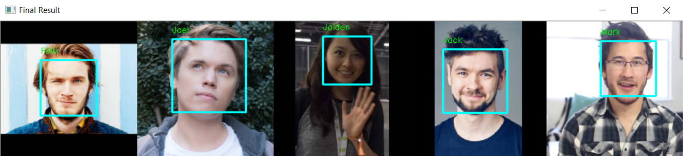

**Figure 1. Result Image**

**Guidelines:**

1. **All** the **steps mentioned in the case** should be **put** in the **corresponding function** in the **template**. **All codes written** **outside** the **corresponding function** will **not be marked**.
2. Do not **modify** or **erase** **any** **codes** in the **template**.

**Reference:**

* + - The dataset is obtained from Google Images. (Note: some datasets are modified for the purpose of this case)