|  |  |
| --- | --- |
| **Project Case** |  |
| COMP7116001  Computer Vision |
| **Computer Science** | **O222-COMP7116-MQ02-00** |
| ***Valid on*** *Odd Semester Year 2021/2022* | **Revision 00** |

1. Seluruh kelompok tidak diperkenankan untuk:

*The whole group is not allowed to:*

* + 1. Melihat sebagian atau seluruh proyek kelompok lain,

*Seeing a part or the whole project from another groups*

* + 1. Menyadur sebagian maupun seluruh proyek dari buku,

*Adapted a part or the whole project from the book*

* + 1. Mendownload sebagian maupun seluruh proyek dari internet,

*Downloading a part or the whole project from the internet,*

* + 1. Mengerjakan soal yang tidak sesuai dengan tema yang ada di soal proyek,

*Working with another theme which is not in accordance with the existing theme in the matter of the project,*

* + 1. Melakukan tindakan kecurangan lainnya,

*Committing other dishonest actions,*

* + 1. Secara sengaja maupun tidak sengaja melakukan segala tindakan kelalaian yang menyebabkan hasil karyanya berhasil dicontek oleh orang lain / kelompok lain.

*Accidentally or intentionally conduct any failure action that cause the results of the project was copied by someone else / other groups.*

1. Jika kelompok terbukti melakukan tindakan seperti yang dijelaskan butir 1 di atas, maka **nilai kelompok** yang melakukan kecurangan (menyontek maupun dicontek) akan di – **NOL** – kan.

*If the group is proved to the actions described in point 1 above, the score of the group which committed dishonest acts (cheating or being cheated) will be “Zero”*

1. Perhatikan jadwal pengumpulan proyek, segala jenis pengumpulan proyek di luar jadwal tidak dilayani.

*Pay attention to the submission schedule for the project, all kinds of submission outside the project schedule will not be accepted*

1. Bila Anda tidak membaca peraturan ini, maka Anda dianggap telah membaca dan menyetujuinya

*If you have missed to read these regulations, so you are considered to have read and agreed on it*

1. Persentase penilaiaan untuk matakuliah ini adalah sebagai berikut:

*Marking percentage for this subject is described as follows:*

|  |  |
| --- | --- |
| **Tugas Mandiri**  *Assignment* | **Proyek**  *Project* |
| 40% | 60% |

1. Software yang digunakan pada matakuliah ini adalah sebagai berikut:

*Software will be used in this subject are described as follows:*

|  |
| --- |
| **Software**  *Software* |
| Visual Studio Code  Python 3.7  SciPy 1.5.0  OpenCV 3.4.2.16 |

## Ekstensi file yang harus disertakan dalam pengumpulan tugas mandiri, proyek dan uap untuk matakuliah ini adalah sebagai berikut:

*File extensions should be included in assignment, project, and final exam collection for this subject are described as follows:*

|  |  |
| --- | --- |
| **Tugas Mandiri**  *Assignment* | **Proyek**  *Project* |
| PY | PY |

## Soal

*Case*

**Top Secret**

**Top Secret** is a new application currently being developed by **CloseAI**. This company focus on developing application with **Artificial Intelligence** concept,especially **Computer Vision**. **Top Secret** needs to add a new computer vision feature to some applications which are already developed. This feature will allow the applications to recognize every user based on **profile** **image** with a **single face** and determine if the user **verified** or **not**. Therefore, as a programmer of **CloseAI**, you are asked to create that feature using **Python programming language** and **OpenCV Library**.

* **Dataset Description**

The given dataset contains **training datasets** consist of **7 - 12 profile images of** **each user** that already uploaded from the applications and **testing images** consisting of **6** **random user**’**s profile images**.

* **Get Path List**

The directories of the **given training dataset** will be stored into a **list** containing the **names of directories**. This list will also be used as the **labels** of the training images.

* **Get Class Id**

The image from the **training dataset** will be **stored** into a **list** and every class will have a generated **image class id**.

* **Detect Face and Filter**

**Faces** inside the **training** **images** will be **detected** and stored into a **list** **of** **images**. The **position** and **size** of the **detected** **face** will also be stored into a **list of rectangles**. You also need to **filter** the training images if there is **no face, or more than one face detected**.

* **Train**

The **list** of **face images** which already **detected** will be used to **train** the **face recognizer**.

* **Get Test Image Data**

The **image** from the **test dataset** will be **loaded** and **stored** into a **list of images**.

* **Predict**

The **list** of **testing images** will be **predicted** to **produce** the **prediction** **result** based on **trained** **recognizer**.

* **Get Verification Status**

The **list** of **prediction** **results** will be **verified** to **produce** the **verification statuses** based on the **list** of **unverified names. Verification statuses** consist of **prediction results** which each of the results will be labeled as “**Verified**” or “**Unverified**”.

* **Draw Prediction Result**

The **list** of **verification statuses** and **prediction results** will be **drawn** to every single test image.

* **Combine and Show Result**

**A list** of **testing images** that have been drawn will be **combined** into a **single image** with the **first row** will be **unverified** user and the **second** **row** the **verified** user. Then all of it must be **resized** with **250 x 250 px** After being combined, **show** the **final image result**.

* **Unverified User**

You are asked to **tag the unverified** **user** with **name** “**Raditya Dika**”, “**Anya Geraldine**”, and “**Raffi Ahmad**”.

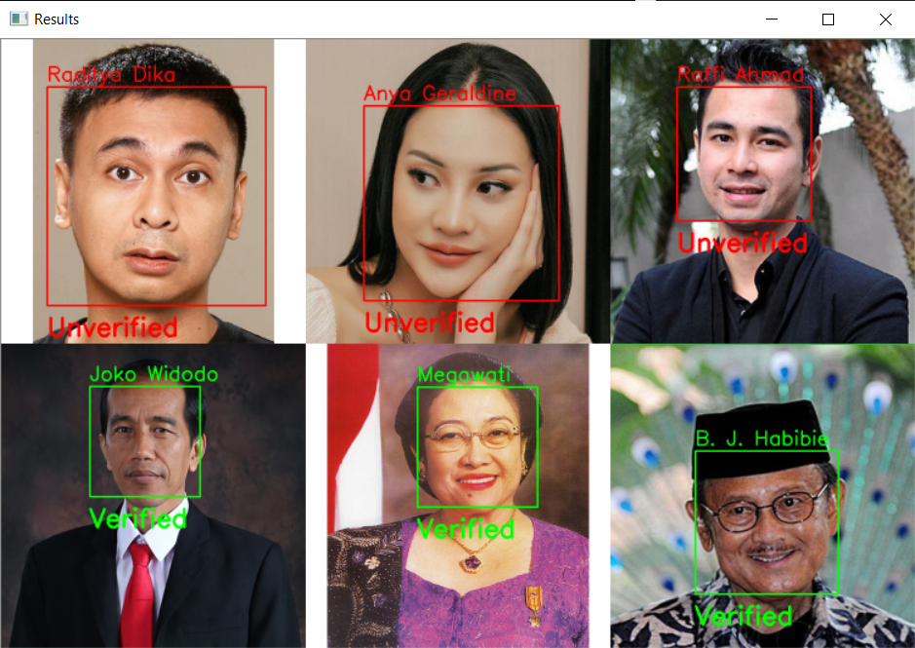

**Figure 1. Image Final Result**

**Guidelines:**

1. **All** the **steps mentioned in the case** should be **put** in the **corresponding function** in the **template**. **All codes written** **outside** the **corresponding function** will **not be marked**.
2. Do not **modify** or **erase** **any** **codes** in the **template**.

**Reference:**

* + - The dataset is obtained from Google Image