|  |  |
| --- | --- |
| **Project Case** |  |
| COMP7116001  Computer Vision |
| **Computer Science** | **O222-COMP7116-LO01-00** |
| ***Valid on*** *Odd Semester Year 2021/2022* | **Revision 00** |

1. Seluruh kelompok tidak diperkenankan untuk:

*The whole group is not allowed to:*

* + 1. Melihat sebagian atau seluruh proyek kelompok lain,

*Seeing a part or the whole project from another groups*

* + 1. Menyadur sebagian maupun seluruh proyek dari buku,

*Adapted a part or the whole project from the book*

* + 1. Mendownload sebagian maupun seluruh proyek dari internet,

*Downloading a part or the whole project from the internet,*

* + 1. Mengerjakan soal yang tidak sesuai dengan tema yang ada di soal proyek,

*Working with another theme which is not in accordance with the existing theme in the matter of the project,*

* + 1. Melakukan tindakan kecurangan lainnya,

*Committing other dishonest actions,*

* + 1. Secara sengaja maupun tidak sengaja melakukan segala tindakan kelalaian yang menyebabkan hasil karyanya berhasil dicontek oleh orang lain / kelompok lain.

*Accidentally or intentionally conduct any failure action that cause the results of the project was copied by someone else / other groups.*

1. Jika kelompok terbukti melakukan tindakan seperti yang dijelaskan butir 1 di atas, maka **nilai kelompok** yang melakukan kecurangan (menyontek maupun dicontek) akan di – **NOL** – kan.

*If the group is proved to the actions described in point 1 above, the score of the group which committed dishonest acts (cheating or being cheated) will be “Zero”*

1. Perhatikan jadwal pengumpulan proyek, segala jenis pengumpulan proyek di luar jadwal tidak dilayani.

*Pay attention to the submission schedule for the project, all kinds of submission outside the project schedule will not be accepted*

1. Bila Anda tidak membaca peraturan ini, maka Anda dianggap telah membaca dan menyetujuinya

*If you have missed to read these regulations, so you are considered to have read and agreed on it*

1. Persentase penilaiaan untuk matakuliah ini adalah sebagai berikut:

*Marking percentage for this subject is described as follows:*

|  |  |
| --- | --- |
| **Tugas Mandiri**  *Assignment* | **Proyek**  *Project* |
| 40% | 60% |

1. Software yang digunakan pada matakuliah ini adalah sebagai berikut:

*Software will be used in this subject are described as follows:*

|  |
| --- |
| **Software**  *Software* |
| Visual Studio Code  Python 3.7  SciPy 1.5.0  OpenCV 3.4.2.16 |

## Ekstensi file yang harus disertakan dalam pengumpulan tugas mandiri, proyek dan uap untuk matakuliah ini adalah sebagai berikut:

*File extensions should be included in assignment, project, and final exam collection for this subject are described as follows:*

|  |  |
| --- | --- |
| **Tugas Mandiri**  *Assignment* | **Proyek**  *Project* |
| PY | PY |

## Soal

*Case*

**Meet Bot**

**Meet Bot** is a technology created by **Lion Corp** to **detect the faces of the participants** invited to the meeting by the CEO. **The meeting with the CEO is divided into 2 rooms** and the **participants have been divided into certain room**s. Participants in **room 1** are as follows: **Elon Musk**, **Steve Jobs**, **Benedict Cumberbatc**h, and **Donald Trump**. Participants in **room 2** are as follows: **IU**, **Kim Se Jeong**, **Kim Seon Ho,** and **Rich Brian. Meet Bot** is responsible for **ensuring that participants attend the designated room**. If the participants enter the **wrong room**, the Meet Bot will **give a warning** that the participant shouldn’t be there. As an **artificial intelligence expert** in **Lion Corp**, you are asked to create that feature using **Python programming language** and **OpenCv Library**.

* **Dataset Description**

The given dataset contains a **training dataset** consisting of **10 profile images of** **each user** that already uploaded from the server and **testing images** consisting of **4** **random user**’**s profile images in each room**.

* **Get Train Images Data**

The **image** from the **training dataset** will be **loaded** and **stored** into a **list of train images** and the **label** of the **train images** will be stored into a **list of train label images**. Every **class** will have a generated **image class id.**

* **Detect Face and Filter**

**Faces** inside the **training** **images** will be **detected** and stored into a **list** **of** **images**. The **position** and **size** of the **detected** **face** will also be stored into a **list of rectangles**. You also need to **filter** the training images if there are **no faces or more than one face detected**.

* **Train**

The **list** of **face images** which already **detected** will be used to **train** the **face recognizer**.

* **Get Test Image Folders**

The **image** folders from the **testing dataset** will be **stored** into a **list of test folders**.

* **Get Test Image Data**

The **image** from the **testing dataset subfolder** will be **loaded** and **stored** into a **list of images**.

* **Predict**

The **list** of **testing images** will be **predicted** to **produce** the **prediction** **result** based on a **trained** **recognizer**.

* **Check the Predicted User**

The **prediction result** is used to **determine** if the predicted user is in the **designed room or not**.

* **Write Prediction Result**

The list of **prediction results** will be **drawn** to every single test image. From the given **prediction results**,you also need to **validate** if the **predicted user** enters the designed room. Draw message “**[predicted user name] – present**” with **green color** if the predicted user enters the designed room. Otherwise, draw message “**[predicted user name] – Shouldn’t be here**” with **red color**.

* **Combine and Show Result**

**A list** of **testing images** that have been drawn will be **combined** into a **single image** for **each room**. After being combined, **show** the **final image result**.

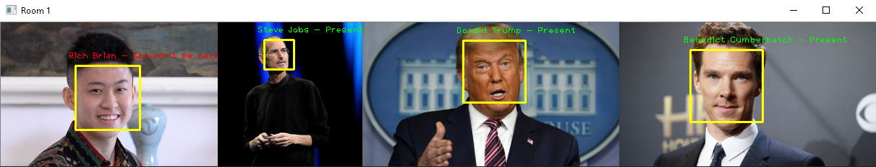

**Figure 1. Image Final Result for Room 1**

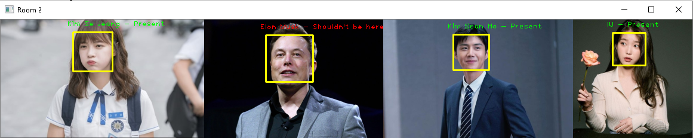

**Figure 2. Image Final Result for Room 2**

**Guidelines:**

1. **All** the **steps mentioned in the case** should be **put** in the **corresponding function** in the **template**. **All codes written** **outside** the **corresponding function** will **not be marked**.
2. Do not **modify** or **erase** **any** **codes** in the **template**.

**Reference:**

* + - The dataset is obtained from Google Image