|  |  |
| --- | --- |
| **Assignment Case** |  |
| COMP7116  Computer Vision |
| **Computer Science** | **O213-COMP7116-MQ03-01** |
| ***Valid on*** *Odd Semester 2020/2021* | **Revision 00** |

1. Seluruh mahasiswa tidak diperkenankan untuk:

*All students are not allowed to:*

* + 1. Melihat sebagian atau seluruh jawaban mahasiswa lain,

*Seeing a part or the whole answer from other student*

* + 1. Menyadur sebagian maupun seluruh jawaban dari buku,

*Adapted a part or the whole answer from the book*

* + 1. Mendownload sebagian maupun seluruh jawaban dari internet,

*Downloading a part or the whole answer from the internet,*

* + 1. Mengerjakan soal yang tidak sesuai dengan tema yang ada di soal,

*Working with another theme which is not in accordance with the existing theme in the matter of the case,*

* + 1. Melakukan tindakan kecurangan lainnya,

*Committing other dishonest actions,*

* + 1. Secara sengaja maupun tidak sengaja melakukan segala tindakan kelalaian yang menyebabkan hasil karyanya berhasil dicontek oleh orang lain / kelompok lain.

*Accidentally or intentionally conduct any failure action that cause the results of the project was copied by someone else / other groups.*

1. Jika mahasiswa terbukti melakukan tindakan seperti yang dijelaskan butir 1 di atas, maka **nilai mahasiswa** yang melakukan kecurangan (menyontek maupun dicontek) akan di – **NOL** – kan.

*If the student is proved to the actions described in point 1 above, the score of the student which committed dishonest acts (cheating or being cheated) will be “Zero”*

1. Perhatikan jadwal pengumpulan jawaban, segala jenis pengumpulan jawaban di luar jadwal tidak dilayani.

*Pay attention to the submission schedule, all kinds of submission outside the schedule will not be accepted*

1. Persentase penilaiaan untuk matakuliah ini adalah sebagai berikut:

*Marking percentage for this subject is described as follows:*

|  |  |  |
| --- | --- | --- |
| **Tugas Mandiri**  *Assignment* | **Proyek**  *Project* | **UAP**  *Final Exam* |
| 40% | 60% | - |

1. Software yang digunakan pada matakuliah ini adalah sebagai berikut:

*Software will be used in this subject are described as follows:*

|  |
| --- |
| **Software**  *Software* |
| Visual Studio Code  Python 3.7  SciPy 1.5.0  OpenCV 3.4.2.16 |

## Ekstensi file yang harus disertakan dalam pengumpulan tugas mandiri untuk matakuliah ini adalah sebagai berikut:

*File extensions should be included in assignment collection for this subject are described as follows:*

|  |  |  |
| --- | --- | --- |
| **Tugas Mandiri**  *Assignment* | **Proyek**  *Project* | **UAP**  *Final Exam* |
| PY | PY | - |

## Soal

*Case*

**Yopaw’s Birthday Party**

Tomorrow is Yopaw’s birthday party. As his best friend, you want to celebrate it with his favorite soft drinks. Unfortunately, you don’t know how to distinguish all the soft drinks brands. So, you decided to **create a program to** help you find Yopaw’s favorite soft drink. Thankfully, the near store has **all pictures of the soft drinks** they have. The program needs a **feature matching** to **compare** **the** **picture of Yopaw’s favorite soft drinks** and **all pictures of the soft drinks** in the store. After the program finished comparing all the soft drinks photos, the program also needs to **show the best match between all comparisons.**

**Dataset Description**

The dataset consists of:

* **object-1.jpg**

Picture of the **object to be found** (**Yopaw’s favorite soft drinks**)

* **Data Folder**

Pictures of **all** **soft drinks available in the store**

All the dataset used in this task can be downloaded from **References** and will be used for the feature matching. **Do not** use **other data** than the dataset that has been given.

**Preprocessing**

Before being processed, **pictures** from the **Data folder** must be preprocessed using **Grayscale** and **Bilateral Filter**.

**Feature Matching**

The **object to be found** will be **matched** with **pictures** from the **Data folder**. All **matching results** will be **compared**, and the **best result** will be **shown**.

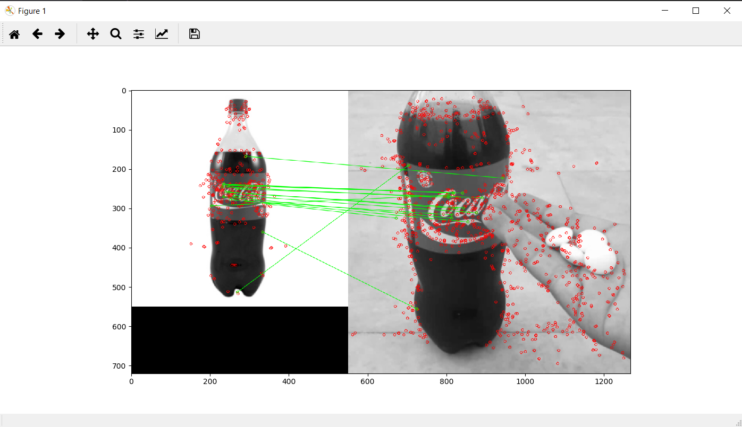

**Figure 1. The best result of feature matching**

**References:**

* <https://cf.shopee.co.id/file/bcd44049672e1daeaf9e67aadec766cf>
* <https://www.ralali.com/v/tokomamangrosir/product/FANTA-FANTA-Minuman-Bersoda-1-Liter-Isi-12-100000175896001>
* <https://cdn.kmall.id/media/catalog/product/cache/c687aa7517cf01e65c009f6943c2b1e9/s/p/sprite_sprite-can--330-ml-_full01.jpg4>
* <https://5.imimg.com/data5/IN/DK/GP/SELLER-88087163/pepsi-2-liter-bottle-500x500.jpg>
* <https://www.dpsgproductfacts.com/smedia/dpsgproductfacts.com/www/product_images/AW_DIET_ROOT_BEER_12.png?v=1481563117>
* <https://adilstore.com/media/catalog/product/cache/1/image/500x300/9df78eab33525d08d6e5fb8d27136e95/f/a/fayrouz_pineapple_330_ml.jpg>
* <https://my247mart.com/832-tm_large_default/mountain-dew-bottle-225liter-x-1pc.jpg>
* <https://www.dollargeneral.com/media/catalog/product/cache/0729a8e318a86bbdd225c6c8aa5967a3/1/9/1942201.jpg>
* <https://i5.walmartimages.ca/images/Large/106/210/1106210.jpg>
* <https://www.dollargeneral.com/media/catalog/product/cache/0729a8e318a86bbdd225c6c8aa5967a3/1/1/11435801.jpg>
* <https://www.meme-arsenal.com/memes/c4cbd799cc04d94a38dfff9d2f35c36b.jpg>