|  |  |
| --- | --- |
| **Assignment Case** |  |
| COMP7116001  Computer Vision |
| **Computer Science** | **O213-COMP7116-MQ06-01** |
| ***Valid on*** *Odd Semester Year 2021/2022* | **Revision 00** |

1. Seluruh mahasiswa tidak diperkenankan untuk:

*All students are not allowed to:*

* + 1. Melihat sebagian atau seluruh jawaban mahasiswa lain,

*Seeing a part or the whole answer from other student*

* + 1. Menyadur sebagian maupun seluruh jawaban dari buku,

*Adapted a part or the whole answer from the book*

* + 1. Mendownload sebagian maupun seluruh jawaban dari internet,

*Downloading a part or the whole answer from the internet,*

* + 1. Mengerjakan soal yang tidak sesuai dengan tema yang ada di soal,

*Working with another theme which is not in accordance with the existing theme in the matter of the case,*

* + 1. Melakukan tindakan kecurangan lainnya,

*Committing other dishonest actions,*

* + 1. Secara sengaja maupun tidak sengaja melakukan segala tindakan kelalaian yang menyebabkan hasil karyanya berhasil dicontek oleh orang lain / kelompok lain.

*Accidentally or intentionally conduct any failure action that cause the results of the project was copied by someone else / other groups.*

1. Jika mahasiswa terbukti melakukan tindakan seperti yang dijelaskan butir 1 di atas, maka **nilai mahasiswa** yang melakukan kecurangan (menyontek maupun dicontek) akan di – **NOL** – kan.

*If the student is proved to the actions described in point 1 above, the score of the student which committed dishonest acts (cheating or being cheated) will be “Zero”*

1. Perhatikan jadwal pengumpulan jawaban, segala jenis pengumpulan jawaban di luar jadwal tidak dilayani.

*Pay attention to the submission schedule, all kinds of submission outside the schedule will not be accepted*

1. Persentase penilaiaan untuk matakuliah ini adalah sebagai berikut:

*Marking percentage for this subject is described as follows:*

|  |  |  |
| --- | --- | --- |
| **Tugas Mandiri**  *Assignment* | **Proyek**  *Project* | **UAP**  *Final Exam* |
| 40% | 60% | - |

1. Software yang digunakan pada matakuliah ini adalah sebagai berikut:

*Software will be used in this subject are described as follows:*

|  |
| --- |
| **Software**  *Software* |
| Visual Studio Code  Python 3.7  SciPy 1.5.0  OpenCV 3.4.2.16 |

## Ekstensi file yang harus disertakan dalam pengumpulan tugas mandiri untuk matakuliah ini adalah sebagai berikut:

*File extensions should be included in assignment collection for this subject are described as follows:*

|  |  |  |
| --- | --- | --- |
| **Tugas Mandiri**  *Assignment* | **Proyek**  *Project* | **UAP**  *Final Exam* |
| PY | PY | - |

## Soal

*Case*

**Devinca’s Problem**

Devinca has a problem that makes her feel uncomfortable. That’s because of her acne. Since she has already run out of face wash, she needs to buy a new one. Because she cannot go to the store, she gave you her **face wash photo** and asked you to help her buy her face wash. You as an **Artificial Intelligence Student** try to practice your computer vision skill. So, you decided to **create a program** to help her find her face wash. Thankfully, the store has **all photos of the face wash** they have. The program needs a **feature matching** to **compare** **the picture of Devinca’s face wash** and **all photos of the face wash in the store**. After the program finished comparing all the face wash photos, the program also needs to **show the best match between all comparisons** so the cashier can help you find the correct face wash.

**Dataset Description**

The dataset consists of:

* **object-1.jpg**

Picture of the **object to be found** (**Devinca’s face wash**)

* **Data Folder**

Pictures of **all** **face wash product available in the store**

All the dataset used in this task can be downloaded from **References** and will be used for the feature matching. **Do not** use **other data** than the dataset that has been given.

**Preprocessing**

Before being processed, **pictures** from the **Data folder** must be preprocessed using **Grayscale** and **Equalize Histogram**.

**Feature Matching**

The **object to be found** will be **matched** with **pictures** from the **Data folder**. All **matching results** will be **compared**, and the **best result** will be **shown**.

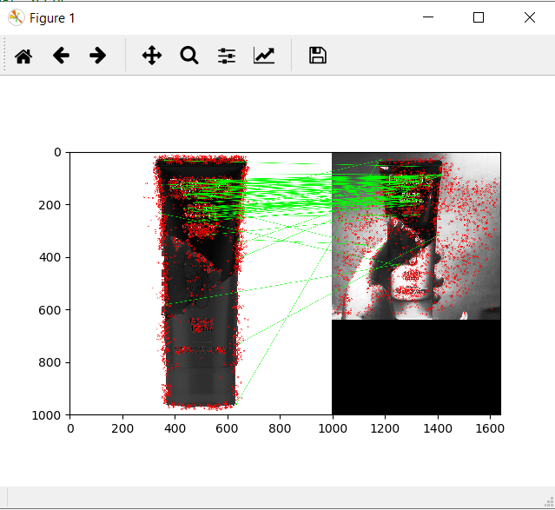

**Figure 1. The best result of feature matching**

**References:**

* <https://www.amazon.in/images/I/71sdO4itFSL._SX522_.jpg>
* <https://id-test-11.slatic.net/p/506a142fdc2c51f0ca1f22e1ebd619da.jpg_720x720q80.jpg_.webp>
* <https://www.sociolla.com/cdn-cgi/image/w=325,format=auto,dpr=1.25/https://images.soco.id/24092805769-1584371631703.png>
* <https://cf.shopee.co.id/file/94d883f5fd4b24e17b1f8c66893cd1fd>
* <https://cf.shopee.co.id/file/9c307461235d50723a5b9da5b1fef22b>
* <https://www.watsons.co.id/medias/WARDAH-MINCLRFY-FF-60ML-50331.jpg>
* <https://id-test-11.slatic.net/p/5/pigeon-facial-foam-3298-4901118-8da499f768e2029140fb660275ee5010-catalog.jpg_720x720q80.jpg_.webp>
* <https://cf.shopee.co.id/file/731fd78e7a03bbad631f93636fb8e1fd>
* <https://cf.shopee.co.id/file/ee754c90831b0e6a88dfe8225f93351e>
* <https://cf.shopee.co.id/file/6bcfdd43c0ec506cda5640bdfd05c410>
* <https://cf.shopee.co.id/file/5c8cdb2d1021149cfa61ef48c525239a>