|  |  |
| --- | --- |
| **Assignment Case** |  |
| COMP6115  Object Oriented Analysis & Design |
| **Computer Science** | **E203-COMP6115-GU01-01** |
| ***Valid on*** *Even Semester Year 2019/2020* | **Revision 00** |

## Soal

*Case*

**Neu-Bank System Information**

**Neu-Bank** is an Indonesian startup company that provides their customers with banking services such as account creation, money withdrawal, and money deposit. They asked you to create a system to support their business process. Their customers can **create a bank account**, **withdraw money**, and **deposit money** within their machine which saves the data into the database.

As a system analyst, you are requested to create a system design of the **Neu-Bank** system based on the following images by using **Visual Paradigm (*.vpp file format):**

**Use Case Diagram**

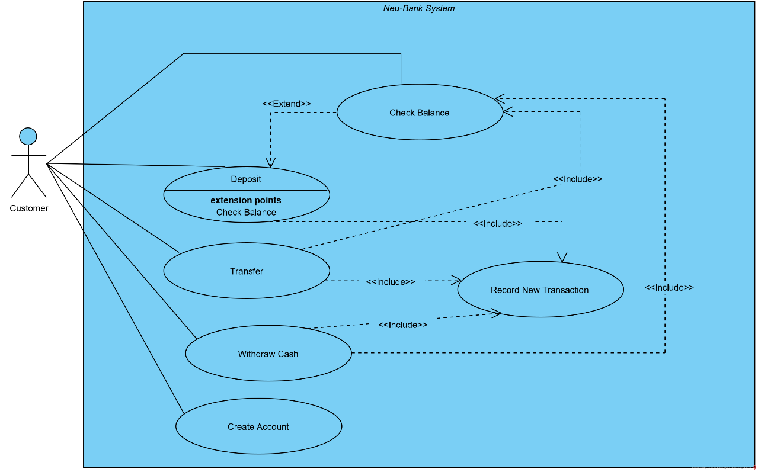

The program must have the **following** **features**:

* **Account creation**

When the **customer** opens the registration page, the program will show a form for the customer to fill with (**full name, address, gender**). Then, the user will proceed by submitting the form. Then, the program will **generate** **a unique account number** and ask the user to input **a new PIN no. for authentication**. Then, the program will **set** **the account’s balance to zero** (**0**).

* **Money withdrawal**

After the customer **logged-in** to the program and chose the “**Withdraw Money**” menu. The program will ask for an **amount of money to withdraw**. It will check if the customer **has enough balance** from their account to make the transaction. If the balance **is not enough**, it will **cancel** the transaction and **redirect the user to the main menu**. **Otherwise**, the program will **deduct the account’s balance with the amount of requested withdrawal money** and **save the transaction records**.

* **Money deposits**

After the customer **logged-in** to the program and chose the “**Deposit Money**” menu. The program will ask for an amount of money to deposit. Then, the program will add it to the account's balance and save the transaction records.

* **Money transfer**

After the customer **logged-in** to the program and chose the “**Transfer**” menu. The program will ask the user to input **recipient’s** **account** **number**. If the inputted **account** **number** is **incorrect**, it will **show an error message** and will **re-ask user to input again**. Then, the program will ask for **an amount of money to transfer**. It will **check** if the customer **has enough balance** from their account to make the transaction. If the balance **is not enough**, it will **cancel** the transaction and **redirect the user to the main menu**. **Otherwise**, the program will **add the recipient account’s balance** and **deduct the account's balance with the transferred amount of money** and **save the transaction records**.

You must create the **following** **diagrams** based on above’s **descriptions**:

* **3 Activity Diagram** (pick **3** from above’s use cases)
* **1 Sequence** **Diagram** (pick **1** from the activity diagrams that you’ve chose before)
* **1 Class** **Diagram** (pick **2** of the **following** **features**):
* **Account creation**
* **Money withdrawal**
* **Money deposits**
* **Money transfer**

**Good Luck.**