|  |
| --- |
| Notes :   1. There are 2 parts in this quiz, Essay and Case. 2. For essay problem:    1. You are required to solve it using by *handwritten on a paper*    2. Subsequently, your essay answers *should be converted in 1 pdf* *file* using this format: *nim.pdf*    3. The lecturers won’t accept any answers using word processing application in order to prevent copy-paste answers in a last minute 3. For case problem:    1. *The submission code is in .cpp file* and using this format: *nim.cpp* 4. All your answers *either essay (nim.pdf) or case (nim.cpp)* *should be zipped and submitted through* the platform that your lecturer set. Other than that, the submission won’t be accepted for any reasons. *(Note : Please zip both files using this format: nim.zip)* 5. Your Quiz will be *marked as 0* if any *plagiarism is found* |

1. Essay (60%)

When deleting, always take the replacement value from **rightmost** of **left** children.

Write down every step for insert and delete happen in all simulation tree below.

* 1. **[20%]** Given Red Black Tree in the figure 1 below:

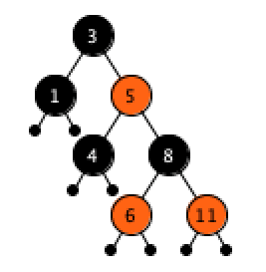

Figure 1Red Black Tree

* + 1. **[10%]** Please insert the following numbers : **12, 13, 15, 14** and **18** subsequently!
    2. **[10%]** Refer to resulting tree in 1(a), please delete the following numbers: **11, 1, 5, 4** and **6** subsequently!
  1. **[20%]** Given B-Tree order 3 in the figure 2 below:

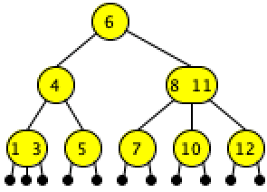

Figure 2 B-Tree Order 3

* + 1. **[10%]** Please insert the following numbers : **2, 9, 13, 15** and **18** subsequently!
    2. **[10%]** Refer to resulting tree in 2(a), please delete the following numbers : **1, 3, 5, 7** and **11** subsequently!
  1. **[20%]** Consider the graph given in Figure 3, find the shortest path from H to G using Dijkstra Algorithm. Write step by step using table and result from the table.

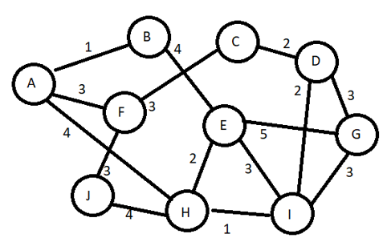

Figure 3 Graph

1. Case (40%)

Sky Ventures is adding more recruitment in **COVID** **Pandemic**, to handle this situation you are obligated to create simple apps for maintaining the database. The apps **must** use AVL **Balance Tree** to make it faster in ***searching***.

**Apps** consist of 4 menus:

1. New Freelancer
2. Update Project
3. Freelancer Resign
4. Exit

Details:

Initial Data of the program:

**Employee Name, Project Name**

=> Nagita Slavina, Ruby

=> Ayu Ting Ting, Diamond

=> Sky, PHP .NET XZ

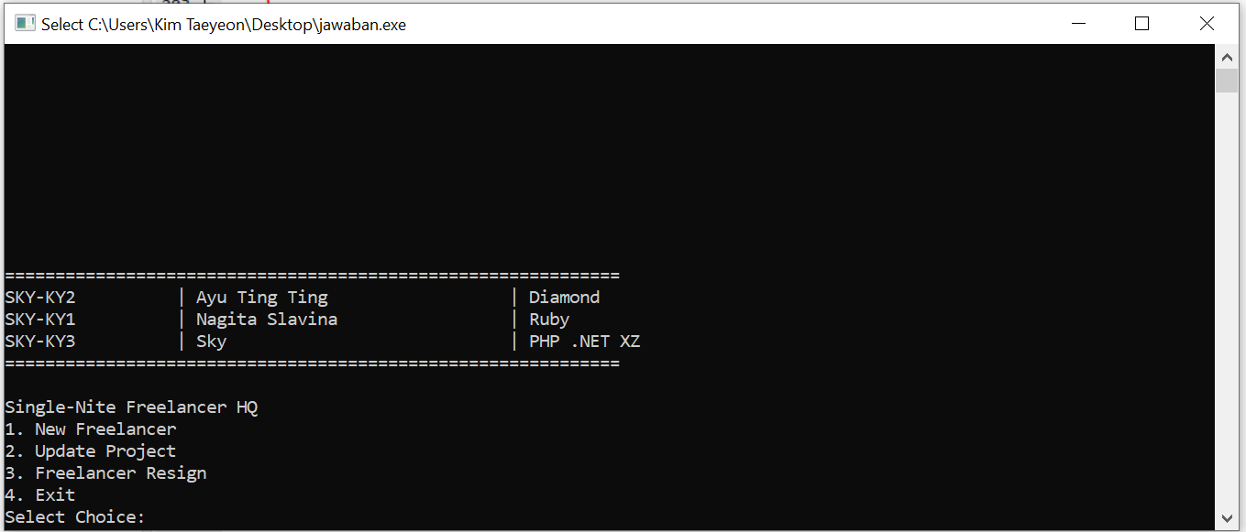

Figure 4 Menu

1. Menu 1 (New Freelancer)

Input Freelancer Name & Input Project Name

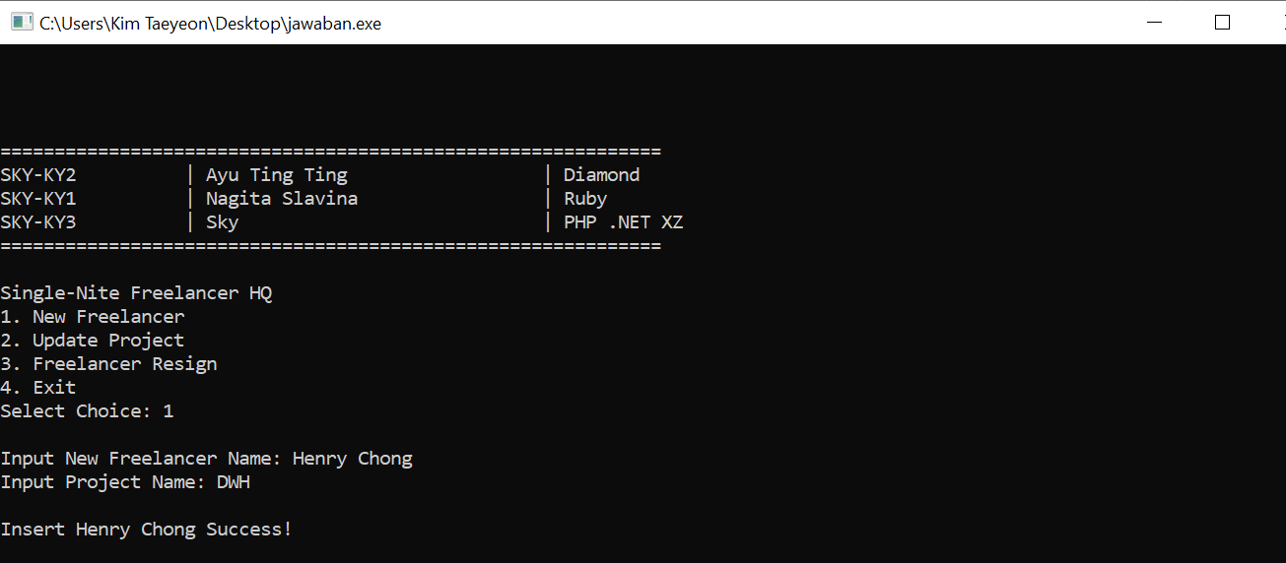

Figure 5 New Freelancer Menu

1. Menu 2 (Update Project)

Input Freelancer Name & New Project Name

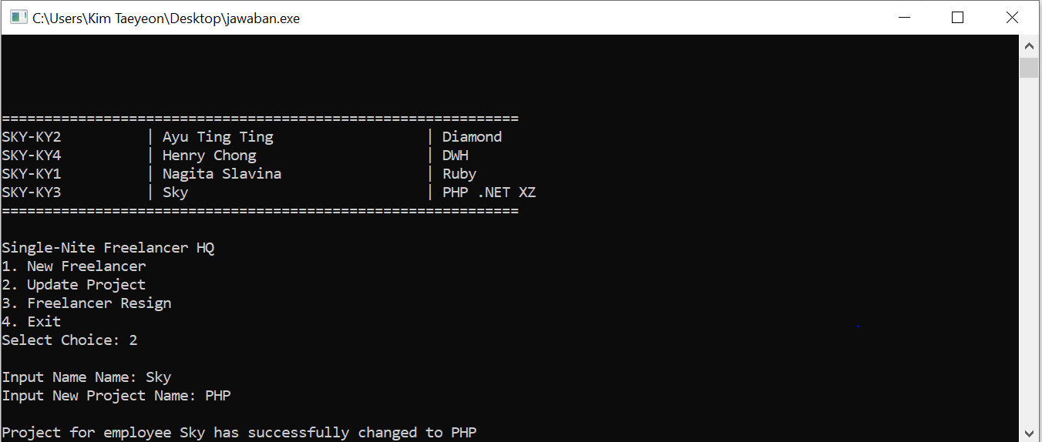

Figure 6 Update Project Menu

1. Menu 3 (Freelancer Resign)

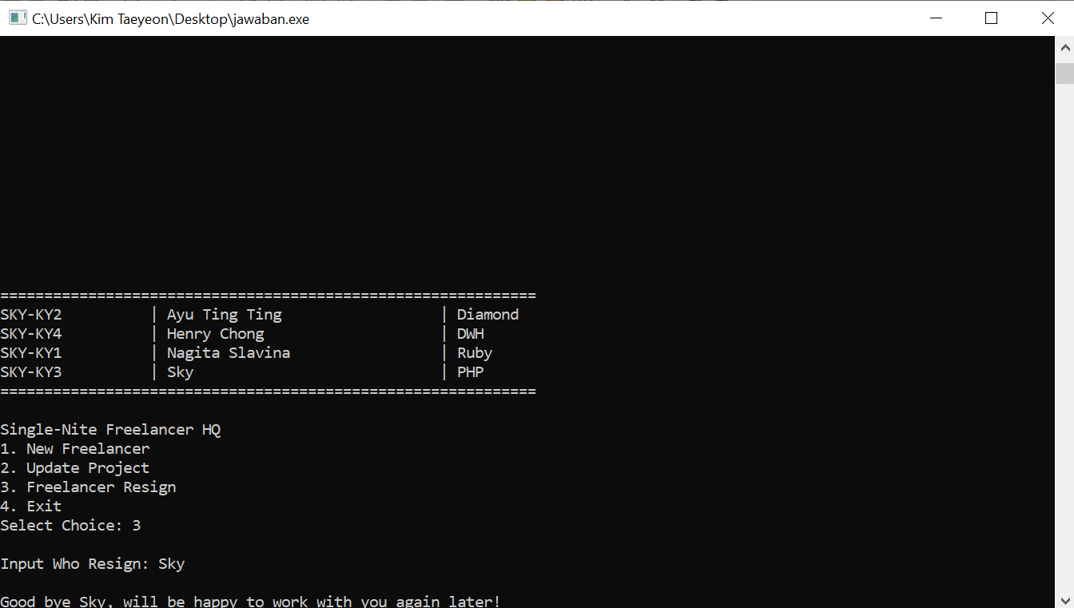

Figure 7 Freelancer Resign Menu

If Employee Not Exists

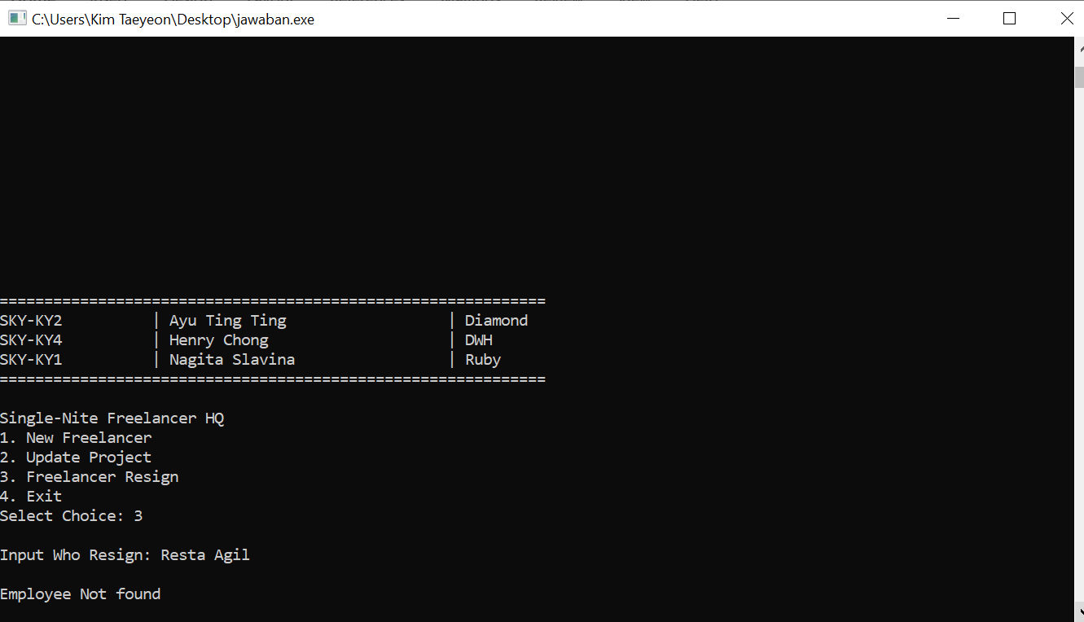

Figure 8 Validation Implemented in Freelancer Resign Menu

-- Good Luck --