|  |  |
| --- | --- |
| **Assignment Case** |  |
| COMP6175 | T0044  Object Oriented Programming |
| **Computer Science** | **E203-COMP6175-LC00103-01** |
| ***Valid on*** *Even Semester Year 2019/2020* | **Revision 00** |

## Soal

*Case*

**Inventory Management System**

**Inventory Management System** is an inventory system that saves list of items available in a certain store. You as a programmer are asked to make **Inventory Management System** that capable of **handling** user **requirements** using **Java Programming Language** with the following specifications:

First, the program will **display** **main menu** that consists of:

1. **View Item in Inventory**
2. **Add New Item to Inventory**
3. **Checkout Item from Inventory**
4. **Exit**

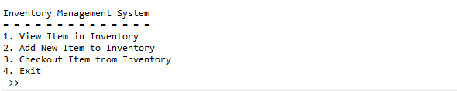

1. If the user chooses **View Item in Inventory (Menu 1)**, then:
   * If **inventory list is empty**, then show the following message:



* + Otherwise, the program will **display list of items** inside inventory along with item’s **id**, item’s **name**, item’s **price**, and item’s **stock**.

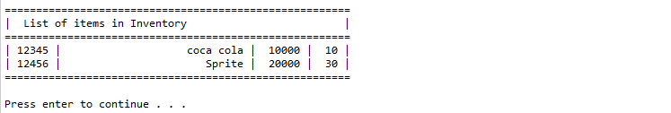

1. If the user chooses **Add New Item to Inventory (Menu 2)**, then:
   * The program will askthe user to **input item id**, which **length** must be **5** characters.
   * If **item** **id** already **exists** in the **inventory list**, then do the following:
     + **Display** item’s **id**, item’s **name**, item’s **price**, and **current** item’s **stock**.
     + **Ask** the user to **input** how many **stocks** to be **added to current** **item’s stocks. Validate** the input **must be number**.
     + **Update** item’s stock by **adding** the user’s **input** to **current item’s stock**.
     + **Display “Success Update Item Stock”** message.

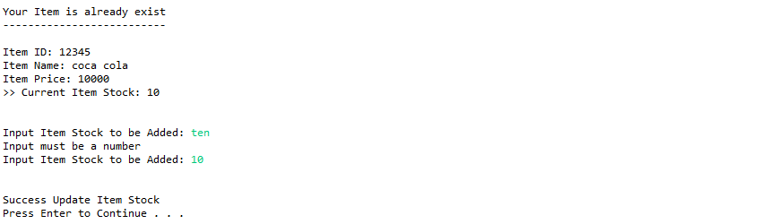

* + - Otherwise, if **item** **id** **does not exist** in inventory list, then do the following:
      * The program will **ask** user to input the following data:
        + **Item name,** which **length** between **5** and **28** **characters**
        + **Item price,** which **value** must be **number** and **more than or equal** to **10000**
        + **Item stock,** which **value** must be **number** and **more** **than** **or** **equal** to **10**
      * Then the program will **save the new item** into the inventory list and **print** success message.

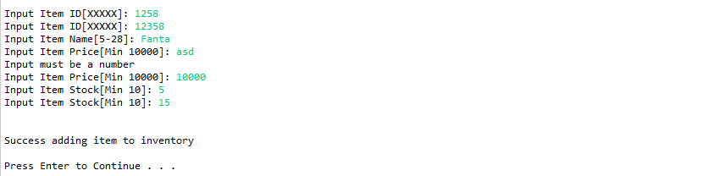

1. If the user chooses **Checkout Item form Inventory (Menu 3)**, then:
   * If inventory list is empty, then show the following message:



* + Otherwise, the program will:
    - **Display list of items** inside inventory along with item’s **id**, item’s **name**, item’s **price**, and item’s **stock**
    - **Ask** user to **input** item’s **id** to be checked out
    - The program will **validate** whether the item is **exists** **in** **the inventory list** or not
    - If the **item does not exist**, ask the user to **re-input** the item’s **id**
    - Otherwise, the program will **check** the **availability** of **item’s stocks**
      * If item’s **stock** is **available** (more than zero):
        + The program will **ask** user to **input** the **amount of stock** to be checkout
        + **Validate** the **input** must be **number** and between **1** and **available** item’s **stock**
        + **Display total revenue** of the item that has been checked out with following formula:

Total Revenue = item’s amount to be checkout * item’s price

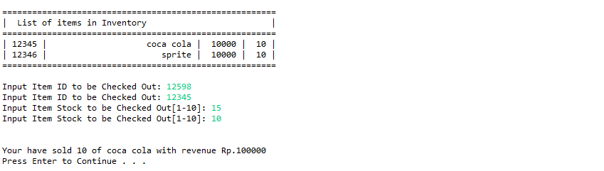

* + - * Otherwise, **display** **message** **“Cannot checkout, item is out of stock!!”** and **redirect** user tothe **main menu**



1. If the user chooses **Exit (Menu 4)**, the program will exit

**Please run the EXE file to see the sample program.**