|  |  |
| --- | --- |
| **Assignment Case** |  |
| COMP6175 | T0044  Object Oriented Programming |
| **Computer Science** | **E203-COMP6175-LC00402-01** |
| ***Valid on*** *Even Semester Year 2019/2020* | **Revision 00** |

## Soal

*Case*

**Blacksmith**

**Blacksmith** is a system that saves weapon data which have been created by the blacksmith. You as a programmer are asked to make this **Blacksmith** program using **Java Programming Language** with the following specifications:

First, the program will show the **main menu** to the user that consists of:

**1. Add Weapon**

**2. View Weapon**

**3. Delete Weapon**

**4. Exit**

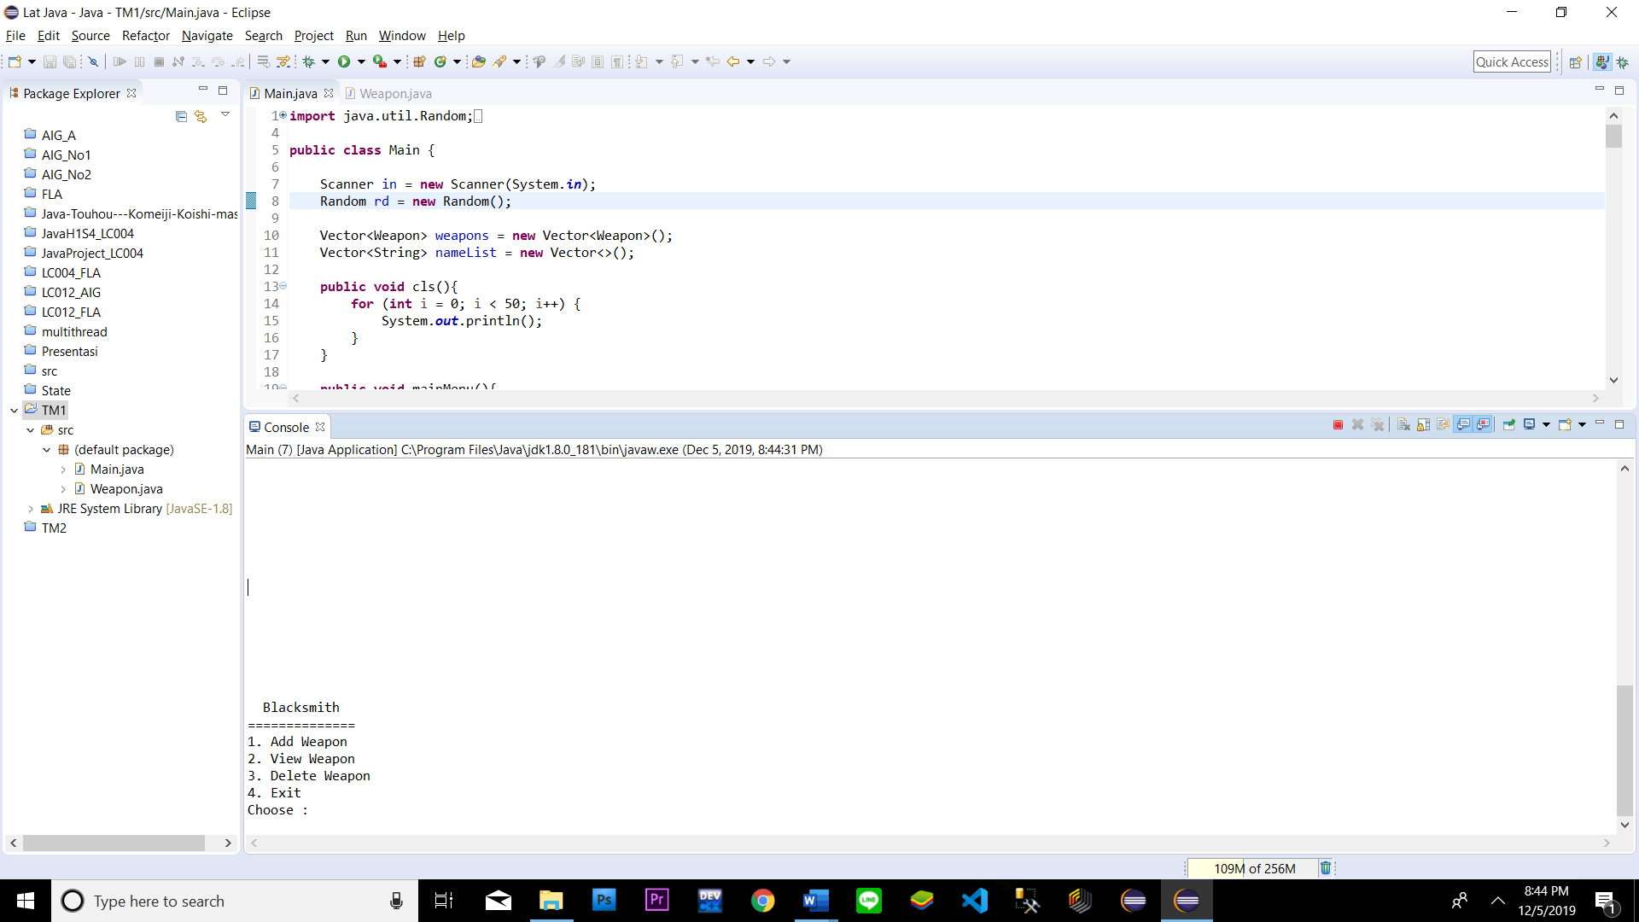

1. If the user chooses **Add Weapon (menu 1),** then:

* First, the program will **randomly** **generate weapon’s id** with this format:

|  |
| --- |
| XXZZZ  X = character [A - Z]  Z = number [0 - 9]  Example: OF098 |

* The program will ask user to input the **weapon’s name**. Validate the **name’s length** must be between **3 and 12 characters** and **must be unique**
* The program will ask user to input **weapon’s quality**. Validate the **quality** must be “**Low**”**,** “**Medium**” **or** “**High**”(**Case Sensitive**)
* After that, the program will **randomly generate the weapon’s power** with the following rules:

|  |  |
| --- | --- |
| Quality | Power |
| Low | 0 - 4999 |
| Medium | 5000 - 9999 |
| High | 10000 – 14999 |

* Calculate the **weapon’s price** with the following rule:

|  |  |
| --- | --- |
| Quality | Price |
| Low | 2000 + power |
| Medium | 3000 + power |
| High | 4000 + power |

* Finally, the program will **save the weapon to the list** and **show message** “**Add weapon success**”

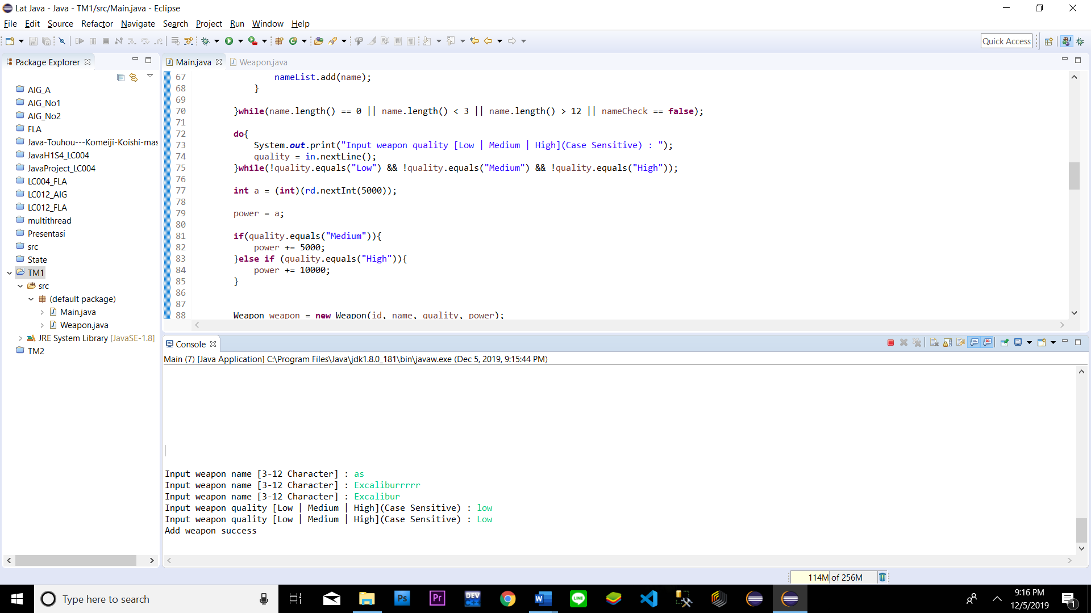

1. If the user chooses **View Weapon (menu 2),** then:

* If there is no weapon data, **show message** “**There is no data..**”

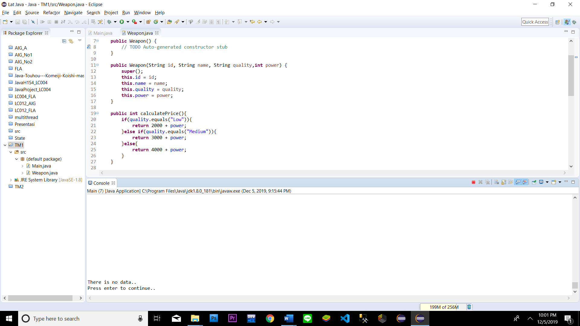

* Otherwise, **print** all the weapon data that have been added

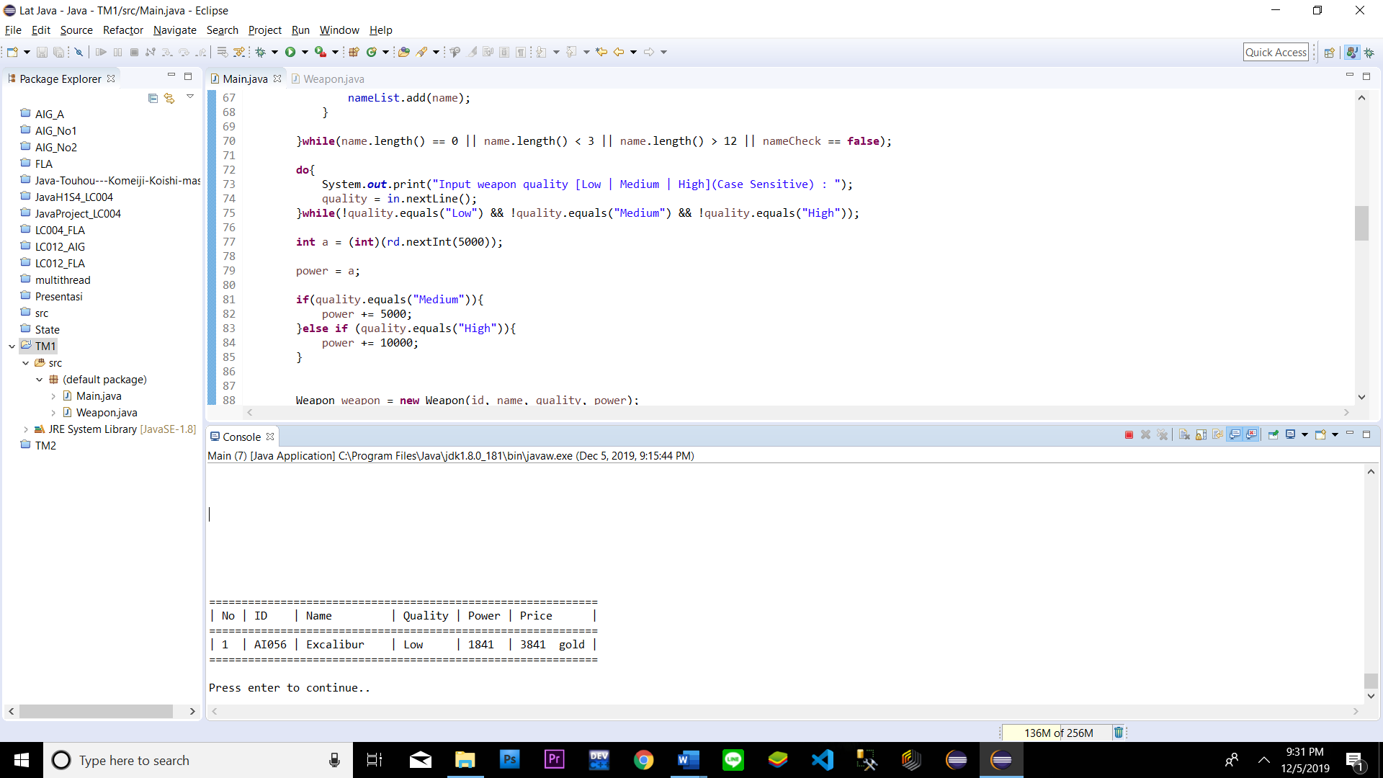

1. If the user chooses **Delete Weapon (menu 3),** then:

* If there is no weapon data, **show message** “**There is no data..**”



* Otherwise, do the following:
* **Print all** the **weapon data** in the list
* Ask the user to **input weapon index to be deleted**.Validate the index must be **between 1 and total weapons**
* If the user **input 0** then the program will back to the **main menu**

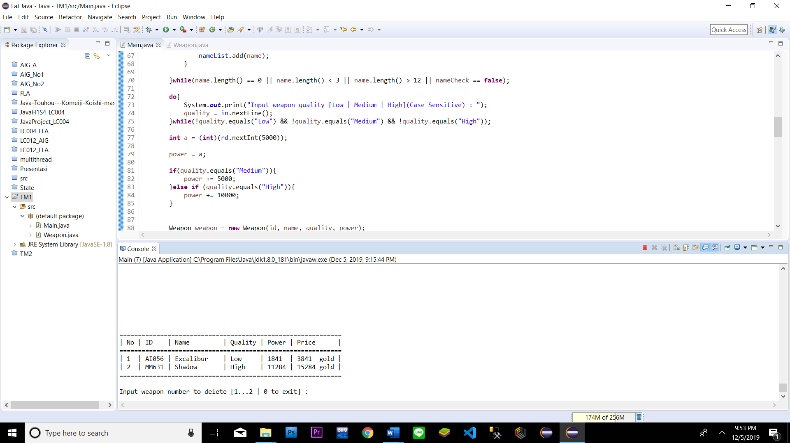

* Otherwise, the program will **delete the selected weapon** from the list and **show message “Delete success..”**

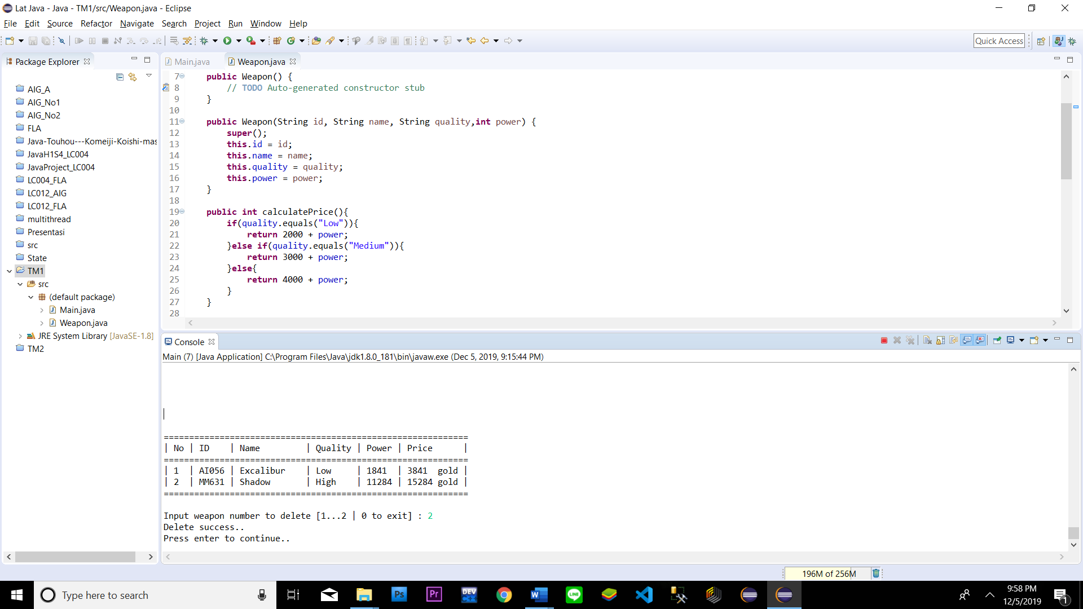

1. If the user chooses **Exit (menu 4),** then the program will **exit**

**Please run the EXE file to see the sample program.**