|  |  |
| --- | --- |
| **Assignment Case** |  |
| COMP6175 | T0044  Object Oriented Programming |
| **Computer Science** | **E203-COMP6175-WR01-01** |
| ***Valid on*** *Even Semester Year 2019/2020* | **Revision 00** |

## Soal

*Case*

**Shoe Shop**

**Shoe Shop** is a popular local shoe seller that is in Jakarta, Indonesia. You as a programmer are asked to make a program for **Shoe Shop’s admin** using **Java Programming Language** with the following specifications:

First, the program will print **main menu** that consists of:

1. **View Shoes**
2. **Add Shoe**
3. **Delete Shoe**
4. **Exit**

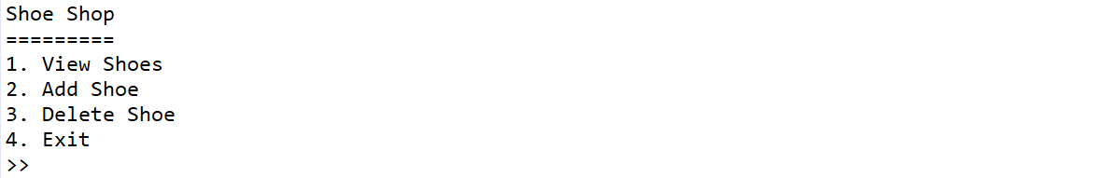

1. If the user chooses **View Shoes (Menu 1)**, then:
   * If **shoe list is empty**, then **show message “No shoes available..”**



* + Otherwise, **show all shoes data**

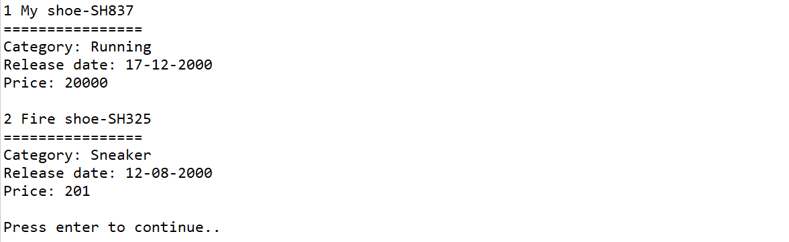

1. If the user chooses **Add Shoe (Menu 2)**, then:
   * The program will ask user to **input** the following data:
     + **Shoe Name**, which must **end with “shoe”**
     + **Shoe Category**, which must between **“Sneaker”, “Running”, or “Boot” (case sensitive)**
     + **Shoe Release Date**, which must follow the following format:

**dd-mm-yyyy**

|  |  |  |
| --- | --- | --- |
| Format | Description | Constraint |
| dd | day | Between 1 - 30 |
| mm | month | Between 1 - 12 |
| yyyy | year | Between 2000 - 2020 |

* + - **Shoe Price**, which is **more than or equals to 5000**
  + After that, the program will generate **Shoe ID** with the following format:

**SHXXX**

**Where:**

**X = Random Number 0-9**

**Example: SH327**

* + Finally, the program will **save the new shoe** into the list

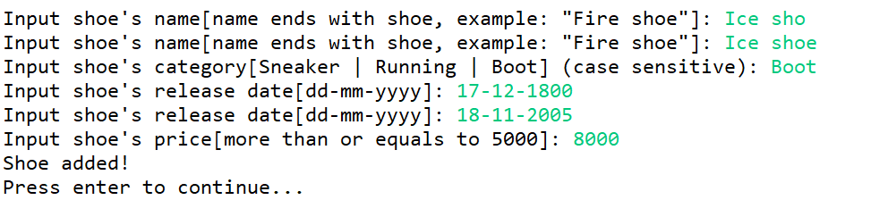

1. If the user chooses **Delete Shoe (Menu 3)**, then:
   * If the **shoe list is empty**, then **show message** **“No shoes available”**



* + Otherwise, do the following:
    - **Print all** the **shoes** in the list.
    - Ask user to **input shoe index**. Validate the index must be **between 1 and total of shoes list**

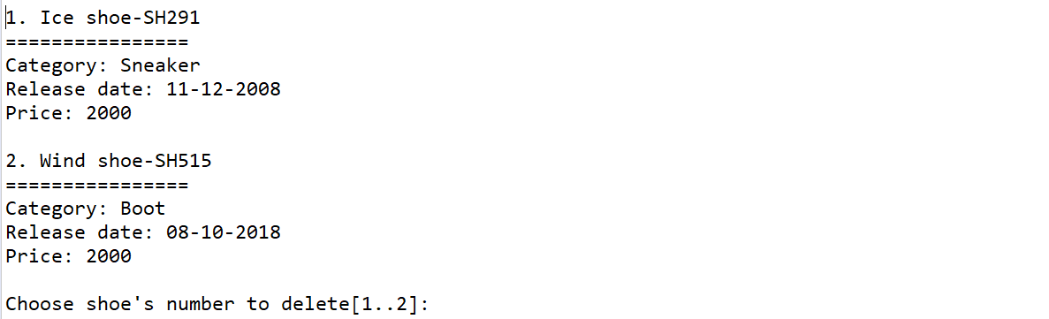

* + - After that, the program will **delete the shoe** from the list and **show message “Shoe removed!”**



1. If the user chooses **Exit (Menu 4)**, the program will print message “**Thank you for using this application!**” and **exit**.

**Please run the EXE file to see the sample program.**